Annexes
Initial Planning Document NPA 416/647 Numbering Relief

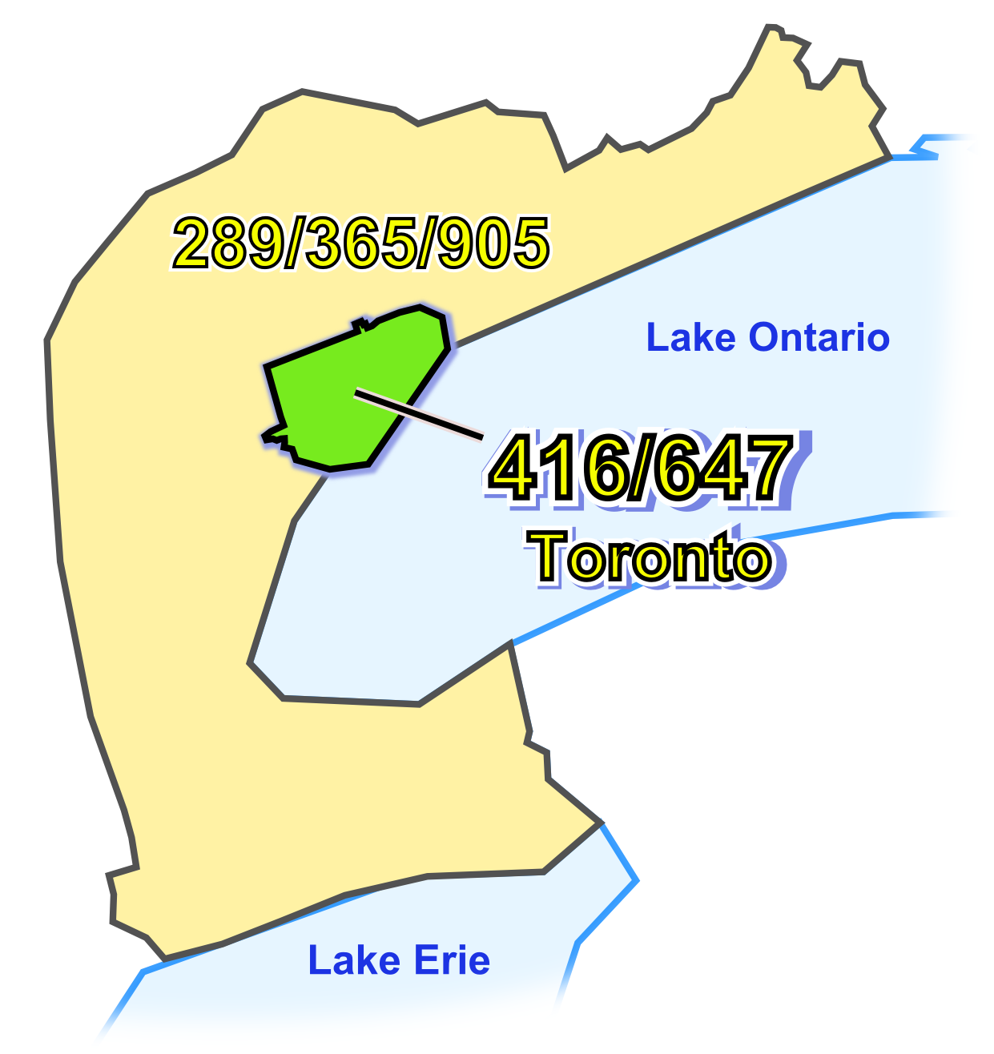

Initial Planning Document (IPD)

Version 1.0 – October 17, 2010

Figure 1 - Overview of NPA 461/647 and Adjacent NPAs
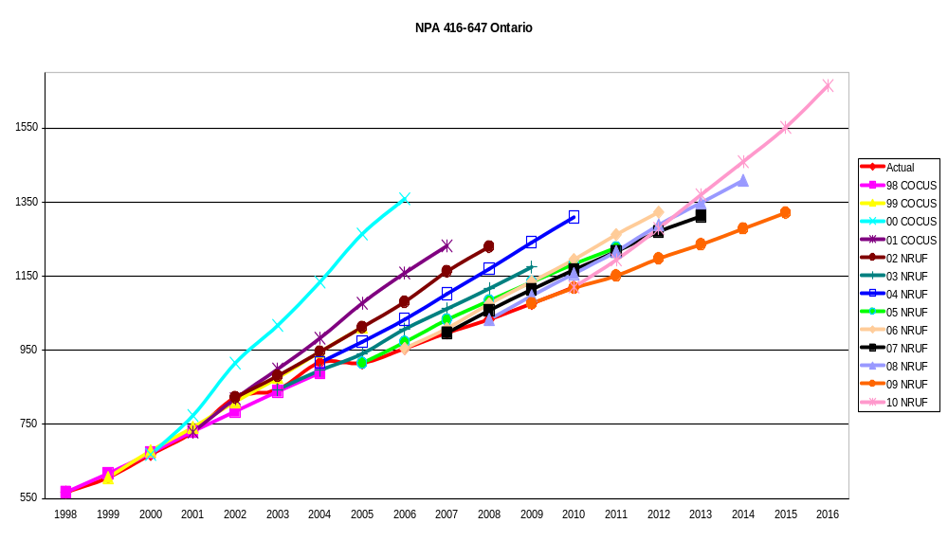
Figure 2 - NPA 416/647 Actual and Forecast CO Code Assignments
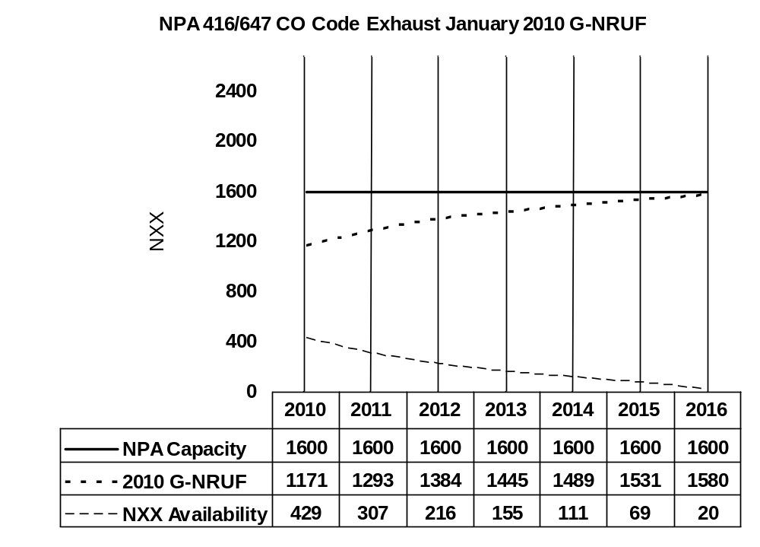
Figure 3 - NPA 416/647 CO Code Exhaust January 2010 G-NRUF

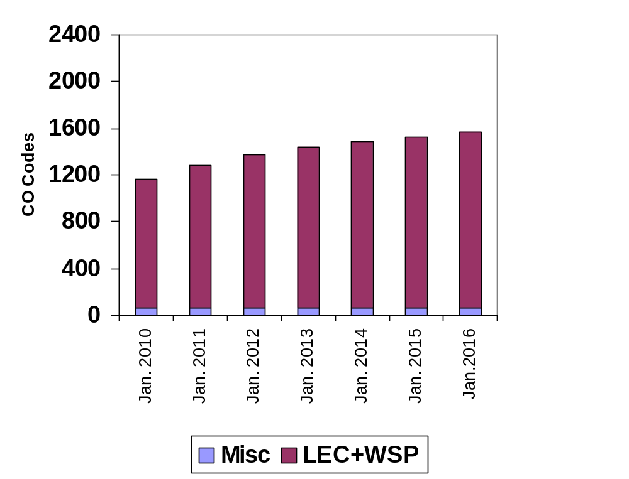
Figure 4 - NPA 416/647 Miscellaneous and LEC+WSP CO Codes 2010 G-NRUF

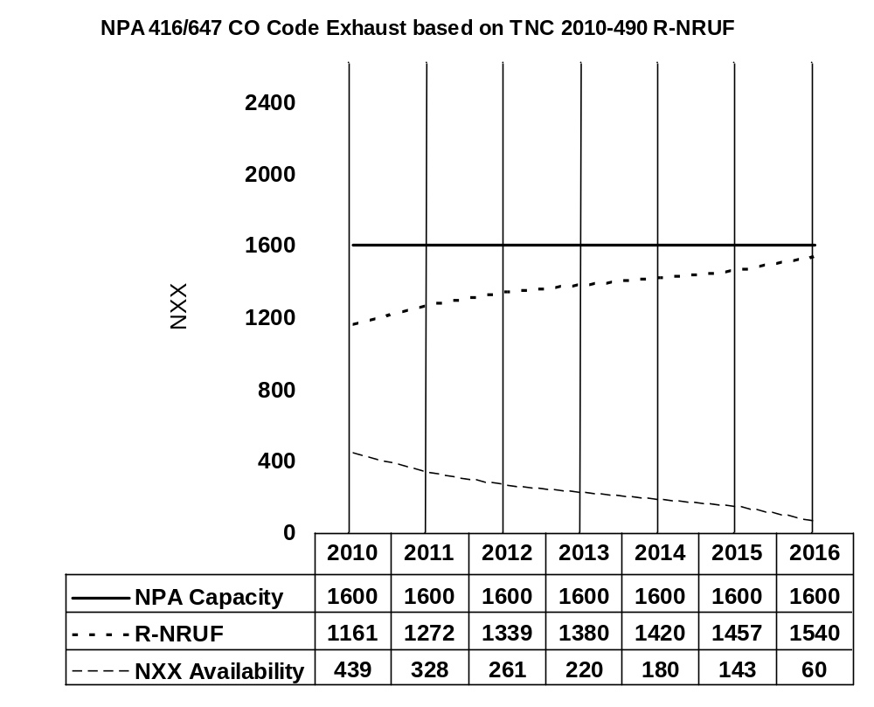

Figure 5 - NPA 416/647 CO Code Exhaust after release of Telecom Notice of Consultation CRTC 2010-490

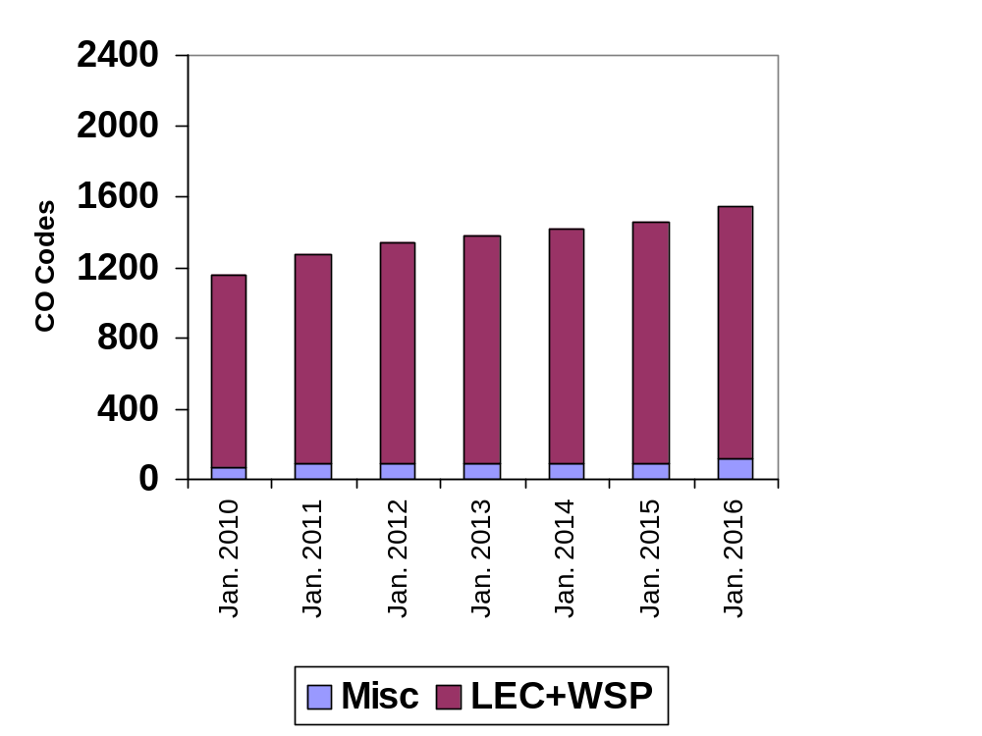

Figure 6 - NPA 416/647 Miscellaneous and LEC+WSP CO Codes after release of Telecom Notice of Consultation CRTC 2010-490

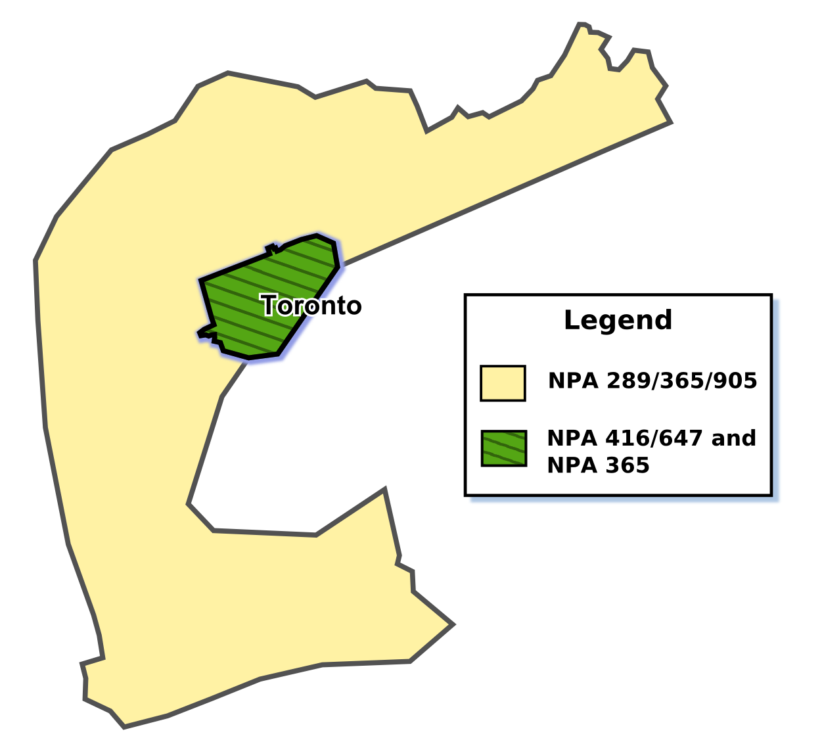

Figure 7 - Plan 1: NPA 365 Boundary Extension Overlay

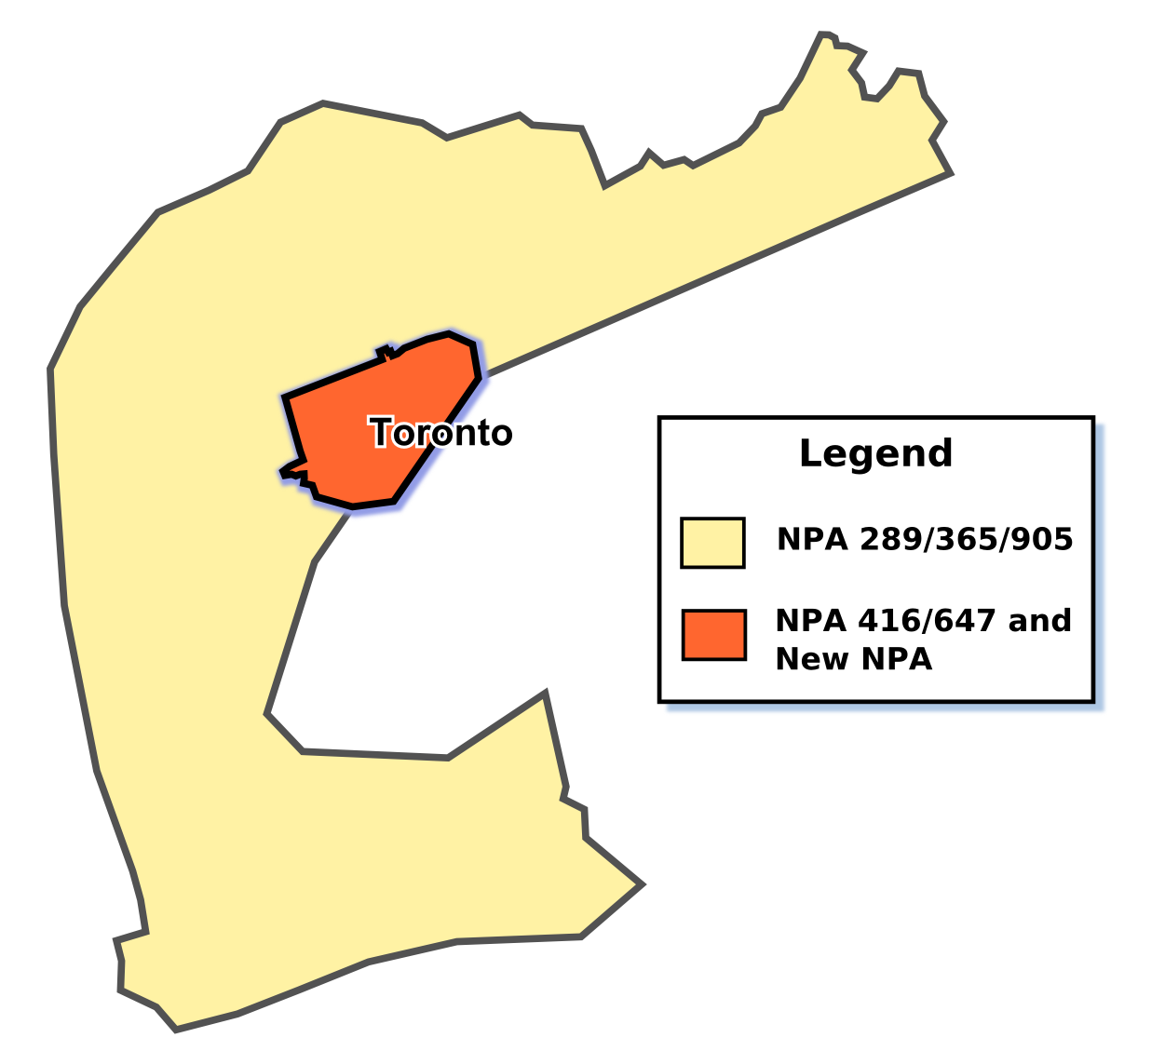

Figure 8 - Plan 2: Distributed Overlay of New NPA on NPA 416/647

Table 1 – Exchange Areas currently in NPA 416/647 and NPA 365 for theese Exchange Areas after each Relief Plan
In Plan 1, boundaries of neighbouring NPA 365 would be extended to include Toronto Exchange currently served by NPA 416/647.

Exchange Areas (currently in NPAs 416/647 and 289/905/365) | Plan 1 |  | Plan 2
Exchange Areas (currently in NPAs 416/647 and 289/905/365) | 289/905/365 | 365 | 416/647 | New NPA
Toronto |  | ✓ | ✓ | ✓
Ajax-Pickering | ✓
Ancaster | ✓
Aurora | ✓
Beamsville | ✓
Beeton | ✓
Bethesda | ✓
Binbrook | ✓
Blackstock | ✓
Bolton | ✓
Bowmanville | ✓
Bradford | ✓
Brampton | ✓
Brooklin | ✓
Burlington | ✓
Caledon East | ✓
Caledonia | ✓
Campbellville | ✓
Castlemore | ✓
Castleton | ✓
Cayuga | ✓
Claremont | ✓
Clarkson | ✓
Cobourg | ✓
Colborne | ✓
Cold Springs | ✓
Cooksville | ✓
Dundas | ✓
Dunnville | ✓
Fisherville | ✓
Fort Erie | ✓
Freelton | ✓
Garden Hill | ✓
Georgetown | ✓
Gormley | ✓
Grafton | ✓
Grimsby | ✓
Hagersville | ✓
Hamilton | ✓
Hampton | ✓
Keswick | ✓
King City | ✓
Kleinburg | ✓
Malton | ✓
Maple | ✓
Markham | ✓
Milton | ✓
Mount Albert | ✓
Mount Hope | ✓
Newcastle | ✓
Newmarket | ✓
Newtonville | ✓
Niagara Falls | ✓
Niagara-on-the-Lake | ✓
Nobleton | ✓
Oak Ridges | ✓
Oakville | ✓
Orono | ✓
Oshawa | ✓
Palgrave | ✓
Pelham | ✓
Port Colborne | ✓
Port Credit | ✓
Port Hope | ✓
Port Perry | ✓
Port Robinson | ✓
Queensville | ✓
Richmond Hill | ✓
Ridgeway | ✓
Roseneath | ✓
Schomberg | ✓
Selkirk | ✓
Snelgrove | ✓
South Pickering | ✓
St. Catharines-Thorold | ✓
Stevensville | ✓
Stoney Creek | ✓
Stouffville | ✓
Streetsville | ✓
Sutton | ✓
Thornhill | ✓
Tottenham | ✓
Unionville | ✓
Uxbridge | ✓
Victoria | ✓
Vineland | ✓
Wainfleet | ✓
Waterdown | ✓
Welcome | ✓
Welland | ✓
Wellandport | ✓
West Lincoln | ✓
Whitby | ✓
Winona | ✓
Woodbridge | ✓

Distribution List

Exatel Inc.  222 McIntyre Street West Suite 505  North Bay, ON  Canada  P1B 2Y8  regulatory@vianet.ca | Regulatory E-Mail  Distributel Communications Limited  177 Nepean Street  Ottawa, ON  Canada  K2P 0B4  regulatory@distributel.ca
Edward Anteccol  Vice President, Regularoty Affairs  Yak Communcations (Canada) Corp  48 Yonge St Suite 1200  Toronto, ON  Canada  M5E 1G6  Telephone: 416-949-1277  Fax: 416-640-1089  edwardantecol@globalive.com | Madalina Armeanca  Marketing Manager  Globalive Wireless management Corp  207 Queen's Quay W, Suite 710  Toronto, ON  M5J 1A7  Telephone: 416-572-0141  Fax: 416-987-1203  mlarmeanca@windmobile.ca
Larry Baines  Wireless Portability & Number Administration  Rogers Wireless  8200 Dixie Road  Brampton, ON  Canada  L6T 0C1  Telephone: 647-747-4649  Fax: 647-747-4557  larry.baines@rci.rogers.com | Bill Barsley  Manager - Planning & Engineering  TELUS  300 Consilium Place  Scarborough, ON  Canada  M1H 3G2  Telephone: 416-279-7989  Fax: 416-279-3930  bill.barsley@telus.com
Marc Berruyer  Network Planner  Videotron Ltd  2155 Boul. Pie IX, 3e etage, bloc A  Montreal, QC  Canada  H1V 2E4  Telephone: 514-380-4255  Fax: 514-899-8452  marc.berruyer@vtl.quebecor.com | Olena Bilozerska  Network Planning Manager  TELUS  300 Consilium Place, 9th Floor  Scarborough, ON  Canada  M1H 3G2  Telephone: 416-279-8521  Olena.Bilozerska@telus.com
Doug Birdwise  Associate Director - Network Planning  Bell Canada  160 Elgin St., Floor 4 (04-E009)  Ottawa, ON  Canada  K1G 3J4  Telephone: 613-781-4366  Fax: 613-569-9675  doug.birdwise@bell.ca | Samer Bishay  CEO  Iristel Inc.  11 Bowan Court  Toronto, ON  Canada  M2K 3A8  Telephone: 416-800-9999  Fax: 416-628-0891  sbishay@iristel.com
Joe Boutros  President  Globility Communications Corporation  108-5343 Dundas St West  Toronto, ON  Canada  M9B 6K5  Telephone: 416-385-0459  Fax: 416-385-0469  jboutros@globility.ca | Laurie Bowie  Network Planning  Bell Canada  162 Southfield Dr.  Strathroy, ON  Canada  N7G 3V6  Telephone: 519-245-8234  Fax: 519-245-5917  laurie.bowie@bell.ca
Glen Brown  Deputy Division Manager  SAIC Canada  60 Queen Street, Suite 1516  Ottawa, ON  Canada  K1P 5Y7  Telephone: 613-683-3291  Fax: 613-563-3399  browng@saiccanada.com | Melanye Caisse  Telecom Analyst  ISP Telecom Inc  1155 Boul Rene-Levesque Ouest Suite 2500  Montreal, QC  Canada  H3B 2K4  Telephone: 416-548-4819  Fax: 416-548-4818  melanye@isptelecom.net
Don Cavanagh  VP  Distributel Communications Limited  177 Nepean Street, Suite 300  Ottawa, ON  Canada  K2P0B4  Telephone: 613-237-7005  Fax: 613-237-7009  donald.cavanagh@distributel.ca | JF Champagne  Executive Director  Canadian Security Association, National Office  610 Alden Road, Suite 100  Markham, ON  Canada  L3R 9Z1  Telephone: 905-513-0622  Fax: 905-513-0624  jfchampagne@canasa.org
Fiona Clegg  CO Code Administration  SAIC Canada  60 Queen Street, Suite 1516  Ottawa, ON  Canada  K1P 5Y7  Telephone: 613-683-3285  Fax: 613-563-3399  cleggf@saiccanada.com | Mark Cuccia  317 Guilbeau Road, Apt.207-E  Lafayette, LA  USA  70506  Telephone: 504-460-0647  markjcuccia@yahoo.com
Jean-Marc D'Aoust  Consultant  Representative for Cogeco Cable Inc.  1720 rue Des Pins  Limoges, ON  Canada  K0A 2M0  Telephone: 613-443-1635  jmdaoust@cgocable.ca | Diane Dolan  Business Analyst  Distributel Communications Limited  177 Nepean Street  Ottawa, ON  Canada  K2P 0B4  Telephone: 613-212-5003  Fax: 613-237-7009  diane.dolan@distributel.ca
Jean-Michel Dupuis  Coordonnateur, Services Publiques  Rogers Communications  800 rue de la Gauchetiere Ouest, Suite 4000  Montreal, QC  Canada  H5A 1K3  Telephone: 1-866-501-7727  Fax: 1-800-506-3962  jeanmichel.dupuis@rci.rogers.com | J. David Farnes  Vice President, Regulatory Affairs  Canadian Wireless Telecommunications Association (CWTA)  130 Albert Street, Suite 1110  Ottawa, ON  Canada  K1P 5G4  Telephone: 613-233-4888 ext. 106  Fax: 613-233-2032  documentcontrol@cwta.ca
Michael Gamey  Manager, Network Engineering  Public Mobile  1920 Yonge St, Suite 400  Toronto, ON  Canada  M4S 3E2  Telephone: 647-764-1400  Fax: 416-486-3269  michael.gamey@publicmobile.ca | J Edward Garner  FlexITy Solutions Inc.  45 Vogell Road, 8th Floor  Richmond Hill, ON  Canada  L4B 3P6  Telephone: 905-787-3548  Fax: 905-787-3599  ted.garner@flexity.ca
Jesse Gasteiger  ExaTEL Inc  128 Larch St., Suite 301  Sudbury, ON  Canada  P3E5J8  Telephone: 705-675-0400  Fax: 705-675-0404  jesse@vianet.ca | Anne Gertzbein  Manager Ancillary Services (411/911) & Local PIC/CARE  MTS Allstream  200 Wellington Street West  Toronto, ON  Canada  M5V 3G2  Telephone: 416-640-5229  Fax: 416-640-5219  anne.gertzbein@mtsallstream.com
Marian Hearn  Project Executive  Canadian LNP Consortium Inc.  11-300 Earl Grey Drive, Suite 113  Kanata, ON  Canada  K2T 1C1  Telephone: 613-256-2600  Fax: 800-406-9250  hearn@clnpc.ca | Lynne Hewitson  Membership Manager  Canadian Security Association (CANASA)  610 Alden Road  Markham, ON  Canada  L3R 9Z1  Telephone: 905-513-0622 ext 223  Fax: 905-513-0624  membership@canasa.org
Larry Hishon  Vice-President Business Development  Fibernetics Corporation  583 Eastgate Walk  Waterloo, ON  Canada  N2K 2V9  Telephone: 519-571-7433  Fax: 519-772-5014  lhishon@fibernetics.ca | Stephanie Jackson  Manager - Public Services Integration; Traffic Engineering  Rogers Communications  8200 Dixie Road  Brampton, ON  Canada  L6T 0C1  Telephone: 647-747-4402  Fax: 647-747-4557  stephanie.jackson@rci.rogers.com
Jasdev Kalsi  Facilities Coordinator  Rogers Communications  800 de la Gauchetiere St West Suite 4000  Montreal, QC  Canada  H5A 1K3  Telephone: 514-937-0102 Ext. 4209  jasdev.kalsi@rci.rogers.com | Suresh Khare  CO Code Manager  SAIC Canada  60 Queen Street, Suite 1516  Ottawa, ON  Canada  K1P 5Y7  Telephone: 613-683-3296  Fax: 613-563-3399  khares@saiccanada.com
Jeanne Lacombe  Senior Analyst  Canadian Radio-television and Telecommunications Commission  Central Building Les Terrasses de la Chaudière 1 Promenade du Portage  Gatineau, QC  Canada  K1A 0N2  Telephone: 819-997-4586  jeanne.lacombe@crtc.gc.ca | Peter Lang  Sr. Manager, Intercarrier Relations  Rogers Communications  333 Bloor Street East  Toronto, ON  Canada  M4W 1G9  Telephone: 416-935-7918  Fax: 416-498-3002  Peter.Lang@rci.rogers.com
Stephen Lau  Voice Planning  MTS Allstream Inc.  MP-10A, 333 Main Street  Winnipeg, MB  Canada  R3C 3V6  Telephone: 204-941-6310  Fax: 204-774-3942  stephen.lau@mtsallstream.com | Sharon Ledwell  Director Carrier Interconnectiohn  Globalive Wireless Management Corp  207 Queen's Quay West  Toronto, ON  Canada  M5J 1A7  Telephone: 416-637-2374  Fax: 416-904-0480  sledwell@globalivewireless.com
Jeremy Lendvay  Senior Analyst  Canadian Radio-television and Telecommunications Commission  1 Promenade du Portage  Gatineau, QC  Canada  K1A 0N2  Telephone: 819-997-4946  Fax: 819-953-3756  jeremy.lendvay@crtc.gc.ca | Natalie Lessard  SAIC Canada  60 Queen Street, Suite 1516  Ottawa, ON  Canada  K1P 5Y7  Telephone: 613-683-3288  Fax: 613-563-3399  lessardn@saiccanada.com
Carolina Lobelia  Network Analyst  Videotron  2155 Pie IX  Montreal, QC  Canada  H1V 2E4  Telephone: 514-380-6923  Fax: 514-899-8452  carolina.lobelia@videotron.com | Bill Mason  Manager, Numbering Administration  Canadian Radio-television and Telecommunications Commission  Central Building Les Terrasses de la Chaudière 1 Promenade du Portage  Gatineau, ON  Canada  K1A 0N2  Telephone: 819-953-8882  Fax: 819-953-0795  bill.mason@crtc.gc.ca
Deirdre Massiah-Gomes  Manager - Technology Strategy  TELUS  200 Consilium Place, Suite 1600  Scarborough, ON  Canada  M1H 3J3  Telephone: 416-279-3070  Fax: 416-279-3949  deirdre.massiah-gomes@telus.com | Andrew Matoga  President  ISP Telecom  1155 Boul Rene-Levesque O Suite 2500  Montreal, QC  Canada  H3B 2K4  Telephone: 416-548-4848  Fax: 416-548-4847  andrew@isptelecom.net
Tony McCarthy  Inter-carrier Operations  Public Mobile  , ON  Toronto  Telephone: 416-317-8984  Fax: 416-486-3269  Tony.McCarthy@publicmobile.ca | Kevin McGouran  Manager - Customer Translations  MTS Allstream  370 King Street, Floor 6  Toronto, ON  Canada  M5V 1J9  Telephone: 416-204-5868  Fax: 416-644-9864  kevin.mcgouran@mtsallstream.com
Keith McIntosh  Manager, Regulatory Affairs  Canadian Wireless Telecommunications Association (CWTA)  130 Albert Street, Suite 1110  Ottawa, ON  Canada  K1P 5G4  Telephone: 613-233-4888 ext. 213  Fax: 613-233-2032  kmcintosh@cwta.ca | David McKeown  FlexITy Solutions Inc.  1668 Valentine Gdn. 8th Floor  Mississauga, ON  Canada  L5J 1H5  Telephone: 905-823-9996  Fax: 416-548-3351  regulatory@flexity.ca
Amor Mohammed  Director, RF Planning & Optimization  Globalive Wireless Management Corp  207 Queen Quay W, Suite 700  Toronto, ON  Canada  M5J1A7  Telephone: 647-260-1486  amohammed@windmobile.ca | Isabelle Morneau  Telecom Policy & Regulatory Affairs  TELUS  21st Floor, 10020-100 Street  Edmonton, AB  Canada  T5J 0N5  isabelle.morneau@telus.com
Khai Nguyen  Associate Director, Wireless Technology Planning  Bell Mobility  5099 Creekbank Road, 5N  Mississauga, ON  Canada  L4W 5N2  Telephone: 905-282-3298  Fax: 905-282-3337  khnguyen@mobility.com | Debby Olley  Globility Communications Corporation  108-5343 Dundas St West  Toronto, ON  Canada  M9B 6K5  Telephone: 416-238-8802  Fax: 416-385-0469  dolley@globility.ca
Francis Paje  Network Planner  Rogers Cable Communications Inc.  8200 Dixie Rd.  Brampton, ON  Canada  L6T 0C1  Telephone: 647-747-1868  Fax: 647-747-4140  francis.paje@rci.rogers.com | Glenn Pilley  Canadian Numbering Administrator  SAIC Canada  60 Queen Street, Suite 1516  Ottawa, ON  Canada  K1P 5Y7  Telephone: 613-683-3289  Fax: 613-563-9293  pilleyg@saiccanada.com
Robert Quance  President  ISP TELECOM Inc.  630 René-Lévesque blvd. West, Suite 2360  Montreal, QC  Canada  H3B 1S6  Telephone: 514-726-1199  Fax: 514-484-3662  robert@isptelecom.net | Jorge Ramos  President  TelNet Communications  50 Richmond Street East, Suite 107  Oshawa, ON  Canada  L1G 7C7  Telephone: 905-674-2000  Fax: 905-728-7918  george@telnetcommunications.com
Karen Robinson  Telus Mobility  200 Consilium Place  Scarborough, ON  Canada  M1H 3J3  Telephone: 416-279-3053  Karen.Robinson3@telus.com | Bill Sandiford  TelNet Communications  50 Richmond St E  Oshawa, ON  Canada  L1G7C7  Telephone: 905-674-2000  Fax: 905-728-7918  bill@sandiford.com
Leo Santoro  Network Analyst  Bell Mobility  5099 Creekbank Rd  Mississauga, ON  Canada  L4W 5N2  Telephone: 905-282-3021  Fax: 905-282-3106  leo.santoro@bell.ca | Rick Schleihauf  Vice President - Carrier Relations  Fibernetics Corporation  605 Boxwood Drive  Cambridge, ON  Canada  N3E 1A5  Telephone: 519-804-3000  Fax: 519-653-7686  rschleihauf@fibernetics.ca
Donna Sguigna  Manager - National Numbering Solutions  Bell Canada  100 Borough Dr Floor 5 Blue  Scarborough, ON  Canada  M1P 4W2  Telephone: 416-296-6172  Fax: 416-296-0685  donna.sguigna@bell.ca | Ofir Smadja  President  COMsolve  3601 Highway 7 East, Suite 400  Markham, ON  Canada  L3R 0M3  Telephone: 416-915-5008  info@comsolveinc.com
Brian Smith  Assoc. Director Wireless IP Networks Technology Planning  Bell Canada (Bell Mobility)  , ON  Canada  Telephone: 905-282-3241  Fax: 905-282-3271  b.smith@bell.ca | Brenda Stevens  Director - Intercarrier Relations  Rogers Communications  333 Bloor St. East, 9th Floor  Toronto, ON  Canada  M4W 1G9  Telephone: 416-935-4898  Fax: 416-935-4875  brenda.stevens@rci.rogers.com
Ian Stevens  Operations Manager  Execulink Telecom Inc.  619 Main Street North, Box 33  Burgessville, ON  Canada  N0J 1C0  Telephone: 519-456-7800  Fax: 519-456-7801  istevens@execulink.com | Peter Szabo  Engineer II - Voice Traffic Engineering  TELUS  7th Floor, 3777 Kingsway  Burnaby, BC  Canada  V5H 3Z7  Telephone: 604-432-2220  peter.szabo@telus.com
Bogdan Tanasie  Manager, Traffic and Facilities Planning  Rogers Communications  8200 Dixie Road  Brampton, ON  Canada  L6T 0C1  Telephone: 647-747-1614  bogdan.tanasie@rci.rogers.com | Nicholas Theriault  Manager - Network Engineering & Development  ISP Telecom  1155 boul. Rene-Levesque W. #2500  Montreal, QC  Canada  H3B 2K4  Telephone: 416-548-4646  Fax: 416-548-4645  ntheriau@isptelecom.net
Gerry Thompson  Manager, Intercarrier Relations  Rogers Communications  333 Bloor Street East, 9th Floor  Toronto, ON  Canada  M4W 1G9  Telephone: 416-935-5239  Fax: 416-935-7719  Gerry.Thompson@rci.rogers.com | Kathleen Turnsek  ExaTEL  222 McIntrye Street West, Suite 505  North Bay, ON  Canada  P1B 2Y9  Telephone: 705-474-3364  Fax: 705-472-9202  kturnsek@vianet.ca
Nina Wang  Senior Project Manager  DAVE Wireless  101 Exchange Ave  Vaughan, ON  Canada  L4K 5R6  Telephone: 416-736-3802  nina.wang@davewireless.com | Kim Wardle  Manager, Competition Implementation & Technology  Canadian Radio-television and Telecommunications Commission  1 Promenade du Portage  Gatineau, QC  Canada  J8X 4B1  Telephone: 819-997-4945  Fax: 819-994-0218  kim.wardle@crtc.gc.ca
Deena Wilson  Executive Assistant  Execulink Telecom  619 Main Street North  Burgessville, ON  Canada  N0J 1C0  Telephone: 519-456-7266  Fax: 519-456-7814  deena@execulink.com | Tom Wong  Globility Communications Corporation  108-5343 Dundas St West  Toronto, ON  Canada  M9B 6K5  Telephone: 416-238-8802  Fax: 416-385-0469  twong@globility.ca
Ayman Youssef  VP Marketing  Globalive Wireless Management Corp  207 Queen's Quay W  Toronto, ON  M5J 1A7  Telephone: 647-700-9724  Fax: 416-987-1203  ayoussef@windmobile.ca | Clayton Zekelman  Managed Network Systems Inc.  3363 Tecumseh Rd. E.  Windsor, ON  Canada  N8W 1H4  Telephone: 519-985-8410  Fax: 519-985-8409  clayton@mnsi.net
Tom Zimnicki
Chief Technology Officer
Fibernetics Corp
55 Northfield Dr East Suite 210
Waterloo, ON
Canada
N2K 3T6
Telephone: 519-489-6700
tom@fibernetics.ca

