NPA 416/437/647
Relief Planning

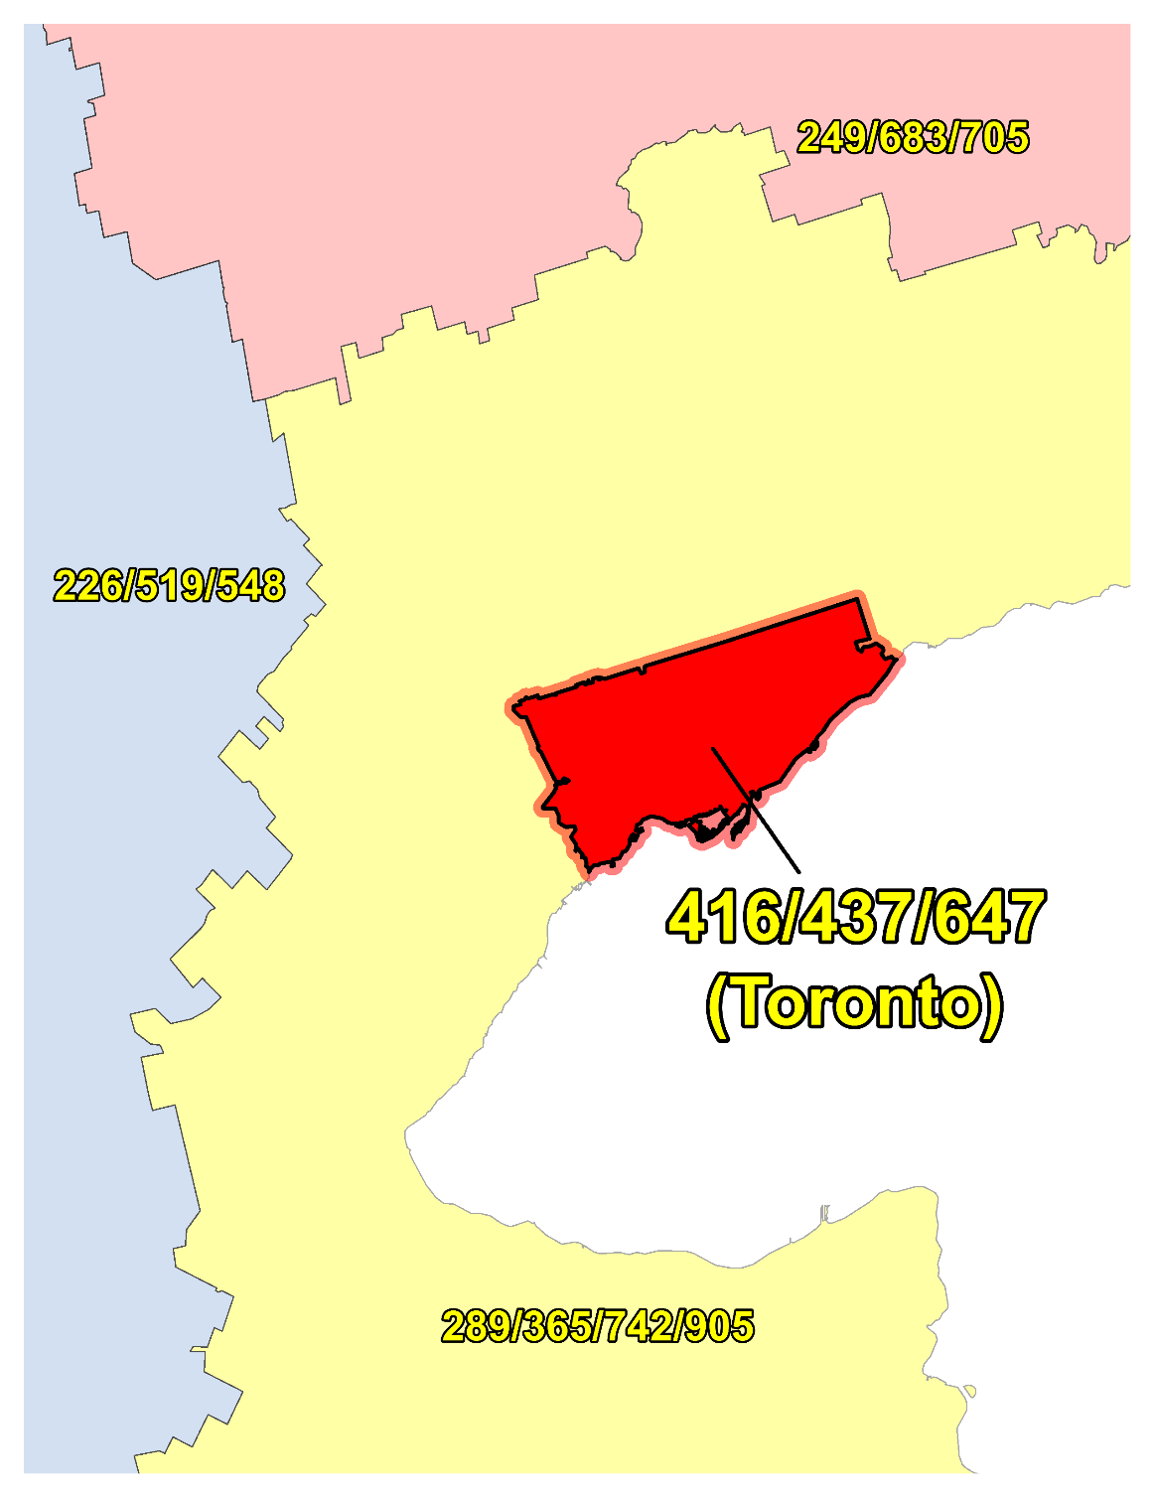

NPA 416/437/647 Proposal for Relief of an Overlay Complex (PROC)
Version 1.0 – 15 September 2022

Canadian Numbering Administrator (CNA)
CNA Staff
613-702-0016
150 Isabella Street, Suite 605 Ottawa ON K1S 5H3
inquiries@cnac.ca

TABLE OF CONTENTS

1. INTRODUCTION 1
2. NPA RELIEF PLANNING PROCESS 2
3. NPA RELIEF METHODS 3
4. NPA EXHAUST INFORMATION 3
5. RELIEF OPTION 4
5.1. Distributed Overlay 4
6. SUMMARY OF RELIEF OPTION 4
7. DIALLING CHANGES FOR LOCAL CALLS 5
8. PROPOSED SCHEDULE 5
9. JEOPARDY CONTINGENCY PLAN (JCP) 6
10. SELECTION OF RELIEF NPA CODE 13
11. RECOMMENDATIONS 14
ANNEXES 0

LIST OF ANNEXES

ANNEX A

Figure 1 – Overview Map of NPA 416/437/647
Figure 2 – NPA 416/437/647 Actual and Forecast CO Code Assignments
Figure 3 – NPA 416/437/647 CO Code Exhaust: January 2022 G-NRUF
Figure 4 – NPA 416/437/647 CO Code Exhaust: Current (September 2022) R-NRUF
Figure 5 – Distributed Overlay

ANNEX B

Table 1 – NPA 387/416/437/647 Exchange Areas After Distributed Overlay

ACRONYM LIST

CATF | Consumer Awareness Task Force
CISC | CRTC Interconnection Steering Committee
CLEC | Competitive Local Exchange Carrier
CLNPC | Canadian Local Number Portability Consortium
CNA | Canadian Numbering Administrator
CO | Central Office
CRTC | Canadian Radio-television and Telecommunications Commission
CSCN | Canadian Steering Committee on Numbering
EAS | Extended Area Service
G-NRUF | General Numbering Resource Utilization Forecast
ILEC | Incumbent Local Exchange Carrier
IPD | Initial Planning Document
ISP | Internet Service Provider
JCP | Jeopardy Contingency Plan
J-NRUF | Jeopardy Numbering Resource Utilization Forecast
LEC | Local Exchange Carrier
LIR | Local Interconnection Region
LNP | Local Number Portability
NANP | North American Numbering Plan
NANPA | North American Numbering Plan Administrator
NITF | Network Implementation Task Force
NoC | Notice of Consultation
NPA | Numbering Plan Area (Area Code)
NRUF | Numbering Resource Utilization Forecast
PD | Planning Document
PED | Projected Exhaust Date
PL | Planning Letter
POI | Point of Interconnection
PROC | Proposal for Relief of an Overlay NPA Complex
PSAP | Public Safety Answering Point
RIP | Relief Implementation Plan
R-NRUF | Relief Planning Numbering Resource Utilization Forecast
RPC | Relief Planning Committee
TSP | Telecommunications Service Provider
WNP | Wireless Number Portability
WSP | Wireless Service Provider

Proposal for Relief of an Overlay NPA Complex (PROC)
Numbering Plan Area (NPA) 416/437/647

INTRODUCTION

The following table provides a high-level summary of the history of area code usage in the area currently served by NPA 416/437/647 since 1947.

Year | Activity
1947 | Area Code 416 and 613 are assigned to Ontario by AT&T
1953 | Area Codes 416 and 613 split to create new Area Code 519
1993 | Area Code 416 split to create new Area Code 905
2001 | New Area Code 647 overlay on 416 in Toronto, Ontario; mandatory ten-digit local dialling implemented (first Canadian overlay)
2013 | New Area Code 437 overlays 416/647 in Toronto, Ontario

The 416/437/647 area code or NPA consists of the single Exchange Area of Toronto, located in Ontario, Canada.

A list of the Exchange Areas in NPA 416/437/647 is provided in Annex B, Table 1.

The table below provides a brief overview of recent activities leading to the development of this Proposal for Relief of an Overlay NPA Complex (PROC) for NPA 416/437/647.

Date | Activity
22 July 2011 | In Telecom Decision CRTC 2011-436, the Commission determined that area code 387, for planning purposes, is to be set aside as the most suitable area code for future area code relief in Toronto, Ontario.
26 March 2019 | The CNA published the January 2019 G-NRUF results which indicated that NPA 416/437/647 had entered the relief planning window. The CNA advised the CRTC to issue a Telecom Notice of Consultation for relief of NPA 416/437/647.
20 September 2019 | The CNA published the July 2019 R-NRUF results which indicated that the Projected Exhaust Date (PED) had been deferred to June 2025.
30 January 2020 | The CRTC released Telecom Notice of Consultation CRTC 2020-35 - in which the CRTC announced the establishment of a CRTC Interconnection Steering Committee ad hoc Relief Planning Committee (RPC) to examine options and make recommendations for providing numbering relief to area codes 416, 437, and 647 in Toronto, Ontario.  For the purposes of this document the new NPA will be 387.
18 August 2020 | The CNA published the July 2020 R-NRUF results which indicated that the PED had changed to November 2025;
23 February 2021 | The CNA published the January 2021 R-NRUF results which indicated that the PED had changed to July 2026;
19 August 2021 | The CNA published the July 2021 R-NRUF results which indicated that the PED had changed to September 2025;
1 March 2022 | The CNA published the January 2022 R-NRUF results which indicated that the PED had been deferred to March 2026.
19 August 2022 | The CNA published the July 2022 R-NRUF results which indicated that the PED had been deferred by 8 months to November 2026.

On 26 March 2019, the CNA announced that NPA 416/437/647 had entered the relief planning window of 72 months according to the aggregate results from the January 2019 General Numbering Resource Utilization Forecast (G-NRUF). The CNA advised the Canadian Radio-television and Telecommunications Commission (CRTC) and industry of this situation. At the Canadian Steering Committee on Numbering (CSCN) conference call held to review the draft aggregate January 2019 G-NRUF results the CNA advised the CSCN that NPA 416/437/647 had entered the relief planning window of 72 months.

On 30 January 2020, the CRTC issued Telecom Notice of Consultation CRTC 2020-35 Establishment of a CISC ad hoc committee for relief planning for area codes 416, 437 and 647 in Toronto, Ontario, by which it established the Relief Planning Committee (RPC) for NPAs 416, 437 and 647 (the 416/437/647 RPC) and directed the CNA to chair this committee.

The CNA notes that based on a Current (September 2022) NRUF from 9 September 2022, the PED for NPA 416/437/647 has changed to April 2026.

This PROC is prepared by the CNA in accordance with Telecom Notice of Consultation CRTC 2020-35 and the Canadian NPA Relief Planning Guideline, Version 7.0 dated 29 January 2019 (the Guideline). A copy of the Guideline is available from the CSCN guidelines web page at: https://crtc.gc.ca/cisc/eng/cisf3fg.htm.

The objective of the NPA Relief Planning process is to ensure that Central Office (CO) Codes and telephone numbers are always available for use by Telecommunications Service Providers (TSPs) and their customers in the geographic area requiring relief.

It is very important to closely monitor the CO Code requirements of all existing and prospective CO Code Holders so that relief can be timed to ensure that CO Codes and telephone numbers are always available for service providers and customers.

In this PROC, a single option is identified for providing NPA relief in the NPA 416/437/647 geographic area. Given the magnitude of this undertaking, intercompany commitment and co-operation are essential throughout the planning, provisioning and implementation stages of the introduction of the new NPA.

NPA RELIEF PLANNING PROCESS

The NPA Relief Planning process and the roles of the participants (i.e. CRTC, CNA, CISC, RPC participants and Interested Parties) for NPA Relief Planning are identified in the Guideline.

To increase public awareness and participation in the NPA Relief Planning process, the CRTC has determined that NPA RPCs will be established as ad hoc committees of the CISC. Generally, a separate ad hoc committee is created to deal with relief in each area code. The CNA, in its function as NPA Relief Planning Coordinator, acts as chair of these ad hoc committees. Meetings and conference calls of the ad hoc NPA RPCs are all open to public participation and are conducted in accordance with the CISC Administrative Guidelines which are available from the CRTC website at: https://crtc.gc.ca/cisc/eng/cag.htm.

NPA Relief Planning is conducted under the regulatory oversight of the CRTC. Notwithstanding the process detailed in the Guideline, the CRTC may exercise its authority under the Telecommunications Act to alter this process at any time. The CRTC has the authority under the Telecommunications Act to review, modify and give final approval to the Planning Document (PD) and the Relief Implementation Plan (RIP) developed and submitted by the RPC to the CRTC via the CISC process.

Section 7.1.6 of the Canadian NPA Relief Planning Guideline requires the CNA to create and maintain a distribution list of parties who may be interested in participating in the RPC and to provide them with advance notice of the initial RPC meeting and the release of a PROC.

Any person wishing to participate in the NPA Relief Planning process can contact the CNA and request to be added to the RPC distribution list. More information on how to participate in CRTC public processes is available at: https://crtc.gc.ca/eng/info_sht/g4.htm.

A summary of Canadian geographic area code relief history is available at: https://cnac.ca/npa_codes/NPA_History.pdf.

NPA RELIEF METHODS

The purpose of this section is to identify and briefly describe NPA Relief Methods.

The Guideline states that: “The only NPA Relief Method considered in Canada is the Distributed Overlay Method which superimposes or “overlays” a Relief NPA on top of an entire existing NPA or NPAs.” There are three types of Distributed Overlay:

- a Distributed Overlay over an existing geographic area served by a single existing NPA (A new NPA is overlaid over a single existing NPA [i.e., the geographic area that is served by a single NPA]);

- a Distributed Overlay over an existing geographic area served by multiple existing overlay NPAs (A new NPA is overlaid over a geographic area that is served by multiple existing overlay NPAs); and,

- a Distributed Overlay over multiple existing geographic areas, each served by one or more existing NPAs (A new NPA is overlaid over multiple existing NPAs [i.e., different geographic areas served by multiple NPAs]. This type of overlay may be considered for NPA relief for two or more adjacent NPAs [i.e., geographic areas within a province]).

NPA EXHAUST INFORMATION

As indicated in the following table, NRUFs for NPA 416/437/647 were used to determine PEDs, (i.e. the dates when CO Codes in NPA 416/437/647 would be expected to exhaust).

NRUF | Projected Exhaust Date (PED)
G-NRUF January 2022 | March 2026
R-NRUF July 2022 | November 2026
R-NRUF Current (September 2022) | April 2026

Refer to Annex A, Figure 2 through Figure 4 for graphs of forecast CO Code demand from current and prospective CO Code Holders and Administrative Codes set aside in Area Code 416/437/647 for the two most recent NRUFs (January 2022 and July 2022).

RELIEF OPTION

The Relief Option as identified and examined in this PROC is a Distributed Overlay over an existing geographic area served by multiple existing overlay NPAs.

Using this method, a new NPA is overlaid over an existing NPA (i.e., the geographic area) that is served by multiple existing overlay NPAs 416/437/647.

The Relief Option identified above was evaluated using the following assumptions:

- The Relief Date for the Distributed Overlay will be 26 April 2025 (approximately 12 months prior to the NPA 416/437/647 PED of April 2026 identified using the Current (September 2022) R-NRUF results).

See Annex A, Figure 5 for a diagram of the Distributed Overlay Relief Option identified by the CNA.

Distributed Overlay

A Distributed Overlay Relief Option was evaluated which would overlay the New NPA over the single Exchange Area comprising the NPA 416/437/647 area. See Annex A, Figure 5.

The introduction of a Distributed Overlay would keep the same number of NPA Relief Planning areas in Ontario.

After this Distributed Overlay, CO Codes in NPA 416/437/647 would be expected to exhaust in Q2 2034.

Subsequent exhaust of NPA 416/437/647 was forecast using the Historical Average growth value of 95 CO Codes per year by comparing the Current (September 2022) data in the table below:

Statistical Method | Data | Period | Quantity of CO Codes
Average | Forecast growth | five-year period (January 2023 until January 2028) | 97
Average | Forecast growth | next six years | 100
Average | Historical growth | past five years | 95

SUMMARY OF RELIEF OPTION

Relief Option | Projected Exhaust Dates |  | Subsequent Relief Dates
Relief Option | NPA 416/437/647 | NPA 387/416/437/647 | Subsequent Relief Dates
Distributed Overlay | April 2026 | June 2034 | June 2033

Note: Distributed Overlay NPA 387 would be in service in 26 April 2025.

DIALLING CHANGES FOR LOCAL CALLS

Currently 10-digit dialling is mandatory for local calls originating within area code 416/437/647. Local dialling plans will not change with this relief.

The addition of the new NPA 387 will not affect the dialling plan for long-distance calls originating within NPA 416/437/647.

Implementation of new NPA 387 will not change the rating of calls.

PROPOSED SCHEDULE

The CNA submits the following schedule for NPA 416/437/647 relief based on the recommendations contained in this PROC and the current PED of April 2026. The RPC will monitor the PED, and if it changes significantly in the future, the RPC will assess the situation and, if necessary, submit recommendations including a revised schedule to the CRTC for consideration and approval.

RELIEF IMPLEMENTATION SCHEDULE
For a Distributed Overlay of NPA 387 over NPA 416/437/647

[Insert Proposed schedule from Excel worksheet]

JEOPARDY CONTINGENCY PLAN (JCP)

The RPC has developed the following JCP for inclusion in the PD for NPA 416/437/647. This JCP is based on the example contained in Appendix F to the Canadian NPA Relief Planning Guideline.

This JCP shall remain in effect until superseded by a CRTC-approved JCP, the Jeopardy Condition is suspended or 66 days prior to the Relief Date.

The following measures shall be implemented in NPA 416/437/647 while a Jeopardy Condition is in effect.

During a Jeopardy Condition, CO Code Applicants shall submit all CO Code applications and related correspondence for the Jeopardy NPA to CRTC staff in addition to the CNA. The CNA shall only assign CO Codes from the exhausting NPA to a CO Code Applicant when instructed by CRTC staff.

- Carriers and/or Telecommunications Service Providers (TSPs):

  - shall age disconnected residential wireline telephone numbers for a maximum of two months;
  - shall age disconnected wireless telephone numbers for a maximum of three months;
  - shall age disconnected business wireline telephone numbers for a maximum of six months. Under special circumstances, the six month aging limit for business telephone numbers may be extended to twelve months, if required, to accommodate local directory publishing dates for high volume call-in applications (e.g., heavily advertised local business numbers such as radio talk shows, food ordering services, ticket sales, chat lines), or for numbers associated with public service emergency applications or for numbers advertised in directories for which customers have requested reference of calls;
  - shall return all CO Codes that are not being used, nor intended to be used to directly serve customers to the assignment pool within two months (e.g., plant test codes);
  - should work towards, and encourage existing customers, to either activate or return the reserved numbers to bring the reserved quantity down to a maximum of 10% of the quantity of numbers In-Service for that customer;
  - shall not allow the quantity of reserved numbers to be increased by new reservation requests by existing customers to more than 10% of the quantity of numbers in service for that customer. In the case of new customers, number reservations shall be limited to 10% of the total quantity of telephone numbers being placed into service for that customer;
  - shall, within 45 days from the date that the CNA declares a Jeopardy Condition submit a Part 1 Form for each remaining reserved CO Code either returning the reserved CO Code to the CNA or requesting assignment of the reserved CO Code. Once the 45-day period has elapsed, the CNA shall make available for general assignment all CO Codes that are still reserved and have not been applied for as assignments on a Part 1 Form received by the CNA. Within 60 days from the date that the CNA declares a Jeopardy Condition, the CNA shall report to CRTC staff and the RPC as to how many of these codes have been assigned or made available for general assignment;
  - shall not be permitted to obtain a new CO Code reservation;
  - shall place all CO Codes assigned prior to the Jeopardy Condition being declared In-Service within three months of the effective date for CO Code activation in the network, or within three months of the date that the Jeopardy Condition was declared. If the CO Code is an Initial Code and the CO Code Holder can demonstrate that, due to circumstances beyond its control, the In-Service date has been delayed beyond the applicable timeframe, then the CNA may grant an extension of up to two months to the In-Service date. The CNA shall initiate reclamation procedures for all CO Codes that have not been placed In-Service within these timeframes unless CRTC staff provides a further extension.

- For new applications for Initial Codes, each CO Code Holder shall certify that the CO Code will be activated in the network and placed In-Service within four months of the date of application for the Code. If the CNA does not receive a Part 4 Form within this timeframe, confirming that the CO Code has been placed In-Service, the CNA will initiate reclamation measures. If the CO Code Holder can demonstrate that, due to circumstances beyond its control, the In-Service date has been delayed not more than six months from the original application date, then the CNA may grant an extension to the In-Service date, so long as the In-Service date is not more than six months beyond the original application date. If the In-Service date has been delayed more than six months from the original application date, then the CNA shall reclaim the Code unless CRTC staff provides a further extension.

- When applying for an Additional Code for Growth, a CO Code Holder who is submitting a Part 1 Form and Appendix B worksheet shall also submit a completed Supplementary Form for a Growth CO Code Application (attached) which certifies and/or provides the following information for the specific switching entity/POI and Exchange Area when the Growth CO Code is being requested in a Jeopardy Condition:

  - certification that all held telephone numbers have been released;
  - certification that reserved numbers do not exceed ten percent of the total quantity of numbers as defined in Appendix G of the Canadian CO Code (NXX) Assignment Guideline;
  - certification that each reseller/dealer had been advised of the Jeopardy Condition and the requirement that they would only be allocated additional numbers during the Jeopardy Condition on the provision to the CO Code Holder of written confirmation that their number inventory has been reduced to an amount less than two times the highest quantity of customer numbers assigned in any month during the previous 12 months. Additional numbering resources will only be provided by the CO Code Holder to the reseller/dealer to the extent that the reseller's/dealer's inventory can only increase up to a maximum of three months' inventory;
  - confirmation that the Part 1 form submitted with the application has the Jeopardy Condition box in section 1.6 checked to certify that the existing CO Codes are projected to exhaust within 4 months of the date of application and that the months-to-exhaust is documented on an Appendix B submitted to the CNA;
  - a completed Telephone Number Utilization Report for the applicable switching entity signed by both a company officer and the company’s authorized representative;
  - confirmation that the requested Growth CO Code was forecasted in the most recent NRUF or an explanation as to why it was not is attached; and,
  - confirmation that the requested Growth CO Code will be placed In-Service within four months of the date of assignment.

- Any CO Codes for growth assigned after the implementation of this JCP must be activated in the network and placed In-Service within four months of assignment. In the event that a CO Code Holder is unable to place the CO Code In-Service within four months of the date of assignment, the CO Code Holder must return the assigned CO Codes or submit a written request for extension to the CNA. Such written requests must include documentation explaining the reason(s) for the missed date and proposing the new In-Service date. If the explanation includes reasons beyond the control of the CO Code Holder, the CNA may extend the In-Service date a maximum of one month. If the CO Code Holder does not place the CO Code In-Service within the one-month extension, the CNA shall initiate the reclamation process at the end of the one-month extension unless CRTC staff provides a further extension.

- A Carrier that has multiple switching entities within an Exchange Area shall examine the possibility of, and implement where feasible, number sharing between those switches as a potential method to delay requirements for additional CO Codes.

- The CNA will request two versions (two separate worksheets (Form 1 and Form 2)) of the J-NRUF input from all current and prospective CO Code Holders quarterly until three (3) months before relief is provided.

  - The forecast quantities in Form 1 should be the same as or lower than the last R-NRUF input submitted, prior to declaration of a Jeopardy Condition. CO Code Holder forecasts may reflect an increase in demand in the period subsequent to the Relief Date.

  - Form 2 will reflect the actual demand required by the CO Code Holder's current business plan and will be provided for information purposes only.

- The CNA will compare the initial J-NRUF input to the recent NRUF inputs, to assess forecasting trends. The CNA shall monitor all inputs and shall test them for reasonableness in consultation with the Carrier. If the CNA is dissatisfied with the reasonableness, or the rationale provided for the deviations, then the matter will be referred to the CRTC staff.

- The CNA will request subsequent J-NRUF input from all current and prospective CO Code Holders quarterly until 3 months before relief is provided. If one or more R-NRUFs have already been conducted, and depending on the severity of the Jeopardy Condition, the CNA may defer a J-NRUF by up to two months if such a deferral brings the timing of that J-NRUF and subsequent J-NRUFs into alignment with other NRUFs that are conducted at 12, 6 or 3 month intervals. Subsequent J-NRUF input will be compared with the initial J-NRUF input to evaluate the effectiveness of the JCP. The CNA shall monitor all J-NRUF inputs and shall test them for reasonableness in consultation with the Telecommunications Service Providers. If the CNA is dissatisfied with the reasonableness, or the rationale provided for the changed forecasts, then the matter will be referred to CRTC staff.

- A CO Code Applicant must have submitted a completed J-NRUF to the CNA before the CNA may assign a CO Code to that CO Code Applicant.

- If a CO Code applicant wishes to request more CO Codes than it identified in its most recent J NRUF, the CO Code Applicant should discuss the matter with the CNA. If the CO Code Applicant wishes to proceed with the request, the CO Code Applicant will forward the request and revised forecast to CRTC staff and the CNA for consideration.

- The CO Codes identified in the NPA CO Code Inventory Chart as “Assignable CO Codes in a Jeopardy Condition” will be assigned in the order determined by the RPC after all CO Codes which are “Available for Assignment as of [day month year] have been assigned.

- After each J-NRUF, the CNA shall provide CRTC staff, the RPC and CSCN participants with a report providing an updated NPA CO Code Inventory Chart for the NPA in jeopardy as well as the aggregate results of the most recent J-NRUF.

- Exceptional issues or concerns may be referred by the CNA, or by individual entities (with a courtesy copy to the CNA), to the CRTC staff for resolution.

- In a situation where the Relief Date is on or after the Projected Exhaust Date (PED), the quantity of CO Codes that may be assigned to a CO Code Applicant prior to the end of the Jeopardy Condition (i.e. 66 days prior to the Relief Date) shall be limited to the quantity forecasted by the CO Code Applicant in its most recent NRUF forecast submitted prior to the Jeopardy Condition being declared by the CNA (if no previous NRUF was submitted, then the previous forecast will be deemed to be zero codes). When making requests to obtain CO Codes prior to the end of the Jeopardy Condition (i.e. 66 days prior to the Relief Date), the CO Code Applicant may change the Exchange Area or the month when the CO Code assignment is required, provided a new J-NRUF and explanation accompanies the application. The control imposed by this option may be relaxed if subsequent J-NRUFs defer the PED to after the Relief Date. CO Codes that become available for assignment due to future reduced demand from other current and prospective CO Code Holders may be assigned at the discretion of CRTC staff.

- If the CNA determines that the implementation of the JCP has not extended the PED of the NPA beyond the Relief Date, the CNA will consult with CRTC staff and further CO Code conservation and assignment procedures may be ordered by the Commission (e.g., rationing, lottery, etc.).

Supplementary form for a Growth CO Code Application – Page 1 of 2 – Telephone Number Utilization Report

This form is required with each request for an Additional Code for Growth in an NPA where a Jeopardy Condition is in effect. It should be submitted to the CNA together with the Part 1 and Appendix B forms that are required for an application for an Additional Code for Growth. See the Part 1 form for information on how and where to submit the form.

I hereby certify that the following information is true and accurate to the best of my knowledge and has been prepared in accordance with Special Conservation Procedures for a Jeopardy Condition contained in the Canadian NPA Relief Planning Guideline or the applicable approved Jeopardy Contingency Plan.

Name & Signature of Authorized Representative of Code Holder Title Date

Name & Signature of Company Officer (see item 3 of this JCP) Title Date

Contact information: Entity Name: __________________ Contact Name: _____________
Address: __________________ City, Province, Postal Code: _____________
Telephone: __________________ Facsimile: _____________
E-mail: __________________

Switch Identification (Switching Entity/POI) CLLI: _______________ Exchange Area: ________________
For the above Switch Identification and Exchange Area for which a Growth CO Code is requested:
I certify that all held telephone numbers have been released
I certify the total quantity of reserved numbers does not exceed ten percent (10%) of the total quantity of telephone numbers as defined in Appendix G of the Canadian CO Code (NXX) Assignment Guideline
I certify that each reseller/dealer has been advised of the Jeopardy Condition and the requirement that they would only be allocated additional numbers during the Jeopardy Condition on the provision to the CO Code Holder of written confirmation that their number inventory has been reduced to an amount less than two (2) times the highest quantity of customer numbers assigned in any month during the previous twelve (12) months. Additional numbering resources will only be provided by the CO Code Holder to the reseller/dealer to the extent that the reseller's/dealer's inventory can only increase up to a maximum of three months' inventory.
The Part 1 form submitted with the application has the Jeopardy Condition box in section 6 checked (this certifies that the existing CO Codes are projected to exhaust within four (4) months of the date of the application or within the period specified in an approved Jeopardy Contingency Plan, and that the months-to-exhaust is documented on an Appendix B submitted to the CNA).
The Telephone Number Utilization Report on page 2 of this form has been completed.
The requested Growth CO Code was forecasted in the most recent NRUF, or an explanation as to why it was not is attached.
The requested Growth CO Code will be placed In-Service within four (4) months of the date of assignment.

Supplementary Form for a Growth CO Code Application – Page 2 of 2 – Telephone Number Utilization Report

Use Arial 9 to complete this form. (Note: If the spreadsheet below does not show on your display, please change the Work view to "Print Layout" or "Reading Layout")
Remarks: _______________________________________________________________________________

NPA 416/437/647 CO Code Inventory Chart

The following chart, and the instructions it contains, will apply in NPA 416/437/647 in a Jeopardy Condition.

The chart below lists quantities of CO Codes unassignable prior to a Jeopardy Condition, CO Codes that become assignable in a Jeopardy Condition and CO Codes in NPA 416/437/647 assigned and In-service as of 15 September 2022. The CO Codes that become assignable in a Jeopardy Condition shall only be made available for assignment when all other available CO Codes have been assigned in the order listed below.

 |  | Quantity
A | Total CO Codes in NPAs 416/437/647 (NXX format) | 2400
B | CO Codes unassignable prior to a Jeopardy Condition
 | N11 Service Codes (211, 311, 411, 511, 611, 711, 811, 911) | 24
 | Special Use Codes (555, 950 & 976) | 8
 | Home NPA Code(s) | 9
 | Current Neighbouring NPA Codes | 0
 | Future Geographic NPA Codes (257, 851) | 4
 | Plant Test Codes (958 & 959) | 6
 | Special 7-digit Dialling Codes (310, 610 & 810) | 8
 | Relief NPAs (387& 942) (Note 1) | 6
 | Total B | 65
C | CO Codes assignable prior to a Jeopardy Condition (C=A-B) | 2335
D | CO Codes unassignable prior to a Jeopardy Condition that become assignable in a Jeopardy Condition:
D | Future Canadian Geographic NPA Codes | 4
D | Current Neighbouring NPA Codes | 0
D | Total D | 4
E | Assignable CO Codes in a Jeopardy Condition (E=C+D) | 2339
F | Assigned CO Codes as of 15 September 2022 | 1919
G | Net CO Codes available for assignment as of 15 September 2022 without a Jeopardy Condition (G=C-F) | 416
H | Net CO Codes available for assignment as of 15 September 2022 in a Jeopardy Condition (H=E-F) | 420

Notes:
- In Telecom Decision CRTC 2011-436, and in Telecom Decision CRTC 2017-38 the Commission determined that setting aside area codes 387 and 942 as the most suitable area codes for future relief in Toronto, Ontario NPAs 416/437/647 would be reasonable.

SELECTION OF RELIEF NPA CODE

If the recommended Relief Option requires a new NPA Code, the criteria for selection of an appropriate area code for relief is addressed in section 4.11 of the Canadian NPA Relief Planning Guideline. The criteria that should be taken into account when Future Canadian Geographic NPAs are being considered as candidates for relief of a specific current Canadian Geographic NPA include the following:

- The preferred Future Canadian Geographic NPA Code should not be an NPA Code that is assigned as a CO Code in the area that is being relieved (Home NPA(s)).

- The preferred Future Canadian Geographic NPA Code should not be an NPA Code that is assigned as a CO Code in another NPA within the same province where there is a possibility that a single new NPA Code could be overlaid on more than one NPA within the province, or where boundary realignment could occur that affects another NPA.

- The preferred Future Canadian Geographic NPA Code should not be an NPA Code that is assigned as a CO Code in an Exchange Area in a neighbouring NPA, if the neighbouring NPA has 7-digit local calling within the NPA and i) the Exchange Area in the neighbouring NPA where the CO Code is assigned has local calling to the NPA being relieved or ii) the Exchange Area in the neighbouring NPA where the CO Code is assigned does not have local calling to the NPA being relieved, but other Exchange Areas within that neighbouring NPA have 7-digit local calling to the Exchange Area where the CO Code is assigned as well as local calling to the new NPA.

CO Codes corresponding to Future Canadian Geographic NPA Codes which are not assigned in NPA 416/437/647 and therefore meet criterion a) above are 387, 460, 487 and 942.

CO Codes 387, 460, and 487 are all assigned in at least one neighbouring NPA so none of these resources meet criterion b).

Criterion c) is not applicable since NPA 416/437/647 has 10-digit local calling and the Exchange Area in the neighbouring NPA does not have local calling to the NPA being relieved.

The NPA Code Selection Tool located on the CNA web site at https://www.cnac.ca/npa_codes/relief/NPA_Selection_Tool.xlsx can assist in selecting a relief NPA Code from the pool of NPA Codes reserved for relief of geographic Canadian NPAs. The following table, extracted from the NPA Code Selection Tool, shows all codes corresponding to Future Canadian Geographic NPA Codes that are designated as unassignable CO Codes in the Home NPA, and therefore are preferred candidates when selecting a relief NPA Code for NPA 416/437/647.

NXX corresponding to Future NPA | 257 | 387 | 854 | 942
Distributed Overlay |  |  |  | üü

Indicates that corresponding CO Code is designated as unassignable in Home NPA(s)
üü indicates Future NPA is designated unassignable in Home & all Neighbouring NPA(s)

In Telecom Decision CRTC 2011-436, the Commission set aside area code 387 for future relief in southwestern Ontario NPAs 416/437/647. Subsequently, in Telecom Decision CRTC 2017-38 the Commission also set aside area code 942 for future relief in southwestern Ontario NPAs 416/437/647 but could be used elsewhere if required.

RECOMMENDATIONS

The CNA recommends:

- The Relief Method should be a Distributed Overlay of a new NPA Code on southwestern Ontario NPA 416/437/647 in accordance with the Canadian NPA Relief Planning Guideline;

- The Relief NPA Code for NPA 416/437/647, in accordance with the Telecom Decision CRTC 2011-436, should be 387; and,

- The Relief Date should be 26 April 2025 to provide Carriers and customers with advanced notification and sufficient lead-time to implement relief in NPA 416/437/647.

ANNEXES

Annex A - Maps and Figures

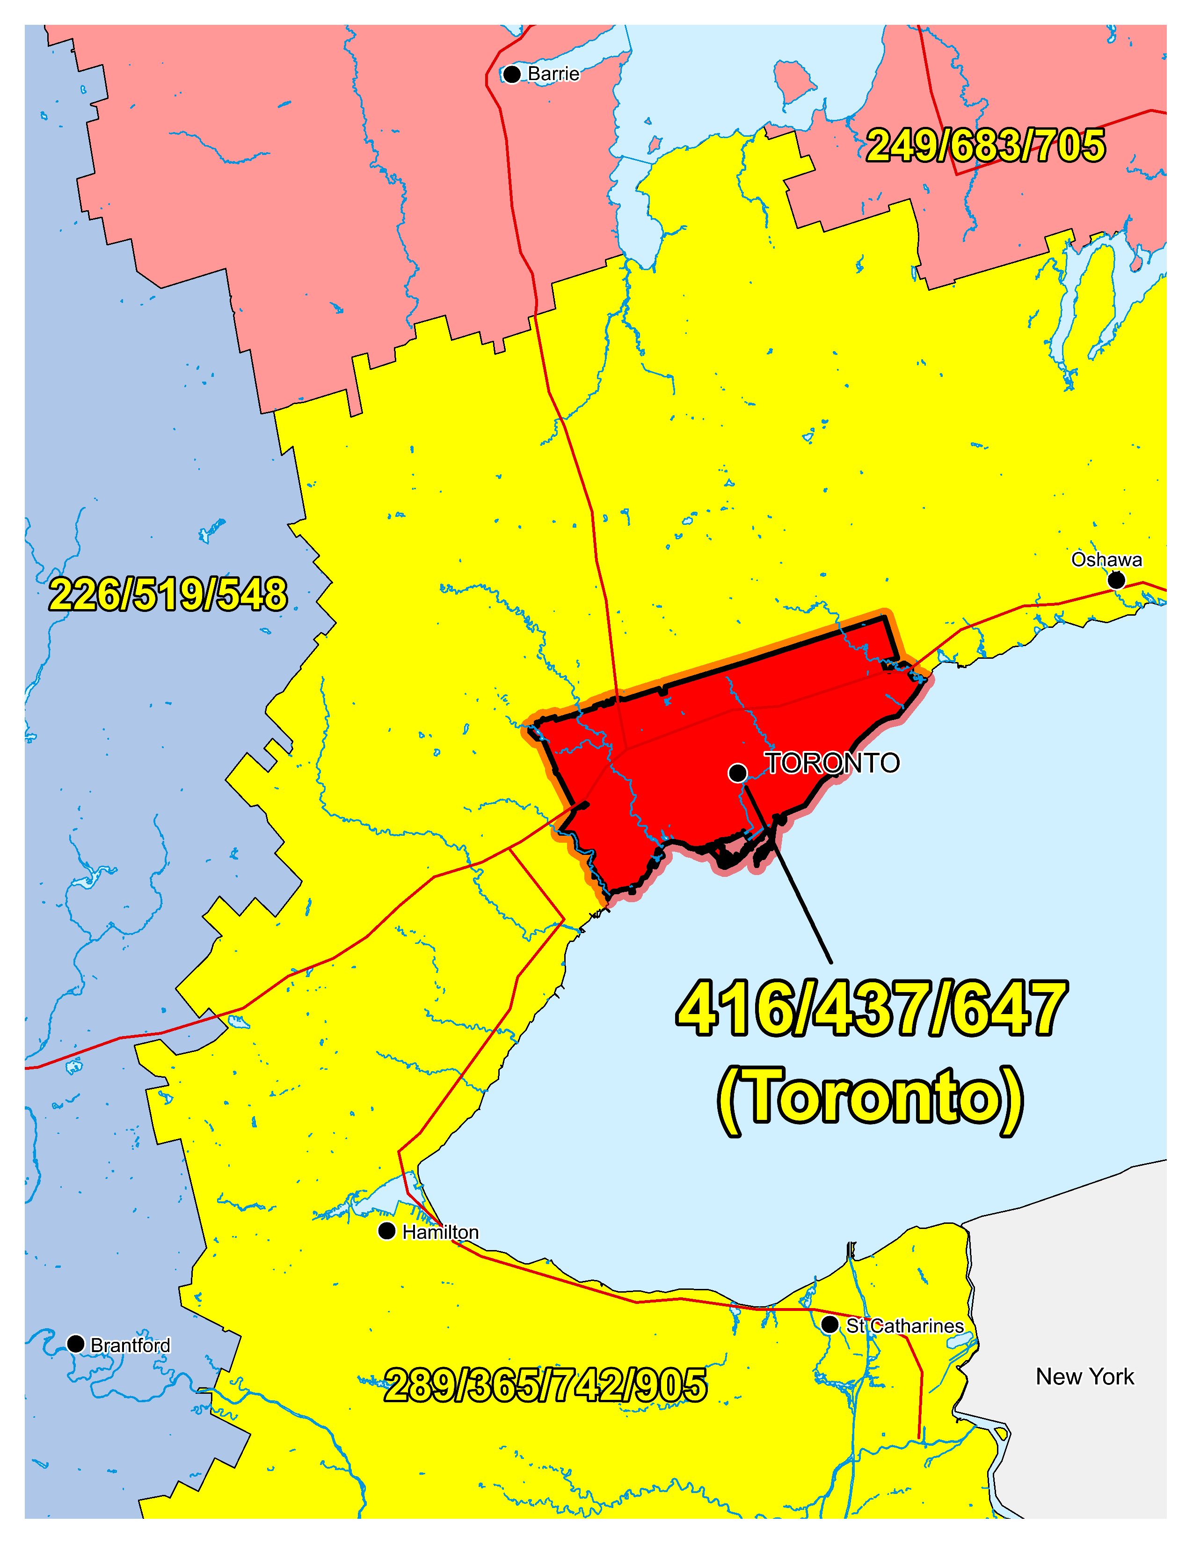
Figure 1 – Overview Map of NPA 416/437/647

Figure 2 – NPA 416/437/647 Actual and Forecast CO Code Assignments

Figure 3 – NPA 416/437/647 CO Code Exhaust: January 2022 G-NRUF

Figure 4 – NPA 416/437/647 CO Code Exhaust: Current (September 2022) R-NRUF

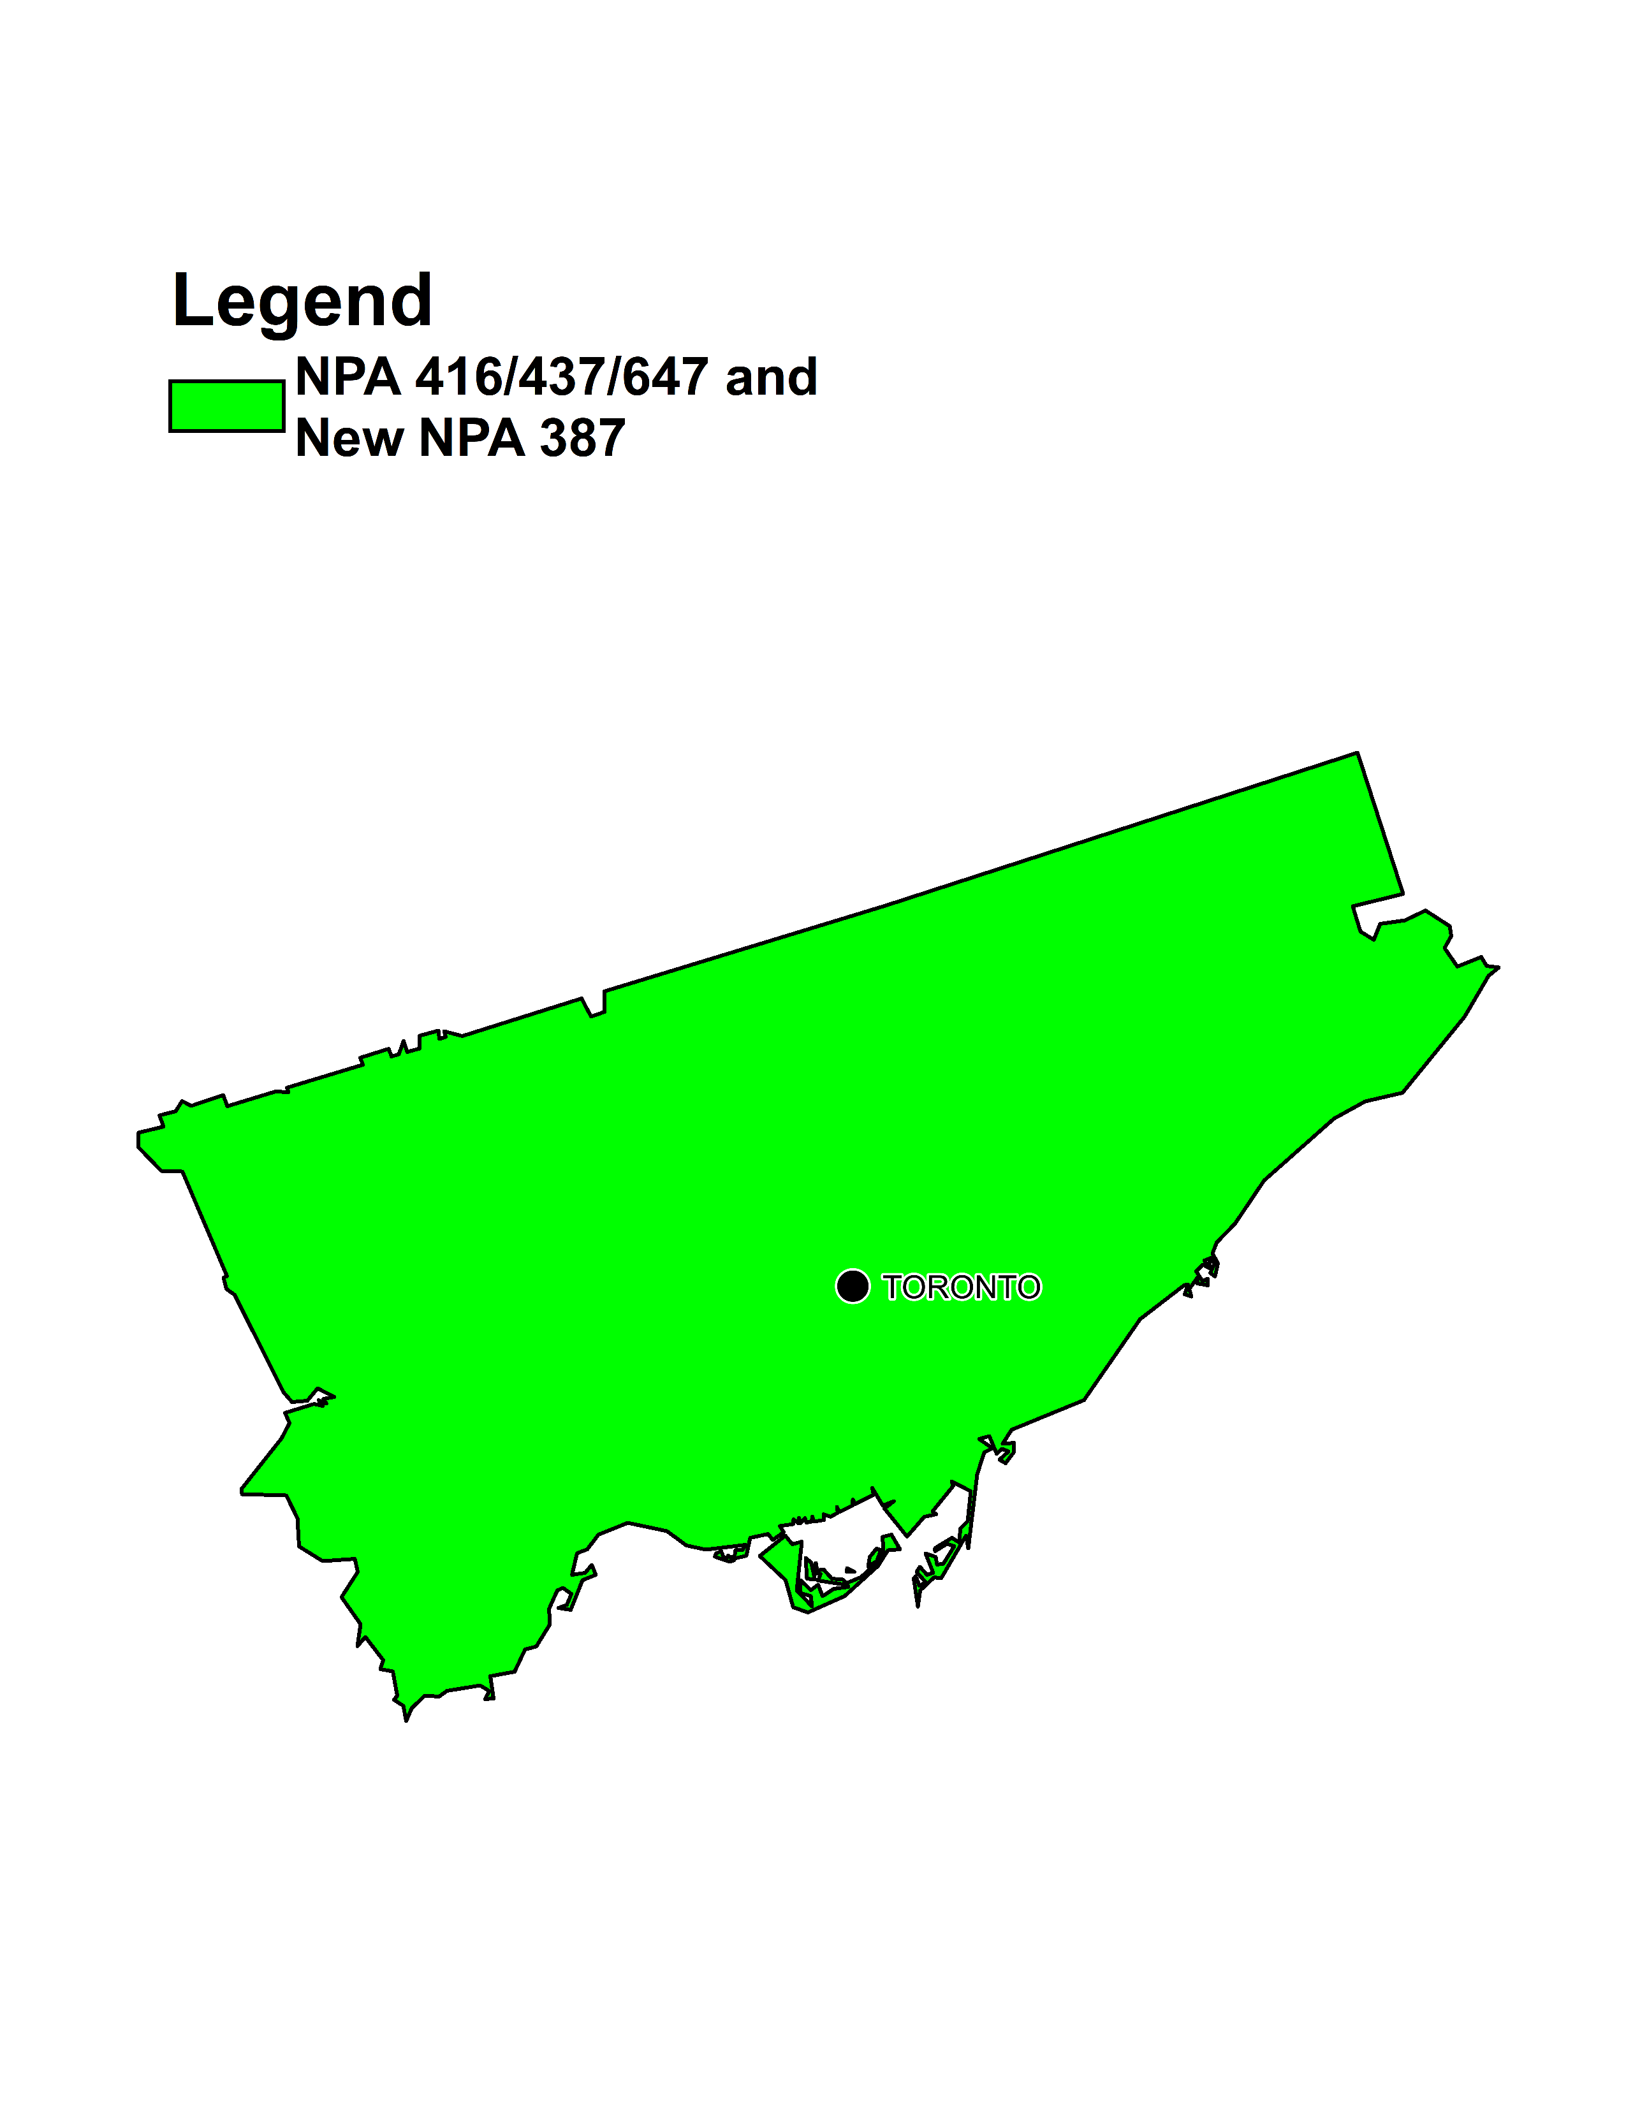

Figure 5 – Distributed Overlay

Annex B - NPA 387/416/437/647/Exchange Areas

Table 1 – NPA 387/416/437/647 Exchange Areas After Distributed Overlay

NPA 387/416/437/647
Exchange Areas
Toronto

