Annexes

Planning Document NPA 403/587/780 Numbering Relief

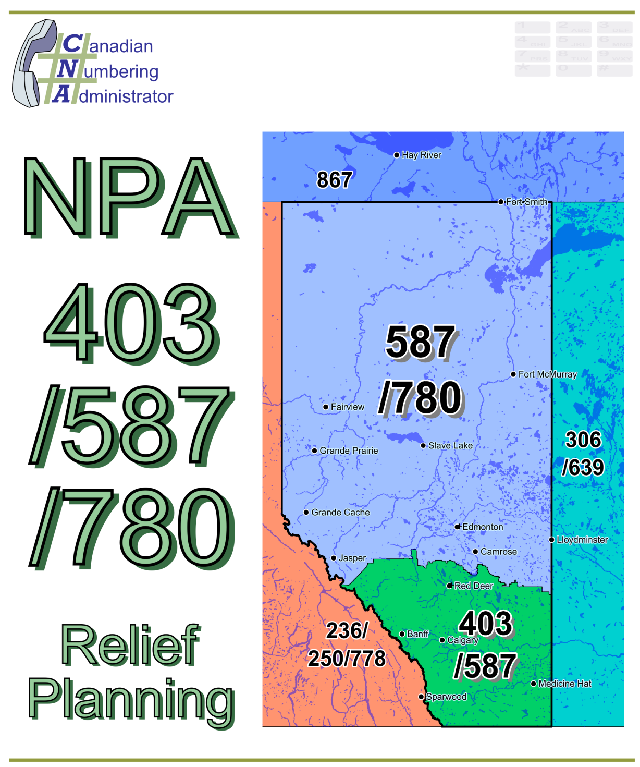

Initial Planning Document (IPD)

Version 1.0

1 April 2013

|  |  |
| --- | --- |
| Canadian Numbering Administrator (CNA)  Suresh Khare  613-683-3296  60 Queen Street, Suite 1516  Ottawa, Ontario K1P 5Y7  khares@saiccanada.com | SAICCanada_Logo_2011-07 |

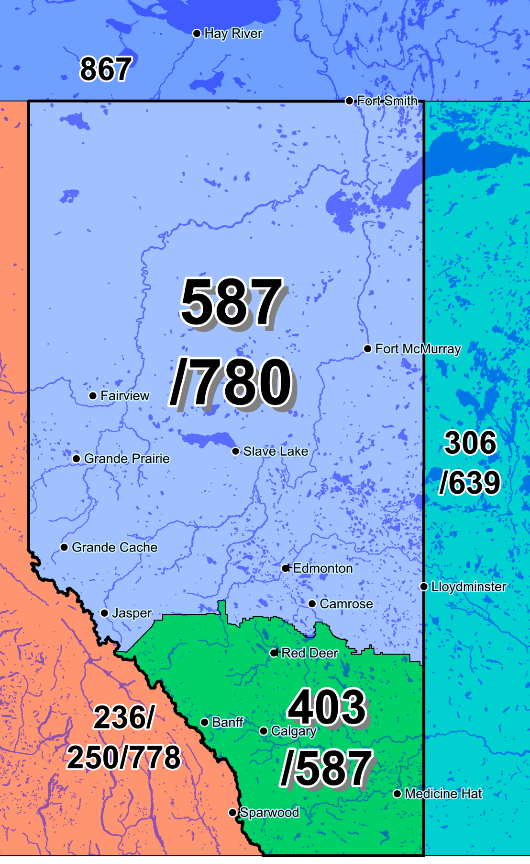

Figure 1 - Overview of NPA 403/587/780 and Adjacent NPAs



Figure 2- NPA 403/587/780 Actual and Forecast CO Code Assignments

Figure 3 - NPA 403/587/780 CO Code Exhaust, January 2012 G-NRUF

Figure 4 - NPA 403/587/780 Miscellaneous and LEC+WSP CO Codes, January 2012 G‑NRUF

Figure 5 - NPA 403/587/780 CO Code Exhaust, July 2012 R-NRUF

Figure 6 - NPA 403/587/780 Miscellaneous and LEC+WSP CO Codes, July 2012 R-NRUF

Figure 7 - NPA 403/587/780 CO Code Exhaust, January 2013 R-NRUF (including NOC directive)

Figure 8 - NPA 403/587/780 Miscellaneous and LEC+WSP CO Codes, January 2013 R-NRUF

(including NOC directive)

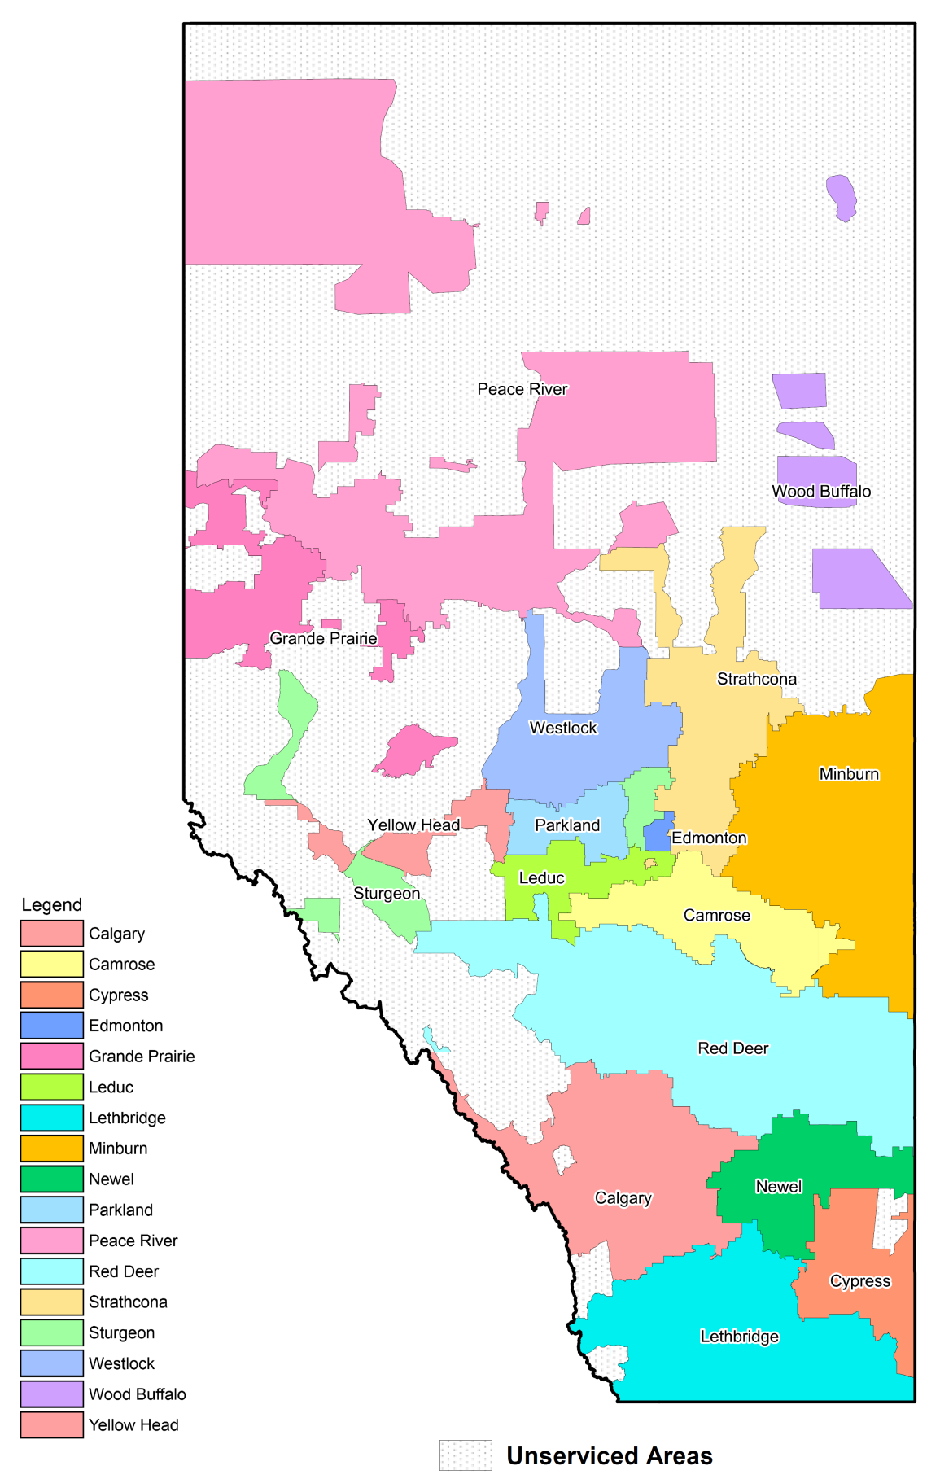

Figure 9 - NPA 403/587/780 LIRs

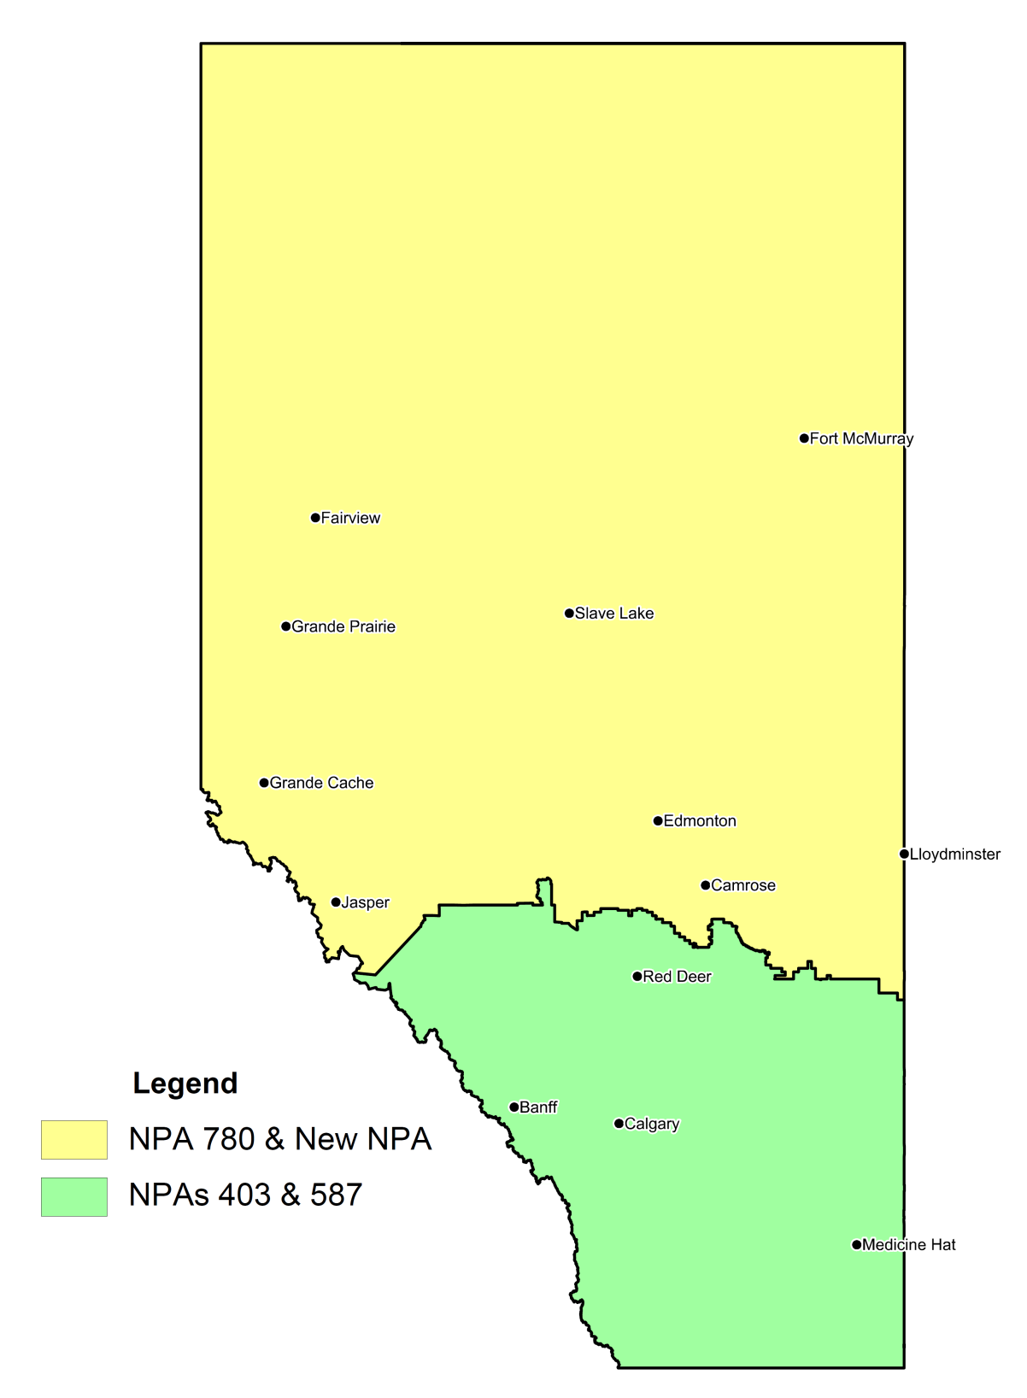

Figure 10 - Option 1: Split - North South Split of NPA 587, South retains NPA 587

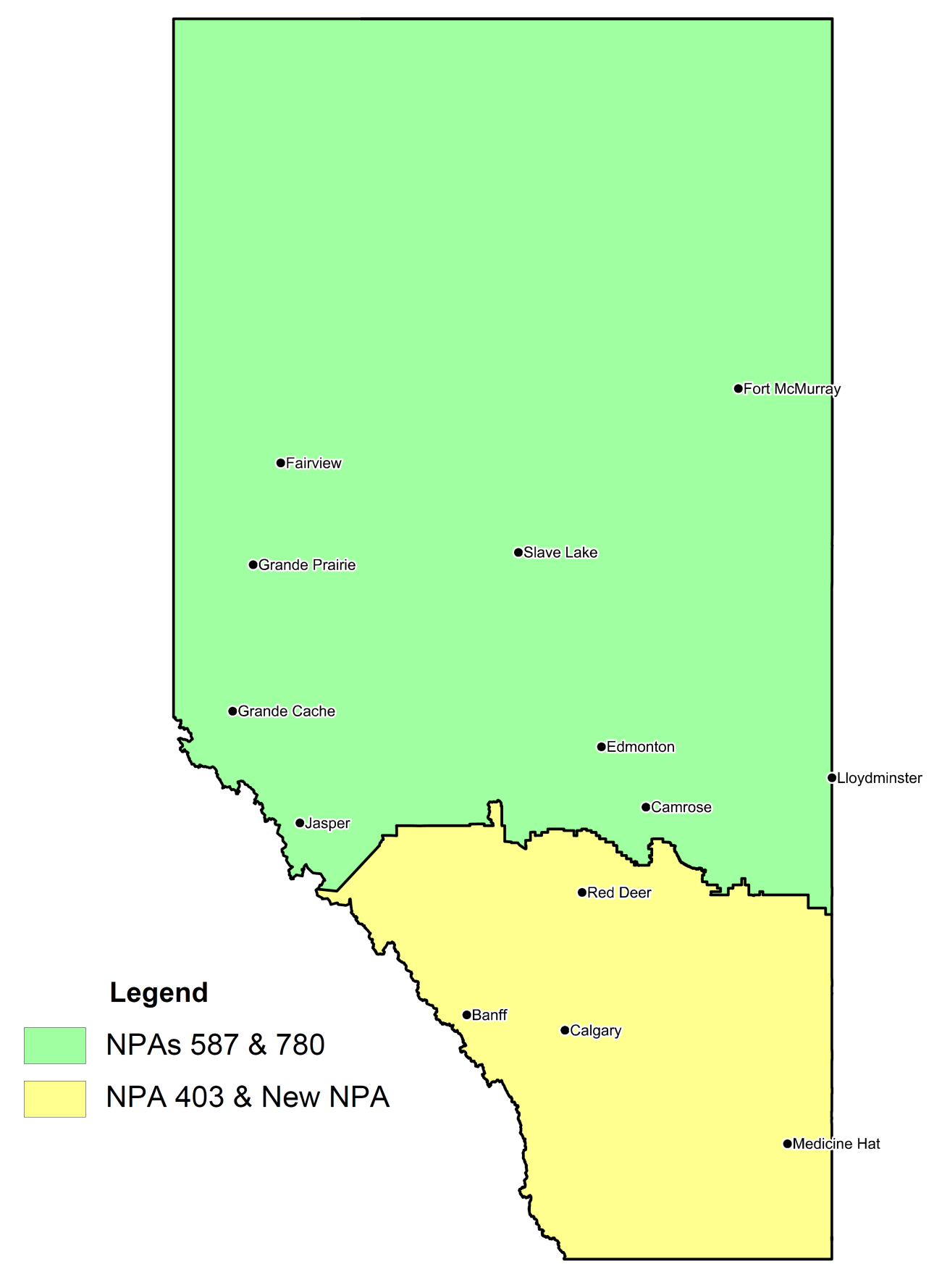

Figure 11 - Option 2: Split - North South Split of NPA 587, North retains NPA 587

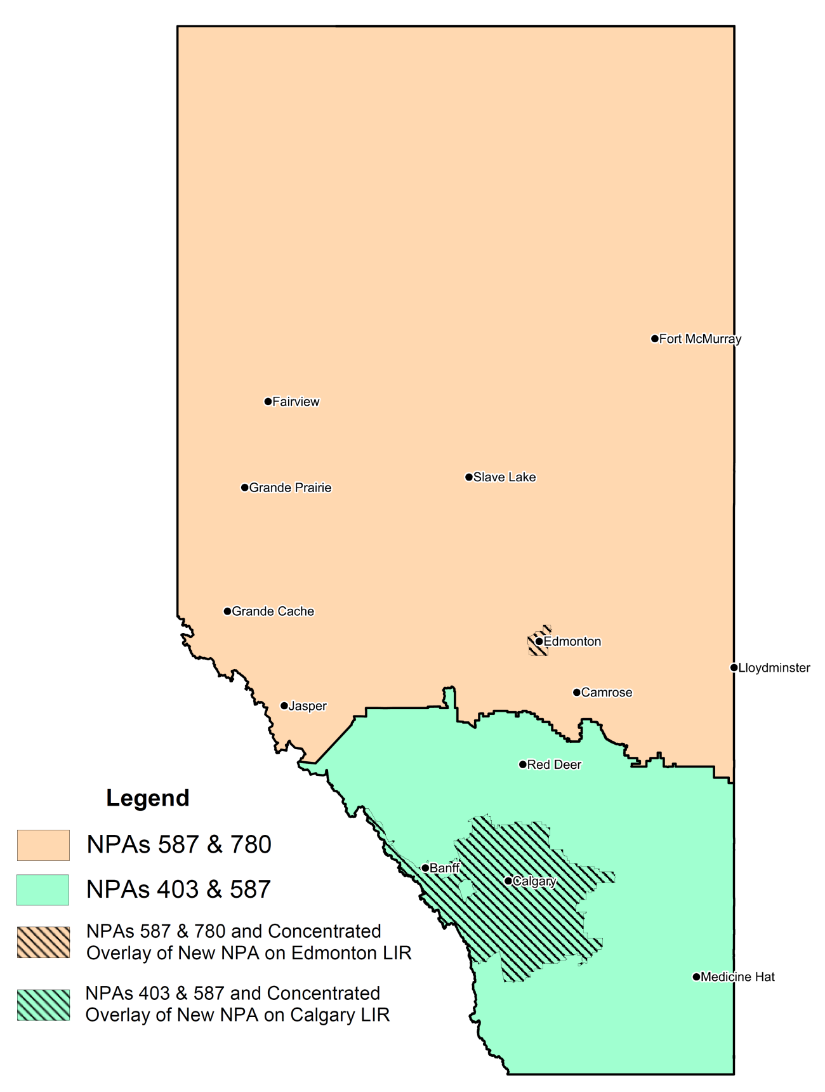

Figure 12 - Option 3: Concentrated Overlay - Concentrated Overlay of New NPA

on Calgary and Edmonton LIRs

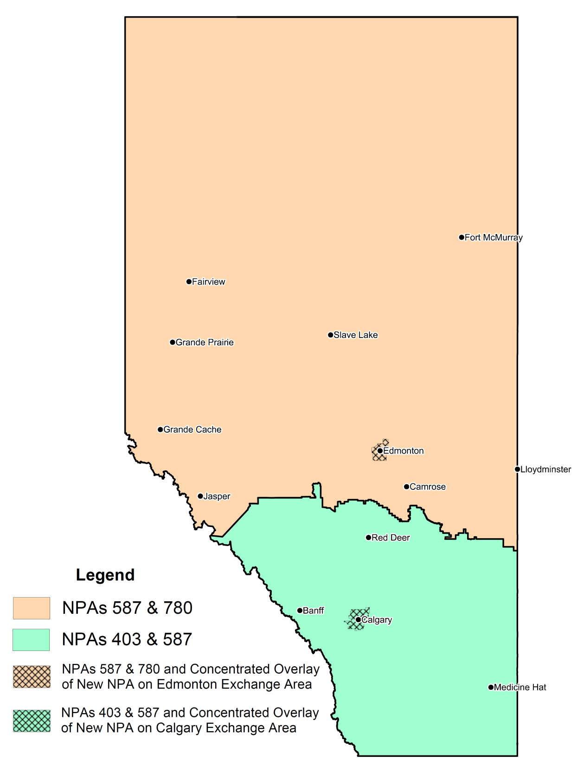

Figure 13 - Option 4: Concentrated Overlay - Concentrated Overlay of New NPA

on Calgary and Edmonton Exchange Areas

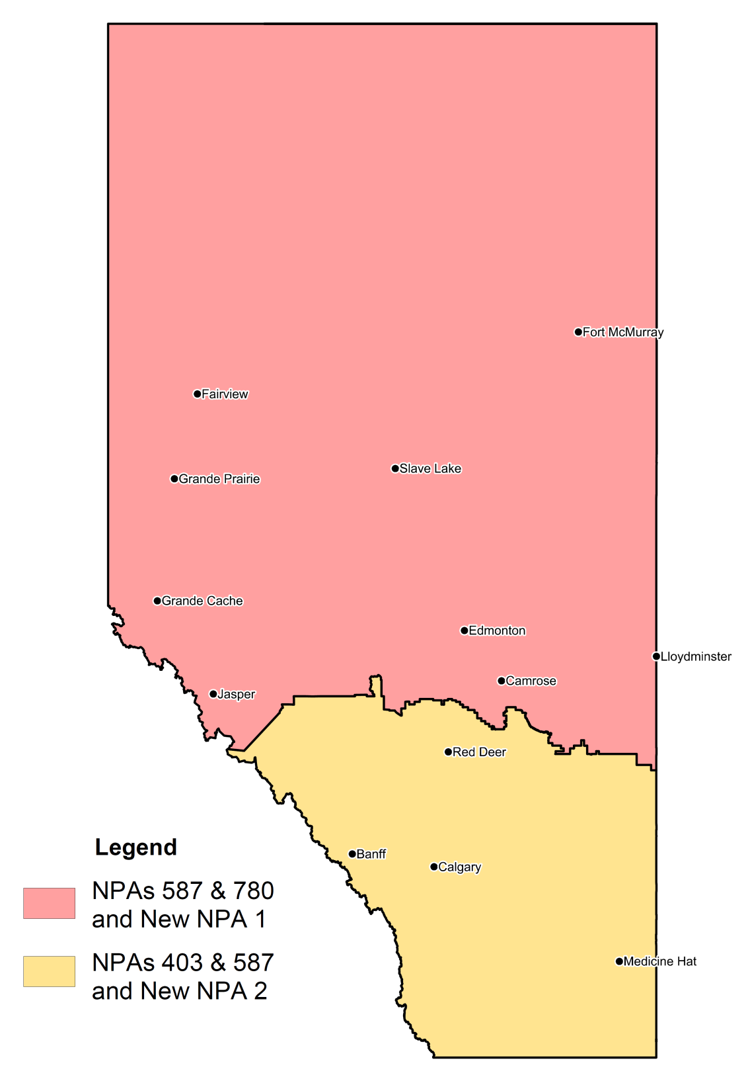

Figure 14 - Option 5: Concentrated Overlay - Concentrated Overlay of two new NPAs - first new NPA overlays NPA 587/780 and the second new NPA overlays NPA 403/587

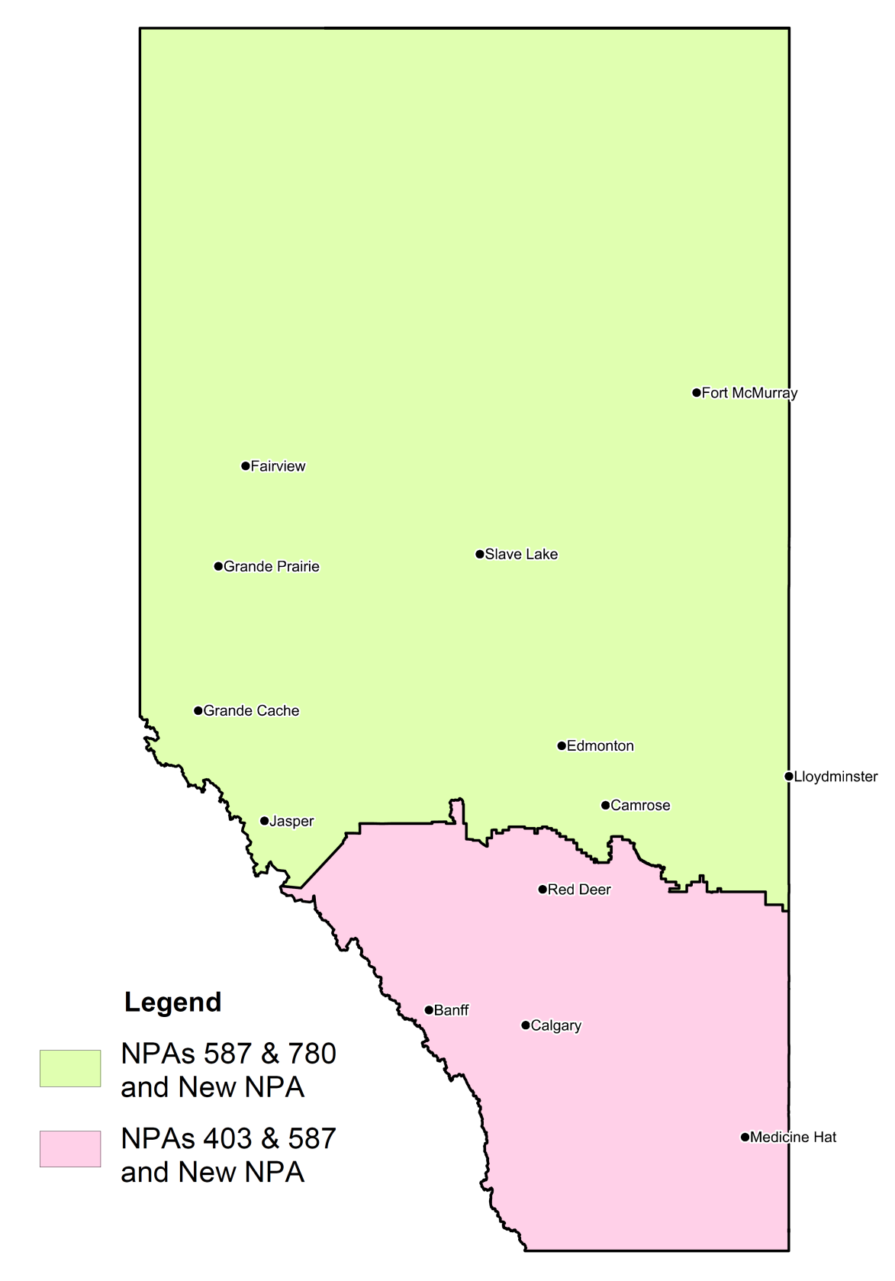

Figure 15 - Option 6: Distributed Overlay - Distributed Overlay of a New NPA on NPA 403/587/780

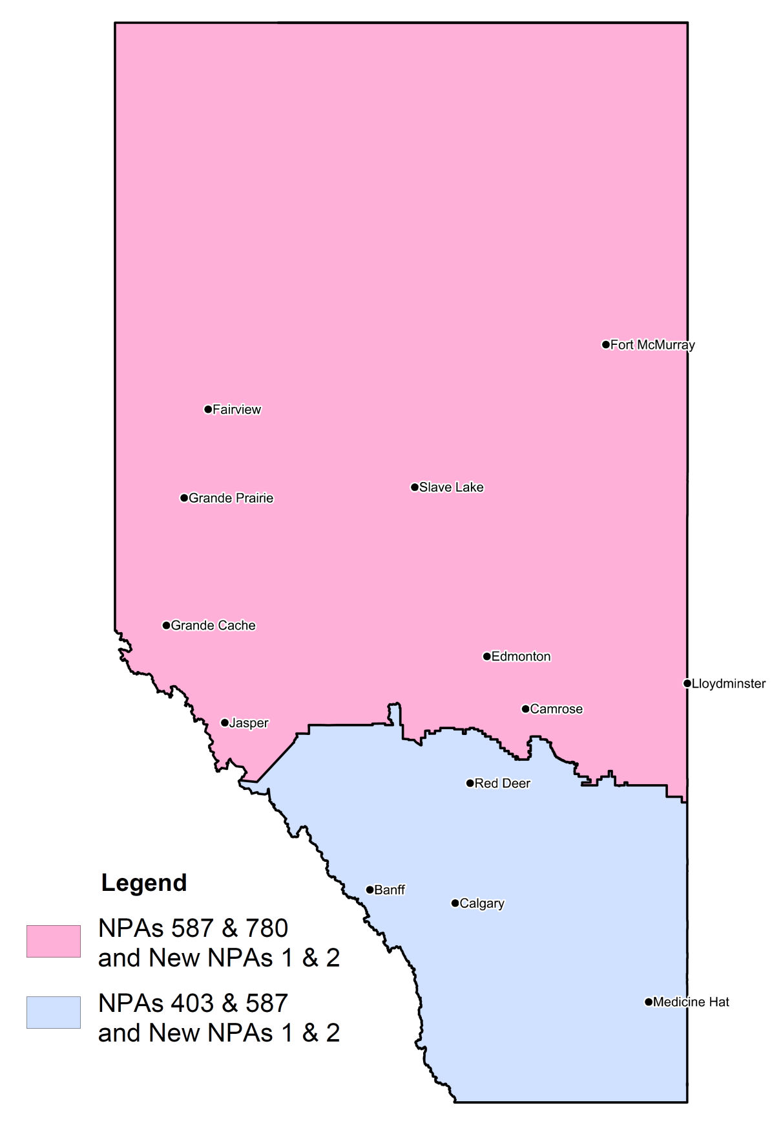

Figure 16 - Option 7: Distributed Overlay - Distributed Overlay of two New NPAs on NPA 403/587/780

Table 1 - Exchange Areas in NPA 403/587/780 and Exchange Areas in NPAs for each Relief Option

|  | **Options** | **Current** | | | **1** | | **2** | | **3** | | **4** | | **5** | | | **6** | | **7** | | |
| --- | --- | --- | --- | --- | --- | --- | --- | --- | --- | --- | --- | --- | --- | --- | --- | --- | --- | --- | --- | --- |
| **No.** | **Exchange Area** | **403** | **780** | **587** | **587** | **New** | **587** | **New** | **587** | **New** | **587** | **New** | **587** | **New 1** | **New 2** | **587** | **New** | **587** | **New 1** | **New 2** |
| 1 | Acadia Valley | **✓** |  | **✓** | **✓** |  |  | **✓** | **✓** |  | **✓** |  | **✓** |  | **✓** | **✓** | **✓** | **✓** | **✓** | **✓** |
| 2 | Acme | **✓** |  | **✓** | **✓** |  |  | **✓** | **✓** | **✓** | **✓** |  | **✓** |  | **✓** | **✓** | **✓** | **✓** | **✓** | **✓** |
| 3 | Airdrie | **✓** |  | **✓** | **✓** |  |  | **✓** | **✓** | **✓** | **✓** |  | **✓** |  | **✓** | **✓** | **✓** | **✓** | **✓** | **✓** |
| 4 | Alix | **✓** |  | **✓** | **✓** |  |  | **✓** | **✓** |  | **✓** |  | **✓** |  | **✓** | **✓** | **✓** | **✓** | **✓** | **✓** |
| 5 | Altaro | **✓** |  | **✓** | **✓** |  |  | **✓** | **✓** |  | **✓** |  | **✓** |  | **✓** | **✓** | **✓** | **✓** | **✓** | **✓** |
| 6 | Arrowwood | **✓** |  | **✓** | **✓** |  |  | **✓** | **✓** | **✓** | **✓** |  | **✓** |  | **✓** | **✓** | **✓** | **✓** | **✓** | **✓** |
| 7 | Banff | **✓** |  | **✓** | **✓** |  |  | **✓** | **✓** | **✓** | **✓** |  | **✓** |  | **✓** | **✓** | **✓** | **✓** | **✓** | **✓** |
| 8 | Barons | **✓** |  | **✓** | **✓** |  |  | **✓** | **✓** |  | **✓** |  | **✓** |  | **✓** | **✓** | **✓** | **✓** | **✓** | **✓** |
| 9 | Bassano | **✓** |  | **✓** | **✓** |  |  | **✓** | **✓** |  | **✓** |  | **✓** |  | **✓** | **✓** | **✓** | **✓** | **✓** | **✓** |
| 10 | Beiseker | **✓** |  | **✓** | **✓** |  |  | **✓** | **✓** | **✓** | **✓** |  | **✓** |  | **✓** | **✓** | **✓** | **✓** | **✓** | **✓** |
| 11 | Bentley | **✓** |  | **✓** | **✓** |  |  | **✓** | **✓** |  | **✓** |  | **✓** |  | **✓** | **✓** | **✓** | **✓** | **✓** | **✓** |
| 12 | Big Valley | **✓** |  | **✓** | **✓** |  |  | **✓** | **✓** |  | **✓** |  | **✓** |  | **✓** | **✓** | **✓** | **✓** | **✓** | **✓** |
| 13 | Bindloss | **✓** |  | **✓** | **✓** |  |  | **✓** | **✓** |  | **✓** |  | **✓** |  | **✓** | **✓** | **✓** | **✓** | **✓** | **✓** |
| 14 | Blackfalds | **✓** |  | **✓** | **✓** |  |  | **✓** | **✓** |  | **✓** |  | **✓** |  | **✓** | **✓** | **✓** | **✓** | **✓** | **✓** |
| 15 | Blackie | **✓** |  | **✓** | **✓** |  |  | **✓** | **✓** | **✓** | **✓** |  | **✓** |  | **✓** | **✓** | **✓** | **✓** | **✓** | **✓** |
| 16 | Bow Island | **✓** |  | **✓** | **✓** |  |  | **✓** | **✓** |  | **✓** |  | **✓** |  | **✓** | **✓** | **✓** | **✓** | **✓** | **✓** |
| 17 | Bowden | **✓** |  | **✓** | **✓** |  |  | **✓** | **✓** |  | **✓** |  | **✓** |  | **✓** | **✓** | **✓** | **✓** | **✓** | **✓** |
| 18 | Bragg Creek | **✓** |  | **✓** | **✓** |  |  | **✓** | **✓** | **✓** | **✓** |  | **✓** |  | **✓** | **✓** | **✓** | **✓** | **✓** | **✓** |
| 19 | Brocket | **✓** |  | **✓** | **✓** |  |  | **✓** | **✓** |  | **✓** |  | **✓** |  | **✓** | **✓** | **✓** | **✓** | **✓** | **✓** |
| 20 | Brooks | **✓** |  | **✓** | **✓** |  |  | **✓** | **✓** |  | **✓** |  | **✓** |  | **✓** | **✓** | **✓** | **✓** | **✓** | **✓** |
| 21 | Burdett | **✓** |  | **✓** | **✓** |  |  | **✓** | **✓** |  | **✓** |  | **✓** |  | **✓** | **✓** | **✓** | **✓** | **✓** | **✓** |
| 22 | Byemoor | **✓** |  | **✓** | **✓** |  |  | **✓** | **✓** |  | **✓** |  | **✓** |  | **✓** | **✓** | **✓** | **✓** | **✓** | **✓** |
| 23 | Calgary | **✓** |  | **✓** | **✓** |  |  | **✓** | **✓** | **✓** | **✓** | **✓** | **✓** |  | **✓** | **✓** | **✓** | **✓** | **✓** | **✓** |
| 24 | Canmore | **✓** |  | **✓** | **✓** |  |  | **✓** | **✓** | **✓** | **✓** |  | **✓** |  | **✓** | **✓** | **✓** | **✓** | **✓** | **✓** |
| 25 | Carbon | **✓** |  | **✓** | **✓** |  |  | **✓** | **✓** |  | **✓** |  | **✓** |  | **✓** | **✓** | **✓** | **✓** | **✓** | **✓** |
| 26 | Cardston | **✓** |  | **✓** | **✓** |  |  | **✓** | **✓** |  | **✓** |  | **✓** |  | **✓** | **✓** | **✓** | **✓** | **✓** | **✓** |
| 27 | Carmangay | **✓** |  | **✓** | **✓** |  |  | **✓** | **✓** |  | **✓** |  | **✓** |  | **✓** | **✓** | **✓** | **✓** | **✓** | **✓** |
| 28 | Caroline | **✓** |  | **✓** | **✓** |  |  | **✓** | **✓** |  | **✓** |  | **✓** |  | **✓** | **✓** | **✓** | **✓** | **✓** | **✓** |
| 29 | Carstairs | **✓** |  | **✓** | **✓** |  |  | **✓** | **✓** | **✓** | **✓** |  | **✓** |  | **✓** | **✓** | **✓** | **✓** | **✓** | **✓** |
| 30 | Castor | **✓** |  | **✓** | **✓** |  |  | **✓** | **✓** |  | **✓** |  | **✓** |  | **✓** | **✓** | **✓** | **✓** | **✓** | **✓** |
| 31 | Cayley | **✓** |  | **✓** | **✓** |  |  | **✓** | **✓** | **✓** | **✓** |  | **✓** |  | **✓** | **✓** | **✓** | **✓** | **✓** | **✓** |
| 32 | Cereal | **✓** |  | **✓** | **✓** |  |  | **✓** | **✓** |  | **✓** |  | **✓** |  | **✓** | **✓** | **✓** | **✓** | **✓** | **✓** |
| 33 | Cessford | **✓** |  | **✓** | **✓** |  |  | **✓** | **✓** |  | **✓** |  | **✓** |  | **✓** | **✓** | **✓** | **✓** | **✓** | **✓** |
| 34 | Champion | **✓** |  | **✓** | **✓** |  |  | **✓** | **✓** | **✓** | **✓** |  | **✓** |  | **✓** | **✓** | **✓** | **✓** | **✓** | **✓** |
| 35 | Claresholm | **✓** |  | **✓** | **✓** |  |  | **✓** | **✓** |  | **✓** |  | **✓** |  | **✓** | **✓** | **✓** | **✓** | **✓** | **✓** |
| 36 | Clive | **✓** |  | **✓** | **✓** |  |  | **✓** | **✓** |  | **✓** |  | **✓** |  | **✓** | **✓** | **✓** | **✓** | **✓** | **✓** |
| 37 | Coaldale | **✓** |  | **✓** | **✓** |  |  | **✓** | **✓** |  | **✓** |  | **✓** |  | **✓** | **✓** | **✓** | **✓** | **✓** | **✓** |
| 38 | Cochrane | **✓** |  | **✓** | **✓** |  |  | **✓** | **✓** | **✓** | **✓** |  | **✓** |  | **✓** | **✓** | **✓** | **✓** | **✓** | **✓** |
| 39 | Consort | **✓** |  | **✓** | **✓** |  |  | **✓** | **✓** |  | **✓** |  | **✓** |  | **✓** | **✓** | **✓** | **✓** | **✓** | **✓** |
| 40 | Coronation | **✓** |  | **✓** | **✓** |  |  | **✓** | **✓** |  | **✓** |  | **✓** |  | **✓** | **✓** | **✓** | **✓** | **✓** | **✓** |
| 41 | Coutts | **✓** |  | **✓** | **✓** |  |  | **✓** | **✓** |  | **✓** |  | **✓** |  | **✓** | **✓** | **✓** | **✓** | **✓** | **✓** |
| 42 | Cowley | **✓** |  | **✓** | **✓** |  |  | **✓** | **✓** |  | **✓** |  | **✓** |  | **✓** | **✓** | **✓** | **✓** | **✓** | **✓** |
| 43 | Craigmile | **✓** |  | **✓** | **✓** |  |  | **✓** | **✓** |  | **✓** |  | **✓** |  | **✓** | **✓** | **✓** | **✓** | **✓** | **✓** |
| 44 | Cremona | **✓** |  | **✓** | **✓** |  |  | **✓** | **✓** | **✓** | **✓** |  | **✓** |  | **✓** | **✓** | **✓** | **✓** | **✓** | **✓** |
| 45 | Crossfield | **✓** |  | **✓** | **✓** |  |  | **✓** | **✓** | **✓** | **✓** |  | **✓** |  | **✓** | **✓** | **✓** | **✓** | **✓** | **✓** |
| 46 | Crowsnest Pass | **✓** |  | **✓** | **✓** |  |  | **✓** | **✓** |  | **✓** |  | **✓** |  | **✓** | **✓** | **✓** | **✓** | **✓** | **✓** |
| 47 | Delburne | **✓** |  | **✓** | **✓** |  |  | **✓** | **✓** |  | **✓** |  | **✓** |  | **✓** | **✓** | **✓** | **✓** | **✓** | **✓** |
| 48 | Delia | **✓** |  | **✓** | **✓** |  |  | **✓** | **✓** |  | **✓** |  | **✓** |  | **✓** | **✓** | **✓** | **✓** | **✓** | **✓** |
| 49 | Didsbury | **✓** |  | **✓** | **✓** |  |  | **✓** | **✓** |  | **✓** |  | **✓** |  | **✓** | **✓** | **✓** | **✓** | **✓** | **✓** |
| 50 | Donalda | **✓** |  | **✓** | **✓** |  |  | **✓** | **✓** |  | **✓** |  | **✓** |  | **✓** | **✓** | **✓** | **✓** | **✓** | **✓** |
| 51 | Drumheller | **✓** |  | **✓** | **✓** |  |  | **✓** | **✓** |  | **✓** |  | **✓** |  | **✓** | **✓** | **✓** | **✓** | **✓** | **✓** |
| 52 | Duchess | **✓** |  | **✓** | **✓** |  |  | **✓** | **✓** |  | **✓** |  | **✓** |  | **✓** | **✓** | **✓** | **✓** | **✓** | **✓** |
| 53 | East Coulee | **✓** |  | **✓** | **✓** |  |  | **✓** | **✓** |  | **✓** |  | **✓** |  | **✓** | **✓** | **✓** | **✓** | **✓** | **✓** |
| 54 | Eckville | **✓** |  | **✓** | **✓** |  |  | **✓** | **✓** |  | **✓** |  | **✓** |  | **✓** | **✓** | **✓** | **✓** | **✓** | **✓** |
| 55 | Elkwater | **✓** |  | **✓** | **✓** |  |  | **✓** | **✓** |  | **✓** |  | **✓** |  | **✓** | **✓** | **✓** | **✓** | **✓** | **✓** |
| 56 | Elnora | **✓** |  | **✓** | **✓** |  |  | **✓** | **✓** |  | **✓** |  | **✓** |  | **✓** | **✓** | **✓** | **✓** | **✓** | **✓** |
| 57 | Empress | **✓** |  | **✓** | **✓** |  |  | **✓** | **✓** |  | **✓** |  | **✓** |  | **✓** | **✓** | **✓** | **✓** | **✓** | **✓** |
| 58 | Enchant | **✓** |  | **✓** | **✓** |  |  | **✓** | **✓** |  | **✓** |  | **✓** |  | **✓** | **✓** | **✓** | **✓** | **✓** | **✓** |
| 59 | Etzicom | **✓** |  | **✓** | **✓** |  |  | **✓** | **✓** |  | **✓** |  | **✓** |  | **✓** | **✓** | **✓** | **✓** | **✓** | **✓** |
| 60 | Exshaw | **✓** |  | **✓** | **✓** |  |  | **✓** | **✓** | **✓** | **✓** |  | **✓** |  | **✓** | **✓** | **✓** | **✓** | **✓** | **✓** |
| 61 | Foremost | **✓** |  | **✓** | **✓** |  |  | **✓** | **✓** |  | **✓** |  | **✓** |  | **✓** | **✓** | **✓** | **✓** | **✓** | **✓** |
| 62 | Fort Macleod | **✓** |  | **✓** | **✓** |  |  | **✓** | **✓** |  | **✓** |  | **✓** |  | **✓** | **✓** | **✓** | **✓** | **✓** | **✓** |
| 63 | Gadsby | **✓** |  | **✓** | **✓** |  |  | **✓** | **✓** |  | **✓** |  | **✓** |  | **✓** | **✓** | **✓** | **✓** | **✓** | **✓** |
| 64 | Gleichen | **✓** |  | **✓** | **✓** |  |  | **✓** | **✓** | **✓** | **✓** |  | **✓** |  | **✓** | **✓** | **✓** | **✓** | **✓** | **✓** |
| 65 | Glenwood | **✓** |  | **✓** | **✓** |  |  | **✓** | **✓** |  | **✓** |  | **✓** |  | **✓** | **✓** | **✓** | **✓** | **✓** | **✓** |
| 66 | Granum | **✓** |  | **✓** | **✓** |  |  | **✓** | **✓** |  | **✓** |  | **✓** |  | **✓** | **✓** | **✓** | **✓** | **✓** | **✓** |
| 67 | Grassy Lake | **✓** |  | **✓** | **✓** |  |  | **✓** | **✓** |  | **✓** |  | **✓** |  | **✓** | **✓** | **✓** | **✓** | **✓** | **✓** |
| 68 | Halkirk | **✓** |  | **✓** | **✓** |  |  | **✓** | **✓** |  | **✓** |  | **✓** |  | **✓** | **✓** | **✓** | **✓** | **✓** | **✓** |
| 69 | Hanna | **✓** |  | **✓** | **✓** |  |  | **✓** | **✓** |  | **✓** |  | **✓** |  | **✓** | **✓** | **✓** | **✓** | **✓** | **✓** |
| 70 | Hays | **✓** |  | **✓** | **✓** |  |  | **✓** | **✓** |  | **✓** |  | **✓** |  | **✓** | **✓** | **✓** | **✓** | **✓** | **✓** |
| 71 | High River | **✓** |  | **✓** | **✓** |  |  | **✓** | **✓** | **✓** | **✓** |  | **✓** |  | **✓** | **✓** | **✓** | **✓** | **✓** | **✓** |
| 72 | Hilda | **✓** |  | **✓** | **✓** |  |  | **✓** | **✓** |  | **✓** |  | **✓** |  | **✓** | **✓** | **✓** | **✓** | **✓** | **✓** |
| 73 | Hussar | **✓** |  | **✓** | **✓** |  |  | **✓** | **✓** | **✓** | **✓** |  | **✓** |  | **✓** | **✓** | **✓** | **✓** | **✓** | **✓** |
| 74 | Innisfail | **✓** |  | **✓** | **✓** |  |  | **✓** | **✓** |  | **✓** |  | **✓** |  | **✓** | **✓** | **✓** | **✓** | **✓** | **✓** |
| 75 | Iron Springs | **✓** |  | **✓** | **✓** |  |  | **✓** | **✓** |  | **✓** |  | **✓** |  | **✓** | **✓** | **✓** | **✓** | **✓** | **✓** |
| 76 | Irricana | **✓** |  | **✓** | **✓** |  |  | **✓** | **✓** | **✓** | **✓** |  | **✓** |  | **✓** | **✓** | **✓** | **✓** | **✓** | **✓** |
| 77 | Irvine | **✓** |  | **✓** | **✓** |  |  | **✓** | **✓** |  | **✓** |  | **✓** |  | **✓** | **✓** | **✓** | **✓** | **✓** | **✓** |
| 78 | Jenner | **✓** |  | **✓** | **✓** |  |  | **✓** | **✓** |  | **✓** |  | **✓** |  | **✓** | **✓** | **✓** | **✓** | **✓** | **✓** |
| 79 | Kananaskis | **✓** |  | **✓** | **✓** |  |  | **✓** | **✓** | **✓** | **✓** |  | **✓** |  | **✓** | **✓** | **✓** | **✓** | **✓** | **✓** |
| 80 | Lacombe | **✓** |  | **✓** | **✓** |  |  | **✓** | **✓** |  | **✓** |  | **✓** |  | **✓** | **✓** | **✓** | **✓** | **✓** | **✓** |
| 81 | Lake Louise | **✓** |  | **✓** | **✓** |  |  | **✓** | **✓** | **✓** | **✓** |  | **✓** |  | **✓** | **✓** | **✓** | **✓** | **✓** | **✓** |
| 82 | Langdon | **✓** |  | **✓** | **✓** |  |  | **✓** | **✓** | **✓** | **✓** |  | **✓** |  | **✓** | **✓** | **✓** | **✓** | **✓** | **✓** |
| 83 | Leslieville | **✓** |  | **✓** | **✓** |  |  | **✓** | **✓** |  | **✓** |  | **✓** |  | **✓** | **✓** | **✓** | **✓** | **✓** | **✓** |
| 84 | Lethbridge | **✓** |  | **✓** | **✓** |  |  | **✓** | **✓** |  | **✓** |  | **✓** |  | **✓** | **✓** | **✓** | **✓** | **✓** | **✓** |
| 85 | Lomond | **✓** |  | **✓** | **✓** |  |  | **✓** | **✓** | **✓** | **✓** |  | **✓** |  | **✓** | **✓** | **✓** | **✓** | **✓** | **✓** |
| 86 | Longview | **✓** |  | **✓** | **✓** |  |  | **✓** | **✓** | **✓** | **✓** |  | **✓** |  | **✓** | **✓** | **✓** | **✓** | **✓** | **✓** |
| 87 | Magrath | **✓** |  | **✓** | **✓** |  |  | **✓** | **✓** |  | **✓** |  | **✓** |  | **✓** | **✓** | **✓** | **✓** | **✓** | **✓** |
| 88 | Manyberries | **✓** |  | **✓** | **✓** |  |  | **✓** | **✓** |  | **✓** |  | **✓** |  | **✓** | **✓** | **✓** | **✓** | **✓** | **✓** |
| 89 | Medicine Hat | **✓** |  | **✓** | **✓** |  |  | **✓** | **✓** |  | **✓** |  | **✓** |  | **✓** | **✓** | **✓** | **✓** | **✓** | **✓** |
| 90 | Milk River | **✓** |  | **✓** | **✓** |  |  | **✓** | **✓** |  | **✓** |  | **✓** |  | **✓** | **✓** | **✓** | **✓** | **✓** | **✓** |
| 91 | Milo | **✓** |  | **✓** | **✓** |  |  | **✓** | **✓** | **✓** | **✓** |  | **✓** |  | **✓** | **✓** | **✓** | **✓** | **✓** | **✓** |
| 92 | Mirror | **✓** |  | **✓** | **✓** |  |  | **✓** | **✓** |  | **✓** |  | **✓** |  | **✓** | **✓** | **✓** | **✓** | **✓** | **✓** |
| 93 | Morley | **✓** |  | **✓** | **✓** |  |  | **✓** | **✓** | **✓** | **✓** |  | **✓** |  | **✓** | **✓** | **✓** | **✓** | **✓** | **✓** |
| 94 | Morrin | **✓** |  | **✓** | **✓** |  |  | **✓** | **✓** |  | **✓** |  | **✓** |  | **✓** | **✓** | **✓** | **✓** | **✓** | **✓** |
| 95 | Nanton | **✓** |  | **✓** | **✓** |  |  | **✓** | **✓** | **✓** | **✓** |  | **✓** |  | **✓** | **✓** | **✓** | **✓** | **✓** | **✓** |
| 96 | New Dayton | **✓** |  | **✓** | **✓** |  |  | **✓** | **✓** |  | **✓** |  | **✓** |  | **✓** | **✓** | **✓** | **✓** | **✓** | **✓** |
| 97 | Nobleford | **✓** |  | **✓** | **✓** |  |  | **✓** | **✓** |  | **✓** |  | **✓** |  | **✓** | **✓** | **✓** | **✓** | **✓** | **✓** |
| 98 | Nordegg | **✓** |  | **✓** | **✓** |  |  | **✓** | **✓** |  | **✓** |  | **✓** |  | **✓** | **✓** | **✓** | **✓** | **✓** | **✓** |
| 99 | Okotoks | **✓** |  | **✓** | **✓** |  |  | **✓** | **✓** | **✓** | **✓** |  | **✓** |  | **✓** | **✓** | **✓** | **✓** | **✓** | **✓** |
| 100 | Olds | **✓** |  | **✓** | **✓** |  |  | **✓** | **✓** |  | **✓** |  | **✓** |  | **✓** | **✓** | **✓** | **✓** | **✓** | **✓** |
| 101 | Oyen | **✓** |  | **✓** | **✓** |  |  | **✓** | **✓** |  | **✓** |  | **✓** |  | **✓** | **✓** | **✓** | **✓** | **✓** | **✓** |
| 102 | Penhold | **✓** |  | **✓** | **✓** |  |  | **✓** | **✓** |  | **✓** |  | **✓** |  | **✓** | **✓** | **✓** | **✓** | **✓** | **✓** |
| 103 | Picture Butte | **✓** |  | **✓** | **✓** |  |  | **✓** | **✓** |  | **✓** |  | **✓** |  | **✓** | **✓** | **✓** | **✓** | **✓** | **✓** |
| 104 | Pincher Creek | **✓** |  | **✓** | **✓** |  |  | **✓** | **✓** |  | **✓** |  | **✓** |  | **✓** | **✓** | **✓** | **✓** | **✓** | **✓** |
| 105 | Ponoka | **✓** |  | **✓** | **✓** |  |  | **✓** | **✓** |  | **✓** |  | **✓** |  | **✓** | **✓** | **✓** | **✓** | **✓** | **✓** |
| 106 | Ralston | **✓** |  | **✓** | **✓** |  |  | **✓** | **✓** |  | **✓** |  | **✓** |  | **✓** | **✓** | **✓** | **✓** | **✓** | **✓** |
| 107 | Raymond | **✓** |  | **✓** | **✓** |  |  | **✓** | **✓** |  | **✓** |  | **✓** |  | **✓** | **✓** | **✓** | **✓** | **✓** | **✓** |
| 108 | Red Deer | **✓** |  | **✓** | **✓** |  |  | **✓** | **✓** |  | **✓** |  | **✓** |  | **✓** | **✓** | **✓** | **✓** | **✓** | **✓** |
| 109 | Rimbey | **✓** |  | **✓** | **✓** |  |  | **✓** | **✓** |  | **✓** |  | **✓** |  | **✓** | **✓** | **✓** | **✓** | **✓** | **✓** |
| 110 | Rockyford | **✓** |  | **✓** | **✓** |  |  | **✓** | **✓** | **✓** | **✓** |  | **✓** |  | **✓** | **✓** | **✓** | **✓** | **✓** | **✓** |
| 111 | Rocky Mountain House | **✓** |  | **✓** | **✓** |  |  | **✓** | **✓** |  | **✓** |  | **✓** |  | **✓** | **✓** | **✓** | **✓** | **✓** | **✓** |
| 112 | Rolling Hills | **✓** |  | **✓** | **✓** |  |  | **✓** | **✓** |  | **✓** |  | **✓** |  | **✓** | **✓** | **✓** | **✓** | **✓** | **✓** |
| 113 | Rosebud | **✓** |  | **✓** | **✓** |  |  | **✓** | **✓** |  | **✓** |  | **✓** |  | **✓** | **✓** | **✓** | **✓** | **✓** | **✓** |
| 114 | Rumsey | **✓** |  | **✓** | **✓** |  |  | **✓** | **✓** |  | **✓** |  | **✓** |  | **✓** | **✓** | **✓** | **✓** | **✓** | **✓** |
| 115 | Saskatchewan River Crossing | **✓** |  | **✓** | **✓** |  |  | **✓** | **✓** |  | **✓** |  | **✓** |  | **✓** | **✓** | **✓** | **✓** | **✓** | **✓** |
| 116 | Schuler | **✓** |  | **✓** | **✓** |  |  | **✓** | **✓** |  | **✓** |  | **✓** |  | **✓** | **✓** | **✓** | **✓** | **✓** | **✓** |
| 117 | Seven Persons | **✓** |  | **✓** | **✓** |  |  | **✓** | **✓** |  | **✓** |  | **✓** |  | **✓** | **✓** | **✓** | **✓** | **✓** | **✓** |
| 118 | Sibbald | **✓** |  | **✓** | **✓** |  |  | **✓** | **✓** |  | **✓** |  | **✓** |  | **✓** | **✓** | **✓** | **✓** | **✓** | **✓** |
| 119 | Spruceview | **✓** |  | **✓** | **✓** |  |  | **✓** | **✓** |  | **✓** |  | **✓** |  | **✓** | **✓** | **✓** | **✓** | **✓** | **✓** |
| 120 | Stand Off | **✓** |  | **✓** | **✓** |  |  | **✓** | **✓** |  | **✓** |  | **✓** |  | **✓** | **✓** | **✓** | **✓** | **✓** | **✓** |
| 121 | Standard | **✓** |  | **✓** | **✓** |  |  | **✓** | **✓** | **✓** | **✓** |  | **✓** |  | **✓** | **✓** | **✓** | **✓** | **✓** | **✓** |
| 122 | Stavely | **✓** |  | **✓** | **✓** |  |  | **✓** | **✓** | **✓** | **✓** |  | **✓** |  | **✓** | **✓** | **✓** | **✓** | **✓** | **✓** |
| 123 | Stettler | **✓** |  | **✓** | **✓** |  |  | **✓** | **✓** |  | **✓** |  | **✓** |  | **✓** | **✓** | **✓** | **✓** | **✓** | **✓** |
| 124 | Stirling | **✓** |  | **✓** | **✓** |  |  | **✓** | **✓** |  | **✓** |  | **✓** |  | **✓** | **✓** | **✓** | **✓** | **✓** | **✓** |
| 125 | Strathmore | **✓** |  | **✓** | **✓** |  |  | **✓** | **✓** | **✓** | **✓** |  | **✓** |  | **✓** | **✓** | **✓** | **✓** | **✓** | **✓** |
| 126 | Sunchild O'Chiese | **✓** |  | **✓** | **✓** |  |  | **✓** | **✓** |  | **✓** |  | **✓** |  | **✓** | **✓** | **✓** | **✓** | **✓** | **✓** |
| 127 | Sundre | **✓** |  | **✓** | **✓** |  |  | **✓** | **✓** |  | **✓** |  | **✓** |  | **✓** | **✓** | **✓** | **✓** | **✓** | **✓** |
| 128 | Sylvan Lake | **✓** |  | **✓** | **✓** |  |  | **✓** | **✓** |  | **✓** |  | **✓** |  | **✓** | **✓** | **✓** | **✓** | **✓** | **✓** |
| 129 | Taber | **✓** |  | **✓** | **✓** |  |  | **✓** | **✓** |  | **✓** |  | **✓** |  | **✓** | **✓** | **✓** | **✓** | **✓** | **✓** |
| 130 | Three Hills | **✓** |  | **✓** | **✓** |  |  | **✓** | **✓** |  | **✓** |  | **✓** |  | **✓** | **✓** | **✓** | **✓** | **✓** | **✓** |
| 131 | Tilley | **✓** |  | **✓** | **✓** |  |  | **✓** | **✓** |  | **✓** |  | **✓** |  | **✓** | **✓** | **✓** | **✓** | **✓** | **✓** |
| 132 | Torrington | **✓** |  | **✓** | **✓** |  |  | **✓** | **✓** |  | **✓** |  | **✓** |  | **✓** | **✓** | **✓** | **✓** | **✓** | **✓** |
| 133 | Trochu | **✓** |  | **✓** | **✓** |  |  | **✓** | **✓** |  | **✓** |  | **✓** |  | **✓** | **✓** | **✓** | **✓** | **✓** | **✓** |
| 134 | Turner Valley | **✓** |  | **✓** | **✓** |  |  | **✓** | **✓** | **✓** | **✓** |  | **✓** |  | **✓** | **✓** | **✓** | **✓** | **✓** | **✓** |
| 135 | Vauxhall | **✓** |  | **✓** | **✓** |  |  | **✓** | **✓** |  | **✓** |  | **✓** |  | **✓** | **✓** | **✓** | **✓** | **✓** | **✓** |
| 136 | Veteran | **✓** |  | **✓** | **✓** |  |  | **✓** | **✓** |  | **✓** |  | **✓** |  | **✓** | **✓** | **✓** | **✓** | **✓** | **✓** |
| 137 | Vulcan | **✓** |  | **✓** | **✓** |  |  | **✓** | **✓** | **✓** | **✓** |  | **✓** |  | **✓** | **✓** | **✓** | **✓** | **✓** | **✓** |
| 138 | Walsh | **✓** |  | **✓** | **✓** |  |  | **✓** | **✓** |  | **✓** |  | **✓** |  | **✓** | **✓** | **✓** | **✓** | **✓** | **✓** |
| 139 | Warner | **✓** |  | **✓** | **✓** |  |  | **✓** | **✓** |  | **✓** |  | **✓** |  | **✓** | **✓** | **✓** | **✓** | **✓** | **✓** |
| 140 | Waterton Park | **✓** |  | **✓** | **✓** |  |  | **✓** | **✓** |  | **✓** |  | **✓** |  | **✓** | **✓** | **✓** | **✓** | **✓** | **✓** |
| 141 | Wrentham | **✓** |  | **✓** | **✓** |  |  | **✓** | **✓** |  | **✓** |  | **✓** |  | **✓** | **✓** | **✓** | **✓** | **✓** | **✓** |
| 142 | Youngstown | **✓** |  | **✓** | **✓** |  |  | **✓** | **✓** |  | **✓** |  | **✓** |  | **✓** | **✓** | **✓** | **✓** | **✓** | **✓** |
| 143 | Alberta Beach |  | **✓** | **✓** |  | **✓** | **✓** |  | **✓** |  | **✓** |  | **✓** | **✓** |  | **✓** | **✓** | **✓** | **✓** | **✓** |
| 144 | Alder Flats |  | **✓** | **✓** |  | **✓** | **✓** |  | **✓** |  | **✓** |  | **✓** | **✓** |  | **✓** | **✓** | **✓** | **✓** | **✓** |
| 145 | Alliance |  | **✓** | **✓** |  | **✓** | **✓** |  | **✓** |  | **✓** |  | **✓** | **✓** |  | **✓** | **✓** | **✓** | **✓** | **✓** |
| 146 | Andrew |  | **✓** | **✓** |  | **✓** | **✓** |  | **✓** |  | **✓** |  | **✓** | **✓** |  | **✓** | **✓** | **✓** | **✓** | **✓** |
| 147 | Anzac |  | **✓** | **✓** |  | **✓** | **✓** |  | **✓** |  | **✓** |  | **✓** | **✓** |  | **✓** | **✓** | **✓** | **✓** | **✓** |
| 148 | Ardrossan |  | **✓** | **✓** |  | **✓** | **✓** |  | **✓** |  | **✓** |  | **✓** | **✓** |  | **✓** | **✓** | **✓** | **✓** | **✓** |
| 149 | Ashmont |  | **✓** | **✓** |  | **✓** | **✓** |  | **✓** |  | **✓** |  | **✓** | **✓** |  | **✓** | **✓** | **✓** | **✓** | **✓** |
| 150 | Assumption |  | **✓** | **✓** |  | **✓** | **✓** |  | **✓** |  | **✓** |  | **✓** | **✓** |  | **✓** | **✓** | **✓** | **✓** | **✓** |
| 151 | Athabasca |  | **✓** | **✓** |  | **✓** | **✓** |  | **✓** |  | **✓** |  | **✓** | **✓** |  | **✓** | **✓** | **✓** | **✓** | **✓** |
| 152 | Barrhead |  | **✓** | **✓** |  | **✓** | **✓** |  | **✓** |  | **✓** |  | **✓** | **✓** |  | **✓** | **✓** | **✓** | **✓** | **✓** |
| 153 | Bashaw |  | **✓** | **✓** |  | **✓** | **✓** |  | **✓** |  | **✓** |  | **✓** | **✓** |  | **✓** | **✓** | **✓** | **✓** | **✓** |
| 154 | Bawlf |  | **✓** | **✓** |  | **✓** | **✓** |  | **✓** |  | **✓** |  | **✓** | **✓** |  | **✓** | **✓** | **✓** | **✓** | **✓** |
| 155 | Bear Canyon |  | **✓** | **✓** |  | **✓** | **✓** |  | **✓** |  | **✓** |  | **✓** | **✓** |  | **✓** | **✓** | **✓** | **✓** | **✓** |
| 156 | Beaumont |  | **✓** | **✓** |  | **✓** | **✓** |  | **✓** |  | **✓** |  | **✓** | **✓** |  | **✓** | **✓** | **✓** | **✓** | **✓** |
| 157 | Beaverlodge |  | **✓** | **✓** |  | **✓** | **✓** |  | **✓** |  | **✓** |  | **✓** | **✓** |  | **✓** | **✓** | **✓** | **✓** | **✓** |
| 158 | Berwyn |  | **✓** | **✓** |  | **✓** | **✓** |  | **✓** |  | **✓** |  | **✓** | **✓** |  | **✓** | **✓** | **✓** | **✓** | **✓** |
| 159 | Blue Ridge |  | **✓** | **✓** |  | **✓** | **✓** |  | **✓** |  | **✓** |  | **✓** | **✓** |  | **✓** | **✓** | **✓** | **✓** | **✓** |
| 160 | Bon Accord |  | **✓** | **✓** |  | **✓** | **✓** |  | **✓** |  | **✓** |  | **✓** | **✓** |  | **✓** | **✓** | **✓** | **✓** | **✓** |
| 161 | Bonanza |  | **✓** | **✓** |  | **✓** | **✓** |  | **✓** |  | **✓** |  | **✓** | **✓** |  | **✓** | **✓** | **✓** | **✓** | **✓** |
| 162 | Bonnyville |  | **✓** | **✓** |  | **✓** | **✓** |  | **✓** |  | **✓** |  | **✓** | **✓** |  | **✓** | **✓** | **✓** | **✓** | **✓** |
| 163 | Boyle |  | **✓** | **✓** |  | **✓** | **✓** |  | **✓** |  | **✓** |  | **✓** | **✓** |  | **✓** | **✓** | **✓** | **✓** | **✓** |
| 164 | Breton |  | **✓** | **✓** |  | **✓** | **✓** |  | **✓** |  | **✓** |  | **✓** | **✓** |  | **✓** | **✓** | **✓** | **✓** | **✓** |
| 165 | Brownvale |  | **✓** | **✓** |  | **✓** | **✓** |  | **✓** |  | **✓** |  | **✓** | **✓** |  | **✓** | **✓** | **✓** | **✓** | **✓** |
| 166 | Bruderheim |  | **✓** | **✓** |  | **✓** | **✓** |  | **✓** |  | **✓** |  | **✓** | **✓** |  | **✓** | **✓** | **✓** | **✓** | **✓** |
| 167 | Cadomin |  | **✓** | **✓** |  | **✓** | **✓** |  | **✓** |  | **✓** |  | **✓** | **✓** |  | **✓** | **✓** | **✓** | **✓** | **✓** |
| 168 | Calling Lake |  | **✓** | **✓** |  | **✓** | **✓** |  | **✓** |  | **✓** |  | **✓** | **✓** |  | **✓** | **✓** | **✓** | **✓** | **✓** |
| 169 | Calmar |  | **✓** | **✓** |  | **✓** | **✓** |  | **✓** |  | **✓** |  | **✓** | **✓** |  | **✓** | **✓** | **✓** | **✓** | **✓** |
| 170 | Camrose |  | **✓** | **✓** |  | **✓** | **✓** |  | **✓** |  | **✓** |  | **✓** | **✓** |  | **✓** | **✓** | **✓** | **✓** | **✓** |
| 171 | Chauvin |  | **✓** | **✓** |  | **✓** | **✓** |  | **✓** |  | **✓** |  | **✓** | **✓** |  | **✓** | **✓** | **✓** | **✓** | **✓** |
| 172 | Chipewyan Lake |  | **✓** | **✓** |  | **✓** | **✓** |  | **✓** |  | **✓** |  | **✓** | **✓** |  | **✓** | **✓** | **✓** | **✓** | **✓** |
| 173 | Chipman |  | **✓** | **✓** |  | **✓** | **✓** |  | **✓** |  | **✓** |  | **✓** | **✓** |  | **✓** | **✓** | **✓** | **✓** | **✓** |
| 174 | Clairmont |  | **✓** | **✓** |  | **✓** | **✓** |  | **✓** |  | **✓** |  | **✓** | **✓** |  | **✓** | **✓** | **✓** | **✓** | **✓** |
| 175 | Clyde |  | **✓** | **✓** |  | **✓** | **✓** |  | **✓** |  | **✓** |  | **✓** | **✓** |  | **✓** | **✓** | **✓** | **✓** | **✓** |
| 176 | Cold Lake |  | **✓** | **✓** |  | **✓** | **✓** |  | **✓** |  | **✓** |  | **✓** | **✓** |  | **✓** | **✓** | **✓** | **✓** | **✓** |
| 177 | Conklin |  | **✓** | **✓** |  | **✓** | **✓** |  | **✓** |  | **✓** |  | **✓** | **✓** |  | **✓** | **✓** | **✓** | **✓** | **✓** |
| 178 | Czar |  | **✓** | **✓** |  | **✓** | **✓** |  | **✓** |  | **✓** |  | **✓** | **✓** |  | **✓** | **✓** | **✓** | **✓** | **✓** |
| 179 | Daysland |  | **✓** | **✓** |  | **✓** | **✓** |  | **✓** |  | **✓** |  | **✓** | **✓** |  | **✓** | **✓** | **✓** | **✓** | **✓** |
| 180 | Debolt |  | **✓** | **✓** |  | **✓** | **✓** |  | **✓** |  | **✓** |  | **✓** | **✓** |  | **✓** | **✓** | **✓** | **✓** | **✓** |
| 181 | Derwent |  | **✓** | **✓** |  | **✓** | **✓** |  | **✓** |  | **✓** |  | **✓** | **✓** |  | **✓** | **✓** | **✓** | **✓** | **✓** |
| 182 | Devon |  | **✓** | **✓** |  | **✓** | **✓** |  | **✓** |  | **✓** |  | **✓** | **✓** |  | **✓** | **✓** | **✓** | **✓** | **✓** |
| 183 | Dixonville |  | **✓** | **✓** |  | **✓** | **✓** |  | **✓** |  | **✓** |  | **✓** | **✓** |  | **✓** | **✓** | **✓** | **✓** | **✓** |
| 184 | Donnelly |  | **✓** | **✓** |  | **✓** | **✓** |  | **✓** |  | **✓** |  | **✓** | **✓** |  | **✓** | **✓** | **✓** | **✓** | **✓** |
| 185 | Drayton Valley |  | **✓** | **✓** |  | **✓** | **✓** |  | **✓** |  | **✓** |  | **✓** | **✓** |  | **✓** | **✓** | **✓** | **✓** | **✓** |
| 186 | Eaglesham |  | **✓** | **✓** |  | **✓** | **✓** |  | **✓** |  | **✓** |  | **✓** | **✓** |  | **✓** | **✓** | **✓** | **✓** | **✓** |
| 187 | Edgerton |  | **✓** | **✓** |  | **✓** | **✓** |  | **✓** |  | **✓** |  | **✓** | **✓** |  | **✓** | **✓** | **✓** | **✓** | **✓** |
| 188 | Edmonton |  | **✓** | **✓** |  | **✓** | **✓** |  | **✓** | **✓** | **✓** | **✓** | **✓** | **✓** |  | **✓** | **✓** | **✓** | **✓** | **✓** |
| 189 | Edmonton International Airport |  | **✓** | **✓** |  | **✓** | **✓** |  | **✓** |  | **✓** |  | **✓** | **✓** |  | **✓** | **✓** | **✓** | **✓** | **✓** |
| 190 | Edson |  | **✓** | **✓** |  | **✓** | **✓** |  | **✓** |  | **✓** |  | **✓** | **✓** |  | **✓** | **✓** | **✓** | **✓** | **✓** |
| 191 | Elk Point |  | **✓** | **✓** |  | **✓** | **✓** |  | **✓** |  | **✓** |  | **✓** | **✓** |  | **✓** | **✓** | **✓** | **✓** | **✓** |
| 192 | Evansburg |  | **✓** | **✓** |  | **✓** | **✓** |  | **✓** |  | **✓** |  | **✓** | **✓** |  | **✓** | **✓** | **✓** | **✓** | **✓** |
| 193 | Fairview |  | **✓** | **✓** |  | **✓** | **✓** |  | **✓** |  | **✓** |  | **✓** | **✓** |  | **✓** | **✓** | **✓** | **✓** | **✓** |
| 194 | Falher |  | **✓** | **✓** |  | **✓** | **✓** |  | **✓** |  | **✓** |  | **✓** | **✓** |  | **✓** | **✓** | **✓** | **✓** | **✓** |
| 195 | Faust |  | **✓** | **✓** |  | **✓** | **✓** |  | **✓** |  | **✓** |  | **✓** | **✓** |  | **✓** | **✓** | **✓** | **✓** | **✓** |
| 196 | Ferintosh |  | **✓** | **✓** |  | **✓** | **✓** |  | **✓** |  | **✓** |  | **✓** | **✓** |  | **✓** | **✓** | **✓** | **✓** | **✓** |
| 197 | Flatbush |  | **✓** | **✓** |  | **✓** | **✓** |  | **✓** |  | **✓** |  | **✓** | **✓** |  | **✓** | **✓** | **✓** | **✓** | **✓** |
| 198 | Forestburg |  | **✓** | **✓** |  | **✓** | **✓** |  | **✓** |  | **✓** |  | **✓** | **✓** |  | **✓** | **✓** | **✓** | **✓** | **✓** |
| 199 | Fort Assiniboine |  | **✓** | **✓** |  | **✓** | **✓** |  | **✓** |  | **✓** |  | **✓** | **✓** |  | **✓** | **✓** | **✓** | **✓** | **✓** |
| 200 | Fort Chipewyan |  | **✓** | **✓** |  | **✓** | **✓** |  | **✓** |  | **✓** |  | **✓** | **✓** |  | **✓** | **✓** | **✓** | **✓** | **✓** |
| 201 | Fort Mackay |  | **✓** | **✓** |  | **✓** | **✓** |  | **✓** |  | **✓** |  | **✓** | **✓** |  | **✓** | **✓** | **✓** | **✓** | **✓** |
| 202 | Fort McMurray |  | **✓** | **✓** |  | **✓** | **✓** |  | **✓** |  | **✓** |  | **✓** | **✓** |  | **✓** | **✓** | **✓** | **✓** | **✓** |
| 203 | Fort Saskatchewan |  | **✓** | **✓** |  | **✓** | **✓** |  | **✓** |  | **✓** |  | **✓** | **✓** |  | **✓** | **✓** | **✓** | **✓** | **✓** |
| 204 | Fort Vermilion |  | **✓** | **✓** |  | **✓** | **✓** |  | **✓** |  | **✓** |  | **✓** | **✓** |  | **✓** | **✓** | **✓** | **✓** | **✓** |
| 205 | Fox Creek |  | **✓** | **✓** |  | **✓** | **✓** |  | **✓** |  | **✓** |  | **✓** | **✓** |  | **✓** | **✓** | **✓** | **✓** | **✓** |
| 206 | Fox Lake |  | **✓** | **✓** |  | **✓** | **✓** |  | **✓** |  | **✓** |  | **✓** | **✓** |  | **✓** | **✓** | **✓** | **✓** | **✓** |
| 207 | Galahad |  | **✓** | **✓** |  | **✓** | **✓** |  | **✓** |  | **✓** |  | **✓** | **✓** |  | **✓** | **✓** | **✓** | **✓** | **✓** |
| 208 | Gibbons |  | **✓** | **✓** |  | **✓** | **✓** |  | **✓** |  | **✓** |  | **✓** | **✓** |  | **✓** | **✓** | **✓** | **✓** | **✓** |
| 209 | Gift Lake |  | **✓** | **✓** |  | **✓** | **✓** |  | **✓** |  | **✓** |  | **✓** | **✓** |  | **✓** | **✓** | **✓** | **✓** | **✓** |
| 210 | Girouxville |  | **✓** | **✓** |  | **✓** | **✓** |  | **✓** |  | **✓** |  | **✓** | **✓** |  | **✓** | **✓** | **✓** | **✓** | **✓** |
| 211 | Glendon |  | **✓** | **✓** |  | **✓** | **✓** |  | **✓** |  | **✓** |  | **✓** | **✓** |  | **✓** | **✓** | **✓** | **✓** | **✓** |
| 212 | Grand Centre |  | **✓** | **✓** |  | **✓** | **✓** |  | **✓** |  | **✓** |  | **✓** | **✓** |  | **✓** | **✓** | **✓** | **✓** | **✓** |
| 213 | Grande Cache |  | **✓** | **✓** |  | **✓** | **✓** |  | **✓** |  | **✓** |  | **✓** | **✓** |  | **✓** | **✓** | **✓** | **✓** | **✓** |
| 214 | Grande Prairie |  | **✓** | **✓** |  | **✓** | **✓** |  | **✓** |  | **✓** |  | **✓** | **✓** |  | **✓** | **✓** | **✓** | **✓** | **✓** |
| 215 | Grassland |  | **✓** | **✓** |  | **✓** | **✓** |  | **✓** |  | **✓** |  | **✓** | **✓** |  | **✓** | **✓** | **✓** | **✓** | **✓** |
| 216 | Grimshaw |  | **✓** | **✓** |  | **✓** | **✓** |  | **✓** |  | **✓** |  | **✓** | **✓** |  | **✓** | **✓** | **✓** | **✓** | **✓** |
| 217 | Grouard |  | **✓** | **✓** |  | **✓** | **✓** |  | **✓** |  | **✓** |  | **✓** | **✓** |  | **✓** | **✓** | **✓** | **✓** | **✓** |
| 218 | Hairy Hill |  | **✓** | **✓** |  | **✓** | **✓** |  | **✓** |  | **✓** |  | **✓** | **✓** |  | **✓** | **✓** | **✓** | **✓** | **✓** |
| 219 | Hardisty |  | **✓** | **✓** |  | **✓** | **✓** |  | **✓** |  | **✓** |  | **✓** | **✓** |  | **✓** | **✓** | **✓** | **✓** | **✓** |
| 220 | Hay Lakes |  | **✓** | **✓** |  | **✓** | **✓** |  | **✓** |  | **✓** |  | **✓** | **✓** |  | **✓** | **✓** | **✓** | **✓** | **✓** |
| 221 | Heinsburg |  | **✓** | **✓** |  | **✓** | **✓** |  | **✓** |  | **✓** |  | **✓** | **✓** |  | **✓** | **✓** | **✓** | **✓** | **✓** |
| 222 | Heisler |  | **✓** | **✓** |  | **✓** | **✓** |  | **✓** |  | **✓** |  | **✓** | **✓** |  | **✓** | **✓** | **✓** | **✓** | **✓** |
| 223 | High Level |  | **✓** | **✓** |  | **✓** | **✓** |  | **✓** |  | **✓** |  | **✓** | **✓** |  | **✓** | **✓** | **✓** | **✓** | **✓** |
| 224 | High Prairie |  | **✓** | **✓** |  | **✓** | **✓** |  | **✓** |  | **✓** |  | **✓** | **✓** |  | **✓** | **✓** | **✓** | **✓** | **✓** |
| 225 | Hines Creek |  | **✓** | **✓** |  | **✓** | **✓** |  | **✓** |  | **✓** |  | **✓** | **✓** |  | **✓** | **✓** | **✓** | **✓** | **✓** |
| 226 | Hinton |  | **✓** | **✓** |  | **✓** | **✓** |  | **✓** |  | **✓** |  | **✓** | **✓** |  | **✓** | **✓** | **✓** | **✓** | **✓** |
| 227 | Hobbema |  | **✓** | **✓** |  | **✓** | **✓** |  | **✓** |  | **✓** |  | **✓** | **✓** |  | **✓** | **✓** | **✓** | **✓** | **✓** |
| 228 | Holden |  | **✓** | **✓** |  | **✓** | **✓** |  | **✓** |  | **✓** |  | **✓** | **✓** |  | **✓** | **✓** | **✓** | **✓** | **✓** |
| 229 | Hughenden |  | **✓** | **✓** |  | **✓** | **✓** |  | **✓** |  | **✓** |  | **✓** | **✓** |  | **✓** | **✓** | **✓** | **✓** | **✓** |
| 230 | Hythe |  | **✓** | **✓** |  | **✓** | **✓** |  | **✓** |  | **✓** |  | **✓** | **✓** |  | **✓** | **✓** | **✓** | **✓** | **✓** |
| 231 | Innisfree |  | **✓** | **✓** |  | **✓** | **✓** |  | **✓** |  | **✓** |  | **✓** | **✓** |  | **✓** | **✓** | **✓** | **✓** | **✓** |
| 232 | Irma |  | **✓** | **✓** |  | **✓** | **✓** |  | **✓** |  | **✓** |  | **✓** | **✓** |  | **✓** | **✓** | **✓** | **✓** | **✓** |
| 233 | Islay |  | **✓** | **✓** |  | **✓** | **✓** |  | **✓** |  | **✓** |  | **✓** | **✓** |  | **✓** | **✓** | **✓** | **✓** | **✓** |
| 234 | Jarvie |  | **✓** | **✓** |  | **✓** | **✓** |  | **✓** |  | **✓** |  | **✓** | **✓** |  | **✓** | **✓** | **✓** | **✓** | **✓** |
| 235 | Jasper |  | **✓** | **✓** |  | **✓** | **✓** |  | **✓** |  | **✓** |  | **✓** | **✓** |  | **✓** | **✓** | **✓** | **✓** | **✓** |
| 236 | Jasper East |  | **✓** | **✓** |  | **✓** | **✓** |  | **✓** |  | **✓** |  | **✓** | **✓** |  | **✓** | **✓** | **✓** | **✓** | **✓** |
| 237 | Jean D’or Prairie |  | **✓** | **✓** |  | **✓** | **✓** |  | **✓** |  | **✓** |  | **✓** | **✓** |  | **✓** | **✓** | **✓** | **✓** | **✓** |
| 238 | Joussard |  | **✓** | **✓** |  | **✓** | **✓** |  | **✓** |  | **✓** |  | **✓** | **✓** |  | **✓** | **✓** | **✓** | **✓** | **✓** |
| 239 | Keephills |  | **✓** | **✓** |  | **✓** | **✓** |  | **✓** |  | **✓** |  | **✓** | **✓** |  | **✓** | **✓** | **✓** | **✓** | **✓** |
| 240 | Keg River |  | **✓** | **✓** |  | **✓** | **✓** |  | **✓** |  | **✓** |  | **✓** | **✓** |  | **✓** | **✓** | **✓** | **✓** | **✓** |
| 241 | Killam |  | **✓** | **✓** |  | **✓** | **✓** |  | **✓** |  | **✓** |  | **✓** | **✓** |  | **✓** | **✓** | **✓** | **✓** | **✓** |
| 242 | Kinuso |  | **✓** | **✓** |  | **✓** | **✓** |  | **✓** |  | **✓** |  | **✓** | **✓** |  | **✓** | **✓** | **✓** | **✓** | **✓** |
| 243 | Kitscoty |  | **✓** | **✓** |  | **✓** | **✓** |  | **✓** |  | **✓** |  | **✓** | **✓** |  | **✓** | **✓** | **✓** | **✓** | **✓** |
| 244 | La Crete |  | **✓** | **✓** |  | **✓** | **✓** |  | **✓** |  | **✓** |  | **✓** | **✓** |  | **✓** | **✓** | **✓** | **✓** | **✓** |
| 245 | Lac La Biche |  | **✓** | **✓** |  | **✓** | **✓** |  | **✓** |  | **✓** |  | **✓** | **✓** |  | **✓** | **✓** | **✓** | **✓** | **✓** |
| 246 | Lamont |  | **✓** | **✓** |  | **✓** | **✓** |  | **✓** |  | **✓** |  | **✓** | **✓** |  | **✓** | **✓** | **✓** | **✓** | **✓** |
| 247 | Lavoy |  | **✓** | **✓** |  | **✓** | **✓** |  | **✓** |  | **✓** |  | **✓** | **✓** |  | **✓** | **✓** | **✓** | **✓** | **✓** |
| 248 | Leduc |  | **✓** | **✓** |  | **✓** | **✓** |  | **✓** |  | **✓** |  | **✓** | **✓** |  | **✓** | **✓** | **✓** | **✓** | **✓** |
| 249 | Legal |  | **✓** | **✓** |  | **✓** | **✓** |  | **✓** |  | **✓** |  | **✓** | **✓** |  | **✓** | **✓** | **✓** | **✓** | **✓** |
| 250 | Little Buffalo Lake |  | **✓** | **✓** |  | **✓** | **✓** |  | **✓** |  | **✓** |  | **✓** | **✓** |  | **✓** | **✓** | **✓** | **✓** | **✓** |
| 251 | Lloydminster |  | **✓** | **✓** |  | **✓** | **✓** |  | **✓** |  | **✓** |  | **✓** | **✓** |  | **✓** | **✓** | **✓** | **✓** | **✓** |
| 252 | Lodgepole |  | **✓** | **✓** |  | **✓** | **✓** |  | **✓** |  | **✓** |  | **✓** | **✓** |  | **✓** | **✓** | **✓** | **✓** | **✓** |
| 253 | Lougheed |  | **✓** | **✓** |  | **✓** | **✓** |  | **✓** |  | **✓** |  | **✓** | **✓** |  | **✓** | **✓** | **✓** | **✓** | **✓** |
| 254 | Ma-Me-O Beach |  | **✓** | **✓** |  | **✓** | **✓** |  | **✓** |  | **✓** |  | **✓** | **✓** |  | **✓** | **✓** | **✓** | **✓** | **✓** |
| 255 | Manning |  | **✓** | **✓** |  | **✓** | **✓** |  | **✓** |  | **✓** |  | **✓** | **✓** |  | **✓** | **✓** | **✓** | **✓** | **✓** |
| 256 | Mannville |  | **✓** | **✓** |  | **✓** | **✓** |  | **✓** |  | **✓** |  | **✓** | **✓** |  | **✓** | **✓** | **✓** | **✓** | **✓** |
| 257 | Marlboro |  | **✓** | **✓** |  | **✓** | **✓** |  | **✓** |  | **✓** |  | **✓** | **✓** |  | **✓** | **✓** | **✓** | **✓** | **✓** |
| 258 | Marwayne |  | **✓** | **✓** |  | **✓** | **✓** |  | **✓** |  | **✓** |  | **✓** | **✓** |  | **✓** | **✓** | **✓** | **✓** | **✓** |
| 259 | Mayerthorpe |  | **✓** | **✓** |  | **✓** | **✓** |  | **✓** |  | **✓** |  | **✓** | **✓** |  | **✓** | **✓** | **✓** | **✓** | **✓** |
| 260 | McLennan |  | **✓** | **✓** |  | **✓** | **✓** |  | **✓** |  | **✓** |  | **✓** | **✓** |  | **✓** | **✓** | **✓** | **✓** | **✓** |
| 261 | Meander River |  | **✓** | **✓** |  | **✓** | **✓** |  | **✓** |  | **✓** |  | **✓** | **✓** |  | **✓** | **✓** | **✓** | **✓** | **✓** |
| 262 | Millet |  | **✓** | **✓** |  | **✓** | **✓** |  | **✓** |  | **✓** |  | **✓** | **✓** |  | **✓** | **✓** | **✓** | **✓** | **✓** |
| 263 | Minburn |  | **✓** | **✓** |  | **✓** | **✓** |  | **✓** |  | **✓** |  | **✓** | **✓** |  | **✓** | **✓** | **✓** | **✓** | **✓** |
| 264 | Morinville |  | **✓** | **✓** |  | **✓** | **✓** |  | **✓** |  | **✓** |  | **✓** | **✓** |  | **✓** | **✓** | **✓** | **✓** | **✓** |
| 265 | Mulhurst |  | **✓** | **✓** |  | **✓** | **✓** |  | **✓** |  | **✓** |  | **✓** | **✓** |  | **✓** | **✓** | **✓** | **✓** | **✓** |
| 266 | Mundare |  | **✓** | **✓** |  | **✓** | **✓** |  | **✓** |  | **✓** |  | **✓** | **✓** |  | **✓** | **✓** | **✓** | **✓** | **✓** |
| 267 | Myrnam |  | **✓** | **✓** |  | **✓** | **✓** |  | **✓** |  | **✓** |  | **✓** | **✓** |  | **✓** | **✓** | **✓** | **✓** | **✓** |
| 268 | Namao |  | **✓** | **✓** |  | **✓** | **✓** |  | **✓** |  | **✓** |  | **✓** | **✓** |  | **✓** | **✓** | **✓** | **✓** | **✓** |
| 269 | Nampa |  | **✓** | **✓** |  | **✓** | **✓** |  | **✓** |  | **✓** |  | **✓** | **✓** |  | **✓** | **✓** | **✓** | **✓** | **✓** |
| 270 | New Norway |  | **✓** | **✓** |  | **✓** | **✓** |  | **✓** |  | **✓** |  | **✓** | **✓** |  | **✓** | **✓** | **✓** | **✓** | **✓** |
| 271 | New Sarepta |  | **✓** | **✓** |  | **✓** | **✓** |  | **✓** |  | **✓** |  | **✓** | **✓** |  | **✓** | **✓** | **✓** | **✓** | **✓** |
| 272 | Newbrook |  | **✓** | **✓** |  | **✓** | **✓** |  | **✓** |  | **✓** |  | **✓** | **✓** |  | **✓** | **✓** | **✓** | **✓** | **✓** |
| 273 | Nisku |  | **✓** | **✓** |  | **✓** | **✓** |  | **✓** |  | **✓** |  | **✓** | **✓** |  | **✓** | **✓** | **✓** | **✓** | **✓** |
| 274 | Niton Junction |  | **✓** | **✓** |  | **✓** | **✓** |  | **✓** |  | **✓** |  | **✓** | **✓** |  | **✓** | **✓** | **✓** | **✓** | **✓** |
| 275 | Onoway |  | **✓** | **✓** |  | **✓** | **✓** |  | **✓** |  | **✓** |  | **✓** | **✓** |  | **✓** | **✓** | **✓** | **✓** | **✓** |
| 276 | Paradise Valley |  | **✓** | **✓** |  | **✓** | **✓** |  | **✓** |  | **✓** |  | **✓** | **✓** |  | **✓** | **✓** | **✓** | **✓** | **✓** |
| 277 | Peace River |  | **✓** | **✓** |  | **✓** | **✓** |  | **✓** |  | **✓** |  | **✓** | **✓** |  | **✓** | **✓** | **✓** | **✓** | **✓** |
| 278 | Peerless Lake |  | **✓** | **✓** |  | **✓** | **✓** |  | **✓** |  | **✓** |  | **✓** | **✓** |  | **✓** | **✓** | **✓** | **✓** | **✓** |
| 279 | Peers |  | **✓** | **✓** |  | **✓** | **✓** |  | **✓** |  | **✓** |  | **✓** | **✓** |  | **✓** | **✓** | **✓** | **✓** | **✓** |
| 280 | Plamondon |  | **✓** | **✓** |  | **✓** | **✓** |  | **✓** |  | **✓** |  | **✓** | **✓** |  | **✓** | **✓** | **✓** | **✓** | **✓** |
| 281 | Provost |  | **✓** | **✓** |  | **✓** | **✓** |  | **✓** |  | **✓** |  | **✓** | **✓** |  | **✓** | **✓** | **✓** | **✓** | **✓** |
| 282 | Radway |  | **✓** | **✓** |  | **✓** | **✓** |  | **✓** |  | **✓** |  | **✓** | **✓** |  | **✓** | **✓** | **✓** | **✓** | **✓** |
| 283 | Rainbow Lake |  | **✓** | **✓** |  | **✓** | **✓** |  | **✓** |  | **✓** |  | **✓** | **✓** |  | **✓** | **✓** | **✓** | **✓** | **✓** |
| 284 | Red Earth |  | **✓** | **✓** |  | **✓** | **✓** |  | **✓** |  | **✓** |  | **✓** | **✓** |  | **✓** | **✓** | **✓** | **✓** | **✓** |
| 285 | Redwater |  | **✓** | **✓** |  | **✓** | **✓** |  | **✓** |  | **✓** |  | **✓** | **✓** |  | **✓** | **✓** | **✓** | **✓** | **✓** |
| 286 | Robb |  | **✓** | **✓** |  | **✓** | **✓** |  | **✓** |  | **✓** |  | **✓** | **✓** |  | **✓** | **✓** | **✓** | **✓** | **✓** |
| 287 | Rochester |  | **✓** | **✓** |  | **✓** | **✓** |  | **✓** |  | **✓** |  | **✓** | **✓** |  | **✓** | **✓** | **✓** | **✓** | **✓** |
| 288 | Rosalind |  | **✓** | **✓** |  | **✓** | **✓** |  | **✓** |  | **✓** |  | **✓** | **✓** |  | **✓** | **✓** | **✓** | **✓** | **✓** |
| 289 | Rycroft |  | **✓** | **✓** |  | **✓** | **✓** |  | **✓** |  | **✓** |  | **✓** | **✓** |  | **✓** | **✓** | **✓** | **✓** | **✓** |
| 290 | Ryley |  | **✓** | **✓** |  | **✓** | **✓** |  | **✓** |  | **✓** |  | **✓** | **✓** |  | **✓** | **✓** | **✓** | **✓** | **✓** |
| 291 | Sangudo |  | **✓** | **✓** |  | **✓** | **✓** |  | **✓** |  | **✓** |  | **✓** | **✓** |  | **✓** | **✓** | **✓** | **✓** | **✓** |
| 292 | Seba Beach |  | **✓** | **✓** |  | **✓** | **✓** |  | **✓** |  | **✓** |  | **✓** | **✓** |  | **✓** | **✓** | **✓** | **✓** | **✓** |
| 293 | Sedgewick |  | **✓** | **✓** |  | **✓** | **✓** |  | **✓** |  | **✓** |  | **✓** | **✓** |  | **✓** | **✓** | **✓** | **✓** | **✓** |
| 294 | Sexsmith |  | **✓** | **✓** |  | **✓** | **✓** |  | **✓** |  | **✓** |  | **✓** | **✓** |  | **✓** | **✓** | **✓** | **✓** | **✓** |
| 295 | Sherwood Park |  | **✓** | **✓** |  | **✓** | **✓** |  | **✓** |  | **✓** |  | **✓** | **✓** |  | **✓** | **✓** | **✓** | **✓** | **✓** |
| 296 | Silver Valley |  | **✓** | **✓** |  | **✓** | **✓** |  | **✓** |  | **✓** |  | **✓** | **✓** |  | **✓** | **✓** | **✓** | **✓** | **✓** |
| 297 | Slave Lake |  | **✓** | **✓** |  | **✓** | **✓** |  | **✓** |  | **✓** |  | **✓** | **✓** |  | **✓** | **✓** | **✓** | **✓** | **✓** |
| 298 | Smith |  | **✓** | **✓** |  | **✓** | **✓** |  | **✓** |  | **✓** |  | **✓** | **✓** |  | **✓** | **✓** | **✓** | **✓** | **✓** |
| 299 | Smoky Lake |  | **✓** | **✓** |  | **✓** | **✓** |  | **✓** |  | **✓** |  | **✓** | **✓** |  | **✓** | **✓** | **✓** | **✓** | **✓** |
| 300 | Spirit River |  | **✓** | **✓** |  | **✓** | **✓** |  | **✓** |  | **✓** |  | **✓** | **✓** |  | **✓** | **✓** | **✓** | **✓** | **✓** |
| 301 | Spruce Grove |  | **✓** | **✓** |  | **✓** | **✓** |  | **✓** |  | **✓** |  | **✓** | **✓** |  | **✓** | **✓** | **✓** | **✓** | **✓** |
| 302 | St. Albert |  | **✓** | **✓** |  | **✓** | **✓** |  | **✓** |  | **✓** |  | **✓** | **✓** |  | **✓** | **✓** | **✓** | **✓** | **✓** |
| 303 | St. Michael |  | **✓** | **✓** |  | **✓** | **✓** |  | **✓** |  | **✓** |  | **✓** | **✓** |  | **✓** | **✓** | **✓** | **✓** | **✓** |
| 304 | St. Paul |  | **✓** | **✓** |  | **✓** | **✓** |  | **✓** |  | **✓** |  | **✓** | **✓** |  | **✓** | **✓** | **✓** | **✓** | **✓** |
| 305 | Stony Plain |  | **✓** | **✓** |  | **✓** | **✓** |  | **✓** |  | **✓** |  | **✓** | **✓** |  | **✓** | **✓** | **✓** | **✓** | **✓** |
| 306 | Strome |  | **✓** | **✓** |  | **✓** | **✓** |  | **✓** |  | **✓** |  | **✓** | **✓** |  | **✓** | **✓** | **✓** | **✓** | **✓** |
| 307 | Swan Hills |  | **✓** | **✓** |  | **✓** | **✓** |  | **✓** |  | **✓** |  | **✓** | **✓** |  | **✓** | **✓** | **✓** | **✓** | **✓** |
| 308 | Thorhild |  | **✓** | **✓** |  | **✓** | **✓** |  | **✓** |  | **✓** |  | **✓** | **✓** |  | **✓** | **✓** | **✓** | **✓** | **✓** |
| 309 | Thorsby |  | **✓** | **✓** |  | **✓** | **✓** |  | **✓** |  | **✓** |  | **✓** | **✓** |  | **✓** | **✓** | **✓** | **✓** | **✓** |
| 310 | Tofield |  | **✓** | **✓** |  | **✓** | **✓** |  | **✓** |  | **✓** |  | **✓** | **✓** |  | **✓** | **✓** | **✓** | **✓** | **✓** |
| 311 | Tomahawk |  | **✓** | **✓** |  | **✓** | **✓** |  | **✓** |  | **✓** |  | **✓** | **✓** |  | **✓** | **✓** | **✓** | **✓** | **✓** |
| 312 | Two Hills |  | **✓** | **✓** |  | **✓** | **✓** |  | **✓** |  | **✓** |  | **✓** | **✓** |  | **✓** | **✓** | **✓** | **✓** | **✓** |
| 313 | Valleyview |  | **✓** | **✓** |  | **✓** | **✓** |  | **✓** |  | **✓** |  | **✓** | **✓** |  | **✓** | **✓** | **✓** | **✓** | **✓** |
| 314 | Vegreville |  | **✓** | **✓** |  | **✓** | **✓** |  | **✓** |  | **✓** |  | **✓** | **✓** |  | **✓** | **✓** | **✓** | **✓** | **✓** |
| 315 | Vermilion |  | **✓** | **✓** |  | **✓** | **✓** |  | **✓** |  | **✓** |  | **✓** | **✓** |  | **✓** | **✓** | **✓** | **✓** | **✓** |
| 316 | Viking |  | **✓** | **✓** |  | **✓** | **✓** |  | **✓** |  | **✓** |  | **✓** | **✓** |  | **✓** | **✓** | **✓** | **✓** | **✓** |
| 317 | Vilna |  | **✓** | **✓** |  | **✓** | **✓** |  | **✓** |  | **✓** |  | **✓** | **✓** |  | **✓** | **✓** | **✓** | **✓** | **✓** |
| 318 | Wabamun |  | **✓** | **✓** |  | **✓** | **✓** |  | **✓** |  | **✓** |  | **✓** | **✓** |  | **✓** | **✓** | **✓** | **✓** | **✓** |
| 319 | Wabasca |  | **✓** | **✓** |  | **✓** | **✓** |  | **✓** |  | **✓** |  | **✓** | **✓** |  | **✓** | **✓** | **✓** | **✓** | **✓** |
| 320 | Wainwright |  | **✓** | **✓** |  | **✓** | **✓** |  | **✓** |  | **✓** |  | **✓** | **✓** |  | **✓** | **✓** | **✓** | **✓** | **✓** |
| 321 | Wandering River |  | **✓** | **✓** |  | **✓** | **✓** |  | **✓** |  | **✓** |  | **✓** | **✓** |  | **✓** | **✓** | **✓** | **✓** | **✓** |
| 322 | Wanham |  | **✓** | **✓** |  | **✓** | **✓** |  | **✓** |  | **✓** |  | **✓** | **✓** |  | **✓** | **✓** | **✓** | **✓** | **✓** |
| 323 | Warburg |  | **✓** | **✓** |  | **✓** | **✓** |  | **✓** |  | **✓** |  | **✓** | **✓** |  | **✓** | **✓** | **✓** | **✓** | **✓** |
| 324 | Warspite |  | **✓** | **✓** |  | **✓** | **✓** |  | **✓** |  | **✓** |  | **✓** | **✓** |  | **✓** | **✓** | **✓** | **✓** | **✓** |
| 325 | Waskatenau |  | **✓** | **✓** |  | **✓** | **✓** |  | **✓** |  | **✓** |  | **✓** | **✓** |  | **✓** | **✓** | **✓** | **✓** | **✓** |
| 326 | Wembley |  | **✓** | **✓** |  | **✓** | **✓** |  | **✓** |  | **✓** |  | **✓** | **✓** |  | **✓** | **✓** | **✓** | **✓** | **✓** |
| 327 | Westlock |  | **✓** | **✓** |  | **✓** | **✓** |  | **✓** |  | **✓** |  | **✓** | **✓** |  | **✓** | **✓** | **✓** | **✓** | **✓** |
| 328 | Wetaskiwin |  | **✓** | **✓** |  | **✓** | **✓** |  | **✓** |  | **✓** |  | **✓** | **✓** |  | **✓** | **✓** | **✓** | **✓** | **✓** |
| 329 | Whitecourt |  | **✓** | **✓** |  | **✓** | **✓** |  | **✓** |  | **✓** |  | **✓** | **✓** |  | **✓** | **✓** | **✓** | **✓** | **✓** |
| 330 | Whitelaw |  | **✓** | **✓** |  | **✓** | **✓** |  | **✓** |  | **✓** |  | **✓** | **✓** |  | **✓** | **✓** | **✓** | **✓** | **✓** |
| 331 | Widewater |  | **✓** | **✓** |  | **✓** | **✓** |  | **✓** |  | **✓** |  | **✓** | **✓** |  | **✓** | **✓** | **✓** | **✓** | **✓** |
| 332 | Wildwood |  | **✓** | **✓** |  | **✓** | **✓** |  | **✓** |  | **✓** |  | **✓** | **✓** |  | **✓** | **✓** | **✓** | **✓** | **✓** |
| 333 | Willingdon |  | **✓** | **✓** |  | **✓** | **✓** |  | **✓** |  | **✓** |  | **✓** | **✓** |  | **✓** | **✓** | **✓** | **✓** | **✓** |
| 334 | Winfield |  | **✓** | **✓** |  | **✓** | **✓** |  | **✓** |  | **✓** |  | **✓** | **✓** |  | **✓** | **✓** | **✓** | **✓** | **✓** |
| 335 | Woking |  | **✓** | **✓** |  | **✓** | **✓** |  | **✓** |  | **✓** |  | **✓** | **✓** |  | **✓** | **✓** | **✓** | **✓** | **✓** |
| 336 | Worsley |  | **✓** | **✓** |  | **✓** | **✓** |  | **✓** |  | **✓** |  | **✓** | **✓** |  | **✓** | **✓** | **✓** | **✓** | **✓** |
| 337 | Zama |  | **✓** | **✓** |  | **✓** | **✓** |  | **✓** |  | **✓** |  | **✓** | **✓** |  | **✓** | **✓** | **✓** | **✓** | **✓** |

Table 2 - NPAs 403/587/780 Exchange Areas in each LIR

| **LIR** | **Exchange Name** | **Remarks** |
| --- | --- | --- |
| Calgary | Acme |  |
| Calgary | Airdrie |  |
| Calgary | Arrowwood |  |
| Calgary | Banff |  |
| Calgary | Beiseker |  |
| Calgary | Blackie |  |
| Calgary | Bragg Creek |  |
| Calgary | Calgary |  |
| Calgary | Canmore |  |
| Calgary | Carstairs |  |
| Calgary | Cayley |  |
| Calgary | Champion |  |
| Calgary | Cochrane |  |
| Calgary | Cremona |  |
| Calgary | Crossfield |  |
| Calgary | Exshaw |  |
| Calgary | Gleichen |  |
| Calgary | High River |  |
| Calgary | Hussar |  |
| Calgary | Irricana |  |
| Calgary | Kananaskis |  |
| Calgary | Lake Louise |  |
| Calgary | Langdon |  |
| Calgary | Lomond |  |
| Calgary | Longview |  |
| Calgary | Milo |  |
| Calgary | Morley |  |
| Calgary | Nanton |  |
| Calgary | Okotoks |  |
| Calgary | Rockyford |  |
| Calgary | Standard |  |
| Calgary | Stavely |  |
| Calgary | Strathmore |  |
| Calgary | Turner Valley |  |
| Calgary | Vulcan |  |
| Cypress | Bow Island |  |
| Cypress | Burdett |  |
| Cypress | Elkwater |  |
| Cypress | Hilda |  |
| Cypress | Irvine |  |
| Cypress | Medicine Hat |  |
| Cypress | Ralston |  |
| Cypress | Schuler |  |
| Cypress | Seven Persons |  |
| Cypress | Walsh |  |
| Lethbridge | Barons |  |
| Lethbridge | Brocket |  |
| Lethbridge | Cardston |  |
| Lethbridge | Carmangay |  |
| Lethbridge | Claresholm |  |
| Lethbridge | Coaldale |  |
| Lethbridge | Coutts |  |
| Lethbridge | Cowley |  |
| Lethbridge | Crowsnest Pass |  |
| Lethbridge | Enchant |  |
| Lethbridge | Etzikom |  |
| Lethbridge | Foremost |  |
| Lethbridge | Fort Macleod |  |
| Lethbridge | Glenwood |  |
| Lethbridge | Granum |  |
| Lethbridge | Grassy Lake |  |
| Lethbridge | Hays |  |
| Lethbridge | Iron Springs |  |
| Lethbridge | Lethbridge |  |
| Lethbridge | Magrath |  |
| Lethbridge | Manyberries |  |
| Lethbridge | Milk River |  |
| Lethbridge | New Dayton |  |
| Lethbridge | Nobleford |  |
| Lethbridge | Picture Butte |  |
| Lethbridge | Pincher Creek |  |
| Lethbridge | Raymond |  |
| Lethbridge | Stand Off |  |
| Lethbridge | Stirling |  |
| Lethbridge | Taber |  |
| Lethbridge | Vauxhall |  |
| Lethbridge | Warner |  |
| Lethbridge | Waterton Park |  |
| Lethbridge | Wrentham |  |
| Newell | Bassano |  |
| Newell | Bindloss |  |
| Newell | Brooks |  |
| Newell | Cessford |  |
| Newell | Duchess |  |
| Newell | Empress |  |
| Newell | Jenner |  |
| Newell | Rolling Hills |  |
| Newell | Tilley |  |
| Red Deer | Acadia Valley |  |
| Red Deer | Alix |  |
| Red Deer | Altario |  |
| Red Deer | Bentley |  |
| Red Deer | Big Valley |  |
| Red Deer | Blackfalds |  |
| Red Deer | Bowden |  |
| Red Deer | Byemoor |  |
| Red Deer | Carbon |  |
| Red Deer | Caroline |  |
| Red Deer | Castor |  |
| Red Deer | Cereal |  |
| Red Deer | Clive |  |
| Red Deer | Consort |  |
| Red Deer | Coronation |  |
| Red Deer | Craigmyle |  |
| Red Deer | Delburne |  |
| Red Deer | Delia |  |
| Red Deer | Didsbury |  |
| Red Deer | Donalda |  |
| Red Deer | Drumheller |  |
| Red Deer | East Coulee |  |
| Red Deer | Eckville |  |
| Red Deer | Elnora |  |
| Red Deer | Gadsby |  |
| Red Deer | Halkirk |  |
| Red Deer | Hanna |  |
| Red Deer | Innisfail |  |
| Red Deer | Lacombe |  |
| Red Deer | Leslieville |  |
| Red Deer | Mirror |  |
| Red Deer | Morrin |  |
| Red Deer | Nordegg |  |
| Red Deer | Olds |  |
| Red Deer | Oyen |  |
| Red Deer | Penhold |  |
| Red Deer | Ponoka |  |
| Red Deer | Red Deer |  |
| Red Deer | Rimbey |  |
| Red Deer | Rocky Mountain House |  |
| Red Deer | Rosebud |  |
| Red Deer | Rumsey |  |
| Red Deer | Saskatchewan River Crossing |  |
| Red Deer | Sibbald |  |
| Red Deer | Spruceview |  |
| Red Deer | Stettler |  |
| Red Deer | Sunchild O'Chiese |  |
| Red Deer | Sundre |  |
| Red Deer | Sylvan Lake |  |
| Red Deer | Three Hills |  |
| Red Deer | Torrington |  |
| Red Deer | Trochu |  |
| Red Deer | Veteran |  |
| Red Deer | Youngstown |  |
| Camrose | Alliance |  |
| Camrose | Bashaw |  |
| Camrose | Bawlf |  |
| Camrose | Camrose |  |
| Camrose | Daysland |  |
| Camrose | Ferintosh |  |
| Camrose | Forestburg |  |
| Camrose | Galahad |  |
| Camrose | Hardisty |  |
| Camrose | Hay Lakes |  |
| Camrose | Heisler |  |
| Camrose | Hobbema |  |
| Camrose | Killam |  |
| Camrose | Lougheed |  |
| Camrose | Ma-Me-O Beach |  |
| Camrose | Millet |  |
| Camrose | Mulhurst |  |
| Camrose | New Norway |  |
| Camrose | New Sarepta |  |
| Camrose | Rosalind |  |
| Camrose | Sedgewick |  |
| Camrose | Strome |  |
| Camrose | Wetaskiwin |  |
| Camrose | Winfield |  |
| Edmonton | Edmonton |  |
| Grande Prairie | Bear Canyon |  |
| Grande Prairie | Beaverlodge |  |
| Grande Prairie | Bonanza |  |
| Grande Prairie | Clairmont |  |
| Grande Prairie | Debolt |  |
| Grande Prairie | Fox Creek |  |
| Grande Prairie | Grande Prairie |  |
| Grande Prairie | Hythe |  |
| Grande Prairie | Rycroft |  |
| Grande Prairie | Sexsmith |  |
| Grande Prairie | Silver Valley |  |
| Grande Prairie | Spirit River |  |
| Grande Prairie | Valleyview |  |
| Grande Prairie | Wanham |  |
| Grande Prairie | Wembley |  |
| Grande Prairie | Woking |  |
| Leduc | Alder Flats |  |
| Leduc | Beaumont |  |
| Leduc | Breton |  |
| Leduc | Calmar |  |
| Leduc | Devon |  |
| Leduc | Drayton Valley |  |
| Leduc | Leduc |  |
| Leduc | Lodgepole |  |
| Leduc | Nisku |  |
| Leduc | Thorsby |  |
| Leduc | Tomahawk |  |
| Leduc | Warburg |  |
| Minburn | Andrew |  |
| Minburn | Ashmont |  |
| Minburn | Bonnyville |  |
| Minburn | Chauvin |  |
| Minburn | Cold Lake |  |
| Minburn | Czar |  |
| Minburn | Derwent |  |
| Minburn | Edgerton |  |
| Minburn | Elk Point |  |
| Minburn | Glendon |  |
| Minburn | Grand Centre |  |
| Minburn | Hairy Hill |  |
| Minburn | Heinsburg |  |
| Minburn | Holden |  |
| Minburn | Hughenden |  |
| Minburn | Innisfree |  |
| Minburn | Irma |  |
| Minburn | Islay |  |
| Minburn | Kitscoty |  |
| Minburn | Lavoy |  |
| Minburn | Lloydminster |  |
| Minburn | Mannville |  |
| Minburn | Marwayne |  |
| Minburn | Minburn |  |
| Minburn | Mundare |  |
| Minburn | Myrnam |  |
| Minburn | Paradise Valley |  |
| Minburn | Provost |  |
| Minburn | Ryley |  |
| Minburn | St. Paul |  |
| Minburn | Two Hills |  |
| Minburn | Vegreville |  |
| Minburn | Vermilion |  |
| Minburn | Viking |  |
| Minburn | Vilna |  |
| Minburn | Wainwright |  |
| Minburn | Willingdon |  |
| Parkland | Alberta Beach |  |
| Parkland | Evansburg |  |
| Parkland | Keephills |  |
| Parkland | Onoway |  |
| Parkland | Seba Beach |  |
| Parkland | Stony Plain |  |
| Parkland | Wabamun |  |
| Parkland | Wildwood |  |
| Peace River | Assumption |  |
| Peace River | Berwyn |  |
| Peace River | Brownvale |  |
| Peace River | Chipewyan Lake |  |
| Peace River | Dixonville |  |
| Peace River | Donnelly |  |
| Peace River | Eaglesham |  |
| Peace River | Fairview |  |
| Peace River | Falher |  |
| Peace River | Faust |  |
| Peace River | Fort Vermilion |  |
| Peace River | Fox Lake |  |
| Peace River | Gift Lake |  |
| Peace River | Girouxville |  |
| Peace River | Grimshaw |  |
| Peace River | Grouard |  |
| Peace River | High Level |  |
| Peace River | High Prairie |  |
| Peace River | Hines Creek |  |
| Peace River | Jean D'or Prairie |  |
| Peace River | Joussard |  |
| Peace River | Keg River |  |
| Peace River | Kinuso |  |
| Peace River | La Crete |  |
| Peace River | Little Buffalo Lake |  |
| Peace River | Manning |  |
| Peace River | McLennan |  |
| Peace River | Meander River |  |
| Peace River | Nampa |  |
| Peace River | Peace River |  |
| Peace River | Peerless Lake |  |
| Peace River | Rainbow Lake |  |
| Peace River | Red Earth |  |
| Peace River | Slave Lake |  |
| Peace River | Smith |  |
| Peace River | Wabasca |  |
| Peace River | Whitelaw |  |
| Peace River | Widewater |  |
| Peace River | Worsley |  |
| Peace River | Zama |  |
| Strathcona | Ardrossan |  |
| Strathcona | Athabasca |  |
| Strathcona | Bon Accord |  |
| Strathcona | Boyle |  |
| Strathcona | Bruderheim |  |
| Strathcona | Calling Lake |  |
| Strathcona | Chipman |  |
| Strathcona | Edmonton International Airport |  |
| Strathcona | Fort Saskatchewan |  |
| Strathcona | Gibbons |  |
| Strathcona | Grassland |  |
| Strathcona | Lac La Biche |  |
| Strathcona | Lamont |  |
| Strathcona | Newbrook |  |
| Strathcona | Plamondon |  |
| Strathcona | Radway |  |
| Strathcona | Redwater |  |
| Strathcona | Sherwood Park |  |
| Strathcona | Smoky Lake |  |
| Strathcona | St. Michael |  |
| Strathcona | Thorhild |  |
| Strathcona | Tofield |  |
| Strathcona | Wandering River |  |
| Strathcona | Warspite |  |
| Strathcona | Waskatenau |  |
| Sturgeon | Cadomin |  |
| Sturgeon | Grande Cache |  |
| Sturgeon | Hinton |  |
| Sturgeon | Jasper |  |
| Sturgeon | Legal |  |
| Sturgeon | Morinville |  |
| Sturgeon | Namao |  |
| Sturgeon | Spruce Grove |  |
| Sturgeon | St. Albert |  |
| Westlock | Barrhead |  |
| Westlock | Blue Ridge |  |
| Westlock | Clyde |  |
| Westlock | Flatbush |  |
| Westlock | Fort Assiniboine |  |
| Westlock | Jarvie |  |
| Westlock | Mayerthorpe |  |
| Westlock | Rochester |  |
| Westlock | Sangudo |  |
| Westlock | Swan Hills |  |
| Westlock | Westlock |  |
| Westlock | Whitecourt |  |
| Wood Buffalo | Anzac |  |
| Wood Buffalo | Conklin |  |
| Wood Buffalo | Fort Chipewyan |  |
| Wood Buffalo | Fort MacKay |  |
| Wood Buffalo | Fort McMurray |  |
| Yellowhead | Edson |  |
| Yellowhead | Jasper East |  |
| Yellowhead | Marlboro |  |
| Yellowhead | Niton Junction |  |
| Yellowhead | Peers |  |
| Yellowhead | Robb |  |

**Distribution List**

Distribution list will be updated until this document is finalized.

|  |  |
| --- | --- |
| NXX Admin  Bell Canada  Telephone:  nxx.admin@bell.ca | Regulatory E-Mail  Distributel Communications Limited  177 Nepean Street  Ottawa, ON  Canada  K2P 0B4  Telephone:  regulatory@distributel.ca |
| Karen (Johnson) Isaacson  Airtel Wireless  3851 Manchester Rd  Calgary, AB  Canada  T2G3Z8  Telephone: 403-257-7100  Fax: 403-257-7101  karen.johnson@airtelwireless.ca | Edward Antecol  VP, Regulatory and Carrier Relations  Globalive Wireless Management  207 Queen Quay West Suite 710  Toronto, ON  M5J 1A7  Telephone: 416-849-1277  Fax: 866-247-1890  eantecol@windmobile.ca |
| Andreea Badea  Iristel Inc.  11 Bowan Court  Toronto, ON  Canada  M2K 3A8  Telephone: 416-800-4747  abadea@iristel.ro | Larry Baines  Wireless Portability & Number Administration  Rogers Wireless  8200 Dixie Road  Brampton, ON  Canada  L6T 0C1  Telephone: 647-747-4649  Fax: 647-747-4557  larry.baines@rci.rogers.com |
| Bill Barsley  Manager - Planning & Engineering  TELUS  27 Marmac Drive  Etobicoke, ON  Canada  M9W 1E7  Telephone: 647-837-6820  Fax: 416-279-3930  bill.barsley@telus.com | Olena Bilozerska  Network Planning Manager  TELUS  300 Consilium Place, 9th Floor  Scarborough, ON  Canada  M1H 3G2  Telephone: 416-279-8521  Olena.Bilozerska@telus.com |
| Doug Birdwise  Interested Party  109 Westpark Drive  Ottawa, ON  Canada  K1B 3G4  Telephone: 613-830-0081  douglas.birdwise@sympatico.ca | Samer Bishay  CEO  Iristel Inc.  11 Bowan Court  Toronto, ON  Canada  M2K 3A8  Telephone: 416-800-9999  Fax: 416-628-0891  regulatory@iristel.com |
| Laurie Bowie  Network Planning  Bell Canada  100 Dundas Street, Floor 4G  London, ON  Canada  N6A 5B6  Telephone: 519-850-5818  laurie.bowie@bell.ca | Glen Brown  Division Manager  SAIC Canada  60 Queen Street, Suite 1516  Ottawa, ON  Canada  K1P 5Y7  Telephone: 613-683-3291  Fax: 613-563-3399  browng@saiccanada.com |
| Kim Brown  Telephone Infrastructure Specialist  Eastlink  PO Box 8660, Station “A”: 6080 Young St, 7th Floor  Halifax, NS  Canada  B3K 5M3  Telephone: 902-446-3794  Fax: 902-405-3426  kim.brown@corp.eastlink.ca | Melanye Caisse  Telecom Analyst  ISP Telecom Inc  1155 Boul Rene-Levesque Ouest Suite 2500  Montreal, QC  Canada  H3B 2K4  Telephone: 416-548-4819  Fax: 416-548-4818  melanye@isptelecom.net |
| JF Champagne  Executive Director  Canadian Security Association, National Office  610 Alden Road, Suite 100  Markham, ON  Canada  L3R 9Z1  Telephone: 905-513-0622  Fax: 905-513-0624  jfchampagne@canasa.org | Fiona Clegg  CO Code Administration  SAIC Canada  60 Queen Street, Suite 1516  Ottawa, ON  Canada  K1P 5Y7  Telephone: 613-683-3285  Fax: 613-563-3399  cleggf@saiccanada.com |
| Toby Cockcroft  Consultant  Comsolve Inc  3601 HWY 7 East, Suite 400  Markham, ON  Canada  L3R 0M3  Telephone: 416-320-2959  toby.cockcroft@comsolveinc.com | David Comrie  CNA  SAIC Canada  1516 - 60 Queen Street  Ottawa, ON  Canada  K1P 5Y7  Telephone: 613-683-3287  Fax: 613-563-3399  comried@saiccanada.com |
| Doug Cooper  Director - Network Profitability  Globility Communications Corp  5343 Dundas St West  Etobicoke, ON  Canada  M9B 6K5  Telephone: 416-207-7760  dcooper@globility.ca | Mark Cuccia  None  317 Guilbeau Road, Apt.207-E  Lafayette, LA  USA  70506  Telephone: 504-460-0647  markjcuccia@yahoo.com |
| Jean-Marc D'Aoust  Consultant  Representative for Cogeco Cable Inc.  1720 rue Des Pins  Limoges, ON  Canada  K0A 2M0  Telephone: 613-443-1635  jmdaoust@distributel.net | Arnie Dehoop  Manager, Network Optimization  Globalive Wireless Management  207 Queens Quay West, Suite 710  Toronto, ON  M5J 1A7  Telephone: 647-722-7022  Fax: 866-247-1890  arniedehoop@globalive.com |
| Diane Dolan  Business Analyst  Distributel Communications Limited  177 Nepean Street  Ottawa, ON  Canada  K2P 0B4  Telephone: 613-212-5003  Fax: 613-237-7009  diane.dolan@distributel.ca | Jean-Michel Dupuis  Coordonnateur, Services Publiques  Rogers Communications Partnershiip  800 rue de la Gauchetiere Ouest, Suite 4000  Montreal, QC  Canada  H5A 1K3  Telephone: 514-928-3911  Fax: 1-800-506-3962  jeanmichel.dupuis@rci.rogers.com |
| Mona Edmond  Director, Marketing & Communications  Canadian Security Association  610 Alden Road, Suite 100  Markham, ON  Canada  L3R 9Z1  Telephone: 905-513-0622 Ext 242  Fax: 905-513-0624  memond@canasa.org | Michael Gamey  Manager, Network Engineering  Public Mobile  1920 Yonge St, Suite 400  Toronto, ON  Canada  M4S 3E2  Telephone: 416-540-2500  Fax: 416-486-3269  Michael.Gamey@publicmobile.ca |
| J Edward Garner  FlexITy Solutions Inc.  45 Vogell Road, 8th Floor  Richmond Hill, ON  Canada  L4B 3P6  Telephone: 905-787-3548  Fax: 905-787-3599  ted.garner@flexity.ca | Anne Gertzbein  Manager Ancillary Services (411/911) & Local PIC/CARE  MTS Allstream Inc.  200 Wellington Street West  Toronto, ON  Canada  M5V 3G2  Telephone: 416-640-5229  Fax: 416-640-5219  anne.gertzbein@mtsallstream.com |
| Lisa Goetz  Yak Communications (Canada) Corp.  48 Yonge Street, Suite 1200  Toronto, ON  Canada  M5E 1G6  Telephone: 416-204-7508 Ext 508  Fax: 416-640-1089  lisagoetz@globalive.com | Gino Grandinetti  Sr. Produce Manager - Consumer Marketing  TELUS  3-1795 Willingdon Ave.  Burnaby, BC  Canada  V5C 6E3  Telephone: 604-432-5701  gino.grandinetti@telus.com |
| Teresa Griffin-Muir  Vice President. Regulatory Affairs  MTS Allstream  45 O'Connor Street, Suite 1400  Ottawa, ON  Canada  K1P 1A4  Telephone: 613-688-8790  Fax: 613-688-8303  iworkstation@mtsallstream.com | Shawn Hall  Sr Communications Manager, Corporate Communications  TELUS  555 Robson Street, Floor 3  Vancouver, BC  Canada  V6B 3K9  Telephone: 604-697-8176  Fax: 604-331-8199  shawn.hall@telus.com |
| Marian Hearn  Project Executive  Canadian LNP Consortium Inc.  350 Palladium Drive, Suite 208  Kanata, ON  Canada  K2V 1A8  Telephone: 613-287-0225  Fax: 800-406-9250  marian.hearn@clnpc.ca | Pierre-Luc Hebert  Assistant General Counsel  Bell Canada  160 Elgin St.  Ottawa, ON  Canada  K1G 3J4  Telephone: 613-785-6363  p.l.hebert@bell.ca |
| Lynne Hewitson  Membership Manager  Canadian Security Association (CANASA)  610 Alden Road  Markham, ON  Canada  L3R 9Z1  Telephone: 905-513-0622 ext 223  Fax: 905-513-0624  membership@canasa.org | Larry Hishon  Vice-President Business Development  Fibernetics Corporation  583 Eastgate Walk  Waterloo, ON  Canada  N2K 2V9  Telephone: 519-571-7433  Fax: 519-772-5014  lhishon@fibernetics.ca |
| Steven Hrabok  Product Specialist - Digital Phone  Shaw  Suite 800, 630 - 3rd Ave SW  Calgary, AB  Canada  T2P 4L4  Telephone: 403-234-6284  Fax: 403-750-6969  dp-tnadmin@sjrb.ca | Wendy Johnson  Business Provisioning Coordinator -TN Admin  Eastlink  6080 Young Street, 1st Floor, PO Box 8660 Station A  Halifax, NS  Canada  B3K 5M3  Telephone: 902-446-3477  Fax: 902.431.1180  wendy.johnson@corp.eastlink.ca |
| Jasdev Kalsi  Facilities Coordinator  Rogers Communications  800 de la Gauchetiere St West Suite 4000  Montreal, QC  Canada  H5A 1K3  Telephone: 514-937-0102 Ext. 4209  jasdev.kalsi@rci.rogers.com | Suresh Khare  CO Code Manager  SAIC Canada  60 Queen Street, Suite 1516  Ottawa, ON  Canada  K1P 5Y7  Telephone: 613-683-3296  Fax: 613-563-3399  khares@saiccanada.com |
| Jeanne Lacombe  Senior Analyst  Canadian Radio-television and Telecommunications Commission  Central Building Les Terrasses de la Chaudière 1 Promenade du Portage  Gatineau, QC  Canada  K1A 0N2  Telephone: 819-997-4586  jeanne.lacombe@crtc.gc.ca | Jocelyn Lalonde  Specialist Translations Engineering  Bell Mobility  200 Boulevard Bouchard  Dorval, QC  Canada  H9S 5X5  Telephone: 514-420-3899  jocelyn.lalonde@bell.ca |
| Dennis Lam  Interested Party  N/A  1116 Chahley Court NW  Edmonton, AB  Canada  T6M 0K5  Telephone: 780-999-9891  dennislam@hotmail.com | Peter Lang  Toronto, ON  Canada  Telephone: 416-230-7842  Peterlang121@yahoo.ca |
| Roger Lee  Manager - Voice Traffic Engineering  TELUS  5th Floor, 3777 Kingsway  Burnaby, BC  Canada  V5H 3Z7  Telephone: 604-695-3182  Fax: 604-663-1300  roger.lee@telus.com | Jeremy Lendvay  Senior Analyst  Canadian Radio-television and Telecommunications Commission  1 Promenade du Portage  Gatineau, QC  Canada  K1A 0N2  Telephone: 819-997-4946  Fax: 819-953-3756  jeremy.lendvay@crtc.gc.ca |
| Natalie Lessard  SAIC Canada  60 Queen Street, Suite 1516  Ottawa, ON  Canada  K1P 5Y7  Telephone: 613-683-3288  Fax: 613-563-3399  lessardn@saiccanada.com | Darryl MacDonald  Bragg Communications  6080 Young Street 6th Floor  Halifax, NS  B3K 5M3  Telephone: 902-484-2942  darryl.macdonald@corp.eastlink.ca |
| Natalie MacDonald  Director of Regulatory Matters  Bragg Communications Incorporated  6080 Young Street, Suite 801  Halifax, NS  Canada  B3K 5M3  Telephone: 902-431-9979  Fax: 902-446-9979  regulatory.matters@corp.eastlink.ca | John C. Manning  Director  NANPA  46000 Center Oak Plaza  Sterling, VA  USA  20166  Telephone: 571-434-5770  Fax: 571-434-5502  john.manning@neustar.biz |
| Seeranie Mansey  Bell Canada  100 Borough Dr. 5 Blue  Scarborough, ON  Canada  M1P 4W2  Telephone: 416-296-6172  Fax: 416-296-0685  seeranie.mansey@bell.ca | Bill Mason  Manager, Numbering Administration  Canadian Radio-television and Telecommunications Commission  Central Building Les Terrasses de la Chaudière 1 Promenade du Portage  Gatineau, QC  Canada  K1A 0N2  Telephone: 819-953-8882  Fax: 819-953-0795  bill.mason@crtc.gc.ca |
| Deirdre Massiah-Gomes  Manager - Technology Strategy  TELUS  200 Consilium Place, Suite 1600  Scarborough, ON  Canada  M1H 3J3  Telephone: 416-279-9000  Fax: 416-279-3949  deirdre.massiah-gomes@telus.com | Andrew Matoga  President  ISP Telecom  1155 Boul Rene-Levesque O Suite 2500  Montreal, QC  Canada  H3B 2K4  Telephone: 416-548-4848  Fax: 416-548-4847  andrew@isptelecom.net |
| Tony McCarthy  Inter-carrier Operations  Public Mobile  Toronto, ON  Canada  Telephone: 416-317-8984  Fax: 416-486-3269  Tony.McCarthy@publicmobile.ca | Kevin McGouran  Senior Technical Specialist  Allstream Inc.  200 Wellington St. W.  Toronto, ON  Canada  M5V 3G2  Telephone: 416-640-9419  Fax: 416-644-9672  kevin.mcgouran@mtsallstream.com |
| David McKeown  View Communications Inc.  1668 Valentine Gdn.  Mississauga, ON  Canada  L5J 1H5  Telephone: 905-823-9996  Fax: 905-823-9288  dmckeown@viewcom.ca | Jacqueline Michelis  Media Relations  Bell Canada  160 Elgin Strett  Ottawa, ON  Canada  K2P 3C4  Telephone: 613-785-1427  jacqueline.michelis@bell.ca |
| Luis Moreno  Globalstar  300 Holiday Square Blvd  Covington, LA  USA  70433  Telephone: 985-273-1863  Fax: 905-890-2175  luis.moreno@globalstar.com | Julia Ni  Voice Traffic Engineering  TELUS  5th Floor, 3777 Kingsway  Burnaby, BC  Canada  V5H 3Z7  Telephone: 604-695-3185  Fax: 604-663-1300  julia.ni@telus.com |
| Frank Norman  None  New Westminster, BC  Canada  Telephone: 604-522-6764  cscnemail@bctip.com | National Office  Canadian Security Association  610 Alden Road, Suite 100  Markham, ON  Canada  L3R 9Z1  Telephone: 905-513-0622  Fax: 905-513-0624  staff@canasa.org |
| Sandra Paglia  Project Manager  Bell Canada (Bell West & GT Group Telecom Services)  76 Adelaide West  Toronto, ON  Canada  M5H 1P6  Telephone: 905-833-7020  sandra.paglia@bell.ca | Helen Petronski  TELUS NPA Relief Initiative Project Manager  TELUS  152 Newbold St.  London, ON  Canada  Telephone: 519-541-9970  helen.petronski@telus.com |
| Glenn Pilley  Canadian Numbering Administrator  SAIC Canada  60 Queen Street, Suite 1516  Ottawa, ON  Canada  K1P 5Y7  Telephone: 613-683-3289  Fax: 613-563-9293  pilleyg@saiccanada.com | Denise Potvin  Associate Director, Regulatory Affairs  Bell Canada  160 Elgin Street, 19th Floor  Ottawa, ON  Canada  K2P 2C4  Telephone: 613-781-1509  Fax: 613-560-0472  denise.potvin@bell.ca |
| Lucie Pugliese  Administrator  Numbering Alliance  1575 Saturne  Brossard, QC  Canada  J4X 1N4  Telephone: 450-465-8277  Fax: 450-465-0703  lucie.pugliese@sympatico.ca | Karen Robinson  Telus Mobility  200 Consilium Place  Scarborough, ON  Canada  M1H 3J3  Telephone: 416-279-3053  Karen.Robinson3@telus.com |
| Edgar R. Rodriguez  Telecom Routing Administration - iconectiv  One Telcordia Drive, Room 4A741  Piscataway, NJ  USA  0884-4157  Telephone: 732-699-6640  Fax: 732-336-6999  erodriguez@iconectiv.com | Mark Rowed  Gateway Tech,Engineering & Operations  Globalstar Inc  14-900 Village Lane Suite 348  Okotoks, AB  T1S 1Z6  Telephone: 403-601-2765  mrowed@globalstar.ca |
| Leo Santoro  Network Analyst  Bell Mobility  5115 Creekbank Rd, Floor 3  Mississauga, ON  Canada  L4W 5R1  Telephone: 905-282-3021  Fax: 905-282-3106  leo.santoro@bell.ca | Liz Sauve  Communications Coordinator  TELUS  555 Robson Street, 3rd Floor  Vancouver, BC  Canada  V6B 3K9  Telephone: 604-453-2488  liz.sauve@telus.com |
| Rick Schleihauf  Vice President - Carrier Relations  Fibernetics Corporation  605 Boxwood Drive  Cambridge, ON  Canada  N3E 1A5  Telephone: 519-804-3000  Fax: 519-653-7686  rschleihauf@fibernetics.ca | Esther Snow  Regulatory Affairs  Shaw Communications Inc.  630 3rd Ave SW, Suite 900  Calgary, AB  Canada  T2P 4L4  Telephone: 403-303-4003  Fax: 403-303-4001  esther.snow@sjrb.ca |
| Matthew Stein  Globility Communications Corporation  500- 5343 Dundas St West  Toronto, ON  Canada  M9B 6K5  Telephone: 416-207-7079  Fax: 877-329-2916  mstein @globility.ca | Peter Szabo  Engineer II - Voice Traffic Engineering  TELUS  5th Floor, 3777 Kingsway  Burnaby, BC  Canada  V5H 3Z7  Telephone: 604-695-3188  Fax: 604-663-1300  peter.szabo@telus.com |
| Alan Tang  Network Planning Manager I  TELUS  300 Consilium Place, Floor 9  Scarborough, ON  Canada  M1H 3G2  Telephone: 416-279-3803  Fax: 416-279-3949  alan.tang@telus.com | Gerry Thompson  Manager, Intercarrier Relations  Rogers Communications  333 Bloor Street East, 9th Floor  Toronto, ON  Canada  M4W 1G9  Telephone: 416-935-5239  Fax: 416-935-7719  Gerry.Thompson@rci.rogers.com |
| Eric Unrau  Director Marketing & Product Development  Navigata  3555 Gilmore Way  Burnaby, BC  Canada  V5G 0B3  Telephone: 604-990-2084  Fax: 604-990-2092  eric.unrau@navigata.ca | Ron Wagner  Manager-Regulatory Affairs  SaskTel  2121 Saskatchewan Drive, 12th Floor  Regina, SK  Canada  S4P 2Y2  Telephone: 306-777-3386  Fax: 306-565-6216  ron.wagner@sasktel.com |
| K.T. Walsh  Company Security Officer / Senior System Specialist  SAIC Canada  60 Queen Street, Suite 1516  Ottawa, ON  Canada  K1P 5Y7  Telephone: 613-683-3290  Fax: 613-563-3399  walshkel@saiccanada.com | George Wasylkiewicz  Sr Project Manager, Technology Strategy PMO  TELUS  18 - 10020 100 St. NW  Edmonton, AB  Canada  T5J 0N5  Telephone: 780-493-3156  Fax: 780-493-5357  george.wasylkiewicz@telus.com |
| Ayman Youssef  VP Marketing  Globalive Wireless Management Corp  207 Queen's Quay W  Toronto, ON  M5J 1A7  Telephone: 647-700-9724  Fax: 416-987-1203  ayoussef@windmobile.ca |