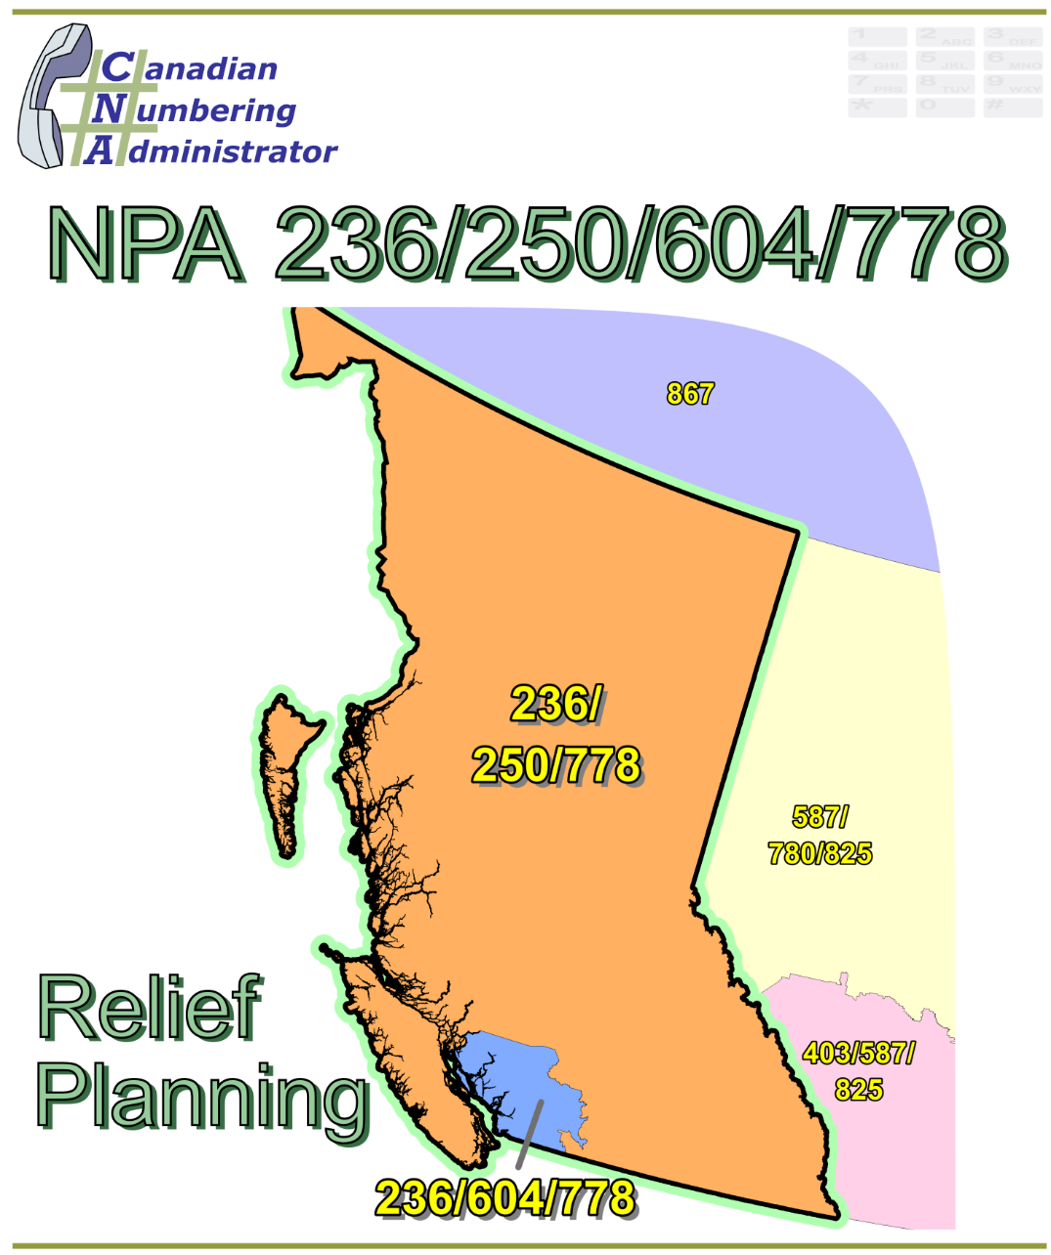

NPA 236/250/604/778 Planning Document (PD)

Version 1.0 – 30 October 2017

|  |  |
| --- | --- |
|  |  |

**TABLE OF CONTENTS**

1. INTRODUCTION 1

2. NPA RELIEF PLANNING PROCESS 3

3. NPA RELIEF METHODS 4

4. NPA EXHAUST INFORMATION 4

5. RELIEF OPTIONS 4

5.1. Concentrated Overlay 5

5.1.1. Option 1: Concentrated Overlay on NPA 604 Exchange Areas 6

5.1.2. Option 2: Concentrated Overlay on Greater Vancouver LIR Exchange Areas 6

5.1.3. Option 3: Concentrated Overlay on Metro Vancouver LPZ Exchange Areas 6

5.2. Distributed Overlay 7

5.2.1. Option 4: Distributed Overlay 7

6. SUMMARY OF RELIEF OPTIONS 8

7. COMPARATIVE ASSESSMENT OF RELIEF OPTIONS 9

7.1. Assessment 9

8. DIALLING CHANGES FOR LOCAL CALLS 10

9. PROPOSED SCHEDULE 10

10. JEOPARDY CONTINGENCY PLAN (JCP) 13

11. SELECTION OF RELIEF NPA CODE 21

12. RECOMMENDATIONS 22

ANNEXES 23

**LIST OF ANNEXES**

**ANNEX A**

Figure 1 – Overview Map of NPA 236/250/604/778

Figure 2 – NPA 236/250/604/778 Actual and Forecast CO Code Assignments

Figure 3 – NPA 236/250/604/778 CO Code Exhaust: January 2016 G NRUF

Figure 4 – NPA 236/250/604/778 Admin and LEC+WSP Codes: January 2016 G‑NRUF

Figure 5 – NPA 236/250/604/778 CO Code Exhaust: January 2017 R-NRUF

Figure 6 – NPA 236/250/604/778 Admin and LEC+WSP Codes: January 2017 R‑NRUF

Figure 7 – NPA 236/250/604/778 CO Code Exhaust: July 2017 R-NRUF

Figure 8 – NPA 236/250/604/778 Admin and LEC+WSP Codes: July 2017 R‑NRUF

Figure 9 – NPA 236/250/604/778 LIRs

Figure 10 – Option 1: Concentrated Overlay on NPA 604 Exchange Areas

Figure 11 – Option 2: Concentrated Overlay on Greater Vancouver LIR Exchange Areas

Figure 12 – Option 3: Concentrated Overlay on Metro Vancouver LPZ Exchange Areas

Figure 13 – Option 4: Distributed Overlay

**ANNEX B**

Table 1 – NPA 236/250/778 Exchange Areas for Each Relief Option

Table 2 – Exchange Areas in Each LIR

Table 3 – Greater Vancouver LIR and Metro Vancouver LPZ Exchange Areas

**ANNEX C**

Distribution List

**ACRONYM LIST**

|  |  |
| --- | --- |
| CATF | Consumer Awareness Task Force |
| CNA | Canadian Numbering Administrator |
| CISC | CRTC Interconnection Steering Committee |
| CLEC | Competitive Local Exchange Carrier |
| CLNPC | Canadian Local Number Portability Consortium |
| CO | Central Office |
| CRTC | Canadian Radio-television and Telecommunications Commission |
| CSCN | Canadian Steering Committee on Numbering |
| G-NRUF | General Numbering Resource Utilization Forecast |
| ILEC | Incumbent Local Exchange Carrier |
| IPD | Initial Planning Document |
| ISP | Internet Service Provider |
| JCP | Jeopardy Contingency Plan |
| J‑NRUF | Jeopardy Numbering Resource Utilization Forecast |
| LEC | Local Exchange Carrier |
| LIR | Local Interconnection Region |
| LNP | Local Number Portability |
| LPZ | Location Porting Zone *(Metro Vancouver)* |
| NANP | North American Numbering Plan |
| NANPA | North American Numbering Plan Administrator |
| NITF | Network Implementation Task Force |
| NoC | Notice of Consultation |
| NPA | Numbering Plan Area (Area Code) |
| NRUF | Number Resource Utilization Forecast |
| PD | Planning Document |
| PED | Projected Exhaust Date |
| PL | Planning Letter |
| POI | Point of Interconnection |
| PSAP | Public Safety Answering Point |
| RIP | Relief Implementation Plan |
| R-NRUF | Relief Planning Numbering Resource Utilization Forecast |
| RPC | Relief Planning Committee |
| TSP | Telecommunications Service Provider |
| WNP | Wireless Number Portability |
| WSP | Wireless Service Providers |

**Planning Document (PD) Number Plan Area (NPA) 236/250/604/778**

# INTRODUCTION

Area Code 604 was originally assigned to British Columbia (BC) by AT&T in 1947 as one of the 86 area codes to be used in Canada and the continental United States.

The following table provides a high level summary of the history of Area Codes in BC since 1947.

|  |  |
| --- | --- |
| **Year** | **Activity** |
| 1947 | Area Code 604 is assigned to BC by AT&T |
| 1996 | Area Code 250 is split from 604 to serve most of British Columbia including [Vancouver Island](https://en.wikipedia.org/wiki/Vancouver_Island) and the Interior Mainland of British Columbia, including the 12 Exchange Areas served by NorthwesTel is assigned new Area Code 250, while the geographic area containing the Lower Mainland (the southwest part of British Columbia) retains Area Code 604 |
| 2001 | New Area Code 778 Concentrated Overlay of Greater Vancouver Regional District, Abbotsford and Mission parts of 604 (Lower Mainland BC including Vancouver) is introduced; remaining 604 Central Office (CO) Codes retained for Area Code 604 outside the concentrated overlay; mandatory ten-digit local dialling is implemented in 604 & 778 at this time |
| 2007 | Area Code 778 Concentrated Overlay of 604 is extended to cover all of British Columbia (province-wide overlay) to provide relief for Area Code 250; remaining 604 CO Codes become assignable throughout 604 region |
| 2008 | Mandatory ten-digit local dialling implemented in 250 area in British Columbia (mandatory ten-digit local dialling becomes universal in the Province of British Columbia) |
| 2013 | New Area Code 236 overlays 250/604/778 in British Columbia (province-wide overlay) |

This Planning Document (PD) addresses the need for numbering relief in the province of British Columbia, which is the geographic area served by NPA Codes 236, 250, 604 and 778. The province of British Columbia is divided into 311 Exchange Areas. A list of the Exchange Areas in NPA 236/250/604/778 is provided in Annex B. The following table provides a breakdown of the number of Exchange Areas that are currently served by four NPA Codes.

|  |  |  |
| --- | --- | --- |
| NPA Code | Geographic Area Served | # Exchange Areas |
| 236 | All of British Columbia | 311 |
| 250 | All of British Columbia except the Lower Mainland (see note below) | 268 |
| 604 | Lower Mainland | 43 |
| 778 | All of British Columbia | 311 |

The rapidly growing demand for CO Codes is exhausting the number of CO Codes available for assignment in NPA 236/250/604/778. The January and July 2017 R-NRUF results indicate that the majority of the projected growth in NPA 236/250/604/778 is limited to about 43 Exchange Areas out of the total of 311 Exchange Areas in this region. In the remaining NPA 236/250/604/778 Exchange Areas there is virtually no projected growth.

In accordance with the *Canadian Numbering Resource Utilization Forecast (C‑NRUF) Guideline*, the CNA is required to conduct a semi‑annual R-NRUF in January and July of each year once an NPA has entered the NPA Relief Planning window.

The table below provides a brief overview of recent activities leading to the development of this PD for NPA 236/250/604/778:

| **Date** | **Activity** |
| --- | --- |
| 28 July 2011 | In Telecom Decision CRTC 2011-451, Area code relief for area codes 250, 604, and 778 in British Columbia the Commission approved that the Relief Method would be a distributed overlay of the NPA 250/604/778 area (i.e., a Province wide overlay) effective 1 June 2013 and NPA Code 236 should be used for the initial relief of NPA 250/604/778. In addition, NPA Code **672** will be set aside for subsequent relief of NPA 236/236/250/604/778.  **For the purposes of this document the new NPA will be 672.** |
| 15 December 2015 | The Canadian Numbering Administrator (CNA) initiated its January 2016 General Numbering Resource Utilization Forecast (G‑NRUF); |
| 9 March 2016 | The CNA notified Canadian Radio‑television and Telecommunications Commission (CRTC) staff that NPA 236/250/604/778 had entered the relief planning window of 72 months, and noted that in accordance with the Guideline, the CRTC is required to issue a Telecom Notice of Consultation (NoC) for the establishment of a CRTC Interconnection Steering Committee (CISC) ad hoc committee for area code relief planning in Area Code 236/250/604/778 for the province of British Columbia; |
| 11 March 2016 | The CNA released the aggregate results of the January 2016 G‑NRUF which indicated that the Projected Exhaust Date (PED) for NPA 236/250/604//778 had moved in from February 2024 to April 2021; |
| 31 May 2016 | The CRTC issued Telecom Notice of Consultation CRTC 2016‑208, in which it established a CISC ad hoc Relief Planning Committee (RPC) to examine options for providing relief to Area Code 236/250/604/778 in British Columbia; |
| 24 June 2016 | The CNA requested a Relief NRUF (R‑NRUF) from the current and prospective Code Holders in NPA 236/250/604/778; |
| 12 October 2016 | The CNA published the July 2016 R‑NRUF results which indicated that the PED had advanced to February 2021; |
| 15 December 2016 | The CNA requested a Relief NRUF (R‑NRUF) from the current and prospective Code Holders in NPA 236/250/604/778; and |
| 29 March 2017 | The CNA published the January 2017 R‑NRUF results which indicated that the PED had advanced to May 2020. |
| 25 September 2017 | The CNA published the July 2017 R-NRUF results which indicated that the PED (May 2020) has not changed from the January 2017 R-NRUF results. |

The IPD, dated 5 May 2017, was prepared by the CNA in accordance with Telecom Notice of Consultation CRTC 2016‑208 and the *Canadian NPA Relief Planning Guideline*, Version 6.0 dated 20 November 2014 (the Guideline). A copy of the Guideline is available from the CRTC CISC CSCN guidelines web page at: <http://www.crtc.gc.ca/cisc/eng/cisf3fg.htm>.

The objective of the NPA Relief Planning process is to identify Relief Options and ensure that CO Codes and telephone numbers are always available for use by Telecommunications Service Providers (TSPs) and their customers in the geographic area requiring relief.

It is very important to closely monitor the CO Code requirements of all existing and prospective CO Code Holders so that relief can be timed to ensure that CO Codes and telephone numbers are always available for service providers and customers.

This Planning Document (PD) was developed by the NPA 236/250/604/778 Relief Planning Committee (RPC) based on the IPD in accordance with the CRTC-approved *Canadian NPA Relief Planning Guideline* (the Guideline) dated 20 November 2014. Various options for providing NPA relief in the NPA 236/250/604/778 geographic area are identified in this PD.

Given the magnitude of this undertaking, intercompany commitment and co‑operation are essential throughout the planning, provisioning and implementation stages of the introduction of a new NPA.

# NPA RELIEF PLANNING PROCESS

The NPA Relief Planning process and the roles of the participants (e.g., CRTC, CNA, CISC, RPC participants, Interested Parties) for NPA Relief Planning are identified in the Guideline.

To increase public awareness and participation in the NPA Relief Planning process, the CRTC has determined that NPA RPCs will be established as ad hoc committees of the CISC. Generally, a separate ad hoc committee is created to deal with relief in each area code. The CNA, in its function as NPA Relief Planning Coordinator, acts as chair of these ad hoc committees. Meetings and conference calls of the ad hoc NPA RPCs are all open to public participation and are conducted in accordance with the *CISC Administrative Guidelines* which are available from the CRTC website at: <http://www.crtc.gc.ca/cisc/eng/cag.htm>.

NPA Relief Planning is conducted under the regulatory oversight of the CRTC. Notwithstanding the process detailed in the Guideline, the CRTC may exercise its authority under the *Telecommunications Act* to alter this process at any time. The CRTC has the authority under the *Telecommunications Act* to review, modify and give final approval to the Planning Document (PD) and the Relief Implementation Plan (RIP) developed and submitted by the RPC to the CRTC via the CISC process.

Section 6.1.6 of the *Canadian NPA Relief Planning Guideline* requires the CNA to create and maintain a distribution list of parties who may be interested in participating in the RPC and to provide them with advance notice of the initial RPC meeting and the IPD.

Any person wishing to participate in the NPA Relief Planning process can contact the CNA and request to be added to the RPC distribution lists. More information on how to participate in CRTC public processes is available at: <http://www.crtc.gc.ca/eng/info_sht/g4.htm>.

A summary of Canadian geographic area code relief history is available at: <http://www.cnac.ca/npa_codes/NPA_History.pdf>.

# NPA RELIEF METHODS

The purpose of this section is to identify and briefly describe NPA Relief Methods.

The Guideline states that “The only Relief Method that should be included in the IPD and PD is the Overlay Method.”

Under the Overlay Method, a relief NPA Code is superimposed or overlaid on top of part or all of an existing NPA. With overlays, changes to existing customers' telephone numbers are not required. The Overlay Method includes three types of overlays that may be identified and assessed. These types of overlays are detailed in Sections 5.1.1 through 5.1.3 of the Guideline, and are:

* Distributed Overlays - a new relief NPA Code is overlaid on top of all of an exhausting NPA;
* Concentrated Overlays - a new relief NPA Code is overlaid on top of part of an exhausting NPA; and
* Boundary Extension Overlays - the boundary of an existing NPA that has spare capacity is extended to overlay part or all of an exhausting NPA.

# NPA EXHAUST INFORMATION

As indicated in the following table, NRUFs for NPA 236/250/604/778 were used to determine PEDs, i.e. the dates when CO Codes in NPA 236/250/604/778 would be expected to exhaust.

|  |  |
| --- | --- |
| **NRUF** | **Projected Exhaust Date (PED)** |
| G-NRUF January 2015 | February 2024 |
| G-NRUF January 2016 | April 2021 |
| R-NRUF July 2016 | February 2021 |
| R‑NRUF January 2017 | May 2020 |
| R‑NRUF July 2017 | May 2020 |

Refer to Annex A, Figures 2, 3, 4, 5, 6, 7 and 8 for graphs of forecast CO Code demand from current and prospective CO Code Holders and charts of Administrative Codes set aside in Area Code 236/250/604/778.

# RELIEF OPTIONS

Based on the basic Relief Methods described in Section 3, the following two methods comprising four Relief Options are identified and have been examined in detail:

* Concentrated Overlay – 3 options
* Distributed Overlay – 1 option

The Relief Options identified above were evaluated using the following assumptions:

* The Relief Date for the distributed overlay option will be 2nd Q 2019 (12 months prior to the NPA 236/250/604/778 PED of May 2020 identified using the January 2017 R‑NRUF results).
* The Relief Date for the three options that use a concentrated overlay will be 4th Q 2018 (18 months prior to the NPA 236/250/604/778 PED of May 2020 identified using the January 2017 R‑NRUF results). This length of time is required to ensure that a sufficient number of CO Codes remain available to provide for the future growth of NPA 236.

A high level LIR map has been provided for reference purposes in Annex A, Figure 7.

See Annex A, Figures 10 through 13 for diagrams of the Relief Options identified by the CNA.

The Relief Methods that are not examined in detail in this PD are:

* Geographic split - not examined in detail since 10-digit local dialling is already in effect in British Columbia and the customers in NPA 778 would have to go through a number change under any of the split options. A split could allow reintroduction of permissive 7‑digit local dialling however this would provide little or no benefit and would cause customers, Carriers and TSPs to incur additional costs after already having incurred costs to change to mandatory 10‑digit local dialling. It would also be inconsistent with the industry migration towards the Uniform Dialling Plan (i.e., 10-digit local and toll dialling).
* Boundary Realignment – although a Boundary Realignment was considered in the IPD, the RPC decided not to examine this option because it would require number changes for 183 CO Codes. Furthermore, Appendix H of the *Canadian NPA Relief Planning Guideline* states that the Boundary Realignment Method should not be considered.
* Technology-specific overlay - not examined in detail because assigning NPA Codes to specific types of technology such as wireline and wireless services has not been possible since wireless number portability came into effect.

## Concentrated Overlay

Existing physical features do not easily lend themselves for use as boundaries to split NPA 236/250/604/778. NPAs 604 and 250 retain their geographical identities since NPA 604 CO Codes are assigned only in the Lower Mainland of BC and CO Codes from NPA 250 are only assigned on Vancouver Island and in Mainland BC. Only the growth NPA 236 and 778 CO Codes can be assigned throughout British Columbia. This Relief Option retains the geographical identities of both the NPA 250 and NPA 604 areas.

Three different Relief Options were evaluated to introduce the new NPA in the NPA 236/250/604/778 geographic area using the concentrated overlay method of providing CO Code relief.

The main advantage of introducing any overlay method as opposed to the geographic split method is that telephone number changes are not necessary in the area where relief is required. However, introduction of a concentrated overlay NPA creates an additional NPA Relief Planning area in British Columbia.

Relief for all concentrated overlay options will be provided in 4Q 2018 (18 months prior to the PED).

### Option 1: Concentrated Overlay on NPA 604 Exchange Areas

This Relief Option would overlay one new NPA 672 over the 43 Exchange Areas comprising the Lower Mainland NPA 604 area; NPA Code 236 would continue to grow over the remaining 268 Exchange Areas located in the Mainland and Vancouver Island areas of NPA 250. See Annex A, Figure 8.

With this overlay, NPA Code 236, NPA Code 604, NPA Code 778 and the New NPA Code 672 would be expected to exhaust in 2Q 2038 and NPA Code 236, NPA Code 250 and the NPA Code 778 would be expected to exhaust in 2Q 2023.

This option increases the number of separate NPA Relief Planning areas in BC from **one to two**. The NPA Relief Planning area (NPA 236/250/778) would exhaust in 2023, will require a new NPA in 2022 and therefore would require immediate subsequent relief planning.

### Option 2: Concentrated Overlay on Greater Vancouver LIR Exchange Areas

This Relief Option would overlay new NPA 672 over the 22 Exchange Areas comprising the Greater Vancouver LIR area and the remaining CO Codes available for assignment from NPA Code 236 would continue to grow over the remaining 289 Exchange Areas located in the Lower Mainland, Mainland and Vancouver Island areas of NPA 236, NPA 250 and NPA 778. See Annex A, Figure 9.

With this overlay, NPA Code 236, NPA Code 604, NPA Code 778 and the New NPA Code 672 would be expected to exhaust in 4Q 2043 and NPA Code 236, NPA Code 250, NPA and the NPA Code 778 would be expected to exhaust in 2Q 2022.

This option increases the number of separate NPA Relief Planning areas in BC from **one to two**. The NPA Relief Planning area outside the Greater Vancouver LIR would exhaust in 2022, will require a new NPA in 2021 and therefore would require immediate subsequent relief planning.

### Option 3: Concentrated Overlay on Metro Vancouver LPZ Exchange Areas

This Relief Option would overlay new NPA 672 over the 17 Exchange Areas comprising the Metro Vancouver Location Porting Zone (LPZ) and the remaining CO Codes available for assignment from NPA Code 236 would continue to grow over the remaining 294 Exchange Areas located in the Lower Mainland, Mainland and Vancouver Island areas of NPA 236, NPA 250 and NPA 778. See Annex A Figure 10.

With this overlay, NPA Code 236, NPA Code 604, NPA Code 778 and the New NPA Code 672 would be expected to exhaust in 3Q 2046 and NPA Code 236, NPA Code 250 and NPA Code 778 would be expected to exhaust in 1Q 2022.

This option increases the number of separate NPA Relief Planning areas in BC from **one to two**. The NPA Relief Planning area outside the Metro Vancouver LPZ would exhaust in 2022, will require a new NPA in 2021 and therefore would require immediate subsequent relief planning.

## Distributed Overlay

One distributed overlay Relief Option was evaluated to provide CO Code relief in the NPA 236/250/604/778 geographical area.

### Option 4: Distributed Overlay

This Relief Option would overlay new NPA Code 672 over all 311 Exchange Areas comprising the NPA 236/250/604/778 area (all of BC). See Annex A Figure 11.

With this overlay, the NPA 236/250/604/778 and new NPA Code 672 would be expected to exhaust in 2Q 2029 and this option will require a new NPA in 2028.

This option retains the number of NPA Relief Planning areas in BC as **one**.

# SUMMARY OF RELIEF OPTIONS

| Relief Option | | Projected Exhaust Dates | | Subsequent Relief Dates |
| --- | --- | --- | --- | --- |
| # | Description | NPA 236 | New NPA 672 |
| 1 | Concentrated Overlay on NPA 604 Exchange Areas  **Notes:**   1. NPA 672 in service 4Q 2018 2. **With a PED of 2023 immediate relief planning would be required.** | 2023 | 2038 | 2022  2037 |
| 2 | Concentrated Overlay on Greater Vancouver LIR Exchange Areas  **Notes:**   1. NPA 672 in service 4Q 2018 2. **With a PED of 2022 immediate relief planning would be required.** | 2022 | 2043 | 2021  2042 |
| 3 | Concentrated Overlay on Metro Vancouver LPZ Exchange Areas  **Notes:**   1. NPA 672 in service 4Q 2018 2. **With a PED of 2022 immediate relief planning would be required.** | 2022 | 2046 | 2021  2045 |
| 4 | Distributed Overlay  **Note:** NPA 672 in service 2Q 2019 | 2020 | 2029  2038 | 2028  2037 |

# COMPARATIVE ASSESSMENT OF RELIEF OPTIONS

The RPC identified 4 Relief Options in Section 5 of this document. A Pro, Neutral or Con (P, N or C) rating was established for each Relief Option for each of the following attributes. The results are listed in the table below the list of attributes.

1. NPA Code Conservation – quantity of new NPAs required in British Columbia within the next 8 years after relief (P = 0 new NPAs; N = 1 new NPA; C = 2 or more new NPAs)
2. Number of separate Relief Planning areas in British Columbia in the long term (P = decrease; N = stays same; C = increase)
3. Level of Carrier Costs – e.g., network implementation, customer awareness (P = Low; N = Medium; C = High)
4. Time required to implement relief, i.e., time between the CRTC's Decision date and the date when CO Codes in the new/relief NPA can be activated (P = shortest; N = medium; C = longest)
5. Length of implementation window i.e., length of time for Carriers to implement relief NPA (P = longest; N = medium; C = shortest)
6. Longevity – the length of time between this relief and subsequent relief activity in British Columbia (e.g., a new area code) (P = 11 or more years; N = 8 through 10 years; C = within 7 years)
7. New Geographic Identities – boundaries of new NPA align with boundaries of known areas (e.g., existing NPA areas, provinces) or identifiable geographical features (e.g., rivers, islands) (P = aligns with existing NPA boundaries; N = aligns with geographical features but not with existing NPA boundaries; C = aligns with neither existing NPA boundaries, nor identifiable geographical features)
8. Potential maximum quantity of NPAs in an Exchange Area in the next 8 years after relief (P = 3 NPA; N = 4 NPAs; C = 5 NPAs)

|  | **Relief Option** | **Pro, Neutral or Con for Each Attribute** | | | | | | | | **Rating** |
| --- | --- | --- | --- | --- | --- | --- | --- | --- | --- | --- |
| # | **Description** | **A** | **B** | **C** | **D** | **E** | **F** | **G** | **H** |  |
| **1** | Concentrated Overlay on NPA 604 Exchange Areas | N | C | N | P | C | C | P | N | -1 |
| **2** | Concentrated Overlay on Greater Vancouver Exchange Areas | N | C | N | P | C | C | C | N | -3 |
| **3** | Concentrated Overlay on Metro Vancouver LPZ Exchange Areas | N | C | N | P | C | C | C | N | -3 |
| **4** | Distributed Overlay | P | N | N | C | P | N | P | N | 2 |

It should be noted that none of the options require Exchange Area boundary changes.

If P, N and C are assigned a weighting of +1, 0 and -1, respectively, then analysis of the above table gives the highest rating of 2 points to Relief Option 4, the next highest rating of -1 points to Relief Option 1, and ratings of -3 to Relief Options 2 and 3.

Relief Option 4 has the highest rating when assessed based on the above criteria.

## Assessment

The RPC prefers **Relief** **Option 4 (Distributed Overlay) of new NPA Code on NPA 236/250/604/778** for the following reasons:

* The existing NPA 236/250/604/778 boundaries are maintained and no new NPA boundary is created, thus avoiding customer confusion;
* The quantity of Relief Planning areas in British Columbia remains unchanged;
* The Distributed Overlay Option provides long-term relief with a PED of 2029;
* Customers in British Columbia have become accustomed to this province-wide approach;
* The Distributed Overlay Option defers the industry cost of implementation for approximately one fiscal year; and,
* Implementing the Distributed Overlay Option is more advantageous than the Concentrated Overlay Options, as demonstrated in the assessment above.

The RPC does not prefer the Concentrated Overlay Options for the following reasons:

* All Concentrated Overlay Options would require an earlier implementation than the Distributed Overlay Option to ensure sufficient CO Codes remain available for assignment in the non-overlaid region;
* All Concentrated Overlay Options would require that subsequent relief planning starts immediately;and,
* All Concentrated Overlay Options would increase the number of separate Relief Planning areas in British Columbia from one to two. This would increase the quantity of geographic areas requiring future relief planning.

In addition to the above, Concentrated Overlay Options 2 and 3 create new NPA boundaries. These boundaries are not easily identifiable which could lead to customer confusion.

# DIALLING CHANGES FOR LOCAL CALLS

10-digit dialling is mandatory for local calls originating within area code 236/250/604/778. Local dialling plans will not change when NPA 236/250/604/778 relief is implemented with new NPA 672.

The addition of the new NPA 672 will not affect the dialling plan for long-distance calls originating within NPA 236/250/604/778.

Implementation of new NPA 672 will not change the rating of calls.

# PROPOSED SCHEDULE

The RPC submits the following schedule for NPA 236/250/604/778 relief based on the recommendations contained in this PD and the current PED of May 2020. The RPC will monitor the PED, and if it changes significantly in the future, the RPC will assess the situation and, if necessary, submit recommendations including a revised schedule to the CRTC for consideration and approval.

**RELIEF IMPLEMENTATION SCHEDULE**

**For an Overlay of new NPA over NPA 236/250/604/778**

| **Item** | **Task or Event** | **PRIME** | **START** | **END** |
| --- | --- | --- | --- | --- |
| 1 | CNA identifies NPA exhaust and notifies by e-mail CRTC staff, CSCN, NANPA & CISC that the NPA will exhaust within the future six year time period | CNA |  | 11-Mar-16 |
| 2 | CNA conducts R-NRUF & releases results | CNA | 20-Jun-16 | 12-Oct-16 |
| 3 | CRTC issues Telecom Notice of Consultation regarding establishment of an ad hoc Relief Planning Committee | CRTC | 11-Mar-16 | 31-May-16 |
| 4 | RPC Chair starts preparing and submitting NPA 236/250/604/778 RPC Chair Reports to the CISC, on an as required basis. | RPC Chair | 31-May-16 |  |
| 5 | CNA develops and distributes Initial Planning Document (IPD) to RPC | CNA | 31-May-16 | 26-May-17 |
| 6 | CNA announces the date for the initial NPA Relief Planning face-to-face meeting & requests contributions | CNA | 26-May-17 | 26-May-17 |
| 7 | RPC participants review IPD & submit contributions to RPC | RPC | 26-May-17 | 11-Oct-17 |
| 8 | CNA issues July 2017 R-NRUF results indicating the same PED of May 2020 as Jan 2017 R-NRUF results | CNA |  | 25-Sep-17 |
| 9 | CNA chairs initial RPC meeting to start development of PD, RIP & PL, & schedules future meetings/conference calls including creation & consultation with CATF and NITF | CNA, RPC | 11-Oct-17 | 12-Oct-17 |
| 10 | CNA chairs subsequent RPC meetings/conference calls to finalize PD & RIP | CNA, RPC | 13-Oct-17 | 10-Nov-17 |
| 11 | CNA forwards the PD and RIP to the CISC and CRTC for approval | CNA | 27-Oct-17 | 24-Nov-17 |
| 12 | Special Types of Telecommunications Service Users (911 PSAPs, alarm companies, ISPs, paging companies, etc.) to identify any concerns to RPC & CRTC | Special Users | 31-May-16 | 24-Nov-17 |
| 13 | CRTC issues Telecom Decision approving the Relief Method, Relief Date, New NPA & Relief Implementation Plan (RIP) | CRTC | 24-Nov-17 | 2-Mar-18 |
| 14 | CNA obtains relief NPA from NANPA | CNA | 2-Mar-18 | 16-Mar-18 |
| 15 | RPC develops the Planning Letter (PL) | RPC | 16-Mar-18 | 30-Mar-18 |
| 16 | Task Forces, TSPs and users implement relief (starts upon CRTC approval of RIP and ends on Relief Date) | TSPs | 2-Mar-18 | 4-May-19 |
| 17 | All Telecom Service Providers (TSPs) to develop and file individual consumer awareness programs with the CRTC (may be done collectively by Telecommunications Alliance) (starts upon CRTC approval of RIP) | TSPs | 2-Mar-18 | 6-Apr-18 |
| 18 | CNA issues media release (in coordination with TSPs and/or Telecommunication Alliance) (may start upon CRTC approval of RIP) | CNA | 2-Mar-18 | 16-Mar-18 |
| 19 | CNA submits PL and RIP to NANPA | CNA | 30-Mar-18 | 13-Apr-18 |
| 20 | NANPA receives and posts Planning Letter to NANPA website (within 2 weeks of receipt from the CNA) | NANPA | 13-Apr-18 | 27-Apr-18 |
| 21 | All TSPs implement consumer awareness activities (starts upon filing of Consumer Awareness Programs with the CRTC and is completed on the Relief Date) | TSPs | 6-Apr-18 | 4-May-19 |
| 22 | All TSPs to notify all customers (including residence, business & special customers) of the new overlay NPA (may start upon the filing of Consumer Awareness Programs with the CRTC) | TSPs | 6-Apr-18 | 7-Sep-18 |
| 23 | TSPs to submit Progress Report #1 to NITF and CATF (starts after completion date for all TSPs to notify their customers and requires 2 weeks) | TSPs | 7-Sep-18 | 21-Sep-18 |
| 24 | NITF and CATF develop & submit Progress Report #1 to RPC (linked to TSP reports to NITF and CATF) | NITF & CATF | 21-Sep-18 | 5-Oct-18 |
| 25 | RPC submits Progress Report #1 to CISC/CRTC (linked to NITF and CATF reports) | RPC | 5-Oct-18 | 19-Oct-18 |
| 26 | iconectiv TRA database updates to add Exchange Areas to new overlay NPA (starts on the date that the PL is posted to the NANPA web site and must be completed by 6 months prior to the Relief Date) | iconectiv TRA | 27-Apr-18 | 2-Nov-18 |
| 27 | All Telecommunications Service Users (including Special Users 911 PSAPs, alarm companies, ISPs, paging companies, etc.) to implement changes to their telecom equipment & systems to accommodate the new NPA (starts upon CRTC approval of RIP and ends on the Relief Date) | Telecom Service Users | 2-Mar-18 | 4-May-19 |
| 28 | Payphone Providers Reprogram Payphones (starts upon CRTC approval of RIP and ends on the Relief Date) | Payphone Providers | 2-Mar-18 | 4-May-19 |
| 29 | TSPs and database owners/operators to modify systems and industry databases (starts upon CRTC approval of RIP and ends on the Relief Date) | TSPs & Database Owners | 2-Mar-18 | 4-May-19 |
| 30 | Operator Services & Directory Assistance Readiness (starts upon CRTC approval of RIP and ends on the Relief Date) | TSPs | 2-Mar-18 | 4-May-19 |
| 31 | Directory Publisher Readiness for overlays (ability to identify the NPA in telephone numbers in the directory published after the Overlay NPA is activated) (starts upon CRTC approval of RIP and ends on the Relief Date) | Directory Publishers | 2-Mar-18 | 4-May-19 |
| 32 | 9-1-1 Systems and Databases Readiness (starts upon CRTC approval of RIP and ends on the Relief Date) | PSAPS, 9 1 1 Service Providers & TSPs | 2-Mar-18 | 4-May-19 |
| 33 | Network Systems & Equipment Readiness (starts upon CRTC approval of RIP and ends on the Relief Date) | TSPs | 2-Mar-18 | 4-May-19 |
| 34 | Service Order & Business System Readiness (starts upon CRTC approval of RIP and ends on the Relief Date) | TSPs | 2-Mar-18 | 4-May-19 |
| 35 | International Gateway Switch Translations Readiness for new NPA (starts upon CRTC approval of RIP and ends on the Relief Date) | Int’l TSPs | 2-Mar-18 | 4-May-19 |
| 36 | Canadian Local Number Portability Consortium (CLNPC) Database Readiness for new NPA (starts upon CRTC approval of RIP and ends on the Relief Date) | CLNPC & NPAC | 2-Mar-18 | 4-May-19 |
| 37 | Toll Free SMS Database Readiness for new NPA (starts upon CRTC approval of RIP and ends on the Relief Date) | Toll TSPs | 2-Mar-18 | 4-May-19 |
| 38 | TSPs apply for Test CO Codes in new NPA (applications may be submitted no more than 6 months and no less than 66 days prior to the start date for the Inter-Carrier Testing Period) (Section 7.16.4 Canadian RP GL) | TSPs | 6-Aug-18 | 30-Nov-18 |
| 39 | Develop Inter-Carrier Network Test Plans and prepare for testing (individual TSPs to make arrangements in accordance with interconnection agreements) (may start upon CRTC approval of RIP and must be completed by start date for the Inter-Carrier Testing Period) | NITF & TSPs | 2-Mar-18 | 1-Feb-19 |
| 40 | All international and domestic Telecommunications Service Providers (TSPs) must activate the new NPA in their networks by the start date for the Inter-Carrier Testing Period | TSPs | 2-Mar-18 | 1-Feb-19 |
| 41 | Activation date for Overlay NPA Test CO Codes and Test Numbers in network (should be completed by the start date for the Inter-Carrier Testing Period) | TSPs |  | 1-Feb-19 |
| 42 | Inter-Carrier Testing Period (subject to Inter-Carrier Network Test Plans) (starts about 3 months prior to the Relief Date, and ends about 1 month after the Relief Date) | NITF & TSPs | 4-Feb-19 | 31-May-19 |
| 43 | TSPs to submit Progress Report #2 to NITF and CATF (starts on commencement of Inter-Carrier Testing Period) | TSPs | 4-Feb-19 | 15-Feb-19 |
| 44 | NITF and CATF develop & submit Progress Report #2 to RPC (linked to TSP reports to NITF and CATF) | NITF & CATF | 15-Feb-19 | 1-Mar-19 |
| 45 | RPC submits Progress Report #2 to CRTC staff (linked to NITF and CATF reports) | RPC | 1-Mar-19 | 15-Mar-19 |
| 46 | Relief Date (earliest date when CO Codes in new NPA may be activated) |  |  | 4-May-19 |
| 47 | TSPs submit Final Report to CATF and NITF (starts on Relief Date and provides 2 weeks for preparation & submission) | TSPs | 6-May-19 | 21-May-19 |
| 48 | NITF and CATF develop & submit Final Progress Report to RPC (linked to TSP reports to NITF and CATF) | NITF & CATF | 21-May-19 | 4-Jun-19 |
| 49 | The RPC submits Final Progress Report to CRTC staff (linked to NITF and CATF reports) | RPC | 4-Jun-19 | 18-Jun-19 |
| 50 | TSPs disconnect Test Codes & Numbers, and submit Part 1 form to return Test Codes (starts 1 month after Relief Date and allows 1 month for completion) | TSPs | 3-Jun-19 | 3-Jul-19 |
| 51 | RPC Chair submits, to the CISC, the final RPC Chair report indicating that the NPA 236/250/604/778 ad hoc RPC is no longer required | RPC Chair | 3-Jul-19 | 6-Aug-19 |

# JEOPARDY CONTINGENCY PLAN (JCP)

The RPC has developed the following JCP for inclusion in the PD for NPA 236/250/604/778. This JCP is based on the example contained in Appendix F to the Canadian NPA Relief Planning Guideline.

This JCP shall remain in effect until superceded by a CRTC-approved JCP, the Jeopardy Condition is suspended, or 66 days prior to the Relief Date.

The following measures shall be implemented in NPA 236/250/604/778 while a Jeopardy Condition is in effect.

During a Jeopardy Condition, CO Code Applicants shall submit all CO Code applications and related correspondence for the Jeopardy NPA to CRTC staff in addition to the CNA. The CNA shall only assign CO Codes from the exhausting NPA to a CO Code Applicant when instructed by CRTC staff.

1. Carriers and/or Telecommunications Service Providers (TSPs):
   1. shall age disconnected residential wireline telephone numbers for a maximum of two months;
   2. shall age disconnected wireless telephone numbers for a maximum of three months;
   3. shall age disconnected business wireline telephone numbers for a maximum of six months. Under special circumstances, the six month aging limit for business telephone numbers may be extended to twelve months, if required, to accommodate local directory publishing dates for high volume call-in applications (e.g., heavily advertised local business numbers such as radio talk shows, food ordering services, ticket sales, chat lines), or for numbers associated with public service emergency applications or for numbers advertised in directories for which customers have requested reference of calls;
   4. shall return all CO Codes that are not being used, nor intended to be used to directly serve customers to the assignment pool within two months (e.g., plant test codes);
   5. should work towards, and encourage existing customers, to either activate or return the reserved numbers to bring the reserved quantity down to a maximum of 10% of the quantity of numbers In-Service for that customer;
   6. shall not allow the quantity of reserved numbers to be increased by new reservation requests by existing customers to more than 10% of the quantity of numbers in service for that customer. In the case of new customers, number reservations shall be limited to 10% of the total quantity of telephone numbers being placed into service for that customer;
   7. shall, within 45 days from the date that the CNA declares a Jeopardy Condition submit a Part 1 Form for each remaining reserved CO Code either returning the reserved CO Code to the CNA or requesting assignment of the reserved CO Code. Once the 45-day period has elapsed, the CNA shall make available for general assignment all CO Codes that are still reserved and have not been applied for as assignments on a Part 1 Form received by the CNA. Within 60 days from the date that the CNA declares a Jeopardy Condition, the CNA shall report to CRTC staff and the RPC as to how many of these codes have been assigned or made available for general assignment;
   8. shall not be permitted to obtain a new CO Code reservation;
   9. shall place all CO Codes assigned prior to the Jeopardy Condition being declared In-Service within three months of the effective date for CO Code activation in the network, or within three months of the date that the Jeopardy Condition was declared. If the CO Code is an Initial Code and the CO Code Holder can demonstrate that, due to circumstances beyond its control, the In-Service date has been delayed beyond the applicable timeframe, then the CNA may grant an extension of up to two months to the In-Service date. The CNA shall initiate reclamation procedures for all CO Codes that have not been placed In-Service within these timeframes unless CRTC staff provides a further extension.
2. For new applications for Initial Codes, each CO Code Holder shall certify that the CO Code will be activated in the network and placed In-Service within four months of the date of application for the Code. If the CNA does not receive a Part 4 Form within this timeframe, confirming that the CO Code has been placed In-Service, the CNA will initiate reclamation measures. If the CO Code Holder can demonstrate that, due to circumstances beyond its control, the In-Service date has been delayed not more than six months from the original application date, then the CNA may grant an extension to the In-Service date, so long as the In-Service date is not more than six months beyond the original application date. If the In-Service date has been delayed more than six months from the original application date, then the CNA shall reclaim the Code unless CRTC staff provides a further extension.
3. When applying for an Additional Code for Growth, a CO Code Holder who is submitting a Part 1 Form and Appendix B worksheet shall also submit a completed Supplementary Form for a Growth CO Code Application (attached) which certifies and/or provides the following information for the specific switching entity/POI and Exchange Area when the Growth CO Code is being requested in a Jeopardy Condition:
   1. certification that all held telephone numbers have been released;
   2. certification that reserved numbers do not exceed ten percent of the total quantity of numbers as defined in Appendix G of the Canadian CO Code (NXX) Assignment Guideline;
   3. certification that each reseller/dealer had been advised of the Jeopardy Condition and the requirement that they would only be allocated additional numbers during the Jeopardy Condition on the provision to the CO Code Holder of written confirmation that their number inventory has been reduced to an amount less than two times the highest quantity of customer numbers assigned in any month during the previous 12 months. Additional numbering resources will only be provided by the CO Code Holder to the reseller/dealer to the extent that the reseller's/dealer's inventory can only increase up to a maximum of three months' inventory;
   4. confirmation that the Part 1 form submitted with the application has the Jeopardy Condition box in section 1.6 checked to certify that the existing CO Codes are projected to exhaust within 4 months of the date of application and that the months-to-exhaust is documented on an Appendix B submitted to the CNA;
   5. a completed Telephone Number Utilization Report for the applicable switching entity signed by both a company officer and the company’s authorized representative;
   6. confirmation that the requested Growth CO Code was forecasted in the most recent NRUF or an explanation as to why it was not is attached; and
   7. confirmation that the requested Growth CO Code will be placed In-Service within four months of the date of assignment.
4. Any CO Codes for growth assigned after the implementation of this JCP must be activated in the network and placed In-Service within four months of assignment. In the event that a CO Code Holder is unable to place the CO Code In-Service within four months of the date of assignment, the CO Code Holder must return the assigned CO Codes or submit a written request for extension to the CNA. Such written requests must include documentation explaining the reason(s) for the missed date and proposing the new In-Service date. If the explanation includes reasons beyond the control of the CO Code Holder, the CNA may extend the In-Service date a maximum of one month. If the CO Code Holder does not place the CO Code In-Service within the one-month extension, the CNA shall initiate the reclamation process at the end of the one-month extension unless CRTC staff provides a further extension.
5. A Carrier that has multiple switching entities within an Exchange Area shall examine the possibility of, and implement where feasible, number sharing between those switches as a potential method to delay requirements for additional CO Codes.
6. The CNA will request two versions (two separate worksheets (Form 1 and Form 2)) of the J-NRUF input from all current and prospective CO Code Holders quarterly until three (3) months before relief is provided.
   1. The forecasted quantities in Form 1 should be the same as or lower than the last R-NRUF input submitted, prior to declaration of a Jeopardy Condition. CO Code Holder forecasts may reflect an increase in demand in the period subsequent to the Relief Date.
   2. Form 2 will reflect the actual demand required by the CO Code Holder's current business plan and will be provided for information purposes only.
7. The CNA will compare the initial J-NRUF input to the recent NRUF inputs, to assess forecasting trends. The CNA shall monitor all inputs and shall test them for reasonableness in consultation with the Carrier. If the CNA is dissatisfied with the reasonableness, or the rationale provided for the deviations, then the matter will be referred to the CRTC staff.
8. The CNA will request subsequent J-NRUF input from all current and prospective CO Code Holders quarterly until 3 months before relief is provided. If one or more R-NRUFs have already been conducted, and depending on the severity of the Jeopardy Condition, the CNA may defer a J-NRUF by up to two months if such a deferral brings the timing of that J‑NRUF and subsequent J-NRUFs into alignment with other NRUFs that are conducted at 12, 6 or 3 month intervals. Subsequent J-NRUF input will be compared with the initial J‑NRUF input to evaluate the effectiveness of the JCP. The CNA shall monitor all J-NRUF inputs and shall test them for reasonableness in consultation with the Telecommunications Service Providers. If the CNA is dissatisfied with the reasonableness, or the rationale provided for the changed forecasts, then the matter will be referred to CRTC staff.
9. A CO Code Applicant must have submitted a completed J-NRUF to the CNA before the CNA may assign a CO Code to that CO Code Applicant.
10. If a CO Code applicant wishes to request more CO Codes than it identified in its most recent J NRUF, the CO Code Applicant should discuss the matter with the CNA. If the CO Code Applicant wishes to proceed with the request, the CO Code Applicant will forward the request and revised forecast to CRTC staff and the CNA for consideration.
11. The CO Codes identified in the NPA CO Code Inventory Chart as “Assignable CO Codes in a Jeopardy Condition” will be assigned in the order determined by the RPC after all CO Codes which are “Available for Assignment as of [day month year] have been assigned.
12. After each J-NRUF, the CNA shall provide CRTC staff, the RPC and CSCN participants with a report providing an updated NPA CO Code Inventory Chart for the NPA in jeopardy as well as the aggregate results of the most recent J-NRUF.
13. Exceptional issues or concerns may be referred by the CNA, or by individual entities (with a courtesy copy to the CNA), to the CRTC staff for resolution.
14. In a situation where the Relief Date is on or after the PED, the quantity of CO Codes that may be assigned to a CO Code Applicant prior to the end of the Jeopardy Condition (i.e., 66 days prior to the Relief Date) shall be limited to the quantity forecasted by the CO Code Applicant in its most recent NRUF forecast submitted prior to the Jeopardy Condition being declared by the CNA (if no previous NRUF was submitted, then the previous forecast will be deemed to be zero codes). When making requests to obtain CO Codes prior to the end of the Jeopardy Condition (i.e., 66 days prior to the Relief Date), the CO Code Applicant may change the Exchange Area or the month when the CO Code assignment is required, provided a new J-NRUF and explanation accompanies the application. The control imposed by this option may be relaxed if subsequent J-NRUFs defer the PED to after the Relief Date. CO Codes that become available for assignment due to future reduced demand from other current and prospective CO Code Holders may be assigned at the discretion of CRTC staff.
15. If the CNA determines that the implementation of the JCP has not extended the Projected Exhaust Date of the NPA beyond the Relief Date, the CNA will consult with CRTC staff and further CO Code conservation and assignment procedures may be ordered by the Commission (e.g., rationing, lottery, etc.).

Supplementary form for a Growth CO Code Application – Page 1 of 2 – Telephone Number Utilization Report

This form is required with each request for an Additional Code for Growth in an NPA where a Jeopardy Condition is in effect. It should be submitted to the CNA together with the Part 1 and Appendix B forms that are required for an application for an Additional Code for Growth. See the Part 1 form for information on how and where to submit the form.

I hereby certify that the following information is true and accurate to the best of my knowledge and has been prepared in accordance with Special Conservation Procedures for a Jeopardy Condition contained in the Canadian NPA Relief Planning Guideline or the applicable approved Jeopardy Contingency Plan.



Name & Signature of Authorized Representative of Code Holder Title Date



Name & Signature of Company Officer (see item 3 of this JCP) Title Date

Contact information: Entity Name: __________________ Contact Name: _____________

Address: __________________ City, Province, Postal Code: _____________

Telephone: __________________ Facsimile: _____________

E-mail: __________________

Switch Identification (Switching Entity/POI) CLLI: _______________ Exchange Area: ________________

For the above Switch Identification and Exchange Area for which a Growth CO Code is requested:

I certify that all held telephone numbers have been released

I certify the total quantity of reserved numbers does not exceed ten percent (10%) of the total quantity of telephone numbers as defined in Appendix G of the Canadian CO Code (NXX) Assignment Guideline

I certify that each reseller/dealer has been advised of the Jeopardy Condition and the requirement that they would only be allocated additional numbers during the Jeopardy Condition on the provision to the CO Code Holder of written confirmation that their number inventory has been reduced to an amount less than two (2) times the highest quantity of customer numbers assigned in any month during the previous twelve (12) months. Additional numbering resources will only be provided by the CO Code Holder to the reseller/dealer to the extent that the reseller's/dealer's inventory can only increase up to a maximum of three months' inventory.

The Part 1 form submitted with the application has the Jeopardy Condition box in section 6 checked (this certifies that the existing CO Codes are projected to exhaust within four (4) months of the date of the application or within the period specified in an approved Jeopardy Contingency Plan, and that the months-to-exhaust is documented on an Appendix B submitted to the CNA).

The Telephone Number Utilization Report on page 2 of this form has been completed.

The requested Growth CO Code was forecasted in the most recent NRUF, or an explanation as to why it was not is attached.

The requested Growth CO Code will be placed In-Service within four (4) months of the date of assignment.

**Supplementary Form for a Growth CO Code Application – Page 2 of 2 – Telephone Number Utilization Report**

Use Arial 9 to complete this form. (Note: If the spreadsheet below does not show on your display, please change the Work view to "Print Layout" or "Reading Layout")



Remarks: _______________________________________________________________________________

________________________________________________________________________________________

**NPA 236/250/604/778 CO Code Inventory Chart**

The following chart and the instructions it contains will apply in NPA 236/250/604/778 in a Jeopardy Condition.

The chart below lists quantities of CO Codes unassignable prior to a Jeopardy Condition, CO Codes that become assignable in a Jeopardy Condition, and CO Codes in NPA 236/250/604/778 assigned and In‑service as of 12 October 2017. The CO Codes that become assignable in a Jeopardy Condition shall only be made available for assignment when all other available CO Codes have been assigned in the order listed below.

|  |  |  |
| --- | --- | --- |
|  |  | **Quantity** |
| **A** | **Total CO Codes in NPAs 236/250/604/778** **(NXX format)** | **3200** |
|  | | |
| **B** | **CO Codes unassignable prior to a Jeopardy Condition** |  |
| N11 Service Codes (211, 311, 411, 511, 611, 711, 811, 911) | 32 |
| Special Use Codes (555, 950 & 976) | 12 |
| Home NPA Code(s) (236,250,604,778) | 15 |
| Current Neighbouring NPA Codes | 0 |
| Future Geographic NPA Codes (Note 1) | 3 |
| Plant Test Codes (958 & 959) | 8 |
| Special 7-digit Dialling Codes (310, 610 & 810) | 10 |
| CO Codes set aside for Initial Codes only | 0 |
| CO Codes set aside for New Entrants only | 0 |
| Protected Codes (250/948,986,987) (Note 2) | 3 |
| **Total B** | 83 |
|  | | |
| **C** | **CO Codes assignable prior to a Jeopardy Condition (C=A-B)** | **3117** |
|  | | |
| **D** | CO Codes unassignable prior to a Jeopardy Condition that become assignable in a Jeopardy Condition: |  |
| Future Canadian Geographic NPA Codes | 0 |
| Current Neighbouring NPA Codes | 0 |
| **Total D** | **0** |
|  | | |
| **E** | **Assignable CO Codes in a Jeopardy Condition (E=C+D)** | **3117** |
| **F** | **Assigned CO Codes as of 30 October 2017** | **2657** |
| **G** | **Net CO Codes available for assignment as of 30 October 2017 without a Jeopardy Condition (G=C-F)** | 460 |
| **H** | **Net CO Codes available for assignment as of 30 October 2017 in a Jeopardy Condition (H=E-F)** | 460 |

**Notes:**

1. Telecom Decision CRTC 2011-451 (28 July 2011) directed that NPA 672 would be the next relief NPA in BC after NPA 236 implementation. CO Code 672 is currently unavailable for assignment in NPAs 236, 604, and 778 and in-service in NPA 250.
2. Three (3) CO Codes (948, 986 & 987) from NPA 250 are protected for future NorthwesTel use as directed in Telecom Decision CRTC 2007‑38 (7 June 2007).

.

# SELECTION OF RELIEF NPA CODE

In Telecom Decision CRTC 2011-451 the CRTC determined that “area code 672 is to be set aside as the most suitable area code for future code relief in British Columbia”.

# RECOMMENDATIONS

The RPC recommends that:

1. The Relief Method should be a Distributed Overlay of a new NPA Code on British Columbia NPA 236/250/604/778;
2. NPA Code 672 should be the Relief NPA Code (In Telecom Decision CRTC 2011-451 the CRTC set aside NPA 672 for next relief NPA in BC.);
3. The Relief Date should be 4 May 2019, which is 12 months prior to the PED of May 2020; and,
4. The proposed schedule in Section 9 should be used for NPA 236/250/604/778 relief (based on the current Projected Exhaust Date (PED) of May 2020).

ANNEXES

1. Maps and Figures

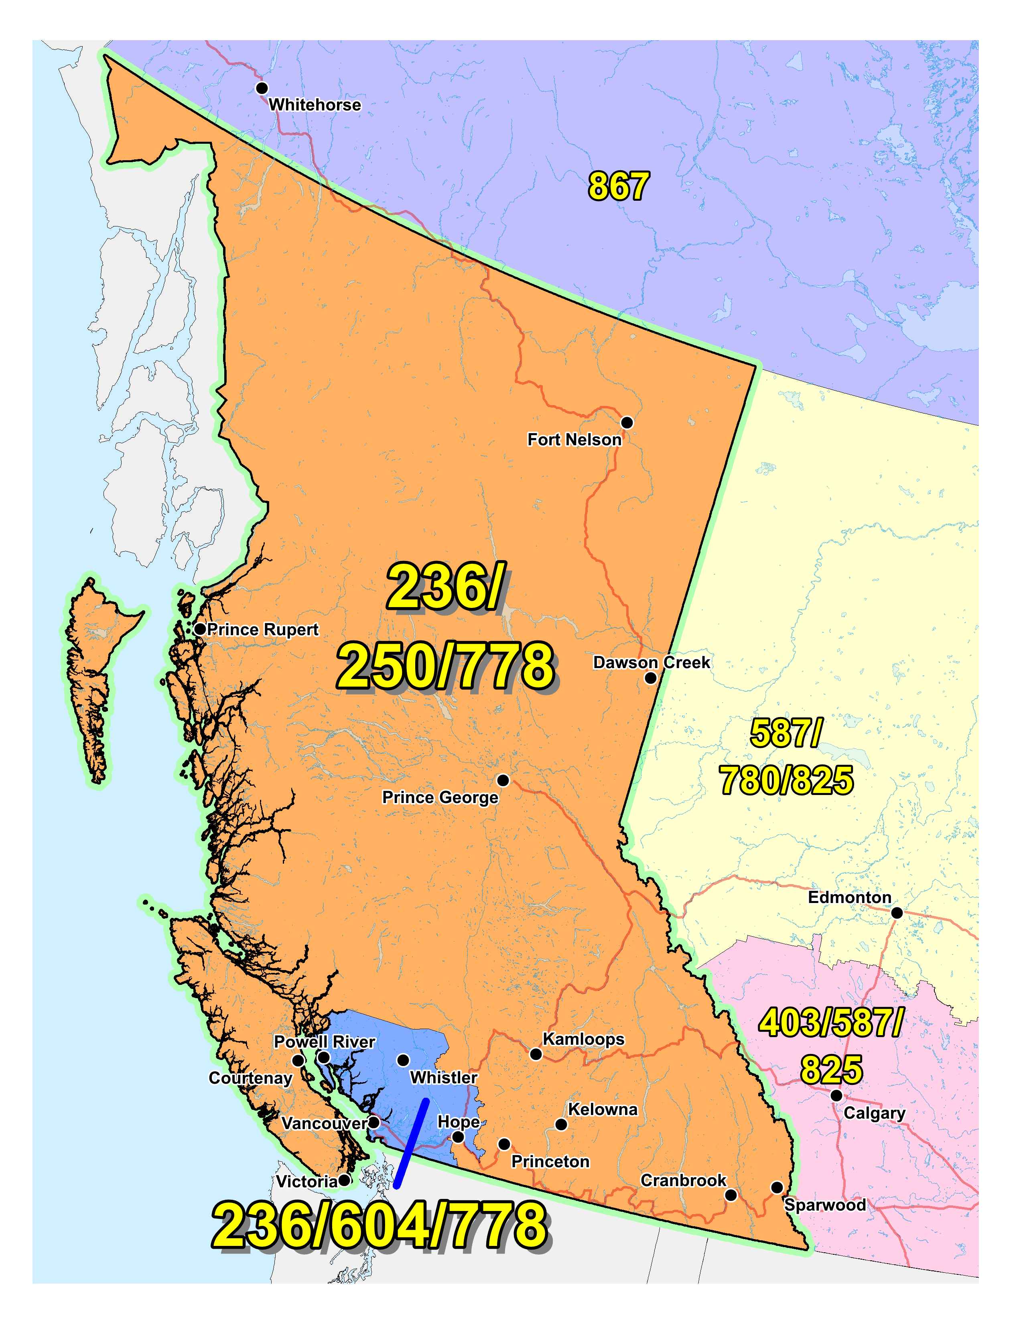

Figure 1 – Overview Map of NPA 236/250/604/778



Figure 2 – NPA 236/250/604/778 Actual and Forecast CO Code Assignments



Figure 3 – NPA 236/250/604/778 CO Code Exhaust: January 2016 G NRUF



Figure 4 – NPA 236/250/604/778 Admin and LEC+WSP Codes: January 2016 G‑NRUF



Figure 5 – NPA 236/250/604/778 CO Code Exhaust: January 2017 R-NRUF



Figure 6 – NPA 236/250/604/778 Admin and LEC+WSP Codes: January 2017 R‑NRUF



Figure 7 – NPA 236/250/604/778 CO Code Exhaust: July 2017 R-NRUF



Figure 8 – NPA 236/250/604/778 Admin and LEC+WSP Codes: July 2017 R‑NRUF

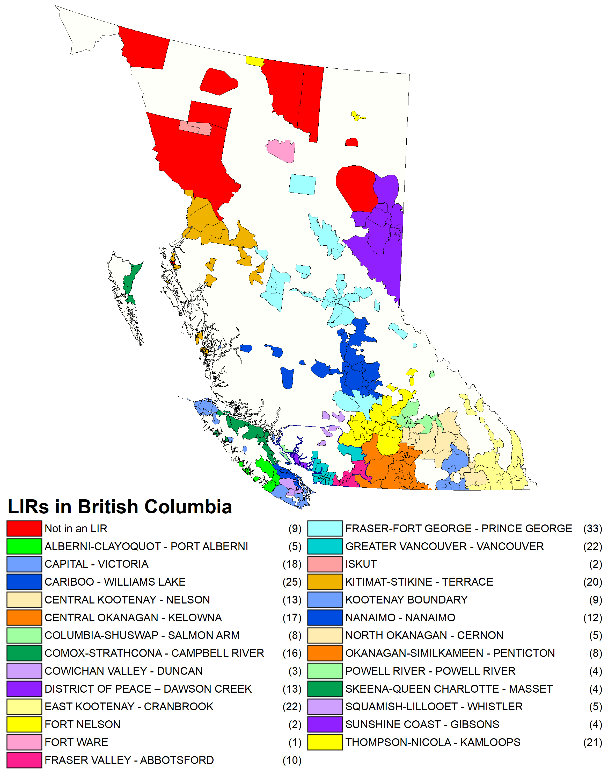

Figure 9 – NPA 236/250/604/778 LIRs

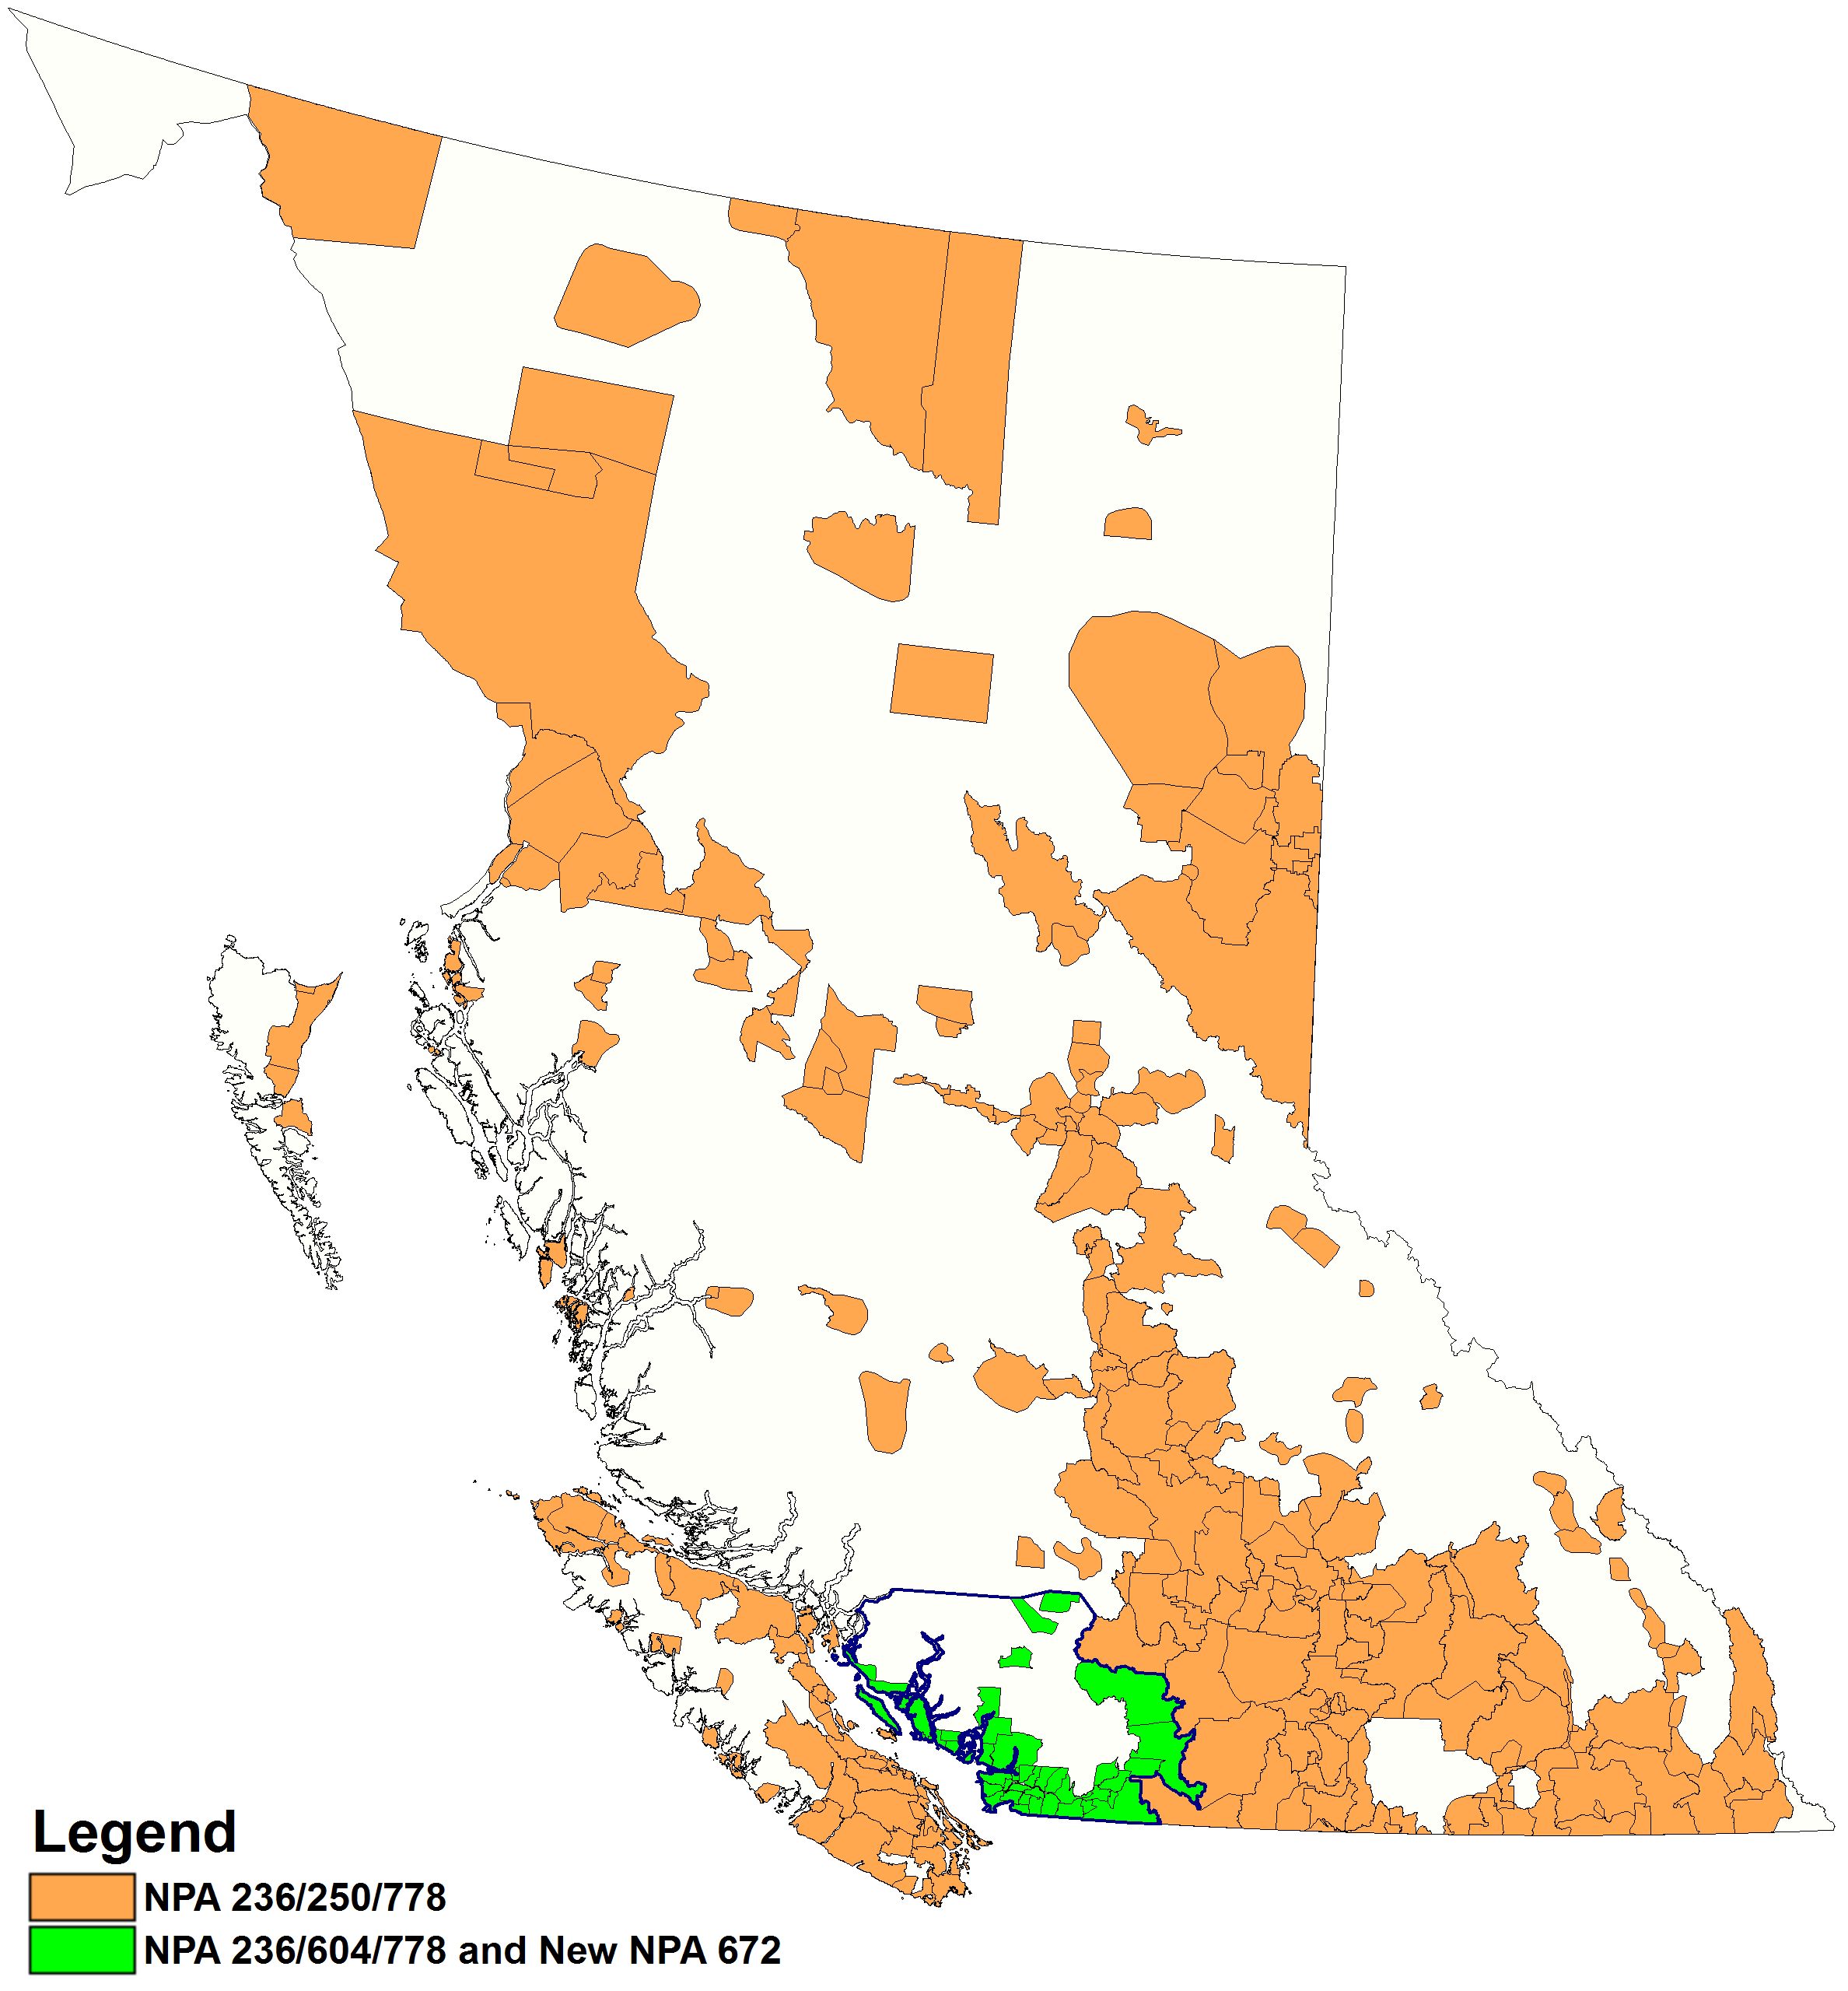

Figure 10 – Option 1: Concentrated Overlay on NPA 604 Exchange Areas

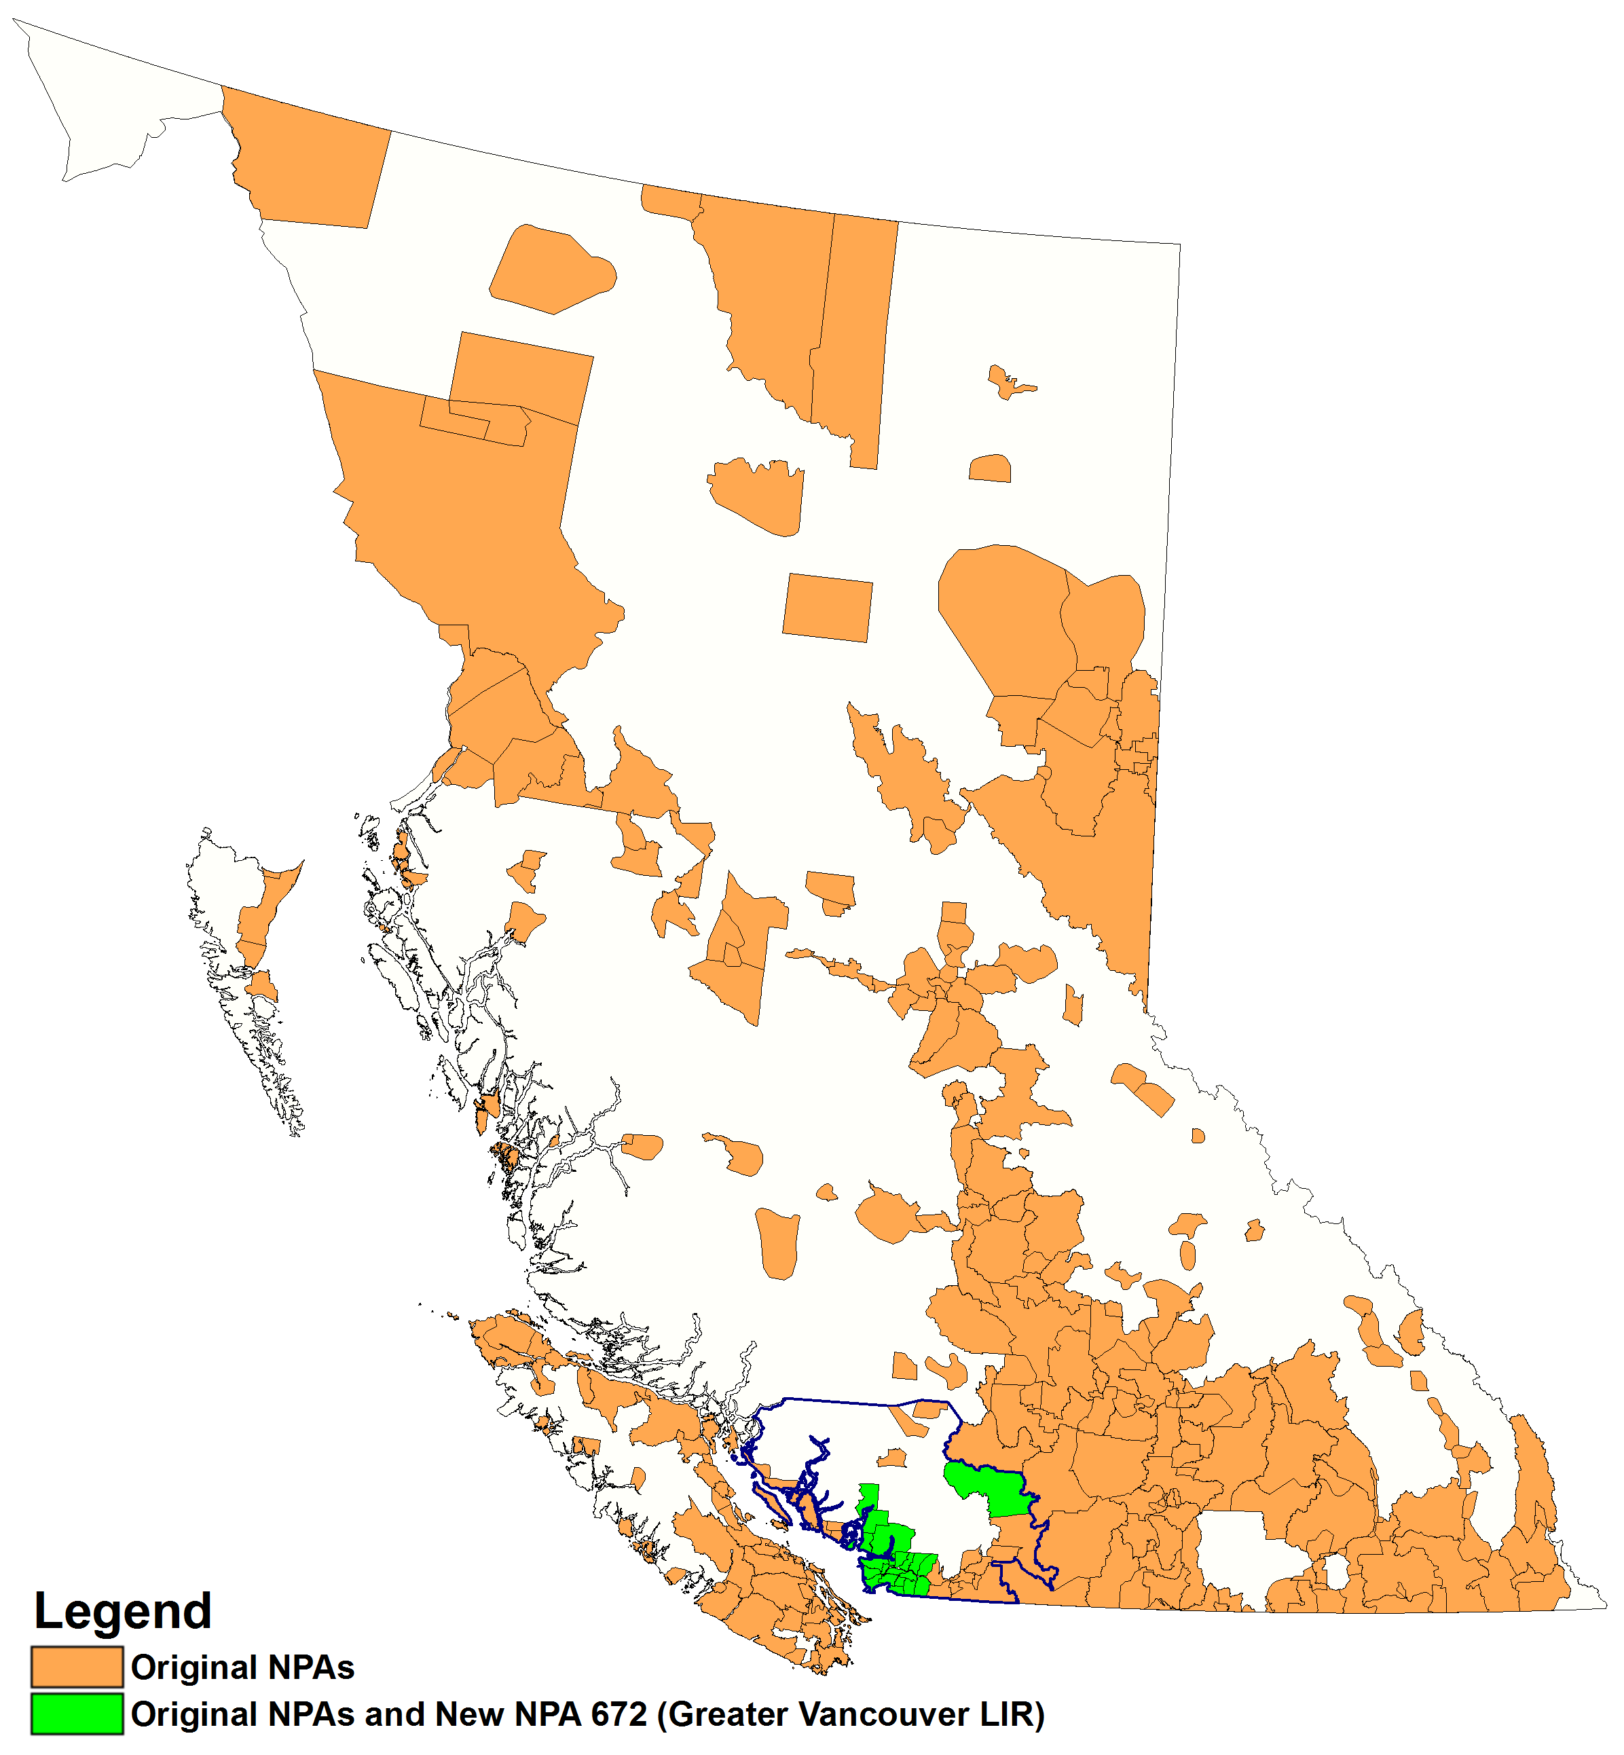

Figure 11 – Option 2: Concentrated Overlay on Greater Vancouver LIR Exchange Areas

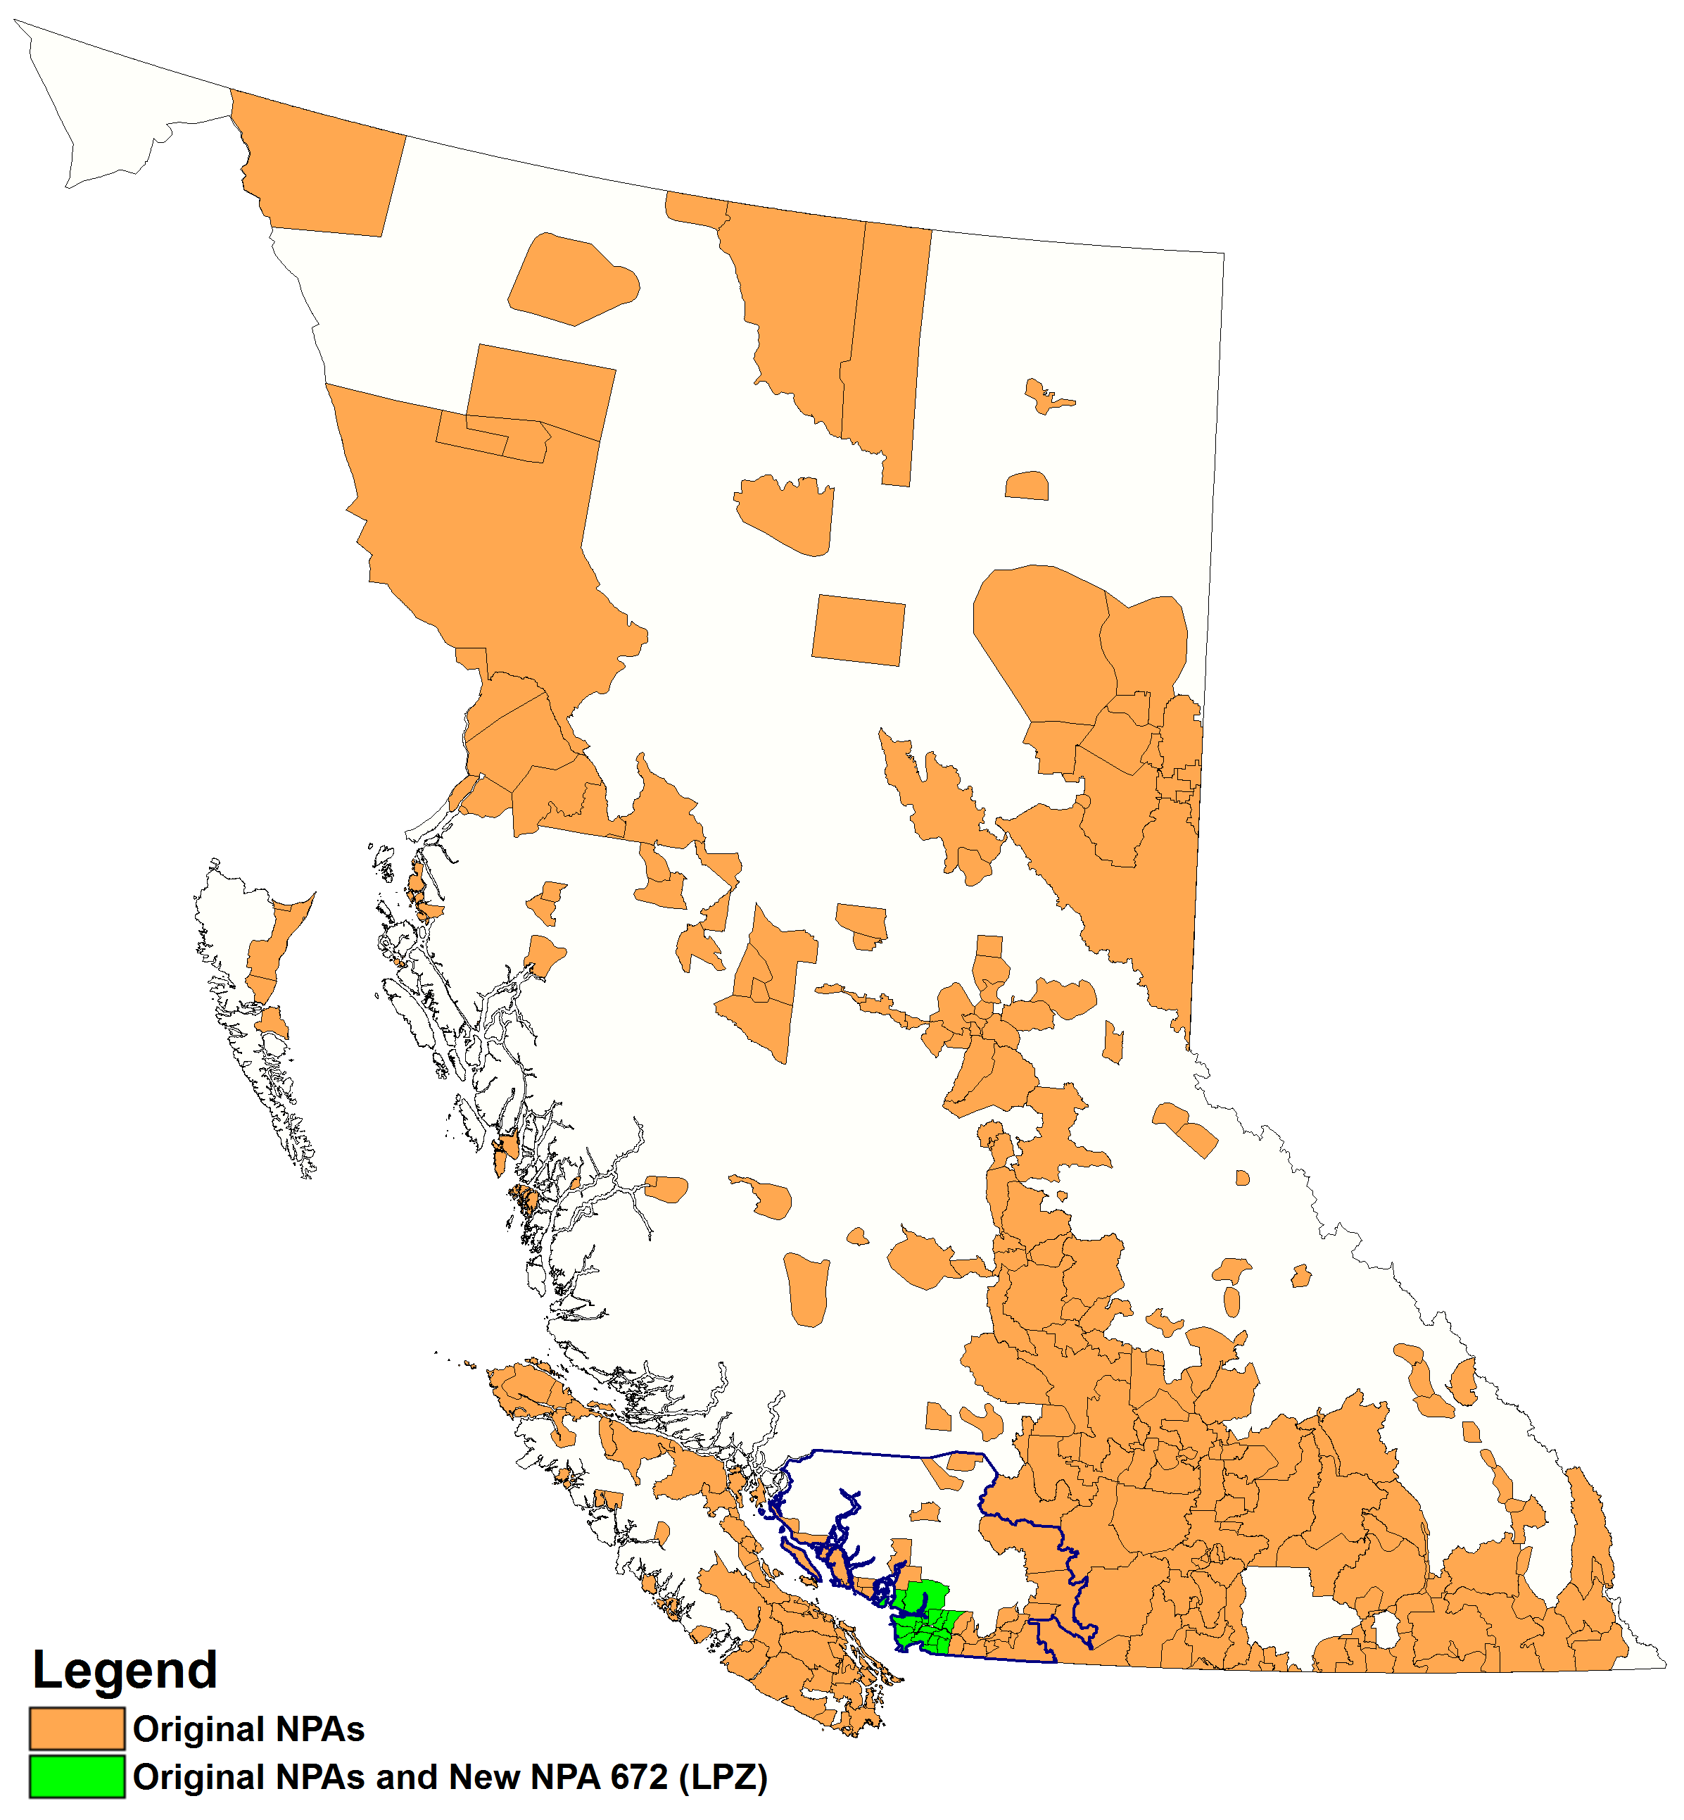

Figure 12 – Option 3: Concentrated Overlay on Metro Vancouver LPZ Exchange Areas

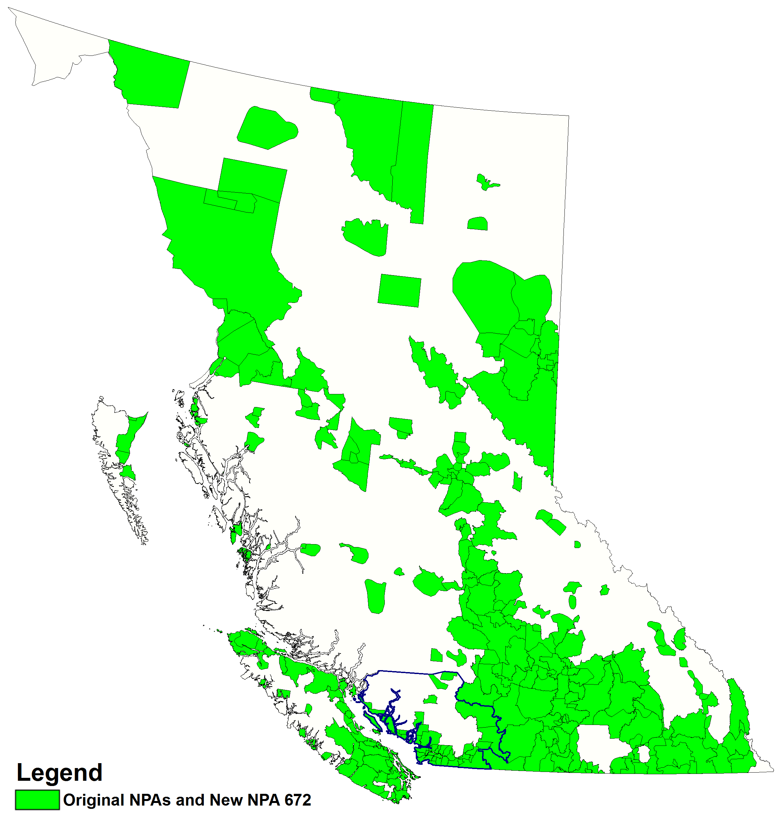

Figure 13 – Option 4: Distributed Overlay

British Columbia Exchange Areas

Table 1 – NPA 236/250/778 Exchange Areas for Each Relief Option

|  | **Concentrated Overlay** | | | | | | **Distributed Overlay** |
| --- | --- | --- | --- | --- | --- | --- | --- |
|  | **Option 1** | | **Option 2** | | **Option 3** | | **Option 4** |
| **Exchange** | **NPA 250 Exchanges** | **NPA 604 Exchanges** | **GVRD LIR Exchanges** | **Outside GVRD Exchanges** | **LPZ Exchanges** | **Outside LPZ Exchanges** | **All BC Exchanges** |
| **NPA 236/250/778 Exchange Areas** | | | | | | | |
| 100 Mile House | ✓ |  |  | ✓ |  | ✓ | ✓ |
| 108 Mile House | ✓ |  |  | ✓ |  | ✓ | ✓ |
| 150 Mile House | ✓ |  |  | ✓ |  | ✓ | ✓ |
| 70 Mile House | ✓ |  |  | ✓ |  | ✓ | ✓ |
| Ahousat | ✓ |  |  | ✓ |  | ✓ | ✓ |
| Aiyansh | ✓ |  |  | ✓ |  | ✓ | ✓ |
| Alert Bay | ✓ |  |  | ✓ |  | ✓ | ✓ |
| Alexis Creek | ✓ |  |  | ✓ |  | ✓ | ✓ |
| Alkali Lake | ✓ |  |  | ✓ |  | ✓ | ✓ |
| Armstrong | ✓ |  |  | ✓ |  | ✓ | ✓ |
| Ashcroft | ✓ |  |  | ✓ |  | ✓ | ✓ |
| Aspen Park | ✓ |  |  | ✓ |  | ✓ | ✓ |
| Atlin | ✓ |  |  | ✓ |  | ✓ | ✓ |
| Avola | ✓ |  |  | ✓ |  | ✓ | ✓ |
| Balfour | ✓ |  |  | ✓ |  | ✓ | ✓ |
| Bamfield | ✓ |  |  | ✓ |  | ✓ | ✓ |
| Barriere | ✓ |  |  | ✓ |  | ✓ | ✓ |
| Bear Lake | ✓ |  |  | ✓ |  | ✓ | ✓ |
| Beaver Cove | ✓ |  |  | ✓ |  | ✓ | ✓ |
| Beaver Valley | ✓ |  |  | ✓ |  | ✓ | ✓ |
| Beaverdell | ✓ |  |  | ✓ |  | ✓ | ✓ |
| Bella Bella | ✓ |  |  | ✓ |  | ✓ | ✓ |
| Bella Coola | ✓ |  |  | ✓ |  | ✓ | ✓ |
| Blue River | ✓ |  |  | ✓ |  | ✓ | ✓ |
| Bob Quinn Lake | ✓ |  |  | ✓ |  | ✓ | ✓ |
| Boswell | ✓ |  |  | ✓ |  | ✓ | ✓ |
| Bouchie Lake | ✓ |  |  | ✓ |  | ✓ | ✓ |
| Bowser | ✓ |  |  | ✓ |  | ✓ | ✓ |
| Bridge Lake | ✓ |  |  | ✓ |  | ✓ | ✓ |
| Burns Lake | ✓ |  |  | ✓ |  | ✓ | ✓ |
| Cache Creek | ✓ |  |  | ✓ |  | ✓ | ✓ |
| Campbell River | ✓ |  |  | ✓ |  | ✓ | ✓ |
| Canal Flats | ✓ |  |  | ✓ |  | ✓ | ✓ |
| Castlegar | ✓ |  |  | ✓ |  | ✓ | ✓ |
| Cedar | ✓ |  |  | ✓ |  | ✓ | ✓ |
| Celista | ✓ |  |  | ✓ |  | ✓ | ✓ |
| Chase | ✓ |  |  | ✓ |  | ✓ | ✓ |
| Chemainus | ✓ |  |  | ✓ |  | ✓ | ✓ |
| Chetwynd | ✓ |  |  | ✓ |  | ✓ | ✓ |
| Chief Lake | ✓ |  |  | ✓ |  | ✓ | ✓ |
| Chilako | ✓ |  |  | ✓ |  | ✓ | ✓ |
| Christina Lake | ✓ |  |  | ✓ |  | ✓ | ✓ |
| Clearwater | ✓ |  |  | ✓ |  | ✓ | ✓ |
| Clinton | ✓ |  |  | ✓ |  | ✓ | ✓ |
| Cluculz Lake | ✓ |  |  | ✓ |  | ✓ | ✓ |
| Cobble Hill | ✓ |  |  | ✓ |  | ✓ | ✓ |
| Comox | ✓ |  |  | ✓ |  | ✓ | ✓ |
| Cortes Island | ✓ |  |  | ✓ |  | ✓ | ✓ |
| Courtenay | ✓ |  |  | ✓ |  | ✓ | ✓ |
| Cranbrook | ✓ |  |  | ✓ |  | ✓ | ✓ |
| Crawford Bay | ✓ |  |  | ✓ |  | ✓ | ✓ |
| Creston | ✓ |  |  | ✓ |  | ✓ | ✓ |
| Cumberland | ✓ |  |  | ✓ |  | ✓ | ✓ |
| Dallas | ✓ |  |  | ✓ |  | ✓ | ✓ |
| Dawson Creek | ✓ |  |  | ✓ |  | ✓ | ✓ |
| Dease Lake | ✓ |  |  | ✓ |  | ✓ | ✓ |
| Decker Lake | ✓ |  |  | ✓ |  | ✓ | ✓ |
| Donald | ✓ |  |  | ✓ |  | ✓ | ✓ |
| Douglas Lake | ✓ |  |  | ✓ |  | ✓ | ✓ |
| Dragon Lake | ✓ |  |  | ✓ |  | ✓ | ✓ |
| Duncan | ✓ |  |  | ✓ |  | ✓ | ✓ |
| Duncan Lake | ✓ |  |  | ✓ |  | ✓ | ✓ |
| Dunster | ✓ |  |  | ✓ |  | ✓ | ✓ |
| East Pine | ✓ |  |  | ✓ |  | ✓ | ✓ |
| Elkford | ✓ |  |  | ✓ |  | ✓ | ✓ |
| Elko | ✓ |  |  | ✓ |  | ✓ | ✓ |
| Enderby | ✓ |  |  | ✓ |  | ✓ | ✓ |
| Fairmont Hot Springs | ✓ |  |  | ✓ |  | ✓ | ✓ |
| Falkland | ✓ |  |  | ✓ |  | ✓ | ✓ |
| Fauquier | ✓ |  |  | ✓ |  | ✓ | ✓ |
| Fernie | ✓ |  |  | ✓ |  | ✓ | ✓ |
| Field | ✓ |  |  | ✓ |  | ✓ | ✓ |
| Flatrock | ✓ |  |  | ✓ |  | ✓ | ✓ |
| Forest Grove | ✓ |  |  | ✓ |  | ✓ | ✓ |
| Fort Fraser | ✓ |  |  | ✓ |  | ✓ | ✓ |
| Fort Nelson | ✓ |  |  | ✓ |  | ✓ | ✓ |
| Fort St. James | ✓ |  |  | ✓ |  | ✓ | ✓ |
| Fort St. John | ✓ |  |  | ✓ |  | ✓ | ✓ |
| Fort Ware | ✓ |  |  | ✓ |  | ✓ | ✓ |
| Francois Lake | ✓ |  |  | ✓ |  | ✓ | ✓ |
| Fraser Lake | ✓ |  |  | ✓ |  | ✓ | ✓ |
| Fruitvale | ✓ |  |  | ✓ |  | ✓ | ✓ |
| Fulford Harbour | ✓ |  |  | ✓ |  | ✓ | ✓ |
| Gabriola Island | ✓ |  |  | ✓ |  | ✓ | ✓ |
| Ganges | ✓ |  |  | ✓ |  | ✓ | ✓ |
| Genelle | ✓ |  |  | ✓ |  | ✓ | ✓ |
| Giscome | ✓ |  |  | ✓ |  | ✓ | ✓ |
| Gold Bridge | ✓ |  |  | ✓ |  | ✓ | ✓ |
| Gold River | ✓ |  |  | ✓ |  | ✓ | ✓ |
| Golden | ✓ |  |  | ✓ |  | ✓ | ✓ |
| Good Hope Lake | ✓ |  |  | ✓ |  | ✓ | ✓ |
| Grand Forks | ✓ |  |  | ✓ |  | ✓ | ✓ |
| Granisle | ✓ |  |  | ✓ |  | ✓ | ✓ |
| Grasmere | ✓ |  |  | ✓ |  | ✓ | ✓ |
| Grassy Plains | ✓ |  |  | ✓ |  | ✓ | ✓ |
| Greenville | ✓ |  |  | ✓ |  | ✓ | ✓ |
| Greenwood | ✓ |  |  | ✓ |  | ✓ | ✓ |
| Gulf Islands | ✓ |  |  | ✓ |  | ✓ | ✓ |
| Hagensborg | ✓ |  |  | ✓ |  | ✓ | ✓ |
| Hansard | ✓ |  |  | ✓ |  | ✓ | ✓ |
| Hartley Bay | ✓ |  |  | ✓ |  | ✓ | ✓ |
| Hartway | ✓ |  |  | ✓ |  | ✓ | ✓ |
| Hazelton | ✓ |  |  | ✓ |  | ✓ | ✓ |
| Hedley | ✓ |  |  | ✓ |  | ✓ | ✓ |
| Hendrix Lake | ✓ |  |  | ✓ |  | ✓ | ✓ |
| Hixon | ✓ |  |  | ✓ |  | ✓ | ✓ |
| Holberg | ✓ |  |  | ✓ |  | ✓ | ✓ |
| Horsefly | ✓ |  |  | ✓ |  | ✓ | ✓ |
| Houston | ✓ |  |  | ✓ |  | ✓ | ✓ |
| Hudson's Hope | ✓ |  |  | ✓ |  | ✓ | ✓ |
| Invermere | ✓ |  |  | ✓ |  | ✓ | ✓ |
| Iskut | ✓ |  |  | ✓ |  | ✓ | ✓ |
| Jaffray | ✓ |  |  | ✓ |  | ✓ | ✓ |
| Jordan River | ✓ |  |  | ✓ |  | ✓ | ✓ |
| Kaslo | ✓ |  |  | ✓ |  | ✓ | ✓ |
| Kelowna | ✓ |  |  | ✓ |  | ✓ | ✓ |
| Keremeos | ✓ |  |  | ✓ |  | ✓ | ✓ |
| Kimberley | ✓ |  |  | ✓ |  | ✓ | ✓ |
| Kincolith | ✓ |  |  | ✓ |  | ✓ | ✓ |
| Kitimat | ✓ |  |  | ✓ |  | ✓ | ✓ |
| Kitkatla | ✓ |  |  | ✓ |  | ✓ | ✓ |
| Kitsault | ✓ |  |  | ✓ |  | ✓ | ✓ |
| Kitwanga | ✓ |  |  | ✓ |  | ✓ | ✓ |
| Klemtu | ✓ |  |  | ✓ |  | ✓ | ✓ |
| Kyuquot | ✓ |  |  | ✓ |  | ✓ | ✓ |
| Lac La Hache | ✓ |  |  | ✓ |  | ✓ | ✓ |
| Ladysmith | ✓ |  |  | ✓ |  | ✓ | ✓ |
| Lake Cowichan | ✓ |  |  | ✓ |  | ✓ | ✓ |
| Lakelse | ✓ |  |  | ✓ |  | ✓ | ✓ |
| Lakeview Heights | ✓ |  |  | ✓ |  | ✓ | ✓ |
| Lantzville | ✓ |  |  | ✓ |  | ✓ | ✓ |
| Lasqueti Island | ✓ |  |  | ✓ |  | ✓ | ✓ |
| Likely | ✓ |  |  | ✓ |  | ✓ | ✓ |
| Lillooet | ✓ |  |  | ✓ |  | ✓ | ✓ |
| Little Fort | ✓ |  |  | ✓ |  | ✓ | ✓ |
| Logan Lake | ✓ |  |  | ✓ |  | ✓ | ✓ |
| Loos | ✓ |  |  | ✓ |  | ✓ | ✓ |
| Lower Post | ✓ |  |  | ✓ |  | ✓ | ✓ |
| Lumby | ✓ |  |  | ✓ |  | ✓ | ✓ |
| Lytton | ✓ |  |  | ✓ |  | ✓ | ✓ |
| Mackenzie | ✓ |  |  | ✓ |  | ✓ | ✓ |
| Manning Park | ✓ |  |  | ✓ |  | ✓ | ✓ |
| Masset | ✓ |  |  | ✓ |  | ✓ | ✓ |
| McBride | ✓ |  |  | ✓ |  | ✓ | ✓ |
| McLeese Lake | ✓ |  |  | ✓ |  | ✓ | ✓ |
| McLeod Lake | ✓ |  |  | ✓ |  | ✓ | ✓ |
| Merritt | ✓ |  |  | ✓ |  | ✓ | ✓ |
| Mica Creek | ✓ |  |  | ✓ |  | ✓ | ✓ |
| Midway | ✓ |  |  | ✓ |  | ✓ | ✓ |
| Montney | ✓ |  |  | ✓ |  | ✓ | ✓ |
| Moyie | ✓ |  |  | ✓ |  | ✓ | ✓ |
| Muncho Lake | ✓ |  |  | ✓ |  | ✓ | ✓ |
| Nakusp | ✓ |  |  | ✓ |  | ✓ | ✓ |
| Nanaimo | ✓ |  |  | ✓ |  | ✓ | ✓ |
| Nanoose | ✓ |  |  | ✓ |  | ✓ | ✓ |
| Naramata | ✓ |  |  | ✓ |  | ✓ | ✓ |
| Nelson | ✓ |  |  | ✓ |  | ✓ | ✓ |
| New Denver | ✓ |  |  | ✓ |  | ✓ | ✓ |
| Nimpo Lake | ✓ |  |  | ✓ |  | ✓ | ✓ |
| North Kamloops | ✓ |  |  | ✓ |  | ✓ | ✓ |
| North Nelson | ✓ |  |  | ✓ |  | ✓ | ✓ |
| Ocean Falls | ✓ |  |  | ✓ |  | ✓ | ✓ |
| Okanagan Falls | ✓ |  |  | ✓ |  | ✓ | ✓ |
| Okanagan Mission | ✓ |  |  | ✓ |  | ✓ | ✓ |
| Oliver | ✓ |  |  | ✓ |  | ✓ | ✓ |
| Osoyoos | ✓ |  |  | ✓ |  | ✓ | ✓ |
| Oyama | ✓ |  |  | ✓ |  | ✓ | ✓ |
| Oyster Bay | ✓ |  |  | ✓ |  | ✓ | ✓ |
| Parksville | ✓ |  |  | ✓ |  | ✓ | ✓ |
| Parson | ✓ |  |  | ✓ |  | ✓ | ✓ |
| Peachland | ✓ |  |  | ✓ |  | ✓ | ✓ |
| Pender Island | ✓ |  |  | ✓ |  | ✓ | ✓ |
| Penticton | ✓ |  |  | ✓ |  | ✓ | ✓ |
| Pineview | ✓ |  |  | ✓ |  | ✓ | ✓ |
| Port Alberni | ✓ |  |  | ✓ |  | ✓ | ✓ |
| Port Alice | ✓ |  |  | ✓ |  | ✓ | ✓ |
| Port Clements | ✓ |  |  | ✓ |  | ✓ | ✓ |
| Port Edward | ✓ |  |  | ✓ |  | ✓ | ✓ |
| Port Hardy | ✓ |  |  | ✓ |  | ✓ | ✓ |
| Port Mcneill | ✓ |  |  | ✓ |  | ✓ | ✓ |
| Port Renfrew | ✓ |  |  | ✓ |  | ✓ | ✓ |
| Port Simpson | ✓ |  |  | ✓ |  | ✓ | ✓ |
| Pouce Coupe | ✓ |  |  | ✓ |  | ✓ | ✓ |
| Prespatou | ✓ |  |  | ✓ |  | ✓ | ✓ |
| Prince George | ✓ |  |  | ✓ |  | ✓ | ✓ |
| Prince Rupert | ✓ |  |  | ✓ |  | ✓ | ✓ |
| Princeton | ✓ |  |  | ✓ |  | ✓ | ✓ |
| Pritchard | ✓ |  |  | ✓ |  | ✓ | ✓ |
| Prophet River | ✓ |  |  | ✓ |  | ✓ | ✓ |
| Puntzi | ✓ |  |  | ✓ |  | ✓ | ✓ |
| Quadra Island | ✓ |  |  | ✓ |  | ✓ | ✓ |
| Qualicum | ✓ |  |  | ✓ |  | ✓ | ✓ |
| Queen Charlotte | ✓ |  |  | ✓ |  | ✓ | ✓ |
| Quesnel | ✓ |  |  | ✓ |  | ✓ | ✓ |
| Radium | ✓ |  |  | ✓ |  | ✓ | ✓ |
| Red Rock | ✓ |  |  | ✓ |  | ✓ | ✓ |
| Revelstoke | ✓ |  |  | ✓ |  | ✓ | ✓ |
| Riondel | ✓ |  |  | ✓ |  | ✓ | ✓ |
| Riske Creek | ✓ |  |  | ✓ |  | ✓ | ✓ |
| Rock Creek | ✓ |  |  | ✓ |  | ✓ | ✓ |
| Rolla | ✓ |  |  | ✓ |  | ✓ | ✓ |
| Rossland | ✓ |  |  | ✓ |  | ✓ | ✓ |
| Rutland | ✓ |  |  | ✓ |  | ✓ | ✓ |
| Saanich | ✓ |  |  | ✓ |  | ✓ | ✓ |
| Salmo | ✓ |  |  | ✓ |  | ✓ | ✓ |
| Salmon Arm | ✓ |  |  | ✓ |  | ✓ | ✓ |
| Salmon Valley | ✓ |  |  | ✓ |  | ✓ | ✓ |
| Sandspit | ✓ |  |  | ✓ |  | ✓ | ✓ |
| Savona | ✓ |  |  | ✓ |  | ✓ | ✓ |
| Sayward | ✓ |  |  | ✓ |  | ✓ | ✓ |
| Shalalth | ✓ |  |  | ✓ |  | ✓ | ✓ |
| Sicamous | ✓ |  |  | ✓ |  | ✓ | ✓ |
| Skookumchuck | ✓ |  |  | ✓ |  | ✓ | ✓ |
| Slocan | ✓ |  |  | ✓ |  | ✓ | ✓ |
| Smithers | ✓ |  |  | ✓ |  | ✓ | ✓ |
| Sointula | ✓ |  |  | ✓ |  | ✓ | ✓ |
| Sooke | ✓ |  |  | ✓ |  | ✓ | ✓ |
| Sorrento | ✓ |  |  | ✓ |  | ✓ | ✓ |
| South Kamloops | ✓ |  |  | ✓ |  | ✓ | ✓ |
| South Slocan | ✓ |  |  | ✓ |  | ✓ | ✓ |
| Sparwood | ✓ |  |  | ✓ |  | ✓ | ✓ |
| Spences Bridge | ✓ |  |  | ✓ |  | ✓ | ✓ |
| Spillimacheen | ✓ |  |  | ✓ |  | ✓ | ✓ |
| Stewart | ✓ |  |  | ✓ |  | ✓ | ✓ |
| Summerland | ✓ |  |  | ✓ |  | ✓ | ✓ |
| Summit Lake | ✓ |  |  | ✓ |  | ✓ | ✓ |
| Tachie | ✓ |  |  | ✓ |  | ✓ | ✓ |
| Tahsis | ✓ |  |  | ✓ |  | ✓ | ✓ |
| Tappen | ✓ |  |  | ✓ |  | ✓ | ✓ |
| Tatla Lake | ✓ |  |  | ✓ |  | ✓ | ✓ |
| Taylor | ✓ |  |  | ✓ |  | ✓ | ✓ |
| Telegraph Creek | ✓ |  |  | ✓ |  | ✓ | ✓ |
| Telkwa | ✓ |  |  | ✓ |  | ✓ | ✓ |
| Terrace | ✓ |  |  | ✓ |  | ✓ | ✓ |
| Thrums | ✓ |  |  | ✓ |  | ✓ | ✓ |
| Toad River | ✓ |  |  | ✓ |  | ✓ | ✓ |
| Tofino | ✓ |  |  | ✓ |  | ✓ | ✓ |
| Topley | ✓ |  |  | ✓ |  | ✓ | ✓ |
| Trail | ✓ |  |  | ✓ |  | ✓ | ✓ |
| Trout Lake | ✓ |  |  | ✓ |  | ✓ | ✓ |
| Tsay Keh Dene | ✓ |  |  | ✓ |  | ✓ | ✓ |
| Tumbler Ridge | ✓ |  |  | ✓ |  | ✓ | ✓ |
| Ucluelet | ✓ |  |  | ✓ |  | ✓ | ✓ |
| Union Bay | ✓ |  |  | ✓ |  | ✓ | ✓ |
| Valemount | ✓ |  |  | ✓ |  | ✓ | ✓ |
| Vallican | ✓ |  |  | ✓ |  | ✓ | ✓ |
| Vanderhoof | ✓ |  |  | ✓ |  | ✓ | ✓ |
| Vanway | ✓ |  |  | ✓ |  | ✓ | ✓ |
| Vavenby | ✓ |  |  | ✓ |  | ✓ | ✓ |
| Vernon | ✓ |  |  | ✓ |  | ✓ | ✓ |
| Victoria | ✓ |  |  | ✓ |  | ✓ | ✓ |
| Wellington | ✓ |  |  | ✓ |  | ✓ | ✓ |
| Wells | ✓ |  |  | ✓ |  | ✓ | ✓ |
| Westbank | ✓ |  |  | ✓ |  | ✓ | ✓ |
| Westsyde | ✓ |  |  | ✓ |  | ✓ | ✓ |
| Westwold | ✓ |  |  | ✓ |  | ✓ | ✓ |
| Wildwood | ✓ |  |  | ✓ |  | ✓ | ✓ |
| Williams Lake | ✓ |  |  | ✓ |  | ✓ | ✓ |
| Willow Point | ✓ |  |  | ✓ |  | ✓ | ✓ |
| Willowbrook | ✓ |  |  | ✓ |  | ✓ | ✓ |
| Winfield | ✓ |  |  | ✓ |  | ✓ | ✓ |
| Winter Harbour | ✓ |  |  | ✓ |  | ✓ | ✓ |
| Wonowon | ✓ |  |  | ✓ |  | ✓ | ✓ |
| Woss Lake | ✓ |  |  | ✓ |  | ✓ | ✓ |
| Wynndel | ✓ |  |  | ✓ |  | ✓ | ✓ |
| Yahk | ✓ |  |  | ✓ |  | ✓ | ✓ |
| Youbou | ✓ |  |  | ✓ |  | ✓ | ✓ |
| Zeballos | ✓ |  |  | ✓ |  | ✓ | ✓ |
| **NPA 236/604/778 Exchange Areas** | | | | | | | |
| Abbotsford |  | ✓ |  | ✓ |  | ✓ | ✓ |
| Agassiz |  | ✓ |  | ✓ |  | ✓ | ✓ |
| Aldergrove |  | ✓ | ✓ |  |  |  | ✓ |
| Black Point |  | ✓ |  | ✓ |  | ✓ | ✓ |
| Boston Bar |  | ✓ | ✓ |  |  |  | ✓ |
| Bowen Island |  | ✓ | ✓ |  | ✓ |  | ✓ |
| Britannia Beach |  | ✓ | ✓ |  |  |  | ✓ |
| Chilliwack |  | ✓ |  | ✓ |  | ✓ | ✓ |
| Cloverdale |  | ✓ | ✓ |  | ✓ |  | ✓ |
| D'Arcy |  | ✓ |  | ✓ |  | ✓ | ✓ |
| Fort Langley |  | ✓ | ✓ |  | ✓ |  | ✓ |
| Gibsons |  | ✓ |  | ✓ |  | ✓ | ✓ |
| Haney |  | ✓ | ✓ |  | ✓ |  | ✓ |
| Hemlock Valley |  | ✓ |  | ✓ |  | ✓ | ✓ |
| Hope |  | ✓ |  | ✓ |  | ✓ | ✓ |
| Ladner |  | ✓ | ✓ |  | ✓ |  | ✓ |
| Langley |  | ✓ | ✓ |  | ✓ |  | ✓ |
| Mission |  | ✓ |  | ✓ |  | ✓ | ✓ |
| New Westminster |  | ✓ | ✓ |  | ✓ |  | ✓ |
| Newton |  | ✓ | ✓ |  | ✓ |  | ✓ |
| North Vancouver |  | ✓ | ✓ |  | ✓ |  | ✓ |
| Pemberton |  | ✓ |  | ✓ |  | ✓ | ✓ |
| Pender Harbour |  | ✓ |  | ✓ |  | ✓ | ✓ |
| Pitt Meadows |  | ✓ | ✓ |  | ✓ |  | ✓ |
| Port Coquitlam |  | ✓ | ✓ |  | ✓ |  | ✓ |
| Port Mellon |  | ✓ |  | ✓ |  | ✓ | ✓ |
| Port Moody |  | ✓ | ✓ |  | ✓ |  | ✓ |
| Powell River |  | ✓ |  | ✓ |  | ✓ | ✓ |
| Richmond |  | ✓ | ✓ |  | ✓ |  | ✓ |
| Rosedale |  | ✓ |  | ✓ |  | ✓ | ✓ |
| Sardis |  | ✓ |  | ✓ |  | ✓ | ✓ |
| Sechelt |  | ✓ |  | ✓ |  | ✓ | ✓ |
| Squamish |  | ✓ | ✓ |  |  |  | ✓ |
| Van Anda |  | ✓ |  | ✓ |  | ✓ | ✓ |
| Vancouver |  | ✓ | ✓ |  | ✓ |  | ✓ |
| West Vancouver |  | ✓ | ✓ |  | ✓ |  | ✓ |
| Westview |  | ✓ |  | ✓ |  | ✓ | ✓ |
| Whalley |  | ✓ | ✓ |  | ✓ |  | ✓ |
| Whistler |  | ✓ |  | ✓ |  | ✓ | ✓ |
| White Rock |  | ✓ | ✓ |  | ✓ |  | ✓ |
| Whonnock |  | ✓ | ✓ |  |  |  | ✓ |
| Yale |  | ✓ |  | ✓ |  | ✓ | ✓ |
| Yarrow |  | ✓ |  | ✓ |  | ✓ | ✓ |

Table 2 – Exchange Areas in Each LIR

| **LIR Name** | **Exchange** |
| --- | --- |
| Alberni-Clayoquot - Port Alberni | Ahousat |
| Alberni-Clayoquot - Port Alberni | Bamfield |
| Alberni-Clayoquot - Port Alberni | Port Alberni |
| Alberni-Clayoquot - Port Alberni | Tofino |
| Alberni-Clayoquot - Port Alberni | Ucluelet |
| Capital - Victoria | Cobble Hill |
| Capital - Victoria | Cortes Island |
| Capital - Victoria | Fulford Harbour |
| Capital - Victoria | Ganges |
| Capital - Victoria | Gold River |
| Capital - Victoria | Gulf Islands |
| Capital - Victoria | Holberg |
| Capital - Victoria | Jordan River |
| Capital - Victoria | Ocean Falls |
| Capital - Victoria | Pender Island |
| Capital - Victoria | Port Alice |
| Capital - Victoria | Port Hardy |
| Capital - Victoria | Port Renfrew |
| Capital - Victoria | Saanich |
| Capital - Victoria | Sooke |
| Capital - Victoria | Tahsis |
| Capital - Victoria | Victoria |
| Capital - Victoria | Winter Harbour |
| Cariboo - Williams Lake | 100 Mile House |
| Cariboo - Williams Lake | 108 Mile House |
| Cariboo - Williams Lake | 150 Mile House |
| Cariboo - Williams Lake | Alexis Creek |
| Cariboo - Williams Lake | Alkali Lake |
| Cariboo - Williams Lake | Beaver Valley |
| Cariboo - Williams Lake | Bella Coola |
| Cariboo - Williams Lake | Bouchie Lake |
| Cariboo - Williams Lake | Bridge Lake |
| Cariboo - Williams Lake | Dragon Lake |
| Cariboo - Williams Lake | Forest Grove |
| Cariboo - Williams Lake | Hagensborg |
| Cariboo - Williams Lake | Hendrix Lake |
| Cariboo - Williams Lake | Horsefly |
| Cariboo - Williams Lake | Lac La Hache |
| Cariboo - Williams Lake | Likely |
| Cariboo - Williams Lake | McLeese Lake |
| Cariboo - Williams Lake | Nimpo Lake |
| Cariboo - Williams Lake | Puntzi |
| Cariboo - Williams Lake | Quesnel |
| Cariboo - Williams Lake | Riske Creek |
| Cariboo - Williams Lake | Tatla Lake |
| Cariboo - Williams Lake | Wells |
| Cariboo - Williams Lake | Wildwood |
| Cariboo - Williams Lake | Williams Lake |
| Central Kootenay - Nelson | Balfour |
| Central Kootenay - Nelson | Boswell |
| Central Kootenay - Nelson | Crawford Bay |
| Central Kootenay - Nelson | Duncan Lake |
| Central Kootenay - Nelson | Fauquier |
| Central Kootenay - Nelson | Kaslo |
| Central Kootenay - Nelson | Nakusp |
| Central Kootenay - Nelson | Nelson |
| Central Kootenay - Nelson | North Nelson |
| Central Kootenay - Nelson | Riondel |
| Central Kootenay - Nelson | South Slocan |
| Central Kootenay - Nelson | Thrums |
| Central Kootenay - Nelson | Trout Lake |
| Central Okanagan - Kelowna | Beaverdell |
| Central Okanagan - Kelowna | Christina Lake |
| Central Okanagan - Kelowna | Grand Forks |
| Central Okanagan - Kelowna | Hedley |
| Central Okanagan - Kelowna | Kelowna |
| Central Okanagan - Kelowna | Keremeos |
| Central Okanagan - Kelowna | Lakeview Heights |
| Central Okanagan - Kelowna | Manning Park |
| Central Okanagan - Kelowna | Merritt |
| Central Okanagan - Kelowna | Okanagan Mission |
| Central Okanagan - Kelowna | Osoyoos |
| Central Okanagan - Kelowna | Oyama |
| Central Okanagan - Kelowna | Peachland |
| Central Okanagan - Kelowna | Princeton |
| Central Okanagan - Kelowna | Rutland |
| Central Okanagan - Kelowna | Westbank |
| Central Okanagan - Kelowna | Winfield |
| Columbia-Shuswap - Salmon Arm | Celista |
| Columbia-Shuswap - Salmon Arm | Chase |
| Columbia-Shuswap - Salmon Arm | Mica Creek |
| Columbia-Shuswap - Salmon Arm | Revelstoke |
| Columbia-Shuswap - Salmon Arm | Salmon Arm |
| Columbia-Shuswap - Salmon Arm | Sicamous |
| Columbia-Shuswap - Salmon Arm | Sorrento |
| Columbia-Shuswap - Salmon Arm | Tappen |
| Comox-Strathcona - Campbell River | Alert Bay |
| Comox-Strathcona - Campbell River | Beaver Cove |
| Comox-Strathcona - Campbell River | Campbell River |
| Comox-Strathcona - Campbell River | Comox |
| Comox-Strathcona - Campbell River | Courtenay |
| Comox-Strathcona - Campbell River | Cumberland |
| Comox-Strathcona - Campbell River | Kyuquot |
| Comox-Strathcona - Campbell River | Oyster Bay |
| Comox-Strathcona - Campbell River | Port Mcneill |
| Comox-Strathcona - Campbell River | Quadra Island |
| Comox-Strathcona - Campbell River | Sayward |
| Comox-Strathcona - Campbell River | Sointula |
| Comox-Strathcona - Campbell River | Union Bay |
| Comox-Strathcona - Campbell River | Willow Point |
| Comox-Strathcona - Campbell River | Woss Lake |
| Comox-Strathcona - Campbell River | Zeballos |
| Cowichan Valley - Duncan | Duncan |
| Cowichan Valley - Duncan | Lake Cowichan |
| Cowichan Valley - Duncan | Youbou |
| District of Peace – Dawson Creek | Chetwynd |
| District of Peace – Dawson Creek | Dawson Creek |
| District of Peace – Dawson Creek | East Pine |
| District of Peace – Dawson Creek | Flatrock |
| District of Peace – Dawson Creek | Fort St. John |
| District of Peace – Dawson Creek | Hudson's Hope |
| District of Peace – Dawson Creek | Montney |
| District of Peace – Dawson Creek | Pouce Coupe |
| District of Peace – Dawson Creek | Prespatou |
| District of Peace – Dawson Creek | Rolla |
| District of Peace – Dawson Creek | Taylor |
| District of Peace – Dawson Creek | Tumbler Ridge |
| District of Peace – Dawson Creek | Willowbrook |
| East Kootenay - Cranbrook | Canal Flats |
| East Kootenay - Cranbrook | Cranbrook |
| East Kootenay - Cranbrook | Creston |
| East Kootenay - Cranbrook | Donald |
| East Kootenay - Cranbrook | Elkford |
| East Kootenay - Cranbrook | Elko |
| East Kootenay - Cranbrook | Fairmont Hot Springs |
| East Kootenay - Cranbrook | Fernie |
| East Kootenay - Cranbrook | Field |
| East Kootenay - Cranbrook | Golden |
| East Kootenay - Cranbrook | Grasmere |
| East Kootenay - Cranbrook | Invermere |
| East Kootenay - Cranbrook | Jaffray |
| East Kootenay - Cranbrook | Kimberley |
| East Kootenay - Cranbrook | Moyie |
| East Kootenay - Cranbrook | Parson |
| East Kootenay - Cranbrook | Radium |
| East Kootenay - Cranbrook | Skookumchuck |
| East Kootenay - Cranbrook | Sparwood |
| East Kootenay - Cranbrook | Spillimacheen |
| East Kootenay - Cranbrook | Wynndel |
| East Kootenay - Cranbrook | Yahk |
| Fort Nelson | Fort Nelson |
| Fort Nelson | Lower Post |
| Fort Nelson | Muncho Lake |
| Fort Nelson | Prophet River |
| Fort Ware | Fort Ware |
| Fraser Valley - Abbotsford | Abbotsford |
| Fraser Valley - Abbotsford | Agassiz |
| Fraser Valley - Abbotsford | Chilliwack |
| Fraser Valley - Abbotsford | Hemlock Valley |
| Fraser Valley - Abbotsford | Hope |
| Fraser Valley - Abbotsford | Mission |
| Fraser Valley - Abbotsford | Rosedale |
| Fraser Valley - Abbotsford | Sardis |
| Fraser Valley - Abbotsford | Yale |
| Fraser Valley - Abbotsford | Yarrow |
| Fraser-Fort George - Prince George | 70 Mile House |
| Fraser-Fort George - Prince George | Bear Lake |
| Fraser-Fort George - Prince George | Burns Lake |
| Fraser-Fort George - Prince George | Chief Lake |
| Fraser-Fort George - Prince George | Chilako |
| Fraser-Fort George - Prince George | Clinton |
| Fraser-Fort George - Prince George | Cluculz Lake |
| Fraser-Fort George - Prince George | Decker Lake |
| Fraser-Fort George - Prince George | Dunster |
| Fraser-Fort George - Prince George | Fort Fraser |
| Fraser-Fort George - Prince George | Fort St. James |
| Fraser-Fort George - Prince George | Francois Lake |
| Fraser-Fort George - Prince George | Fraser Lake |
| Fraser-Fort George - Prince George | Giscome |
| Fraser-Fort George - Prince George | Granisle |
| Fraser-Fort George - Prince George | Grassy Plains |
| Fraser-Fort George - Prince George | Hansard |
| Fraser-Fort George - Prince George | Hartway |
| Fraser-Fort George - Prince George | Hixon |
| Fraser-Fort George - Prince George | Loos |
| Fraser-Fort George - Prince George | Mackenzie |
| Fraser-Fort George - Prince George | McBride |
| Fraser-Fort George - Prince George | McLeod Lake |
| Fraser-Fort George - Prince George | Pineview |
| Fraser-Fort George - Prince George | Prince George |
| Fraser-Fort George - Prince George | Red Rock |
| Fraser-Fort George - Prince George | Salmon Valley |
| Fraser-Fort George - Prince George | Summit Lake |
| Fraser-Fort George - Prince George | Tachie |
| Fraser-Fort George - Prince George | Tsay Keh Dene |
| Fraser-Fort George - Prince George | Valemount |
| Fraser-Fort George - Prince George | Vanderhoof |
| Fraser-Fort George - Prince George | Vanway |
| Greater Vancouver - Vancouver | Aldergrove |
| Greater Vancouver - Vancouver | Boston Bar |
| Greater Vancouver - Vancouver | Bowen Island |
| Greater Vancouver - Vancouver | Britannia Beach |
| Greater Vancouver - Vancouver | Cloverdale |
| Greater Vancouver - Vancouver | Fort Langley |
| Greater Vancouver - Vancouver | Haney |
| Greater Vancouver - Vancouver | Ladner |
| Greater Vancouver - Vancouver | Langley |
| Greater Vancouver - Vancouver | New Westminster |
| Greater Vancouver - Vancouver | Newton |
| Greater Vancouver - Vancouver | North Vancouver |
| Greater Vancouver - Vancouver | Pitt Meadows |
| Greater Vancouver - Vancouver | Port Coquitlam |
| Greater Vancouver - Vancouver | Port Moody |
| Greater Vancouver - Vancouver | Richmond |
| Greater Vancouver - Vancouver | Squamish |
| Greater Vancouver - Vancouver | Vancouver |
| Greater Vancouver - Vancouver | West Vancouver |
| Greater Vancouver - Vancouver | Whalley |
| Greater Vancouver - Vancouver | White Rock |
| Greater Vancouver - Vancouver | Whonnock |
| Iskut | Good Hope Lake |
| Iskut | Iskut |
| Iskut | Telegraph Creek |
| Kitimat-Stikine - Terrace | Aiyansh |
| Kitimat-Stikine - Terrace | Bella Bella |
| Kitimat-Stikine - Terrace | Greenville |
| Kitimat-Stikine - Terrace | Hartley Bay |
| Kitimat-Stikine - Terrace | Hazelton |
| Kitimat-Stikine - Terrace | Houston |
| Kitimat-Stikine - Terrace | Kincolith |
| Kitimat-Stikine - Terrace | Kitimat |
| Kitimat-Stikine - Terrace | Kitkatla |
| Kitimat-Stikine - Terrace | Kitsault |
| Kitimat-Stikine - Terrace | Kitwanga |
| Kitimat-Stikine - Terrace | Klemtu |
| Kitimat-Stikine - Terrace | Lakelse |
| Kitimat-Stikine - Terrace | Port Edward |
| Kitimat-Stikine - Terrace | Port Simpson |
| Kitimat-Stikine - Terrace | Smithers |
| Kitimat-Stikine - Terrace | Stewart |
| Kitimat-Stikine - Terrace | Telkwa |
| Kitimat-Stikine - Terrace | Terrace |
| Kitimat-Stikine - Terrace | Topley |
| Kootenay Boundary | Castlegar |
| Kootenay Boundary | Fruitvale |
| Kootenay Boundary | Genelle |
| Kootenay Boundary | New Denver |
| Kootenay Boundary | Rossland |
| Kootenay Boundary | Salmo |
| Kootenay Boundary | Slocan |
| Kootenay Boundary | Trail |
| Kootenay Boundary | Vallican |
| Nanaimo - Nanaimo | Bowser |
| Nanaimo - Nanaimo | Cedar |
| Nanaimo - Nanaimo | Chemainus |
| Nanaimo - Nanaimo | Gabriola Island |
| Nanaimo - Nanaimo | Ladysmith |
| Nanaimo - Nanaimo | Lantzville |
| Nanaimo - Nanaimo | Lasqueti Island |
| Nanaimo - Nanaimo | Nanaimo |
| Nanaimo - Nanaimo | Nanoose |
| Nanaimo - Nanaimo | Parksville |
| Nanaimo - Nanaimo | Qualicum |
| Nanaimo - Nanaimo | Wellington |
| North Okanagan - Cernon | Armstrong |
| North Okanagan - Cernon | Enderby |
| North Okanagan - Cernon | Falkland |
| North Okanagan - Cernon | Lumby |
| North Okanagan - Cernon | Vernon |
| Okanagan-Similkameen - Penticton | Greenwood |
| Okanagan-Similkameen - Penticton | Midway |
| Okanagan-Similkameen - Penticton | Naramata |
| Okanagan-Similkameen - Penticton | Okanagan Falls |
| Okanagan-Similkameen - Penticton | Oliver |
| Okanagan-Similkameen - Penticton | Penticton |
| Okanagan-Similkameen - Penticton | Rock Creek |
| Okanagan-Similkameen - Penticton | Summerland |
| Powell River - Powell River | Black Point |
| Powell River - Powell River | Powell River |
| Powell River - Powell River | Van Anda |
| Powell River - Powell River | Westview |
| Skeena-Queen Charlotte - Masset | Masset |
| Skeena-Queen Charlotte - Masset | Port Clements |
| Skeena-Queen Charlotte - Masset | Queen Charlotte |
| Skeena-Queen Charlotte - Masset | Sandspit |
| Squamish-lillooet - Whistler | D'Arcy |
| Squamish-lillooet - Whistler | Gold Bridge |
| Squamish-lillooet - Whistler | Pemberton |
| Squamish-lillooet - Whistler | Shalalth |
| Squamish-lillooet - Whistler | Whistler |
| Sunshine Coast - Gibsons | Gibsons |
| Sunshine Coast - Gibsons | Pender Harbour |
| Sunshine Coast - Gibsons | Port Mellon |
| Sunshine Coast - Gibsons | Sechelt |
| Thompson-Nicola - Kamloops | Ashcroft |
| Thompson-Nicola - Kamloops | Aspen Park |
| Thompson-Nicola - Kamloops | Avola |
| Thompson-Nicola - Kamloops | Barriere |
| Thompson-Nicola - Kamloops | Blue River |
| Thompson-Nicola - Kamloops | Cache Creek |
| Thompson-Nicola - Kamloops | Clearwater |
| Thompson-Nicola - Kamloops | Dallas |
| Thompson-Nicola - Kamloops | Douglas Lake |
| Thompson-Nicola - Kamloops | Lillooet |
| Thompson-Nicola - Kamloops | Little Fort |
| Thompson-Nicola - Kamloops | Logan Lake |
| Thompson-Nicola - Kamloops | Lytton |
| Thompson-Nicola - Kamloops | North Kamloops |
| Thompson-Nicola - Kamloops | Pritchard |
| Thompson-Nicola - Kamloops | Savona |
| Thompson-Nicola - Kamloops | South Kamloops |
| Thompson-Nicola - Kamloops | Spences Bridge |
| Thompson-Nicola - Kamloops | Vavenby |
| Thompson-Nicola - Kamloops | Westsyde |
| Thompson-Nicola - Kamloops | Westwold |
| Wonowon/Blueberry | Wonowon |
| No LIR | Atlin |
| No LIR | Bob Quinn Lake |
| No LIR | Dease Lake |
| No LIR | Prince Rupert |
| No LIR | Toad River |

Table 3 – Greater Vancouver LIR and Metro Vancouver LPZ Exchange Areas

| **Exchange** | **Greater Vancouver LIR** | **Location Porting Zone** |
| --- | --- | --- |
| Aldergrove | ✓ |  |
| Boston Bar | ✓ |  |
| Bowen Island | ✓ | ✓ |
| Britannia Beach | ✓ |  |
| Cloverdale | ✓ | ✓ |
| Fort Langley | ✓ | ✓ |
| Haney | ✓ | ✓ |
| Ladner | ✓ | ✓ |
| Langley | ✓ | ✓ |
| New Westminster | ✓ | ✓ |
| Newton | ✓ | ✓ |
| North Vancouver | ✓ | ✓ |
| Pitt Meadows | ✓ | ✓ |
| Port Coquitlam | ✓ | ✓ |
| Port Moody | ✓ | ✓ |
| Richmond | ✓ | ✓ |
| Squamish | ✓ |  |
| Vancouver | ✓ | ✓ |
| West Vancouver | ✓ | ✓ |
| Whalley | ✓ | ✓ |
| White Rock | ✓ | ✓ |
| Whonnock | ✓ |  |

1. Distribution List

|  |  |
| --- | --- |
| CLEC Admin  Comwave Networks  61 Wildcat Road  Toronto, ON  Canada  M3J 2P5  clecteam@comwave.net | Numbering E-Mail  Distributel Communications Limited  177 Nepean Street  Ottawa, ON  Canada  K2P 0B4  numbering@distributel.ca |
| NXX Admin  Bell Canada  nxx.admin@bell.ca | Edward Antecol  VP, Regulatory and Carrier Relations  Freedom Mobile Inc.  207 Queen Quay West Suite 710  Toronto, ON  Canada  M5J 1A7  Telephone: 416-849-1277  Fax: 866-247-1890  EAntecol@FreedomMobile.ca |
| Chris Armstrong  Sales & Marketing Manager  CityWest cable & Telephone (formerly Prince Rupert Telephones)  248 Third Ave W.  Prince Rupert, BC  Canada  V8J 1L1  Telephone: 250-627-0902  Fax: 250-627-0905  Chris.Armstrong@cwct.ca | Andreea Badea  Iristel Inc.  11 Bowan Court  Toronto, ON  Canada  M2K 3A8  Telephone: 416-800-4747  abadea@iristel.ro |
| Bill Barsley  Manager - Planning & Engineering  TELUS  27 Marmac Drive  Etobicoke, ON  Canada  M9W 1E7  Telephone: 416-279-7989  Fax: 416-279-3930  bill.barsley@telus.com | Ron Barzakay  CTO  Comwave Networks  61 Wildcat Rd  Toronto, ON  M3J 2P5  Telephone: 416-663-9700 X 302  Fax: 416-736-3150  rbarzakay@comwave.net |
| Vivek Bhardwaj  Traffic Specialist  Rogers Communications  8200 Dixie Rd.  Brampton, ON  Canada  L6T 0C1  Telephone: 647-747-3569  vivek.bhardwaj@rci.rogers.com | Olena Bilozerska  Network Planning Manager I, TS CC Planning & Management  TELUS  200 Consilium Place, Floor 6  Scarborough, ON  Canada  M1H 3G2  Telephone: 647-837-1798  Olena.Bilozerska@telus.com |
| Doug Birdwise  Interested Party  109 Westpark Drive  Ottawa, ON  Canada  K1B 3G4  Telephone: 613-830-0081  douglas.birdwise@sympatico.ca | Samer Bishay  CEO  Iristel Inc.  11 Bowan Court  Toronto, ON  Canada  M2K 3A8  Telephone: 416-800-9999  Fax: 416-628-0891  sbishay@iristel.com |
| Heather Bishop  Executive Administrative Assistant  CityWest Cable & Telephone Corp.  248 3rd Avenue West  Prince Rupert, BC  Canada  V8G 1L1  Telephone: 250-627-0910  heather.bishop@cwct.ca | Eric Boer  Director, Voice Network Services  teliPhone Navigata-Westel  1210-200 Granville St  Vancouver, BC  Canada  V6C 1S4  Telephone: 604-990-2058  Fax: 604-990-2040  eric.boer@navigata.ca |
| Laurie Bowie  Network Planning  Bell Canada  100 Dundas Street, Floor 4G  London, ON  Canada  N6A 5B6  Telephone: 519-850-5818  laurie.bowie@bell.ca | Glen Brown  Division Manager  Leidos Canada Inc.  60 Queen Street, Suite 1516  Ottawa, ON  Canada  K1P 5Y7  Telephone: 613-683-3291  Fax: 613-563-3399  browng@leidos.ca |
| Kim Brown  Telephone Infrastructure Specialist  Eastlink  PO Box 8660, Station “A”: 6080 Young St, 7th Floor  Halifax, NS  Canada  B3K 5M3  Telephone: 902-446-3794  Fax: 902-405-3426  kim.brown@corp.eastlink.ca | Joseph Cabrera  Senior Analyst - Dispute Resolution and Regulatory Implementation  CRTC  1 Promenade du Portage  Gatineau, QC  Canada  J8X 4B1  Telephone: 819-934-6352  Fax: 819-997-4610  joseph.cabrera@crtc.gc.ca |
| Melanye Caisse  Telecom Analyst  ISP Telecom Inc  1155 Boul Rene-Levesque Ouest Suite 2500  Montreal, QC  Canada  H3B 2K4  Telephone: 416-548-4819  Fax: 416-548-4818  melanye@isptelecom.net | Don Cavanagh  VP  Distributel Communications Limited  177 Nepean Street, Suite 300  Ottawa, ON  Canada  K2P 0B4  Telephone: 613-237-7005  Fax: 613-237-7009  donald.cavanagh@distributel.ca |
| JF Champagne  Executive Director  Canadian Security Association, National Office  610 Alden Road, Suite 100  Markham, ON  Canada  L3R 9Z1  Telephone: 905-513-0622  Fax: 905-513-0624  jfchampagne@canasa.org | Fiona Clegg  CO Code Administration  Leidos Canada Inc.  60 Queen Street, Suite 1516  Ottawa, ON  Canada  K1P 5Y7  Telephone: 613-683-3285  Fax: 613-563-3399  cleggf@leidos.ca |
| Eric Coburn  IP Management Specialist  Shaw Telecom Inc.  Suite 800, 630 – 3rd Ave SW  Calgary, AB  Canada  T2P 4L4  Telephone: 403-750-7481  Fax: 403-750-6999  dp-tnadmin@sjrb.ca | David Comrie  CNA  Leidos Canada Inc.  1516 - 60 Queen Street  Ottawa, ON  Canada  K1P 5Y7  Telephone: 613-683-3287  Fax: 613-563-3399  comried@leidos.ca |
| Doug Cooper  Director, Network Profitability and Planning  Primus Canada  5343 Dundas St W Suite 108  Toronto, ON  Canada  Telephone: 416-207-7760  dcooper@primustel.ca | Arnie Dehoop  Manager, Network Optimization  Freedom Mobile Inc.  207 Queens Quay West, Suite 710  Toronto, ON  Canada  M5J 1A7  Telephone: 289-700-2200  Fax: 866-247-1890  Adehoop@FreedomMobile.ca |
| John Demco  Director  Webnames.ca Inc  3rd Floor, 322 Water Street  Vancouver, BC  Canada  V6B 1B6  Telephone: 604-822-6724  Fax: 604-633-3174  demco@webnames.ca | Irma Dulay  Primus Telecommunications Canada Inc.  500- 5343 Dundas St West  Toronto, ON  Canada  M9B 6K5  Telephone: 416-207-7151  Fax: 877-329-6875  idulay@primustel.ca |
| Jean-Michel Dupuis  Senior Public Services Specialist  Rogers Communications Canada Inc.  800 rue de la Gauchetiere Ouest, Suite 4000  Montreal, QC  Canada  H5A 1K3  Telephone: 1-866-501-7727  Fax: 1-800-506-3962  jeanmichel.dupuis@rci.rogers.com | Kurt Eby  Director of Regulatory Affairs  Canadian Wireless Telecommunications Association (CWTA)  80 Elgin Street, Suite 30  Ottawa, ON  Canada  K1P 6R2  Telephone: 613-233-5884 Ext. 213  Fax: 613-233-2032  documentcontrol@cwta.ca |
| Mona Emond  Director, Marketing & Communications  Canadian Security Association  610 Alden Road, Suite 100  Markham, ON  Canada  L3R 9Z1  Telephone: 905-513-0622 Ext 242  Fax: 905-513-0624  memond@canasa.org | Diane Faillant  Associate - Network Management/NSS (National Numbering Solution)  Bell Canada  671 LAGAUCHETIERE Ouest. 11  Montreal, QC  Canada  H3B 2M8  Telephone: 514-870-6044  Fax: 514-786-9062  diane.faillant@bell.ca |
| Ling Fang  Traffic Specialist  Rogers Communications  8200 Dixie Rd  Brampton, ON  Canada  L6T0C1  Telephone: 647-747-4657  ling.fang@rci.rogers.com | Johny Fernandez  Technology Strategy  TELUS Mobility  300 C  Scarborough, ON  Canada  M1H 3J3  Telephone: 647-453-4442  Johny.fernandez@telus.com |
| Paul Fleming  Cable Telephone Assistant Manager  Citywest Telephone Corp  248 3rd Avenue West  Prince Rupert, BC  Canada  V8J 1L1  Telephone: 778-634-0026  Fax: 778-634-8214  Paul.Fleming@cwct.ca | Gino Grandinetti  Manager - Products & Services, Local & Enhanced Services  TELUS  4535 Canada Way, Floor 03  Burnaby, BC  Canada  V5G 1J9  Telephone: 604-695-4755  gino.grandinetti@telus.com |
| Pierre Guynot de Boismenu  Manager of Core Network Engineering and Operations, Wireless  Bragg Communications Inc  60800 Young St 6th Floor  Halifax, NS  Canada  B3K5M3  Telephone: 902-414-8020  Fax: 902-444-1019  pierre.guynotdeboismenu@corp.eastlink.ca | Sam Haigh  Asset Manager - Voice, ITM Edge Services  NorthwesTel Inc.  P.O. Bag 790, 5201-50th Avenue 10th Fl.  Yellowknife, NT  Canada  X1A 2N6  Telephone: 867-920-3655  Fax: 867-669-7933  Shaigh@nwtel.ca |
| Shawn Hall  Sr Communications Manager, Corporate Communications  TELUS  555 Robson Street, Floor 3  Vancouver, BC  Canada  V6B 3K9  Telephone: 604-697-8176  Fax: 604-331-8199  shawn.hall@telus.com | Austin He  Network Planning Analyst,Carrier Relations,Network Profitability & Planning  Primus Telecommunications Canada Inc.  5343 Dundas Street W. Suite 500  Toronto, ON  Canada  M9B 6K5  Telephone: 416-207-3361  ahe@primustel.ca |
| Marian Hearn  Project Executive  Canadian LNP Consortium Inc.  350 Palladium Drive, Suite 208  Kanata, ON  Canada  K2V 1A8  Telephone: 613-287-0225  Fax: 800-406-9250  marian.hearn@clnpc.ca | Lynne Hewitson  Membership Manager  Canadian Security Association (CANASA)  610 Alden Road  Markham, ON  Canada  L3R 9Z1  Telephone: 905-513-0622 ext 223  Fax: 905-513-0624  membership@canasa.org |
| Larry Hishon  Vice-President Business Development  Fibernetics Corporation  583 Eastgate Walk  Waterloo, ON  Canada  N2K 2V9  Telephone: 519-571-7433  Fax: 519-772-5014  lhishon@fibernetics.ca | Sandra Hobbs  Network Marketing Specialist  Rogers Communications Canada Inc.  1600-4710 Kingsway  Burnaby, BC  Canada  V5H 4W4  Telephone: 604-431-1748  Fax: 604-431-1546  sandra.hobbs@rci.rogers.com |
| Andrew Hofmann  South Island Cable Ltd.  PO Box 76  Port Renfrew, BC  Canada  V0S 1K0  Telephone: 250-483-1409 Ext 111  Fax: 250-483-1489  legal@southislandcable.com | Steven Hrabok  Product Specialist - Digital Phone  Shaw  Suite 800, 630 - 3rd Ave SW  Calgary, AB  Canada  T2P 4L4  Telephone: 403-234-6284  Fax: 403-750-6969  dp-tnadmin@sjrb.ca |
| Laine Hutchinson  MGR, CARRIER SERVICES (VOICE)  Shaw Business  2431 37 AVENUE NE  Calgary, AB  Canada  T2E 6Y7  Telephone: (587) 390-2238  Laine.Hutchinson@sjrb.ca | Kim Isaacs  Director Carrier Relations  Allstream  6160 Golden Hills Dr  Golden Valley, MN  USA  55416  Telephone: 763-745-8463  Kim.Isaacs@allstream.com |
| Stephanie Jackson  Manager - Public Services Integration; Traffic Engineering  Rogers Communications Canada Inc.  8200 Dixie Road  Brampton, ON  Canada  L6T 0C1  Telephone: 647-747-4402  Fax: 647-747-4557  stephanie.jackson@rci.rogers.com | Alan Jordache  Senior Engineer  TELUS Mobility  200 Consilium Pl, Floor 13  Scarborough, ON  M1H 3J3  Telephone: 416-279-3248  Fax: 416-279-3930  ALAN.JORDACHE@TELUS.COM |
| Suresh Khare  CO Code Manager  Leidos Canada Inc.  60 Queen Street, Suite 1516  Ottawa, ON  Canada  K1P 5Y7  Telephone: 613-683-3296  Fax: 613-563-3399  khares@leidos.ca | Denning Lai  City Telecom Inc. (CITI)  3781 Victoria Park Ave., Unit 13  Scarborough, ON  Canada  M1W 3K5  Telephone: 416-502-6038  denning@ctinets.ca |
| Roger Lee  Manager - Voice Traffic Engineering  TELUS  5th Floor, 3777 Kingsway  Burnaby, BC  Canada  V5H 3Z7  Telephone: 604-695-3182  Fax: 604-663-1300  roger.lee@telus.com | Graham LeGeyt  Principal Systems Architect  Shaw Communications Inc.  2728 Hopewell Place, N.E.  Calgary, AB  Canada  T1Y 7J7  Telephone: 403-781-4940  graham.legeyt@sjrb.ca |
| Natalie Lessard  CO Code Administration  Leidos Canada Inc.  60 Queen Street, Suite 1516  Ottawa, ON  Canada  K1P 5Y7  Telephone: 613-683-3288  Fax: 613-563-3399  lessardn@leidos.ca | Natalie MacDonald  Director of Regulatory Matters  Bragg Communications Incorporated  6080 Young Street, Suite 801  Halifax, NS  Canada  B3K 5M3  Telephone: 902-431-9979  Fax: 902-446-9979  regulatory.matters@corp.eastlink.ca |
| Jennifer Mack  Traffic Specialist  Rogers Communications  8200 Dixie Rd.  Brampton, ON  Canada  L6T 0C1  Telephone: 647-747-2168  jennifer.mack@rci.rogers.ca | John MacKenzie  Regulatory Affairs  Telus  Telephone: 780-493-5579  john.mackenzie@telus.com |
| Lindsay Magri  Marketing Manager  Eastlink  18 Sydenham Street East, PO Box 1800  Aylmer, ON  Canada  N5H 3E7  Telephone: 519-773-1214  Fax: 519-764-3217  lindsay.magri@corp.eastlink.ca | Wanda Marie Mali  Manager - National Numbering Solutions  Bell Canada  100 Borough Dr, Floor 5 Blue  Scarborough, ON  M1P4W2  Telephone: 416-296-6076  Fax: 416-296-0685  wanda_marie.mali@bell.ca |
| John C. Manning  Director  NANPA  46000 Center Oak Plaza  Sterling, VA  USA  20166  Telephone: 571-434-5770  Fax: 571-434-5502  john.manning@team.neustar | Deirdre Massiah-Gomes  Manager - Technology Strategy  TELUS  200 Consilium Place, Suite 1600  Scarborough, ON  Canada  M1H 3J3  Telephone: 416-279-9000  Fax: 416-279-3949  deirdre.massiah-gomes@telus.com |
| Andrew Matoga  President  ISP Telecom  1155 Boul Rene-Levesque O Suite 2500  Montreal, QC  Canada  H3B 2K4  Telephone: 416-548-4848  Fax: 416-548-4847  andrew@isptelecom.net | Kevin McGouran  Tech Ops Engineering Specialist  Allstream Inc.  85 Riviera Drive  Markham, ON  Canada  L3R 5J6  Telephone: 416-640-9419  Fax: 416-644-9672  kevin.mcgouran@zayo.com |
| Nancy McIntyre  Mgr - Planning & Engineering  TELUS  3777 Kingsway Floor 07S  Burnaby, BC  V5H 3Z7  Telephone: 604-908-2029  nancy.mcintyre2@telus.com | Nicola McLaughlin  Team Lead  Allstream  200 Wellington St W. F12  Toronto, ON  Canada  M5V 3G2  Telephone: 416-640-5271  Nicola.mclaughlin@allstream.com |
| Anne McMillan  Regulatory Analyst  Distributel Communications Limited  177 Nepean Street, Suite 300  Ottawa, ON  Canada  Telephone: 613-317-3210  anne.mcmillan@distributel.ca | Priyesh Modi  Project Manager  Comwave Networks  61 Wildcat Rd  Toronto, ON  M3J 2P5  Telephone: 416-663-9700 X 320  Fax: 416-736-3165  pmodi@comwave.net |
| Amor Mohammed  Director, RF Planning & Optimization  Globalive Wireless Management Corp  207 Queen Quay W, Suite 700  Toronto, ON  Canada  M5J1A7  Telephone: 647-260-1486  amohammed@freedommobile.ca | Isabelle Morneau  Telecom Policy & Regulatory Affairs  TELUS  21st Floor, 10020-100 Street  Edmonton, AB  Canada  T5J 0N5  isabelle.morneau@telus.com |
| Daniel Morrison  Specialist - Voice Network Services  Bell Canada  100 Dundas St Flr 3  London, ON  Canada  N6A 5B6  Telephone: 519-850-6386  daniel.morrison@bell.ca | John Muise  Director of Service Implementation & Project Management  Distributel Communications Limited  300-177 Nepean Street  Ottawa, ON  Canada  K2P 0B4  Telephone: 613-237-3019  Fax: 613-237-7009  john.muise@distributel.ca |
| Darren Muloin  Mascon Cable Systems Inc.  PO Box 3386 - 4901 Auto Road SE  Salmon Arm, BC  Canada  V1E 4S2  Telephone: 250-832-6000  darren@masconcable.ca | Sundar Nagulan  SS7 Voice Engineer  Comwave Networks  61 Wildcat Rd  Toronto, ON  M3J 2P5  Telephone: 416-663-9700 X 3210  snagulan@comwave.net |
| Julia Ni  Voice Traffic Engineering  TELUS  5th Floor, 3777 Kingsway  Burnaby, BC  Canada  V5H 3Z7  Telephone: 604-695-3185  Fax: 604-663-1300  julia.ni@telus.com | Frank Norman  Interested Party  New Westminster, BC  Canada  Telephone: 604-200-8288  fn-cscnemail@bctip.com |
| Catherine O’Grady  Senior Manager, Provisioning  Allstream  200 Wellington St W. F12  Toronto, ON  Canada  M5V 3G2  Telephone: 416-644-9703  catherine.ogrady@allstream.com | Peter Oldfield  Manager, Strategic Industry Planning  Rogers Communications Canada Inc.  1 Mount Pleasant Road  Toronto, ON  Canada  M4Y 2Y5  Telephone: 416-935-6030  Fax: 416-935-7502  peter.oldfield@rci.rogers.com |
| Simon-Pierre Olivier  Director, Regulatory Affairs  Rogers Communications Canada Inc.  800 de la Gauchetiere West, 4th Floor  Montreal, QC  Canada  H5A 1K3  Telephone: 514-350-6595  Fax: 514-734-6622  simon-pierre.olivier@fidomobile.ca | Sandra Paglia  Project Manager  Bell Canada (Bell West & GT Group Telecom Services)  76 Adelaide West  Toronto, ON  Canada  M5H 1P6  Telephone: 905-833-7020  sandra.paglia@bell.ca |
| Helen Petronski  Project Manager II, BBB & Strategic AB  TELUS  25 York Street, Floor 22  Toronto, ON  Canada  M5J 2V5  Telephone: 647-837-4875  helen.petronski@telus.com | Valerie Plaskacz  Canadian Radio-television and Telecommunications Commission  1 Promenade du Portage  Gatineau, QC  Canada  J8X 4B1  Telephone: 819-994-1576  Valerie.Plaskacz@crtc.gc.ca |
| Denise Potvin  Associate Director, Regulatory Affairs  Bell Canada  160 Elgin Street, 19th Floor  Ottawa, ON  Canada  K2P 2C4  Telephone: 613-781-1509  Fax: 613-560-0472  denise.potvin@bell.ca | Michelle Preda  Regulatory Affairs Manager  Iristel  675 Cochrane Dr  Markham, ON  L3R0B8  Telephone: 416-800-0032  mpreda@iristel.ro |
| Lucie Pugliese  Administrator  Telecommunications Alliance  1575 Saturne  Brossard, QC  Canada  J4X 1N4  Telephone: 450-465-8277  Fax: 450-465-0703  lucie.pugliese@sympatico.ca | Robert Quance  President  ISP TELECOM Inc.  630 René-Lévesque blvd. West, Suite 2360  Montreal, QC  Canada  H3B 1S6  Telephone: 514-726-1199  Fax: 514-484-3662  robert@isptelecom.net |
| Heidi Reed  Vancouver Telephone Company Limited  7361 Calhoun Pl, Suite 650  Rockville, MD  USA  20855  Telephone: 301-610-4300  heidi.reed@excel.com | Sarah Reilly  Porting Group Manager - Telecommunications  Distributel Communications Limited  177 Nepean Street, Suite 300  Ottawa, ON  Canada  K2P 0B4  Telephone: 613-237-7191  sarah.reilly@distributel.ca |
| Serina Repole  CityWest Mobility Corp.  248 Third Avenue West  Prince Rupert, BC  Canada  V8J 1L1  Telephone: 250 627 0910  serina.repole@cwct.ca | Brian Reyes  Traffic Specialist  Rogers Communications  8200 Dixie Rd  Brampton, ON  L6T0C1  Telephone: 647-747-4657  brian.reyes@rci.rogers.com |
| Karen Robinson  Telus Mobility  200 Consilium Place  Scarborough, ON  Canada  M1H 3J3  Telephone: 416-279-3053  Karen.Robinson3@telus.com | Edgar R. Rodriguez  Telecom Routing Administration - iconectiv  One Telcordia Drive, Room 4A741  Piscataway, NJ  USA  0884-4157  Telephone: 732-699-6640  Fax: 732-336-6999  erodriguez@iconectiv.com |
| Leo Santoro  Network Analyst  Bell Mobility  5115 Creekbank Rd, Floor 3  Mississauga, ON  Canada  L4W 5R1  Telephone: 905-282-3021  Fax: 905-282-3106  leo.santoro@bell.ca | Liz Sauve  Communications Coordinator  TELUS  555 Robson Street, 3rd Floor  Vancouver, BC  Canada  V6B 3K9  Telephone: 604-453-2488  liz.sauve@telus.com |
| Rick Schleihauf  VP – Regulatory Affairs and Carrier Relations  Fibernetics Corporation  605 Boxwood Drive  Cambridge, ON  Canada  N3E 1A5  Telephone: 519-489-6700 ext 629  Fax: 519-653-7686  rschleihauf@corp.fibernetics.ca | Craig Schneider  Carrier Services Group  TELUS Communications  Fl. 9, TELUS Plaza South, 10020 - 100 Street  Edmonton, AB  Canada  T5J 0N5  Telephone: 780-493-2502  Fax: 780-425-0866  craig.schneider@telus.com |
| Emmanuel Shousha  Senior Traffic Specialist  Rogers Communications  800, Gauchetiere O, Bureau 4000  Montreal, QC  Canada  H5A 1K3  Telephone: 514-995-0000  se000895@rci.rogers.com | Esther Snow  Manager, Regulatory Affairs  Shaw Telecom Inc.  630 - 3 Ave SW  Calgary, AB  Canada  T2P 4L4  Telephone: 250-417-3885  Fax: 250-417-3899  regulatory@sjrb.ca |
| Gord Sutherland  Regulatory Manager  Bell  111, 5th Avenue SW  Calgary, AB  Canada  T2P 3Y6  Telephone: 403-410-8663  Fax: 403-410-4026  Gord.Sutherland@bell.ca | Peter Szabo  Sr. Engineer - Voice Traffic Engineering  TELUS  7th Floor, 3777 Kingsway  Burnaby, BC  Canada  V5H 3Z7  Telephone: 604-695-3188  Fax: 604-663-1300  peter.szabo@telus.com |
| Alan Tang  Network Planning Manager I  TELUS  300 Consilium Place, Floor 9  Scarborough, ON  Canada  M1H 3G2  Telephone: 416-279-3803  Fax: 416-279-3949  alan.tang@telus.com | Gerry Thompson  Manager, Intercarrier Relations  Rogers Communications Canada Inc.  350 Bloor Street East, 6th Floor  Toronto, ON  Canada  M4W 0A1  Telephone: 416-935-5239  Fax: 416-935-7719  Gerry.Thompson@rci.rogers.com |
| Kelly Walsh  CNA System Administrator  Leidos Canada Inc.  60 Queen St, Suite 1516  Ottawa, ON  Canada  K1P 5Y7  Telephone: 613-683-3290  Fax: 613-563-3399  walshkel@leidos.ca | George Wasylkiewicz  Sr Project Manager, Technology Strategy PMO  TELUS  18 - 10020 100 St. NW  Edmonton, AB  Canada  T5J 0N5  Telephone: 780-493-3156  Fax: 780-493-5357  george.wasylkiewicz@telus.com |
| Albert Yin  Comwave Networks Inc.  Telephone: 416-663-9700 Ext 330  Fax: 416-736-3165  ayin@comwave.net |  |