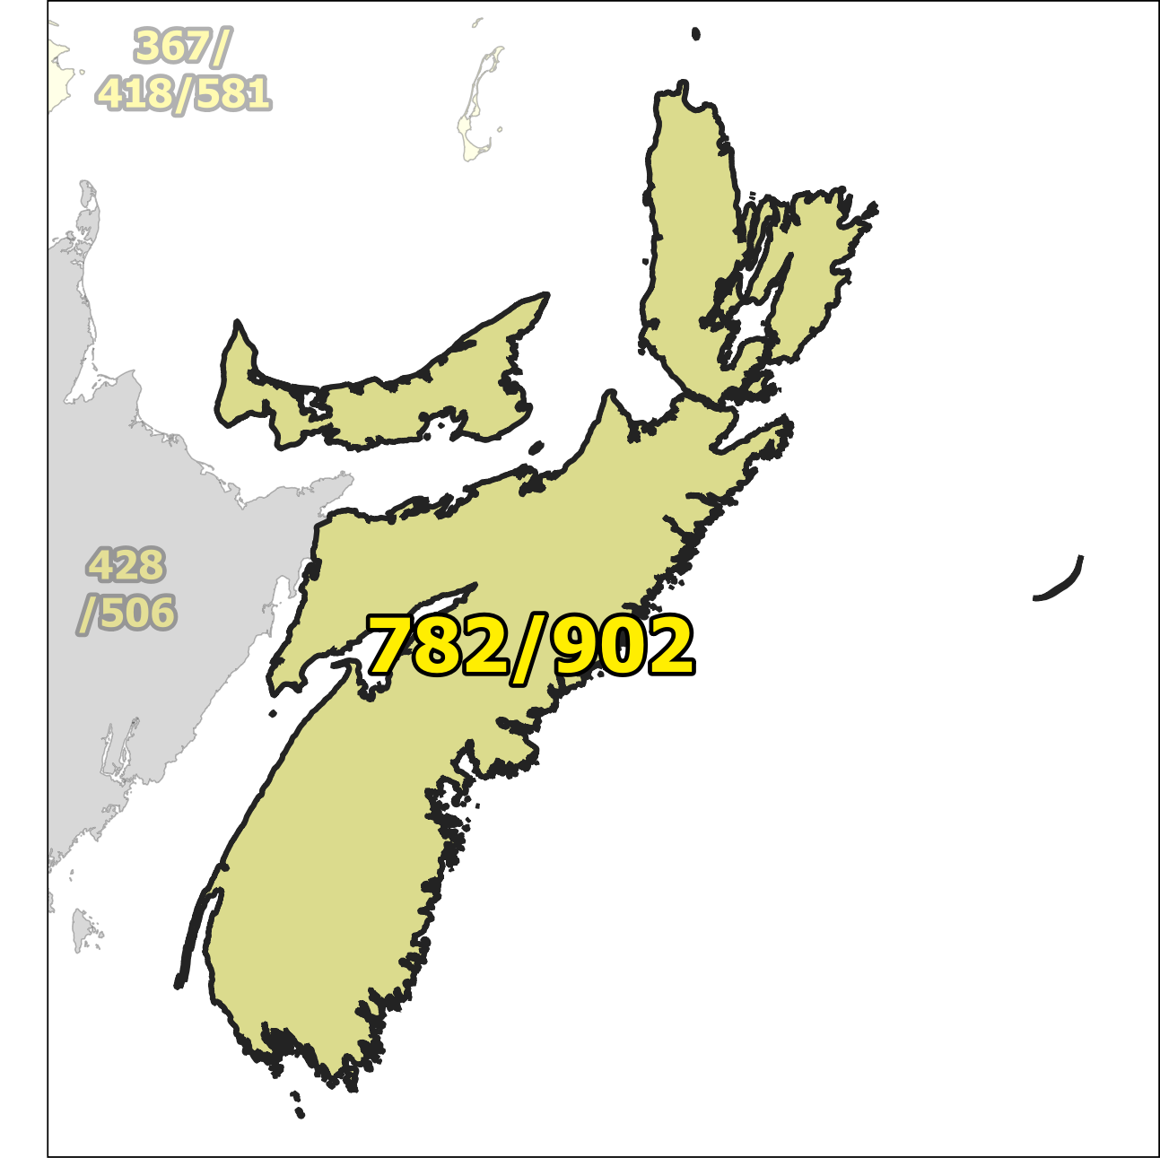

NPA 782/902 Planning Document (PD)

Version 1.0 – 28 August 2025

TABLE OF CONTENTS

1. INTRODUCTION 1
2. NPA RELIEF PLANNING PROCESS 2
3. NPA RELIEF METHODS 3
4. NPA EXHAUST INFORMATION 3
5. RELIEF OPTION 3
5.1. Distributed Overlay 4
6. SUMMARY OF RELIEF OPTION 4
7. DIALLING CHANGES FOR LOCAL CALLS 4
8. PROPOSED SCHEDULE 5
9. JEOPARDY CONTINGENCY PLAN (JCP) 0
10. SELECTION OF RELIEF NPA CODE 7
11. RECOMMENDATIONS 8
ANNEXES 9

LIST OF ANNEXES

ANNEX A

Figure 1 – Overview Map of NPA 782/902 1
Figure 2 – NPA 782-902 Actual and Forecast CO Code Assignments 2
Figure 3 – NPA 782/902 CO Code Exhaust – January 2025 G-NRUF 2
Figure 4 – Distributed Overlay 3

ANNEX B

Table 1 – NPA 782/902 Exchange Areas After Distributed Overlay B-1

ACRONYM LIST

CATF | Consumer Awareness Task Force
CNA | Canadian Numbering Administrator
CISC | CRTC Interconnection Steering Committee
CLEC | Competitive Local Exchange Carrier
CLNPC | Canadian Local Number Portability Consortium
CO | Central Office
CRTC | Canadian Radio-television and Telecommunications Commission
CSCN | Canadian Steering Committee on Numbering
EAS | Extended Area Service
G-NRUF | General Numbering Resource Utilization Forecast
ILEC | Incumbent Local Exchange Carrier
IPD | Initial Planning Document
ISP | Internet Service Provider
JCP | Jeopardy Contingency Plan
J-NRUF | Jeopardy Numbering Resource Utilization Forecast
LEC | Local Exchange Carrier
LIR | Local Interconnection Region
LNP | Local Number Portability
NANP | North American Numbering Plan
NANPA | North American Numbering Plan Administrator
NITF | Network Implementation Task Force
NoC | Notice of Consultation
NPA | Numbering Plan Area (Area Code)
NRUF | Numbering Resource Utilization Forecast
PD | Planning Document
PED | Projected Exhaust Date
PL | Planning Letter
POI | Point of Interconnection
PROC | Proposal for Relief of an Overlay NPA Complex
PSAP | Public Safety Answering Point
RIP | Relief Implementation Plan
R-NRUF | Relief Planning Numbering Resource Utilization Forecast
RPC | Relief Planning Committee
TSP | Telecommunications Service Provider
WNP | Wireless Number Portability
WSP | Wireless Service Provider

Planning Document (PD) Numbering Plan Area (NPA) 367/418/581

INTRODUCTION

NPA 782/902 consists of 174 Exchange Areas serving Nova Scotia and Prince Edward Island. Based on the January 2025 G-NRUF results, NPA 782/902 is projected to exhaust in June 2028.

Neighbouring NPAs to NPA 782/902 that could be affected by this relief activity include 428/506.

The following table provides a high-level summary of the history of area code usage in the area currently served by NPA 782/902.

Year | Activity
1947 | NPA 902 was assigned to Nova Scotia, New Brunswick, Prince Edward Island and Newfoundland and Labrador
1955 | New Brunswick and Newfoundland and Labrador were removed from NPA 902. NPA 902 only covers Nova Scotia and Prince Edward Island
2014 | New area code 782 was implemented using the Distributed Overlay method.

The table below provides a brief overview of recent activities leading to the development of this PD for NPA 782/902.

Date | Activity
27 March 2025 | The CNA published the January 2025 G-NRUF results indicating a Projected Exhaust Date of June 2028. The CNA requested that CRTC staff issue a Notice of Consultation (NoC) to establish an ad hoc Relief Planning Committee for NPA 782/902.
23 June 2025 | The CRTC issued Telecom NoC CRTC 2025-155 - Establishment of a CISC ad hoc committee for relief planning for area codes 782 and 902 in Nova Scotia and Prince Edward Island

This Planning Document is prepared by the RPC in accordance with Telecom Notice of Consultation CRTC 2025-155 and the Canadian NPA Relief Planning Guideline (the Guideline). A copy of the Guideline is available from the Canadian Radio-Television and Telecommunications Commission (CRTC), CRTC Interconnection Steering Committee (CISC), Canadian Steering Committee on Numbering (CSCN) guidelines web page at: https://crtc.gc.ca/cisc/eng/cisf3fg.htm.

The objective of the NPA Relief Planning process is to ensure that CO Codes and telephone numbers are always available for use by TSPs and their customers in the geographic area requiring relief.

It is very important to closely monitor the CO Code requirements of all existing and prospective CO Code Holders so that relief can be timed to ensure that CO Codes and telephone numbers are always available for service providers and customers.

In this PD, a single option is identified for providing NPA relief in the NPA 782/902 geographic area. Given the magnitude of this undertaking, intercompany commitment and co-operation are essential throughout the planning, provisioning and implementation stages of the introduction of the new NPA.

NPA RELIEF PLANNING PROCESS

The NPA Relief Planning process and the roles of the participants (i.e. CRTC, CNA, CISC, Relief Planning Committee (RPC) participants and Interested Parties) for NPA Relief Planning are identified in the Guideline.

To increase public awareness and participation in the NPA Relief Planning process, the CRTC has determined that NPA RPCs will be established as ad hoc committees of the CISC. Generally, a separate ad hoc committee is created to deal with relief in each area code. The CNA, in its function as NPA Relief Planning Coordinator, acts as chair of these ad hoc committees. Meetings and conference calls of the ad hoc NPA RPCs are all open to public participation and are conducted in accordance with the CISC Administrative Guidelines which are available from the CRTC website at: https://www.crtc.gc.ca/cisc/eng/cag.htm.

NPA Relief Planning is conducted under the regulatory oversight of the CRTC. Notwithstanding the process detailed in the Guideline, the CRTC may exercise its authority under the Telecommunications Act to alter this process at any time. The CRTC has the authority under the Telecommunications Act to review, modify and give final approval to the Planning Document (PD) and the Relief Implementation Plan (RIP) developed and submitted by the RPC to the CRTC via the CISC process.

Section 7.1.6 of the Canadian NPA Relief Planning Guideline requires the CNA to create and maintain a distribution list of parties who may be interested in participating in the RPC and to provide them with advance notice of the initial RPC meeting and the release of a PROC.

Any person wishing to participate in the NPA Relief Planning process can contact the CNA and request to be added to the RPC distribution list. More information on how to participate in CRTC public processes is available at: http://www.crtc.gc.ca/eng/info_sht/g4.htm.

A summary of Canadian geographic area code relief history is available at: https://www.cnac.ca/npa_codes/NPA_History.pdf.

NPA RELIEF METHODS

The purpose of this section is to identify and briefly describe NPA Relief Methods.

The Guideline states that: “The only NPA Relief Method considered in Canada is the Distributed Overlay Method which superimposes or “overlays” a Relief NPA on top of an entire existing NPA or NPAs.” There are three types of Distributed Overlay:

- a Distributed Overlay over an existing geographic area served by a single existing NPA (in the case of an Overlay NPA Complex, this type is not applicable),

- a Distributed Overlay over an existing geographic area served by multiple existing overlay NPAs and,

- a Distributed Overlay over multiple existing geographic areas, each served by one or more existing NPAs.

NPA EXHAUST INFORMATION

As indicated in the following table, the following NRUF for NPA 782/902 was used to determine the PED, (i.e. the dates when CO Codes in NPA 782/902 would be expected to exhaust).

NRUF | Projected Exhaust Date (PED)
January 2025 G-NRUF (published 27 March 2025) | June 2028

Refer to Annex A, Figures 2 & 3 for graphs of forecast CO Code demand from current and prospective CO Code Holders and Administrative Codes set aside in area code 782/902 for the most recent NRUF (January 2025).

RELIEF OPTION

The Relief Option as identified and examined in this PD is a Distributed Overlay over an existing geographic area served by multiple existing overlay NPAs.

Using this method, a new NPA is overlaid over an existing NPA (i.e., the geographic area) that is served by the overlay complex of NPAs 782/902.

The Relief Option identified above was evaluated using the following assumption:

- The average historical growth of 46 CO Codes was used to identify the subsequent PED for this Relief Option by comparing the data in the table below:

Statistical Method | Data | Period | Quantity of CO Codes
Average | Forecast Growth | Next six years | 86
Average | Forecast Growth | Five-year period (Jan 2026 to Jan 2031) | 70
Average | Historical Growth | Past five years | 46

- The Relief Date for the Distributed Overlay will be 27 November 2027 (approximately 7 months prior to the NPA 782/902 PED of June 2028 identified using the January 2025 G-NRUF results).

See Annex A, Figure 4 for diagram of the Distributed Overlay Relief Option identified by the RPC.

Distributed Overlay

A Distributed Overlay Relief Option was evaluated which would overlay the NPA 851 over all 174 Exchange Areas comprising the NPA 782/902 area. See Annex A, Figure 4.

The introduction of a Distributed Overlay would retain the number of NPA Relief Planning areas in Nova Scotia and Prince Edward Island.

After this Distributed Overlay, CO Codes in NPA 782/851/902 would be expected to exhaust in Q1 2044.

SUMMARY OF RELIEF OPTION

Relief Option | Projected Exhaust Dates |  | Subsequent Relief Dates
Relief Option | NPA 782/902 | NPA 782/851/902 | Subsequent Relief Dates
Distributed Overlay | June 2028 | March 2044 | September 2043

Note: Distributed Overlay NPA 851 would be in service on 27 November 2027.

DIALLING CHANGES FOR LOCAL CALLS

Currently 10-digit dialling is mandatory for local calls originating within area code NPA 782/902 and all neighbouring NPAs (i.e., NPA 428/506). Local dialling plans will not change with this relief.

SELECTION OF RELIEF NPA CODE

In Telecom Decision CRTC 2022-308, NPA 851 was set aside for future relief in NPA 782/902.

PROPOSED RELIEF DATE

The Canadian NPA Relief Planning Guideline, Version 8.0, dated 15 May 2023, recommends that the Relief Date be approximately six (6) months prior to the PED. Based on the January 2025 G-NRUF results, the PED is June 2028. Six months prior to June 2028 would be December 2027. However, typically companies try to avoid scheduling events in December. Accordingly, the proposed Relief Date is 27 November 2027.

PROPOSED SCHEDULE

The RPC submits the following schedule for NPA 782/902 relief based on the recommendations contained in this PD and the current PED of June 2028. The RPC will monitor the PED, and if it changes significantly in the future, the RPC will assess the situation and, if necessary, submit recommendations including a revised schedule to the CRTC for consideration and approval.

RELIEF IMPLEMENTATION SCHEDULE
For a Distributed Overlay of NPA 851 over NPA 782/902

Item | Task or Event | PRIME | START | END
1 | CNA identifies NPA exhaust and notifies by e-mail CRTC staff, CSCN, NANPA & CISC that the NPA will exhaust within the future three-year time period | CNA |  | 2025-03-27
2 | CRTC issues Telecom Notice of Consultation regarding establishment of an ad hoc Relief Planning Committee | CRTC |  | 2025-06-23
3 | CNA conducts initial R-NRUF and releases results | CNA | 2025-03-27 | 2025-09-30
4 | RPC Chair starts preparing and submitting RPC Chair Reports to the CISC, on an as required basis. | RPC Chair | 2025-06-23 | 2028-02-27
5 | CNA develops the PROC | CNA | 2025-03-27 | 2025-06-30
6 | CNA distributes the PROC to RPC | CNA | 2025-06-30 | 2025-07-15
7 | RPC participants review PROC & submit contributions to RPC |  | 2025-07-15 | 2025-08-15
8 | CNA chairs initial RPC conference call to start development of PD, RIP & PL, & schedules future meetings/conference calls including creation & consultation with CATF and NITF | CNA, RPC | 2025-08-15 | 2025-08-22
9 | CNA distributed revised PD and RIP based upon initial conference call discussions | CNA | 2025-08-22 | 2025-09-08
10 | CNA chairs subsequent RPC conference calls to finalize PD & RIP | CNA, RPC | 2025-09-08 | 2025-11-08
13 | Special Types of Telecommunications Service Users (911 PSAPs, alarm companies, ISPs, paging companies, etc.) to identify any concerns to RPC & CRTC | Special Users | 2025-08-22 | 2025-11-24
11 | CNA forwards the PD and RIP to the CISC and CRTC for approval | CNA | 2025-11-08 | 2025-11-24
12 | CISC reviews and forwards PD and RIP to the CRTC for approval | CISC | 2025-11-24 | 2025-12-24
14 | CRTC issues Telecom Decision approving the Relief Method, Relief Date, New NPA & Relief Implementation Plan (RIP) | CRTC | 2025-12-24 | 2026-03-24
15 | CNA obtains relief NPA from NANPA | CNA | 2026-03-24 | 2026-03-31
16 | CNA submits the Planning Letter (PL) to NANPA | RPC | 2026-03-31 | 2026-04-09
17 | Task Forces, TSPs and users implement relief (starts upon CRTC approval of RIP and ends on Relief Date) | TSPs | 2026-03-24 | 2027-11-27
18 | All Telecom Service Providers (TSPs) to develop and file individual consumer awareness programs with the CRTC (may be done collectively by Telecommunications Alliance) (starts upon CRTC approval of RIP and must be completed 9 months prior to the Relief Date) | TSPs | 2026-03-24 | 2027-02-27
19 | TSPs and/or Telecommunication Alliance issue media release (may start upon CRTC approval of RIP) | CNA | 2026-03-24 | 2026-03-31
20 | NANPA receives and posts Planning Letter to NANPA website (within 2 weeks of receipt from the CNA) | NANPA | 2026-04-09 | 2026-04-23
21 | All TSPs implement consumer awareness activities (starts upon filing of Consumer Awareness Programs with the CRTC and is completed on the Relief Date) | TSPs | 2027-02-27 | 2027-11-27
22 | All TSPs to notify all customers (including residence, business & special customers) of the new overlay NPA (may start upon the filing of Consumer Awareness Programs with the CRTC) | TSPs | 2027-02-27 | 2027-05-27
23 | TSPs to submit Progress Report #1 to NITF and CATF (starts after completion date for all TSPs to notify their customers and requires 2 weeks) | TSPs | 2027-05-27 | 2027-06-10
24 | NITF and CATF develop & submit Progress Report #1 to RPC (linked to TSP reports to NITF and CATF) | NITF & CATF | 2027-06-10 | 2027-06-25
25 | RPC submits Progress Report #1 to CISC/CRTC (linked to NITF and CATF reports) | RPC | 2027-07-12 | 2027-07-26
26 | CNA sends relief implementation information for updating BIRRDS to iconectiv | CNA | 2027-01-20 | 2027-01-27
27 | iconectiv TRA database updates to add Exchange Areas to new overlay NPA (starts 7 months before Inter-carrier test date and ends 6 months before Inter-carrier test date) | iconectiv TRA | 2027-01-27 | 2027-02-27
28 | All Telecommunications Service Users (including Special Users 911 PSAPs, alarm companies, ISPs, paging companies, etc.) to implement changes to their telecom equipment & systems to accommodate the new NPA (starts upon CRTC approval of RIP and ends on the Relief Date) | Telecom Service Users | 2026-03-24 | 2027-11-27
29 | Payphone Providers Reprogram Payphones (starts upon CRTC approval of RIP and ends on the Relief Date) | Payphone Providers | 2026-03-24 | 2027-11-27
30 | TSPs and database owners/operators to modify systems and industry databases (starts upon CRTC approval of RIP and ends on the Relief Date) | TSPs & Database Owners | 2026-03-24 | 2027-11-27
31 | Operator Services & Directory Assistance Readiness (starts upon CRTC approval of RIP and ends on the Relief Date) | TSPs | 2026-03-24 | 2027-11-27
32 | Directory Publisher Readiness for overlays (ability to identify the NPA in telephone numbers in the directory published after the Overlay NPA is activated) (starts upon CRTC approval of RIP and ends on the Relief Date) | Directory Publishers | 2026-03-24 | 2027-11-27
33 | 9-1-1 Systems and Databases Readiness (starts upon CRTC approval of RIP and ends on the Relief Date) | PSAPS, 9 1 1 Service Providers & TSPs | 2026-03-24 | 2027-11-27
34 | Network Systems & Equipment Readiness (starts upon CRTC approval of RIP and ends on the Relief Date) | TSPs | 2026-03-24 | 2027-11-27
35 | Service Order & Business System Readiness (starts upon CRTC approval of RIP and ends on the Relief Date) | TSPs | 2026-03-24 | 2027-11-27
36 | International Gateway Switch Translations Readiness for new NPA (starts upon CRTC approval of RIP and ends on the Relief Date) | Int’l TSPs | 2026-03-24 | 2027-11-27
37 | Canadian Local Number Portability Consortium (CLNPC) Database Readiness for new NPA (starts upon CRTC approval of RIP and ends on the Relief Date) | CLNPC & NPAC | 2026-03-24 | 2027-11-27
38 | Toll Free SMS Database Readiness for new NPA (starts upon CRTC approval of RIP and ends on the Relief Date) | Toll TSPs | 2026-03-24 | 2027-11-27
39 | TSPs apply for Test CO Codes in new NPA (applications may be submitted no more than 6 months and no less than 66 days prior to the start date for the Inter-Carrier Testing Period) (Section 7.16.4 Canadian RP GL) | TSPs | 2027-02-27 | 2027-06-22
40 | Develop Inter-Carrier Network Test Plans and prepare for testing (individual TSPs to make arrangements in accordance with interconnection agreements) (may start upon CRTC approval of RIP and must be completed by start date for the Inter-Carrier Testing Period) | NITF & TSPs | 2026-03-24 | 2027-08-27
41 | All international and domestic Telecommunications Service Providers (TSPs) must activate the new NPA in their networks by the start date for the Inter-Carrier Testing Period | TSPs | 2026-03-24 | 2027-08-27
42 | Activation date for Overlay NPA Test CO Codes and Test Numbers in network (should be completed by the start date for the Inter-Carrier Testing Period) | TSPs |  | 2027-08-27
43 | Inter-Carrier Testing Period (subject to Inter-Carrier Network Test Plans) (starts about 3 months prior to the Relief Date, and ends about 1 month after the Relief Date) | NITF & TSPs | 2027-08-27 | 2027-12-27
44 | TSPs to submit Progress Report #2 to NITF and CATF (starts on commencement of Inter-Carrier Testing Period) | TSPs | 2027-08-27 | 2027-09-13
45 | NITF and CATF develop & submit Progress Report #2 to RPC (linked to TSP reports to NITF and CATF) | NITF & CATF | 2027-09-13 | 2027-09-27
46 | RPC submits Progress Report #2 to CRTC staff (linked to NITF and CATF reports) | RPC | 2027-09-27 | 2027-10-13
47 | Relief Date (earliest date when CO Codes in new NPA may be activated) |  |  | 2027-11-27
48 | TSPs submit Final Report to CATF and NITF (starts on Relief Date and provides 2 weeks for preparation & submission) | TSPs | 2027-11-27 | 2027-12-10
49 | NITF and CATF develop & submit Final Progress Report to RPC (linked to TSP reports to NITF and CATF) | NITF & CATF | 2027-12-10 | 2027-12-24
50 | The RPC submits Final Progress Report to CRTC staff (linked to NITF and CATF reports) | RPC | 2027-12-24 | 2028-01-07
51 | TSPs disconnect Test Codes & Numbers, and submit Part 1 form to return Test Codes (starts 1 month after Relief Date and allows 1 month for completion) | TSPs | 2027-12-27 | 2028-01-27
52 | RPC Chair submits, to the CISC, the final RPC Chair report indicating that the ad hoc RPC is no longer required | RPC Chair | 2028-01-27 | 2028-02-27

JEOPARDY CONTINGENCY PLAN (JCP)

The RPC has developed the following JCP for inclusion in the PD for NPA 782/902. This JCP is based on the example contained in Appendix F to the Canadian NPA Relief Planning Guideline.

This JCP shall remain in effect until superseded by a CRTC-approved JCP, the Jeopardy Condition is suspended or 66 days prior to the Relief Date.

The following measures shall be implemented in NPA 782/902 while a Jeopardy Condition is in effect.

During a Jeopardy Condition, CO Code Applicants shall submit all CO Code applications and related correspondence for the Jeopardy NPA to CRTC staff in addition to the CNA. The CNA shall only assign CO Codes from the exhausting NPA to a CO Code Applicant when instructed by CRTC staff.

- Carriers and/or Telecommunications Service Providers (TSPs):

  - shall age disconnected residential wireline telephone numbers for a maximum of two months;
  - shall age disconnected wireless telephone numbers for a maximum of three months;
  - shall age disconnected business wireline telephone numbers for a maximum of six months. Under special circumstances, the six month aging limit for business telephone numbers may be extended to twelve months, if required, to accommodate local directory publishing dates for high volume call-in applications (e.g., heavily advertised local business numbers such as radio talk shows, food ordering services, ticket sales, chat lines), or for numbers associated with public service emergency applications or for numbers advertised in directories for which customers have requested reference of calls;
  - shall return all CO Codes that are not being used, nor intended to be used to directly serve customers to the assignment pool within two months (e.g., plant test codes);
  - should work towards, and encourage existing customers, to either activate or return the reserved numbers to bring the reserved quantity down to a maximum of 10% of the quantity of numbers In-Service for that customer;
  - shall not allow the quantity of reserved numbers to be increased by new reservation requests by existing customers to more than 10% of the quantity of numbers in service for that customer. In the case of new customers, number reservations shall be limited to 10% of the total quantity of telephone numbers being placed into service for that customer;
  - shall, within 45 days from the date that the CNA declares a Jeopardy Condition submit a Part 1 Form for each remaining reserved CO Code either returning the reserved CO Code to the CNA or requesting assignment of the reserved CO Code. Once the 45-day period has elapsed, the CNA shall make available for general assignment all CO Codes that are still reserved and have not been applied for as assignments on a Part 1 Form received by the CNA. Within 60 days from the date that the CNA declares a Jeopardy Condition, the CNA shall report to CRTC staff and the RPC as to how many of these codes have been assigned or made available for general assignment;
  - shall not be permitted to obtain a new CO Code reservation;
  - shall place all CO Codes assigned prior to the Jeopardy Condition being declared In-Service within three months of the effective date for CO Code activation in the network, or within three months of the date that the Jeopardy Condition was declared. If the CO Code is an Initial Code and the CO Code Holder can demonstrate that, due to circumstances beyond its control, the In-Service date has been delayed beyond the applicable timeframe, then the CNA may grant an extension of up to two months to the In-Service date. The CNA shall initiate reclamation procedures for all CO Codes that have not been placed In-Service within these timeframes unless CRTC staff provides a further extension.

- For new applications for Initial Codes, each CO Code Holder shall certify that the CO Code will be activated in the network and placed In-Service within four months of the date of application for the Code. If the CNA does not receive a Part 4 Form within this timeframe, confirming that the CO Code has been placed In-Service, the CNA will initiate reclamation measures. If the CO Code Holder can demonstrate that, due to circumstances beyond its control, the In-Service date has been delayed not more than six months from the original application date, then the CNA may grant an extension to the In-Service date, so long as the In-Service date is not more than six months beyond the original application date. If the In-Service date has been delayed more than six months from the original application date, then the CNA shall reclaim the Code unless CRTC staff provides a further extension.

- When applying for an Additional Code for Growth, a CO Code Holder who is submitting a Part 1 Form and Appendix B worksheet shall also submit a completed Supplementary Form for a Growth CO Code Application (attached) which certifies and/or provides the following information for the specific switching entity/POI and Exchange Area when the Growth CO Code is being requested in a Jeopardy Condition:

  - certification that all held telephone numbers have been released;
  - certification that reserved numbers do not exceed ten percent of the total quantity of numbers as defined in Appendix G of the Canadian CO Code (NXX) Assignment Guideline;
  - certification that each reseller/dealer had been advised of the Jeopardy Condition and the requirement that they would only be allocated additional numbers during the Jeopardy Condition on the provision to the CO Code Holder of written confirmation that their number inventory has been reduced to an amount less than two times the highest quantity of customer numbers assigned in any month during the previous 12 months. Additional numbering resources will only be provided by the CO Code Holder to the reseller/dealer to the extent that the reseller's/dealer's inventory can only increase up to a maximum of three months' inventory;
  - confirmation that the Part 1 form submitted with the application has the Jeopardy Condition box in section 1.6 checked to certify that the existing CO Codes are projected to exhaust within 4 months of the date of application and that the months-to-exhaust is documented on an Appendix B submitted to the CNA;
  - a completed Telephone Number Utilization Report for the applicable switching entity signed by both a company officer and the company’s authorized representative;
  - confirmation that the requested Growth CO Code was forecasted in the most recent NRUF or an explanation as to why it was not is attached; and,
  - confirmation that the requested Growth CO Code will be placed In-Service within four months of the date of assignment.

- Any CO Codes for growth assigned after the implementation of this JCP must be activated in the network and placed In-Service within four months of assignment. In the event that a CO Code Holder is unable to place the CO Code In-Service within four months of the date of assignment, the CO Code Holder must return the assigned CO Codes or submit a written request for extension to the CNA. Such written requests must include documentation explaining the reason(s) for the missed date and proposing the new In-Service date. If the explanation includes reasons beyond the control of the CO Code Holder, the CNA may extend the In-Service date a maximum of one month. If the CO Code Holder does not place the CO Code In-Service within the one-month extension, the CNA shall initiate the reclamation process at the end of the one-month extension unless CRTC staff provides a further extension.

- A Carrier that has multiple switching entities within an Exchange Area shall examine the possibility of, and implement where feasible, number sharing between those switches as a potential method to delay requirements for additional CO Codes.

- The CNA will request two versions (two separate worksheets (Form 1 and Form 2)) of the J-NRUF input from all current and prospective CO Code Holders quarterly until three (3) months before relief is provided.

  - The forecast quantities in Form 1 should be the same as or lower than the last R-NRUF input submitted, prior to declaration of a Jeopardy Condition. CO Code Holder forecasts may reflect an increase in demand in the period subsequent to the Relief Date.

  - Form 2 will reflect the actual demand required by the CO Code Holder's current business plan and will be provided for information purposes only.

- The CNA will compare the initial J-NRUF input to the recent NRUF inputs, to assess forecasting trends. The CNA shall monitor all inputs and shall test them for reasonableness in consultation with the Carrier. If the CNA is dissatisfied with the reasonableness, or the rationale provided for the deviations, then the matter will be referred to the CRTC staff.

- The CNA will request subsequent J-NRUF input from all current and prospective CO Code Holders quarterly until 3 months before relief is provided. If one or more R-NRUFs have already been conducted, and depending on the severity of the Jeopardy Condition, the CNA may defer a J-NRUF by up to two months if such a deferral brings the timing of that J-NRUF and subsequent J-NRUFs into alignment with other NRUFs that are conducted at 12, 6 or 3 month intervals. Subsequent J-NRUF input will be compared with the initial J-NRUF input to evaluate the effectiveness of the JCP. The CNA shall monitor all J-NRUF inputs and shall test them for reasonableness in consultation with the Telecommunications Service Providers. If the CNA is dissatisfied with the reasonableness, or the rationale provided for the changed forecasts, then the matter will be referred to CRTC staff.

- A CO Code Applicant must have submitted a completed J-NRUF to the CNA before the CNA may assign a CO Code to that CO Code Applicant.

- If a CO Code applicant wishes to request more CO Codes than it identified in its most recent J NRUF, the CO Code Applicant should discuss the matter with the CNA. If the CO Code Applicant wishes to proceed with the request, the CO Code Applicant will forward the request and revised forecast to CRTC staff and the CNA for consideration.

- The CO Codes identified in the NPA CO Code Inventory Chart as “Assignable CO Codes in a Jeopardy Condition” will be assigned in the order determined by the RPC after all CO Codes which are “Available for Assignment as of [day month year] have been assigned.

- After each J-NRUF, the CNA shall provide CRTC staff, the RPC and CSCN participants with a report providing an updated NPA CO Code Inventory Chart for the NPA in jeopardy as well as the aggregate results of the most recent J-NRUF.

- Exceptional issues or concerns may be referred by the CNA, or by individual entities (with a courtesy copy to the CNA), to the CRTC staff for resolution.

- In a situation where the Relief Date is on or after the PED, the quantity of CO Codes that may be assigned to a CO Code Applicant prior to the end of the Jeopardy Condition (i.e. 66 days prior to the Relief Date) shall be limited to the quantity forecasted by the CO Code Applicant in its most recent NRUF forecast submitted prior to the Jeopardy Condition being declared by the CNA (if no previous NRUF was submitted, then the previous forecast will be deemed to be zero codes). When making requests to obtain CO Codes prior to the end of the Jeopardy Condition (i.e. 66 days prior to the Relief Date), the CO Code Applicant may change the Exchange Area or the month when the CO Code assignment is required, provided a new J-NRUF and explanation accompanies the application. The control imposed by this option may be relaxed if subsequent J-NRUFs defer the PED to after the Relief Date. CO Codes that become available for assignment due to future reduced demand from other current and prospective CO Code Holders may be assigned at the discretion of CRTC staff.

- If the CNA determines that the implementation of the JCP has not extended the Projected Exhaust Date of the NPA beyond the Relief Date, the CNA will consult with CRTC staff and further CO Code conservation and assignment procedures may be ordered by the Commission (e.g., rationing, lottery, etc.).

Supplementary form for a Growth CO Code Application – Page 1 of 2 – Telephone Number Utilization Report

This form is required with each request for an Additional Code for Growth in an NPA where a Jeopardy Condition is in effect. It should be submitted to the CNA together with the Part 1 and Appendix B forms that are required for an application for an Additional Code for Growth. See the Part 1 form for information on how and where to submit the form.

I hereby certify that the following information is true and accurate to the best of my knowledge and has been prepared in accordance with Special Conservation Procedures for a Jeopardy Condition contained in the Canadian NPA Relief Planning Guideline or the applicable approved Jeopardy Contingency Plan.

Name & Signature of Authorized Representative of Code Holder Title Date

Name & Signature of Company Officer (see item 3 of this JCP) Title Date

Contact information: Entity Name: __________________ Contact Name: _____________
Address: __________________ City, Province, Postal Code: _____________
Telephone: __________________ Facsimile: _____________
E-mail: __________________

Switch Identification (Switching Entity/POI) CLLI: _______________ Exchange Area: ________________
For the above Switch Identification and Exchange Area for which a Growth CO Code is requested:
I certify that all held telephone numbers have been released
I certify the total quantity of reserved numbers does not exceed ten percent (10%) of the total quantity of telephone numbers as defined in Appendix G of the Canadian CO Code (NXX) Assignment Guideline
I certify that each reseller/dealer has been advised of the Jeopardy Condition and the requirement that they would only be allocated additional numbers during the Jeopardy Condition on the provision to the CO Code Holder of written confirmation that their number inventory has been reduced to an amount less than two (2) times the highest quantity of customer numbers assigned in any month during the previous twelve (12) months. Additional numbering resources will only be provided by the CO Code Holder to the reseller/dealer to the extent that the reseller's/dealer's inventory can only increase up to a maximum of three months' inventory.
The Part 1 form submitted with the application has the Jeopardy Condition box in section 6 checked (this certifies that the existing CO Codes are projected to exhaust within four (4) months of the date of the application or within the period specified in an approved Jeopardy Contingency Plan, and that the months-to-exhaust is documented on an Appendix B submitted to the CNA).
The Telephone Number Utilization Report on page 2 of this form has been completed.
The requested Growth CO Code was forecasted in the most recent NRUF, or an explanation as to why it was not is attached.
The requested Growth CO Code will be placed In-Service within four (4) months of the date of assignment.

Supplementary Form for a Growth CO Code Application – Page 2 of 2 – Telephone Number Utilization Report

Use Arial 9 to complete this form. (Note: If the spreadsheet below does not show on your display, please change the Work view to "Print Layout" or "Reading Layout")
Remarks: _______________________________________________________________________________
________________________________________________________________________________________

NPA 782/902 CO Code Inventory Chart

The following chart and the instructions it contains will apply in NPA 367/418/581 in a Jeopardy Condition.

The chart below lists quantities of CO Codes unassignable prior to a Jeopardy Condition, CO Codes that become assignable in a Jeopardy Condition and CO Codes in NPA 782/902 assigned and In-service as of 15 July 2025. The CO Codes that become assignable in a Jeopardy Condition shall only be made available for assignment when all other available CO Codes have been assigned in the order listed below.

 |  | Quantity
A | Total CO Codes in NPAs 782/902 (NXX format) | 1600
B | CO Codes unassignable prior to a Jeopardy Condition
 | N11 Service Codes (211, 311, 411, 511, 611, 711, 811, 911) | 16
 | Special Use Codes (555, 950 & 976) | 6
 | Home NPA Code(s) | 4
 | Current Neighbouring NPA Codes (List) | 0
 | Future Geographic NPA Codes (List)  (Note 1) | 1
 | Plant Test Codes (958 & 959) | 4
 | Special 7-digit Dialling Codes (310, 610 & 810) | 5
 | Total B | 36
C | CO Codes assignable prior to a Jeopardy Condition (C=A-B) | 1564
D | CO Codes unassignable prior to a Jeopardy Condition that become assignable in a Jeopardy Condition:
D | Future Canadian Geographic NPA Codes (Notes 1 & 2) | 1
D | Current Neighbouring NPA Codes (List) (Note 3) | 0
D | Total D | 1
E | Assignable CO Codes in a Jeopardy Condition (E=C+D) | 1565
F | Assigned CO Codes as of 15 July 2025 | 1227
G | Net CO Codes available for assignment as of 15 July 2025 without a Jeopardy Condition (G=C-F) | 337
H | Net CO Codes available for assignment as of 15 July 2025 in a Jeopardy Condition (H=E-F) | 338

Notes:
- In Telecom Decision CRTC 2022-308, the Commission determined that area code 851 should be set aside as a potential future relief area code for area codes 782 and 902.
- CO Code 851 should become assignable in a Jeopardy Condition.
- In an extreme Jeopardy Condition (i.e. when the Projected Exhaust Date is earlier than the Relief Date), any CO Codes protected as Neighbouring NPA Codes could be assignable with CRTC staff approval.

SELECTION OF RELIEF NPA CODE

In Telecom Decision CRTC 2022-308, NPA 851 was set aside for future relief in NPA 782/902.

RECOMMENDATIONS

The RPC recommends:

- The Relief Method should be a Distributed Overlay of a new NPA Code on NPA 782/902 in Nova Scotia and Prince Edward Island;

- The Relief NPA Code for NPA 782/902 should be NPA 851 as per Telecom Decision CRTC 2022-308, dated 8 November 2022, for future relief of NPA 782/902; and

- The Relief Date should be 27 November 2027 to provide Carriers and customers with advanced notification and sufficient lead-time to implement relief in NPA 782/902.

ANNEXES

Planning Document (PD)
Numbering Plan Area (NPA) 782/902

MAPS AND FIGURES

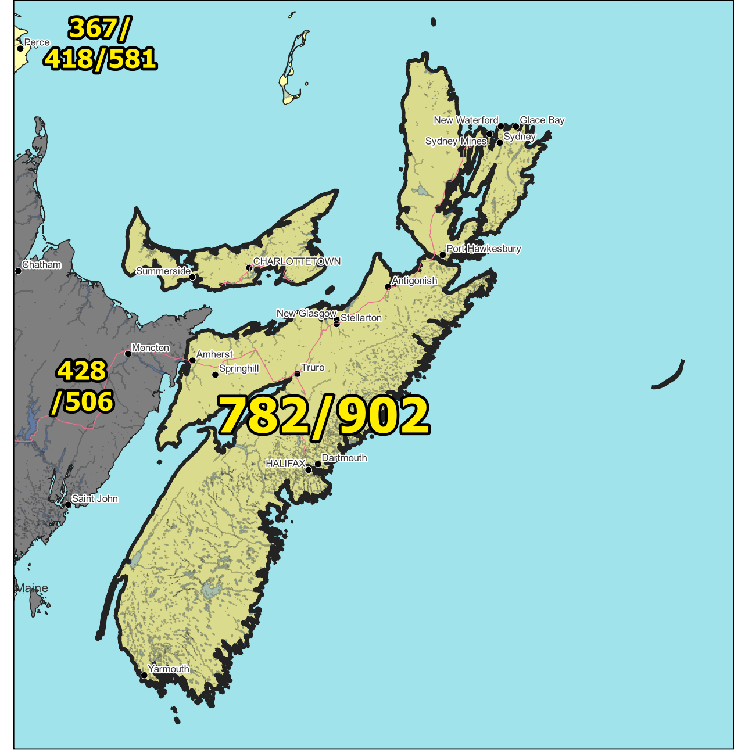

Figure 1 – Overview Map of NPA 782/902

Figure 2 – NPA 782-902 Actual and Forecast CO Code Assignments

Figure 3 – NPA 782/902 CO Code Exhaust – January 2025 G-NRUF
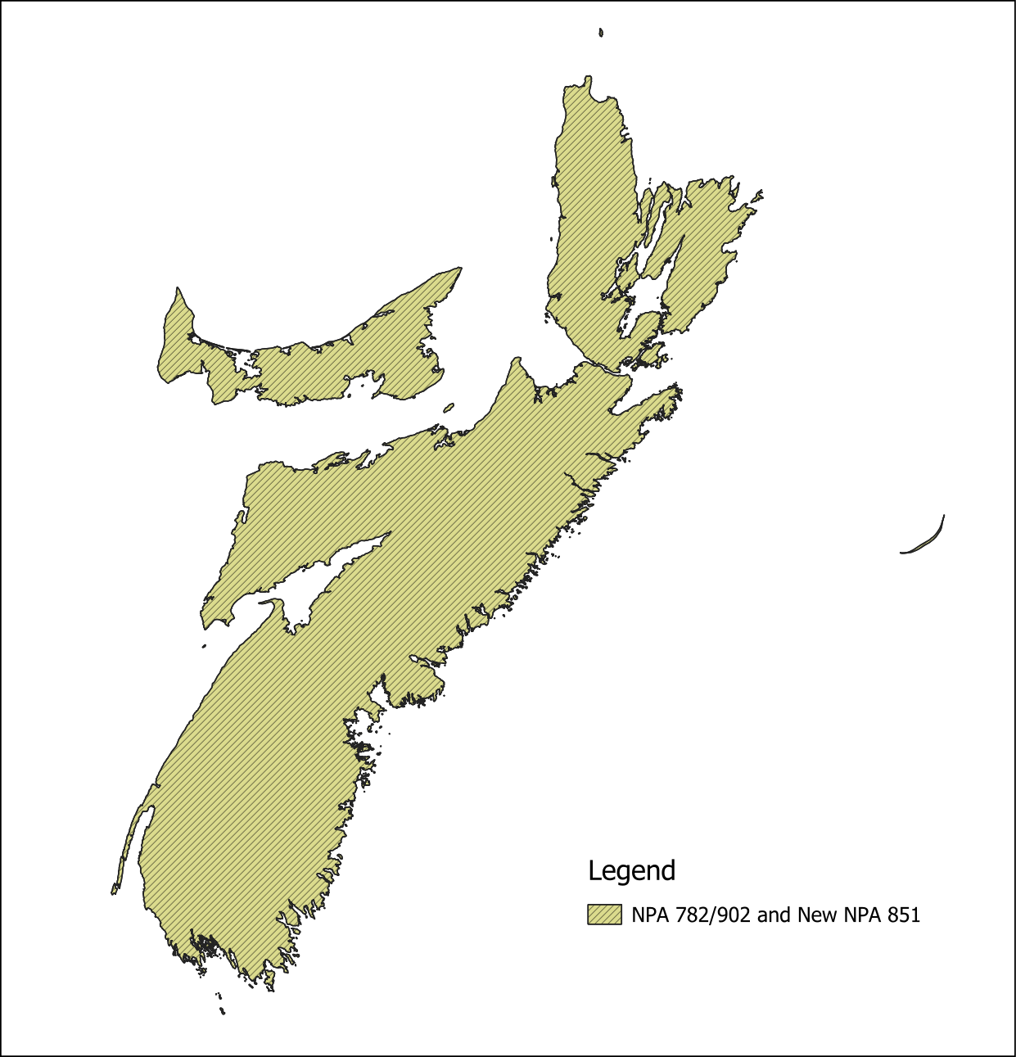

Figure 4 – Distributed Overlay

NPA 782/902 EXCHANGE AREAS

# | Exchange Area
1 | Advocate
2 | Alberton
3 | Amherst
4 | Annapolis Royal
5 | Antigonish
6 | Argyle
7 | Arichat
8 | Aylesford
9 | Baddeck
10 | Barrington
11 | Bass River
12 | Bear River
13 | Bedeque
14 | Berwick
15 | Blandford
16 | Boisdale
17 | Borden
18 | Boularderie
19 | Bridgetown
20 | Bridgewater
21 | Brookfield
22 | Brooklyn
23 | Caledonia
24 | Canning
25 | Canso
26 | Cardigan
27 | Carleton
28 | Charlottetown
29 | Chelsea
30 | Chester
31 | Cheticamp
32 | Cheverie
33 | Chezzetcook
34 | Clark's Harbour
35 | Clarksville
36 | Collingwood
37 | Country Harbour
38 | Covehead
39 | Crapaud
40 | Debert
41 | Digby
42 | Dingwall
43 | East Bay
44 | Ecum Secum
45 | Eldon
46 | Elmsdale
47 | Eskasoni
48 | Freeport
49 | French Village
50 | Gabarus
51 | Georgetown
52 | Glace Bay
53 | Goldboro
54 | Goshen
55 | Grand Narrows
56 | Great Village
57 | Guysborough
58 | Halifax
59 | Hantsport
60 | Heatherton
61 | Hopewell
62 | Hubbards
63 | Hunter River
64 | Ingonish
65 | Inverness
66 | Iona
67 | Kennetcook
68 | Kensington
69 | Kentville
70 | Kenzieville
71 | Ketch Harbour
72 | Kingston
73 | L'Ardoise
74 | LaHave
75 | Lake Charlotte
76 | Larry's River
77 | Lawrencetown
78 | Liscomb
79 | Liverpool
80 | Lockeport
81 | Louisbourg
82 | Louisdale
83 | Lunenburg
84 | Mabou
85 | Maccan
86 | Mahone Bay
87 | Maitland
88 | Margaree
89 | Margaree Forks
90 | Marion Bridge
91 | Melrose
92 | Merigomish
93 | Meteghan
94 | Middleton
95 | Mill Village
96 | Monastery
97 | Montague
98 | Morell-St. Peters
99 | Mount Stewart
100 | Mount Uniacke
101 | Mulgrave
102 | Murray River
103 | Musquodoboit
104 | Musquodoboit Harbour
105 | Neil's Harbour
106 | New Germany
107 | New Glasgow
108 | New Haven
109 | New London
110 | New Ross
111 | New Waterford
112 | Noel
113 | North Sydney
114 | O'Leary
115 | Oxford
116 | Parrsboro
117 | Pictou
118 | Port Bickerton
119 | Port Dufferin
120 | Port Greville
121 | Port Hawkesbury
122 | Port Hood
123 | Port Maitland
124 | Port Morien
125 | Port Mouton
126 | Prospect Road
127 | Pubnico
128 | Pugwash
129 | Queensport
130 | River Hebert
131 | River John
132 | Riverport
133 | Rusticoville
134 | Sackville
135 | Saltsprings
136 | Sandy Cove
137 | Saulnierville
138 | Sheet Harbour
139 | Shelburne
140 | Sherbrooke
141 | Shubenacadie
142 | Souris
143 | South Lake
144 | Southampton
145 | Springfield
146 | Springhill
147 | St. Ann's Bay
148 | St. Margarets
149 | St. Peters
150 | Stewiacke
151 | Summerside
152 | Sydney
153 | Tangier
154 | Tatamagouche
155 | Thorburn
156 | Tignish
157 | Truro
158 | Tusket
159 | Tyne Valley
160 | Upper Musquodoboit
161 | Upper Stewiacke
162 | Vernon River
163 | Wallace
164 | Walton
165 | Waverley
166 | Wedgeport
167 | Wellington
168 | Wentworth
169 | Weymouth
170 | Whycocomagh
171 | Windsor
172 | Wolfville
173 | Woods Harbour
174 | Yarmouth

