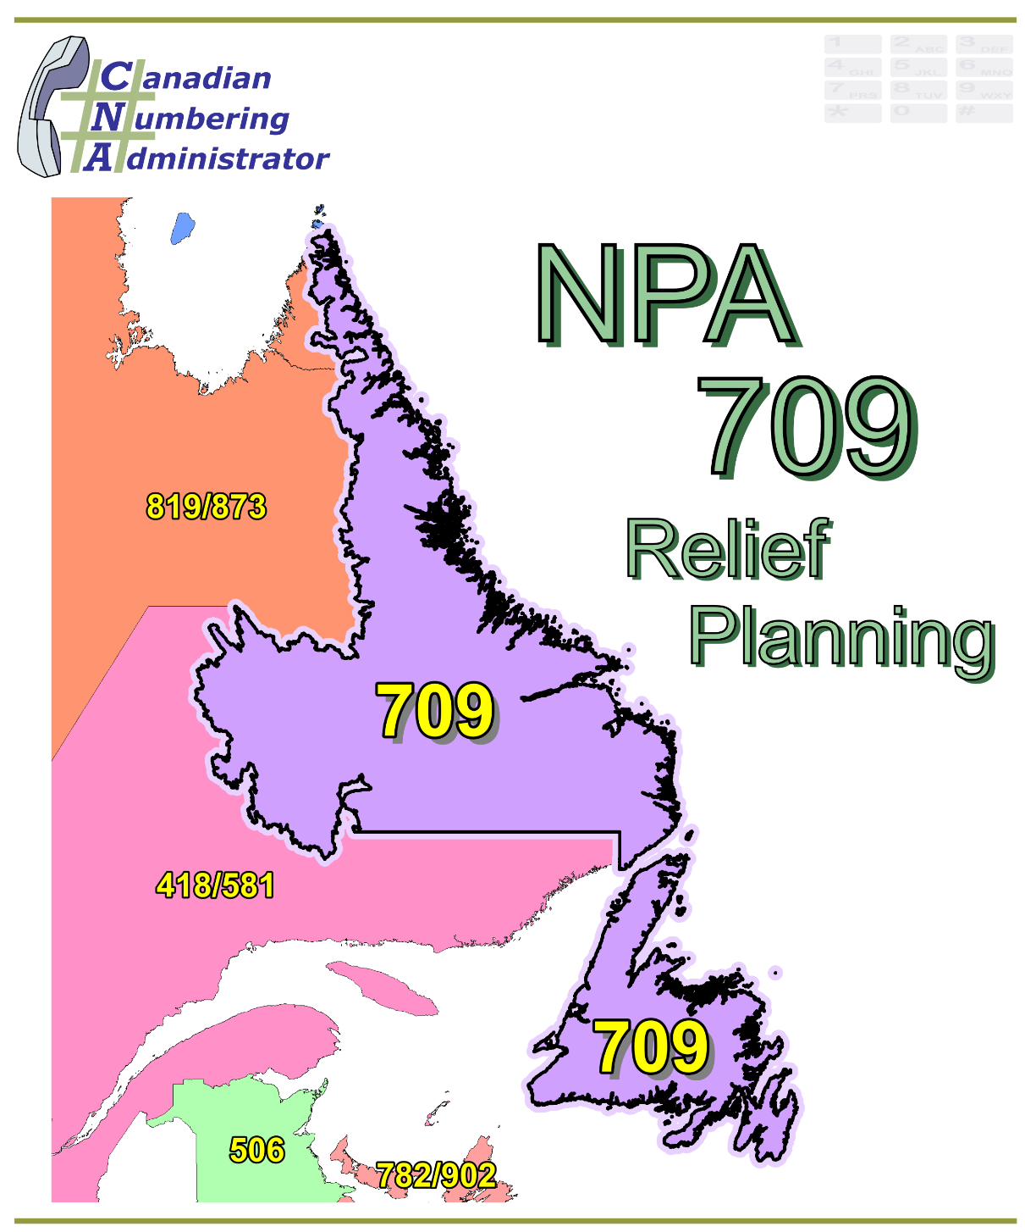

BELL CANADA CONTRIBUTION

9 September 2016

This contribution is being submitted by the contributor as a basis for discussion and should not be construed as a binding proposal on the part of the contributors, who reserve the right to add to, amend, or withdraw the contents of this contribution at any time.

NPA 709 Planning Document (PD)

Version 1.0 – XX XXXXX 2016

|  |  |
| --- | --- |
| Canadian Numbering Administrator (CNA)  Suresh Khare  613-683-3296  60 Queen Street, Suite 1516  Ottawa, Ontario K1P 5Y7  khares@leidos.ca | LeidosCanada_halfbackground_small |

**TABLE OF CONTENTS**

[1. INTRODUCTION 1](#_Toc456696301)

[2. NPA RELIEF PLANNING PROCESS 2](#_Toc456696302)

[3. NPA RELIEF METHODS 3](#_Toc456696303)

[4. NPA EXHAUST INFORMATION 4](#_Toc456696304)

[5. RELIEF OPTIONS 4](#_Toc456696305)

[5.1. Distributed Overlay 4](#_Toc456696306)

[5.1.1. Option 1: Distributed Overlay of new NPA Code on NPA 709 5](#_Toc456696307)

[5.2. Concentrated Overlay 5](#_Toc456696308)

[5.2.1. Option 2: Concentrated Overlay of new NPA Code on Capital Coast LIR 5](#_Toc456696309)

[5.2.2. Option 3: Concentrated Overlay of new NPA Code on Humber LIR 5](#_Toc456696310)

[5.2.3. Option 4: Concentrated Overlay of new NPA Code on Capital Coast & Humber LIRs 5](#_Toc456696311)

[6. Summary of Relief Options 6](#_Toc456696312)

[7. COMPARATIVE ASSESSMENT OF RELIEF OPTIONS 6](#_Toc456696313)

[7.1. Assessment 7](#_Toc456696314)

[7.1.1. Distributed Overlay 8](#_Toc456696315)

[7.1.2. Concentrated Overlay 8](#_Toc456696316)

[7.1.2.1. Concentrated Overlay of new NPA Code on Capital Coast LIR 8](#_Toc456696317)

[7.1.2.2. Concentrated Overlay of new NPA Code on Humber LIR 8](#_Toc456696318)

[7.1.2.3. Concentrated Overlay of new NPA Code on Capital Coast & Humber LIRs 8](#_Toc456696319)

[8. DIALLING CHANGES FOR LOCAL CALLS 8](#_Toc456696320)

[9. IMPLEMENTATION OF MANDATORY 10-DIGIT LOCAL DIALLING 9](#_Toc456696321)

[10. CO CODES FOR NEW ENTRANTS ONLY 9](#_Toc456696322)

[11. PROPOSED SCHEDULE 10](#_Toc456696323)

[12. JEOPARDY CONTINGENCY PLAN (JCP) 15](#_Toc456696324)

[13. SELECTION OF RELIEF NPA CODE 23](#_Toc456696325)

[14. RECOMMENDATIONS 24](#_Toc456696326)

[ANNEXES 25](#_Toc456696327)

**LIST OF ANNEXES**

**ANNEX A**

[Figure 1 – Overview Map of NPA 709](#_Toc456696341)

[Figure 2 – NPA 709 Actual and Forecast CO Code Assignments](#_Toc456696342)

[Figure 3 – NPA 709 CO Code Exhaust: April 2016 J-NRUF](#_Toc456696343)

[Figure 4 – NPA 709 Admin and LEC+WSP Codes: April 2016 J‑NRUF](#_Toc456696344)

[Figure 5 – NPA 709 CO Code Exhaust: May 2016 NoC & April 2016 J‑NRUF](#_Toc456696345)

[Figure 6 – NPA 709 Admin and LEC+WSP Codes: May 2016 NoC and April 2016 J‑NRUF](#_Toc456696346)

[Figure 7 – NPA 709 LIRs](#_Toc456696347)

[Figure 8 – Option 1: Distributed Overlay](#_Toc456696348)

[Figure 9 – Option 2: Concentrated Overlay of new NPA Code on Capital Coast LIR](#_Toc456696349)

[Figure 10 – Option 3: Concentrated Overlay of new NPA Code on Humber LIR](#_Toc456696350)

[Figure 11 – Option 4: Concentrated Overlay of new NPA Code on Capital Coast & Humber LIRs](#_Toc456696351)

**ANNEX B**

[Table 1 – Exchange Areas in NPA 709 before and after each Relief Option](#_Toc456696339)

[Table 2 – Exchange Areas in each LIR](#_Toc456696340)

**ANNEX C**

Distribution List

**ACRONYM LIST**

|  |  |
| --- | --- |
| CATF | Consumer Awareness Task Force |
| CNA | Canadian Numbering Administrator |
| CISC | CRTC Interconnection Steering Committee |
| CLEC | Competitive Local Exchange Carrier |
| CLNPC | Canadian Local Number Portability Consortium |
| CO | Central Office |
| CRTC | Canadian Radio-television and Telecommunications Commission |
| CSCN | Canadian Steering Committee on Numbering |
| G-NRUF | General Numbering Resource Utilization Forecast |
| ILEC | Incumbent Local Exchange Carrier |
| IPD | Initial Planning Document |
| ISP | Internet Service Provider |
| JCP | Jeopardy Contingency Plan |
| J‑NRUF | Jeopardy Numbering Resource Utilization Forecast |
| LEC | Local Exchange Carrier |
| LIR | Local Interconnection Region |
| LNP | Local Number Portability |
| NANP | North American Numbering Plan |
| NANPA | North American Numbering Plan Administrator |
| NITF | Network Implementation Task Force |
| NoC | Notice of Consultation |
| NPA | Numbering Plan Area (Area Code) |
| NRUF | Number Resource Utilization Forecast |
| PD | Planning Document |
| PED | Projected Exhaust Date |
| PL | Planning Letter |
| POI | Point of Interconnection |
| PSAP | Public Safety Answering Point |
| RIP | Relief Implementation Plan |
| R-NRUF | Relief Planning Numbering Resource Utilization Forecast |
| RPC | Relief Planning Committee |
| TSP | Telecommunications Service Provider |
| WNP | Wireless Number Portability |
| WSP | Wireless Service Providers |

**Planning Document (PD) Number Plan Area (NPA) 709**

# INTRODUCTION

The new Area Code 709 for Newfoundland and Labrador was created in 1962 by splitting from Area Code 506, with 506 being retained by New Brunswick. Area Code 709 consists of 211 Exchange Areas serving the province of Newfoundland and Labrador which includes the major communities of Corner Brook, Gander, Grand Falls, Happy Valley‑Goose Bay, Labrador City‑Wabush, Marystown and St. John’s. A list of the Exchange Areas in NPA 709 is provided in Annex B.

Most of the growth for existing service providers in Area Code 709 is concentrated in less than ten (10) Exchange Areas, with the majority of this growth being in the Exchange Areas of Corner Brook, Gander, Grand Falls, Happy Valley‑Goose Bay, Labrador City‑Wabush, Marystown and St. John’s. However the growth resulting from service providers introducing initial service in new areas is spread over a larger number of Exchange Areas throughout Area Code 709, with proportionally greater growth occurring outside the major communities. The total combined growth is therefore not concentrated in or limited to the Exchange Areas serving the major communities.

Assignment of Central Office (CO) Codes for Local Exchange Carriers (LECs) and Wireless Service Providers (WSPs) has accelerated demand for CO Codes primarily due to the establishment and/or expansion of the Telecommunications Service Providers’ (TSPs) footprints throughout Area Code 709. For the purposes of this document a footprint is the first CO Code assigned to a Code Holder in a unique Exchange Area.

The table below provides a brief overview of recent activities leading to the development of this PD for NPA 709:

| **Date** | **Activity** |
| --- | --- |
| 15 December 2015 | The Canadian Numbering Administrator (CNA) initiated its January 2016 General Numbering Resource Utilization Forecast (G‑NRUF). |
| 9 March 2016 | The CNA notified Canadian Radio‑television and Telecommunications Commission (CRTC) staff that NPA 709 was in a Jeopardy Condition, and asked the CRTC to issue a Telecom Notice of Consultation (NoC) for the establishment of a CRTC Interconnection Steering Committee (CISC) ad hoc committee for area code relief planning in Area Code 709 for the province of Newfoundland and Labrador; |
| 11 March 2016 | The CNA released the aggregate results of the January 2016 G‑NRUF which indicated that the Projected Exhaust Date (PED) for NPA 709 had moved in from August 2024 to May 2019; |
| 14 March 2016 | The CNA declared a Jeopardy Condition and requested a Jeopardy NRUF (J‑NRUF) from the current and prospective Code Holders in NPA 709; and |
| 16 May 2016 | The CNA published the April 2016 J‑NRUF results which indicated that the PED had advanced to March 2019. |
| 31 May 2016 | The CRTC issued Telecom Notice of Consultation CRTC 2016‑205, in which it established a CISC ad hoc Relief Planning Committee (RPC) to examine options for providing relief to Area Code 709 in Newfoundland and Labrador.  The Notice of Consultation (NoC) directed the RPC to set aside 2 CO Codes for initial code assignments exclusively for New Entrants. |
| 2-Sept-2016 | The CNA published the July 2016 J‑NRUF results which indicated the PED is March 2019 which is identical to the PED of the previous J-NRUF. |

The IPD, dated 5 August 2016, was prepared by the CNA in accordance with Telecom Notice of Consultation CRTC 2016‑205 and the Canadian NPA Relief Planning Guideline, Version 6.0 dated 20 November 2014 (the Guideline). A copy of the Guideline is available from the CRTC CISC CSCN guidelines web page at: <http://www.crtc.gc.ca/cisc/eng/cisf3fg.htm>.

The objective of the NPA Relief Planning process is to ensure that CO Codes and telephone numbers are always available for use by TSPs and their customers in the geographic area requiring relief.

It is very important to closely monitor the CO Code requirements of all existing and prospective CO Code Holders so that relief can be timed to ensure that CO Codes and telephone numbers are always available for service providers and customers.

This contribution for the Planning Document (PD) was developed by Bell Canada based on the IPD and in accordance with the CRTC‑approved Canadian NPA Relief Planning Guideline (the Guideline) dated 20 November 2014. Various options for providing relief in the NPA 709 Numbering Plan Area are examined in this PD.

Given the magnitude of this undertaking, intercompany commitment and co‑operation are essential throughout the planning, provisioning and implementation stages of the introduction of a new NPA.

# NPA RELIEF PLANNING PROCESS

The NPA Relief Planning process and the roles of the participants (e.g., CRTC, CNA, CISC, RPC participants, Interested Parties) for NPA Relief Planning are identified in the Guideline.

To increase public awareness and participation in the NPA Relief Planning process, the CRTC has determined that NPA RPCs will be established as ad hoc committees of the CISC. Generally, a separate ad hoc committee is created to deal with relief in each area code. The CNA, in its function as NPA Relief Planning Coordinator, acts as chair of these ad hoc committees. Meetings and conference calls of the ad hoc NPA RPCs are all open to public participation and are conducted in accordance with the CISC Administrative Guidelines which are available from the CRTC website at: <http://www.crtc.gc.ca/cisc/eng/cag.htm>.

NPA Relief Planning is conducted under the regulatory oversight of the CRTC. Notwithstanding the process detailed in the Guideline, the CRTC may exercise its authority under the *Telecommunications Act* to alter this process at any time. The CRTC has the authority under the *Telecommunications Act* to review, modify and give final approval to the Planning Document (PD) and the Relief Implementation Plan (RIP) developed and submitted by the RPC to the CRTC via the CISC process.

Section 6.1.6 of the Canadian NPA Relief Planning Guideline requires the CNA to create and maintain a distribution list of parties who may be interested in participating in the RPC and to provide them with advance notice of the initial RPC meeting and the IPD.

Any person wishing to participate in the NPA Relief Planning process can contact the CNA and request to be added to the RPC distribution lists. More information on how to participate in CRTC public processes is available at: <http://www.crtc.gc.ca/eng/info_sht/g4.htm>.

A summary of Canadian geographic area code relief history is available at: <http://www.cnac.ca/npa_codes/NPA_History.pdf>.

The following table provides a brief history of the evolution of NPA 709:

|  |  |
| --- | --- |
| **Year** | **Activity** |
| 1947 | AT&T created the 9 new Area Codes for Canada, NPA 902 was assigned for the provinces of New Brunswick, Nova Scotia, Prince Edward Island and Newfoundland and Labrador (Note 1); |
| 1955 | The new Area Code 506 was created by splitting NPA 902. NPA 506 was assigned for New Brunswick and Newfoundland and Labrador, and Nova Scotia and Prince Edward Island retained NPA 902; and |
| 1962 | The new Area Code 709 was created by splitting NPA 506. NPA 709 was assigned to the province of Newfoundland and Labrador and New Brunswick retained NPA 506. |

Note 1: Newfoundland and Labrador became the tenth province to enter the [Canadian Confederation](https://en.wikipedia.org/wiki/Canadian_Confederation) on March 31, 1949, as "Newfoundland". On December 6, 2001, an [amendment](https://en.wikipedia.org/wiki/Amendments_to_the_Constitution_of_Canada) was made to the [Constitution of Canada](https://en.wikipedia.org/wiki/Constitution_of_Canada) to [change the province's official name](https://en.wikipedia.org/wiki/Geographical_renaming) to Newfoundland and Labrador.

The CNA has analysed the J‑NRUF results and has concluded that the average actual annual forecast growth is approximately 15 CO Codes per year. The rest of the forecast demand is due to CO Code requests for establishing a footprint in NPA 709 Exchange Areas.

For calculations of future Projected Exhaust Dates (PEDs) of the current and Relief NPAs in all plans the CNA has used average annual growth beyond the six-year forecast period; thereby discounting the footprint expansion.

# NPA RELIEF METHODS

The purpose of this section is to identify and briefly describe NPA Relief Methods.

The Guideline states that “The only Relief Method that should be included in the IPD and PD [Planning Document] is the Overlay Method.”

Under the Overlay Method, a relief NPA Code is superimposed or overlaid on top of part or all of an existing NPA. With overlays, changes to existing customers' telephone numbers are not required. The Overlay Method includes three types of overlays that may be identified and assessed. These types of overlays are detailed in Sections 5.1.1 through 5.1.3 of the Guideline, and are:

* Distributed Overlays - a new relief NPA Code is overlaid on top of all of an exhausting NPA;
* Concentrated Overlays - a new relief NPA Code is overlaid on top of part of an exhausting NPA; and
* Boundary Extension Overlays - the boundary of an existing NPA that has spare capacity is extended to overlay part or all of an exhausting NPA.

# NPA EXHAUST INFORMATION

As indicated in the following table, NRUFs for NPA 709 were used to determine PEDs, i.e. the dates when CO Codes in NPA 709 would be expected to exhaust.

|  |  |
| --- | --- |
| **NRUF** | **Projected Exhaust Date (PED)** |
| G-NRUF January 2015 | August 2024 |
| G-NRUF January 2016 | May 2019 |
| J-NRUF April 2016 | March 2019 |
| J-NRUF April 2016 plus NoC CRTC 2016-205 | March 2019 |
| J-NRUF July 2016 | March 2019 |

Refer to Annex A, Figures 2, 3, 4, 5, and 6 for graphs of forecast CO Code demand from current and prospective CO Code Holders and charts of Administrative Codes set aside in Area Code 709.

# RELIEF OPTIONS

Based on the basic Relief Methods, the following Relief Options were identified and examined in detail:

* Distributed Overlay – One option
* Concentrated Overlay – Three options

In accordance with the Guideline the CNA did not examine a boundary extension overlay because this would create an NPA boundary that crosses provincial borders. See Annex A, Figures 8 through 11 for diagrams of the Relief Options identified by the CNA.

The Relief Options identified above were evaluated using the following assumptions:

* The Relief Date for the distributed overlay option will be 3rd Q 2018 (six (6) months prior to the NPA 709 PED of March 2019 identified using the April 2016 J‑NRUF results).
* The Relief Date for the concentrated overlay options will be 1st Q 2018 (twelve (12) months prior to the NPA 709 PED of March 2019 identified using the April 2016 J‑NRUF results).

## Distributed Overlay

One distributed overlay Relief Option was evaluated to provide CO Code relief in the NPA 709 geographic area.

### Option 1: Distributed Overlay of new NPA Code on NPA 709

This Relief Option would introduce a new NPA Code as an overlay on all 211 Exchange Areas in the NPA 709 area. See Annex A Figure 8.

With this Relief Option, the number of separate Relief Planning areas in Newfoundland and Labrador would not change.

After this distributed overlay, NPA 709 and the new NPA would be expected to exhaust in 2060.

## Concentrated Overlay

Three concentrated overlay Relief Options were evaluated to provide CO Code relief in the NPA 709 geographic area. These Relief Options are dependent on Local Interconnection Regions (LIRs) in NPA 709. See Figure 7.

### Option 2: Concentrated Overlay of new NPA Code on Capital Coast LIR

This Relief Option would overlay a new NPA Code over the Capital Coast LIR (87 Exchange Areas) and the remaining 124 Exchange Areas in the province of Newfoundland and Labrador would continue to grow using CO Codes from NPA 709. This concentrated overlay would have to be implemented in April 2018 to ensure a quantity of NXXs is available in NPA 709 for forecast growth in the remainder of the province. See Annex A Figure 9.

With this Relief Option, the number of separate Relief Planning areas in Newfoundland and Labrador would increase from one to two.

After this concentrated overlay, NPA 709 and the new NPA would be expected to exhaust in Q2 2019 (June) and 2076 respectively.

### Option 3: Concentrated Overlay of new NPA Code on Humber LIR

This Relief Option would overlay a new NPA Code over the Humber LIR (104 Exchange Areas) and the remaining 107 Exchange Areas in the province of Newfoundland and Labrador would continue to grow using CO Codes from NPA 709. This concentrated overlay would have to be implemented in April 2018 to ensure a quantity of NXXs is available in NPA 709 for forecast growth in the remainder of the province. See Annex A Figure 10.

With this Relief Option, the number of separate Relief Planning areas in Newfoundland and Labrador would increase from one to two.

After this concentrated overlay, NPA 709 and the new NPA would be expected to exhaust in Q3 2019 (August) and 2076 respectively.

### Option 4: Concentrated Overlay of new NPA Code on Capital Coast & Humber LIRs

This Relief Option would overlay a new NPA Code over the Capital Coast and Humber LIR (191 Exchange Areas) and the remaining 20 Exchange Areas in the province of Newfoundland and Labrador would continue to grow using CO Codes from NPA 709. This concentrated overlay would have to be implemented in April 2018 to ensure a quantity of NXXs is available in NPA 709 for forecast growth in the remainder of the province. See Annex A Figure 11.

With this Relief Option, the number of separate Relief Planning areas in Newfoundland and Labrador would increase from one to two.

After this concentrated overlay, NPA 709 and the new NPA would be expected to exhaust in 2072 and 2060 respectively.

# Summary of Relief Options

| Relief Option | | Projected Exhaust Dates | | Relief - Timing & Type | |
| --- | --- | --- | --- | --- | --- |
| # | Description | NPA 709 | New NPA | Relief Date | Type |
| 1 | Distributed Overlay of new NPA Code on NPA 709 | 2019 | 2060 | 3Q 2018 | D |
| 2 | Concentrated Overlay of new NPA Code on Capital Coast LIR | 2019 | 2076 | 1st Q 2018 | C |
| 3 | Concentrated Overlay of new NPA Code on Humber LIR | 2019 | 2076 | 1st Q 2018 | C |
| 4 | Concentrated Overlay of new NPA Code on Capital Coast & Humber LIRs | 2072 | 2060 | 1st Q 2018 | C |
| Key | C = Concentrated Overlay  D = Distributed Overlay | | | | |

# COMPARATIVE ASSESSMENT OF RELIEF OPTIONS

The CNA has provided the template below to assist the RPC with their comparative assessment of the relief identified in section 5 of the PD. On review of the IPD/PD the RPC may modify the criteria and will complete the table.

The RPC identified X Relief Options in section 5 of this document. A Pro, Neutral or Con (P, N or C) rating was established for each Relief Option for each of the following attributes. The results are listed in the table below the list of attributes.

1. NPA Code Conservation – quantity of new NPAs required in Newfoundland and Labrador within the next XX years after relief (20XX – 20YY) (P = 0 new NPAs; N = 1 new NPA; C = 2 or more new NPAs)
2. Number of separate Relief Planning areas in Newfoundland and Labrador in the long term (P = decrease; N = stays same; C = increase)
3. Quantity of Potential Number Changes for existing customers' numbers either immediately or in the future (P = none; C = many)
4. Level of Carrier Costs – e.g., including implementation, customer awareness, rate of return (P = Low; N = Medium; C = High)
5. Time required to implement relief, i.e., time between the CRTC's Decision date and the date when CO Codes in the new/relief NPA can be activated (P = shortest; N = medium; C = longest)
6. Longevity – the length of time between this relief and subsequent relief activity in NPA 709 (e.g., a new area code) (P = 15 or more years; N = 9 through 14 years; C = within 8 years)
7. Established Geographic Identities – changes in boundaries of existing NPAs (P = none; C = 1 or more existing NPAs affected)
8. New Geographic Identities – boundaries of new NPA align with boundaries of known areas (e.g., existing NPA areas, provinces) or identifiable geographical features (e.g., rivers, islands) (P = aligns with existing NPA boundaries; N = aligns with geographical features but not with existing NPA boundaries; C = aligns with neither existing NPA boundaries, nor identifiable geographical features)
9. Creates areas with mix of 7‑ and 10‑digit local dialling in Newfoundland and Labrador (P = none; N = minor amount; C = significant)
10. Consistent with the transition towards universal 10‑digit local dialling, the Uniform Dialling Plan and future NANP Expansion (P = Yes; C = No)
11. Reprogram Mobile Phones – requirement to reprogram wireless devices to accommodate the number changes (P = Low; C = High)
12. Potential maximum quantity of NPAs in an Exchange Area in the next XX years after relief (20XX – 20YY) (P = 1 NPA; N = 2 NPAs)

| **Relief Option** | | **Pro, Neutral or Con for Each Attribute** | | | | | | | | | | | | **Rating** |
| --- | --- | --- | --- | --- | --- | --- | --- | --- | --- | --- | --- | --- | --- | --- |
| # | **Description** | **A** | **B** | **C** | **D** | **E** | **F** | **G** | **H** | **I** | **J** | **K** | **L** |  |
| **1** | Distributed Overlay of new NPA Code on NPA 709 |  |  |  |  |  |  |  |  |  |  |  |  |  |
| **2** | Concentrated Overlay of new NPA Code on Capital Coast LIR |  |  |  |  |  |  |  |  |  |  |  |  |  |
| **3** | Concentrated Overlay of new NPA Code on Humber LIR |  |  |  |  |  |  |  |  |  |  |  |  |  |
| **4** | Concentrated Overlay of new NPA Code on Capital Coast & Humber LIRs |  |  |  |  |  |  |  |  |  |  |  |  |  |

It should be noted that none of the options require Exchange Area boundary changes.

If P, N and C are assigned a weighting of +1, 0 and -1, respectively, then analysis of the above table gives the highest rating of X points to Relief Option X, and the next highest rating of X points to Relief Option X and the subsequent ratings of X for Relief Options X and X and, finally, X for Relief Options X and X.

Relief Option X has the highest rating when assessed based on the above criteria.

## Assessment

Bell Canada does not recommend the Concentrated Overlay Options for the following reasons:

* All concentrated overlay options will be required to be implemented in 1Q 2018 in order to ensure a quantity of CO Codes is available for assignment in the non-overlaid region. This does not allow enough time for Bell Canada (and potentially other carriers) to implement 10-digit dialing and the new NPA. The earlier implementation of Relief would require that customers change over to 10-digit dialling earlier than they would have to in a Distributed Overlay that could be problematic for some customers (e.g., alarm companies, telemetric services; 9-1-1 PSAPS);
* All concentrated overlay options create a new NPA boundary between the concentrated overlay NPA and the outlying areas. These boundaries are not easily identifiable which could lead to customer confusion.
* All concentrated overlay options implement the new NPA on non-contiguous regions resulting in difficulty in providing clear and concise consumer communications.
* All concentrated overlay options increase the number of separate Relief Planning areas in Newfoundland and Labrador from one to two. This increases the quantity of geographic areas that would require future relief planning activity which would require customers and Carriers to incur higher future relief costs than the distributed overlay option.
* Options 2 (Concentrated Overlay of new NPA Code on Capital Coast LIR) and Option 3 (Concentrated Overlay of new NPA Code on Humber LIR ) do not provide sufficient relief as NPA 709 would exhaust in both cases in Q3 2019.
* Option 4 (Concentrated Overlay of new NPA Code on Capital Coast and Humber LIRs) would create a Number Planning Area outside the concentrated overlay area with a very small population size which would be very inefficient from a numbering conservation and use perspective.

In summary, Bell Canada recommends the Relief Option 1: Distributed Overlay of new NPA Code on NPA 709 for the following reasons:

* The distributed overlay option can be implemented in 3Q or 4Q 2018 which will provide additional time for customers and carriers to implement 10-digit dialing and the new NPA.
* The existing NPA 709 boundary is maintained and no new NPA boundary is created, thus avoiding customer confusion regarding NPA boundaries.
* The quantity of Relief Planning areas in Newfoundland and Labrador stays the same.
* The distributed overlay option provides long term relief with a project exhaust date of 2060.

### Distributed Overlay

# DIALLING CHANGES FOR LOCAL CALLS

Currently the dialling for local calls within NPA 709 and across its boundaries is as follows:

* 7-digit dialling for local calls within NPA 709;
* in addition to providing 7-digit dialling for local calls within NPA 709, most TSPs permit 10‑digit dialling, or 10‑ and 11‑digit dialling;
* 7-digit local calling from NPA 709 and adjacent Canadian NPA 418/581 from Labrador City‑Wabush, Labrador and Fermont, Quebec;
* 10-digit local calling from Fermont, Quebec (NPA 418/581) to Labrador City‑Wabush, Labrador; and,
* no local calling between NPA 709 and other adjacent NPAs.

The Toll call dialling arrangement for NPA 709 is not impacted due to the NPA relief.

The table below identifies recommended modifications to the dialling plan for local calls originating within the NPA 709 area.

**Local Dialling Plan for Customers in NPA 709 and new NPA**

| **Local CallingScenarios** | **Dial Plan \*** |
| --- | --- |
| **Before Relief** | 7/10/11-digits |
| **After 709 Concentrated Overlay** | 10/11-digits |
| **After 709 Distributed Overlay** | 10/11-digits |

\* dependent on local Carrier

# IMPLEMENTATION OF MANDATORY 10-DIGIT LOCAL DIALLING

In Telecom Regulatory Policy CRTC 2009‑156, section 13, regarding dialling plan changes, the Commission retained the general obligation for all relevant TSPs to inform all customers about dialling plan changes but that TSPs may determine the appropriate methods to inform their customers. Accordingly, TSPs may determine the appropriate methods for informing their customers of dialling plan changes that will occur as part of NPA relief projects (e.g., network announcements on 7‑digit dialled calls, bill messages and inserts, customer letters, e-mail messages, media advertising, web sites, etc.).

Equipment used by LECs to provide service in some Exchange Areas may not be able to connect a call following an announcement (i.e., cut-through), as is usually expected during transition to an overlay. Investments that would be required to upgrade or replace network elements to provide transition announcements in some communities could be significant relative to their size, and such investments would provide a capability that would only be used for a short time, i.e. during the dialling transition period.

In Telecom Decision CRTC 2006‑26, the CRTC addressed the above situation and established a process and requirements for Carriers to follow. It is recommended that the same approach be adopted for NPA 709.

In the Decision, the Commission directed TSPs to:

* send monthly bill inserts in each of the four (4) months immediately prior to the month when mandatory 10‑digit local dialling is scheduled to be implemented;
* place two (2) notices in local newspapers (if available), one during the month prior to the month when mandatory 10‑digit local dialling is scheduled to be implemented, and one during the month when mandatory 10-digit local dialling is scheduled to be implemented;
* send a personal letter to each affected customer, to be received ten (10) days prior to the implementation date of mandatory 10-digit local dialling; and
* place information on the TSPs' websites in a prominent, highly visible location for the minimum period of about five (5) months ending at the end of the month when mandatory 10 digit local dialling is scheduled to be implemented.

# CO CODES FOR NEW ENTRANTS ONLY

When area code relief planning becomes necessary, the CRTC usually directs that quantities of CO Codes in an exhausting NPA be set aside prior to relief as unavailable for assignment to ensure that some CO Codes in the exhausting NPA will be available after relief via an overlay for initial code assignments for New Entrants only and for initial code assignments for applicants in general or those already providing service in the NPA. In the absence of a Jeopardy Condition, exhaust of the NPA, or a split, the set-aside CO Codes would only be available after relief via an overlay, and any set-aside CO Codes remaining two (2) years after the overlay would be returned to the general pool.

A New Entrant is an entity who, at the time of their first request for assignment of CO Code(s) in an NPA, does not provide any telecommunications services and does not hold any CO Codes within the boundaries of the NPA.

Direction regarding set-aside CO Codes is provided by subparagraphs a), b) and c) of the fifth paragraph of section 9.1 of the Canadian NPA Relief Planning Guideline, which requires that the RPC establish the following as part of the Jeopardy Contingency Plan (JCP):

1. *If the CRTC has directed, or the RPC has recommended (e.g., per section 5.2 of this guideline), that CO Codes in the exhausting NPA be set aside for initial code assignments for New Entrants only for assignment following relief, then, if all other available CO Codes in the exhausting NPA have been assigned, or if the CRTC has approved a split, these set-aside codes should be made available during the Jeopardy Condition for assignment as initial codes for New Entrants only, i.e. for assignment prior to relief.*
2. *If the CRTC has directed, or the RPC has recommended (e.g., per section 5.2 of this guideline), that CO Codes in the exhausting NPA be set aside for initial code assignments for applicants in general for assignment following relief, then the JCP should specify that these set-aside CO Codes will become available for general assignment when a Jeopardy Condition is in effect*.
3. *If a Jeopardy Condition is in effect and, if all other available CO Codes in the exhausting NPA have been assigned, CRTC staff may make some or all of the CO Codes in the two pools identified in a) and b), above, available for assignment to any entity for any purpose.*

Telecom Notice of Consultation CRTC 2016‑205, *Establishment of a CISC ad hoc committee for area code relief planning for area code 709 in Newfoundland and Labrador*, was issued by the Commission on 31 May 2016.

In paragraph 13 of the Notice of Consultation, the Commission directed the NPA 709 RPC to set aside two (2) CO Codes for initial code assignments exclusively for New Entrants for a period of two (2) years after the introduction of the new area code in Newfoundland and Labrador or until the pool is depleted, whichever occurs first. Accordingly, the CNA has set aside two (2) CO Codes, as directed.

If the CRTC-approved Relief Method is an overlay, then these quantities of set aside CO Codes would become available for assignment as specified above during the two (2) year time period after implementation of the overlay. Any set‑aside CO Codes remaining unassigned at the end of the two (2) year time period would be returned to the general pool of assignable CO Codes.

# PROPOSED SCHEDULE

[Bell Canada has proposed a Relief Implementation Schedule in a separate contribution which can be amended by the RPC and then imported to this document and the Relief Implementation Plan.]

The RPC submits the following schedule for NPA 709 relief based on the recommendations contained in this PD and the current PED of March 2019. The RPC will monitor the PED, and if it changes significantly in the future (e.g., is advanced or delayed by greater than six (6) months), the RPC will assess the situation and, if necessary, submit recommendations including a revised schedule to the CRTC for consideration and approval.

**RELIEF IMPLEMENTATION SCHEDULE**

**For an Overlay of new NPA over NPA 709**

| **Item** | **Task or Event** | **PRIME** | **START** | **END** |
| --- | --- | --- | --- | --- |
| 1 | CNA identifies NPA exhaust and notifies by e-mail CRTC staff, CSCN, NANPA & CISC that the NPA will exhaust within 72 months | CNA |  | 11-Mar-16 |
| 2 | CNA conducts J-NRUF & releases results | CNA | 14-Mar-16 | 16-May-16 |
| 3 | CRTC issues Telecom Notice of Consultation regarding establishment of an ad hoc Relief Planning Committee | CRTC |  | 31-May-16 |
| 4 | CNA announces the date for the initial NPA Relief Planning face-to-face meeting & requests contributions | CNA | 05-Aug-16 | 20-Sep-16 |
| 5 | CNA develops and distributes IPD to RPC | CNA | 31-May-16 | 05-Aug-16 |
| 6 | RPC participants review IPD & submit contributions to RPC | RPC | 05-Aug-16 | 13-Sep-16 |
| 7 | CNA chairs initial RPC meeting to start development of PD, RIP & PL, & schedules future meetings/conference calls | CNA, RPC | 20-Sep-16 |  |
| 8 | CNA chairs subsequent RPC meetings/conference calls to finalize PD | CNA, RPC | 23-Sep-16 |  |
| 9 | CNA forwards the PD to the CISC and CRTC for approval | CNA |  |  |
| 10 | Special Types of Telecommunications Service Users (9-1-1 PSAPs, alarm companies, ISPs, paging companies, etc.) to identify any concerns to RPC & CRTC | Special Users |  |  |
| 11 | CRTC issues Telecom Decision approving the Relief Method, Relief Date, New NPA & directs the RPC to develop the RIP | CRTC |  |  |
| 12 | CNA obtains relief NPA from NANPA | CNA |  |  |
| 13 | CNA holds RPC meetings to create Network Implementation and Consumer Awareness Task Forces (NITF and CATF) and the RPC develops and finalizes RIP | CNA, RPC |  |  |
| 14 | CNA forwards the RIP to the CISC and CRTC for approval | CNA |  |  |
| 15 | CRTC issues Telecom Decision approving the RIP | CRTC |  |  |
| 16 | Task Forces, TSPs and users implement relief (starts at CRTC approval of Relief Option & Date and ends on Relief Date) | TSPs |  |  |
| 17 | All TSPs to develop and file individual consumer awareness programs with the CRTC (may be done collectively by a Telecommunications Alliance) (starts at CRTC approval of RIP and should be completed about 24 months prior to the Relief Date) | TSPs |  |  |
| 18 | CNA issues media release (in coordination with Telecommunications Alliance) (may start on CRTC approval of RIP and should be issued at least 18 months prior to the Relief Date) | CNA |  |  |
| 19 | CNA submits PL and RIP to NANPA (should be submitted at least 18 months prior to the Relief Date) | CNA |  |  |
| 20 | NANPA receives and posts PL to NANPA website (within 2 weeks of receipt from the CNA) | NANPA |  |  |
| 21 | All TSPs implement consumer awareness activities (starts on filing of Consumer Awareness Programs with the CRTC and is completed on the Relief Date) | TSPs |  |  |
| 22 | All TSPs to notify all customers (residence, business & special customers) of the need to transition from 7- to 10-digit local dialling and the new overlay NPA (may start with the filing of Consumer Awareness Programs with the CRTC and all customers should be notified at least 18 months prior to the Relief Date) | TSPs |  |  |
| 23 | TSPs to submit Progress Report #1 to NITF and CATF (starts after completion date for all TSPs to notify their customers and requires 2 weeks) | TSPs |  |  |
| 24 | NITF and CATF develop & submit Progress Report #1 to RPC (linked to TSP reports to NITF and CATF) | NITF & CATF |  |  |
| 25 | RPC submits Progress Report #1 to CRTC staff (linked to NITF and CATF reports) | RPC |  |  |
| 26 | iconectiv TRA database updates to add Exchange Areas to new overlay NPA (starts on the date that the PL is posted to the NANPA web site and must be completed by 6 months prior to the Relief Date) | iconectiv TRA |  |  |
| 27 | All TSPs and Telecommunications Service Users (including Special Users, 9-1-1 PSAPs, alarm companies, ISPs, paging companies, payphone providers, etc.) to implement changes to their telecom equipment & systems to accommodate the new NPA and the transition from 7‑ to 10‑digit local dialling (starts on CRTC approval of RIP and ends on the Relief Date) | Telecom Service Users |  |  |
| 28 | Payphone Providers Reprogram Payphones (starts on CRTC approval of RIP and ends on the Relief Date) | Payphone Providers |  |  |
| 29 | TSPs and database owners/operators to modify systems and industry databases (starts on CRTC approval of RIP and ends on the Relief Date) | TSPs & Database Owners |  |  |
| 30 | Operator Services & Directory Assistance Readiness (starts on CRTC approval of RIP and ends on the Relief Date) | TSPs |  |  |
| 31 | Directory Publisher Readiness for relief (ability to identify the NPA in telephone numbers in the directory published after the new NPA is activated) (starts on CRTC approval of RIP and ends on the Relief Date) | Directory Publishers |  |  |
| 32 | 9-1-1 Systems and Databases Readiness (starts on CRTC approval of RIP and ends on the Relief Date) | PSAPS, 9‑1‑1  Service Providers & TSPs |  |  |
| 33 | Network Systems & Equipment Readiness (starts on CRTC approval of RIP and ends on the Relief Date) | TSPs |  |  |
| 34 | Service Order & Business System Readiness (starts on CRTC approval of RIP and ends on the Relief Date) | TSPs |  |  |
| 35 | International Gateway Switch Translations Readiness for new NPA (starts on CRTC approval of RIP and ends on the Relief Date) | Int’l TSPs |  |  |
| 36 | Canadian Local Number Portability Consortium (CLNPC) Database Readiness for new NPA (starts on CRTC approval of RIP and ends on the Relief Date) | CLNPC & NPAC |  |  |
| 37 | Toll Free SMS Database Readiness for new NPA (starts on CRTC approval of RIP and ends on the Relief Date) | Toll TSPs |  |  |
| 38 | TSPs apply for Test CO Codes in new NPA (applications may be submitted no more than 6 months and no less than 66 days prior to the start date for the Inter-Carrier Testing Period) (Section 7.16.4 of the Guideline) | TSPs |  |  |
| 39 | Develop Inter-Carrier Network Test Plans and prepare for testing (individual TSPs to make arrangements in accordance with interconnection agreements) (may start on CRTC approval of RIP and must be completed by start date for the Inter-Carrier Testing Period) | NITF & TSPs |  |  |
| 40 | All international and domestic TSPs must activate the new NPA in their networks by the start date for the Inter-Carrier Testing Period | TSPs |  |  |
| 41 | Date by which TSPs must route all calls using 10-digit signalling (i.e., cease use of 7-digit signalling) for local traffic sent to and received from other TSPs (must be completed by the start date for the Inter-Carrier Testing Period) (TSPs may, but are not obligated to, negotiate special routing arrangements on a bilateral basis if required) | TSPs |  |  |
| 42 | Activation date for new NPA Test CO Codes and Test Numbers in network must be completed by the start date for the Inter-Carrier Testing Period) | TSPs |  |  |
| 43 | Inter-Carrier Testing Period (subject to Inter-Carrier Network Test Plans) (starts about 3 months prior to the start date for the 7- to 10-Digit Dialling Transition Period) | NITF & TSPs |  |  |
| 44 | TSPs to submit Progress Report #2 to NITF and CATF (starts on commencement of Inter-Carrier Testing Period) | TSPs |  |  |
| 45 | NITF and CATF develop & submit Progress Report #2 to RPC (linked to TSP reports to NITF and CATF) | NITF & CATF |  |  |
| 46 | RPC submits Progress Report #2 to CRTC staff (linked to NITF and CATF reports) | RPC |  |  |
| 47 | Phase-in of 7- to 10-Digit Dialling Transition Period announcements (starts about 3 months prior to Relief Date and occurs over 1 week) | TSPs |  |  |
| 48 | Phase-in of mandatory 10-digit dialling announcements (occurs over 1 week and should be completed at least 1 week prior to Relief Date to address any problems that may arise) | TSPs |  |  |
| 49 | Relief Date (earliest date when CO Codes in new NPA may be activated) |  |  |  |
| 50 | TSPs submit Final Report to NITF and CATF (starts on Relief Date and provides 2 weeks for preparation & submission) | TSPs |  |  |
| 51 | NITF and CATF develop & submit Final Progress Report to RPC (linked to TSP reports to NITF and CATF) | NITF & CATF |  |  |
| 52 | RPC submits Final Progress Report to CRTC staff (linked to NITF and CATF reports) | RPC |  |  |
| 53 | TSPs disconnect Test Codes & Numbers, and submit Part 1 form to return Test Codes (starts 1 month after Relief Date and allows 1 month for completion) | TSPs |  |  |
| 54 | TSPs change Mandatory 10-Digit Dialling Announcement to standard announcement (mandatory announcement is required for a minimum of 3 months) (removal starts about 3 months after Relief Date and must be completed within 1 month) | TSPs |  |  |

# JEOPARDY CONTINGENCY PLAN (JCP)

The CNA has provided the template below to assist the RPC with the development of the Jeopardy Contingency Plan (JCP).

The RPC has developed the following JCP for inclusion in the PD for NPA 709. This JCP is based on the example contained in Appendix F to the Canadian NPA Relief Planning Guideline.

This JCP shall remain in effect until superceded by a CRTC-approved JCP, the Jeopardy Condition is suspended, or 66 days prior to the Relief Date.

The following measures shall be implemented in NPA 709 while a Jeopardy Condition is in effect.

During a Jeopardy Condition, CO Code Applicants shall submit all CO Code applications and related correspondence for the Jeopardy NPA to CRTC staff in addition to the CNA. The CNA shall only assign CO Codes from the exhausting NPA to a CO Code Applicant when instructed by CRTC staff.

1. Carriers and/or Telecommunications Service Providers (TSPs):
   1. shall age disconnected residential wireline telephone numbers for a maximum of two months;
   2. shall age disconnected wireless telephone numbers for a maximum of three months;
   3. shall age disconnected business wireline telephone numbers for a maximum of six months. Under special circumstances, the six month aging limit for business telephone numbers may be extended to twelve months, if required, to accommodate local directory publishing dates for high volume call-in applications (e.g., heavily advertised local business numbers such as radio talk shows, food ordering services, ticket sales, chat lines), or for numbers associated with public service emergency applications or for numbers advertised in directories for which customers have requested reference of calls;
   4. shall return all CO Codes that are not being used, nor intended to be used to directly serve customers to the assignment pool within two months (e.g., plant test codes);
   5. should work towards, and encourage existing customers, to either activate or return the reserved numbers to bring the reserved quantity down to a maximum of 10% of the quantity of numbers In-Service for that customer;
   6. shall not allow the quantity of reserved numbers to be increased by new reservation requests by existing customers to more than 10% of the quantity of numbers in service for that customer. In the case of new customers, number reservations shall be limited to 10% of the total quantity of telephone numbers being placed into service for that customer;
   7. shall, within 45 days from the date that the CNA declares a Jeopardy Condition submit a Part 1 Form for each remaining reserved CO Code either returning the reserved CO Code to the CNA or requesting assignment of the reserved CO Code. Once the 45-day period has elapsed, the CNA shall make available for general assignment all CO Codes that are still reserved and have not been applied for as assignments on a Part 1 Form received by the CNA. Within 60 days from the date that the CNA declares a Jeopardy Condition, the CNA shall report to CRTC staff and the RPC as to how many of these codes have been assigned or made available for general assignment;
   8. shall not be permitted to obtain a new CO Code reservation;
   9. shall place all CO Codes assigned prior to the Jeopardy Condition being declared In-Service within three months of the effective date for CO Code activation in the network, or within three months of the date that the Jeopardy Condition was declared. If the CO Code is an Initial Code and the CO Code Holder can demonstrate that, due to circumstances beyond its control, the In-Service date has been delayed beyond the applicable timeframe, then the CNA may grant an extension of up to two months to the In-Service date. The CNA shall initiate reclamation procedures for all CO Codes that have not been placed In-Service within these timeframes unless CRTC staff provides a further extension.
2. For new applications for Initial Codes, each CO Code Holder shall certify that the CO Code will be activated in the network and placed In-Service within four months of the date of application for the Code. If the CNA does not receive a Part 4 Form within this timeframe, confirming that the CO Code has been placed In-Service, the CNA will initiate reclamation measures. If the CO Code Holder can demonstrate that, due to circumstances beyond its control, the In-Service date has been delayed not more than six months from the original application date, then the CNA may grant an extension to the In-Service date, so long as the In-Service date is not more than six months beyond the original application date. If the In-Service date has been delayed more than six months from the original application date, then the CNA shall reclaim the Code unless CRTC staff provides a further extension.
3. When applying for an Additional Code for Growth, a CO Code Holder who is submitting a Part 1 Form and Appendix B worksheet shall also submit a completed Supplementary Form for a Growth CO Code Application (attached) which certifies and/or provides the following information for the specific switching entity/POI and Exchange Area when the Growth CO Code is being requested in a Jeopardy Condition:
   1. certification that all held telephone numbers have been released;
   2. certification that reserved numbers do not exceed ten percent of the total quantity of numbers as defined in Appendix G of the Canadian CO Code (NXX) Assignment Guideline;
   3. certification that each reseller/dealer had been advised of the Jeopardy Condition and the requirement that they would only be allocated additional numbers during the Jeopardy Condition on the provision to the CO Code Holder of written confirmation that their number inventory has been reduced to an amount less than two times the highest quantity of customer numbers assigned in any month during the previous 12 months. Additional numbering resources will only be provided by the CO Code Holder to the reseller/dealer to the extent that the reseller's/dealer's inventory can only increase up to a maximum of three months' inventory;
   4. confirmation that the Part 1 form submitted with the application has the Jeopardy Condition box in section 1.6 checked to certify that the existing CO Codes are projected to exhaust within 4 months of the date of application or within the period specified within an approved JCP, and that the months-to-exhaust is documented on an Appendix B submitted to the CNA;
   5. a completed Telephone Number Utilization Report;
   6. confirmation that the requested Growth CO Code was forecasted in the most recent NRUF or an explanation as to why it was not is attached; and
   7. confirmation that the requested Growth CO Code will be placed In-Service within four months of the date of assignment.
4. Any CO Codes for growth assigned after the implementation of this JCP must be activated in the network and placed In-Service within four months of assignment. In the event that a CO Code Holder is unable to place the CO Code In-Service within four months of the date of assignment, the CO Code Holder must submit a written request for extension to the CNA. Such written requests must include documentation explaining the reason(s) for the missed date and proposing the new In-Service date. If the explanation includes reasons beyond the control of the CO Code Holder, the CNA may extend the In-Service date a maximum of one month. If the CO Code Holder does not place the CO Code In-Service within the one-month extension, the CNA shall reclaim the CO Code immediately at the end of the one-month extension unless CRTC staff provides a further extension.
5. A Carrier that has multiple switching entities within an Exchange Area shall examine the possibility of, and implement where feasible, number sharing between those switches as a potential method to delay requirements for additional CO Codes.
6. The CNA will request two versions of the J-NRUF input from all current and prospective CO Code Holders quarterly until three (3) months before relief is provided.
   1. The forecasted quantities in Version 1 should be the same as or lower than the April 2016 J‑NRUF input submitted by CO Code Holders for the period up to 66 days prior to the Relief Date. CO Code Holder forecasts may reflect an increase in demand in the period subsequent to the Relief Date.
   2. Version 2 will reflect the actual demand required by the CO Code Holder's current business plan and will be provided for information purposes only.
7. The CNA will compare the initial J-NRUF input to the recent NRUF inputs, to assess forecasting trends. The CNA shall monitor all inputs and shall test them for reasonableness in consultation with the Carrier. If the CNA is dissatisfied with the reasonableness, or the rationale provided for the deviations, then the matter will be referred to the Commission.
8. The CNA will request subsequent J-NRUF input from all current and prospective CO Code Holders quarterly until 3 months before relief is provided. If one or more R-NRUFs have already been conducted, and depending on the severity of the Jeopardy Condition, the CNA may defer a J-NRUF by up to two months if such a deferral brings the timing of that J‑NRUF and subsequent J-NRUFs into alignment with other NRUFs that are conducted at 12, 6 or 3 month intervals. Subsequent J-NRUF input will be compared with the initial J‑NRUF input to evaluate the effectiveness of the JCP. The CNA shall monitor all J-NRUF inputs and shall test them for reasonableness in consultation with the Telecommunications Service Providers. If the CNA is dissatisfied with the reasonableness, or the rationale provided for the changed forecasts, then the matter will be referred to the Commission.
9. A CO Code Applicant must have submitted a completed J-NRUF to the CNA before the CNA may assign a CO Code to that CO Code Applicant.
10. When a CO Code Applicant requests more CO Codes than it identified in its April 2016J‑NRUF forecast or initial J‑NRUF, the CNA will discuss the matter with the CO Code Applicant and if the CO Code Applicant wishes to proceed with the request, the CNA will forward the request to CRTC staff for consideration.
11. The CO Codes identified in the NPA CO Code Inventory Chart as “Assignable CO Codes in a Jeopardy Condition” will be assigned in the order determined by the RPC after all CO Codes which are “Available for Assignment as of dd/mm/yyyy” have been assigned.
12. After each J-NRUF, the CNA shall provide the Commission and the RPC participants with a report providing an updated NPA CO Code Inventory Chart for the NPA in jeopardy as well as the aggregate results of the most recent J-NRUF.
13. Exceptional issues or concerns may be referred by the CNA, or by individual entities (with a courtesy copy to the CNA), to the Commission for resolution.
14. In a situation where the Relief Date is on or after the PED, the quantity of CO Codes that may be assigned to a CO Code Applicant prior to the end of the Jeopardy Condition (i.e., 66 days prior to the Relief Date) shall be limited to the quantity forecasted by the CO Code Applicant in its April 2016 J-NRUF (if no previous NRUF has been submitted, then the previous forecast will be deemed to be zero codes). When making requests to obtain CO Codes prior to the end of the Jeopardy Condition (i.e., 66 days prior to the Relief Date), the CO Code Applicant may change the Exchange Area or the month when the CO Code assignment is required, provided a new J-NRUF and explanation accompanies the application. The control imposed by this option may be relaxed if subsequent J-NRUFs defer the PED to after the Relief Date. CO Codes that become available for assignment due to future reduced demand from other current and prospective CO Code Holders may be assigned at the discretion of CRTC staff.
15. If the CNA determines that the implementation of the JCP has not extended the Projected Exhaust Date of the NPA beyond the Relief Date, the CNA will consult with Commission staff and further CO Code conservation and assignment procedures may be ordered by the Commission (e.g., rationing, lottery, etc.).
16. In this instance, the CRTC has directed the CNA to set aside a quantity of CO Codes for Initial Code assignments exclusively for New Entrants, so the following actions will be taken.[[1]](#footnote-1)

The CO Codes set aside for Initial Code assignments exclusively for New Entrants shall be made available, subject to any CRTC staff instruction, for Initial Code assignment to New Entrants prior to the relief if all other available CO Codes in the exhausting NPA have been assigned. Any CO Codes from this previously set-aside pool that remain when the Jeopardy Condition ends shall be returned to the pool for Initial Code assignments for New Entrants for assignment following relief.

If all other available CO Codes in the exhausting NPA have been assigned, CRTC staff may make some or all of the CO Codes in the set-aside pool available for assignment to any entity for any purpose.

**Supplementary Form for a Growth CO Code Application – Page 1 of 2**

This form is required with each request for an Additional Code for Growth in an NPA where a Jeopardy Condition is in effect. It should be submitted to the CNA with the Part 1 and Appendix B forms that are required for an application for an Additional Code for Growth. See the Part 1 form for how and where to submit the form.

I hereby certify that the following information is true and accurate to the best of my knowledge and has been prepared in accordance with procedures for a Jeopardy Condition specified by the Canadian NPA Relief Planning Guidelines, or an approved NPA-specific Jeopardy Contingency Plan.

\_\_\_\_\_\_\_\_\_\_\_\_\_\_\_\_\_\_\_\_\_\_\_\_\_\_\_\_\_\_\_\_\_\_\_\_\_\_\_\_\_\_\_\_ \_\_\_\_\_\_\_\_\_\_\_\_\_\_\_\_ \_\_\_\_\_\_\_\_\_\_\_\_\_\_\_\_

Signature of Authorized Representative of Code Holder Title Date

Contact information: Entity Name: \_\_\_\_\_\_\_\_\_\_\_\_\_\_\_\_\_\_ Contact Name: \_\_\_\_\_\_\_\_\_\_\_\_\_

Address: \_\_\_\_\_\_\_\_\_\_\_\_\_\_\_\_\_\_ City, Province, Postal Code: \_\_\_\_\_\_\_\_\_\_\_\_\_

Telephone: \_\_\_\_\_\_\_\_\_\_\_\_\_\_\_\_\_\_ Facsimile: \_\_\_\_\_\_\_\_\_\_\_\_\_

E-mail: \_\_\_\_\_\_\_\_\_\_\_\_\_\_\_\_\_\_

Switch Identification (Switching Entity/POI) CLLI: \_\_\_\_\_\_\_\_\_\_\_\_\_\_\_ Exchange Area: \_\_\_\_\_\_\_\_\_\_\_\_\_\_\_\_

For the above Switch Identification and Exchange Area for which a Growth CO Code is requested:

I certify that all held telephone numbers have been released

I certify the total quantity of reserved numbers does not exceed 10% of the total quantity of telephone numbers as defined in Appendix G of the Canadian CO Code (NXX) Assignment Guideline

I certify that each reseller/dealer has been advised of the Jeopardy Condition and the requirement that they would only be allocated additional numbers during the Jeopardy Condition on the provision to the CO Code Holder of written confirmation that their number inventory has been reduced to an amount less than two times the highest quantity of customer numbers assigned in any month during the previous 12 months. Additional numbering resources will only be provided by the CO Code Holder to the reseller/dealer to the extent that the reseller's/dealer's inventory can only increase up to a maximum of three months' inventory.

the Part 1 form submitted with the application has the Jeopardy Condition box in section 6 checked (this certifies that the existing CO Codes are projected to exhaust within 4 months of the date of the application or within the period specified in an approved Jeopardy Contingency Plan, and that the months-to-exhaust is documented on an Appendix B submitted to the CNA)

the Telephone Number Utilization Report on the page 2 of this form has been completed

the requested Growth CO Code was forecasted in the most recent NRUF, or an explanation as to why it was not is attached

the requested Growth CO Code will be placed in service within four months of assignment

**Supplementary Form for a Growth CO Code Application – Page 2 of 2 – Telephone Number Utilization Report**

Use Arial 9 to complete this form. (Note: If the spreadsheet below does not show on your display, please change the Work view to "Print Layout" or "Reading Layout")



Remarks: \_\_\_\_\_\_\_\_\_\_\_\_\_\_\_\_\_\_\_\_\_\_\_\_\_\_\_\_\_\_\_\_\_\_\_\_\_\_\_\_\_\_\_\_\_\_\_\_\_\_\_\_\_\_\_\_\_\_\_\_\_\_\_\_\_\_\_\_\_\_\_\_\_\_\_\_\_\_\_

\_\_\_\_\_\_\_\_\_\_\_\_\_\_\_\_\_\_\_\_\_\_\_\_\_\_\_\_\_\_\_\_\_\_\_\_\_\_\_\_\_\_\_\_\_\_\_\_\_\_\_\_\_\_\_\_\_\_\_\_\_\_\_\_\_\_\_\_\_\_\_\_\_\_\_\_\_\_\_\_\_\_\_\_\_\_\_\_

**NPA 709 CO Code Inventory Chart**

The following chart and the instructions it contains will apply in NPA 709 in a Jeopardy Condition.

The chart below lists quantities of CO Codes unassignable prior to a Jeopardy Condition, CO Codes that become assignable in a Jeopardy Condition, and CO Codes in NPA 709 assigned and In‑service as of 05 August 2016. The CO Codes that become assignable in a Jeopardy Condition shall only be made available for assignment when all other available CO Codes have been assigned in the order listed below.

|  |  |  |
| --- | --- | --- |
|  |  | **Quantity** |
| **A** | **Total CO Codes in NPAs 709** **(NXX format)** | **800** |
|  | | |
| **B** | **CO Codes unassignable prior to a Jeopardy Condition** |  |
| N11 Service Codes (211, 311, 411, 511, 611, 711, 811, 911) | 8 |
| Special Use Codes (555, 950 & 976) | 3 |
| Home NPA Code(s) (709) | 1 |
| Current Neighbouring NPA Codes (418, 581) | 2 |
| Future Geographic NPA Codes (354, 367, 382, 387, 474, 487, 568, 871, 879, 942) (Note 1) | 10 |
| Plant Test Codes (958 & 959) | 2 |
| Special 7-digit Dialling Codes (310, 610 & 810) | 3 |
| CO Codes set aside for Initial Codes for New Entrants only | 2 |
| 9-1-1 Misdial Codes (912, 914 & 915) | 3 |
| **Total B** | **34** |
|  | | |
| **C** | **CO Codes assignable prior to a Jeopardy Condition (C=A-B)** | **766** |
|  | | |
| **D** | CO Codes unassignable prior to a Jeopardy Condition that become assignable in a Jeopardy Condition: |  |
| Future Canadian Geographic NPA Codes (354, 367, 382, 387, 474, 487, 568, 871, 942) (Note 2) | 9 |
| Current Neighbouring NPA Codes (assign CO Code 418 and 581, in the Eastern portion of NPA 709) (Note 3) | 2 |
| 911 Misdial Codes (912, 914 & 915) | 3 |
| **Total D** | **14** |
|  | | |
| **E** | **Assignable CO Codes in a Jeopardy Condition (E=C+D)** | **780** |
| **F** | **Assigned CO Codes as of 05 August 2016** | **540** |
| **G** | **Net CO Codes available for assignment as of 05 August 2016 without a Jeopardy Condition (G=C-F)** | 226 |
| **H** | **Net CO Codes available for assignment as of 05 August 2016 in a Jeopardy Condition (H=E-F)** | 240 |

**Notes:**

1. 14 out of a total 24 Future Canadian Geographic NPAs are already assigned or assignable as CO Codes in NPA 709
2. CO Codes 354, 367, 382, 387, 474, 487, 568, 871, and 942 should become assignable in a Jeopardy Condition. CO Code 879 might not become assignable even in a Jeopardy Condition as it has been set aside in accordance with Telecom Decision CRTC 2010-784 as the Relief NPA for NPA 709.
3. In an extreme Jeopardy Condition (i.e., when the Projected Exhaust Date is earlier than the Relief Date), the 2 CO Codes corresponding to current Neighbouring NPA Codes (418 and 581) may be made assignable in certain portions of NPA 709 with CRTC staff approval.

# SELECTION OF RELIEF NPA CODE

In the event that the recommended relief option requires a new NPA Code, the criteria for selection of an appropriate area code for relief is addressed in section 4.10 of the Canadian NPA Relief Planning Guideline. The criteria that should be taken into account when Future Canadian Geographic NPAs are being considered as candidates for relief of a specific current Canadian Geographic NPA include the following:

1. The preferred Future Canadian Geographic NPA Code should not be an NPA Code that is assigned as a CO Code in the area that is being relieved (Home NPA(s)).
2. The preferred Future Canadian Geographic NPA Code should not be an NPA Code that is assigned as a CO Code in another NPA within the same province where there is a possibility that a single new NPA Code could be overlaid on more than one NPA within the province, or where boundary realignment could occur that affects another NPA.
3. The preferred Future Canadian Geographic NPA Code should not be an NPA Code that is assigned as a CO Code in an Exchange Area in a neighbouring NPA, if the neighbouring NPA has 7-digit local calling within the NPA, and i) the Exchange Area in the neighbouring NPA where the CO Code is assigned has local calling to the NPA being relieved, or ii) the Exchange Area in the neighbouring NPA where the CO Code is assigned does not have local calling to the NPA being relieved, but other Exchange Areas within that neighbouring NPA have 7-digit local calling to the Exchange Area where the CO Code is assigned as well as local calling to the new NPA.

On the CNA web site at <http://www.cnac.ca/npa_codes/relief/NPA_Selection_Tool.xlsx> there is an NPA Selection Tool that may assist in determining which of the NPA Codes that are currently available for assignment in Canada are most suitable for relief of an exhausting NPA.

CO Codes corresponding to Future Canadian Geographic NPA Codes which are not assigned in NPA 709 and therefore meet criterion a) above are 354, 367, 382, 387, 474, 487, 568, 871, 879, and 942.

Criterion b) is not applicable since Newfoundland and Labrador have a single Numbering Plan Area.

Criterion c) is not applicable since the only neighbouring NPAs have 10-digit local calling.

All of the NPA Codes (354, 367, 382, 387, 474, 487, 568, 871, 879, and 942) are therefore equally suitable as a new NPA Code for the relief of NPA 709, unless analysis of potential future code reservations for NPA reliefs in other areas of Canada, or TSP cost considerations indicate a preference for one code over another for the relief of NPA 709.

The NPA Code Selection Tool located on the CNA web site at <http://www.cnac.ca/npa_codes/relief/NPA_Selection_Tool.xlsx> can assist in selecting a relief NPA Code from the pool of NPA Codes reserved for relief of geographic Canadian NPAs. The following table, extracted from the NPA Code Selection Tool, shows all codes corresponding to Future Canadian Geographic NPA Codes that are designated as unassignable CO Codes in the Home NPA, therefore are preferred candidates when selecting a relief NPA Code for NPA 709.

| **NXX corresponding to Future NPA** | **354** | **367** | **382** | **387** | **474** | **487** | **568** | **871** | **879** | **942** |
| --- | --- | --- | --- | --- | --- | --- | --- | --- | --- | --- |
| Distributed Overlay (Option 1) | ✓ | ✓ | ✓ | ✓ | ✓ | ✓ | ✓ | ✓ | ✓ | ✓✓ |
| Concentrated Overlay (Option 2) | ✓ | ✓ | ✓ | ✓ | ✓ | ✓ | ✓ | ✓ | ✓ | ✓✓ |
| Concentrated Overlay (Option 3) | ✓ | ✓ | ✓ | ✓ | ✓ | ✓ | ✓ | ✓ | ✓ | ✓✓ |
| Concentrated Overlay (Option 4) | ✓ | ✓ | ✓ | ✓ | ✓ | ✓ | ✓ | ✓ | ✓ | ✓✓ |

✓ Indicates that corresponding CO Code is designated as unassignable in Home NPA(s)

✓✓ Indicates that corresponding CO Code is designated as unassignable in Home NPA(s) and all neighbouring NPA(s)

Based on the above table, all of the Future Canadian Geographic NPA Codes which are not assigned in NPA 709 meet all the criteria for relief of NPA 709.

In CSCN TIF Report 87 (CNRE087A), dated 10 April 2010, *re: Reservation of Future Canadian Geographic NPA Codes for relief of existing Canadian NPAs forecast to exhaust in the next 25 year timeframe*, the CSCN submitted recommendations to the Commission for reserving NPA Codes for future relief of existing Canadian NPAs.

On 22 October 2010, the CRTC issued Telecom Decision CRTC 2010-784 *CRTC Interconnection Steering Committee consensus item – Reservation of area codes for future area code relief*. In this Decision, the CRTC directed the CNA to "set aside" the area codes proposed by the CSCN for future relief of existing in-service area codes that are forecast to exhaust during the next twenty-five (25) years. The CRTC noted in the Decision that if these area codes are required for other purposes before they are used as the CSCN has proposed, the CNA may request that the Commission approve their use for alternative assignments. See <http://www.crtc.gc.ca/eng/archive/2010/2010-784.htm>. In the Decision the CRTC directed the CNA to set aside NPA 879 for the relief of NPA 709.

In light of the Decision and the fact that the area code 879 still meets the criteria for relief of NPA 709, Bell Canada proposes that NPA Code 879 be implemented for relief of 709.

# RECOMMENDATIONS

1. The Relief Method should be a distributed overlay of a new NPA Code on Newfoundland and Labrador NPA 709;
2. NPA Code 879 should be the Relief NPA Code (In Telecom Decision CRTC 2010-784 *CRTC Interconnection Steering Committee consensus item – Reservation of area codes for future area code relief*, the CRTC directed the CNA to set aside NPA 879 for the relief of NPA 709.);
3. The Relief Date should be 24 November 2018 in order to provide Carriers and customers with advanced notification and sufficient lead-time to implement relief given the Jeopardy Condition in NPA 709;
4. The local dialling plan should be changed to 10 digits for all local calls within NPA 709;
5. A 7- to 10-digit local dialling transition period should be implemented commencing on 17 August 2018, with network announcements on calls dialed using 7 digits phased in over one week between 17 August 2018 and 24 August 2018;
6. Mandatory 10-digit local dialling should be implemented commencing on 10 November 2018, with network announcements on calls dialled using 7 digits phased in over one week between 10 November 2018 and 17 November 2018; and
7. Standard network announcements should be implemented commencing on 2 February 2019 and completed within one month by 2 March 2019.

ANNEXES

1. Maps and Figures

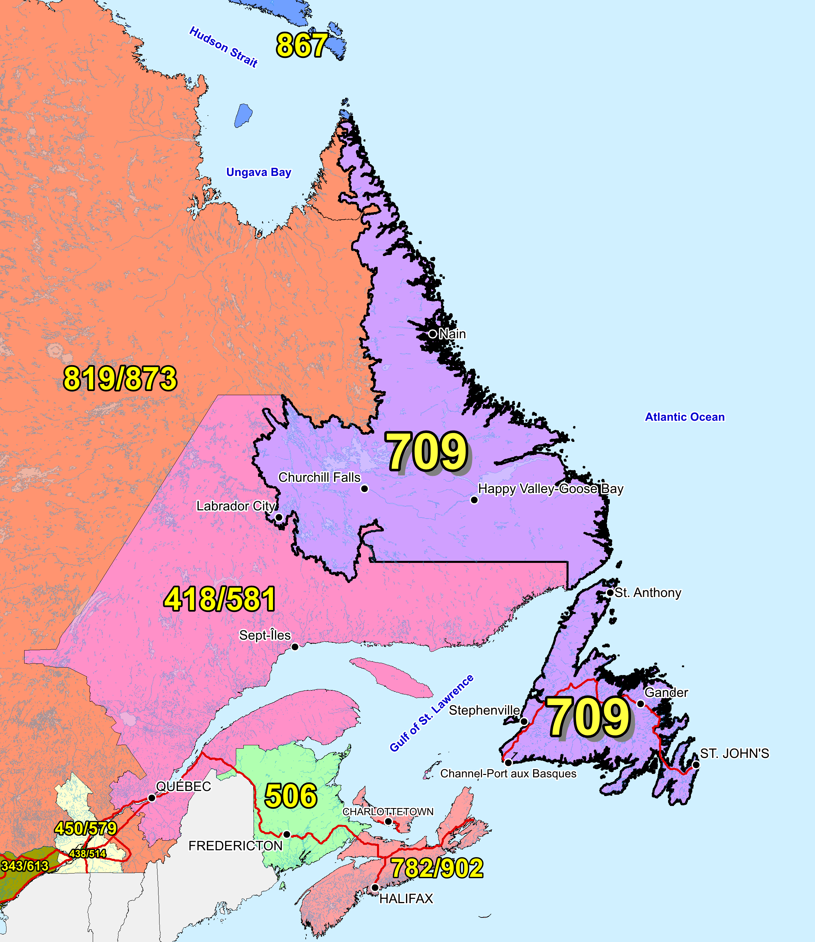

Figure 1 – Overview Map of NPA 709

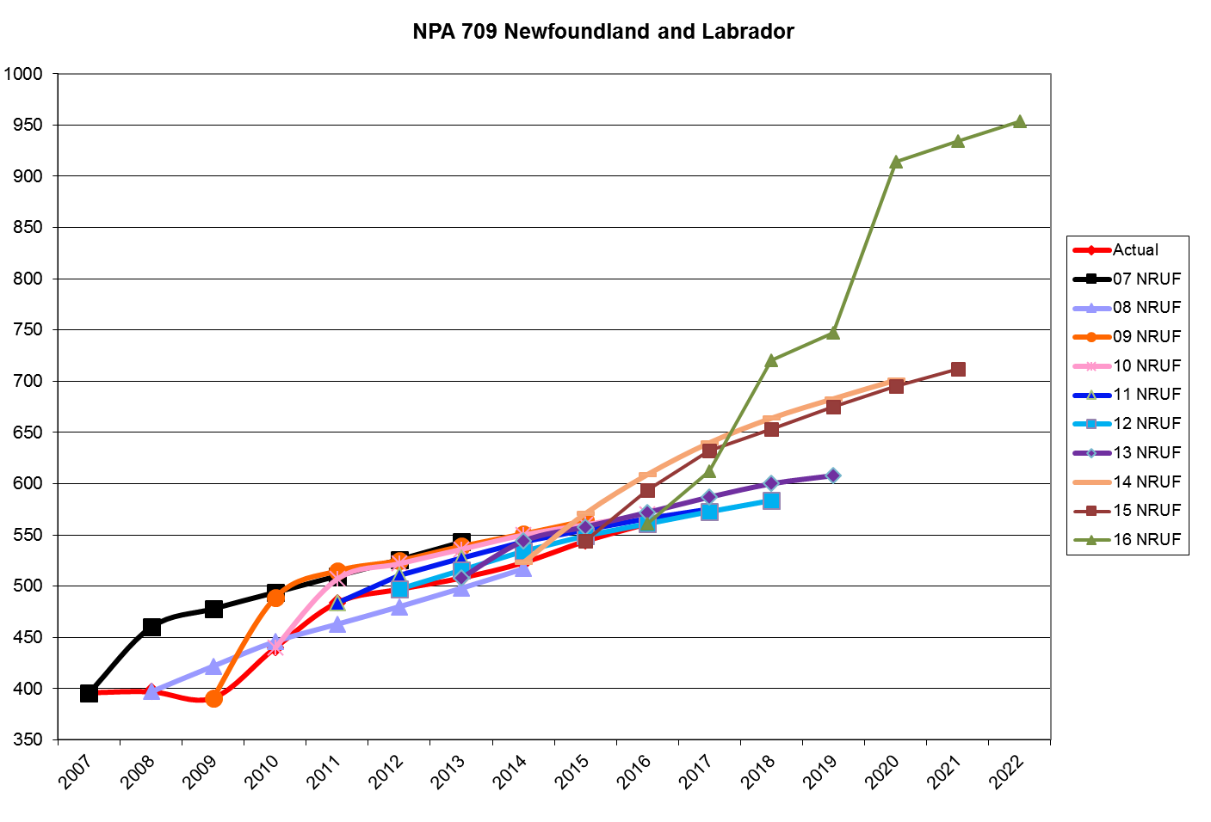

Figure 2 – NPA 709 Actual and Forecast CO Code Assignments



Figure 3 – NPA 709 CO Code Exhaust: April 2016 J-NRUF



Figure 4 – NPA 709 Admin and LEC+WSP Codes: April 2016 J‑NRUF



Figure 5 – NPA 709 CO Code Exhaust: May 2016 NoC & April 2016 J‑NRUF



Figure 6 – NPA 709 Admin and LEC+WSP Codes: May 2016 NoC and April 2016 J‑NRUF

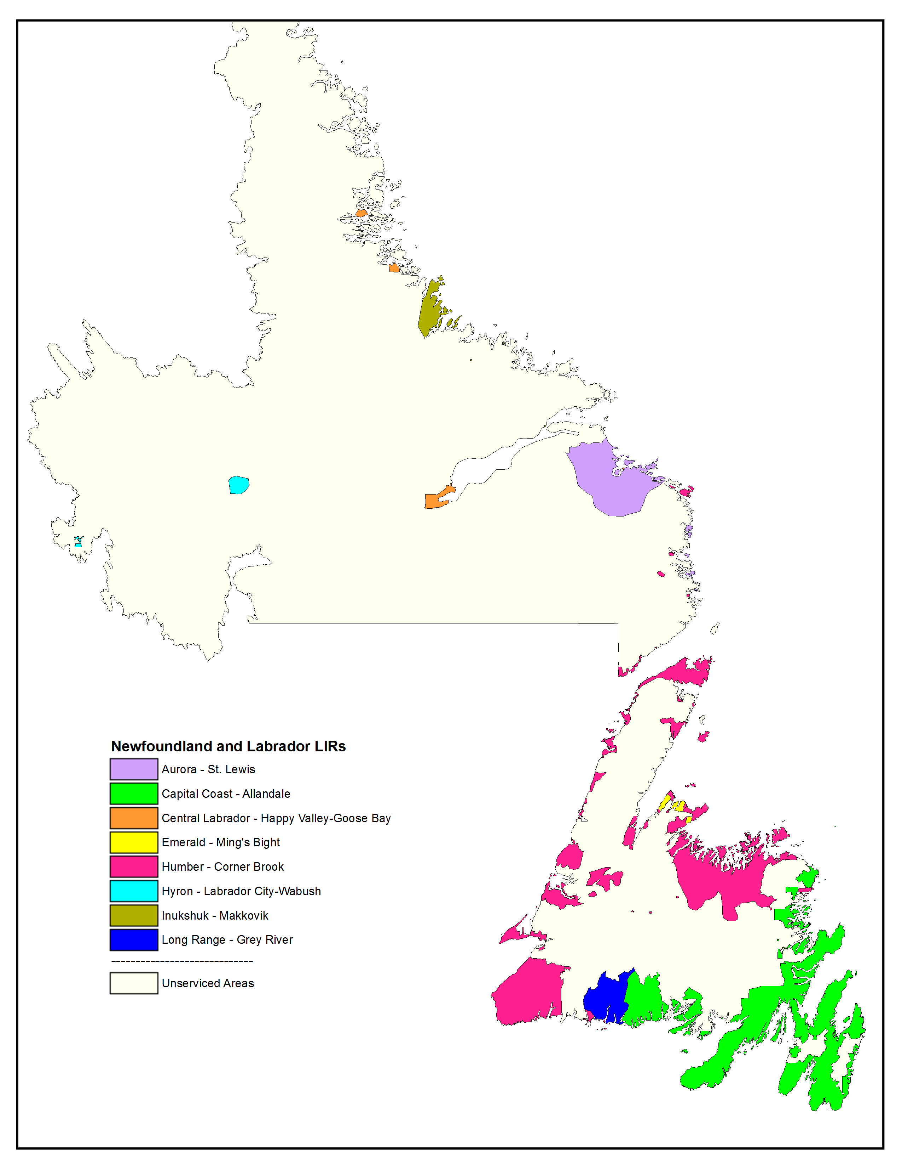

Figure 7 – NPA 709 LIRs

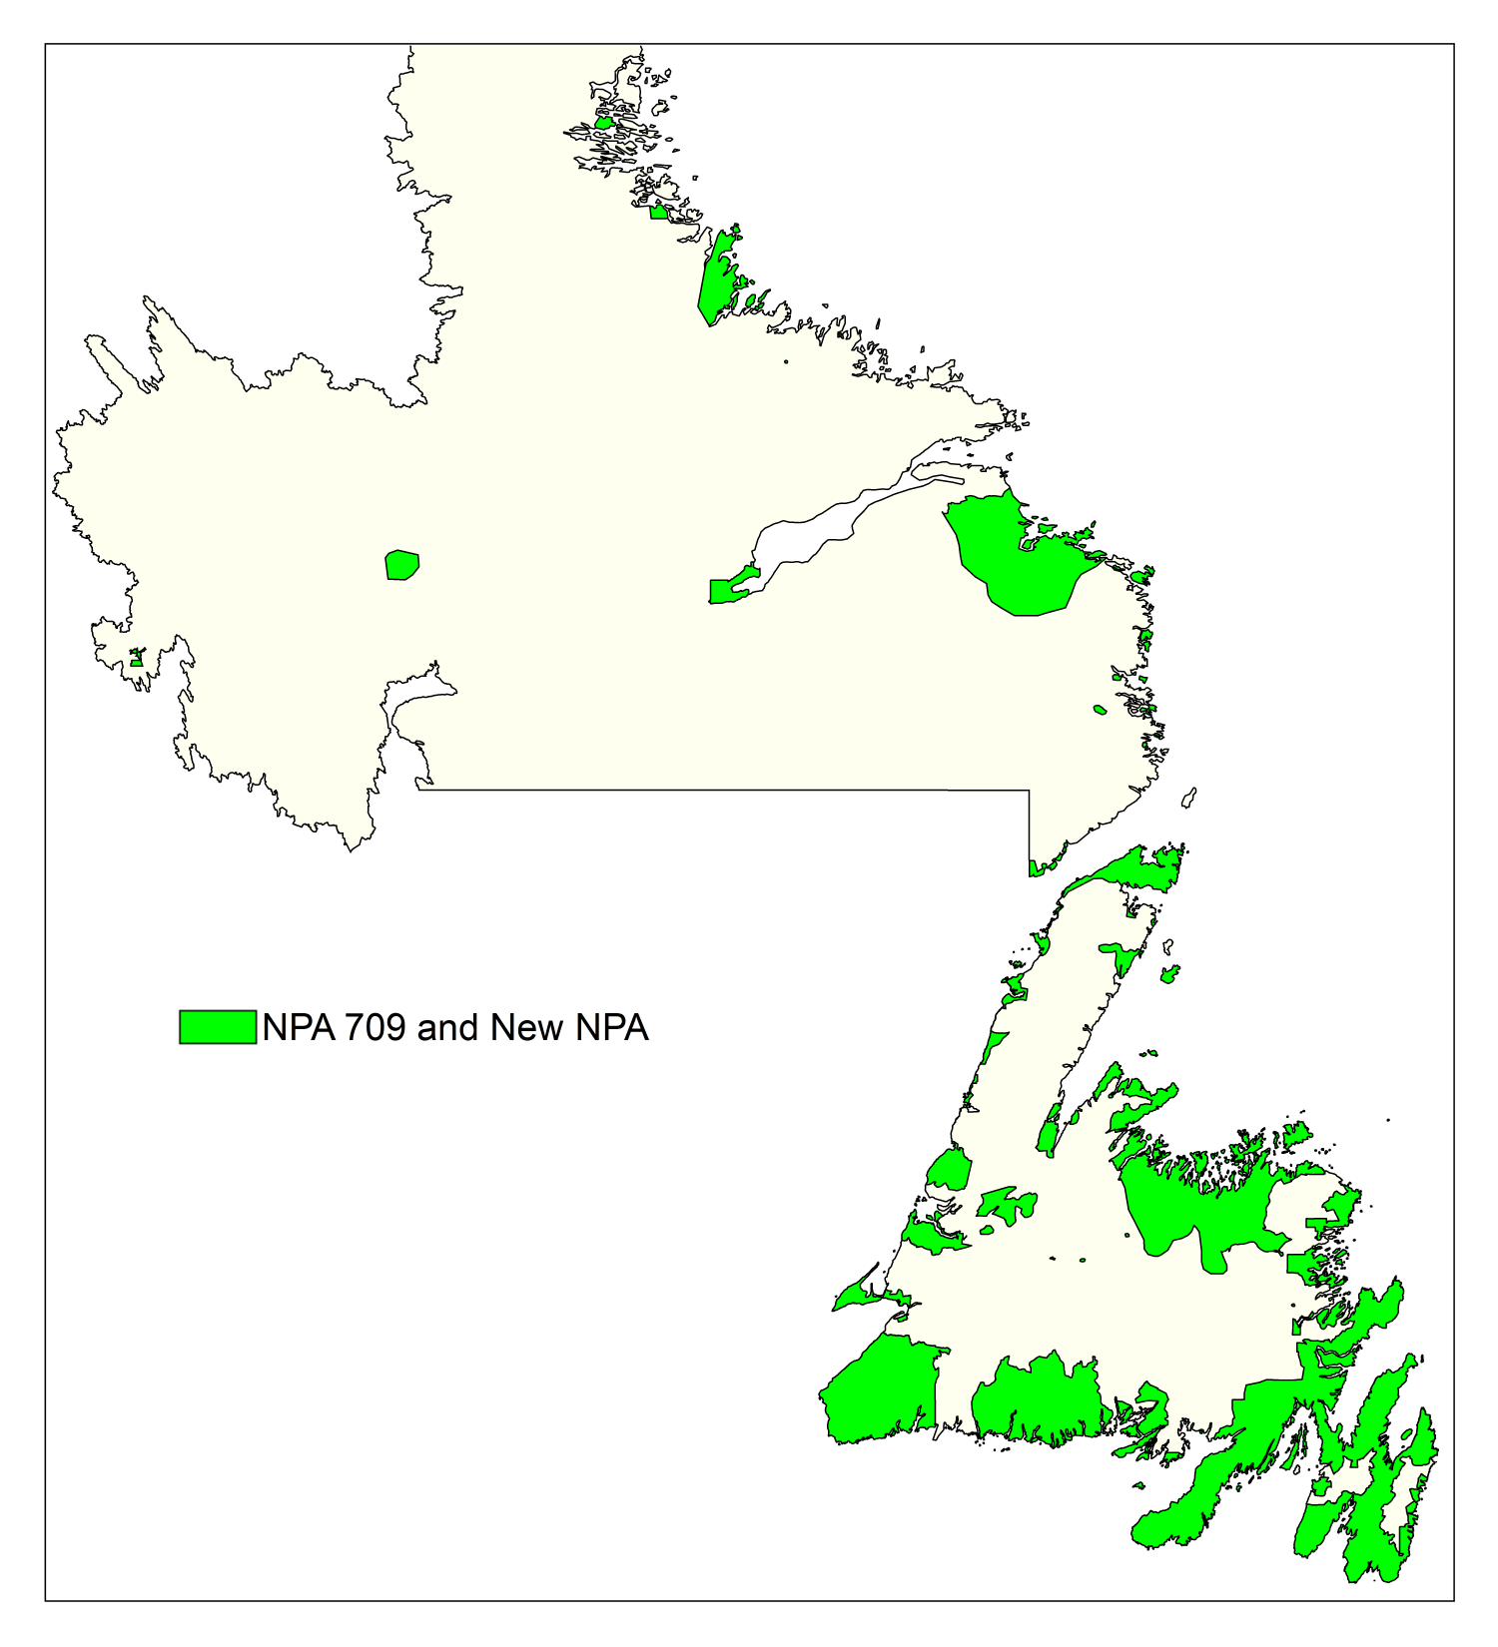

Figure 8 – Option 1: Distributed Overlay

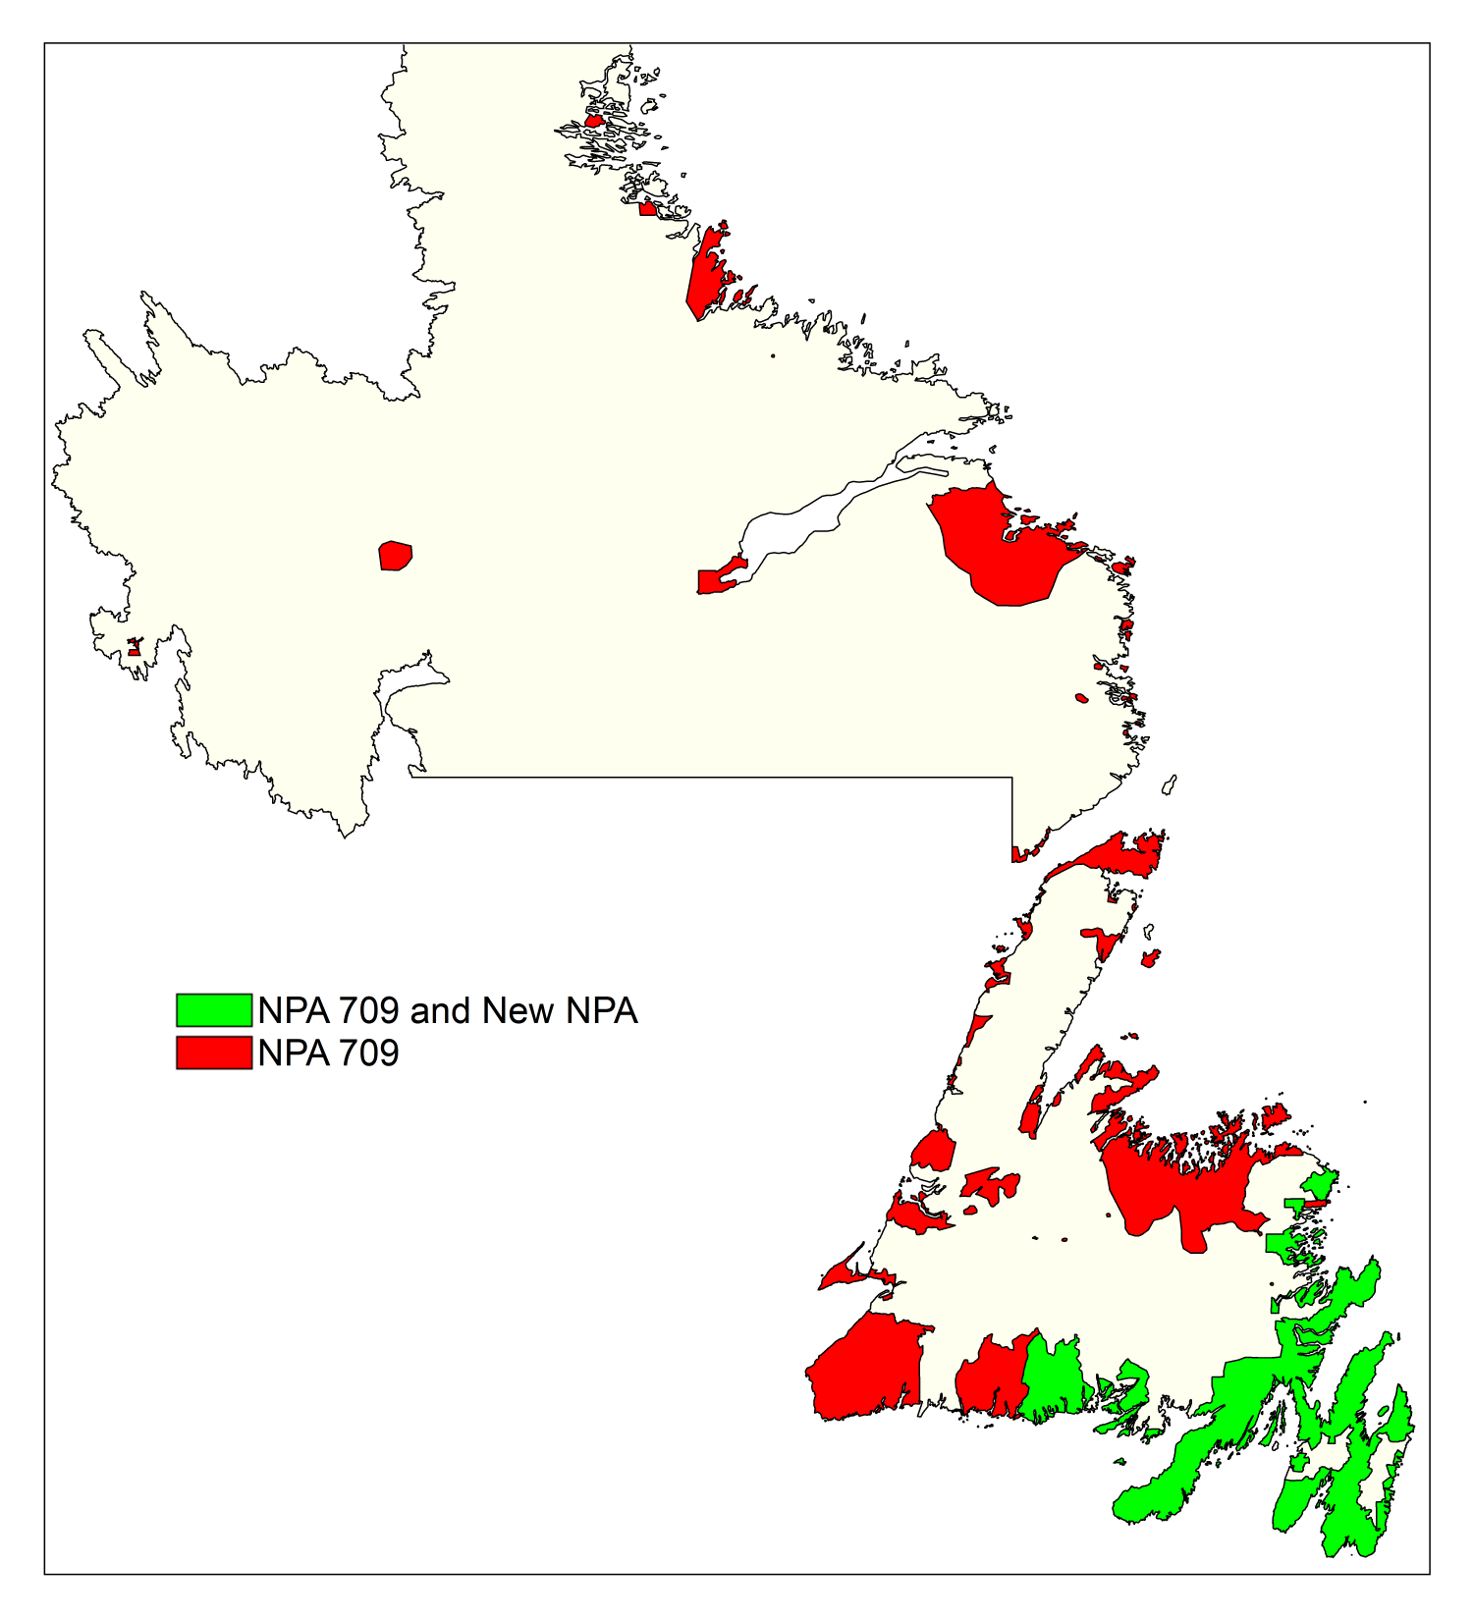

Figure 9 – Option 2: Concentrated Overlay of new NPA Code on Capital Coast LIR

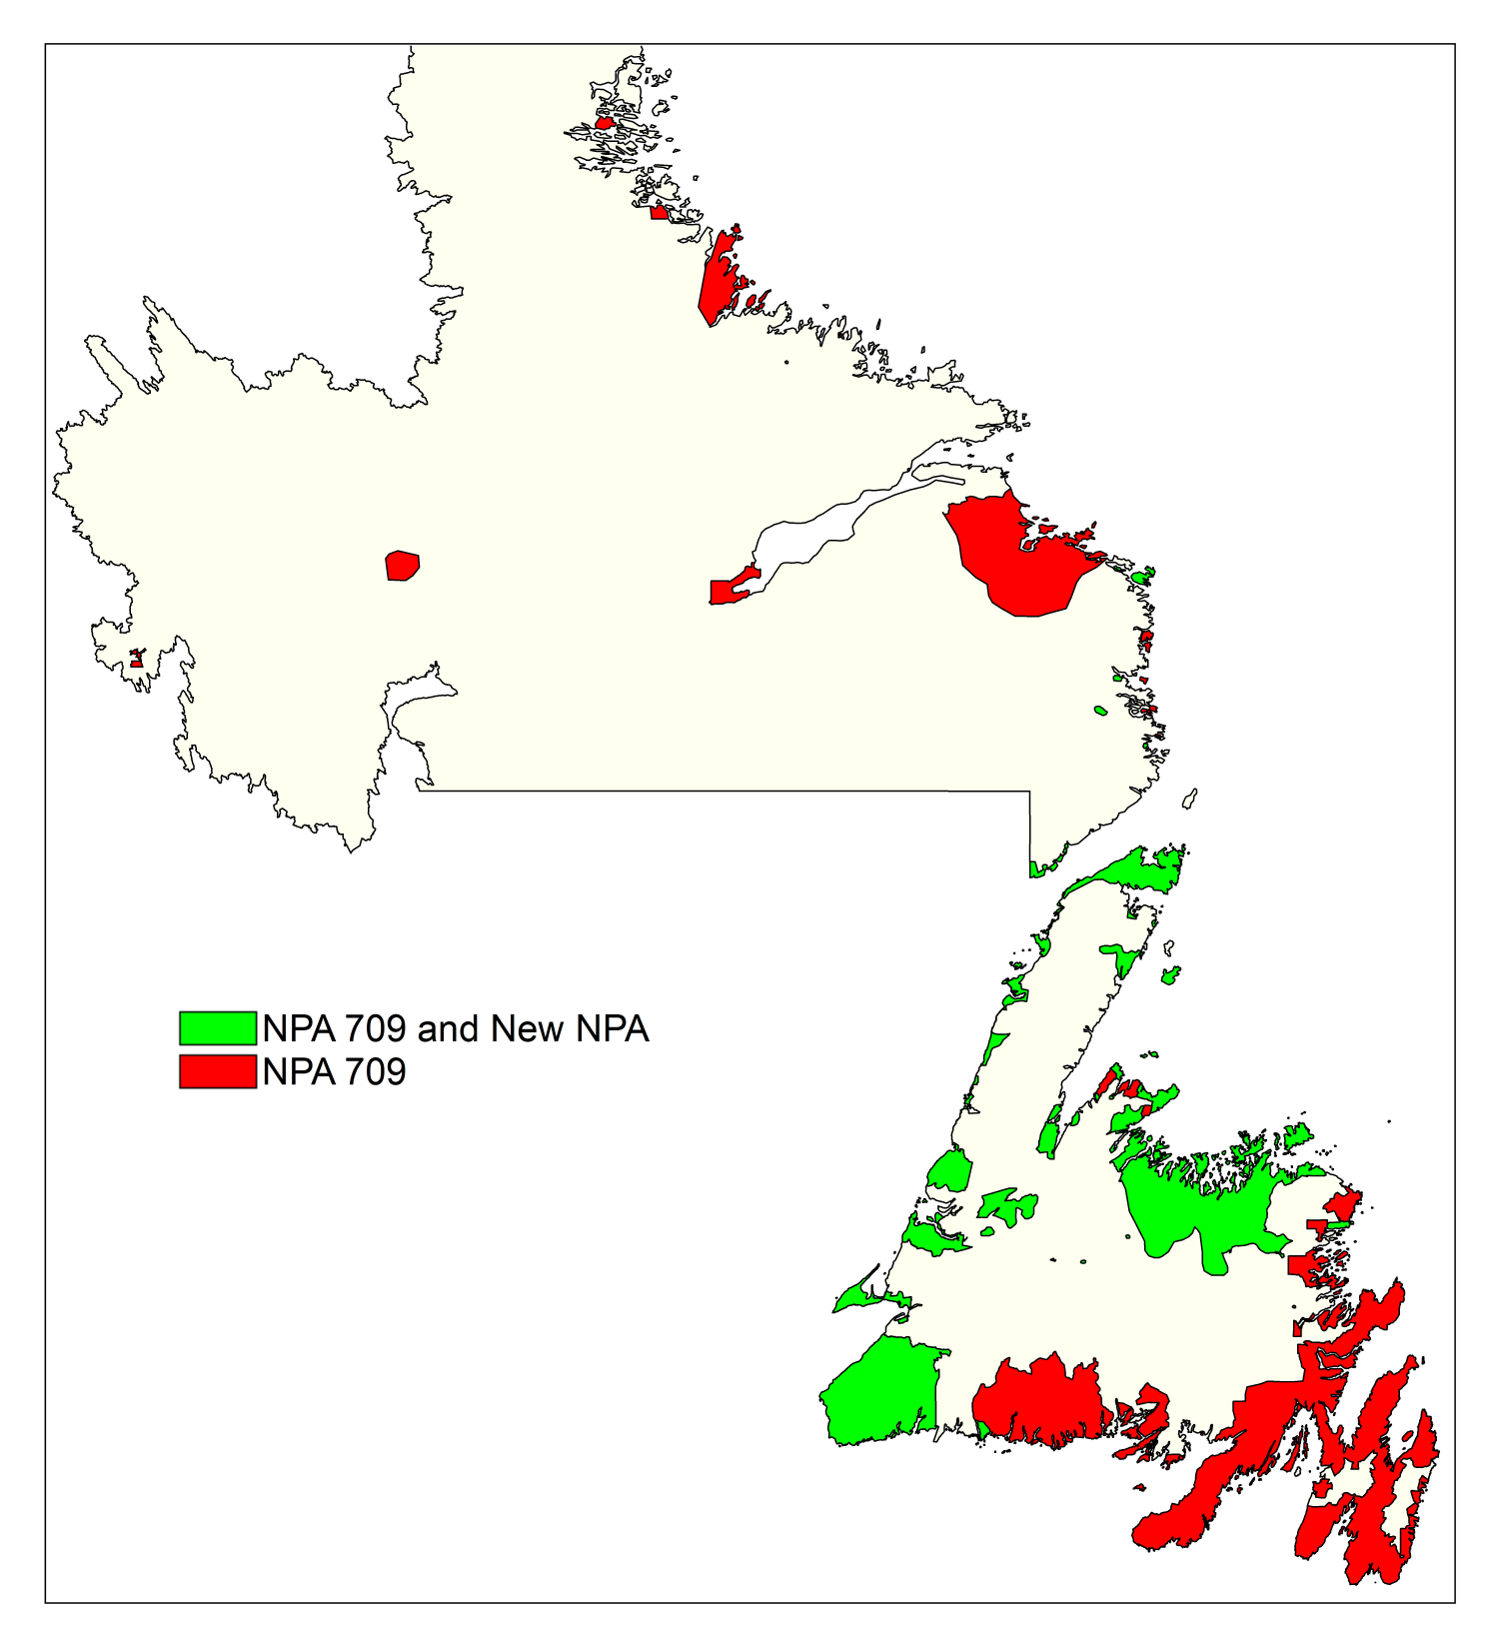

Figure 10 – Option 3: Concentrated Overlay of new NPA Code on Humber LIR

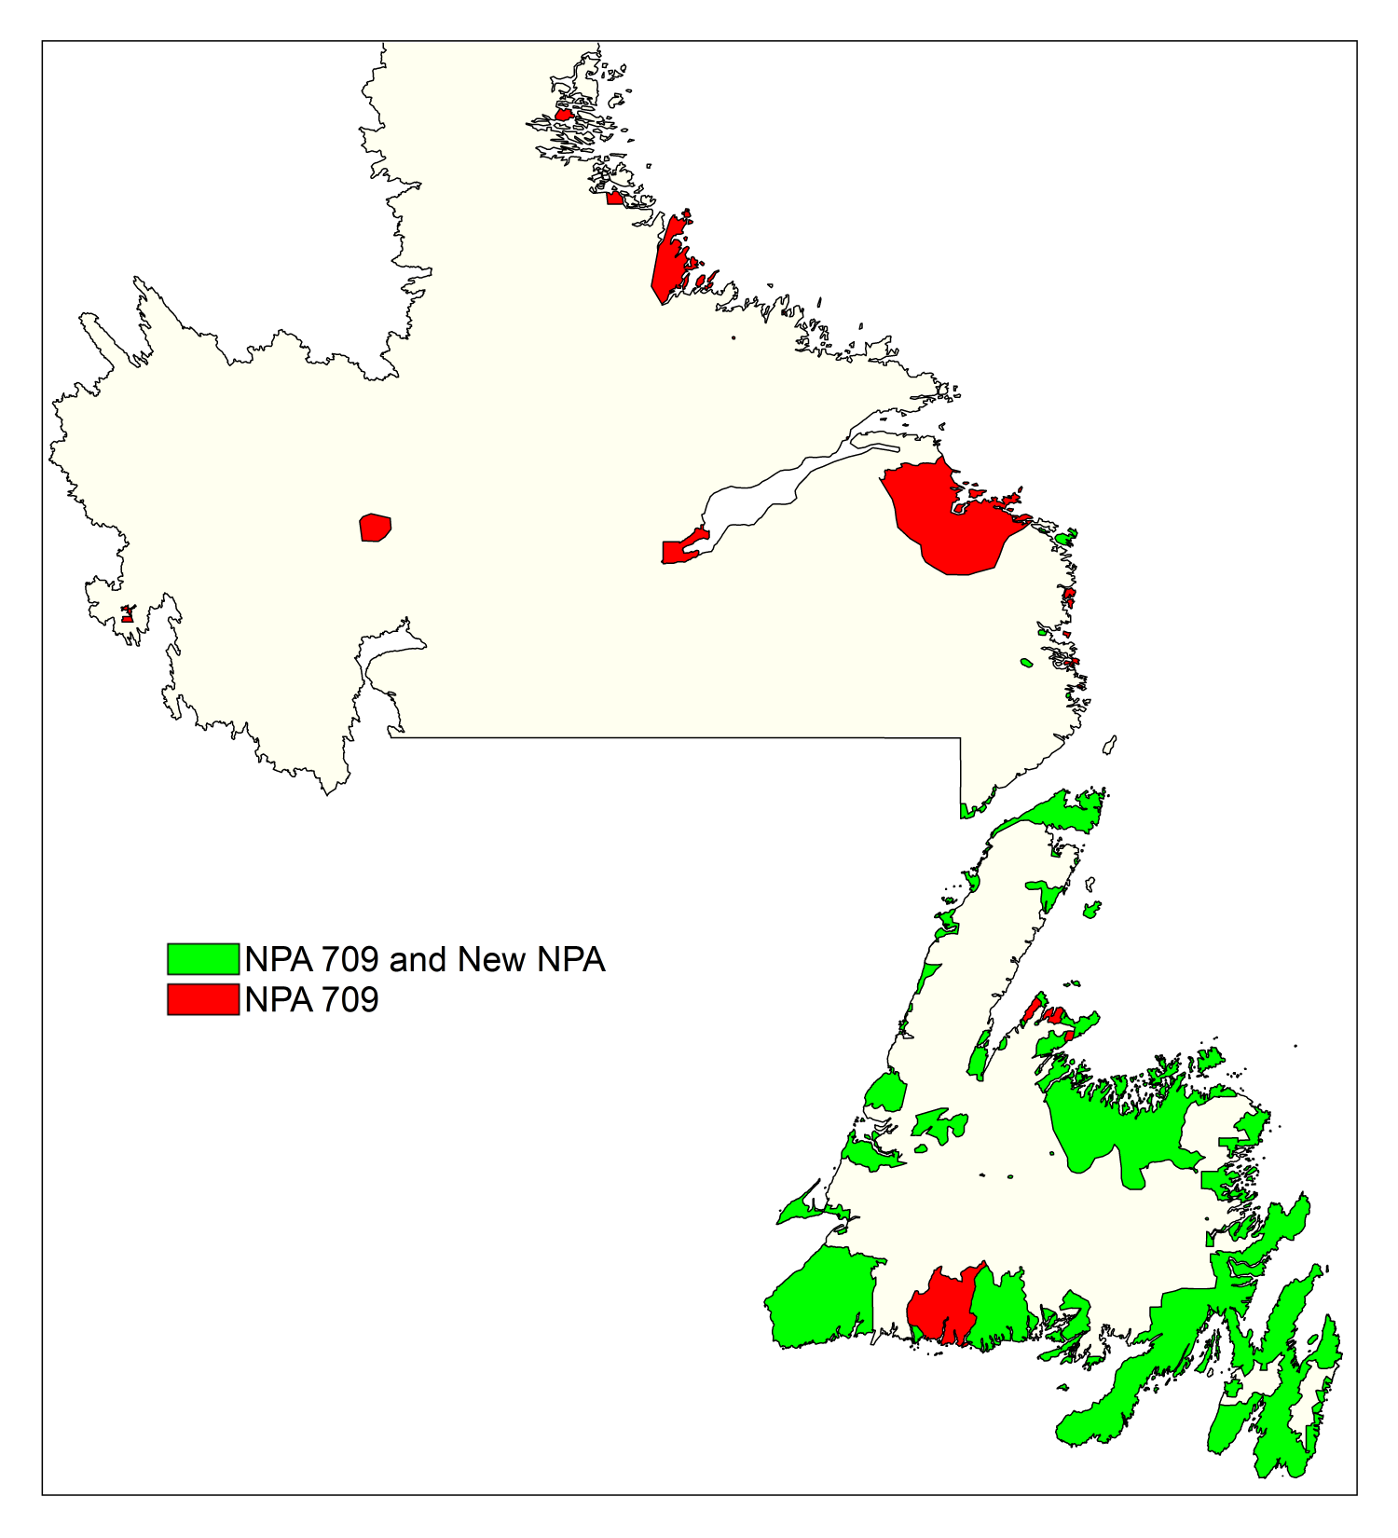

Figure 11 – Option 4: Concentrated Overlay of new NPA Code on Capital Coast & Humber LIRs

1. NPA 709 Exchange Areas

Table 1 – Exchange Areas in NPA 709 before and after each Relief Option

| **Exchange Area** | **DIST. OVERLAY** | | **CAPITALCST** | | **HUMBER** | | **CAPITALCST & HUMBER** | |
| --- | --- | --- | --- | --- | --- | --- | --- | --- |
| **709** | **New NPA** | **709** | **New NPA** | **709** | **New NPA** | **709** | **New NPA** |
| Arnold's Cove | ✓ | ✓ | ✓ | ✓ | ✓ |  | ✓ | ✓ |
| Badger | ✓ | ✓ | ✓ |  | ✓ | ✓ | ✓ | ✓ |
| Baie Verte | ✓ | ✓ | ✓ |  | ✓ | ✓ | ✓ | ✓ |
| Bay L'Argent | ✓ | ✓ | ✓ | ✓ | ✓ |  | ✓ | ✓ |
| Bay Roberts | ✓ | ✓ | ✓ | ✓ | ✓ |  | ✓ | ✓ |
| Beaumont | ✓ | ✓ | ✓ |  | ✓ | ✓ | ✓ | ✓ |
| Bell Island | ✓ | ✓ | ✓ | ✓ | ✓ |  | ✓ | ✓ |
| Belleoram | ✓ | ✓ | ✓ | ✓ | ✓ |  | ✓ | ✓ |
| Bellevue | ✓ | ✓ | ✓ | ✓ | ✓ |  | ✓ | ✓ |
| Benoit's Cove | ✓ | ✓ | ✓ |  | ✓ | ✓ | ✓ | ✓ |
| Birchy Bay | ✓ | ✓ | ✓ |  | ✓ | ✓ | ✓ | ✓ |
| Bishop's Falls | ✓ | ✓ | ✓ |  | ✓ | ✓ | ✓ | ✓ |
| Black Duck Cove | ✓ | ✓ | ✓ |  | ✓ | ✓ | ✓ | ✓ |
| Black Tickle | ✓ | ✓ | ✓ |  | ✓ | ✓ | ✓ | ✓ |
| Bonavista | ✓ | ✓ | ✓ | ✓ | ✓ |  | ✓ | ✓ |
| Botwood | ✓ | ✓ | ✓ |  | ✓ | ✓ | ✓ | ✓ |
| Boyd's Cove | ✓ | ✓ | ✓ |  | ✓ | ✓ | ✓ | ✓ |
| Branch | ✓ | ✓ | ✓ | ✓ | ✓ |  | ✓ | ✓ |
| Brent's Cove | ✓ | ✓ | ✓ |  | ✓ | ✓ | ✓ | ✓ |
| Brig Bay | ✓ | ✓ | ✓ |  | ✓ | ✓ | ✓ | ✓ |
| Brigus | ✓ | ✓ | ✓ | ✓ | ✓ |  | ✓ | ✓ |
| Brown's Arm | ✓ | ✓ | ✓ |  | ✓ | ✓ | ✓ | ✓ |
| Buchans | ✓ | ✓ | ✓ |  | ✓ | ✓ | ✓ | ✓ |
| Burgeo | ✓ | ✓ | ✓ |  | ✓ | ✓ | ✓ | ✓ |
| Burin | ✓ | ✓ | ✓ | ✓ | ✓ |  | ✓ | ✓ |
| Burlington | ✓ | ✓ | ✓ |  | ✓ | ✓ | ✓ | ✓ |
| Campbellton | ✓ | ✓ | ✓ |  | ✓ | ✓ | ✓ | ✓ |
| Cape Broyle | ✓ | ✓ | ✓ | ✓ | ✓ |  | ✓ | ✓ |
| Carbonear | ✓ | ✓ | ✓ | ✓ | ✓ |  | ✓ | ✓ |
| Carmanville | ✓ | ✓ | ✓ |  | ✓ | ✓ | ✓ | ✓ |
| Cartwright | ✓ | ✓ | ✓ |  | ✓ |  | ✓ |  |
| Catalina | ✓ | ✓ | ✓ | ✓ | ✓ |  | ✓ | ✓ |
| Centreville | ✓ | ✓ | ✓ | ✓ | ✓ |  | ✓ | ✓ |
| Chance Cove | ✓ | ✓ | ✓ | ✓ | ✓ |  | ✓ | ✓ |
| Change Islands | ✓ | ✓ | ✓ |  | ✓ | ✓ | ✓ | ✓ |
| Chapel Arm | ✓ | ✓ | ✓ | ✓ | ✓ |  | ✓ | ✓ |
| Charlottetown (Bonavista Bay) | ✓ | ✓ | ✓ | ✓ | ✓ |  | ✓ | ✓ |
| Charlottetown (Labrador) | ✓ | ✓ | ✓ |  | ✓ | ✓ | ✓ | ✓ |
| Churchill Falls | ✓ | ✓ | ✓ |  | ✓ |  | ✓ |  |
| Clarenville | ✓ | ✓ | ✓ | ✓ | ✓ |  | ✓ | ✓ |
| Clarke's Head | ✓ | ✓ | ✓ |  | ✓ | ✓ | ✓ | ✓ |
| Codroy | ✓ | ✓ | ✓ |  | ✓ | ✓ | ✓ | ✓ |
| Come By Chance | ✓ | ✓ | ✓ | ✓ | ✓ |  | ✓ | ✓ |
| Comfort Cove - Newstead | ✓ | ✓ | ✓ |  | ✓ | ✓ | ✓ | ✓ |
| Conche | ✓ | ✓ | ✓ |  | ✓ | ✓ | ✓ | ✓ |
| Cook's Harbour | ✓ | ✓ | ✓ |  | ✓ | ✓ | ✓ | ✓ |
| Coomb's Cove | ✓ | ✓ | ✓ | ✓ | ✓ |  | ✓ | ✓ |
| Corner Brook | ✓ | ✓ | ✓ |  | ✓ | ✓ | ✓ | ✓ |
| Cottrell's Cove | ✓ | ✓ | ✓ |  | ✓ | ✓ | ✓ | ✓ |
| Cow Head | ✓ | ✓ | ✓ |  | ✓ | ✓ | ✓ | ✓ |
| Daniel's Harbour | ✓ | ✓ | ✓ |  | ✓ | ✓ | ✓ | ✓ |
| Deer Lake | ✓ | ✓ | ✓ |  | ✓ | ✓ | ✓ | ✓ |
| Degras | ✓ | ✓ | ✓ |  | ✓ | ✓ | ✓ | ✓ |
| Eastport | ✓ | ✓ | ✓ | ✓ | ✓ |  | ✓ | ✓ |
| Englee | ✓ | ✓ | ✓ |  | ✓ | ✓ | ✓ | ✓ |
| English Harbour East | ✓ | ✓ | ✓ | ✓ | ✓ |  | ✓ | ✓ |
| English Harbour West | ✓ | ✓ | ✓ | ✓ | ✓ |  | ✓ | ✓ |
| Fairhaven | ✓ | ✓ | ✓ | ✓ | ✓ |  | ✓ | ✓ |
| Fermeuse | ✓ | ✓ | ✓ | ✓ | ✓ |  | ✓ | ✓ |
| Fleur De Lys | ✓ | ✓ | ✓ |  | ✓ | ✓ | ✓ | ✓ |
| Flower's Cove | ✓ | ✓ | ✓ |  | ✓ | ✓ | ✓ | ✓ |
| Fogo | ✓ | ✓ | ✓ |  | ✓ | ✓ | ✓ | ✓ |
| Forteau | ✓ | ✓ | ✓ |  | ✓ | ✓ | ✓ | ✓ |
| Francois | ✓ | ✓ | ✓ | ✓ | ✓ |  | ✓ | ✓ |
| Freshwater | ✓ | ✓ | ✓ | ✓ | ✓ |  | ✓ | ✓ |
| Gambo | ✓ | ✓ | ✓ | ✓ | ✓ |  | ✓ | ✓ |
| Gander | ✓ | ✓ | ✓ |  | ✓ | ✓ | ✓ | ✓ |
| Garden Cove | ✓ | ✓ | ✓ | ✓ | ✓ |  | ✓ | ✓ |
| Garnish | ✓ | ✓ | ✓ | ✓ | ✓ |  | ✓ | ✓ |
| Gaultois | ✓ | ✓ | ✓ | ✓ | ✓ |  | ✓ | ✓ |
| Glenwood | ✓ | ✓ | ✓ |  | ✓ | ✓ | ✓ | ✓ |
| Glovertown | ✓ | ✓ | ✓ | ✓ | ✓ |  | ✓ | ✓ |
| Grand Bank | ✓ | ✓ | ✓ | ✓ | ✓ |  | ✓ | ✓ |
| Grand Falls | ✓ | ✓ | ✓ |  | ✓ | ✓ | ✓ | ✓ |
| Grandois | ✓ | ✓ | ✓ |  | ✓ | ✓ | ✓ | ✓ |
| Green Island Cove | ✓ | ✓ | ✓ |  | ✓ | ✓ | ✓ | ✓ |
| Greenspond | ✓ | ✓ | ✓ |  | ✓ | ✓ | ✓ | ✓ |
| Grey River | ✓ | ✓ | ✓ |  | ✓ |  | ✓ |  |
| Griquet | ✓ | ✓ | ✓ |  | ✓ | ✓ | ✓ | ✓ |
| Hampden | ✓ | ✓ | ✓ |  | ✓ | ✓ | ✓ | ✓ |
| Happy Valley - Goose Bay | ✓ | ✓ | ✓ |  | ✓ |  | ✓ |  |
| Harbour Breton | ✓ | ✓ | ✓ | ✓ | ✓ |  | ✓ | ✓ |
| Harbour Main | ✓ | ✓ | ✓ | ✓ | ✓ |  | ✓ | ✓ |
| Hare Bay | ✓ | ✓ | ✓ | ✓ | ✓ |  | ✓ | ✓ |
| Harry's Harbour | ✓ | ✓ | ✓ |  | ✓ | ✓ | ✓ | ✓ |
| Hawkes Bay | ✓ | ✓ | ✓ |  | ✓ | ✓ | ✓ | ✓ |
| Heart's Content | ✓ | ✓ | ✓ | ✓ | ✓ |  | ✓ | ✓ |
| Heart's Delight | ✓ | ✓ | ✓ | ✓ | ✓ |  | ✓ | ✓ |
| Hermitage | ✓ | ✓ | ✓ | ✓ | ✓ |  | ✓ | ✓ |
| Hickman's Harbour | ✓ | ✓ | ✓ | ✓ | ✓ |  | ✓ | ✓ |
| Hillgrade | ✓ | ✓ | ✓ |  | ✓ | ✓ | ✓ | ✓ |
| Hillview | ✓ | ✓ | ✓ | ✓ | ✓ |  | ✓ | ✓ |
| Hopedale | ✓ | ✓ | ✓ |  | ✓ |  | ✓ |  |
| Horwood | ✓ | ✓ | ✓ |  | ✓ | ✓ | ✓ | ✓ |
| Island Harbour | ✓ | ✓ | ✓ |  | ✓ | ✓ | ✓ | ✓ |
| Isle Aux Morts | ✓ | ✓ | ✓ |  | ✓ | ✓ | ✓ | ✓ |
| Jackson's Arm | ✓ | ✓ | ✓ |  | ✓ | ✓ | ✓ | ✓ |
| Jamestown | ✓ | ✓ | ✓ | ✓ | ✓ |  | ✓ | ✓ |
| Jeffreys | ✓ | ✓ | ✓ |  | ✓ | ✓ | ✓ | ✓ |
| Joe Batt's Arm | ✓ | ✓ | ✓ |  | ✓ | ✓ | ✓ | ✓ |
| King's Cove | ✓ | ✓ | ✓ | ✓ | ✓ |  | ✓ | ✓ |
| King's Point | ✓ | ✓ | ✓ |  | ✓ | ✓ | ✓ | ✓ |
| L'Anse Au Loup | ✓ | ✓ | ✓ |  | ✓ | ✓ | ✓ | ✓ |
| Labrador City - Wabush | ✓ | ✓ | ✓ |  | ✓ |  | ✓ |  |
| Ladle Cove | ✓ | ✓ | ✓ |  | ✓ | ✓ | ✓ | ✓ |
| Lamaline | ✓ | ✓ | ✓ | ✓ | ✓ |  | ✓ | ✓ |
| LaPoile | ✓ | ✓ | ✓ |  | ✓ | ✓ | ✓ | ✓ |
| Lark Harbour | ✓ | ✓ | ✓ |  | ✓ | ✓ | ✓ | ✓ |
| LaScie | ✓ | ✓ | ✓ |  | ✓ | ✓ | ✓ | ✓ |
| Leading Tickles | ✓ | ✓ | ✓ |  | ✓ | ✓ | ✓ | ✓ |
| Lewisporte | ✓ | ✓ | ✓ |  | ✓ | ✓ | ✓ | ✓ |
| Little Bay | ✓ | ✓ | ✓ |  | ✓ | ✓ | ✓ | ✓ |
| Little Bay Islands | ✓ | ✓ | ✓ |  | ✓ | ✓ | ✓ | ✓ |
| Little Harbour | ✓ | ✓ | ✓ | ✓ | ✓ |  | ✓ | ✓ |
| Little Heart's Ease | ✓ | ✓ | ✓ | ✓ | ✓ |  | ✓ | ✓ |
| Long Harbour | ✓ | ✓ | ✓ | ✓ | ✓ |  | ✓ | ✓ |
| Long Pond | ✓ | ✓ | ✓ | ✓ | ✓ |  | ✓ | ✓ |
| Lourdes | ✓ | ✓ | ✓ |  | ✓ | ✓ | ✓ | ✓ |
| Lower Island Cove | ✓ | ✓ | ✓ | ✓ | ✓ |  | ✓ | ✓ |
| Lumsden | ✓ | ✓ | ✓ | ✓ | ✓ |  | ✓ | ✓ |
| Main Brook | ✓ | ✓ | ✓ |  | ✓ | ✓ | ✓ | ✓ |
| Makkovik | ✓ | ✓ | ✓ |  | ✓ |  | ✓ |  |
| Mary's Harbour | ✓ | ✓ | ✓ |  | ✓ | ✓ | ✓ | ✓ |
| Marystown | ✓ | ✓ | ✓ | ✓ | ✓ |  | ✓ | ✓ |
| McCallum | ✓ | ✓ | ✓ | ✓ | ✓ |  | ✓ | ✓ |
| McIvers | ✓ | ✓ | ✓ |  | ✓ | ✓ | ✓ | ✓ |
| Millertown | ✓ | ✓ | ✓ |  | ✓ | ✓ | ✓ | ✓ |
| Milltown | ✓ | ✓ | ✓ | ✓ | ✓ |  | ✓ | ✓ |
| Ming's Bight | ✓ | ✓ | ✓ |  | ✓ |  | ✓ |  |
| Monkstown | ✓ | ✓ | ✓ | ✓ | ✓ |  | ✓ | ✓ |
| Monroe | ✓ | ✓ | ✓ | ✓ | ✓ |  | ✓ | ✓ |
| Moreton's Harbour | ✓ | ✓ | ✓ |  | ✓ | ✓ | ✓ | ✓ |
| Mount Carmel | ✓ | ✓ | ✓ | ✓ | ✓ |  | ✓ | ✓ |
| Musgrave Harbour | ✓ | ✓ | ✓ |  | ✓ | ✓ | ✓ | ✓ |
| Musgravetown | ✓ | ✓ | ✓ | ✓ | ✓ |  | ✓ | ✓ |
| Nain | ✓ | ✓ | ✓ |  | ✓ |  | ✓ |  |
| Natuashish | ✓ | ✓ | ✓ |  | ✓ |  | ✓ |  |
| New Chelsea | ✓ | ✓ | ✓ | ✓ | ✓ |  | ✓ | ✓ |
| New Harbour | ✓ | ✓ | ✓ | ✓ | ✓ |  | ✓ | ✓ |
| Newman's Cove | ✓ | ✓ | ✓ | ✓ | ✓ |  | ✓ | ✓ |
| Nipper's Harbour | ✓ | ✓ | ✓ |  | ✓ |  | ✓ |  |
| Norman's Bay | ✓ | ✓ | ✓ |  | ✓ |  | ✓ |  |
| Norris Arm | ✓ | ✓ | ✓ |  | ✓ | ✓ | ✓ | ✓ |
| Northwest River | ✓ | ✓ | ✓ |  | ✓ |  | ✓ |  |
| Old Perlican | ✓ | ✓ | ✓ | ✓ | ✓ |  | ✓ | ✓ |
| Pacquet | ✓ | ✓ | ✓ |  | ✓ | ✓ | ✓ | ✓ |
| Paradise River | ✓ | ✓ | ✓ |  | ✓ |  | ✓ |  |
| Pasadena | ✓ | ✓ | ✓ |  | ✓ | ✓ | ✓ | ✓ |
| Petit Forte | ✓ | ✓ | ✓ | ✓ | ✓ |  | ✓ | ✓ |
| Pinsent's Arm | ✓ | ✓ | ✓ |  | ✓ |  | ✓ |  |
| Plate Cove | ✓ | ✓ | ✓ | ✓ | ✓ |  | ✓ | ✓ |
| Point Leamington | ✓ | ✓ | ✓ |  | ✓ | ✓ | ✓ | ✓ |
| Pool's Cove | ✓ | ✓ | ✓ | ✓ | ✓ |  | ✓ | ✓ |
| Port Albert | ✓ | ✓ | ✓ |  | ✓ | ✓ | ✓ | ✓ |
| Port Au Port | ✓ | ✓ | ✓ |  | ✓ | ✓ | ✓ | ✓ |
| Port Aux Basques | ✓ | ✓ | ✓ |  | ✓ | ✓ | ✓ | ✓ |
| Port Blandford | ✓ | ✓ | ✓ | ✓ | ✓ |  | ✓ | ✓ |
| Port Hope Simpson | ✓ | ✓ | ✓ |  | ✓ | ✓ | ✓ | ✓ |
| Port Rexton | ✓ | ✓ | ✓ | ✓ | ✓ |  | ✓ | ✓ |
| Port Saunders | ✓ | ✓ | ✓ |  | ✓ | ✓ | ✓ | ✓ |
| Portugal Cove | ✓ | ✓ | ✓ | ✓ | ✓ |  | ✓ | ✓ |
| Postville | ✓ | ✓ | ✓ |  | ✓ |  | ✓ |  |
| Pouch Cove | ✓ | ✓ | ✓ | ✓ | ✓ |  | ✓ | ✓ |
| Princeton | ✓ | ✓ | ✓ | ✓ | ✓ |  | ✓ | ✓ |
| Raleigh | ✓ | ✓ | ✓ |  | ✓ | ✓ | ✓ | ✓ |
| Ramea | ✓ | ✓ | ✓ |  | ✓ | ✓ | ✓ | ✓ |
| Red Bay | ✓ | ✓ | ✓ |  | ✓ | ✓ | ✓ | ✓ |
| Reef's Harbour | ✓ | ✓ | ✓ |  | ✓ | ✓ | ✓ | ✓ |
| Rencontre East | ✓ | ✓ | ✓ | ✓ | ✓ |  | ✓ | ✓ |
| Rigolet | ✓ | ✓ | ✓ |  | ✓ |  | ✓ |  |
| River Of Ponds | ✓ | ✓ | ✓ |  | ✓ | ✓ | ✓ | ✓ |
| Robert's Arm | ✓ | ✓ | ✓ |  | ✓ | ✓ | ✓ | ✓ |
| Rocky Harbour | ✓ | ✓ | ✓ |  | ✓ | ✓ | ✓ | ✓ |
| Roddickton | ✓ | ✓ | ✓ |  | ✓ | ✓ | ✓ | ✓ |
| Rose Blanche | ✓ | ✓ | ✓ |  | ✓ | ✓ | ✓ | ✓ |
| Rushoon | ✓ | ✓ | ✓ | ✓ | ✓ |  | ✓ | ✓ |
| Seal Cove (Fortune Bay) | ✓ | ✓ | ✓ | ✓ | ✓ |  | ✓ | ✓ |
| Seal Cove (White Bay) | ✓ | ✓ | ✓ |  | ✓ | ✓ | ✓ | ✓ |
| Seldom | ✓ | ✓ | ✓ |  | ✓ | ✓ | ✓ | ✓ |
| Sop's Arm | ✓ | ✓ | ✓ |  | ✓ | ✓ | ✓ | ✓ |
| South Brook | ✓ | ✓ | ✓ |  | ✓ | ✓ | ✓ | ✓ |
| Springdale | ✓ | ✓ | ✓ |  | ✓ | ✓ | ✓ | ✓ |
| St. Alban's | ✓ | ✓ | ✓ | ✓ | ✓ |  | ✓ | ✓ |
| St. Anthony | ✓ | ✓ | ✓ |  | ✓ | ✓ | ✓ | ✓ |
| St. Brendan's | ✓ | ✓ | ✓ | ✓ | ✓ |  | ✓ | ✓ |
| St. Bride's | ✓ | ✓ | ✓ | ✓ | ✓ |  | ✓ | ✓ |
| St. George's | ✓ | ✓ | ✓ |  | ✓ | ✓ | ✓ | ✓ |
| St. John's | ✓ | ✓ | ✓ | ✓ | ✓ |  | ✓ | ✓ |
| St. Lawrence | ✓ | ✓ | ✓ | ✓ | ✓ |  | ✓ | ✓ |
| St. Lewis | ✓ | ✓ | ✓ |  | ✓ |  | ✓ |  |
| St. Mary's | ✓ | ✓ | ✓ | ✓ | ✓ |  | ✓ | ✓ |
| Stephenville | ✓ | ✓ | ✓ |  | ✓ | ✓ | ✓ | ✓ |
| Stephenville Crossing | ✓ | ✓ | ✓ |  | ✓ | ✓ | ✓ | ✓ |
| Summerford | ✓ | ✓ | ✓ |  | ✓ | ✓ | ✓ | ✓ |
| Summerside | ✓ | ✓ | ✓ |  | ✓ | ✓ | ✓ | ✓ |
| Terra Nova | ✓ | ✓ | ✓ | ✓ | ✓ |  | ✓ | ✓ |
| Terrenceville | ✓ | ✓ | ✓ | ✓ | ✓ |  | ✓ | ✓ |
| Torbay | ✓ | ✓ | ✓ | ✓ | ✓ |  | ✓ | ✓ |
| Trepassey | ✓ | ✓ | ✓ | ✓ | ✓ |  | ✓ | ✓ |
| Triton | ✓ | ✓ | ✓ |  | ✓ | ✓ | ✓ | ✓ |
| Trout River | ✓ | ✓ | ✓ |  | ✓ | ✓ | ✓ | ✓ |
| Twillingate | ✓ | ✓ | ✓ |  | ✓ | ✓ | ✓ | ✓ |
| Upper Island Cove | ✓ | ✓ | ✓ | ✓ | ✓ |  | ✓ | ✓ |
| Wesleyville | ✓ | ✓ | ✓ | ✓ | ✓ |  | ✓ | ✓ |
| Western Bay | ✓ | ✓ | ✓ | ✓ | ✓ |  | ✓ | ✓ |
| Westport | ✓ | ✓ | ✓ |  | ✓ | ✓ | ✓ | ✓ |
| Whitbourne | ✓ | ✓ | ✓ | ✓ | ✓ |  | ✓ | ✓ |
| Wild Cove | ✓ | ✓ | ✓ |  | ✓ |  | ✓ |  |
| Williams Harbour | ✓ | ✓ | ✓ |  | ✓ |  | ✓ |  |
| Witless Bay | ✓ | ✓ | ✓ | ✓ | ✓ |  | ✓ | ✓ |
| Woody Point | ✓ | ✓ | ✓ |  | ✓ | ✓ | ✓ | ✓ |

Table 2 – Exchange Areas in each LIR

| **LIR Name** | **Exchange Name** |
| --- | --- |
| Aurora - St. Lewis | Norman's Bay |
| Aurora - St. Lewis | Paradise River |
| Aurora - St. Lewis | Pinsent's Arm |
| Aurora - St. Lewis | St. Lewis |
| Aurora - St. Lewis | Williams Harbour |
| Capital Coast - Allandale | Arnold's Cove |
| Capital Coast - Allandale | Bay L'Argent |
| Capital Coast - Allandale | Bay Roberts |
| Capital Coast - Allandale | Bell Island |
| Capital Coast - Allandale | Belleoram |
| Capital Coast - Allandale | Bellevue |
| Capital Coast - Allandale | Bonavista |
| Capital Coast - Allandale | Branch |
| Capital Coast - Allandale | Brigus |
| Capital Coast - Allandale | Burin |
| Capital Coast - Allandale | Cape Broyle |
| Capital Coast - Allandale | Carbonear |
| Capital Coast - Allandale | Catalina |
| Capital Coast - Allandale | Centreville |
| Capital Coast - Allandale | Chance Cove |
| Capital Coast - Allandale | Chapel Arm |
| Capital Coast - Allandale | Charlottetown (Bonavista Bay) |
| Capital Coast - Allandale | Clarenville |
| Capital Coast - Allandale | Come By Chance |
| Capital Coast - Allandale | Coomb's Cove |
| Capital Coast - Allandale | Eastport |
| Capital Coast - Allandale | English Harbour East |
| Capital Coast - Allandale | English Harbour West |
| Capital Coast - Allandale | Fairhaven |
| Capital Coast - Allandale | Fermeuse |
| Capital Coast - Allandale | Francois |
| Capital Coast - Allandale | Freshwater |
| Capital Coast - Allandale | Gambo |
| Capital Coast - Allandale | Garden Cove |
| Capital Coast - Allandale | Garnish |
| Capital Coast - Allandale | Gaultois |
| Capital Coast - Allandale | Glovertown |
| Capital Coast - Allandale | Grand Bank |
| Capital Coast - Allandale | Harbour Breton |
| Capital Coast - Allandale | Harbour Main |
| Capital Coast - Allandale | Hare Bay |
| Capital Coast - Allandale | Heart's Content |
| Capital Coast - Allandale | Heart's Delight |
| Capital Coast - Allandale | Hermitage |
| Capital Coast - Allandale | Hickman's Harbour |
| Capital Coast - Allandale | Hillview |
| Capital Coast - Allandale | Jamestown |
| Capital Coast - Allandale | King's Cove |
| Capital Coast - Allandale | Lamaline |
| Capital Coast - Allandale | Little Harbour |
| Capital Coast - Allandale | Little Heart's Ease |
| Capital Coast - Allandale | Long Harbour |
| Capital Coast - Allandale | Long Pond |
| Capital Coast - Allandale | Lower Island Cove |
| Capital Coast - Allandale | Lumsden |
| Capital Coast - Allandale | Marystown |
| Capital Coast - Allandale | McCallum |
| Capital Coast - Allandale | Milltown |
| Capital Coast - Allandale | Monkstown |
| Capital Coast - Allandale | Monroe |
| Capital Coast - Allandale | Mount Carmel |
| Capital Coast - Allandale | Musgravetown |
| Capital Coast - Allandale | New Chelsea |
| Capital Coast - Allandale | New Harbour |
| Capital Coast - Allandale | Newman's Cove |
| Capital Coast - Allandale | Old Perlican |
| Capital Coast - Allandale | Petit Forte |
| Capital Coast - Allandale | Plate Cove |
| Capital Coast - Allandale | Pool's Cove |
| Capital Coast - Allandale | Port Blandford |
| Capital Coast - Allandale | Port Rexton |
| Capital Coast - Allandale | Portugal Cove |
| Capital Coast - Allandale | Pouch Cove |
| Capital Coast - Allandale | Princeton |
| Capital Coast - Allandale | Rencontre East |
| Capital Coast - Allandale | Rushoon |
| Capital Coast - Allandale | Seal Cove (Fortune Bay) |
| Capital Coast - Allandale | St. Alban's |
| Capital Coast - Allandale | St. Brendan's |
| Capital Coast - Allandale | St. Bride's |
| Capital Coast - Allandale | St. John's |
| Capital Coast - Allandale | St. Lawrence |
| Capital Coast - Allandale | St. Mary's |
| Capital Coast - Allandale | Terra Nova |
| Capital Coast - Allandale | Terrenceville |
| Capital Coast - Allandale | Torbay |
| Capital Coast - Allandale | Trepassey |
| Capital Coast - Allandale | Upper Island Cove |
| Capital Coast - Allandale | Wesleyville |
| Capital Coast - Allandale | Western Bay |
| Capital Coast - Allandale | Whitbourne |
| Capital Coast - Allandale | Witless Bay |
| Central Labrador - Happy Valley-Goose Bay | Cartwright |
| Central Labrador - Happy Valley-Goose Bay | Happy Valley - Goose Bay |
| Central Labrador - Happy Valley-Goose Bay | Nain |
| Central Labrador - Happy Valley-Goose Bay | Natuashish |
| Central Labrador - Happy Valley-Goose Bay | Northwest River |
| Emerald - Ming's Bight | Ming's Bight |
| Emerald - Ming's Bight | Nipper's Harbour |
| Emerald - Ming's Bight | Wild Cove |
| Humber - Corner Brook | Badger |
| Humber - Corner Brook | Baie Verte |
| Humber - Corner Brook | Beaumont |
| Humber - Corner Brook | Benoit's Cove |
| Humber - Corner Brook | Birchy Bay |
| Humber - Corner Brook | Bishop's Falls |
| Humber - Corner Brook | Black Duck Cove |
| Humber - Corner Brook | Black Tickle |
| Humber - Corner Brook | Botwood |
| Humber - Corner Brook | Boyd's Cove |
| Humber - Corner Brook | Brent's Cove |
| Humber - Corner Brook | Brig Bay |
| Humber - Corner Brook | Brown's Arm |
| Humber - Corner Brook | Buchans |
| Humber - Corner Brook | Burgeo |
| Humber - Corner Brook | Burlington |
| Humber - Corner Brook | Campbellton |
| Humber - Corner Brook | Carmanville |
| Humber - Corner Brook | Change Islands |
| Humber - Corner Brook | Charlottetown (Labrador) |
| Humber - Corner Brook | Clarke's Head |
| Humber - Corner Brook | Codroy |
| Humber - Corner Brook | Comfort Cove - Newstead |
| Humber - Corner Brook | Conche |
| Humber - Corner Brook | Cook's Harbour |
| Humber - Corner Brook | Corner Brook |
| Humber - Corner Brook | Cottrell's Cove |
| Humber - Corner Brook | Cow Head |
| Humber - Corner Brook | Daniel's Harbour |
| Humber - Corner Brook | Deer Lake |
| Humber - Corner Brook | Degras |
| Humber - Corner Brook | Englee |
| Humber - Corner Brook | Fleur De Lys |
| Humber - Corner Brook | Flower's Cove |
| Humber - Corner Brook | Fogo |
| Humber - Corner Brook | Forteau |
| Humber - Corner Brook | Gander |
| Humber - Corner Brook | Glenwood |
| Humber - Corner Brook | Grand Falls |
| Humber - Corner Brook | Grandois |
| Humber - Corner Brook | Green Island Cove |
| Humber - Corner Brook | Greenspond |
| Humber - Corner Brook | Griquet |
| Humber - Corner Brook | Hampden |
| Humber - Corner Brook | Harry's Harbour |
| Humber - Corner Brook | Hawkes Bay |
| Humber - Corner Brook | Hillgrade |
| Humber - Corner Brook | Horwood |
| Humber - Corner Brook | Island Harbour |
| Humber - Corner Brook | Isle Aux Morts |
| Humber - Corner Brook | Jackson's Arm |
| Humber - Corner Brook | Jeffreys |
| Humber - Corner Brook | Joe Batt's Arm |
| Humber - Corner Brook | King's Point |
| Humber - Corner Brook | Ladle Cove |
| Humber - Corner Brook | L'Anse Au Loup |
| Humber - Corner Brook | La Poile |
| Humber - Corner Brook | Lark Harbour |
| Humber - Corner Brook | LaScie |
| Humber - Corner Brook | Leading Tickles |
| Humber - Corner Brook | Lewisporte |
| Humber - Corner Brook | Little Bay |
| Humber - Corner Brook | Little Bay Islands |
| Humber - Corner Brook | Lourdes |
| Humber - Corner Brook | Main Brook |
| Humber - Corner Brook | Mary's Harbour |
| Humber - Corner Brook | McIvers |
| Humber - Corner Brook | Millertown |
| Humber - Corner Brook | Moreton's Harbour |
| Humber - Corner Brook | Musgrave Harbour |
| Humber - Corner Brook | Norris Arm |
| Humber - Corner Brook | Pacquet |
| Humber - Corner Brook | Pasadena |
| Humber - Corner Brook | Point Leamington |
| Humber - Corner Brook | Port Albert |
| Humber - Corner Brook | Port Au Port |
| Humber - Corner Brook | Port Aux Basques |
| Humber - Corner Brook | Port Hope Simpson |
| Humber - Corner Brook | Port Saunders |
| Humber - Corner Brook | Raleigh |
| Humber - Corner Brook | Ramea |
| Humber - Corner Brook | Red Bay |
| Humber - Corner Brook | Reef's Harbour |
| Humber - Corner Brook | River of Ponds |
| Humber - Corner Brook | Robert's Arm |
| Humber - Corner Brook | Rocky Harbour |
| Humber - Corner Brook | Roddickton |
| Humber - Corner Brook | Rose Blanche |
| Humber - Corner Brook | Seal Cove (White Bay) |
| Humber - Corner Brook | Seldom |
| Humber - Corner Brook | Sop's Arm |
| Humber - Corner Brook | South Brook |
| Humber - Corner Brook | Springdale |
| Humber - Corner Brook | St. Anthony |
| Humber - Corner Brook | St. George's |
| Humber - Corner Brook | Stephenville |
| Humber - Corner Brook | Stephenville Crossing |
| Humber - Corner Brook | Summerford |
| Humber - Corner Brook | Summerside |
| Humber - Corner Brook | Triton |
| Humber - Corner Brook | Trout River |
| Humber - Corner Brook | Twillingate |
| Humber - Corner Brook | Westport |
| Humber - Corner Brook | Woody Point |
| Hyron - Labrador City-Wabush | Churchill Falls |
| Hyron - Labrador City-Wabush | Labrador City - Wabush |
| Inukshuk - Makkovik | Hopedale |
| Inukshuk - Makkovik | Makkovik |
| Inukshuk - Makkovik | Postville |
| Inukshuk - Makkovik | Rigolet |
| Long Range - Grey River | Grey River |

1. Distribution List

|  |  |
| --- | --- |
| CLEC Admin  Comwave Networks  61 Wildcat Road  Toronto, ON  Canada  M3J 2P5  clecteam@comwave.net | Andreea Badea  Iristel Inc.  11 Bowan Court  Toronto, ON  Canada  M2K 3A8  Telephone: 416-800-4747  abadea@iristel.ro |
| Rishi Bahall  Director, Netwok Engineering and Infrastructure  YAK Communications (Canada) Corp  48 Yonge St, Suite 1200  Toronto, ON  Canada  Telephone: 416-204-0224  Fax: 416-640-1089  Bahall@Globalive.com | Olena Bilozerska  Network Planning Manager I, TS CC Planning & Management  TELUS  200 Consilium Place, Floor 6  Scarborough, ON  Canada  M1H 3G2  Telephone: 647-837-1798  Olena.Bilozerska@telus.com |
| Doug Birdwise  Interested Party  109 Westpark Drive  Ottawa, ON  Canada  K1B 3G4  Telephone: 613-830-0081  douglas.birdwise@sympatico.ca | Samer Bishay  CEO  Iristel Inc.  11 Bowan Court  Toronto, ON  Canada  M2K 3A8  Telephone: 416-800-9999  Fax: 416-628-0891  sbishay@iristel.com |
| Eric Boer  Director, Voice Network Services  teliPhone Navigata-Westel  1210-200 Granville St  Vancouver, BC  Canada  V6C 1S4  Telephone: 604-990-2058  Fax: 604-990-2040  eric.boer@teliphone.com | Laurie Bowie  Network Planning  Bell Canada  100 Dundas Street, Floor 4G  London, ON  Canada  N6A 5B6  Telephone: 519-850-5818  laurie.bowie@bell.ca |
| Glen Brown  Division Manager  Leidos Canada Inc.  60 Queen Street, Suite 1516  Ottawa, ON  Canada  K1P 5Y7  Telephone: 613-683-3291  Fax: 613-563-3399  browng@leidos.ca | Kim Brown  Telephone Infrastructure Specialist  Eastlink  PO Box 8660, Station “A”: 6080 Young St, 7th Floor  Halifax, NS  Canada  B3K 5M3  Telephone: 902-446-3794  Fax: 902-405-3426  kim.brown@corp.eastlink.ca |
| Joseph Cabrera  Senior Analyst - Dispute Resolution and Regulatory Implementation  Canadian Radio-television and Telecommunications Commission  1 Promenade du Portage  Gatineau, QC  Canada  J8X 4B1  Telephone: 819-934-6352  Fax: 819-997-4610  joseph.cabrera@crtc.gc.ca | Geoffrey Carberry  Interested General Public  15 Pinware Crescent  Mount Pearl, NL  Canada  A1N 2M3  Telephone: 709-690-1256  GeoffCarberry@outlook.com |
| JF Champagne  Executive Director  Canadian Security Association, National Office  610 Alden Road, Suite 100  Markham, ON  Canada  L3R 9Z1  Telephone: 905-513-0622  Fax: 905-513-0624  jfchampagne@canasa.org | Fiona Clegg  CO Code Administration  Leidos Canada Inc.  60 Queen Street, Suite 1516  Ottawa, ON  Canada  K1P 5Y7  Telephone: 613-683-3285  Fax: 613-563-3399  cleggf@leidos.ca |
| David Comrie  CNA  Leidos Canada Inc.  1516 - 60 Queen Street  Ottawa, ON  Canada  K1P 5Y7  Telephone: 613-683-3287  Fax: 613-563-3399  comried@leidos.ca | Doug Cooper  Director, Netowrk Profitability and Planning  Primus Canada  5343 Dundas St W Suite 108  Toronto, ON  Canada  Telephone: 416-207-7760  dcooper@primustel.ca |
| Sue Coulter  Provisioning  Allstream  200 Wellington St West  Toronto, ON  M5V3G2  Telephone: 416-644-7398  sue.coulter@zayo.com | Irma Dulay  Primus Telecommunications Canada Inc.  500- 5343 Dundas St West  Toronto, ON  Canada  M9B 6K5  Telephone: 416-207-7151  Fax: 877-329-6875  idulay@primustel.ca |
| Mona Edmond  Director, Marketing & Communications  Canadian Security Association  610 Alden Road, Suite 100  Markham, ON  Canada  L3R 9Z1  Telephone: 905-513-0622 Ext 242  Fax: 905-513-0624  memond@canasa.org | Pierre Guynot de Boismenu  President  Bragg Communications Inc  60800 Young St 6th Floor  Halifax, NS  Canada  B3K5M3  Telephone: 902-414-8020  Fax: 902-444-1019  pierre.guynotdeboismenu@corp.eastlink.ca |
| Austin He  Network Planning Analyst,Carrier Relations,Network Profitability & Planning  Primus Telecommunications Canada Inc.  5343 Dundas Street W. Suite 500  Toronto, ON  Canada  M9B 6K5  Telephone: 416-207-3361  ahe@primustel.ca | Marian Hearn  Project Executive  Canadian LNP Consortium Inc.  350 Palladium Drive, Suite 208  Kanata, ON  Canada  K2V 1A8  Telephone: 613-287-0225  Fax: 800-406-9250  marian.hearn@clnpc.ca |
| Lynne Hewitson  Membership Manager  Canadian Security Association (CANASA)  610 Alden Road  Markham, ON  Canada  L3R 9Z1  Telephone: 905-513-0622 ext 223  Fax: 905-513-0624  membership@canasa.org | Larry Hishon  Vice-President Business Development  Fibernetics Corporation  583 Eastgate Walk  Waterloo, ON  Canada  N2K 2V9  Telephone: 519-571-7433  Fax: 519-772-5014  lhishon@fibernetics.ca |
| Stephanie Jackson  Manager - Public Services Integration; Traffic Engineering  Rogers Communications Canada Inc.  8200 Dixie Road  Brampton, ON  Canada  L6T 0C1  Telephone: 647-747-4402  Fax: 647-747-4557  stephanie.jackson@rci.rogers.com | Jasdev Kalsi  Senior Telecom Analyst  Rogers Communications Canada Inc.  800 de la Gauchetiere St West, Suite 4000  Montreal, QC  Canada  H5A 1K3  Telephone: 514-981-8442  jasdev.kalsi@rci.rogers.com |
| Suresh Khare  CO Code Manager  Leidos Canada Inc.  60 Queen Street, Suite 1516  Ottawa, ON  Canada  K1P 5Y7  Telephone: 613-683-3296  Fax: 613-563-3399  khares@leidos.ca | Natalie Lessard  CO Code Administration  Leidos Canada Inc.  60 Queen Street, Suite 1516  Ottawa, ON  Canada  K1P 5Y7  Telephone: 613-683-3288  Fax: 613-563-3399  lessardn@leidos.ca |
| Wanda Marie Mali  T/Manager - National Numbering Solutions  Bell Canada  100 Borough Dr, Floor 5 Blue  Scarborough, ON  M1P4W2  Telephone: 416-296-6076  Fax: 416-296-0685  wanda\_marie.mali@bell.ca | John C. Manning  Director  NANPA  46000 Center Oak Plaza  Sterling, VA  USA  20166  Telephone: 571-434-5770  Fax: 571-434-5502  john.manning@neustar.biz |
| Deirdre Massiah-Gomes  Manager - Technology Strategy  TELUS  200 Consilium Place, Suite 1600  Scarborough, ON  Canada  M1H 3J3  Telephone: 416-279-9000  Fax: 416-279-3949  deirdre.massiah-gomes@telus.com | Nicola McLaughlin  Team Lead  Allstream  200 Wellington St W. F12  Toronto, ON  Canada  M5V 3G2  Telephone: 416-640-5271  nicola.mclaughlin@zayo.com |
| Sundar Nagulan  SS7 Voice Engineer  Comwave Networks  61 Wildcat Rd  Toronto, ON  M3J 2P5  Telephone: 416-663-9700 X 3210  snagulan@comwave.net | Catherine O’Grady  Senior Manager, Provisioning  Allstream  200 Wellington St W. F12  Toronto, ON  Canada  M5V 3G2  Telephone: 416-644-9703  catherine.ogrady@zayo.com |
| Valerie Plaskacz  Canadian Radio-television and Telecommunications Commission  1 Promenade du Portage  Gatineau, QC  Canada  J8X 4B1  Telephone: 819-994-1576  Valerie.Plaskacz@crtc.gc.ca | Michelle Preda  Regulatory Affairs Manager  Iristel  675 Cochrane Dr  Markham, ON  L3R0B8  Telephone: 416-800-0032  mpreda@iristel.ro |
| Lucie Pugliese  Administrator  Numbering Alliance  1575 Saturne  Brossard, QC  Canada  J4X 1N4  Telephone: 450-465-8277  Fax: 450-465-0703  lucie.pugliese@sympatico.ca | Karen Robinson  Telus Mobility  200 Consilium Place  Scarborough, ON  Canada  M1H 3J3  Telephone: 416-279-3053  Karen.Robinson3@telus.com |
| Leo Santoro  Network Analyst  Bell Mobility  5115 Creekbank Rd, Floor 3  Mississauga, ON  Canada  L4W 5R1  Telephone: 905-282-3021  Fax: 905-282-3106  leo.santoro@bell.ca | Rick Schleihauf  Vice President Regulatory Affairs & Carrier Relations  Fibernetics Corporation  605 Boxwood Drive  Cambridge, ON  Canada  N3E 1A5  Telephone: 519-489-6700 ext 629  Fax: 519-653-7686  rschleihauf@fibernetics.ca |
| Gerry Thompson  Manager, Intercarrier Relations  Rogers Communications Canada Inc.  333 Bloor Street East, 9th Floor  Toronto, ON  Canada  M4W 1G9  Telephone: 416-935-5239  Fax: 416-935-7719  Gerry.Thompson@rci.rogers.com | Eric Unrau  Director Marketing & Product Development  Teliphone Navigata-Westel Communication Inc  1210-200 Granville St  Vancouver, BC  Canada  V6G 1S4  Telephone: 604-990-2084  Fax: 604-990-2092  eric.unrau@teliphone.ca |
| Kelly Walsh  Company Security Officer / Senior System Specialist  Leidos Canada Inc.  60 Queen Street, Suite 1516  Ottawa, ON  Canada  K1P 5Y7  Telephone: 613-683-3290  Fax: 613-563-3399  walshkel@leidos.ca | Albert Yin  Comwave Networks Inc.  Telephone: 416-663-9700 Ext 330  Fax: 416-736-3165  ayin@comwave.net |

1. A New Entrant is an entity who, at the time of their first request for assignment of CO Code(s) in an NPA, does not provide any telecommunications services and does not hold any CO Codes within the boundaries of the NPA. [↑](#footnote-ref-1)