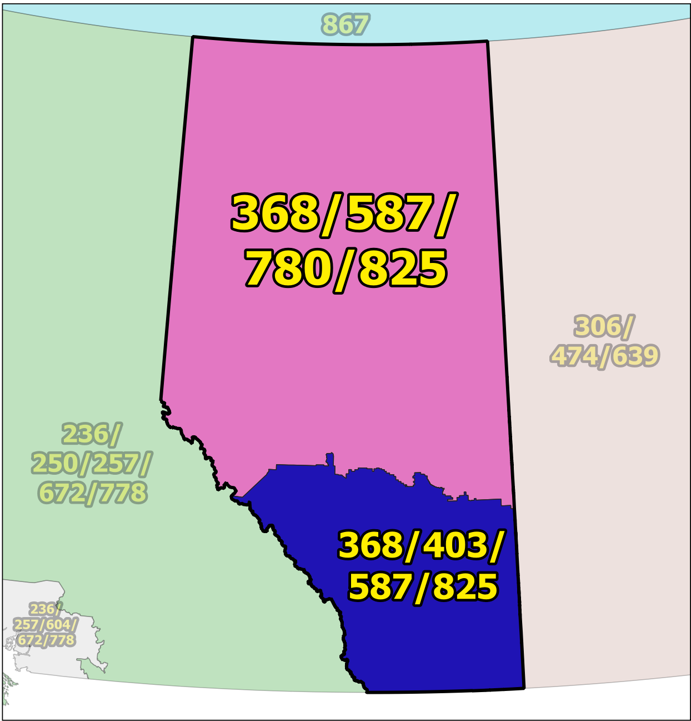

NPA 368/403/587/780/825 Planning Document (PD)
Version 1.0 – 25 June 2026

TABLE OF CONTENTS

1. INTRODUCTION 1
2. NPA RELIEF PLANNING PROCESS 2
3. NPA RELIEF METHODS 3
4. NPA EXHAUST INFORMATION 3
5. RELIEF OPTION 4
5.1 Distributed Overlay 4
SUMMARY OF RELIEF OPTION 4
6. DIALLING CHANGES FOR LOCAL CALLS 5
7. PROPOSED RELIEF DATE 5
8. PROPOSED SCHEDULE 5
9. JEOPARDY CONTINGENCY PLAN (JCP) 0
10. SELECTION OF RELIEF NPA CODE 1
11. RECOMMENDATIONS 1
ANNEXES 2

LIST OF ANNEXES

ANNEX A

Figure 1 – Overview Map of NPA 368/403/587/780/825 1
Figure 2 – NPA 368/403/587/780/825 Actual and Forecast CO Code Assignments 2
Figure 3 – 368/403/587/780/825 CO Code Exhaust – January 2025 G-NRUF 2
Figure 4 – Distributed Overlay 3

ANNEX B

Table 1 – NPA 368/403/587/780/825 Exchange Areas After Distributed Overlay B-1

ACRONYM LIST
CATF | Consumer Awareness Task Force
CNA | Canadian Numbering Administrator
CISC | CRTC Interconnection Steering Committee
CLEC | Competitive Local Exchange Carrier
CLNPC | Canadian Local Number Portability Consortium
CO | Central Office
CRTC | Canadian Radio-television and Telecommunications Commission
CSCN | Canadian Steering Committee on Numbering
EAS | Extended Area Service
G-NRUF | General Numbering Resource Utilization Forecast
ILEC | Incumbent Local Exchange Carrier
IPD | Initial Planning Document
ISP | Internet Service Provider
JCP | Jeopardy Contingency Plan
J-NRUF | Jeopardy Numbering Resource Utilization Forecast
LEC | Local Exchange Carrier
LIR | Local Interconnection Region
LNP | Local Number Portability
NANP | North American Numbering Plan
NANPA | North American Numbering Plan Administrator
NITF | Network Implementation Task Force
NoC | Notice of Consultation
NPA | Numbering Plan Area (area code)
NRUF | Numbering Resource Utilization Forecast
PD | Planning Document
PED | Projected Exhaust Date
PL | Planning Letter
POI | Point of Interconnection
PROC | Proposal for Relief of an Overlay NPA Complex
PSAP | Public Safety Answering Point
RIP | Relief Implementation Plan
R-NRUF | Relief Planning Numbering Resource Utilization Forecast
RPC | Relief Planning Committee
TSP | Telecommunications Service Provider
WNP | Wireless Number Portability
WSP | Wireless Service Provider

Planning Document (PD) for Relief of an Overlay NPA Complex
Numbering Plan Area (NPA) 368/403/587/780/825

INTRODUCTION

Numbering Plan Area (NPA) 403, commonly referred to as an area code, was originally assigned to Alberta by AT&T in 1947 as one of the 86 area codes to be used in Canada and the continental United States.

In January 1999 NPA 780 was split from NPA 403. NPA 403 was retained in southern Alberta (Calgary) while NPA 780 became the area code for northern Alberta (Edmonton). The following table provides a high level summary of the history of area code usage in the area currently served by NPA 368/403/587/780/825 since 1947.

Year | Activity
1947 | Area code 403 is assigned to Alberta by AT&T
1999  (January) | Area code 403 is split. New area code 780 for northern Alberta (Edmonton) and 403 is retained for southern Alberta (Calgary)
2008  (September) | New area code 587 overlay of 403 and 780 to serve all of Alberta (province-wide overlay); mandatory ten-digit local dialling implemented (mandatory ten-digit local dialling becomes universal in the Province of Alberta)
2016  (April) | New area code 825 overlay of 403, 587 and 780 to serve all of Alberta (province-wide overlay)
2022  (April) | New area code 368 overlay of 403, 587, 780 and 825 to serve all of Alberta (province-wide overlay)

Forecast results from the January 2026 S-NRUF indicate NPA 368/403/587/780/825 is projected to exhaust in February 2029.

NPAs neighbouring NPA 368/403/587/780/825 that could be affected by this relief activity include 236/250/257/604/672/778, 306/474/639, and 867.

Area code 368/403/587/780/825 consists of 337 Exchange Areas, including Exchange Areas of Airdrie, Calgary, Edmonton, Fort McMurray, Grande Prairie, Lethbridge, Medicine Hat and Red Deer. A list of the Exchange Areas in NPA 368/403/587/780/825 is provided in Annex B.

The table below provides a brief overview of recent activities leading to the development of this PD for NPA 368/403/587/780/825.

Date | Activity
14 June 2022 | The CSCN submitted CNRE134A which included a recommendation to set aside NPA 568 for future relief of NPA 368/403/587/780/825.  For the purposes of this document the new NPA will be 568.
25 March 2026 | January 2026 Numbering Resource Utilization Forecast (NRUF) indicated that NPA 368/403/587/780/825 was forecast to exhaust within 33 months with a Projected Exhaust Date (PED) of February 2029.
14 May 2026 | The CRTC issued Telecom Notice of Consultation CRTC 2026-88 – Establishment of a CISC ad hoc committee for relief planning for area codes 368, 403, 587, 780, and 825 in Alberta

This Planning Document is prepared by the RPC in accordance with Telecom Notice of Consultation CRTC 2026-88 and the Canadian NPA Relief Planning Guideline (the Guideline). A copy of the Guideline is available from the CRTC, CRTC Interconnection Steering Committee (CISC), Canadian Steering Committee on Numbering (CSCN) guidelines web page at: https://crtc.gc.ca/cisc/eng/cisf3fg.htm.

The objective of the NPA Relief Planning process is to ensure that Central Office (CO) Codes and telephone numbers are always available for use by Telecommunications Service Providers (TSPs) and their customers in the geographic area requiring relief.

It is very important to closely monitor the CO Code requirements of all existing and prospective CO Code Holders so that relief can be timed to ensure that CO Codes and telephone numbers are always available for service providers and customers.

In this PD, a single option is identified for providing NPA relief in the NPA 368/403/587/780/825 geographic area. Given the magnitude of this undertaking, intercompany commitment and co-operation are essential throughout the planning, provisioning and implementation stages of the introduction of the new NPA.

NPA RELIEF PLANNING PROCESS

The NPA Relief Planning process and the roles of the participants (i.e. CRTC, CNA, CISC, Relief Planning Committee (RPC) participants and Interested Parties) for NPA Relief Planning are identified in the Guideline.

To increase public awareness and participation in the NPA Relief Planning process, the CRTC has determined that NPA RPCs will be established as ad hoc committees of the CISC. Generally, a separate ad hoc committee is created to deal with relief in each area code. The CNA, in its function as NPA Relief Planning Coordinator, acts as chair of these ad hoc committees. Meetings and conference calls of the ad hoc NPA RPCs are all open to public participation and are conducted in accordance with the CISC Administrative Guidelines which are available from the CRTC website at: https://crtc.gc.ca/cisc/eng/cag.htm

NPA Relief Planning is conducted under the regulatory oversight of the CRTC. Notwithstanding the process detailed in the Guideline, the CRTC may exercise its authority under the Telecommunications Act to alter this process at any time. The CRTC has the authority under the Telecommunications Act to review, modify and give final approval to the Planning Document (PD) and the Relief Implementation Plan (RIP) developed and submitted by the RPC to the CRTC via the CISC process.

Section 7.1.6 of the Canadian NPA Relief Planning Guideline requires the CNA to create and maintain a distribution list of parties who may be interested in participating in the RPC and to provide them with advance notice of the initial RPC meeting and the release of a PROC.

Any person wishing to participate in the NPA Relief Planning process can contact the CNA and request to be added to the RPC distribution list. More information on how to participate in CRTC public processes is available at: https://crtc.gc.ca/eng/info_sht/g4.htm.

A summary of Canadian geographic area code relief history is available at: https://cnac.ca/npa_codes/NPA_History.pdf.

NPA RELIEF METHODS

The purpose of this section is to identify and briefly describe NPA Relief Methods.

The Guideline states that: “The only NPA Relief Method considered in Canada is the Distributed Overlay Method which superimposes or “overlays” a Relief NPA on top of an entire existing NPA or NPAs.” There are three types of Distributed Overlay:

- a Distributed Overlay over an existing geographic area served by a single existing NPA (a new NPA is overlaid over a single existing NPA (i.e., the geographic area) that is served by a single NPA);

- a Distributed Overlay over an existing geographic area served by multiple existing overlay NPAs (a new NPA is overlaid over a single existing NPA (i.e., the geographic area) that is served by multiple existing overlay NPAs) and,

- a Distributed Overlay over multiple existing geographic areas, each served by one or more existing NPAs (a new NPA is overlaid over multiple existing NPAs (i.e., different geographic areas served by multiple NPAs. This type of overlay may be considered for NPA relief for two or more adjacent NPAs (i.e., geographic areas) within a province).

In the case of relief of an Overlay NPA Complex, Distributed Overlay type “a)” (a Distributed Overlay over an existing geographic area served by a single existing NPA) would not be applicable.

NPA EXHAUST INFORMATION

As indicated in the following table, NRUFs for NPA 368/403/587/780/825 were used to determine PEDs, (i.e., the dates when CO Codes in NPA 368/403/587/780/825 would be expected to exhaust).

NRUF | Projected Exhaust Date (PED)
January 2025 G-NRUF | March 2029
July 2025 S-NRUF | April 2028
January 2026 S-NRUF | February 2029

Refer to Annex A, Figures 2 & 3 for graphs of forecast CO Code demand from current and prospective CO Code Holders and Administrative Codes set aside in area code 368/403/587/780/825 for the most recent S-NRUF (January 2026).

RELIEF OPTION

The Relief Option as identified and examined in this PD is a Distributed Overlay over an existing geographic area served by multiple existing overlay NPAs.

Using this method, a new NPA is overlaid over an existing NPA (i.e., the geographic area) that is served by multiple existing overlay NPAs 368/403/587/780/825.

The Relief Option identified above was evaluated using the following assumption:

- The average historical growth of 74 CO Codes was used to identify the subsequent PED for this Relief Option by comparing the data in the table below:

Statistical Method | Data | Period | Quantity of CO Codes
average | forecast growth | next six years | 226
average | forecast growth | five-year period (Jan 2027 to Jan 2032) | 186
average | historical growth | past five years | 74

- The Relief Date for the Distributed Overlay will be 10 June 2028 (approximately 8 months prior to the NPA 368/403/587/780/825 PED of February 2029 identified using the January 2026 S-NRUF results).

See Annex A, Figure 4 for diagram of the Distributed Overlay Relief Option

5.1 Distributed Overlay

A Distributed Overlay Relief Option was evaluated which would overlay the NPA 568 over all 337 Exchange Areas comprising the NPA 368/403/587/780/825 area.

The introduction of a Distributed Overlay would retain the number of NPA Relief Planning areas in Alberta.

After this Distributed Overlay, CO Codes in NPA 368/403/568/587/780/825 would be expected to exhaust in Q4 2033.

SUMMARY OF RELIEF OPTION

Relief Option | Projected Exhaust Dates |  | Subsequent Relief Dates
Relief Option | NPA 368/403/587/780/825 | NPA 368/403/568/587/780/825 | Subsequent Relief Dates
Distributed Overlay | February 2029 | October 2033 | April 2033

Note: Distributed Overlay NPA 568 would be in service on 10 June 2028.

DIALLING CHANGES FOR LOCAL CALLS

Currently 10-digit dialling is mandatory for local calls originating within area code NPA 368/403/587/780/825 and all neighbouring NPAs (i.e., NPA 236/250/257/604/672/778, 306/474/639, and 867). Local dialling plans will not change with this relief.

The addition of the new NPA 568 will not affect the dialling plan for long-distance calls originating within NPA 368/403/568/587/780/825.

PROPOSED RELIEF DATE

The Canadian NPA Relief Planning Guideline, Version 8.0, dated 15 May 2023 recommends that the Relief Date be 6 to 9 months prior to the Projected Exhaust Date. Based on the January 2026 S-NRUF results, the PED for NPA 368/403/587/780/825 is February 2029. Accordingly, the RPC is proposing a Relief Date of 10 June 2028 which is 8 months prior to the Projected Exhaust Date to avoid the months July and August.

PROPOSED SCHEDULE

The CNA has provided a proposed relief implementation schedule in Excel. Once agreed to by the RPC, the recommended Relief Implementation Schedule will be converted to Word and pasted here.

The RPC submits the following schedule for NPA 368/403/587/780/825 relief based on the recommendations contained in this PROC and the current PED of February 2029. The RPC will monitor the PED, and if it changes significantly in the future, the RPC will assess the situation and, if necessary, submit recommendations including a revised schedule to the CRTC for consideration and approval.

RELIEF IMPLEMENTATION SCHEDULE
For a Distributed Overlay 568 over NPA 368/403/587/780/825

[Insert Proposed schedule from Excel worksheet]

JEOPARDY CONTINGENCY PLAN (JCP)

The RPC has agreed to follow the JCP contained in Appendix F of the Canadian NPA Relief Planning Guideline with the following exceptions.

This JCP shall remain in effect until superseded by a CRTC-approved JCP, the Jeopardy Condition is suspended or 66 days prior to the Relief Date.

The following measures shall be implemented in NPA 368/403/587/780/825 while a Jeopardy Condition is in effect.

During a Jeopardy Condition, CO Code Applicants shall submit all CO Code applications and related correspondence for the Jeopardy NPA to CRTC staff in addition to the CNA. The CNA shall only assign CO Codes from the exhausting NPA to a CO Code Applicant when instructed by CRTC staff.

- Carriers and/or Telecommunications Service Providers (TSPs):

  - shall age disconnected residential wireline telephone numbers for a maximum of two months;
  - shall age disconnected wireless telephone numbers for a maximum of three months;
  - shall age disconnected business wireline telephone numbers for a maximum of six months. Under special circumstances, the six month aging limit for business telephone numbers may be extended to twelve months, if required, to accommodate local directory publishing dates for high volume call-in applications (e.g., heavily advertised local business numbers such as radio talk shows, food ordering services, ticket sales, chat lines), or for numbers associated with public service emergency applications or for numbers advertised in directories for which customers have requested reference of calls;
  - shall return all CO Codes that are not being used, nor intended to be used to directly serve customers to the assignment pool within two months (e.g., plant test codes);
  - should work towards, and encourage existing customers, to either activate or return the reserved numbers to bring the reserved quantity down to a maximum of 10% of the quantity of numbers In-Service for that customer;
  - shall not allow the quantity of reserved numbers to be increased by new reservation requests by existing customers to more than 10% of the quantity of numbers in service for that customer. In the case of new customers, number reservations shall be limited to 10% of the total quantity of telephone numbers being placed into service for that customer;
  - shall, within 45 days from the date that the CNA declares a Jeopardy Condition submit a Part 1 Form for each remaining reserved CO Code either returning the reserved CO Code to the CNA or requesting assignment of the reserved CO Code. Once the 45-day period has elapsed, the CNA shall make available for general assignment all CO Codes that are still reserved and have not been applied for as assignments on a Part 1 Form received by the CNA. Within 60 days from the date that the CNA declares a Jeopardy Condition, the CNA shall report to CRTC staff and the RPC as to how many of these codes have been assigned or made available for general assignment;
  - shall not be permitted to obtain a new CO Code reservation;
  - shall place all CO Codes assigned prior to the Jeopardy Condition being declared In-Service within three months of the effective date for CO Code activation in the network, or within three months of the date that the Jeopardy Condition was declared. If the CO Code is an Initial Code and the CO Code Holder can demonstrate that, due to circumstances beyond its control, the In-Service date has been delayed beyond the applicable timeframe, then the CNA may grant an extension of up to two months to the In-Service date. The CNA shall initiate reclamation procedures for all CO Codes that have not been placed In-Service within these timeframes unless CRTC staff provides a further extension.

- For new applications for Initial Codes, each CO Code Holder shall certify that the CO Code will be activated in the network and placed In-Service within four months of the date of application for the Code. If the CNA does not receive a Part 4 Form within this timeframe, confirming that the CO Code has been placed In-Service, the CNA will initiate reclamation measures. If the CO Code Holder can demonstrate that, due to circumstances beyond its control, the In-Service date has been delayed not more than six months from the original application date, then the CNA may grant an extension to the In-Service date, so long as the In-Service date is not more than six months beyond the original application date. If the In-Service date has been delayed more than six months from the original application date, then the CNA shall reclaim the Code unless CRTC staff provides a further extension.

- When applying for an Additional Code for Growth, a CO Code Holder who is submitting a Part 1 Form and Appendix B worksheet shall also submit a completed Supplementary Form for a Growth CO Code Application (attached) which certifies and/or provides the following information for the specific switching entity/POI and Exchange Area when the Growth CO Code is being requested in a Jeopardy Condition:

  - certification that all held telephone numbers have been released;
  - certification that reserved numbers do not exceed ten percent of the total quantity of numbers as defined in Appendix G of the Canadian CO Code (NXX) Assignment Guideline;
  - certification that each reseller/dealer had been advised of the Jeopardy Condition and the requirement that they would only be allocated additional numbers during the Jeopardy Condition on the provision to the CO Code Holder of written confirmation that their number inventory has been reduced to an amount less than two times the highest quantity of customer numbers assigned in any month during the previous 12 months. Additional numbering resources will only be provided by the CO Code Holder to the reseller/dealer to the extent that the reseller's/dealer's inventory can only increase up to a maximum of three months' inventory;
  - confirmation that the Part 1 form submitted with the application has the Jeopardy Condition box in section 1.6 checked to certify that the existing CO Codes are projected to exhaust within 4 months of the date of application and that the months-to-exhaust is documented on an Appendix B submitted to the CNA;
  - a completed Telephone Number Utilization Report for the applicable switching entity signed by both a company officer and the company’s authorized representative;
  - confirmation that the requested Growth CO Code was forecasted in the most recent NRUF or an explanation as to why it was not is attached; and
  - confirmation that the requested Growth CO Code will be placed In-Service within four months of the date of assignment.

- Any CO Codes for growth assigned after the implementation of this JCP must be activated in the network and placed In-Service within four months of assignment. In the event that a CO Code Holder is unable to place the CO Code In-Service within four months of the date of assignment, the CO Code Holder must return the assigned CO Codes or submit a written request for extension to the CNA. Such written requests must include documentation explaining the reason(s) for the missed date and proposing the new In-Service date. If the explanation includes reasons beyond the control of the CO Code Holder, the CNA may extend the In-Service date a maximum of one month. If the CO Code Holder does not place the CO Code In-Service within the one-month extension, the CNA shall initiate the reclamation process at the end of the one-month extension unless CRTC staff provides a further extension.

- A Carrier that has multiple switching entities within an Exchange Area shall examine the possibility of, and implement where feasible, number sharing between those switches as a potential method to delay requirements for additional CO Codes.

- The CNA will request two versions (two separate worksheets (Form 1 and Form 2)) of the J-NRUF input from all current and prospective CO Code Holders quarterly until three (3) months before relief is provided.

  - The forecasted quantities in Form 1 should be the same as or lower than the last R-NRUF input submitted, prior to declaration of a Jeopardy Condition. CO Code Holder forecasts may reflect an increase in demand in the period subsequent to the Relief Date.

  - Form 2 will reflect the actual demand required by the CO Code Holder's current business plan and will be provided for information purposes only.

- The CNA will compare the initial J-NRUF input to the recent NRUF inputs, to assess forecasting trends. The CNA shall monitor all inputs and shall test them for reasonableness in consultation with the Carrier. If the CNA is dissatisfied with the reasonableness, or the rationale provided for the deviations, then the matter will be referred to the CRTC staff.

- The CNA will request subsequent J-NRUF input from all current and prospective CO Code Holders quarterly until 3 months before relief is provided. If one or more R-NRUFs have already been conducted, and depending on the severity of the Jeopardy Condition, the CNA may defer a J-NRUF by up to two months if such a deferral brings the timing of that J-NRUF and subsequent J-NRUFs into alignment with other NRUFs that are conducted at 12, 6 or 3 month intervals. Subsequent J-NRUF input will be compared with the initial J-NRUF input to evaluate the effectiveness of the JCP. The CNA shall monitor all J-NRUF inputs and shall test them for reasonableness in consultation with the Telecommunications Service Providers. If the CNA is dissatisfied with the reasonableness, or the rationale provided for the changed forecasts, then the matter will be referred to CRTC staff.

- A CO Code Applicant must have submitted a completed J-NRUF to the CNA before the CNA may assign a CO Code to that CO Code Applicant.

- If a CO Code applicant wishes to request more CO Codes than it identified in its most recent J-NRUF, the CO Code Applicant should discuss the matter with the CNA. If the CO Code Applicant wishes to proceed with the request, the CO Code Applicant will forward the request and revised forecast to CRTC staff and the CNA for consideration.

- The CO Codes identified in the NPA CO Code Inventory Chart as “Assignable CO Codes in a Jeopardy Condition” will be assigned in the order determined by the RPC after all CO Codes which are “Available for Assignment as of [day month year] have been assigned.

- After each J-NRUF, the CNA shall provide CRTC staff, the RPC and CSCN participants with a report providing an updated NPA CO Code Inventory Chart for the NPA in jeopardy as well as the aggregate results of the most recent J-NRUF.

- Exceptional issues or concerns may be referred by the CNA, or by individual entities (with a courtesy copy to the CNA), to the CRTC staff for resolution.

- In a situation where the Relief Date is on or after the PED, the quantity of CO Codes that may be assigned to a CO Code Applicant prior to the end of the Jeopardy Condition (i.e., 66 days prior to the Relief Date) shall be limited to the quantity forecasted by the CO Code Applicant in its most recent NRUF forecast submitted prior to the Jeopardy Condition being declared by the CNA (if no previous NRUF was submitted, then the previous forecast will be deemed to be zero codes). When making requests to obtain CO Codes prior to the end of the Jeopardy Condition (i.e., 66 days prior to the Relief Date), the CO Code Applicant may change the Exchange Area or the month when the CO Code assignment is required, provided a new J-NRUF and explanation accompanies the application. The control imposed by this option may be relaxed if subsequent J-NRUFs defer the PED to after the Relief Date. CO Codes that become available for assignment due to future reduced demand from other current and prospective CO Code Holders may be assigned at the discretion of CRTC staff.

- If the CNA determines that the implementation of the JCP has not extended the Projected Exhaust Date of the NPA beyond the Relief Date, the CNA will consult with CRTC staff and further CO Code conservation and assignment procedures may be ordered by the Commission (e.g., rationing, lottery, etc.).

Supplementary form for a Growth CO Code Application – Page 1 of 2 – Telephone Number Utilization Report

This form is required with each request for an Additional Code for Growth in an NPA where a Jeopardy Condition is in effect. It should be submitted to the CNA together with the Part 1 and Appendix B forms that are required for an application for an Additional Code for Growth. See the Part 1 form for information on how and where to submit the form.

I hereby certify that the following information is true and accurate to the best of my knowledge and has been prepared in accordance with Special Conservation Procedures for a Jeopardy Condition contained in the Canadian NPA Relief Planning Guideline or the applicable approved Jeopardy Contingency Plan.

Name & Signature of Authorized Representative of Code Holder Title Date

Name & Signature of Company Officer (see item 3 of this JCP) Title Date

Contact information: Entity Name: __________________ Contact Name: _____________
Address: __________________ City, Province, Postal Code: _____________
Telephone: __________________ Facsimile: _____________
E-mail: __________________

Switch Identification (Switching Entity/POI) CLLI: _______________ Exchange Area: ________________
For the above Switch Identification and Exchange Area for which a Growth CO Code is requested:
I certify that all held telephone numbers have been released
I certify the total quantity of reserved numbers does not exceed ten percent (10%) of the total quantity of telephone numbers as defined in Appendix G of the Canadian CO Code (NXX) Assignment Guideline
I certify that each reseller/dealer has been advised of the Jeopardy Condition and the requirement that they would only be allocated additional numbers during the Jeopardy Condition on the provision to the CO Code Holder of written confirmation that their number inventory has been reduced to an amount less than two (2) times the highest quantity of customer numbers assigned in any month during the previous twelve (12) months. Additional numbering resources will only be provided by the CO Code Holder to the reseller/dealer to the extent that the reseller's/dealer's inventory can only increase up to a maximum of three months' inventory.
The Part 1 form submitted with the application has the Jeopardy Condition box in section 6 checked (this certifies that the existing CO Codes are projected to exhaust within four (4) months of the date of the application or within the period specified in an approved Jeopardy Contingency Plan, and that the months-to-exhaust is documented on an Appendix B submitted to the CNA).
The Telephone Number Utilization Report on page 2 of this form has been completed.
The requested Growth CO Code was forecasted in the most recent NRUF, or an explanation as to why it was not is attached.
The requested Growth CO Code will be placed In-Service within four (4) months of the date of assignment.

Supplementary Form for a Growth CO Code Application – Page 2 of 2 – Telephone Number Utilization Report

Use Arial 9 to complete this form. (Note: If the spreadsheet below does not show on your display, please change the Work view to "Print Layout" or "Reading Layout")
Remarks: _______________________________________________________________________________
________________________________________________________________________________________

NPA 368/403/587/780/825 CO Code Inventory Chart

The following chart, and the instructions it contains, will apply in NPA 368/403/587/780/825 in a Jeopardy Condition.

The chart below lists quantities of CO Codes unassignable prior to a Jeopardy Condition, CO Codes that become assignable in a Jeopardy Condition, and CO Codes in NPA 368/403/587/780/825 assigned and In-service as of 14 May 2026. The CO Codes that become assignable in a Jeopardy Condition shall only be made available for assignment when all other available CO Codes have been assigned in the order listed below.

 |  | Quantity
A | Total CO Codes in NPAs 368/403/587/780/825 (NXX format) | 4000
B | CO Codes unassignable prior to a Jeopardy Condition
B | N11 Service Codes (211, 311, 411, 511, 611, 711, 811, 911) | 40
B | Special Use Codes (555, 950, 976 & 988) | 16
B | Home NPA Code(s) (403, 587, 780, 825) | 21
B | Current Neighbouring NPA Codes | 1
B | Future Geographic NPA Codes | 0
B | Plant Test Codes (958 & 959) | 10
B | Special 7-digit Dialling Codes (310, 610 & 810) | 13
B | Total B | 101
C | CO Codes assignable prior to a Jeopardy Condition (C=A-B) | 3899
D | CO Codes unassignable prior to a Jeopardy Condition that become assignable in a Jeopardy Condition:
D | Future Canadian Geographic NPA Codes | 0
D | Current Neighbouring NPA Codes | 1
D | Total D | 1
E | Assignable CO Codes in a Jeopardy Condition (E=C+D) | 3900
F | Assigned CO Codes as of 14 May 2026 | 3201
G | Net CO Codes available for assignment as of 14 May 2026 without a Jeopardy Condition (G=C-F) | 698
H | Net CO Codes available for assignment as of 14 May 2026 in a Jeopardy Condition (H=E-F) | 699

SELECTION OF RELIEF NPA CODE

In Telecom Decision CRTC 2022-308, the CRTC directed that NPA 568 be set aside for future relief in NPA 368/403/587/780/825.

RECOMMENDATIONS

The CNA recommends:

- The Relief Method should be a Distributed Overlay of a new NPA Code over the province of Alberta area of NPA 368/403/587/780/825;

- The Relief NPA Code for NPA 368/403/587/780/825 should be NPA 568; and,

- The Relief Date should be 10 June 2028 to provide Carriers and customers with advanced notification and sufficient lead-time to implement relief in NPA 368/403/587/780/825.

ANNEXES

Planning Document (PD)
Numbering Plan Area (NPA) 368/403/587/780/825

Maps and Figures

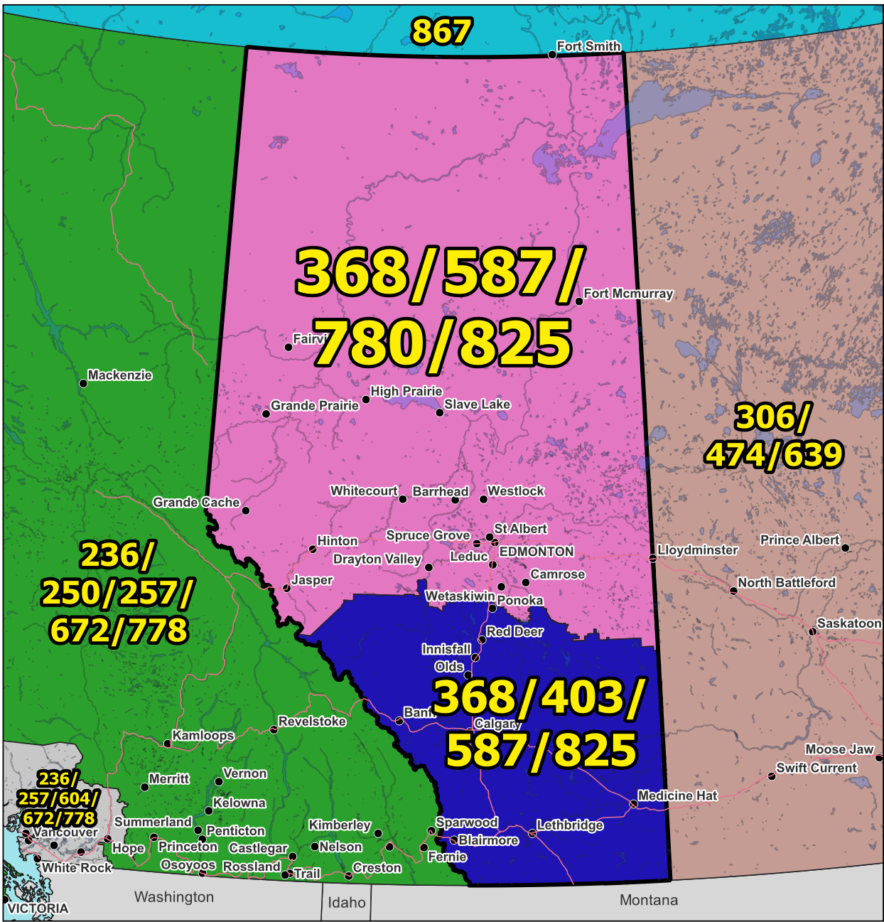

Figure 1 – Overview Map of NPA 368/403/587/780/825

Figure 2 – NPA 368/403/587/780/825 Actual and Forecast CO Code Assignments

Figure 3 – NPA 368/403/587/780/825 CO Code Exhaust: January 2026 S-NRUF

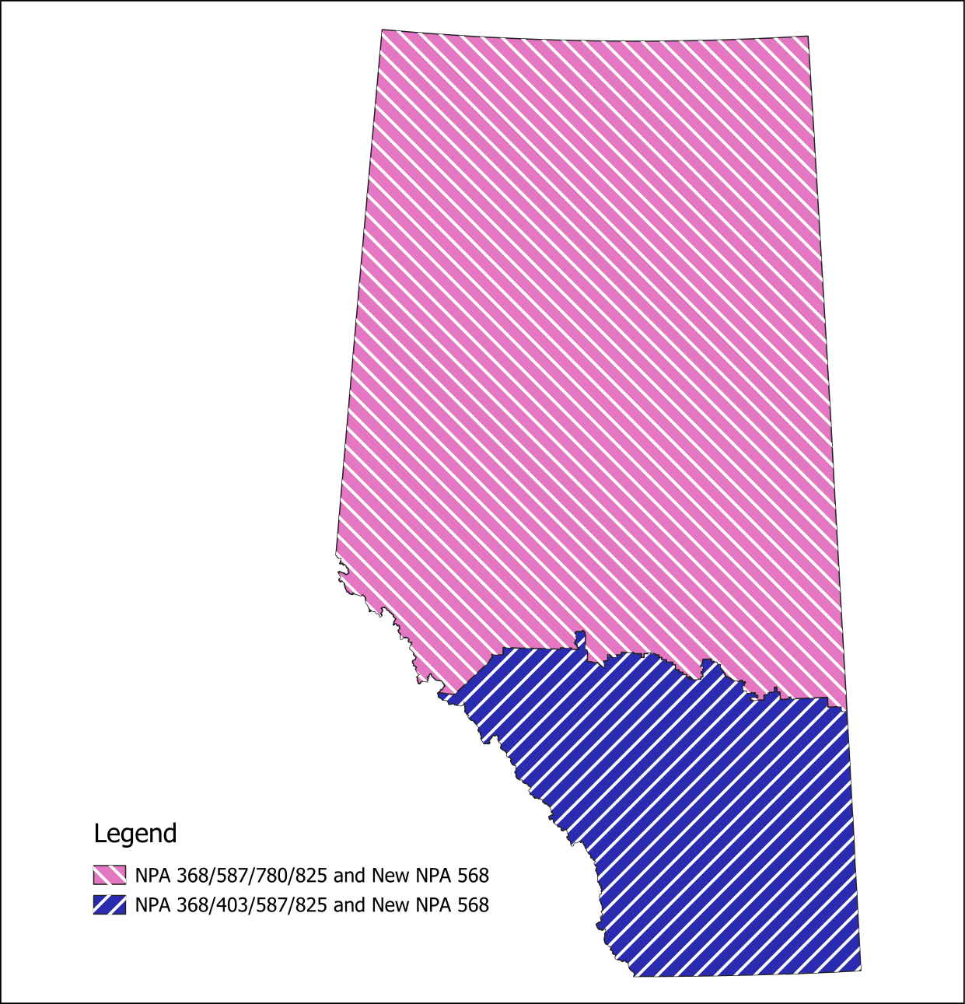

Figure 4 – Option 1: Distributed Overlay

NPAs 368/403/587/780/825 Exchange Areas

Exchange Area
Acadia Valley
Acme
Airdrie
Alberta Beach
Alder Flats
Alix
Alliance
Altario
Andrew
Anzac
Ardrossan
Arrowwood
Ashmont
Assumption
Athabasca
Banff
Barons
Barrhead
Bashaw
Bassano
Bawlf
Bear Canyon
Beaumont
Beaverlodge
Beiseker
Bentley
Berwyn
Big Valley
Bindloss
Blackfalds
Blackie
Blue Ridge
Bon Accord
Bonanza
Bonnyville
Bow Island
Bowden
Boyle
Bragg Creek
Breton
Brocket
Brooks
Brownvale
Bruderheim
Burdett
Byemoor
Cadomin
Calgary
Calling Lake
Calmar
Camrose
Canmore
Carbon
Cardston
Carmangay
Caroline
Carstairs
Castor
Cayley
Cereal
Cessford
Champion
Chauvin
Chipewyan Lake
Chipman
Clairmont
Claresholm
Clive
Clyde
Coaldale
Cochrane
Cold Lake
Conklin
Consort
Coronation
Coutts
Cowley
Craigmyle
Cremona
Crossfield
Crowsnest Pass
Czar
Daysland
Debolt
Delburne
Delia
Derwent
Devon
Didsbury
Dixonville
Donalda
Donnelly
Drayton Valley
Drumheller
Duchess
Eaglesham
East Coulee
Eckville
Edgerton
Edmonton
Edmonton International Airport
Edson
Elk Point
Elkwater
Elnora
Empress
Enchant
Etzikom
Evansburg
Exshaw
Fairview
Falher
Faust
Ferintosh
Flatbush
Foremost
Forestburg
Fort Assiniboine
Fort Chipewyan
Fort Mackay
Fort Macleod
Fort McMurray
Fort Saskatchewan
Fort Vermilion
Fox Creek
Fox Lake
Gadsby
Galahad
Gibbons
Gift Lake
Girouxville
Gleichen
Glendon
Glenwood
Grand Centre
Grande Cache
Grande Prairie
Granum
Grassland
Grassy Lake
Grimshaw
Grouard
Hairy Hill
Halkirk
Hanna
Hardisty
Hay Lakes
Hays
Heinsburg
Heisler
High Level
High Prairie
High River
Hilda
Hines Creek
Hinton
Hobbema
Holden
Hughenden
Hussar
Hythe
Innisfail
Innisfree
Irma
Iron Springs
Irricana
Irvine
Islay
Jarvie
Jasper
Jasper East
Jean D'or Prairie
Jenner
Joussard
Kananaskis
Keephills
Keg River
Killam
Kinuso
Kitscoty
La Crete
Lac La Biche
Lacombe
Lake Louise
Lamont
Langdon
Lavoy
Leduc
Legal
Leslieville
Lethbridge
Little Buffalo Lake
Lloydminster
Lodgepole
Lomond
Longview
Lougheed
Ma-Me-O Beach
Magrath
Manning
Mannville
Manyberries
Marlboro
Marwayne
Mayerthorpe
McLennan
Meander River
Medicine Hat
Milk River
Millet
Milo
Minburn
Mirror
Morinville
Morley
Morrin
Mulhurst
Mundare
Myrnam
Namao
Nampa
Nanton
New Dayton
New Norway
New Sarepta
Newbrook
Nisku
Niton Junction
Nobleford
Nordegg
Okotoks
Olds
Onoway
Oyen
Paradise Valley
Peace River
Peerless Lake
Peers
Penhold
Picture Butte
Pincher Creek
Plamondon
Ponoka
Provost
Radway
Rainbow Lake
Ralston
Raymond
Red Deer
Red Earth
Redwater
Rimbey
Robb
Rochester
Rocky Mountain House
Rockyford
Rolling Hills
Rosalind
Rosebud
Rumsey
Rycroft
Ryley
Sangudo
Saskatchewan River Crossing
Schuler
Seba Beach
Sedgewick
Seven Persons
Sexsmith
Sherwood Park
Sibbald
Silver Valley
Slave Lake
Smith
Smoky Lake
Spirit River
Spruce Grove
Spruceview
St. Albert
St. Michael
St. Paul
Stand Off
Standard
Stavely
Stettler
Stirling
Stony Plain
Strathmore
Strome
Sunchild O'Chiese
Sundre
Swan Hills
Sylvan Lake
Taber
Thorhild
Thorsby
Three Hills
Tilley
Tofield
Tomahawk
Torrington
Trochu
Turner Valley
Two Hills
Valleyview
Vauxhall
Vegreville
Vermilion
Veteran
Viking
Vilna
Vulcan
Wabamun
Wabasca
Wainwright
Walsh
Wandering River
Wanham
Warburg
Warner
Warspite
Waskatenau
Waterton Park
Wembley
Westlock
Wetaskiwin
Whitecourt
Whitelaw
Widewater
Wildwood
Willingdon
Winfield
Woking
Worsley
Wrentham
Youngstown
Zama

*** END OF DOCUMENT ***

