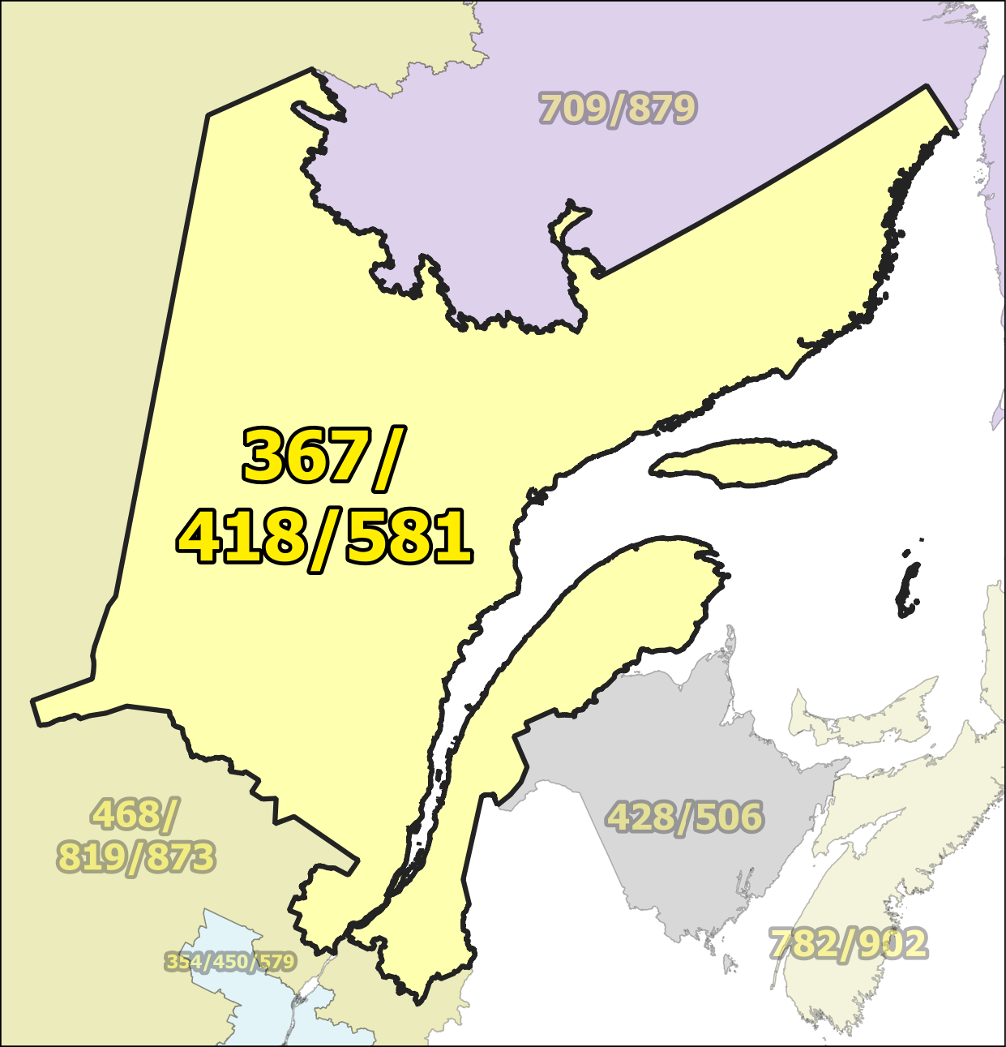

NPA 367/418/581 Proposal for Relief of an Overlay NPA Complex (PROC)
Version 1.0 – 30 January 2025

Canadian Numbering Administrator (CNA)
613-702-0016
880 Taylor Creek Dr, Room 102
Orleans, ON K4A 0Z9
www.cnac.ca

TABLE OF CONTENTS

1. INTRODUCTION 1
2. NPA RELIEF PLANNING PROCESS 2
3. NPA RELIEF METHOD 3
4. NPA EXHAUST INFORMATION 3
5. RELIEF OPTION 4
6. DIALLING CHANGES FOR LOCAL CALLS 5
7. SELECTION OF RELIEF NPA CODE 5
8. PROPOSED RELIEF DATE 6
9. PROPOSED SCHEDULE 6
10. JEOPARDY CONTINGENCY PLAN (JCP) 6
11. RECOMMENDATIONS 1
ANNEXES 2

ACRONYM LIST

CATF | Consumer Awareness Task Force
CNA | Canadian Numbering Administrator
CISC | CRTC Interconnection Steering Committee
CLEC | Competitive Local Exchange Carrier
CLNPC | Canadian Local Number Portability Consortium
CO | Central Office
CRTC | Canadian Radio-television and Telecommunications Commission
CSCN | Canadian Steering Committee on Numbering
EAS | Extended Area Service
G-NRUF | General Numbering Resource Utilization Forecast
ILEC | Incumbent Local Exchange Carrier
IPD | Initial Planning Document
ISP | Internet Service Provider
JCP | Jeopardy Contingency Plan
J-NRUF | Jeopardy Numbering Resource Utilization Forecast
LEC | Local Exchange Carrier
LIR | Local Interconnection Region
LNP | Local Number Portability
NANP | North American Numbering Plan
NANPA | North American Numbering Plan Administrator
NITF | Network Implementation Task Force
NoC | Notice of Consultation
NPA | Numbering Plan Area (area code)
NRUF | Numbering Resource Utilization Forecast
PD | Planning Document
PED | Projected Exhaust Date
PL | Planning Letter
POI | Point of Interconnection
PROC | Proposal for Relief of an Overlay NPA Complex
PSAP | Public Safety Answering Point
RIP | Relief Implementation Plan
R-NRUF | Relief Planning Numbering Resource Utilization Forecast
RPC | Relief Planning Committee
TSP | Telecommunications Service Provider
WNP | Wireless Number Portability
WSP | Wireless Service Provider

Proposal for Relief of an Overlay NPA Complex (PROC)
Numbering Plan Area (NPA) 367/418/581

INTRODUCTION

Number Planning Area (NPA or area code) 367/418/581 consists of 258 Exchange Areas serving Eastern Québec. Based on the July 2024 Relief Planning Numbering Resource Utilization Forecast (R-NRUF) results, NPA 367/418/581 is projected to exhaust in August 2027.

NPAs neighbouring NPA 367/418/581 that could be affected by this relief activity include 428/506, 468/819/873, and 709/879.

Area code 367/418/581 consists of 258 Exchange Areas, including Exchange Areas of Alma, Chicoutimi and Québec in the northern and eastern parts of the province of Québec in Canada. A list of the Exchange Areas in NPA 367/418/581 is provided in Annex B.

The following table provides a high-level summary of the history of area code usage in the area currently served by NPA 367/418/581.

Year | Activity
1947 | Area code 418 was originally assigned to northeast Québec by AT&T.
2008 | New area code 581 provided relief using the Distributed Overlay method and mandatory ten-digit local dialling was implemented.
2018 | New area code 367 was implemented using the Distributed Overlay method.

The table below provides a brief overview of recent activities leading to the development of this PROC for NPA 367/418/581.

Date | Activity
29 March 2023 | January 2023 Numbering Resource Utilization Forecast (NRUF) indicated that NPA 367/418/581 was forecast to exhaust within 72 months with a Projected Exhaust Date (PED) of June 2027.
18 August 2023 | July 2023 R-NRUF results indicated a PED of June 2027.
30 October 2023 | The CSCN submitted CNRE137B which included a recommendation to set aside NPA 273 for future relief of NPA 367/418/581.  For the purposes of this document the new NPA will be 273.
28 March 2024 | January 2024 R-NRUF results indicated a PED of July 2027.
11 September 2024 | July 2024 R-NRUF results indicated a PED of August 2027. This put NPA 367/418/581 in the Relief Planning window, in accordance with the Canadian NPA Relief Planning Guideline, Version 8.0, dated 15 May 2023. The CNA notified Canadian Radio-television and Telecommunications Commission (CRTC) staff and requested a Notice of Consultation.

This PROC is prepared by the CNA in accordance with Telecom Notice of Consultation CRTC 2025-15 and the Canadian NPA Relief Planning Guideline (the Guideline). A copy of the Guideline is available from the CRTC, CRTC Interconnection Steering Committee (CISC), Canadian Steering Committee on Numbering (CSCN) guidelines web page at: https://crtc.gc.ca/cisc/eng/cisf3fg.htm.

The objective of the NPA Relief Planning process is to ensure that Central Office (CO) Codes and telephone numbers are always available for use by Telecommunications Service Providers (TSPs) and their customers in the geographic area requiring relief.

It is very important to closely monitor the CO Code requirements of all existing and prospective CO Code Holders so that relief can be timed to ensure that CO Codes and telephone numbers are always available for service providers and customers.

In this PROC, a single option is identified for providing NPA relief in the NPA 367/418/581 geographic area. Given the magnitude of this undertaking, intercompany commitment and co-operation are essential throughout the planning, provisioning and implementation stages of the introduction of the new NPA.

NPA RELIEF PLANNING PROCESS

The NPA Relief Planning process and the roles of the participants (i.e. CRTC, CNA, CISC, Relief Planning Committee (RPC) participants and Interested Parties) for NPA Relief Planning are identified in the Guideline.

To increase public awareness and participation in the NPA Relief Planning process, the CRTC has determined that NPA RPCs will be established as ad hoc committees of the CISC. Generally, a separate ad hoc committee is created to deal with relief in each area code. The CNA, in its function as NPA Relief Planning Coordinator, acts as chair of these ad hoc committees. Meetings and conference calls of the ad hoc NPA RPCs are all open to public participation and are conducted in accordance with the CISC Administrative Guidelines which are available from the CRTC website at: https://crtc.gc.ca/cisc/eng/cag.htm.

NPA Relief Planning is conducted under the regulatory oversight of the CRTC. Notwithstanding the process detailed in the Guideline, the CRTC may exercise its authority under the Telecommunications Act to alter this process at any time. The CRTC has the authority under the Telecommunications Act to review, modify and give final approval to the Planning Document (PD) and the Relief Implementation Plan (RIP) developed and submitted by the RPC to the CRTC via the CISC process.

The Guideline requires the CNA to create and maintain a distribution list of parties who may be interested in participating in the RPC and to provide them with advance notice of the initial RPC meeting and the release of a PROC.

Any person wishing to participate in the NPA Relief Planning process can contact the CNA and request to be added to the RPC distribution list. More information on how to participate in CRTC public processes is available at: https://crtc.gc.ca/eng/info_sht/g4.htm.

A summary of Canadian geographic area code relief history is available at: https://cnac.ca/npa_codes/NPA_History.pdf.

NPA RELIEF METHOD

The Guideline describes the Distributed Overlay method and the three types of Distributed Overlays that can be implemented in Canada.

In the case of an Overlay NPA Complex, only two types of Distributed Overlay apply:

- Distributed Overlay over an existing geographic area served by multiple existing overlay NPAs; and
- Distributed Overlay over multiple existing geographic areas, each served by one or more existing NPAs.

In the case of relief of an Overlay NPA Complex, Distributed Overlay type “a)” (a Distributed Overlay over an existing geographic area served by a single existing NPA) would not be applicable.

NPA EXHAUST INFORMATION

As indicated in the following table, NRUFs for NPA 367/418/581 were used to determine PEDs, (i.e., the dates when CO Codes in NPA 367/418/581 would be expected to exhaust).

NRUF | Projected Exhaust Date (PED)
January 2023 G-NRUF | June 2027
July 2023 R-NRUF | June 2027
January 2024 R-NRUF | July 2027
July 2024 R-NRUF | August 2027

RELIEF OPTION

The Relief Option as identified and examined in this PROC is a Distributed Overlay over an existing geographic area served by multiple existing overlay NPAs.

Using this method, a new NPA is overlaid over an existing NPA (i.e., the geographic area) that is served by multiple existing overlay NPAs 367/418/581.

The Relief Option identified above was evaluated using the following assumptions:

- The average historical growth of 51 CO Codes was used to identify the subsequent PED for this Relief Option by comparing the data in the table below:

Statistical Method | Data | Period | Quantity of CO Codes
average | forecast growth | next six years | 168
average | forecast growth | five-year period (Jan 2025 to Jan 2030) | 149
average | historical growth | past five years | 51

- The Relief Date for the Distributed Overlay will be 27 February 2027 (approximately 6 months prior to the NPA 367/418/581 PED of August 2027 identified using the July 2024 R-NRUF results).

A Distributed Overlay Relief Option was evaluated which would overlay the NPA 273 over all 258 Exchange Areas comprising the NPA 367/418/581 area.

The introduction of a Distributed Overlay would retain the number of NPA Relief Planning areas in Québec.

After this Distributed Overlay, CO Codes in NPA 273/367/418/581 would be expected to exhaust in Q4 2038.

SUMMARY OF RELIEF OPTION
Relief Option | Projected Exhaust Dates |  | Subsequent Relief Dates
Relief Option | NPA 367/418/581 | NPA 273/367/418/581 | Subsequent Relief Dates
Distributed Overlay | August 2027 | December 2038 | June 2038

Note: Distributed Overlay NPA 273 would be in service in Q1 2027.

DIALLING CHANGES FOR LOCAL CALLS

Currently 10-digit dialling is mandatory for local calls originating within area ode NPA 367/418/581 and all neighbouring NPAs (i.e., 428/506, 468/819/873, and 709/879). Local dialling plans will not change with this relief.

SELECTION OF RELIEF NPA CODE

In TIF Report CNRE137B, submitted to CRTC staff on 30 October 2023, the CSCN recommended that area code 273 be set aside for the future relief of NPA 367/418/581.

PROPOSED RELIEF DATE

The Canadian NPA Relief Planning Guideline, Version 8.0, dated 15 May 2023 recommends that the Relief Date be 6 to 9 months prior to the Projected Exhaust Date. Based on the July 2024 R-NRUF results, the PED for NPA 367/418/581 is August 2027. Accordingly, the CNA is proposing a Relief Date of 27 February 2027.

PROPOSED SCHEDULE

The CNA has provided a proposed relief implementation schedule in Excel. Once agreed to by the RPC, the recommended Relief Implementation Schedule will be converted to Word and pasted here.

The CNA submits the following schedule for NPA 367/418/581 relief based on the recommendations contained in this PROC and the current PED of August 2027. The RPC will monitor the PED, and if it changes significantly in the future, the RPC will assess the situation and, if necessary, submit recommendations including a revised schedule to the CRTC for consideration and approval.

[Insert Proposed schedule from Excel worksheet]

JEOPARDY CONTINGENCY PLAN (JCP)

The RPC has agreed to follow the JCP contained in Appendix F of the Canadian NPA Relief Planning Guideline with the following exceptions.

This JCP shall remain in effect until superseded by a CRTC-approved JCP, the Jeopardy Condition is suspended or 66 days prior to the Relief Date.

The following measures shall be implemented in NPA 367/418/581 while a Jeopardy Condition is in effect.

During a Jeopardy Condition, CO Code Applicants shall submit all CO Code applications and related correspondence for the Jeopardy NPA to CRTC staff in addition to the CNA. The CNA shall only assign CO Codes from the exhausting NPA to a CO Code Applicant when instructed by CRTC staff.

- Carriers and/or Telecommunications Service Providers (TSPs):

  - shall age disconnected residential wireline telephone numbers for a maximum of two months;
  - shall age disconnected wireless telephone numbers for a maximum of three months;
  - shall age disconnected business wireline telephone numbers for a maximum of six months. Under special circumstances, the six month aging limit for business telephone numbers may be extended to twelve months, if required, to accommodate local directory publishing dates for high volume call-in applications (e.g., heavily advertised local business numbers such as radio talk shows, food ordering services, ticket sales, chat lines), or for numbers associated with public service emergency applications or for numbers advertised in directories for which customers have requested reference of calls;
  - shall return all CO Codes that are not being used, nor intended to be used to directly serve customers to the assignment pool within two months (e.g., plant test codes);
  - should work towards, and encourage existing customers, to either activate or return the reserved numbers to bring the reserved quantity down to a maximum of 10% of the quantity of numbers In-Service for that customer;
  - shall not allow the quantity of reserved numbers to be increased by new reservation requests by existing customers to more than 10% of the quantity of numbers in service for that customer. In the case of new customers, number reservations shall be limited to 10% of the total quantity of telephone numbers being placed into service for that customer;
  - shall, within 45 days from the date that the CNA declares a Jeopardy Condition submit a Part 1 Form for each remaining reserved CO Code either returning the reserved CO Code to the CNA or requesting assignment of the reserved CO Code. Once the 45-day period has elapsed, the CNA shall make available for general assignment all CO Codes that are still reserved and have not been applied for as assignments on a Part 1 Form received by the CNA. Within 60 days from the date that the CNA declares a Jeopardy Condition, the CNA shall report to CRTC staff and the RPC as to how many of these codes have been assigned or made available for general assignment;
  - shall not be permitted to obtain a new CO Code reservation;
  - shall place all CO Codes assigned prior to the Jeopardy Condition being declared In-Service within three months of the effective date for CO Code activation in the network, or within three months of the date that the Jeopardy Condition was declared. If the CO Code is an Initial Code and the CO Code Holder can demonstrate that, due to circumstances beyond its control, the In-Service date has been delayed beyond the applicable timeframe, then the CNA may grant an extension of up to two months to the In-Service date. The CNA shall initiate reclamation procedures for all CO Codes that have not been placed In-Service within these timeframes unless CRTC staff provides a further extension.

- For new applications for Initial Codes, each CO Code Holder shall certify that the CO Code will be activated in the network and placed In-Service within four months of the date of application for the Code. If the CNA does not receive a Part 4 Form within this timeframe, confirming that the CO Code has been placed In-Service, the CNA will initiate reclamation measures. If the CO Code Holder can demonstrate that, due to circumstances beyond its control, the In-Service date has been delayed not more than six months from the original application date, then the CNA may grant an extension to the In-Service date, so long as the In-Service date is not more than six months beyond the original application date. If the In-Service date has been delayed more than six months from the original application date, then the CNA shall reclaim the Code unless CRTC staff provides a further extension.

- When applying for an Additional Code for Growth, a CO Code Holder who is submitting a Part 1 Form and Appendix B worksheet shall also submit a completed Supplementary Form for a Growth CO Code Application (attached) which certifies and/or provides the following information for the specific switching entity/POI and Exchange Area when the Growth CO Code is being requested in a Jeopardy Condition:

  - certification that all held telephone numbers have been released;
  - certification that reserved numbers do not exceed ten percent of the total quantity of numbers as defined in Appendix G of the Canadian CO Code (NXX) Assignment Guideline;
  - certification that each reseller/dealer had been advised of the Jeopardy Condition and the requirement that they would only be allocated additional numbers during the Jeopardy Condition on the provision to the CO Code Holder of written confirmation that their number inventory has been reduced to an amount less than two times the highest quantity of customer numbers assigned in any month during the previous 12 months. Additional numbering resources will only be provided by the CO Code Holder to the reseller/dealer to the extent that the reseller's/dealer's inventory can only increase up to a maximum of three months' inventory;
  - confirmation that the Part 1 form submitted with the application has the Jeopardy Condition box in section 1.6 checked to certify that the existing CO Codes are projected to exhaust within 4 months of the date of application and that the months-to-exhaust is documented on an Appendix B submitted to the CNA;
  - a completed Telephone Number Utilization Report for the applicable switching entity signed by both a company officer and the company’s authorized representative;
  - confirmation that the requested Growth CO Code was forecasted in the most recent NRUF or an explanation as to why it was not is attached; and
  - confirmation that the requested Growth CO Code will be placed In-Service within four months of the date of assignment.

- Any CO Codes for growth assigned after the implementation of this JCP must be activated in the network and placed In-Service within four months of assignment. In the event that a CO Code Holder is unable to place the CO Code In-Service within four months of the date of assignment, the CO Code Holder must return the assigned CO Codes or submit a written request for extension to the CNA. Such written requests must include documentation explaining the reason(s) for the missed date and proposing the new In-Service date. If the explanation includes reasons beyond the control of the CO Code Holder, the CNA may extend the In-Service date a maximum of one month. If the CO Code Holder does not place the CO Code In-Service within the one-month extension, the CNA shall initiate the reclamation process at the end of the one-month extension unless CRTC staff provides a further extension.

- A Carrier that has multiple switching entities within an Exchange Area shall examine the possibility of, and implement where feasible, number sharing between those switches as a potential method to delay requirements for additional CO Codes.

- The CNA will request two versions (two separate worksheets (Form 1 and Form 2)) of the J-NRUF input from all current and prospective CO Code Holders quarterly until three (3) months before relief is provided.

  - The forecasted quantities in Form 1 should be the same as or lower than the last R-NRUF input submitted, prior to declaration of a Jeopardy Condition. CO Code Holder forecasts may reflect an increase in demand in the period subsequent to the Relief Date.

  - Form 2 will reflect the actual demand required by the CO Code Holder's current business plan and will be provided for information purposes only.

- The CNA will compare the initial J-NRUF input to the recent NRUF inputs, to assess forecasting trends. The CNA shall monitor all inputs and shall test them for reasonableness in consultation with the Carrier. If the CNA is dissatisfied with the reasonableness, or the rationale provided for the deviations, then the matter will be referred to the CRTC staff.

- The CNA will request subsequent J-NRUF input from all current and prospective CO Code Holders quarterly until 3 months before relief is provided. If one or more R-NRUFs have already been conducted, and depending on the severity of the Jeopardy Condition, the CNA may defer a J-NRUF by up to two months if such a deferral brings the timing of that J-NRUF and subsequent J-NRUFs into alignment with other NRUFs that are conducted at 12, 6 or 3 month intervals. Subsequent J-NRUF input will be compared with the initial J-NRUF input to evaluate the effectiveness of the JCP. The CNA shall monitor all J-NRUF inputs and shall test them for reasonableness in consultation with the Telecommunications Service Providers. If the CNA is dissatisfied with the reasonableness, or the rationale provided for the changed forecasts, then the matter will be referred to CRTC staff.

- A CO Code Applicant must have submitted a completed J-NRUF to the CNA before the CNA may assign a CO Code to that CO Code Applicant.

- If a CO Code applicant wishes to request more CO Codes than it identified in its most recent J NRUF, the CO Code Applicant should discuss the matter with the CNA. If the CO Code Applicant wishes to proceed with the request, the CO Code Applicant will forward the request and revised forecast to CRTC staff and the CNA for consideration.

- The CO Codes identified in the NPA CO Code Inventory Chart as “Assignable CO Codes in a Jeopardy Condition” will be assigned in the order determined by the RPC after all CO Codes which are “Available for Assignment as of [day month year] have been assigned.

- After each J-NRUF, the CNA shall provide CRTC staff, the RPC and CSCN participants with a report providing an updated NPA CO Code Inventory Chart for the NPA in jeopardy as well as the aggregate results of the most recent J-NRUF.

- Exceptional issues or concerns may be referred by the CNA, or by individual entities (with a courtesy copy to the CNA), to the CRTC staff for resolution.

- In a situation where the Relief Date is on or after the PED, the quantity of CO Codes that may be assigned to a CO Code Applicant prior to the end of the Jeopardy Condition (i.e., 66 days prior to the Relief Date) shall be limited to the quantity forecasted by the CO Code Applicant in its most recent NRUF forecast submitted prior to the Jeopardy Condition being declared by the CNA (if no previous NRUF was submitted, then the previous forecast will be deemed to be zero codes). When making requests to obtain CO Codes prior to the end of the Jeopardy Condition (i.e., 66 days prior to the Relief Date), the CO Code Applicant may change the Exchange Area or the month when the CO Code assignment is required, provided a new J-NRUF and explanation accompanies the application. The control imposed by this option may be relaxed if subsequent J-NRUFs defer the PED to after the Relief Date. CO Codes that become available for assignment due to future reduced demand from other current and prospective CO Code Holders may be assigned at the discretion of CRTC staff.

- If the CNA determines that the implementation of the JCP has not extended the Projected Exhaust Date of the NPA beyond the Relief Date, the CNA will consult with CRTC staff and further CO Code conservation and assignment procedures may be ordered by the Commission (e.g., rationing, lottery, etc.).

Supplementary form for a Growth CO Code Application – Page 1 of 2 – Telephone Number Utilization Report

This form is required with each request for an Additional Code for Growth in an NPA where a Jeopardy Condition is in effect. It should be submitted to the CNA together with the Part 1 and Appendix B forms that are required for an application for an Additional Code for Growth. See the Part 1 form for information on how and where to submit the form.

I hereby certify that the following information is true and accurate to the best of my knowledge and has been prepared in accordance with Special Conservation Procedures for a Jeopardy Condition contained in the Canadian NPA Relief Planning Guideline or the applicable approved Jeopardy Contingency Plan.

Name & Signature of Authorized Representative of Code Holder Title Date

Name & Signature of Company Officer (see item 3 of this JCP) Title Date

Contact information: Entity Name: __________________ Contact Name: _____________
Address: __________________ City, Province, Postal Code: _____________
Telephone: __________________ Facsimile: _____________
E-mail: __________________

Switch Identification (Switching Entity/POI) CLLI: _______________ Exchange Area: ________________
For the above Switch Identification and Exchange Area for which a Growth CO Code is requested:
I certify that all held telephone numbers have been released
I certify the total quantity of reserved numbers does not exceed ten percent (10%) of the total quantity of telephone numbers as defined in Appendix G of the Canadian CO Code (NXX) Assignment Guideline
I certify that each reseller/dealer has been advised of the Jeopardy Condition and the requirement that they would only be allocated additional numbers during the Jeopardy Condition on the provision to the CO Code Holder of written confirmation that their number inventory has been reduced to an amount less than two (2) times the highest quantity of customer numbers assigned in any month during the previous twelve (12) months. Additional numbering resources will only be provided by the CO Code Holder to the reseller/dealer to the extent that the reseller's/dealer's inventory can only increase up to a maximum of three months' inventory.
The Part 1 form submitted with the application has the Jeopardy Condition box in section 6 checked (this certifies that the existing CO Codes are projected to exhaust within four (4) months of the date of the application or within the period specified in an approved Jeopardy Contingency Plan, and that the months-to-exhaust is documented on an Appendix B submitted to the CNA).
The Telephone Number Utilization Report on page 2 of this form has been completed.
The requested Growth CO Code was forecasted in the most recent NRUF, or an explanation as to why it was not is attached.
The requested Growth CO Code will be placed In-Service within four (4) months of the date of assignment.

Supplementary Form for a Growth CO Code Application – Page 2 of 2 – Telephone Number Utilization Report

Use Arial 9 to complete this form. (Note: If the spreadsheet below does not show on your display, please change the Work view to "Print Layout" or "Reading Layout")
Remarks: _______________________________________________________________________________
________________________________________________________________________________________

NPA 367/418/581 CO Code Inventory Chart

The following chart and the instructions it contains will apply in NPA 367/418/581 in a Jeopardy Condition.

The chart below lists quantities of CO Codes unassignable prior to a Jeopardy Condition, CO Codes that become assignable in a Jeopardy Condition, and CO Codes in NPA 367/418/581 assigned and In-service as of 30 January 2025. The CO Codes that become assignable in a Jeopardy Condition shall only be made available for assignment when all other available CO Codes have been assigned in the order listed below.

 |  | Quantity
A | Total CO Codes in NPAs 367/418/581 (NXX format) | 2400
B | CO Codes unassignable prior to a Jeopardy Condition
B | N11 Service Codes (211, 311, 411, 511, 611, 711, 811, 911) | 24
B | Special Use Codes (555, 950, 976 & 988) | 10
B | Home NPA Code(s) (367, 418, 581) | 9
B | Current Neighbouring NPA Codes | 0
B | Future Geographic NPA Codes | 9
B | Plant Test Codes (958 & 959) | 6
B | Special 7-digit Dialling Codes (310, 610 & 810) | 8
B | Total B | 66
C | CO Codes assignable prior to a Jeopardy Condition (C=A-B) | 2334
D | CO Codes unassignable prior to a Jeopardy Condition that become assignable in a Jeopardy Condition:
D | Future Canadian Geographic NPA Codes | 9
D | Current Neighbouring NPA Codes | 0
D | Total D | 9
E | Assignable CO Codes in a Jeopardy Condition (E=C+D) | 2343
F | Assigned CO Codes as of 30 January 2025 | 1699
G | Net CO Codes available for assignment as of 30 January 2025 without a Jeopardy Condition (G=C-F) | 635
H | Net CO Codes available for assignment as of 30 January 2025 in a Jeopardy Condition (H=E-F) | 644

Notes:
- In CNRE137B, the CSCN recommend the NPA 273 be set aside for future relief in NPA 367/418/581.

RECOMMENDATIONS

The CNA recommends:

- The Relief Method should be a Distributed Overlay of a new NPA Code over the eastern-Québec area of NPA 367/418/581;

- The Relief NPA Code for NPA 367/418/581 should be NPA 273; and,

- The Relief Date should be 27 February 2027 to provide Carriers and customers with advanced notification and sufficient lead-time to implement relief in NPA 367/418/581.

ANNEXES

Maps and Figures

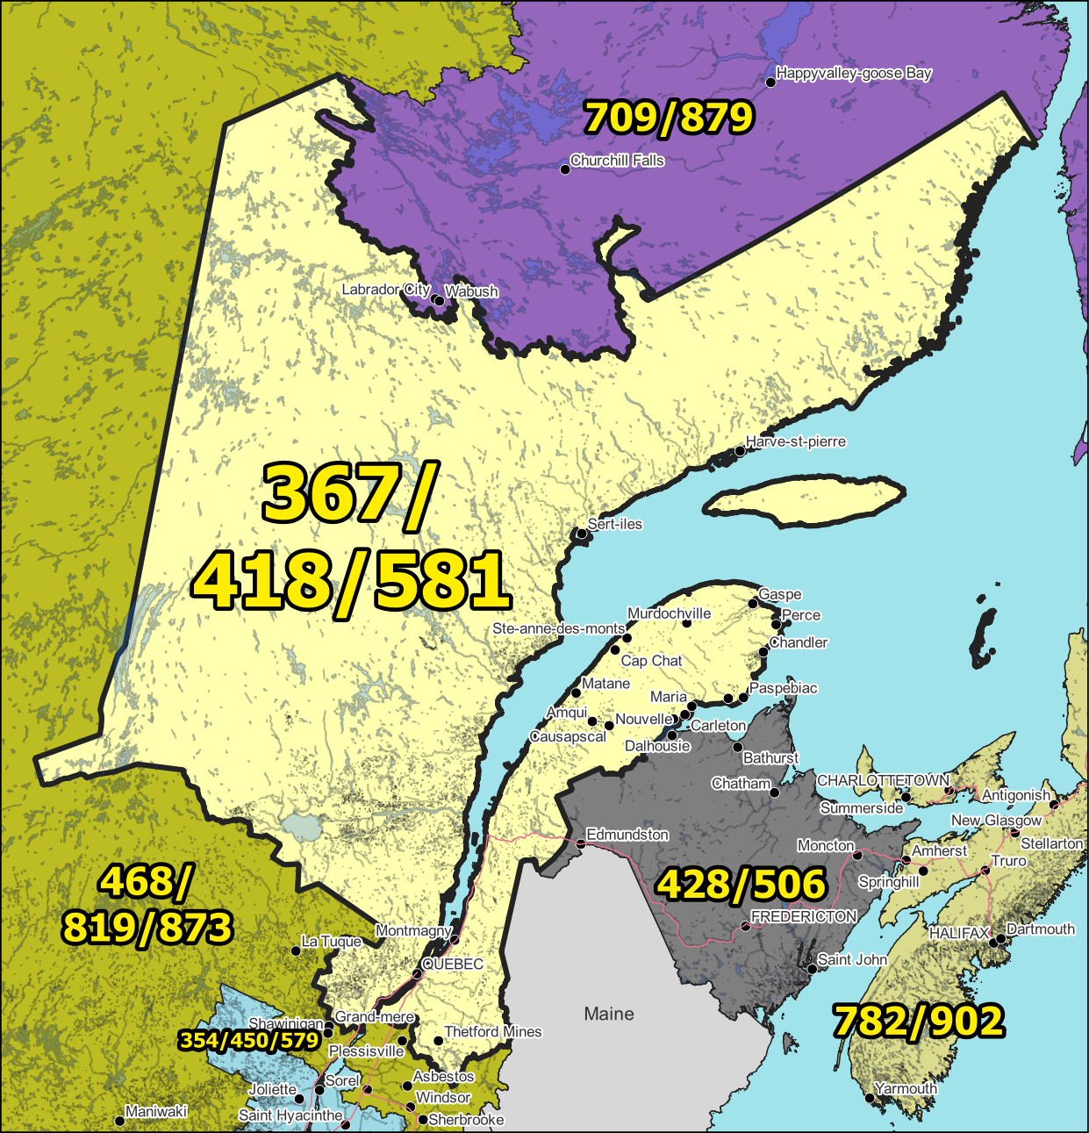

Figure 1 – Overview Map of NPA 367/418/581

Figure 2 – NPA 367/418/581 Actual and Forecast CO Code Assignments

Figure 3 – NPA 367/418/581 CO Code Exhaust: July 2024 R-NRUF

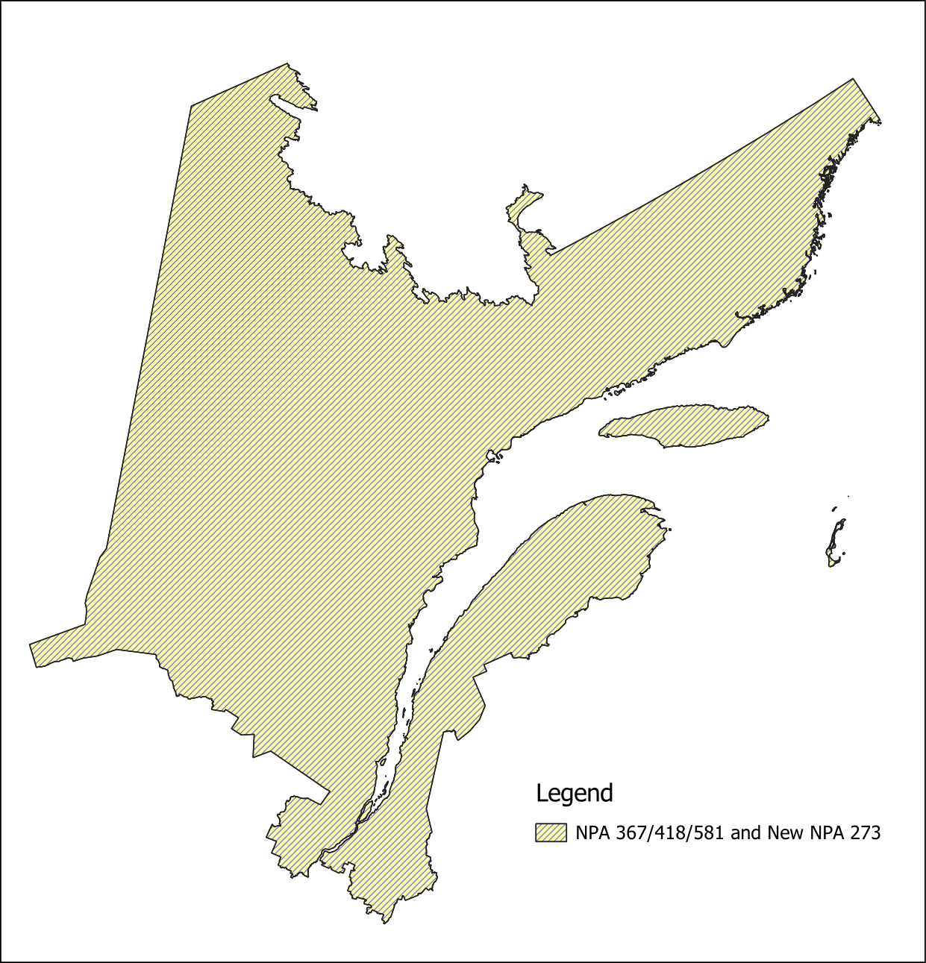

Figure 4 – Option 1: Distributed Overlay

NPAs 367/418/581 Exchange Areas

Exchange Area
Aguanish
Albanel
Alma
Amqui
Anse-St-Jean
Armagh
Baie-Comeau
Baie-Comeau (Hauterive)
Baie-des-Sables
Baie-Johan-Beetz
Baie-St-Paul
Baie-Ste-Catherine
Baie-Trinite
Barachois
Batiscan
Beauceville
Bergeronnes
Bic
Biencourt
Black Lake
Blanc-Sablon
Boischatel
Bonaventure
Bonne-Esperance
Cabano
Cap-aux-Meules
Cap-Chat
Cap-des-Rosiers
Cap-Saint-Ignace
Caplan
Carleton
Causapscal
Chambord
Chandler
Chapais
Charny
Chateau-Richer
Chevery
Chibougamau
Chicoutimi
Chute-aux-Outardes
Chute-des-Passes
Clarke City
Clermont
Cloridorme
Colombier
Courcelles
Delisle
Desbiens
Disraeli
Dolbeau
Donnacona
East Broughton
Esprit-Saint
Ferland
Fermont
Forestville
Frampton
Garthby
Gaspe
Girardville
Godbout
Grande-Entree
Grande-Riviere
Grande-Vallee
Harrington Harbour
Havre-Aubert
Havre-aux-Maisons
Havre-Saint-Pierre
Hebertville
Hebertville-Station
Ile-aux-Coudres
Inverness
Jonquiere
L'Ile-Verte
L'Islet
La Baie (Chicoutimi Co.)
La Dore
La Guadeloupe
La Malbaie
La Martre
La Pocatiere
La Romaine
Lac Bouchette
Lac-au-Saumon
Lac-aux-Sables
Lac-Etchemin
Lac-Frontiere
Lambton
Laterriere
Leeds
Les Boules
Les Eboulements
Les Escoumins
Les Mechins
Levis
Loretteville
Luceville
Manicouagan 5
Maria
Matane
Matapedia
Metabetchouan
Milot
Mistissini
Moisie
Mont-Joli
Mont-Louis
Montmagny
Murdochville
Mutton Bay
Natashquan
Neuville
New Carlisle
New Richmond
Newport
Normandin
Notre-Dame-des-Laurentides
Notre-Dame-du-Lac
Nouvelle
Parc-des-Laurentides
Pentecote
Perce
Peribonka
Petite-Riviere-St-Francois
Pointe-a-la-Croix
Pont-Rouge
Port-Cartier
Port-Daniel
Port-Menier
Portneuf
Quebec
Rimouski
Riviere-a-Pierre
Riviere-au-Renard
Riviere-au-Tonnerre
Riviere-Bleue
Riviere-du-Loup
Riviere-Saint-Jean
Roberval
Sacre-Coeur
Saint-Adelphe
Saint-Agapit
Saint-Alexis-de-Matapedia
Saint-Anselme
Saint-Antoine-de-Tilly
Saint-Apollinaire
Saint-Augustin
Saint-Augustin (Duplessis)
Saint-Basile
Saint-Bernard-de-Dorchester
Saint-Camille
Saint-Casimir
Saint-Charles
Saint-Come
Saint-Damien-de-Buckland
Saint-Edouard-de-Lotbiniere
Saint-Fabien
Saint-Fabien-de-Panet
Saint-Flavien
Saint-Francois
Saint-Gabriel
Saint-Gedeon-de-Beauce
Saint-Georges-de-Beauce
Saint-Henri-de-Levis
Saint-Jean-Port-Joli
Saint-Joseph-de-Beauce
Saint-Lambert-de-Lauzon
Saint-Leon-le-Grand
Saint-Luc
Saint-Magloire
Saint-Malachie
Saint-Marc-des-Carrieres
Saint-Martin
Saint-Michel
Saint-Moise
Saint-Odilon
Saint-Pamphile
Saint-Patrice-de-Beaurivage
Saint-Paul-de-Montminy
Saint-Prosper-de-Dorchester
Saint-Raphael
Saint-Raymond
Saint-Rene-de-Matane
Saint-Roch-des-Aulnaies
Saint-Simon-de-Rimouski
Saint-Stanislas
Saint-Theophile
Saint-Tite
Saint-Ubalde
Saint-Ulric
Saint-Zacharie
Sainte-Agathe-de-Lotbiniere
Sainte-Anne-de-la-Perade
Sainte-Anne-des-Monts
Sainte-Blandine
Sainte-Claire
Sainte-Croix
Sainte-Felicite
Sainte-Henedine
Sainte-Justine
Sainte-Lucie
Sainte-Marie-de-Beauce
Sainte-Perpetue
Sainte-Rose
Sainte-Thecle
Sault-au-Mouton
Sayabec
Schefferville
Sept-Iles
Squatec
St-Alexandre
St-Ambroise-de-Chicoutimi
St-Andre
St-Eleuthere
St-Ephrem-de-Beauce
St-Felicien
St-Ferdinand-D'Halifax
St-Fereol
St-Fidele
St-Fulgence
St-Gedeon
St-Hilarion
St-Honore
St-Honore (Chicoutimi Co.)
St-Honore (Temiscouata Co.)
St-Irenee
St-Jean-de-Dieu
St-Jean-ile-d'Orleans
St-Just-de-Bretenieres
St-Methode-de-Frontenac
St-Nicolas
St-Pacome
St-Pascal
St-Philippe-de-Neri
St-Prime
St-Simeon
St-Tite-des-Caps
St-Urbain
St-Victor-de-Beauce
Ste-Anne-de-Beaupre
Ste-Anne-de-Portneuf
Ste-Brigitte-de-Laval
Ste-Catherine
Ste-Petronille
Ste-Rose-du-Nord
Stoneham
Stratford
Tadoussac
Tete-a-la-Baleine
Thetford Mines
Tring Jonction
Trois-Pistoles
Val-Alain
Val-Brillant
Valcartier
Vallee-Jonction
Ville Degelis

*** END OF DOCUMENT ***

