Promoting the introduction of area code 273 in
Quebec, currently served by area codes
367, 418, and 581

Progress Report #1

Submitted to the CRTC October 2026

Progress Report #1, 273 AREA CODE
In Quebec

1. Executive Summary
This Progress Report documents the communications activities undertaken by participating carriers in connection with the introduction of area code 273 in Quebec, as approved by Telecom Decision CRTC 2025-269. The new area code addresses the growing demand for telephone numbers in the 367/418/581 area code complex and is effective February 27, 2027.
As of the date of this report, the majority of planned awareness activities have been completed or are actively in progress. All carriers have confirmed implementation of internal communications and public-facing outreach in accordance with the Communications Plan submitted to the CRTC in May 2026.
No change to local dialing patterns is required. The awareness campaign focuses on informing consumers, businesses, and government authorities that new telephone numbers may be assigned the 273-area code beginning in February 2027.

2. Background
In Telecom Decision CRTC 2025-269, the Canadian Radio-television and Telecommunications Commission (CRTC) approved the introduction of area code 273, effective February 27, 2027, to address the need for additional telephone numbers in the 367/418/581 area code complex in Quebec. The participating carriers submitted a joint Communications Plan to the CRTC in May 2026 outlining their proposed awareness activities.
Key Messages Communicated:
- A new area code, 273, will be added in the 367/418/581 region in Quebec starting February 27, 2027.
- The 273 area code will co-exist with area codes already in use in this region.
- There will be no change to existing telephone numbers.
- 10-digit dialing will continue for local calls.
- Local and long distance calling areas remain unchanged.
- Emergency calls (9-1-1) and 3-digit special numbers continue to be dialed using 3 digits.

3. Carrier Progress Reports
The following sections summarize the communications activities completed or in progress by each participating carrier as of October 2026.



Date | Tactics | Target | Status
May-June 2026 | Media Release | All customers | Completed
May-June 2026 | Bell.ca new area code page update | All customers | Completed
May-June 2026 | Internal messaging | Frontline customer agents | Completed
May-June 2026 | Social message | All customers | Completed
May-June 2026 | Email | Government (municipalities, federal and provincial government) | Completed
August-September 2026 | Customer Notifications | Residential, business, wholesale customers | Completed



Date | Tactics | Target | Status
June 2026 | Internal communications | Frontline staff, technical support and marketing/ communications | Completed
July 2026 | Website Update | All customers | Completed
July 2026 | Customer Notifications | Residential, business, wholesale customers | Completed



Date | Tactics | Target | Status
May-June 2026 | Internal messaging | Customer service agents | Completed
May-June 2026 | Website information pages | All Fibernetics customers | Completed
June-Dec. 2026 | Messaging to customers | All Fibernetics customers in impacted areas | Ongoing
Dec. 2026-Feb. 2027 | Reminder messages | All Fibernetics customers in impacted regions | TBD


Date | Tactics | Target | Status
May-June 2026 | Media Release | All customers | Completed
May-June 2026 | IXICA website new area code page update | All customers | Completed
May-June 2026 | Internal messaging | Frontline customer agents | Completed
May-June 2026 | Social message | All customers | Completed
May-June 2026 | Email | Government (municipalities, federal and provincial government) | Completed

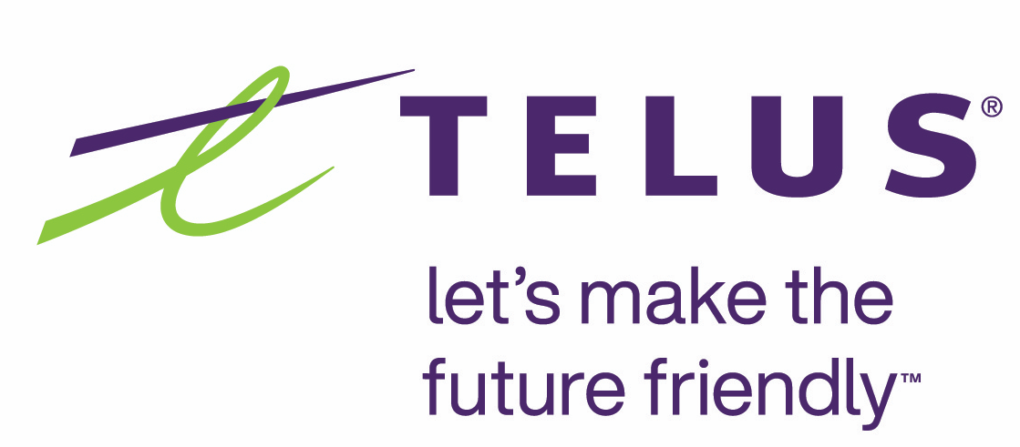

Date | Tactics | Target | Status
May-June 2026 | Media Release | All customers | Completed
July 2026 | TELUS.com new area code page update | All customers | Completed
June 2026 | Internal messaging | Frontline customer agents | Completed
July 2026 | Bill messages | All customers | Completed
Aug 2026 | Email | Government (municipalities, federal and provincial government) | Completed

As of October 2026, most activities under the 273 Area Code Overlay Communications Plan have been completed.

Any remaining activities will be completed in accordance with the timelines established in the Communications Plan submitted to the CRTC in May 2026.

