**NPA 226/519/548**

**Relief Planning** 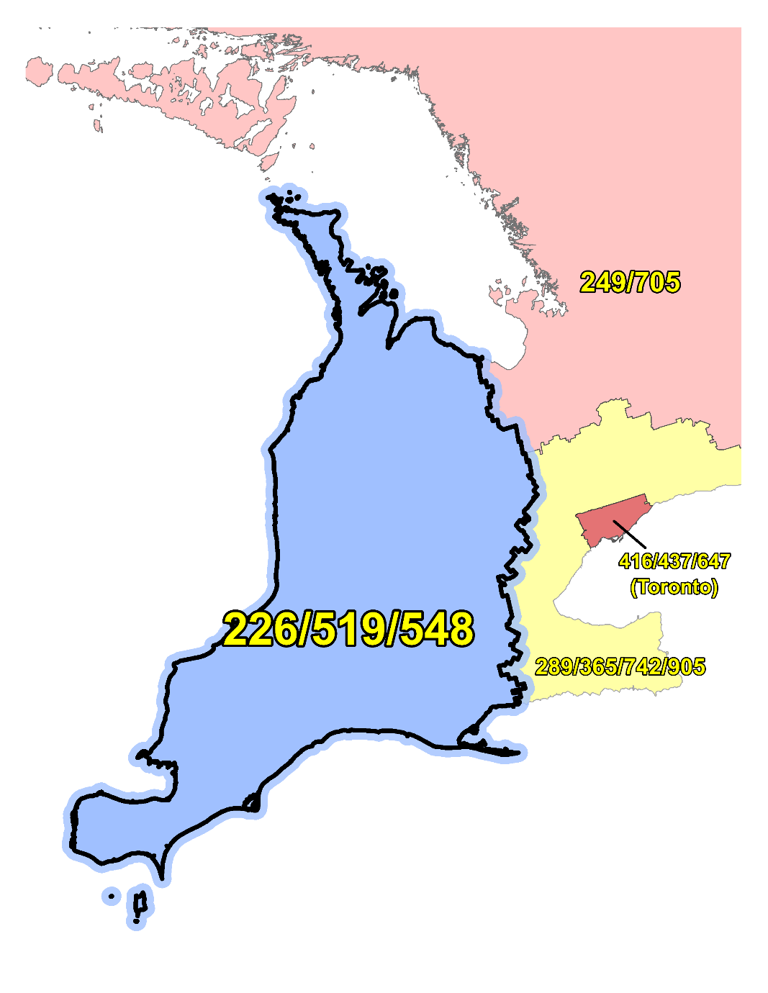

**NPA 226/519/548 PLANNING DOCUMENT (PD)**

**Version 1.0 – 28 October 2021**

**TABLE OF CONTENTS**

1. INTRODUCTION 1

2. NPA RELIEF PLANNING PROCESS 2

3. NPA RELIEF METHODS 3

4. NPA EXHAUST INFORMATION 3

5. RELIEF OPTION 4

5.1. Distributed Overlay 4

6. SUMMARY OF RELIEF OPTION 4

7. DIALLING CHANGES FOR LOCAL CALLS 5

8. PROPOSED SCHEDULE 5

9. JEOPARDY CONTINGENCY PLAN (JCP) 10

10. SELECTION OF RELIEF NPA CODE 17

11. RECOMMENDATIONS 18

ANNEXES 19

**LIST OF ANNEXES**

**ANNEX A**

Figure 1 – Overview Map of NPA 226/519/548 1

Figure 2 – NPA 226/519/548 Actual and Forecast CO Code Assignments 2

Figure 3 – NPA 226/519/548 CO Code Exhaust: January 2021 G-NRUF 3

Figure 4 – NPA 226/519/548 CO Code Exhaust: July 2021 R-NRUF 3

Figure 5 – Distributed Overlay 4

**ANNEX B**

Table 1 – NPA 226/382/519/548 Exchange Areas After Distributed Overlay 1

**ANNEX C**

Distribution List

**ACRONYM LIST**

|  |  |
| --- | --- |
| CATF | Consumer Awareness Task Force |
| CNA | Canadian Numbering Administrator |
| CISC | CRTC Interconnection Steering Committee |
| CLEC | Competitive Local Exchange Carrier |
| CLNPC | Canadian Local Number Portability Consortium |
| CO | Central Office |
| CRTC | Canadian Radio-television and Telecommunications Commission |
| CSCN | Canadian Steering Committee on Numbering |
| EAS | Extended Area Service |
| G-NRUF | General Numbering Resource Utilization Forecast |
| ILEC | Incumbent Local Exchange Carrier |
| IPD | Initial Planning Document |
| ISP | Internet Service Provider |
| JCP | Jeopardy Contingency Plan |
| J‑NRUF | Jeopardy Numbering Resource Utilization Forecast |
| LEC | Local Exchange Carrier |
| LIR | Local Interconnection Region |
| LNP | Local Number Portability |
| NANP | North American Numbering Plan |
| NANPA | North American Numbering Plan Administrator |
| NITF | Network Implementation Task Force |
| NoC | Notice of Consultation |
| NPA | Numbering Plan Area (Area Code) |
| NRUF | Numbering Resource Utilization Forecast |
| PD | Planning Document |
| PED | Projected Exhaust Date |
| PL | Planning Letter |
| POI | Point of Interconnection |
| PROC | Proposal for Relief of an Overlay NPA Complex |
| PSAP | Public Safety Answering Point |
| RIP | Relief Implementation Plan |
| R-NRUF | Relief Planning Numbering Resource Utilization Forecast |
| RPC | Relief Planning Committee |
| TSP | Telecommunications Service Provider |
| WNP | Wireless Number Portability |
| WSP | Wireless Service Provider |

**Planning Document (PD)**

**Numbering Plan Area (NPA) 226/519/548**

# INTRODUCTION

Numbering Plan Areas (NPAs) 416 and 613, commonly referred to as area codes, were originally assigned to Ontario by AT&T in 1947 as two of the 86 area codes to be used in Canada and the continental United States. In 1953, NPA 519 was split from NPA 416 and NPA 613 and in 1957, NPA 705 was split from NPA 519 and NPA 613.

In 2006, 10-digit local dialling was mandated by the Canadian Radio-television and Telecommunications Commission (CRTC) to provide relief for NPA 519 and NPA 226 was introduced.

In 2016, NPA 548 was introduced to provide relief for NPA 226/519.

The following table provides a high-level summary of the history of area code usage in the area currently served by NPA 226/519/548 since 1947.

|  |  |
| --- | --- |
| **Year** | **Activity** |
| 1947 | Area Codes 416 and 613 are assigned to Ontario by AT&T |
| 1953 | Area Code 519 is split from 416 and 613 |
| 1957 | Area Code 705 is split from 519 and 613 |
| 2006 | New area code 226 overlay of 519 southwest Ontario; mandatory ten-digit local dialling implemented in 226 & 519 |
| 2016 | New area code 548 overlay of 226/519 in southwestern Ontario |

The 226/519/548 area code or NPA consists of 210 Exchange Areas including the rapidly growing exchanges of Brantford, Chatham, Guelph, Hespeler, Kitchener‑Waterloo, London, Orangeville, Sarnia, Windsor and Woodstock, located in the southwestern part of Ontario in Canada.

A list of the Exchange Areas in NPA 226/519/548 is provided in Annex B, Table 1.

The table below provides a brief overview of recent activities leading to the development of this Proposal for Relief of an Overlay NPA Complex (PROC) for NPA 226/519/548.

| **Date** | **Activity** |
| --- | --- |
| 30 October 2013 | In Telecom Decision CRTC 2013-575, the Commission determined to set aside area code 382 as the most suitable area code for future relief in southwestern Ontario NPAs 226/519/548.  **For the purposes of this document, the new NPA will be 382.** |
| 23 February 2021 | The CNA published the January 2021 R-NRUF results, which indicated that the Projected Exhaust Date (PED) had advanced to July 2024. |
| 30 July 2021 | The CRTC released Telecom Notice of Consultation CRTC 2021‑245- *Establishment of a CISC ad hoc committee for relief planning for area codes 226, 519 and 548 in* southwestern Ontario *in* which the CRTC announced the establishment of a CRTC Interconnection Steering Committee ad hoc Relief Planning Committee (RPC) to examine options and make recommendations for providing numbering relief to area codes 226, 519 and 548 in southwestern Ontario. |
| 19 August 2021 | The CNA published the July 2021 R-NRUF results, which indicated that the PED had been deferred by 1 month to August 2024. |
| 17 September 2021 | The CNA issued the PROC. |

This PD is prepared by the RPC in accordance with Telecom Notice of Consultation CRTC 2018‑409 and the *Canadian NPA Relief Planning Guideline*, Version 7.0 dated 29 January 2019 (the Guideline). A copy of the Guideline is available from the Canadian Radio-Television and Telecommunications Commission (CRTC), CRTC Interconnection Steering Committee (CISC), Canadian Steering Committee on Numbering (CSCN) guidelines web page at: <https://crtc.gc.ca/cisc/eng/cisf3fg.htm>.

The objective of the NPA Relief Planning process is to ensure that CO Codes and telephone numbers are always available for use by TSPs and their customers in the geographic area requiring relief.

It is very important to closely monitor the CO Code requirements of all existing and prospective CO Code Holders so that relief can be timed to ensure that CO Codes and telephone numbers are always available for service providers and customers.

In this PD, a single option is identified for providing NPA relief in the NPA 226/519/548 geographic area. Given the magnitude of this undertaking, intercompany commitment and co‑operation are essential throughout the planning, provisioning and implementation stages of the introduction of a new NPA.

# NPA RELIEF PLANNING PROCESS

The NPA Relief Planning process and the roles of the participants (i.e., CRTC, CNA, CISC, RPC participants and Interested Parties) for NPA Relief Planning are identified in the Guideline.

To increase public awareness and participation in the NPA Relief Planning process, the CRTC has determined that NPA RPCs will be established as ad hoc committees of the CISC. Generally, a separate ad hoc committee is created to deal with relief in each area code. The CNA, in its function as NPA Relief Planning Coordinator, acts as chair of these ad hoc committees. Meetings and conference calls of the ad hoc NPA RPCs are all open to public participation and are conducted in accordance with the *CISC Administrative Guidelines* which are available from the CRTC website at: [<http://www.crtc.gc.ca/cisc/eng/cag.htm>](http://www.crtc.gc.ca/cisc/eng/cag.htm.).

NPA Relief Planning is conducted under the regulatory oversight of the CRTC. Notwithstanding the process detailed in the Guideline, the CRTC may exercise its authority under the *Telecommunications Act* to alter this process at any time. The CRTC has the authority under the *Telecommunications Act* to review, modify and give final approval to the PD and the Relief Implementation Plan (RIP) developed and submitted by the RPC to the CRTC via the CISC process.

Section 7.1.6 of the *Canadian NPA Relief Planning Guideline* requires the CNA to create and maintain a distribution list of parties who may be interested in participating in the RPC and to provide them with advance notice of the initial RPC meeting and the release of a PROC.

Any person wishing to participate in the NPA Relief Planning process can contact the CNA and request to be added to the RPC distribution list. More information about how to participate in CRTC public processes is available at: <http://www.crtc.gc.ca/eng/info_sht/g4.htm>.

A summary of Canadian geographic area code relief history is available at: <http://www.cnac.ca/npa_codes/NPA_History.pdf>.

# NPA RELIEF METHODS

The purpose of this section is to identify and briefly describe NPA Relief Methods.

The Guideline states that: “The only NPA Relief Method considered in Canada is the Distributed Overlay Method which superimposes or “overlays” a Relief NPA on top of an entire existing NPA or NPAs.” There are three types of Distributed Overlay:

1. a Distributed Overlay over an existing geographic area served by a single existing NPA (A new NPA is overlaid over a single existing NPA [i.e., the geographic area that is served by a single NPA]);
2. a Distributed Overlay over an existing geographic area served by multiple existing overlay NPAs (A new NPA is overlaid over a single existing NPA [i.e., the geographic area] that is served by multiple existing overlay NPAs); and,
3. a Distributed Overlay over multiple existing geographic areas, each served by one or more existing NPAs (A new NPA is overlaid over multiple existing NPAs [i.e., different geographic areas served by multiple NPAs]. This type of overlay may be considered for NPA relief for two or more adjacent NPAs [i.e., geographic areas] within a province).

# NPA EXHAUST INFORMATION

As indicated in the following table, NRUFs for NPA 226/519/548 were used to determine PEDs (i.e., the dates when CO Codes in NPA  226/519/548 would be expected to exhaust).

|  |  |
| --- | --- |
| **NRUF** | **Projected Exhaust Date (PED)** |
| G‑NRUF January 2021 | April 2024 |
| R‑NRUF July 2021 | August 2024 |

Refer to Annex A, Figure 2 through Figure 4 for graphs of forecast CO Code demand from current and prospective CO Code Holders and charts of Administrative Codes set aside in area code 226/519/548 for the two most recent NRUFs (January 2021 and July 2021).

# RELIEF OPTION

The Relief Option as identified and examined in this PD is a Distributed Overlay over an existing geographic area served by multiple existing overlay NPAs.

Using this method, a new NPA is overlaid over an existing NPA (i.e., the geographic area). In this case, the new NPA 382 will be overlaid over the geographic area currently served by NPA 226/519/548.

The Relief Option identified above was evaluated assuming that the Relief Date for the Distributed Overlay will be 17 June 2023 (approximately 14 months prior to the NPA 226/519/548 PED of August 2024 identified using the July 2021 R‑NRUF results).

See Annex A, Figure 5 for a diagram of the Distributed Overlay Relief Option identified by the RPC.

## Distributed Overlay

One Distributed Overlay Relief Option was evaluated which would overlay the NPA 382 over the 210 Exchange Areas comprising the NPA 226/519/548 area. See Annex A, Figure 5.

The introduction of a Distributed Overlay would keep the same number of NPA Relief Planning areas in Ontario.

After this Distributed Overlay, CO Codes in NPA 226/519/548 would be expected to exhaust in Q4 2034.

Subsequent exhaust of NPA 226/519/548 was forecast using the Five-Year Historical growth value of 72 CO Codes per year by comparing the July 2021 R-NRUF data in the table below:

| **Statistical Method** | **Data** | **Period** | **Quantity of CO Codes** |
| --- | --- | --- | --- |
| Median | Forecast growth | next six years | 113 |
| Average | Forecast growth | five-year period (January 2021 until January 2026) | 115 |
| Average | Forecast growth | next six years | 147 |
| Average | Historical growth | past five years | 81 |
| Median | Historical growth | past five years | 72 |

# SUMMARY OF RELIEF OPTION

|  |  |  |  |
| --- | --- | --- | --- |
| **Relief Option** | **Projected Exhaust Dates** | | **Subsequent Relief Dates** |
| **NPA 226/519/548** | **NPA 226/382/519/548** |
| Distributed Overlay | August 2024 | October 2034 | October 2033 |

**Note: For a Distributed Overlay, NPA 382 would be in service in 17 June 2023.**

# DIALLING CHANGES FOR LOCAL CALLS

Currently 10-digit dialling is mandatory for local calls originating within area code NPA 226/519/548. Local dialling plans will not change with this relief.

# PROPOSED SCHEDULE

The RPC submits the following schedule for NPA 226/519/548 relief based on the recommendations contained in this PD and the current PED of August 2024. The RPC will monitor the PED, and if it changes significantly in the future, the RPC will assess the situation and, if necessary, submit recommendations including a revised schedule to the CRTC for consideration and approval.

**RELIEF IMPLEMENTATION SCHEDULE**

**For a Distributed Overlay of NPA 382 over NPA 226/519/548**

| **Item** | **Task or Event** | **PRIME** | **START** | **END** |
| --- | --- | --- | --- | --- |
| 1 | NPA 382 is set aside for future relief of southwestern Ontario NPAs 226/519/548 per Telecom Decision CRTC 2013-575. **For the purpose of this document the new NPA will be 382** | CRTC |  | October 30, 2013 |
| 2 | CNA identifies NPA exhaust of January 2025 and notifies CRTC staff, CSCN, NANPA & CISC by email that the NPA will exhaust within the future six year time period | CNA |  | February 23, 2021 |
| 3 | CNA published the Initial R-NRUF (July 2021) results which indicated that PED has deferred to August 2024 | CNA | June 15, 2021 | August 19, 2021 |
| 4 | CRTC issues Telecom Notice of Consultation regarding establishment of an ad hoc Relief Planning Committee | CRTC |  | July 30, 2021 |
| 5 | RPC Chair starts preparing and submitting RPC Chair Reports to the CISC, on an as required basis. | RPC Chair | July 30, 2021 | September 26, 2023 |
| 6 | CNA conducts January 2021 R-NRUF results indicating the PED has advanced to April 2024. | CNA |  | February 23, 2021 |
| 7 | CNA issues July 2021 R-NRUF results indicating the PED has been deferred to August 2024. | CNA |  | August 19, 2021 |
| 8 | CNA releases the PROC | CNA |  | September 21, 2021 |
| 9 | RPC participants review PROC & submit contributions to RPC |  | September 21, 2021 | October 13, 2021 |
| 10 | CNA chairs initial RPC conference call to start development of PD and RIP and schedules future meetings/conference calls including creation & consultation with CATF and NITF | CNA, RPC | October 14, 2021 | October 14, 2021 |
| 11 | CNA chairs subsequent RPC conference calls to finalize PD & RIP | CNA, RPC | October 14, 2021 | October 28, 2021 |
| 12 | CNA forwards the PD and RIP to the CISC and CRTC for approval | CNA | October 28, 2021 | November 4, 2021 |
| 13 | Special Types of Telecommunications Service Users (911 PSAPs, alarm companies, ISPs, paging companies, etc.) to identify any concerns to RPC & CRTC | Special Users | October 14, 2021 | November 4, 2021 |
| 14 | CRTC issues Telecom Decision approving the Relief Method, Relief Date, New NPA and RIP | CRTC | November 4, 2021 | May 4, 2022 |
| 15 | CNA obtains relief NPA from NANPA | CNA | May 4, 2022 | May 6, 2022 |
| 16 | All Telecom Service Providers (TSPs) to develop and file individual consumer awareness programs with the CRTC (may be done collectively by Telecommunications Alliance) (starts upon CRTC approval of RIP) | TSPs | May 4, 2022 | September 17, 2022 |
| 17 | CNA submits PL to NANPA | CNA |  | May 6, 2022 |
| 18 | NANPA receives and posts Planning Letter to NANPA website (within 2 weeks of receipt from the CNA) | NANPA | May 6, 2022 | May 17, 2022 |
| 19 | All TSPs implement consumer awareness activities (starts upon filing of Consumer Awareness Programs with the CRTC and is completed on the Relief Date) | TSPs | September 17, 2022 | June 17, 2023 |
| 20 | CNA issues media release (in coordination with TSPs and/or Telecommunication Alliance) (may start upon CRTC approval of RIP) | CNA | May 4, 2022 | November 17, 2022 |
| 21 | All TSPs to notify all customers (including residence, business & special customers) of the new overlay NPA (may start upon the filing of Consumer Awareness Programs with the CRTC) | TSPs | September 17, 2022 | November 17, 2022 |
| 22 | TSPs to submit Progress Report #1 to NITF and CATF (starts after completion date for all TSPs to notify their customers and requires 2 weeks) | TSPs | November 17, 2022 | December 1, 2022 |
| 23 | NITF and CATF develop & submit Progress Report #1 to RPC (linked to TSP reports to NITF and CATF) | NITF & CATF | December 1, 2022 | December 15, 2022 |
| 24 | RPC reviews and approves NITF and CATF Progress Report #1 | RPC | December 15, 2022 | January 13, 2023 |
| 25 | RPC submits Progress Report #1 to CRTC staff (linked to NITF and CATF reports) | RPC | January 13, 2023 | January 27, 2023 |
| 26 | CNA submits database updates to iconectiv for the new NPA (starts at date of PL publication and should be completed by 7 months before the Test Date) | CNA |  | August 17, 2022 |
| 27 | iconectiv TRA database updates to add Exchange Areas to new overlay NPA (starts on the date that the PL is posted to the NANPA web site and must be completed by 6 months prior to the Test Date) | iconectiv TRA | August 17, 2022 | September 17, 2022 |
| 28 | All Telecommunications Service Users (including Special Users 911 PSAPs, alarm companies, ISPs, paging companies, etc.) to implement changes to their telecom equipment & systems to accommodate the new NPA (starts upon CRTC approval of RIP and ends on the Relief Date) | Telecom Service Users | May 4, 2022 | June 17, 2023 |
| 29 | Payphone Providers Reprogram Payphones (starts upon CRTC approval of RIP and ends on the Relief Date) | Payphone Providers | May 4, 2022 | June 17, 2023 |
| 30 | TSPs and database owners/operators to modify systems and industry databases (starts upon CRTC approval of RIP and ends on the Relief Date) | TSPs & Database Owners | May 4, 2022 | June 17, 2023 |
| 31 | Operator Services & Directory Assistance Readiness (starts upon CRTC approval of RIP and ends on the Relief Date) | TSPs | May 4, 2022 | June 17, 2023 |
| 32 | Directory Publisher Readiness for overlays (ability to identify the NPA in telephone numbers in the directory published after the Overlay NPA is activated) (starts upon CRTC approval of RIP and ends on the Relief Date) | Directory Publishers | May 4, 2022 | June 17, 2023 |
| 33 | 9-1-1 Systems and Databases Readiness (starts upon CRTC approval of RIP and ends on the Relief Date) | PSAPS, 9 1 1 Service Providers & TSPs | May 4, 2022 | June 17, 2023 |
| 34 | Network Systems & Equipment Readiness (starts upon CRTC approval of RIP and ends on the Relief Date) | TSPs | May 4, 2022 | June 17, 2023 |
| 35 | Service Order & Business System Readiness (starts upon CRTC approval of RIP and ends on the Relief Date) | TSPs | May 4, 2022 | June 17, 2023 |
| 36 | International Gateway Switch Translations Readiness for new NPA (starts upon CRTC approval of RIP and ends on the Relief Date) | Int’l TSPs | May 4, 2022 | June 17, 2023 |
| 37 | Canadian Local Number Portability Consortium (CLNPC) Database Readiness for new NPA (starts upon CRTC approval of RIP and ends on the Relief Date) | CLNPC & NPAC | May 4, 2022 | June 17, 2023 |
| 38 | Toll Free SMS Database Readiness for new NPA (starts upon CRTC approval of RIP and ends on the Relief Date) | Toll TSPs | May 4, 2022 | June 17, 2023 |
| 39 | TSPs apply for Test CO Codes in new NPA (applications may be submitted no more than 6 months and no less than 66 days prior to the start date for the Inter-Carrier Testing Period) (Section 7.16.4 Canadian RP GL) | TSPs | September 17, 2022 | January 10, 2023 |
| 40 | Develop Inter-Carrier Network Test Plans and prepare for testing (individual TSPs to make arrangements in accordance with interconnection agreements) (may start upon CRTC approval of RIP and must be completed by start date for the Inter-Carrier Testing Period) | NITF & TSPs | May 4, 2022 | March 17, 2023 |
| 41 | All international and domestic Telecommunications Service Providers (TSPs) must activate the new NPA in their networks by the start date for the Inter-Carrier Testing Period | TSPs | May 4, 2022 | March 17, 2023 |
| 42 | Activation date for Overlay NPA Test CO Codes and Test Numbers in network (should be completed by the start date for the Inter-Carrier Testing Period) | TSPs |  | March 17, 2023 |
| 43 | Inter-Carrier Testing Period (subject to Inter-Carrier Network Test Plans) (starts about 3 months prior to the Relief Date, and ends about 1 month after the Relief Date) | NITF & TSPs | March 17, 2023 | July 14, 2023 |
| 44 | TSPs to submit Progress Report #2 to NITF (starts on commencement of Inter-Carrier Testing Period) | TSPs | March 17, 2023 | March 31, 2023 |
| 45 | NITF develops & submits Progress Report #2 to RPC (linked to TSP reports to NITF) | NITF | March 31, 2023 | April 18, 2023 |
| 46 | RPC reviews and approves NITF Progress Report #2 | RPC | April 18, 2023 | May 2, 2023 |
| 47 | RPC submits Progress Report #2 to CRTC staff (linked to NITF report) | RPC | May 2, 2023 | May 16, 2023 |
| 48 | Relief Date (earliest date when CO Codes in new NPA may be activated) |  |  | June 17, 2023 |
| 49 | TSPs submit Final Report to CATF and NITF (starts on Relief Date and provides 2 weeks for preparation & submission) | TSPs | June 19, 2023 | July 3, 2023 |
| 50 | NITF and CATF develop & submit Final Progress Report to RPC (linked to TSP reports to NITF and CATF) | NITF & CATF | July 4, 2023 | July 18, 2023 |
| 51 | RPC reviews and approves NITF and CATF Final Progress Report | RPC | July 18, 2023 | August 1, 2023 |
| 51 | The RPC submits Final Progress Report to CRTC staff (linked to NITF and CATF reports) | RPC | August 1, 2023 | August 16, 2023 |
| 52 | TSPs disconnect Test Codes & Numbers, and submit Part 1 form to return Test Codes (starts 1 month after Relief Date and allows 1 month for completion) | TSPs | July 14, 2023 | August 21, 2023 |
| 53 | RPC Chair submits, to the CISC, the final RPC Chair report indicating that the **NPA 226/519/548** ad hoc RPC is no longer required | RPC Chair | August 21, 2023 | September 26, 2023 |

# JEOPARDY CONTINGENCY PLAN (JCP)

The RPC has developed the following JCP for inclusion in the PD for NPA 226/519/548. This JCP is based on the example contained in Appendix F to the *Canadian NPA Relief Planning Guideline*.

This JCP shall remain in effect until superseded by a CRTC-approved JCP, the Jeopardy Condition is suspended or 66 days prior to the Relief Date.

The following measures shall be implemented in NPA 226/519/548 while a Jeopardy Condition is in effect.

During a Jeopardy Condition, CO Code Applicants shall submit all CO Code applications and related correspondence for the Jeopardy NPA to CRTC staff in addition to the CNA. The CNA shall only assign CO Codes from the exhausting NPA to a CO Code Applicant when instructed by CRTC staff.

1. Carriers and/or Telecommunications Service Providers (TSPs):
   1. shall age disconnected residential wireline telephone numbers for a maximum of two months;
   2. shall age disconnected wireless telephone numbers for a maximum of three months;
   3. shall age disconnected business wireline telephone numbers for a maximum of six months. Under special circumstances, the six month aging limit for business telephone numbers may be extended to twelve months, if required, to accommodate local directory publishing dates for high volume call-in applications (e.g., heavily advertised local business numbers such as radio talk shows, food ordering services, ticket sales, chat lines), or for numbers associated with public service emergency applications or for numbers advertised in directories for which customers have requested reference of calls;
   4. shall return all CO Codes that are not being used, nor intended to be used to directly serve customers to the assignment pool within two months (e.g., plant test codes);
   5. should work towards, and encourage existing customers, to either activate or return the reserved numbers to bring the reserved quantity down to a maximum of 10% of the quantity of numbers In-Service for that customer;
   6. shall not allow the quantity of reserved numbers to be increased by new reservation requests by existing customers to more than 10% of the quantity of numbers in service for that customer. In the case of new customers, number reservations shall be limited to 10% of the total quantity of telephone numbers being placed into service for that customer;
   7. shall, within 45 days from the date that the CNA declares a Jeopardy Condition submit a Part 1 Form for each remaining reserved CO Code either returning the reserved CO Code to the CNA or requesting assignment of the reserved CO Code. Once the 45-day period has elapsed, the CNA shall make available for general assignment all CO Codes that are still reserved and have not been applied for as assignments on a Part 1 Form received by the CNA. Within 60 days from the date that the CNA declares a Jeopardy Condition, the CNA shall report to CRTC staff and the RPC as to how many of these codes have been assigned or made available for general assignment;
   8. shall not be permitted to obtain a new CO Code reservation;
   9. shall place all CO Codes assigned prior to the Jeopardy Condition being declared In-Service within three months of the effective date for CO Code activation in the network, or within three months of the date that the Jeopardy Condition was declared. If the CO Code is an Initial Code and the CO Code Holder can demonstrate that, due to circumstances beyond its control, the In-Service date has been delayed beyond the applicable timeframe, then the CNA may grant an extension of up to two months to the In-Service date. The CNA shall initiate reclamation procedures for all CO Codes that have not been placed In-Service within these timeframes unless CRTC staff provides a further extension.
2. For new applications for Initial Codes, each CO Code Holder shall certify that the CO Code will be activated in the network and placed In-Service within four months of the date of application for the Code. If the CNA does not receive a Part 4 Form within this timeframe, confirming that the CO Code has been placed In-Service, the CNA will initiate reclamation measures. If the CO Code Holder can demonstrate that, due to circumstances beyond its control, the In-Service date has been delayed not more than six months from the original application date, then the CNA may grant an extension to the In-Service date, so long as the In-Service date is not more than six months beyond the original application date. If the In-Service date has been delayed more than six months from the original application date, then the CNA shall reclaim the Code unless CRTC staff provides a further extension.
3. When applying for an Additional Code for Growth, a CO Code Holder who is submitting a Part 1 Form and Appendix B worksheet shall also submit a completed Supplementary Form for a Growth CO Code Application (attached) which certifies and/or provides the following information for the specific switching entity/POI and Exchange Area when the Growth CO Code is being requested in a Jeopardy Condition:
   1. certification that all held telephone numbers have been released;
   2. certification that reserved numbers do not exceed ten percent of the total quantity of numbers as defined in Appendix G of the Canadian CO Code (NXX) Assignment Guideline;
   3. certification that each reseller/dealer had been advised of the Jeopardy Condition and the requirement that they would only be allocated additional numbers during the Jeopardy Condition on the provision to the CO Code Holder of written confirmation that their number inventory has been reduced to an amount less than two times the highest quantity of customer numbers assigned in any month during the previous 12 months. Additional numbering resources will only be provided by the CO Code Holder to the reseller/dealer to the extent that the reseller's/dealer's inventory can only increase up to a maximum of three months' inventory;
   4. confirmation that the Part 1 form submitted with the application has the Jeopardy Condition box in section 1.6 checked to certify that the existing CO Codes are projected to exhaust within 4 months of the date of application and that the months-to-exhaust is documented on an Appendix B submitted to the CNA;
   5. a completed Telephone Number Utilization Report for the applicable switching entity signed by both a company officer and the company’s authorized representative;
   6. confirmation that the requested Growth CO Code was forecasted in the most recent NRUF or an explanation as to why it was not is attached; and,
   7. confirmation that the requested Growth CO Code will be placed In-Service within four months of the date of assignment.
4. Any CO Codes for growth assigned after the implementation of this JCP must be activated in the network and placed In-Service within four months of assignment. In the event that a CO Code Holder is unable to place the CO Code In-Service within four months of the date of assignment, the CO Code Holder must return the assigned CO Codes or submit a written request for extension to the CNA. Such written requests must include documentation explaining the reason(s) for the missed date and proposing the new In-Service date. If the explanation includes reasons beyond the control of the CO Code Holder, the CNA may extend the In-Service date a maximum of one month. If the CO Code Holder does not place the CO Code In-Service within the one-month extension, the CNA shall initiate the reclamation process at the end of the one-month extension unless CRTC staff provides a further extension.
5. A Carrier that has multiple switching entities within an Exchange Area shall examine the possibility of, and implement where feasible, number sharing between those switches as a potential method to delay requirements for additional CO Codes.
6. The CNA will request two versions (two separate worksheets (Form 1 and Form 2)) of the J-NRUF input from all current and prospective CO Code Holders quarterly until three (3) months before relief is provided.
   1. The forecast quantities in Form 1 should be the same as or lower than the last R‑NRUF input submitted, prior to declaration of a Jeopardy Condition. CO Code Holder forecasts may reflect an increase in demand in the period subsequent to the Relief Date.
   2. Form 2 will reflect the actual demand required by the CO Code Holder's current business plan and will be provided for information purposes only.
7. The CNA will compare the initial J-NRUF input to the recent NRUF inputs, to assess forecasting trends. The CNA shall monitor all inputs and shall test them for reasonableness in consultation with the Carrier. If the CNA is dissatisfied with the reasonableness, or the rationale provided for the deviations, then the matter will be referred to the CRTC staff.
8. The CNA will request subsequent J-NRUF input from all current and prospective CO Code Holders quarterly until 3 months before relief is provided. If one or more R-NRUFs have already been conducted, and depending on the severity of the Jeopardy Condition, the CNA may defer a J-NRUF by up to two months if such a deferral brings the timing of that J‑NRUF and subsequent J-NRUFs into alignment with other NRUFs that are conducted at 12, 6 or 3-month intervals. Subsequent J-NRUF input will be compared with the initial J‑NRUF input to evaluate the effectiveness of the JCP. The CNA shall monitor all J-NRUF inputs and shall test them for reasonableness in consultation with the Telecommunications Service Providers. If the CNA is dissatisfied with the reasonableness, or the rationale provided for the changed forecasts, then the matter will be referred to CRTC staff.
9. A CO Code Applicant must have submitted a completed J-NRUF to the CNA before the CNA may assign a CO Code to that CO Code Applicant.
10. If a CO Code applicant wishes to request more CO Codes than it identified in its most recent J NRUF, the CO Code Applicant should discuss the matter with the CNA. If the CO Code Applicant wishes to proceed with the request, the CO Code Applicant will forward the request and revised forecast to CRTC staff and the CNA for consideration.
11. The CO Codes identified in the NPA CO Code Inventory Chart as “Assignable CO Codes in a Jeopardy Condition” will be assigned in the order determined by the RPC after all CO Codes which are “Available for Assignment as of [day month year] have been assigned.
12. After each J-NRUF, the CNA shall provide CRTC staff, the RPC and CSCN participants with a report providing an updated NPA CO Code Inventory Chart for the NPA in jeopardy as well as the aggregate results of the most recent J-NRUF.
13. Exceptional issues or concerns may be referred by the CNA, or by individual entities (with a courtesy copy to the CNA), to the CRTC staff for resolution.
14. In a situation where the Relief Date is on or after the Projected Exhaust Date (PED), the quantity of CO Codes that may be assigned to a CO Code Applicant prior to the end of the Jeopardy Condition (i.e. 66 days prior to the Relief Date) shall be limited to the quantity forecasted by the CO Code Applicant in its most recent NRUF forecast submitted prior to the Jeopardy Condition being declared by the CNA (if no previous NRUF was submitted, then the previous forecast will be deemed to be zero codes). When making requests to obtain CO Codes prior to the end of the Jeopardy Condition (i.e. 66 days prior to the Relief Date), the CO Code Applicant may change the Exchange Area or the month when the CO Code assignment is required, provided a new J-NRUF and explanation accompanies the application. The control imposed by this option may be relaxed if subsequent J-NRUFs defer the PED to after the Relief Date. CO Codes that become available for assignment due to future reduced demand from other current and prospective CO Code Holders may be assigned at the discretion of CRTC staff.
15. If the CNA determines that the implementation of the JCP has not extended the PED of the NPA beyond the Relief Date, the CNA will consult with CRTC staff and further CO Code conservation and assignment procedures may be ordered by the Commission (e.g., rationing, lottery, etc.).

.

Supplementary form for a Growth CO Code Application – Page 1 of 2 – Telephone Number Utilization Report

This form is required with each request for an Additional Code for Growth in an NPA where a Jeopardy Condition is in effect. It should be submitted to the CNA together with the Part 1 and Appendix B forms that are required for an application for an Additional Code for Growth. See the Part 1 form for information on how and where to submit the form.

I hereby certify that the following information is true and accurate to the best of my knowledge and has been prepared in accordance with Special Conservation Procedures for a Jeopardy Condition contained in the *Canadian NPA Relief Planning Guideline* or the applicable approved Jeopardy Contingency Plan.



Name & Signature of Authorized Representative of Code Holder Title Date



Name & Signature of Company Officer (see item 3 of this JCP) Title Date

Contact information: Entity Name: __________________ Contact Name: _____________

Address: __________________ City, Province, Postal Code: _____________

Telephone: __________________ Facsimile: _____________

E-mail: __________________

Switch Identification (Switching Entity/POI) CLLI: _______________ Exchange Area: ________________

For the above Switch Identification and Exchange Area for which a Growth CO Code is requested:

I certify that all held telephone numbers have been released

I certify the total quantity of reserved numbers does not exceed ten percent (10%) of the total quantity of telephone numbers as defined in Appendix G of the *Canadian CO Code (NXX) Assignment Guideline*

I certify that each reseller/dealer has been advised of the Jeopardy Condition and the requirement that they would only be allocated additional numbers during the Jeopardy Condition on the provision to the CO Code Holder of written confirmation that their number inventory has been reduced to an amount less than two (2) times the highest quantity of customer numbers assigned in any month during the previous twelve (12) months. Additional numbering resources will only be provided by the CO Code Holder to the reseller/dealer to the extent that the reseller's/dealer's inventory can only increase up to a maximum of three months' inventory.

The Part 1 form submitted with the application has the Jeopardy Condition box in section 6 checked (this certifies that the existing CO Codes are projected to exhaust within four (4) months of the date of the application or within the period specified in an approved Jeopardy Contingency Plan, and that the months-to-exhaust is documented on an Appendix B submitted to the CNA).

The Telephone Number Utilization Report on page 2 of this form has been completed.

The requested Growth CO Code was forecasted in the most recent NRUF, or an explanation as to why it was not is attached.

The requested Growth CO Code will be placed In-Service within four (4) months of the date of assignment.

**Supplementary Form for a Growth CO Code Application – Page 2 of 2 – Telephone Number Utilization Report**

Use Arial 9 to complete this form. (Note: If the spreadsheet below does not show on your display, please change the Work view to "Print Layout" or "Reading Layout")



Remarks: _______________________________________________________________________________

________________________________________________________________________________________

**NPA 226/519/548 CO Code Inventory Chart**

The following chart and the instructions it contains will apply in NPA 226/519/548 in a Jeopardy Condition.

The chart below lists quantities of CO Codes unassignable prior to a Jeopardy Condition, CO Codes that become assignable in a Jeopardy Condition and CO Codes in NPA 226/519/548 assigned and In‑service as of 28 October 2021. The CO Codes that become assignable in a Jeopardy Condition shall only be made available for assignment when all other available CO Codes have been assigned in the order listed below.

|  |  |  |
| --- | --- | --- |
|  |  | **Quantity** |
| **A** | **Total CO Codes in NPAs 226/519/548** **(NXX format)** | **2,400** |
|  | | |
| **B** | **CO Codes unassignable prior to a Jeopardy Condition** |  |
|  | N11 Service Codes (211, 311, 411, 511, 611, 711, 811, 911) | 24 |
|  | Special Use Codes (555, 950 & 976) | 8 |
|  | Home NPA Codes | 9 |
|  | Current Neighbouring NPA Codes | 0 |
|  | Future Geographic NPA Codes (382, 460, 487) (Note 1) | 9 |
|  | Plant Test Codes (958 & 959) | 6 |
|  | Special 7-digit Dialling Codes (310, 610 & 810) | 8 |
|  | **Total B** | 64 |
|  | | |
| **C** | **CO Codes assignable prior to a Jeopardy Condition (C=A-B)** | **2,336** |
|  | | |
| **D** | CO Codes unassignable prior to a Jeopardy Condition that become assignable in a Jeopardy Condition: |  |
| Future Canadian Geographic NPA Codes (Note 1) | 4 |
| Current Neighbouring NPA Codes | 0 |
| **Total D** | **4** |
|  | | |
| **E** | **Assignable CO Codes in a Jeopardy Condition (E=C+D)** | **2,340** |
| **F** | **Assigned CO Codes as of 28 October 2021** | **1,830** |
| **G** | **Net CO Codes available for assignment as of 28 October 2021 without a Jeopardy Condition (G=C-F)** | 506 |
| **H** | **Net CO Codes available for assignment as of 28 October 2021 in a Jeopardy Condition (H=E-F)** | 510 |

**Note:**

1. In Telecom Decision CRTC 2013-575, the Commission determined that “setting aside area code 382 as the most suitable area code for future relief in southwestern Ontario” NPAs 226/519/548.

# SELECTION OF RELIEF NPA CODE

In the event that the recommended Relief Option requires a new NPA Code, the criteria for selection of an appropriate area code for relief is addressed in section 4.11 of the *Canadian NPA Relief Planning Guideline*. The criteria that should be taken into account when Future Canadian Geographic NPAs are being considered as candidates for relief of a specific current Canadian Geographic NPA include the following:

1. The preferred Future Canadian Geographic NPA Code should not be an NPA Code that is assigned as a CO Code in the area that is being relieved (Home NPAs).
2. The preferred Future Canadian Geographic NPA Code should not be an NPA Code that is assigned as a CO Code in another NPA within the same province where there is a possibility that a single new NPA Code could be overlaid on more than one NPA within the province, or where boundary realignment could occur that affects another NPA.
3. The preferred Future Canadian Geographic NPA Code should not be an NPA Code that is assigned as a CO Code in an Exchange Area in a neighbouring NPA, if the neighbouring NPA has 7-digit local calling within the NPA and i) the Exchange Area in the neighbouring NPA where the CO Code is assigned has local calling to the NPA being relieved or ii) the Exchange Area in the neighbouring NPA where the CO Code is assigned does not have local calling to the NPA being relieved, but other Exchange Areas within that neighbouring NPA have 7-digit local calling to the Exchange Area where the CO Code is assigned as well as local calling to the new NPA.

CO Codes corresponding to Future Canadian Geographic NPA Codes which are not assigned in NPA 226/519/548 and therefore meet criterion a) above are 382, 460 and 487.

CO Codes 382, 460 and 487 are all assigned in at least one neighbouring NPA so none of these resources meet criterion b).

Criterion c) is not applicable since NPA 226/519/548 has 10-digit local calling and the Exchange Area in the neighbouring NPA does not have local calling to the NPA being relieved.

The NPA Code Selection Tool located on the CNA web site at <http://www.cnac.ca/npa_codes/relief/NPA_Selection_Tool.xlsx> can assist in selecting a relief NPA Code from the pool of NPA Codes reserved for relief of geographic Canadian NPAs. The following table, extracted from the NPA Code Selection Tool, shows all CO Codes corresponding to Future Canadian Geographic NPA Codes that are designated as unassignable CO Codes in the Home NPA, and therefore are preferred candidates when selecting a relief NPA Code for NPA 226/519/548.

| **NXX corresponding to Future NPA** | **382** | **460** | **487** |
| --- | --- | --- | --- |
| Distributed Overlay | ✓ | ✓ | ✓ |

✓ Indicates that corresponding CO Code is designated as unassignable in Home NPA(s)

NPA Codes (382, 460 and 487) are equally suitable as a new NPA Code for the relief of NPA 226/519/548, unless analysis of potential future code reservations for NPA reliefs in other areas of Canada, or TSP cost considerations indicate a preference for one code over another for the relief of NPA 226/519/548.

In Telecom Decision CRTC 2013-575, the Commission set aside area code 382 for future relief in southwestern Ontario NPAs 226/519/548.

# RECOMMENDATIONS

The RPC recommends:

1. The Relief Method should be a Distributed Overlay of a new NPA Code on southwestern Ontario NPA 226/519/548 in accordance with the *Canadian NPA Relief Planning Guideline*;
2. The Relief NPA Code for NPA 226/519/548, in accordance with the Telecom Decision CRTC 2013-575, should be 382; and,
3. The Relief Date should be 17 June 2023 to provide Carriers and customers with advanced notification and sufficient lead-time to implement relief in NPA 226/519/548.

ANNEXES

**Annex A - Maps and Figures**

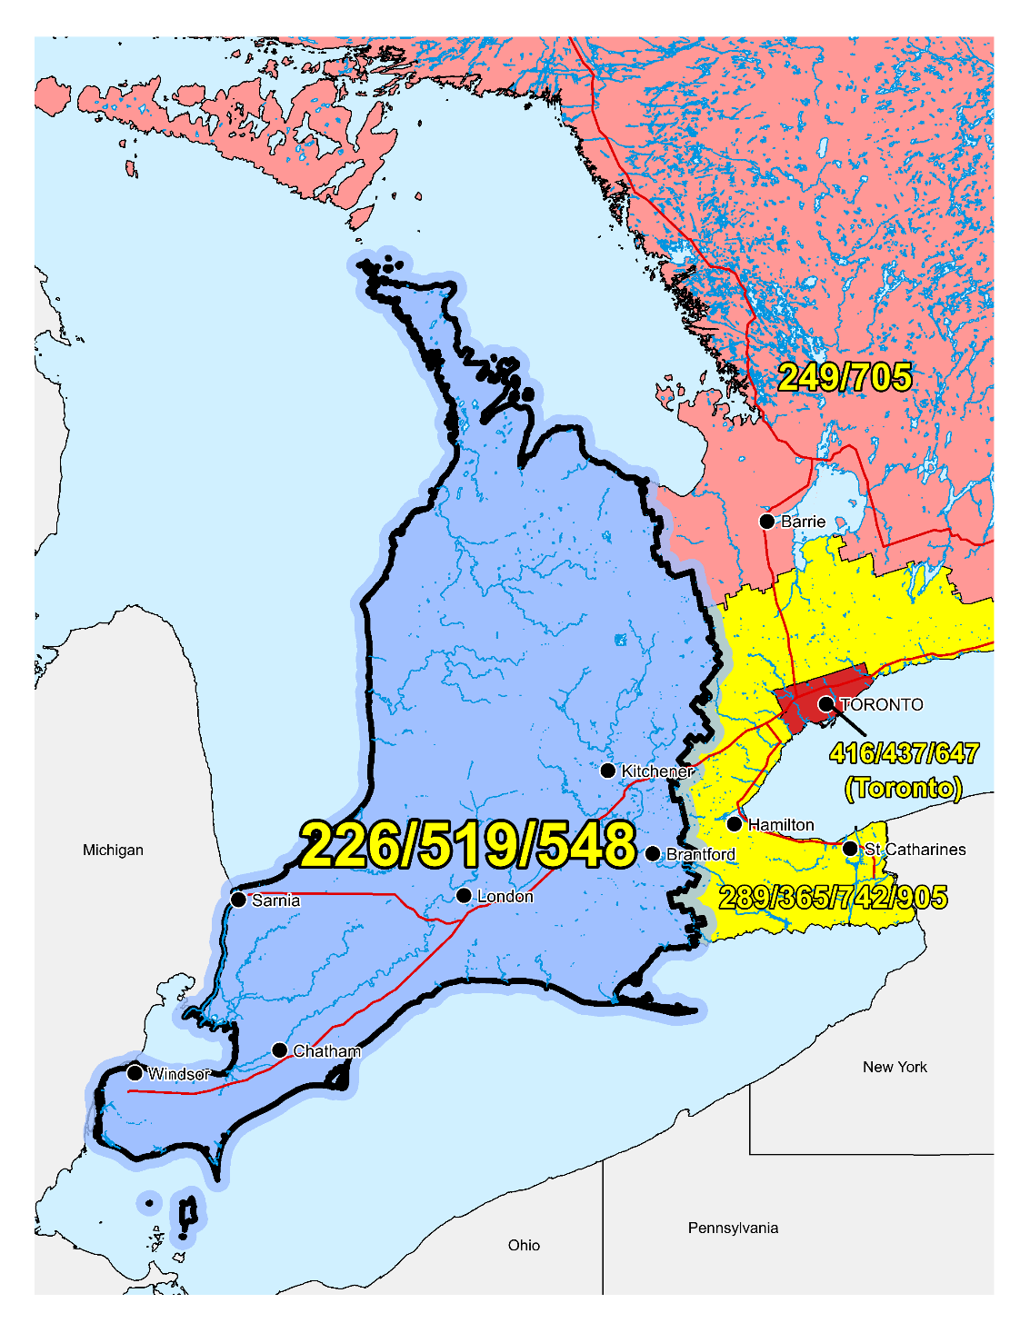

**Figure 1** – **Overview Map of NPA 226/519/548**



**Figure 2** – **NPA 226/519/548 Actual and Forecast CO Code Assignments**



**Figure 3** – **NPA 226/519/548 CO Code Exhaust: January 2021 G-NRUF**



**Figure 4** – **NPA 226/519/548 CO Code Exhaust: July 2021 R-NRUF**

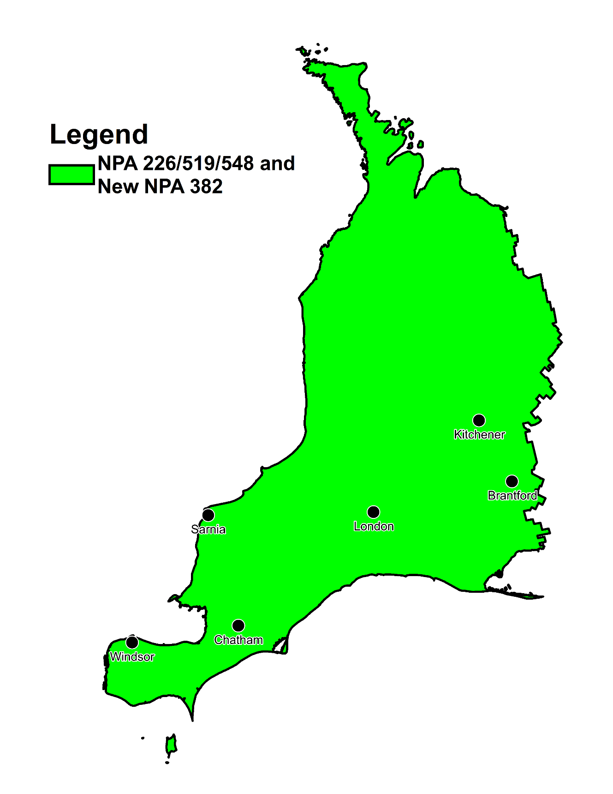

**Figure 5** – **Distributed Overlay**

**Annex B -** **NPA 226/382/519/548 Exchange Areas**

**Table 1 – NPA 226/382/519/548 Exchange Areas After Distributed Overlay**

| **NPA 226/382/519/548**  **Exchange Areas** |
| --- |
|
|
| Aberarder |
| Acton |
| Ailsa Craig |
| Alvinston |
| Alvinston Independant |
| Amherstburg |
| Arkona |
| Arthur |
| Atwood |
| Auburn |
| Aylmer |
| Ayr |
| Ayton |
| Baden |
| Bayfield |
| Beachville |
| Belle River |
| Belmont |
| Blenheim |
| Blyth |
| Bothwell |
| Brantford |
| Breslau |
| Brigden |
| Bright |
| Bright's Grove |
| Brownsville |
| Brussels |
| Burford |
| Burgessville |
| Caledon |
| Cargill |
| Centralia |
| Chatham |
| Chatsworth |
| Chesley |
| Clifford |
| Clinton |
| Clinton Independant |
| Comber |
| Corunna |
| Cottam |
| Courtright |
| Crediton |
| Dashwood |
| Delhi |
| Dorchester |
| Drayton |
| Dresden |
| Drumbo |
| Dublin |
| Dundalk |
| Dungannon |
| Durham |
| Dutton |
| Dyer's Bay |
| Eastwood |
| Elmira |
| Elora |
| Embro |
| Emeryville |
| Erin |
| Essex |
| Exeter |
| Fergus |
| Feversham |
| Fingal |
| Flesherton |
| Forest |
| Galt |
| Glencoe |
| Goderich |
| Gorrie |
| Grand Bend |
| Grand Valley |
| Granton |
| Guelph |
| Hanover |
| Harrietsville |
| Harriston |
| Harrow |
| Hensall |
| Hensall Independent |
| Hepworth |
| Hespeler |
| Hickson |
| Highgate |
| Hillsburgh |
| Holstein |
| Ilderton |
| Ingersoll |
| Innerkip |
| Inwood Independant |
| Jarvis |
| Kerwood |
| Kincardine |
| Kingsville |
| Kintore |
| Kirkton |
| Kitchener-Waterloo |
| La Salle |
| Lambeth |
| Langton |
| Leamington |
| Linwood |
| Lions Head |
| Listowel |
| London |
| Lucan |
| Lucknow |
| Lynden |
| Maidstone |
| Markdale |
| McGregor |
| Meaford |
| Melbourne |
| Merlin |
| Mildmay |
| Milverton |
| Mitchell |
| Monkton |
| Mount Brydges |
| Mount Forest |
| Mount Pleasant |
| Nairn |
| Neustadt |
| New Dundee |
| New Hamburg |
| Norwich |
| Norwich Independent |
| Ohsweken |
| Oil Springs |
| Orangeville |
| Otterville |
| Owen Sound |
| Paisley |
| Palmerston |
| Paris |
| Parkhill |
| Pelee Island |
| Petrolia |
| Plattsville |
| Pleasant Park |
| Port Burwell |
| Port Dover |
| Port Elgin |
| Port Franks |
| Port Lambton |
| Port Rowan |
| Port Stanley |
| Preston |
| Princeton |
| Ridgetown |
| Ripley |
| Rockwood |
| Rodney |
| Sarnia |
| Sauble Beach |
| Scotland |
| Seaforth |
| Seaforth Independant |
| Sebringville |
| Shakespeare |
| Shedden |
| Shelburne |
| Simcoe |
| Sombra |
| Southampton |
| Sparta |
| St. Clements |
| St. George |
| St. Jacobs |
| St. Marys |
| St. Thomas |
| Stokes Bay |
| Stoney Point |
| Straffordville |
| Stratford |
| Strathroy |
| Tara |
| Tavistock |
| Tecumseh |
| Teeswater |
| Thamesford |
| Thamesville |
| Thedford |
| Thornbury |
| Thorndale |
| Tilbury |
| Tillsonburg |
| Tiverton |
| Tobermory |
| Uniondale |
| Walkerton |
| Wallaceburg |
| Wardsville |
| Waterford |
| Watford |
| Watford Independent |
| Wellesley |
| West Lorne |
| Wheatley |
| Wiarton |
| Windsor |
| Wingham |
| Woodslee |
| Woodstock |
| Woodstock Independent |
| Wyoming |
| Zurich |

**Annex C - Distribution List**

|  |  |
| --- | --- |
| Joey-Lynn Abdulkader  Specialist Regulatory Affairs  Bell Canada  160 Elgin Street, 19th Floor  Ottawa, ON  Canada  K2P 2C4  Telephone: 613-785-6314  Fax: 613-560-0472  joey-lynn.abdulkader@bell.ca | Edward Antecol  VP Professional Services  COMsolve Inc.  70 East Beaver Creek Road, #202  Richmond Hill, ON  Canada  L4B 3B2  Telephone: 416-915-5008 x106  edward.antecol@comsolveinc.com |
| Andreea Badea  Iristel Inc.  11 Bowan Court  Toronto, ON  Canada  M2K 3A8  Telephone: 416-800-4747  abadea@iristel.ro | Jenoshan Balasingam  IXICA Communications Inc.  174 Shropshire Drive  Toronto, ON  Canada  M1P 1Z7  Telephone: 844-747-2729 ext: 1100  jenoshan@ixica.com |
| Ron Barzakay  CTO  Comwave Networks  61 Wildcat Rd  Toronto, ON  M3J 2P5  Telephone: 416-663-9700 X 302  Fax: 416-736-3150  rbarzakay@comwave.net | Sharon Bell  Director of Finance and Regulatory  Bruce Telecom  Canada  Telephone: 519-368-1256  sharon.bell@brucetelecom.com |
| Vivek Bhardwaj  Traffic Specialist  Rogers Communications  8200 Dixie Rd.  Brampton, ON  Canada  L6T 0C1  Telephone: 647-747-3569  vivek.bhardwaj@rci.rogers.com | Pavel Bigarov  CNA System Administrator  Canadian Numbering Administrator  150 Isabella Street - Suite 605  Ottawa, ON  Canada  K1S 5H3  Telephone: 613-702-0016  pavel.bigarov@cnac.ca |
| Pavel Bigarov  CNA System Administrator  Canadian Numbering Administrator  150 Isabella Street - Suite 605  Ottawa, ON  Canada  K1S 5H3  Telephone: 613-702-0016  pavel.bigarov@cnac.ca | Olena Bilozerska  Network Planning Manager I, TS CC Planning & Management  TELUS  200 Consilium Place, Floor 6  Scarborough, ON  Canada  M1H 3G2  Telephone: 647-837-1798  Olena.Bilozerska@telus.com |
| Samer Bishay  CEO  Iristel Inc.  11 Bowan Court  Toronto, ON  Canada  M2K 3A8  Telephone: 416-800-9999  Fax: 416-628-0891  sbishay@iristel.com | Kim Brown  Carrier Services Manager  Eastlink  PO Box 8660, Station “A”: 6080 Young St, 7th Floor  Halifax, NS  Canada  B3K 5M3  Telephone: 902-446-3794  Fax: 902-405-3426  kim.brown@corp.eastlink.ca |
| Melanye Caisse  Telecom Analyst  ISP Telecom Inc  1155 Boul Rene-Levesque Ouest Suite 2500  Montreal, QC  Canada  H3B 2K4  Telephone: 416-548-4819  Fax: 416-548-4818  melanye@isptelecom.net | Stephen Catane  Sr. Manager, Service Delivery and Activation  Allstream  Telephone: 416 644 9726  stephen.catane@allstream.com |
| Don Cavanagh  VP  Distributel Communications Limited  177 Nepean Street, Suite 300  Ottawa, ON  Canada  K2P 0B4  Telephone: 613-237-7005  Fax: 613-237-7009  donald.cavanagh@distributel.ca | Fiona Clegg  Numbering Resource Administration  Canadian Numbering Administrator  150 Isabella Street, Suite 605  Ottawa, ON  Canada  K1S 5H3  Telephone: 613-702-0016 ext. 202  fiona.clegg@cnac.ca |
| David Comrie  Numbering Resource Administration  Canadian Numbering Administrator  150 Isabella Street, Suite 605  Ottawa, ON  Canada  K1S 5H3  Telephone: 613-702-0016 ext. 204  david.comrie@cnac.ca | Doug Cooper  Director Network Planning and Profitability  Distributel  801-3300 Bloor St. West  Toronto, ON  M8X2X2  Telephone: 647-317-2924  doug.cooper@distributel.ca |
| JC De Jesus  VP Delivery  Allstream  Telephone: 416-640-9567  jc.dejesus@allstream.com | John DeHeer  General Manager  Quadro Communications  1845 Road 164, PO Box 101  Kirkton, ON  Canada  N0K 1K0  Telephone: 519-229-8933  Fax: 519-229-8998  john.deheer@quadrotelecom.ca |
| Jean-François Dumoulin  VP, Regulatory and Government Affairs  Iristel  Canada  Telephone: 514-800-1577  jdumoulin@iristel.com | Wayne Eichenberger  Vice President, Network Operations  Wightman Telecom Ltd.  Canada  Telephone: +1 519 327-9305  weichenberger@wightman.ca |
| Johny Fernandez  Technology Strategy  TELUS Mobility  200 Consilium Place, 6th Flr  Scarborough, ON  Canada  M1H 3J3  Telephone: 647-453-4442  Johny.fernandez@telus.com | Marc Gaudrault  CEO  TekSavvy Solutions Inc  227 Rue Montcalm  Gatineau, QC  J8Y 3B9  Telephone: 855-864-1572  ddolan@teksavvy.ca |
| Marlo Gelito  Engineer II - TRANSLATIONS & TRAFFIC NETWORK OPERATION  TELUS  3777 Kingsway, Floor 07  Burnaby, BC  V5H 3Z7  Telephone: 604-695-3189  marlo.gelito@telus.com | Geoff Greening  Brooke Telecom Co-operative Limited  PO BOX 40, 3241 Park Street  Inwood, ON  N0N 1K0  Telephone: 519-844-2160  Fax: 519-844-2077  geoff@brooketel.coop |
| Praba Gunam  President/CEO  InnSysVoice Corp.  4500 Sheppard Ave E, Suite 111  Toronto, ON  Canada  M1S 3R6  Telephone: 416-800-0797  praba@innsys.ca | Pierre Guynot de Boismenu  Manager of Core Network Engineering and Operations, Wireless  Bragg Communications Inc  60800 Young St 6th Floor  Halifax, NS  Canada  B3K 5L2  Telephone: 902-414-8020  Fax: 902-444-1019  pierre.guynotdeboismenu@corp.eastlink.ca |
| Austin He  Network Planning Analyst, Network Planning  Primus Management ULC.  2680 Skymark Avenue, Suite 100  Mississauga, ON  Canada  L4W 5L6  Telephone: 416-207-3361  AHe@primustel.ca | Marian Hearn  Project Executive  Canadian LNP Consortium Inc.  350 Palladium Drive, Suite 208  Kanata, ON  Canada  K2V 1A8  Telephone: 613-287-0225  Fax: 800-406-9250  marian.hearn@clnpc.ca |
| Pierre-Luc Hebert  Assistant General Counsel  Bell Canada  160 Elgin St.  Ottawa, ON  Canada  K1G 3J4  Telephone: 613-785-6363  p.l.hebert@bell.ca | Larry Hishon  Senior Network Engineer  Fibernetics Corporation  605 Boxwood Drive  Cambridge, ON  Canada  N3E 1A5  Telephone: 519-571-7433  Fax: 519-772-5014  lhishon@fibernetics.ca |
| Marie-Christine Hudon  Network Provisioning  Bell Canada  671 Rue De La Gauchetière, O.11  Montreal, QC  H3B 2M8  Telephone: 514-870-7839  m-christine.hudon@bell.ca | Stephanie Jackson  Manager - Public Services Integration; Traffic Engineering  Rogers Communications Canada Inc.  8200 Dixie Road  Brampton, ON  Canada  L6T 0C1  Telephone: 647-747-4402  Fax: 647-747-4557  stephanie.jackson@rci.rogers.com |
| Charmaine Kestle  Admin Manager  Quadro Communications Co-operative Inc.  1845 Road 164, PO Box 101  Kirkton, ON  Canada  N0K 1K0  Telephone: 519-229-8933  Fax: 519-229-8998  regulatory@quadro.net | Suresh Khare  CO Code Manager  Canadian Numbering Administrator  150 Isabella Street, Suite 605  Ottawa, ON  Canada  K1S 5H3  Telephone: 613-702-0016 ext. 201  suresh.khare@cnac.ca |
| Phillip Koneswaran  VP - Business  IXICA Communications Inc.  174 Shropshire Drive  Toronto, ON  Canada  M1P 1Z7  Telephone: 844-747-2729 ext: 2100  phillip@ixica.com | Priyantha Kumara  Wightman Telecom Ltd.  100 Elora Street North, Box 70  Clifford, ON  Canada  N0G 1M0  priyantha@wightman.ca |
| Angela Lawrence  General Manager  Hay Communications Co-operative Limited  PO Box 99  Zurich, ON  N0M2T0  Telephone: 519-236-1182  Fax: 519-236-7776  angela@haymail.ca | Natalie Lessard  Numbering Resource Administration  Canadian Numbering Administrator  150 Isabella Street, Suite 605  Ottawa, ON  Canada  K1S 5H3  Telephone: 613-702-0016 ext. 203  natalie.lessard@cnac.ca |
| Jennifer Mack  Traffic Specialist  Rogers Communications  8200 Dixie Rd.  Brampton, ON  Canada  L6T 0C1  Telephone: 647-747-2168  jennifer.mack@rci.rogers.ca | Wanda Marie Mali  Manager - National Numbering Solutions  Bell Canada  100 Borough Dr, Floor 5 Blue  Scarborough, ON  M1P 4W2  Telephone: 416-296-6076  Fax: 416-296-0685  wanda_marie.mali@bell.ca |
| Andrew Matoga  VP President  ISP Telecom  1155 Boul Rene-Levesque O Suite 2500  Montreal, QC  Canada  H3B 2K4  Telephone: 416-548-4626  Fax: 416-548-4847  andrew@isptelecom.net | Ryan McClinchey  General Manager  HuronTel  60 Queen St  Ripley, ON  N0G 2R0  Telephone: 519-395-5799  regulatory@hurontel.on.ca |
| Nancy McIntyre  Mgr - Planning & Engineering  TELUS  3777 Kingsway Floor 07S  Burnaby, BC  V5H 3Z7  Telephone: 604-908-2029  nancy.mcintyre2@telus.com | Nicola McLaughlin  Team Lead  Allstream  200 Wellington St W. F12  Toronto, ON  Canada  M5V 3G2  Telephone: 416-640-5271  Nicola.mclaughlin@allstream.com |
| Rodger McNabb  Manager Contracts and Receivables  Canadian LNP Consortium Inc.  350 Palladium Drive. Suite 208  Kanata, ON  Canada  K2V 1A8  Telephone: 613-287-0226  rodger.mcnabb@clnpc.ca | Linda Middegaal  Office Manager  Tuckersmith Communications Co-operative Limited  General Delivery, 40023 Kippen Road  Kippen, ON  Canada  N0M 2E0  Telephone: 519-233-7033  Fax: 519-263-5000  linda@tcc.on.ca |
| Sundar Nagulan  Team Lead - Voice Engineering  Comwave Networks  61 Wildcat Rd  Toronto, ON  M3J 2P5  Telephone: 647-427-8363  snagulan@comwave.net | Ken Naylor  General Manager  Mornington Communication Co-Op  16 Mill St E  Milverton, ON  Telephone: 519-595-6501  knaylor@mornington.ca |
| Ronda Otto  Sr. Director Service Delivery  Allstream  Telephone: 763-270-3557  ronda.otto@allstream.com | Sonali Pandey  E911 Administrator  Freedom Mobile Inc.  207 Queens Quay, Suite 710  Toronto, ON  Canada  M5J 1A7  Telephone: 647-551-8552  Fax: N/A  spandey@freedommobile.ca |
| Danielle Paquin  Director, Governmental Affairs – Québec  Canadian Security Association (CANASA)  Canada  Telephone: (905) 513-0622 x 226  membership@canasa.org | Drew Penner  Manager – Network Planning and Carrier Relations  Navigata Communications Limited  177 Nepean Street, Suite 400  Ottawa, ON  K2P 0B4  Telephone: 613-317-3614  drew.penner@distributel.ca |
| Elizabth Pereira  Senior Manager, Service Delivery  Allstream  Telephone: 647-776-1868  elizabeth.pereira@allstream.com | Rob Petruk  Gosfield North Communication Co-operative Ltd  Canada  Telephone: 519-839-6300  Fax: 519-839-5505  regulatory@gosfieldtel.ca |
| Robert Quance  President  ISP TELECOM Inc.  630 René-Lévesque blvd. West, Suite 2360  Montreal, QC  Canada  H3B 1S6  Telephone: 416-548-4636  Fax: 514-484-3662  robert@isptelecom.net | Andreea Radut  DID Ordering Specialist  Iristel  Telephone: 416.800.4747  Fax: 416.800.7931  didorders@iristel.com |
| Brian Reyes  Traffic Specialist  Rogers Communications  8200 Dixie Rd  Brampton, ON  L6T0C1  Telephone: 647-747-4657  brian.reyes@rci.rogers.com | Quamrul Hasan Robin  E911 Consultant  Freedom Mobile  207 Queens Quay West Suite 710  Toronto, ON  M5J 1A7  Telephone: 647-225-9523  qrobin@freedommobile.ca |
| Karen Robinson  Network Planning Manager – Translations & Traffic Network Operation  TELUS  200 Consilium Place  Scarborough, ON  Canada  M1H 3J3  Telephone: 647-684-3053  Karen.Robinson3@telus.com | Leo Santoro  Network Analyst  Bell Mobility  5115 Creekbank Rd, Floor 3  Mississauga, ON  Canada  L4W 5R1  Telephone: 905-282-3021  Fax: 905-282-3106  leo.santoro@bell.ca |
| Jacques Sarrazin  President of the CLNP consortium  Canadian LNP Consortium Inc.  Suite 208, 350 Palladium Dr  Kanata, ON  Canada  K2V 1A8  Telephone: 613-287-0225  Fax: 613-823-1169  sarrazin@clnpc.ca | Jill Schatz  Corporate Affairs  Execulink Telecom  1127 Ridgeway Rd  Woodstock, ON  Canada  Telephone: 519-456-7230  Fax: 519-860-7242  jill.schatz@execulinktelecom.ca |
| Rick Schleihauf  VP – Regulatory Affairs and Carrier Relations  Fibernetics Corporation  605 Boxwood Drive  Cambridge, ON  Canada  N3E 1A5  Telephone: 519-489-6700 ext 629  Fax: 519-653-7686  rschleihauf@corp.fibernetics.ca | Angela Schneider  Manager, Secretary-Treasurer  Hay Communications Co-operative Limited  PO Box 99, 72863 Blind Line, Hay Township  Zurich, ON  Canada  N0M 2T0  Telephone: 519-236-4333  Fax: 519-236-7776  a.schneider@hay.net |
| Cosmina Sisiala  DID Ordering Manager  Iristel  Telephone: 416-800-1811  Fax: 416-800-7931  didorders@iristel.com | Eric Smith  Vice President, Regulatory Affairs  Canadian Wireless Telecommunications Association (CWTA)  80 Elgin Street, Suite 30  Ottawa, ON  Canada  K1P 6R2  Telephone: 613-233-5884 Ext. 255  Fax: 613-233-2032  documentcontrol@cwta.ca |
| Ian Stevens  Operations Manager  Execulink Telecom Inc.  619 Main Street North, Box 33  Burgessville, ON  Canada  N0J 1C0  Telephone: 519-456-7800  Fax: 519-456-7801  istevens@execulink.com | Barry Stone  Field Operations Manager  Quadro Communications Co-operative Inc  1845 Road 164, PO Box 101  Kirkton, ON  Canada  N0K 1K0  Telephone: 519-229-8430  Fax: 519-229-8998  barry.stone@quadrotelecom.ca |
| Tom Sullivan  CEO  Bruce Telecom  3145 Hwy 21, PO Box 80  Tilverton, ON  N0G 2T0  Telephone: 519-368-1225  Fax: 519-368-1285  tom.sullivan@brucetelecom.com | Gerry Thompson  Manager, Intercarrier Relations  Rogers Communications Canada Inc.  350 Bloor Street East, 6th Floor  Toronto, ON  Canada  M4W 0A1  Telephone: 416-935-5239  Fax: 416-935-7719  Gerry.Thompson@rci.rogers.com |
| Bruce Uy  TN Administrator  Shaw Telecom Inc  2728 Hopewell Pl NE  Calgary, AB  T1Y 7J7  Telephone: 403-234-6271  Fax: 403-750-4501  bruce.uy@sjrb.ca | Kelly T. Walsh  CNA Program Manager  Canadian Numbering Administrator  150 Isabella Street - Suite 605  Ottawa, ON  Canada  K1S 5H3  Telephone: 613-702-0016 ext 205  kelly.walsh@cnac.ca |
| Clayton Zekelman  Managed Network Systems Inc.  3363 Tecumseh Rd. E.  Windsor, ON  Canada  N8W 1H4  Telephone: 519-985-8410  Fax: 519-985-8409  clayton@mnsi.net |  |