19 April 2024
TIF 118 (Update CSCN-Administered Guidelines for Thousands-Block Pooling)
CSCN Conference Call

Participants: Fiona Clegg - COMsolve Inc. (CNA)
Kelly T. Walsh - COMsolve Inc. (CNA)
Natalie Ann Lessard - COMsolve Inc. (CNA)
Stephen Walsh - COMsolve Inc. (CNA)
John Nakamura - 10X People / INC Co-Chair
Kim Isaacs - Allstream
Joey-Lynn Abdulkader - Bell Canada
Marie-Christine Hudon - Bell Canada
Leo Santoro - Bell Mobility
Bill Barsley - CNAC
Glenn Pilley - CNAC
Anamika Bharti - Cogeco
Ed Antecol - COMsolve Inc.
Alexander Pittman - CRTC staff
Étienne Robelin - CRTC staff
Sarah Reilly - Distributel
Michael Adesina - Freedom Mobile
Sarah Halko - iconectiv/TRA
Karen Robinson - KROB Solutions
Jonathan Holmes - ITPA
Tara Farquhar - NANPA
Marcel Champagne - Neustar
Greg Kinloch - NorthWestel
Darryl Evans - Quadro Communications
Jennifer Mack - Rogers
Ken Shackleton - Rogers
Diane Dolan - Teksavvy
Olena Bilozerska - TELUS
Jean-Sebastien Tremblay - Videotron
Marc Berruyer - Videotron
James Sewell - Westman Communications

Welcome:

Kelly Walsh, as CSCN Chair, welcomed the attendees.

Fiona Clegg reviewed the list of attendees.

Discussion:

It was asked if anything other than a Friday afternoon was discussed for this CSCN meeting. The response was that the other days for holding a meeting were not available. It was also noted that the preference of most CSCN participants is not to hold meetings on Fridays.

It was noted that there are three contributions from Edward Antecol, COMsolve:

- CNCO234A – When can you request a New CO Code in a Pooled Area?
- CNCO235A – Thousands-Block Number Pooling Guidelines – Definitions
- CNCO236A – Block Return Checklist for SPs Prior to Submitting a Part 1A for a Thousands-Block Return

It was noted that the CNA may encourage Carriers to apply for number blocks, but the CNA does not add blocks to the pool for an Exchange Area.

CNCO234A – When can you request a New CO Code in a Pooled Area

Ed Antecol presented the flowchart related to requesting new CO Codes in a pooled area. He noted that a new LRN is required if a Carrier is planning to enter an Exchange Area for the first time, have a new switch or POI.

There was some debate about the merits of semi-annual forecasts, especially in relation to what was termed the “second option” (Does exchange pool have sufficient blocks to satisfy the industry 6 months demand?) It was noted that this option will not be possible if forecasts are not done semi-annually. This option exists in the US but is supported by a mechanism that requires 6-month forecasts.

Taking away the second option would limit a Carrier’s ability to request pool replenishment (which limits the amount of contamination) and would force them to accept possibly contaminated blocks from the pool. The con for this option is all the work required to develop semi-annual forecasts (especially for large Carriers). There is a need to balance whether the work is worth having the flexibility to obtain numbers using pool replenishment.

If the Canadian industry decides not to do semi-annual forecasting, then option 2 needs to be taken off the table. It was noted that this is a decision that needs to be taken back and discussed internally. Ed Antecol suggested that, in aggregate, an annual forecast is usually overstated by 200%. If forecasting were only done annually, the number block pools would probably be overfull.

In the US, the Carriers submit the 6-month forecasts semi-annually. NANPA believes that the forecasts are overstated in the US as well even though the forecasting is more frequent.

Tara Farquhar, NANPA, provided the following data:

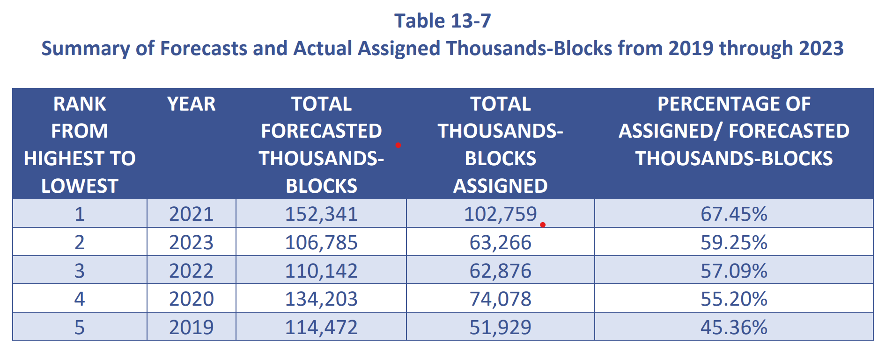
The above table came from section 13.2 of the 2023 Annual Report on the NANPA website.

K.T. Walsh noted that the CNA does have a mean absolute percentage error (MAPE) graph included in the January 2024 G- and R-NRUF Report.

It was noted that a CRTC waiver may allow the assignment of an entire CO Code to a TSP. In response to a question about the process in the US, it was noted that a waiver is from a regulator if a CO Code for a large customer is requested, and a dedicated CO Code also requires a customer letter. NANPA will not make a CO Code assignment of this type without the letter and the waiver.

It was noted that the boxes in the flowchart addressing pool replenishment are a cross-over between this TIF and TIF 119 (Inclusion of unused numbers from previously assigned CO Codes in pool of available thousand-blocks).

CNCO235A – Thousands-Block Number Pooling Guidelines – Definitions

Ed Antecol presented the contribution and noted that the definition of “Contamination” in the contribution includes not available for assignment. Unavailable for assignment may need to be defined.

In response to a question, it was noted that thousands blocks from a single CO Code can be assigned to any type of Carrier that qualifies for telephone number assignment.

Ed Antecol noted that the purpose of the contribution was to begin accumulating common definitions. The idea is that this list of definitions will be a living document and will be supplemented by terminology used in future contributions.

A couple of non-substantive changes were made to the document.

CNCO236A – Block Return Checklist for SPs Prior to Submitting a Part 1A for a Thousands-Block Return

Agreement was reached to discuss CNCO236A (Thousands Block Pooling - Block Return Checklist) today, even though it has not been in circulation for 5 business days.

Ed Antecol presented the contribution. He noted that item 2 contains the words “not assigned in switching entities/POIs” which was taken from the ATIS specification. He asked if anyone knew what this meant. Is it referring to LRNs? There was no response and it was concluded that the question requires further research.

In response to a question, it was noted that “Intra Service Provider” (ISP) port means a Carrier ports the numbers to itself.

It was asked if there is an automated process for ISP ports? In response it was noted that there are vendors that can provide automation for multiple intra-ports (99 per block assuming contamination is 10%).

It was asked what fee will be applied to ports? In response it was noted that this is a question for the CLNPC and, also, it is for them to decide how that charging mechanism will work.

It was noted that there is no process for snap-back for an aging number. There will at least be a 45-day lag before it can go into another Carrier’s inventory. Unfortunately, aging takes 90 days.

It was asked whether each Carrier should have an internal aging pool.

The process that is missing is deactivating an aging number and working out how to intercept it before it goes back into a Carrier’s inventory and, instead, goes to the Carrier that now has the block.

It was suggested that aging numbers should be subject to intra service provider ports. Other participants recommended thinking about the topic some more.

It was noted that the snap-back process is not built in. It was noted that there is a need to lock down the block and wait until the 90-days required for aging has passed. In response, it was noted that this would be cumbersome and adds unnecessary time to the process.

In response to a question, it was noted that “lock down” means the block would be pulled out of a Carrier’s inventory and no numbers would be assigned from that block. It was asked if there is going to be a 90-day period between lock-down and releasing a block to the pool.

A participant stated that they could not find a specific regulatory requirement for a TSP to provide vacant number announcement treatment on an aging telephone number.

It was asked if it is mandatory to donate or return blocks or can the TSP retain those blocks for future demand. It was noted that this question is addressed at the beginning of the contribution. A TSP can retain its inventory to the extent that it can be used within the next 6 months.

The CNA will send out a CSCN Meeting invitation for further discussion of TIF 118 (Update CSCN-Administered Guidelines for Thousands-Block Pooling) Thursday, May 2, 2024, 13:00 – 15:00 ET.

CSCN participants should create contributions for: a) the frequency of forecasting in conjunction with the flexibility to request new CO Codes where the industry forecasted demand is greater than the number of blocks in the pool; and b) input to finalize how to deal with numbers in the aging pools (e.g., intra service provider porting of aged numbers or 90-day lock down for a block with aging numbers).

The Chair of the CSCN thanked the participants for attending the meeting.

Summary of Agreements Reached:

- Agreement was reached to discuss CNCO236A (Thousands Block Pooling - Block Return Checklist) today, even though it has not been in circulation for 5 business days.

Summary of Action Items:

- The CNA will send out a CSCN Meeting invitation for further discussion of TIF 118 (Update CSCN-Administered Guidelines for Thousands-Block Pooling) Thursday, May 2, 2024, 13:00 – 15:00 ET. (Completed)

- CSCN participants should create contributions for: a) the frequency of forecasting in conjunction with the flexibility to request new CO Codes where the industry forecasted demand is greater than the number of blocks in the pool; and b) input to finalize how to deal with numbers in the aging pools (e.g., intra service provider porting of aged numbers or 90-day lock down for a block with aging numbers).

Attachments:

CNCO234A - COMsolve contribution - TIF 118 - Flow chart of when to request a new CO Code in a pooled area

CNCO235B - COMsolve contribution - TIF 118 - TBP Guideline Definitions

CNCO236B - COMsolve contribution - TIF 118 - TBP Block Return Checklist

