26 March 2026
CSCN Meeting
TIF 125 (TBP Controlled Production Rollout)
Conference Call

Participants: David Comrie - COMsolve Inc. (CNA)
Fiona Clegg - COMsolve Inc. (CNA)
Kelly T. Walsh - COMsolve Inc. (CNA)
Natalie Ann Lessard - COMsolve Inc. (CNA)
Stephen Walsh - COMsolve Inc. (CNA)
Joey-Lynn Abdulkader - Bell Canada
Marie-Christine Hudon - Bell Canada
Francois Dalton - City West
Chantale Neapole - CLNPC
Rodger McNabb - CLNPC
Ed Antecol - COMsolve Inc.
Alexander Pittman - CRTC staff
Étienne Robelin - CRTC staff
Sage Wiese - CTA
Sarah Reilly - Distributel
Justin Gerogiannis - Eastlink
Richard Schleihauf - Fibernetics
Michael Adesina - Freedom Mobile
Vince Yelle - Groupe Maskatel
Mark Peeters - HuronTel
Connie Hartman - TNS/TRA
Karen Robinson - KROB Numbering Solutions
Tara Farquhar - NANPA
Marcel Champagne - Neustar/Transunion
Temitope Adeyemi - NorthWestel
Andrew Hew - Rogers
Michael Studniberg - Rogers
Bruce Uy - Rogers
Aditi Sharma - Sasktel
Damandeep Singh - Sasktel
Lucie Lang - Sasktel
Allyson Blevins - Sinch / INC Co-Chair
Bob Bruce - Syniverse
Brian Duce - Tbaytel
Diane Dolan - Teksavvy
Beth Connell - TELUS
Farhan Ali Ghulam Ali - TELUS
Marlo Gelito - TELUS
Olena Bilozerska - TELUS
Rick Cousineau - TELUS
Jean-Sebastien Tremblay - Videotron
Marc Berruyer - Videotron
Martin Perreault - Videotron
James Sewell - Westman Communications
Shauna Colby - Tbaytel

Welcome:

Kelly Walsh, as CSCN Chair, welcomed the attendees.

David Comrie, as CSCN Secretary, reviewed the list of participants.

Action Item Review:

- CRTC staff will look into what they can do to ensure maximum participation in the scheduled TIF 125 Phase Implementation meeting. (Ongoing)

- The CNA will include a description of the phase being implemented with the TBP Phase Implementation Plan (Completed)

- The CNA will post a copy of the Phase 1 Launch Trial Implementation Plan as CNCO323A. (Completed)

- The CNA will remove phase-specific details from the new contributions and post it as a CNCO318B as a TBP Phase Implementation template. (Completed)

Discussion:

Kelly Walsh noted that this meeting is to review the overall TBP implementation plan and report to be submitted to the CISC and CRTC.

Kelly Walsh noted that during the last TIF 125 meeting, the CNA took an action item to discuss cost breakdown of the Fair Share Plan. The CNA discussed it with TNS and it was decided that it would not be appropriate for the CNA to host that discussion so anyone with a Fair Share agreement should contact TNS TRA to discuss a breakdown of their Fair Share plan, or those with a 3rd party service provider should contact their AOCN and ask them to have a discussion.

Étienne Robelin noted that there was a request for a TBP readiness checklist last year to be sent out. This was aggregated by the TBP Coordinator. The results are on the Commission website.

The reports are publicly available on the Commission’s website on the record of NOC 2023-92 under reports.

Excerpt:
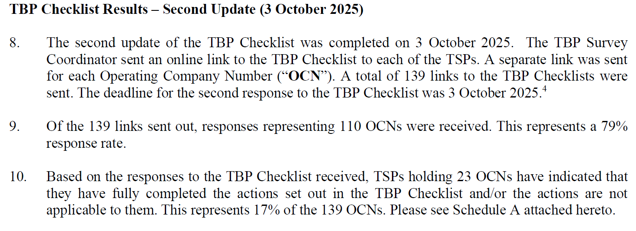

Action Item: The CSCN Secretary will send a link to the CNAC report to the CSCN distribution list. (Completed)

Joey-Lynn Abdulkader presented CNRE160B.

CNRE160B - Bell contribution - TIF 125 - Draft TIF Report - TBP Readiness Affirmation Form and Recommendations to Facilitate the Rollout of Thousands-Block Pooling (incl. in-meeting changes)

Kelly Walsh asked the group if they wanted to shorten the comment period for this report once it has been reposted with today’s edits.

The group reviewed CNCO319C.

CNCO319C - Bell contribution - TIF 125 - Draft of Carrier Affirmation of Thousands-Block Pooling Readiness form (incl. in-meeting changes)

Agreement was reached to accept CNCO319C as modified during today’s call.

Action Item: The CSCN Secretary will post the updated version of CNCO319C as CNCO319D on the CSCN Drafts page. (Completed)

Kelly Walsh presented https://cnac.ca/co_codes/TBP/TBP_Implementation.

Agreement was reached to accept the modified version of CNRE160B as CNRE160C and post it for a shortened comment period of 5 business days. If there are no substantive changes, it will be considered final, the affirmation form will be attached, and the report will be sent to the CISC for consideration.

Action Item: The CNA will rename the modified version of CNRE160B as CNRE160C and post it for a shortened comment period of 5 business days. If there are no substantive changes, it will be considered final, the affirmation form will be attached, and the report will be sent to the CISC for consideration. (Ongoing)

The group reviewed CNCO318B.

CNCO318C - CSCN Contribution - TIF 125 - Template for Steps for rolling out TBP in 1 or more Exchanges

Agreement was reached to accept CNCO318B on as CNCO318C.

The group reviewed CNCO323A.

CNCO323A - CSCN contribution - TIF 125 - TBP Phase 1-LaunchTrial Implementation Plan (incl. in-meeting changes)

Agreement was reached to accept changes to the Phase 1 Launch Trial Plan CNCO323A as CNCO323B.

Action Item: The CSCN Secretary will post CNCO318C and CNCO323B. (Completed)

Agreement was reached to accept CNCO312G as modified today as CNCO312H.

Agreement was reached to accept CNCO322A as modified today as CNRE161A.

Agreement was reached to shorten the commenting period for CNCO312H and CNRE161A to 5 business days.

Action Item: The CSCN Secretary will post CNRE161A and CNCO312H on the CNA website for comment for 5 business days. If there are no substantive changes, they will be combined and submitted to the CISC for consideration. (Ongoing)

The Chair thanked everyone for participating.

Summary of Agreements Reached:

- Agreement was reached to accept CNCO319C as modified during today’s call.

- Agreement was reached to accept the modified version of CNRE160B as CNRE160C and post it for a shortened comment period of 5 business days. If there are no substantive changes, it will be considered final, the affirmation form will be attached, and the report will be sent to the CISC for consideration.

- Agreement was reached to accept CNCO318B on as CNCO318C.

- Agreement was reached to accept changes to the Phase 1 Launch Trial Plan CNCO323A as CNCO323B.

- Agreement was reached to accept CNCO312G as modified today as CNCO312H.

- Agreement was reached to accept CNCO322A as modified today as CNRE161A.

- Agreement was reached to shorten the commenting period for CNCO312H and CNRE161A to 5 business days.

Summary of Action Items:

- The CSCN Secretary will send a link to the CNAC report to the CSCN distribution list. (Completed)

- The CSCN Secretary will post the updated version of CNCO319C as CNCO319D on the CSCN Drafts page. (Completed)

- The CSCN the modified version of CNRE160B as CNRE160C and post it for a shortened comment period of 5 business days. If there are no substantive changes, it will be considered final, the affirmation form will be attached, and the report will be sent to the CISC for consideration. (Ongoing)

- The CSCN Secretary will post CNCO318C and CNCO323B. (Completed)

- The CSCN Secretary will post CNRE161A and CNCO312H on the CNA website for comment for 5 business days. If there are no substantive changes, they will be combined and submitted to the CISC for consideration. (Ongoing)
Attachments:

See text above for the attachments.

