CRTC INTERCONNECTION STEERING COMMITTEE
CONTRIBUTION FORM:
Working Group: CSCN Date of Submission: 2024-05-07
Contribution #: 241A
TIF #: 118 (also TIF 119) File ID: CNCO241A
Task Title: Update CSCN-Administered Guidelines for Thousands-Block Pooling
Related to Task(s) ID:
Contributor:
Name: Ed Antecol
Company: COMsolve Inc.
Address:
Tel:
Fax:
E-mail: Edward.antecol@comsolveinc.com
Distribution to: CSCN
Subject:
Semi-annual forecasting requirements

Introduction
This submission presents a proposal for new forecasting requirements to improve Canadian number utilization by carriers, and to ensure carriers are returning unused Thousands-Blocks as appropriate.

NRUF in the United States
NANPA is required to collect, store and maintain number resource utilization and forecast data. Following FCC's rules, assignees holding geographic and/or certain non-geographic (NPA 5XX and 900) telephone numbers must report on their holdings twice each year (February 1 and August 1)using the Form 502, the Numbering Resource Utilization/Forecast (NRUF) Report.
Geographic NRUF Form 502 — found at https://nationalnanpa.com/nruf_resources/index.html.
Utilization
Utilization reporting is by Rate Center (Exchange Area equivalent, and by inventory status.
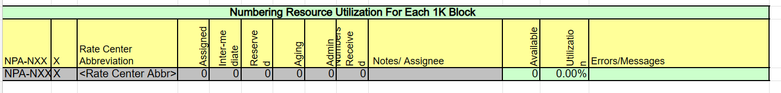
Note 1: “Assigned” numbers are defined as "numbers working in the Public
Switched Telephone Network under an agreement such as a contract or tariff at the request of
specific end users or customers for their use, or numbers not yet working but having a customer
service order pending. Numbers that are not yet working and have a service order pending for
more than five days shall not be classified as assigned numbers.

Note 2: “Intermediate” numbers are defined as "numbers that are made available for use by another telecommunications carrier or non-carrier entity for the purpose of providing telecommunications service to an end user or customer." An exception to this requirement is numbers ported for the purpose of transferring an established customer's service to another service provider, in which case the numbers are classified as "Assigned" by the porting carrier and not counted by the receiving carrier. For intermediate numbers provided by carriers to non-carrier entities, the providing carrier must report utilization for these numbers. Numbers assigned to end users by a non-carrier entity should be reported by the providing carrier as "Assigned." Any remaining numbers held by a non-carrier entity that are not assigned to end users shall be reported by the providing carrier as "Intermediate." The sum of numbers reported by the carrier for the non-carrier entity in these two categories should always equal the total of numbers held by the non-carrier entity.

Note 3: Utilization equals “Assigned numbers/(Received numbers – Intermediate numbers). See formula in spreadsheet.

Forecast

Two forms are typically required for carriers involved in pool areas, Form F-1a, and Form F1-b.

Form F-1a
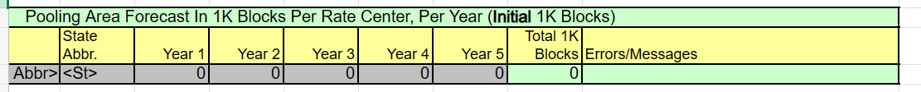

Form F-1b

Recommendations to Improve Number Utilization in Canada:

- Canada adopt Utilization reporting by Exchange Area at the Thousands-Block level in all areas where Thousands-Block pooling is (or will be in effect).
- Canada adopt reporting of Intermediate numbers in calculation of Utilization.
- Canada adopt Forecasts by Exchange Area at the Thousands-Block level in all areas where Thousands-Block pooling is (or will be in effect).

Rationale

Utilization reporting by Exchange Area will help ensure that carriers can examine their inventories and return blocks where utilization levels are low.

Reporting of Intermediate numbers will allow for better tracking of true utilization by a carrier and accountability for numbers provided to resellers.

Exchange Area level forecasting is necessary to provide carriers with the flexibility for pool replenishment requests (i.e., a new CO code) even when there are sufficient Thousands-Blocks in a pool to meet the immediate request so long as the remaining six month forecasted demand is greater than the blocks in the pool.

https://nationalnanpa.com/nruf/index.html
https://nationalnanpa.com/pdf/NRUF/Geographic_NRUF_Instructions.pdf
https://nationalnanpa.com/pdf/NRUF/Geographic_NRUF_Instructions.pdf

