Annexes
Planning Document NPA 705 Numbering Relief

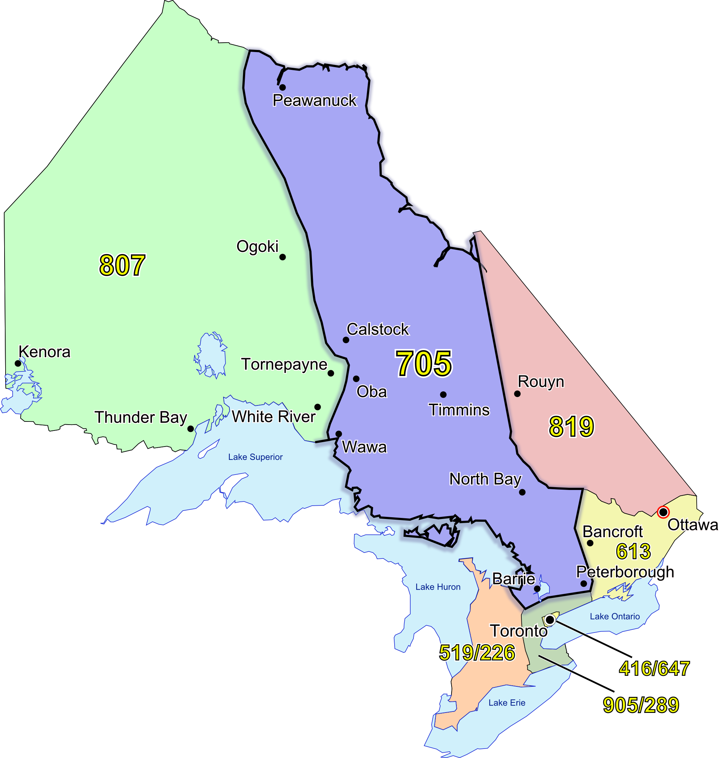

Initial Planning Document (IPD)
Version 1.0 – April 8, 2009

Canadian Numbering Administrator (CNA)  Suresh Khare  613-563-7242-315  60 Queen Street, Suite 1516  Ottawa, Ontario K1P 5Y7  khares@saiccanada.com | 

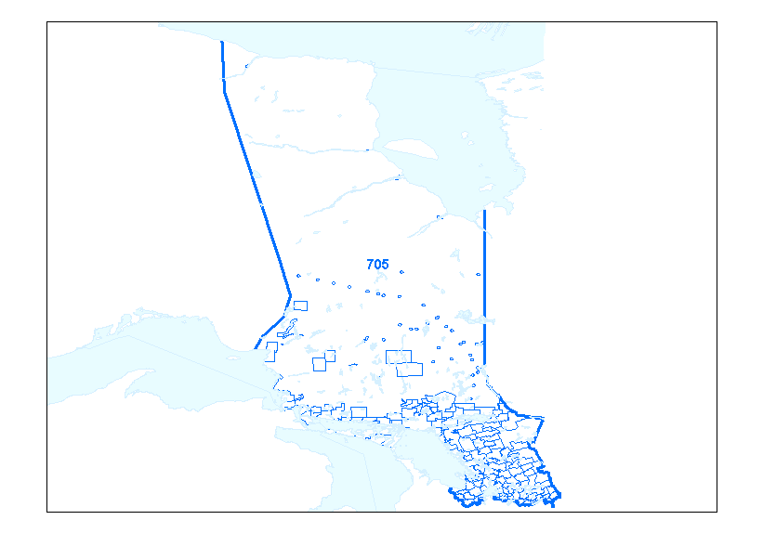
Figure 1 - Overview of NPA 705 and Adjacent NPAs
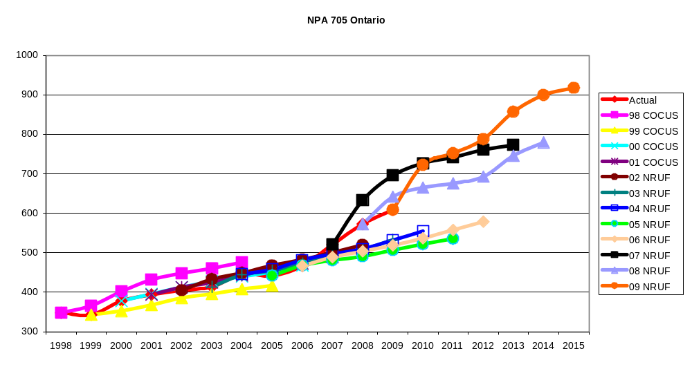

Figure 2 - NPA 705 Actual and Forecast CO Code Assignments
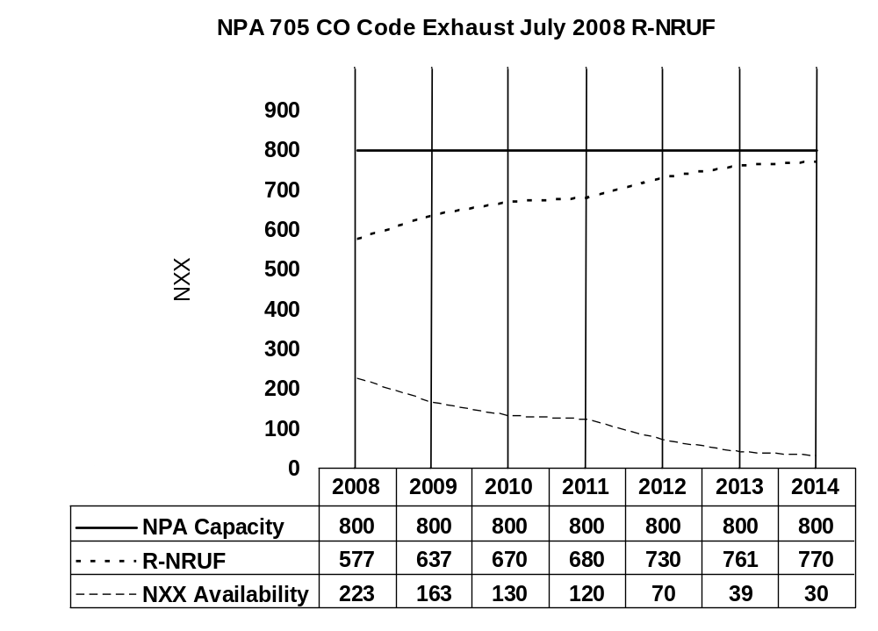
Figure 3 - NPA 705 CO Code Exhaust July 2008 R-NRUF

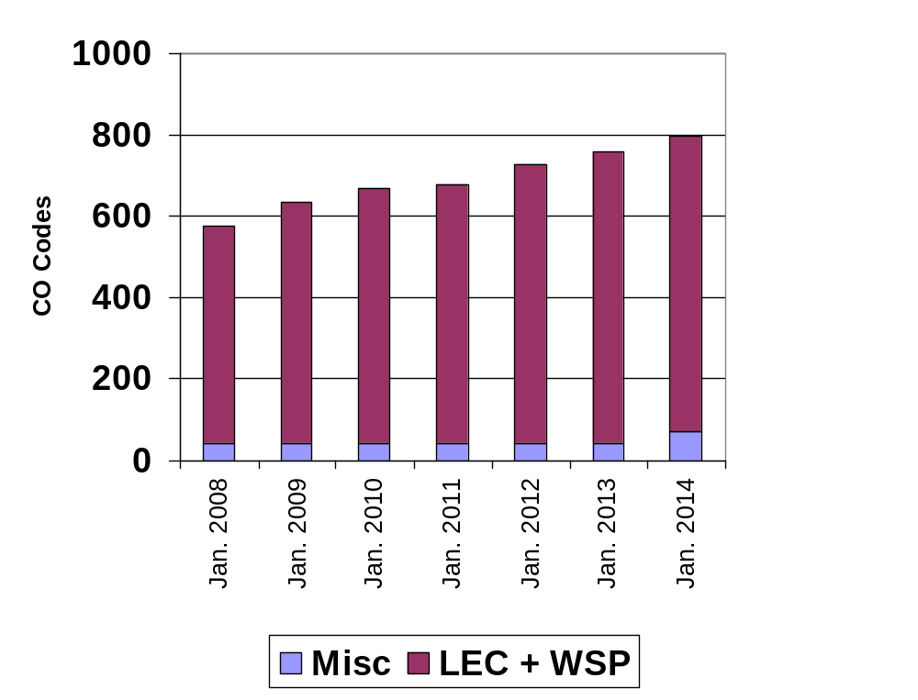
Figure 4 - NPA 705 CO Code Exhaust July 2008 R-NRUF

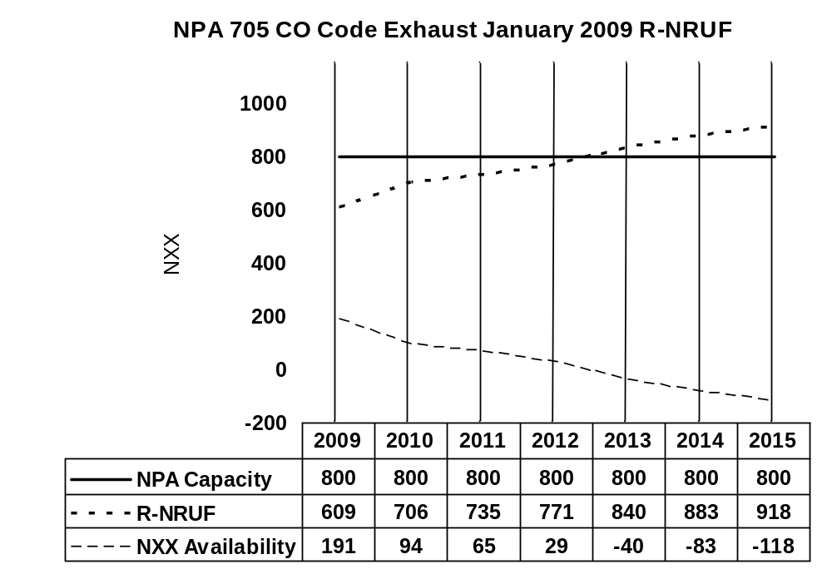
Figure 5 - NPA 705 CO Code Exhaust January 2009 R-NRUF

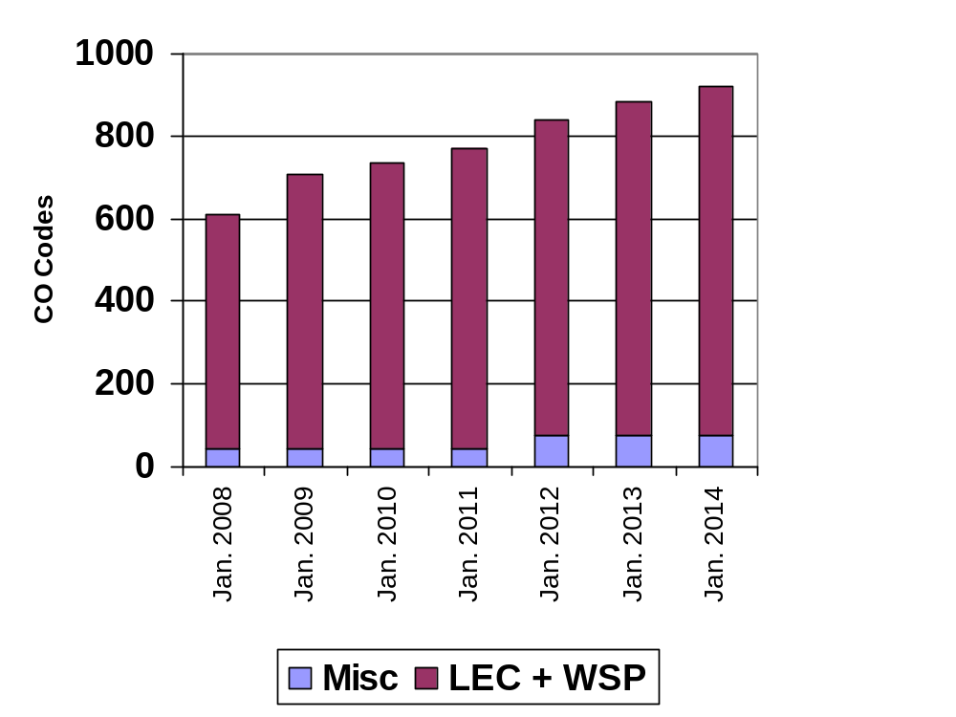
Figure 6 - NPA 705 CO Code Exhaust January 2009 R-NRUF

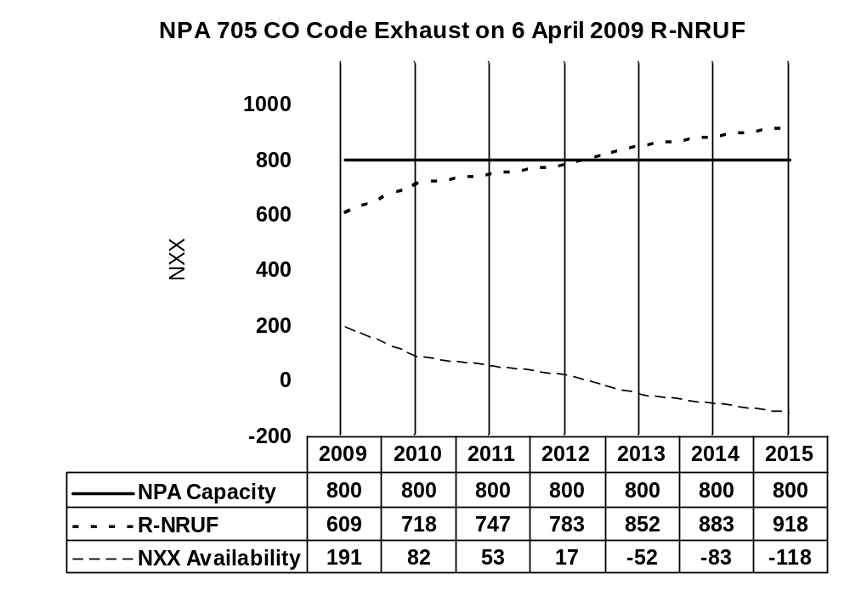

Figure 7 - NPA 705 CO Code Exhaust after release of Telecom Notice of Consultation CRTC 2009-179

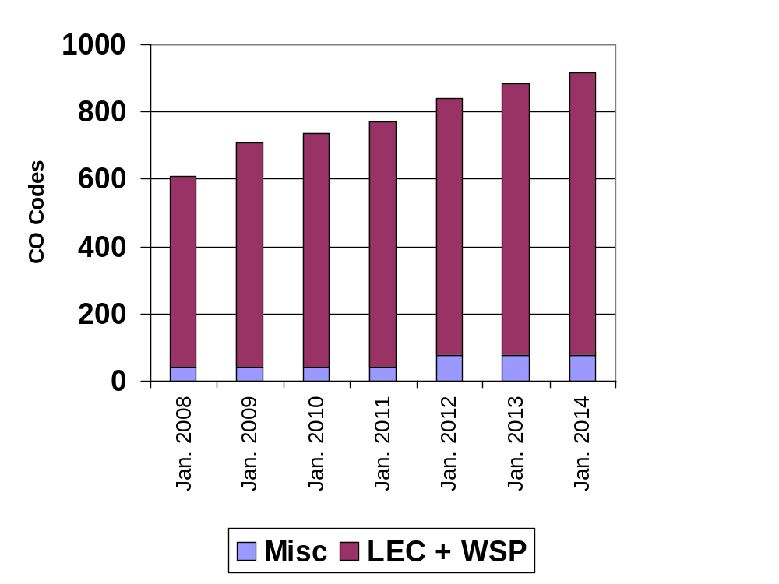

Figure 8 - NPA 705 CO Code Exhaust after release of Telecom Notice of Consultation CRTC 2009-179

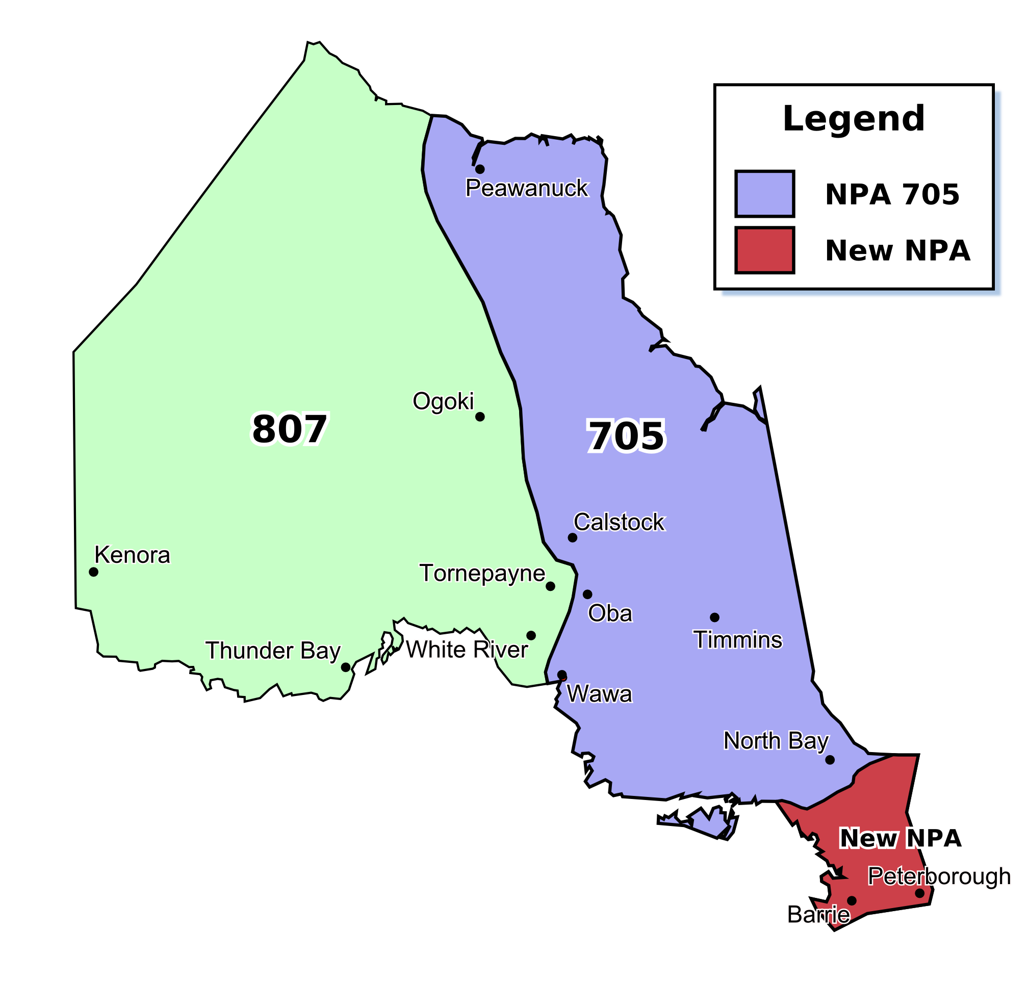

Figure 9 - Plan 1a: Split - North Bay LIR in North (North retains NPA 705)

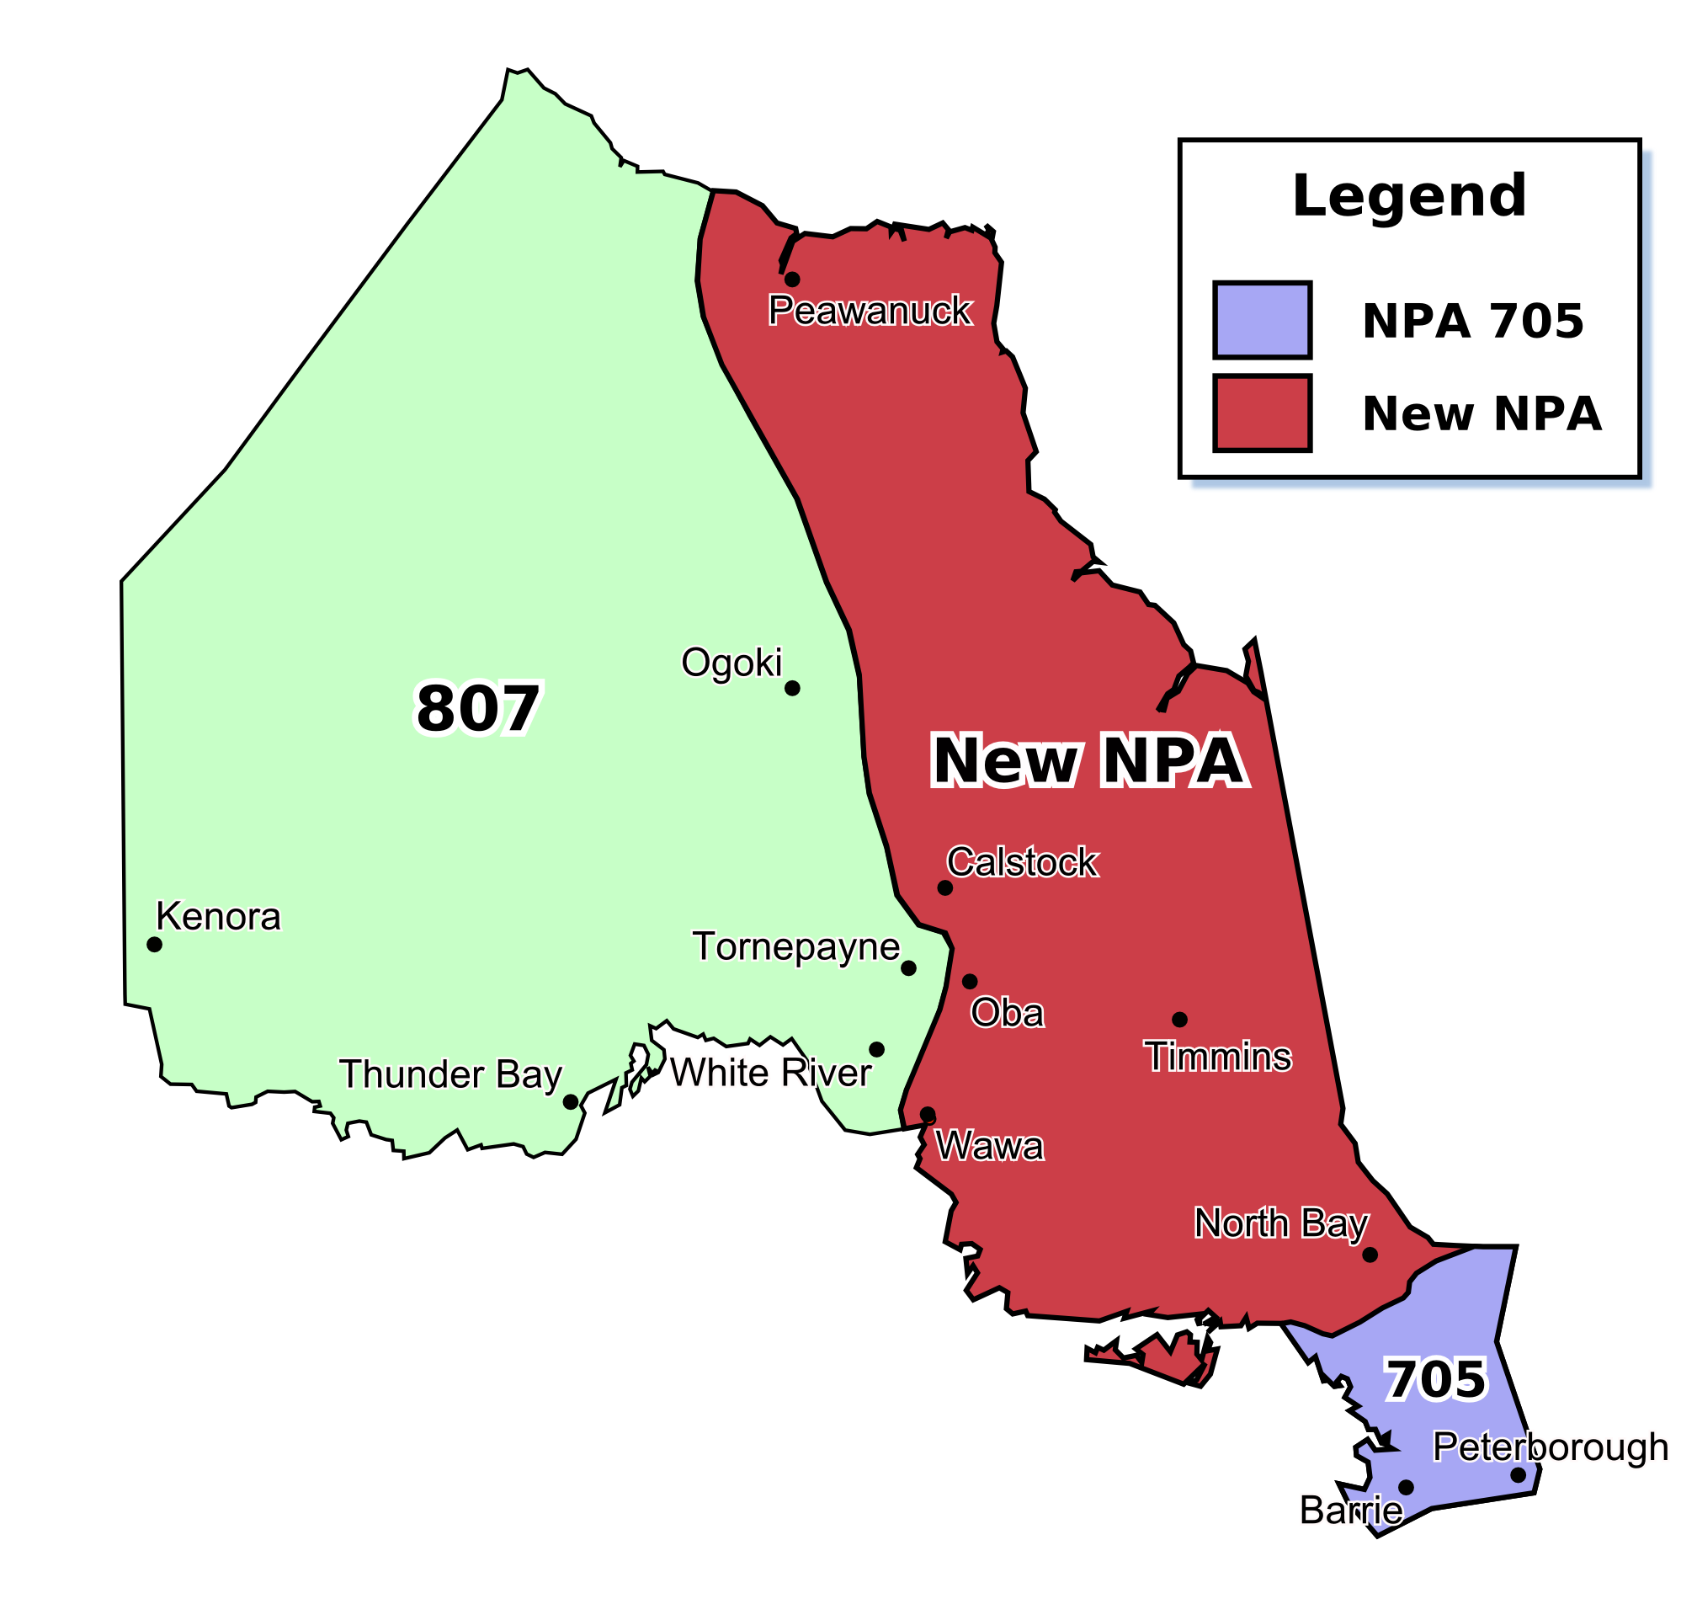

Figure 10 - Plan 1b: Split - North Bay LIR in North (South retains NPA 705)

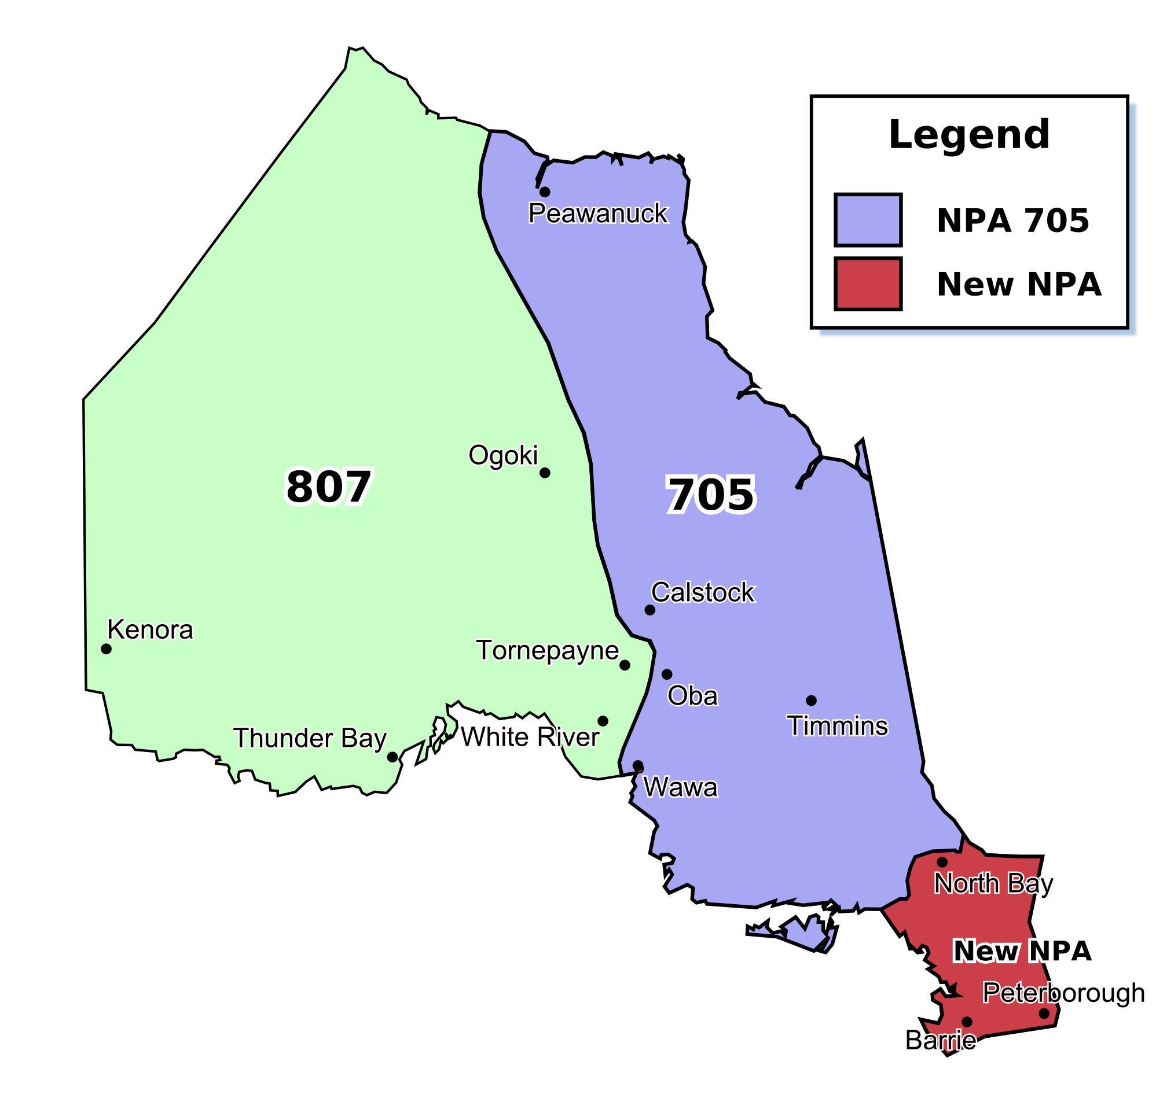

Figure 11 - Plan 2a: Split - North Bay LIR in South (North retains NPA 705)

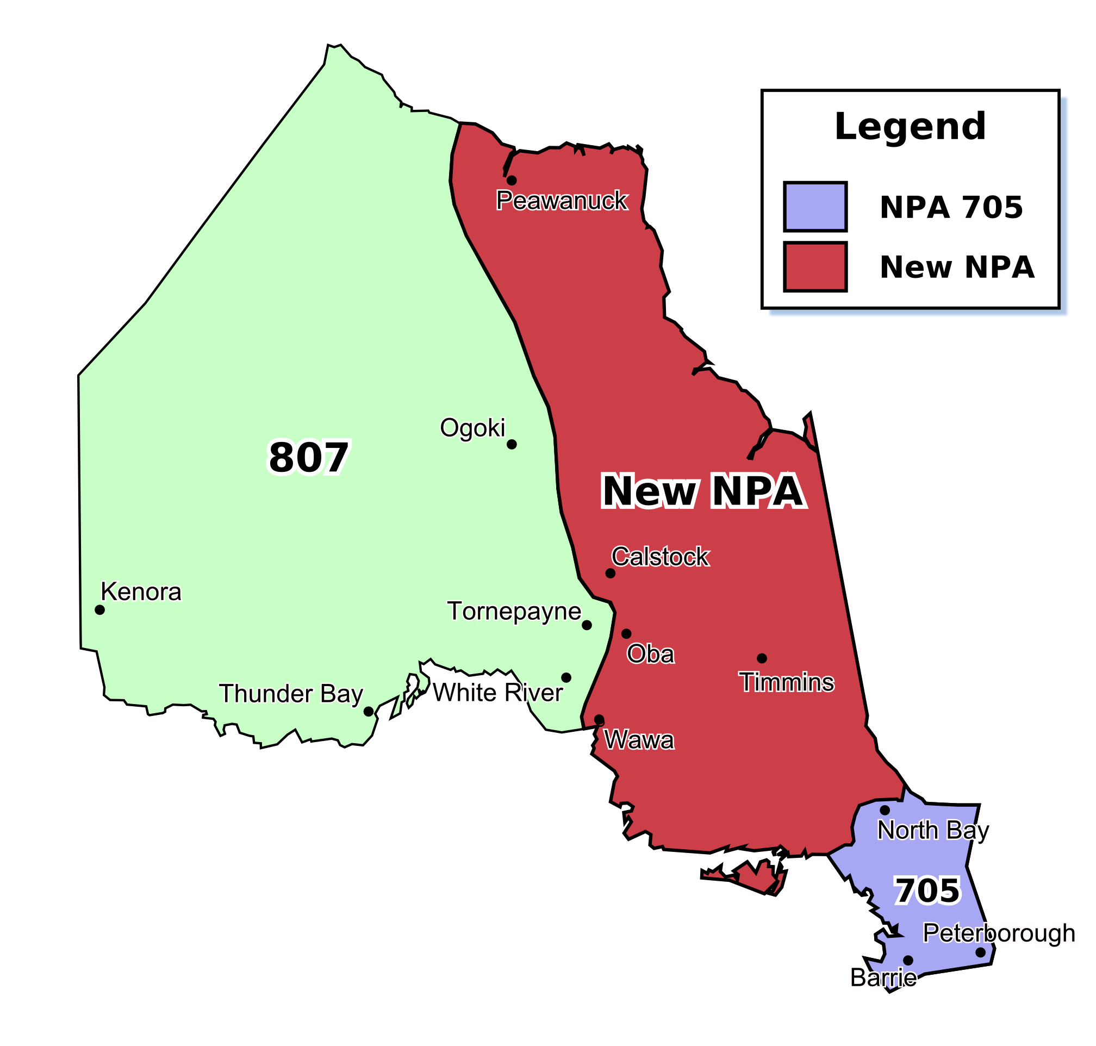

Figure 12 - Plan 2b: Split - North Bay LIR in South (South retains NPA 705)

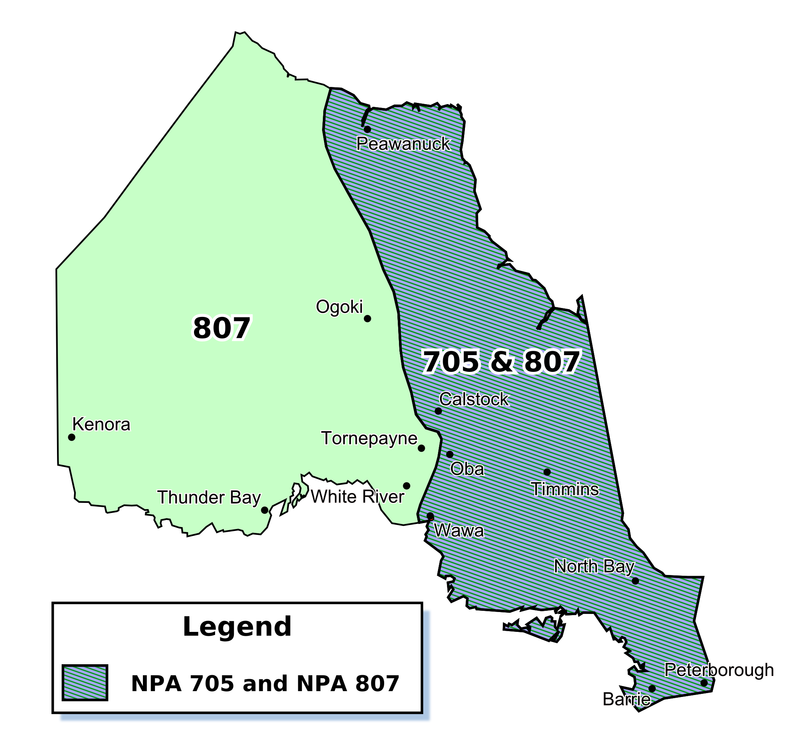

Figure 13 - Plan 3: NPA 807 Boundary Extension Overlay

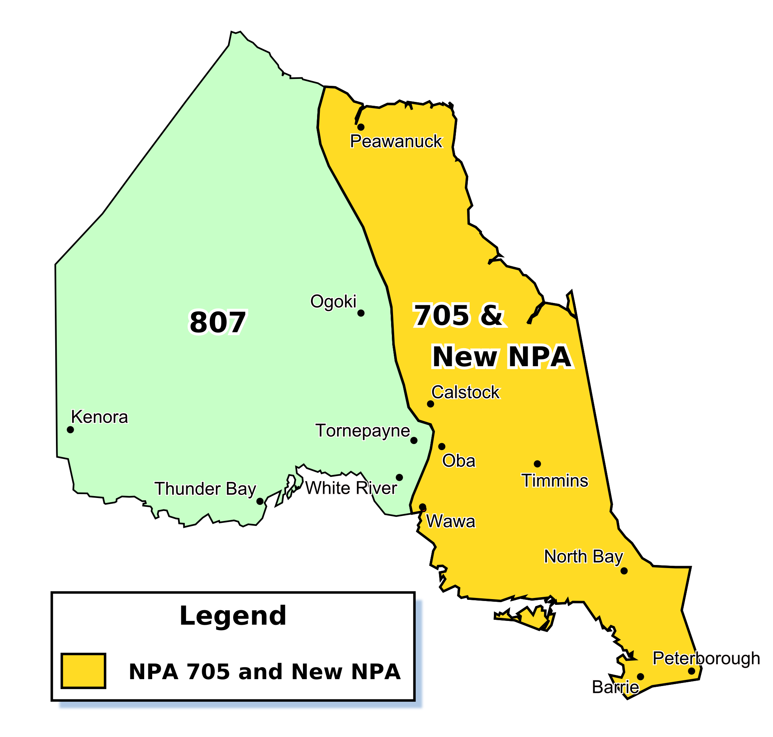
Figure 14 - Plan 4: Distributed Overlay of New NPA on NPA 705

Table 1 – Exchange Areas currently in NPA 705, 807 and New NPA for these Exchange Areas after each Relief Plan

 | 1a |  | 1b |  | 2a |  | 2b |  | 3 |  | 4
Exchange Area | New | 705 | New | 705 | New | 705 | New | 705 | 807 | 705 | New | 705
Abitibi Canyon |  | ✓ | ✓ |  |  | ✓ | ✓ |  | ✓ | ✓ | ✓ | ✓
Alban |  | ✓ | ✓ |  |  | ✓ | ✓ |  | ✓ | ✓ | ✓ | ✓
Algoma Mills |  | ✓ | ✓ |  |  | ✓ | ✓ |  | ✓ | ✓ | ✓ | ✓
Algonquin Park | ✓ |  |  | ✓ | ✓ |  |  | ✓ | ✓ | ✓ | ✓ | ✓
Alliston | ✓ |  |  | ✓ | ✓ |  |  | ✓ | ✓ | ✓ | ✓ | ✓
Apsley | ✓ |  |  | ✓ | ✓ |  |  | ✓ | ✓ | ✓ | ✓ | ✓
Attawapiskat |  | ✓ | ✓ |  |  | ✓ | ✓ |  | ✓ | ✓ | ✓ | ✓
Azilda |  | ✓ | ✓ |  |  | ✓ | ✓ |  | ✓ | ✓ | ✓ | ✓
Bailieboro | ✓ |  |  | ✓ | ✓ |  |  | ✓ | ✓ | ✓ | ✓ | ✓
Bala | ✓ |  |  | ✓ | ✓ |  |  | ✓ | ✓ | ✓ | ✓ | ✓
Barrie | ✓ |  |  | ✓ | ✓ |  |  | ✓ | ✓ | ✓ | ✓ | ✓
Batchawana Bay |  | ✓ | ✓ |  |  | ✓ | ✓ |  | ✓ | ✓ | ✓ | ✓
Baysville | ✓ |  |  | ✓ | ✓ |  |  | ✓ | ✓ | ✓ | ✓ | ✓
Beaverton | ✓ |  |  | ✓ | ✓ |  |  | ✓ | ✓ | ✓ | ✓ | ✓
Bethany | ✓ |  |  | ✓ | ✓ |  |  | ✓ | ✓ | ✓ | ✓ | ✓
Biscotasing |  | ✓ | ✓ |  |  | ✓ | ✓ |  | ✓ | ✓ | ✓ | ✓
Blezard Valley |  | ✓ | ✓ |  |  | ✓ | ✓ |  | ✓ | ✓ | ✓ | ✓
Blind River |  | ✓ | ✓ |  |  | ✓ | ✓ |  | ✓ | ✓ | ✓ | ✓
Bluewater | ✓ |  |  | ✓ | ✓ |  |  | ✓ | ✓ | ✓ | ✓ | ✓
Bobcaygeon | ✓ |  |  | ✓ | ✓ |  |  | ✓ | ✓ | ✓ | ✓ | ✓
Bonfield |  | ✓ | ✓ |  | ✓ |  |  | ✓ | ✓ | ✓ | ✓ | ✓
Borden-Angus | ✓ |  |  | ✓ | ✓ |  |  | ✓ | ✓ | ✓ | ✓ | ✓
Bracebridge | ✓ |  |  | ✓ | ✓ |  |  | ✓ | ✓ | ✓ | ✓ | ✓
Brechin | ✓ |  |  | ✓ | ✓ |  |  | ✓ | ✓ | ✓ | ✓ | ✓
Bridgenorth | ✓ |  |  | ✓ | ✓ |  |  | ✓ | ✓ | ✓ | ✓ | ✓
Britt | ✓ |  |  | ✓ | ✓ |  |  | ✓ | ✓ | ✓ | ✓ | ✓
Bruce Mines |  | ✓ | ✓ |  |  | ✓ | ✓ |  | ✓ | ✓ | ✓ | ✓
Buckhorn | ✓ |  |  | ✓ | ✓ |  |  | ✓ | ✓ | ✓ | ✓ | ✓
Burk's Falls | ✓ |  |  | ✓ | ✓ |  |  | ✓ | ✓ | ✓ | ✓ | ✓
Burleigh Falls | ✓ |  |  | ✓ | ✓ |  |  | ✓ | ✓ | ✓ | ✓ | ✓
Callander |  | ✓ | ✓ |  | ✓ |  |  | ✓ | ✓ | ✓ | ✓ | ✓
Calstock |  | ✓ | ✓ |  |  | ✓ | ✓ |  | ✓ | ✓ | ✓ | ✓
Cambray | ✓ |  |  | ✓ | ✓ |  |  | ✓ | ✓ | ✓ | ✓ | ✓
Cameron | ✓ |  |  | ✓ | ✓ |  |  | ✓ | ✓ | ✓ | ✓ | ✓
Campbellford | ✓ |  |  | ✓ | ✓ |  |  | ✓ | ✓ | ✓ | ✓ | ✓
Cannington | ✓ |  |  | ✓ | ✓ |  |  | ✓ | ✓ | ✓ | ✓ | ✓
Capreol |  | ✓ | ✓ |  |  | ✓ | ✓ |  | ✓ | ✓ | ✓ | ✓
Carnarvon | ✓ |  |  | ✓ | ✓ |  |  | ✓ | ✓ | ✓ | ✓ | ✓
Cartier |  | ✓ | ✓ |  |  | ✓ | ✓ |  | ✓ | ✓ | ✓ | ✓
Cavan | ✓ |  |  | ✓ | ✓ |  |  | ✓ | ✓ | ✓ | ✓ | ✓
Chapleau |  | ✓ | ✓ |  |  | ✓ | ✓ |  | ✓ | ✓ | ✓ | ✓
Chelmsford |  | ✓ | ✓ |  |  | ✓ | ✓ |  | ✓ | ✓ | ✓ | ✓
Christian Island | ✓ |  |  | ✓ | ✓ |  |  | ✓ | ✓ | ✓ | ✓ | ✓
Chub Lake |  | ✓ | ✓ |  |  | ✓ | ✓ |  | ✓ | ✓ | ✓ | ✓
Cobalt |  | ✓ | ✓ |  |  | ✓ | ✓ |  | ✓ | ✓ | ✓ | ✓
Coboconk | ✓ |  |  | ✓ | ✓ |  |  | ✓ | ✓ | ✓ | ✓ | ✓
Cochrane |  | ✓ | ✓ |  |  | ✓ | ✓ |  | ✓ | ✓ | ✓ | ✓
Coldwater | ✓ |  |  | ✓ | ✓ |  |  | ✓ | ✓ | ✓ | ✓ | ✓
Collingwood | ✓ |  |  | ✓ | ✓ |  |  | ✓ | ✓ | ✓ | ✓ | ✓
Coniston |  | ✓ | ✓ |  |  | ✓ | ✓ |  | ✓ | ✓ | ✓ | ✓
Connaught |  | ✓ | ✓ |  |  | ✓ | ✓ |  | ✓ | ✓ | ✓ | ✓
Cookstown | ✓ |  |  | ✓ | ✓ |  |  | ✓ | ✓ | ✓ | ✓ | ✓
Creemore | ✓ |  |  | ✓ | ✓ |  |  | ✓ | ✓ | ✓ | ✓ | ✓
Desbarats |  | ✓ | ✓ |  |  | ✓ | ✓ |  | ✓ | ✓ | ✓ | ✓
Deux Rivières |  | ✓ | ✓ |  | ✓ |  |  | ✓ | ✓ | ✓ | ✓ | ✓
Dokis |  | ✓ | ✓ |  | ✓ |  |  | ✓ | ✓ | ✓ | ✓ | ✓
Dorset | ✓ |  |  | ✓ | ✓ |  |  | ✓ | ✓ | ✓ | ✓ | ✓
Dubreuilville |  | ✓ | ✓ |  |  | ✓ | ✓ |  | ✓ | ✓ | ✓ | ✓
Dunsford | ✓ |  |  | ✓ | ✓ |  |  | ✓ | ✓ | ✓ | ✓ | ✓
Dwight | ✓ |  |  | ✓ | ✓ |  |  | ✓ | ✓ | ✓ | ✓ | ✓
Earlton |  | ✓ | ✓ |  |  | ✓ | ✓ |  | ✓ | ✓ | ✓ | ✓
Echo Bay |  | ✓ | ✓ |  |  | ✓ | ✓ |  | ✓ | ✓ | ✓ | ✓
Elk Lake |  | ✓ | ✓ |  |  | ✓ | ✓ |  | ✓ | ✓ | ✓ | ✓
Elliot Lake |  | ✓ | ✓ |  |  | ✓ | ✓ |  | ✓ | ✓ | ✓ | ✓
Elmvale | ✓ |  |  | ✓ | ✓ |  |  | ✓ | ✓ | ✓ | ✓ | ✓
Emsdale | ✓ |  |  | ✓ | ✓ |  |  | ✓ | ✓ | ✓ | ✓ | ✓
Englehart |  | ✓ | ✓ |  |  | ✓ | ✓ |  | ✓ | ✓ | ✓ | ✓
Espanola |  | ✓ | ✓ |  |  | ✓ | ✓ |  | ✓ | ✓ | ✓ | ✓
Estaire |  | ✓ | ✓ |  |  | ✓ | ✓ |  | ✓ | ✓ | ✓ | ✓
Fauquier |  | ✓ | ✓ |  |  | ✓ | ✓ |  | ✓ | ✓ | ✓ | ✓
Fenelon Falls | ✓ |  |  | ✓ | ✓ |  |  | ✓ | ✓ | ✓ | ✓ | ✓
Field |  | ✓ | ✓ |  | ✓ |  |  | ✓ | ✓ | ✓ | ✓ | ✓
Foleyet |  | ✓ | ✓ |  |  | ✓ | ✓ |  | ✓ | ✓ | ✓ | ✓
Fort Albany |  | ✓ | ✓ |  |  | ✓ | ✓ |  | ✓ | ✓ | ✓ | ✓
Garson |  | ✓ | ✓ |  |  | ✓ | ✓ |  | ✓ | ✓ | ✓ | ✓
Gogama |  | ✓ | ✓ |  |  | ✓ | ✓ |  | ✓ | ✓ | ✓ | ✓
Gooderham | ✓ |  |  | ✓ | ✓ |  |  | ✓ | ✓ | ✓ | ✓ | ✓
Gore Bay |  | ✓ | ✓ |  |  | ✓ | ✓ |  | ✓ | ✓ | ✓ | ✓
Goulais |  | ✓ | ✓ |  |  | ✓ | ✓ |  | ✓ | ✓ | ✓ | ✓
Gowganda |  | ✓ | ✓ |  |  | ✓ | ✓ |  | ✓ | ✓ | ✓ | ✓
Gravenhurst | ✓ |  |  | ✓ | ✓ |  |  | ✓ | ✓ | ✓ | ✓ | ✓
Haileybury |  | ✓ | ✓ |  |  | ✓ | ✓ |  | ✓ | ✓ | ✓ | ✓
Haliburton | ✓ |  |  | ✓ | ✓ |  |  | ✓ | ✓ | ✓ | ✓ | ✓
Hanmer |  | ✓ | ✓ |  |  | ✓ | ✓ |  | ✓ | ✓ | ✓ | ✓
Hastings | ✓ |  |  | ✓ | ✓ |  |  | ✓ | ✓ | ✓ | ✓ | ✓
Havelock | ✓ |  |  | ✓ | ✓ |  |  | ✓ | ✓ | ✓ | ✓ | ✓
Hawk Junction |  | ✓ | ✓ |  |  | ✓ | ✓ |  | ✓ | ✓ | ✓ | ✓
Hearst |  | ✓ | ✓ |  |  | ✓ | ✓ |  | ✓ | ✓ | ✓ | ✓
Honey Harbour | ✓ |  |  | ✓ | ✓ |  |  | ✓ | ✓ | ✓ | ✓ | ✓
Huntsville | ✓ |  |  | ✓ | ✓ |  |  | ✓ | ✓ | ✓ | ✓ | ✓
Iron Bridge |  | ✓ | ✓ |  |  | ✓ | ✓ |  | ✓ | ✓ | ✓ | ✓
Iroquois Falls AP |  | ✓ | ✓ |  |  | ✓ | ✓ |  | ✓ | ✓ | ✓ | ✓
Iroquois Falls NT |  | ✓ | ✓ |  |  | ✓ | ✓ |  | ✓ | ✓ | ✓ | ✓
Kamiskotia |  | ✓ | ✓ |  |  | ✓ | ✓ |  | ✓ | ✓ | ✓ | ✓
Kapuskasing |  | ✓ | ✓ |  |  | ✓ | ✓ |  | ✓ | ✓ | ✓ | ✓
Kashechewan |  | ✓ | ✓ |  |  | ✓ | ✓ |  | ✓ | ✓ | ✓ | ✓
Keene | ✓ |  |  | ✓ | ✓ |  |  | ✓ | ✓ | ✓ | ✓ | ✓
Killarney |  | ✓ | ✓ |  |  | ✓ | ✓ |  | ✓ | ✓ | ✓ | ✓
Kinmount | ✓ |  |  | ✓ | ✓ |  |  | ✓ | ✓ | ✓ | ✓ | ✓
Kirkfield | ✓ |  |  | ✓ | ✓ |  |  | ✓ | ✓ | ✓ | ✓ | ✓
Kirkland Lake |  | ✓ | ✓ |  |  | ✓ | ✓ |  | ✓ | ✓ | ✓ | ✓
Lafontaine | ✓ |  |  | ✓ | ✓ |  |  | ✓ | ✓ | ✓ | ✓ | ✓
Lakefield | ✓ |  |  | ✓ | ✓ |  |  | ✓ | ✓ | ✓ | ✓ | ✓
Larder Lake |  | ✓ | ✓ |  |  | ✓ | ✓ |  | ✓ | ✓ | ✓ | ✓
Latchford |  | ✓ | ✓ |  |  | ✓ | ✓ |  | ✓ | ✓ | ✓ | ✓
Lefroy | ✓ |  |  | ✓ | ✓ |  |  | ✓ | ✓ | ✓ | ✓ | ✓
Levack |  | ✓ | ✓ |  |  | ✓ | ✓ |  | ✓ | ✓ | ✓ | ✓
Lindsay | ✓ |  |  | ✓ | ✓ |  |  | ✓ | ✓ | ✓ | ✓ | ✓
Little Britain | ✓ |  |  | ✓ | ✓ |  |  | ✓ | ✓ | ✓ | ✓ | ✓
Little Current |  | ✓ | ✓ |  |  | ✓ | ✓ |  | ✓ | ✓ | ✓ | ✓
Lively |  | ✓ | ✓ |  |  | ✓ | ✓ |  | ✓ | ✓ | ✓ | ✓
Mactier | ✓ |  |  | ✓ | ✓ |  |  | ✓ | ✓ | ✓ | ✓ | ✓
Magnetawan | ✓ |  |  | ✓ | ✓ |  |  | ✓ | ✓ | ✓ | ✓ | ✓
Manitowaning/  Wikwemikong |  | ✓ | ✓ |  |  | ✓ | ✓ |  | ✓ | ✓ | ✓ | ✓
Markstay |  | ✓ | ✓ |  |  | ✓ | ✓ |  | ✓ | ✓ | ✓ | ✓
Marten River |  | ✓ | ✓ |  |  | ✓ | ✓ |  | ✓ | ✓ | ✓ | ✓
Massey |  | ✓ | ✓ |  |  | ✓ | ✓ |  | ✓ | ✓ | ✓ | ✓
Matachewan |  | ✓ | ✓ |  |  | ✓ | ✓ |  | ✓ | ✓ | ✓ | ✓
Matheson |  | ✓ | ✓ |  |  | ✓ | ✓ |  | ✓ | ✓ | ✓ | ✓
Mattawa |  | ✓ | ✓ |  | ✓ |  |  | ✓ | ✓ | ✓ | ✓ | ✓
Mattice |  | ✓ | ✓ |  |  | ✓ | ✓ |  | ✓ | ✓ | ✓ | ✓
McKellar | ✓ |  |  | ✓ | ✓ |  |  | ✓ | ✓ | ✓ | ✓ | ✓
Midland | ✓ |  |  | ✓ | ✓ |  |  | ✓ | ✓ | ✓ | ✓ | ✓
Milford Bay | ✓ |  |  | ✓ | ✓ |  |  | ✓ | ✓ | ✓ | ✓ | ✓
Millbrook | ✓ |  |  | ✓ | ✓ |  |  | ✓ | ✓ | ✓ | ✓ | ✓
Mindemoya |  | ✓ | ✓ |  |  | ✓ | ✓ |  | ✓ | ✓ | ✓ | ✓
Minden | ✓ |  |  | ✓ | ✓ |  |  | ✓ | ✓ | ✓ | ✓ | ✓
Missanabie |  | ✓ | ✓ |  |  | ✓ | ✓ |  | ✓ | ✓ | ✓ | ✓
Moonbeam |  | ✓ | ✓ |  |  | ✓ | ✓ |  | ✓ | ✓ | ✓ | ✓
Moonstone | ✓ |  |  | ✓ | ✓ |  |  | ✓ | ✓ | ✓ | ✓ | ✓
Moose Factory |  | ✓ | ✓ |  |  | ✓ | ✓ |  | ✓ | ✓ | ✓ | ✓
Moosonee |  | ✓ | ✓ |  |  | ✓ | ✓ |  | ✓ | ✓ | ✓ | ✓
Nephton | ✓ |  |  | ✓ | ✓ |  |  | ✓ | ✓ | ✓ | ✓ | ✓
New Liskeard |  | ✓ | ✓ |  |  | ✓ | ✓ |  | ✓ | ✓ | ✓ | ✓
Nobel | ✓ |  |  | ✓ | ✓ |  |  | ✓ | ✓ | ✓ | ✓ | ✓
Noelville |  | ✓ | ✓ |  |  | ✓ | ✓ |  | ✓ | ✓ | ✓ | ✓
North Bay |  | ✓ | ✓ |  | ✓ |  |  | ✓ | ✓ | ✓ | ✓ | ✓
Norwood | ✓ |  |  | ✓ | ✓ |  |  | ✓ | ✓ | ✓ | ✓ | ✓
Oakwood | ✓ |  |  | ✓ | ✓ |  |  | ✓ | ✓ | ✓ | ✓ | ✓
Oba |  | ✓ | ✓ |  |  | ✓ | ✓ |  | ✓ | ✓ | ✓ | ✓
Omemee | ✓ |  |  | ✓ | ✓ |  |  | ✓ | ✓ | ✓ | ✓ | ✓
Opasatika |  | ✓ | ✓ |  |  | ✓ | ✓ |  | ✓ | ✓ | ✓ | ✓
Ophir |  | ✓ | ✓ |  |  | ✓ | ✓ |  | ✓ | ✓ | ✓ | ✓
Orillia | ✓ |  |  | ✓ | ✓ |  |  | ✓ | ✓ | ✓ | ✓ | ✓
Oro | ✓ |  |  | ✓ | ✓ |  |  | ✓ | ✓ | ✓ | ✓ | ✓
Otter Lake | ✓ |  |  | ✓ | ✓ |  |  | ✓ | ✓ | ✓ | ✓ | ✓
Parry Sound | ✓ |  |  | ✓ | ✓ |  |  | ✓ | ✓ | ✓ | ✓ | ✓
Peawanuck |  | ✓ | ✓ |  |  | ✓ | ✓ |  | ✓ | ✓ | ✓ | ✓
Pefferlaw | ✓ |  |  | ✓ | ✓ |  |  | ✓ | ✓ | ✓ | ✓ | ✓
Penetanguishene | ✓ |  |  | ✓ | ✓ |  |  | ✓ | ✓ | ✓ | ✓ | ✓
Peterborough | ✓ |  |  | ✓ | ✓ |  |  | ✓ | ✓ | ✓ | ✓ | ✓
Pineal Lake |  | ✓ | ✓ |  |  | ✓ | ✓ |  | ✓ | ✓ | ✓ | ✓
Pointe Au Baril | ✓ |  |  | ✓ | ✓ |  |  | ✓ | ✓ | ✓ | ✓ | ✓
Port Carling | ✓ |  |  | ✓ | ✓ |  |  | ✓ | ✓ | ✓ | ✓ | ✓
Port Loring |  | ✓ | ✓ |  | ✓ |  |  | ✓ | ✓ | ✓ | ✓ | ✓
Port McNicoll | ✓ |  |  | ✓ | ✓ |  |  | ✓ | ✓ | ✓ | ✓ | ✓
Port Sydney | ✓ |  |  | ✓ | ✓ |  |  | ✓ | ✓ | ✓ | ✓ | ✓
Powassan |  | ✓ | ✓ |  | ✓ |  |  | ✓ | ✓ | ✓ | ✓ | ✓
Ramore |  | ✓ | ✓ |  |  | ✓ | ✓ |  | ✓ | ✓ | ✓ | ✓
Ramsay |  | ✓ | ✓ |  |  | ✓ | ✓ |  | ✓ | ✓ | ✓ | ✓
Redbridge |  | ✓ | ✓ |  | ✓ |  |  | ✓ | ✓ | ✓ | ✓ | ✓
Restoule |  | ✓ | ✓ |  | ✓ |  |  | ✓ | ✓ | ✓ | ✓ | ✓
Rosseau | ✓ |  |  | ✓ | ✓ |  |  | ✓ | ✓ | ✓ | ✓ | ✓
Sault Ste. Marie |  | ✓ | ✓ |  |  | ✓ | ✓ |  | ✓ | ✓ | ✓ | ✓
Searchmont |  | ✓ | ✓ |  |  | ✓ | ✓ |  | ✓ | ✓ | ✓ | ✓
Sebright | ✓ |  |  | ✓ | ✓ |  |  | ✓ | ✓ | ✓ | ✓ | ✓
Severn Bridge | ✓ |  |  | ✓ | ✓ |  |  | ✓ | ✓ | ✓ | ✓ | ✓
Silverwater |  | ✓ | ✓ |  |  | ✓ | ✓ |  | ✓ | ✓ | ✓ | ✓
Smooth Rock Falls |  | ✓ | ✓ |  |  | ✓ | ✓ |  | ✓ | ✓ | ✓ | ✓
South Porcupine |  | ✓ | ✓ |  |  | ✓ | ✓ |  | ✓ | ✓ | ✓ | ✓
South River | ✓ |  |  | ✓ | ✓ |  |  | ✓ | ✓ | ✓ | ✓ | ✓
Spanish |  | ✓ | ✓ |  |  | ✓ | ✓ |  | ✓ | ✓ | ✓ | ✓
Sprucedale | ✓ |  |  | ✓ | ✓ |  |  | ✓ | ✓ | ✓ | ✓ | ✓
St. Charles |  | ✓ | ✓ |  |  | ✓ | ✓ |  | ✓ | ✓ | ✓ | ✓
St. Joseph Island |  | ✓ | ✓ |  |  | ✓ | ✓ |  | ✓ | ✓ | ✓ | ✓
Stayner | ✓ |  |  | ✓ | ✓ |  |  | ✓ | ✓ | ✓ | ✓ | ✓
Stroud | ✓ |  |  | ✓ | ✓ |  |  | ✓ | ✓ | ✓ | ✓ | ✓
Sturgeon Falls |  | ✓ | ✓ |  | ✓ |  |  | ✓ | ✓ | ✓ | ✓ | ✓
Sudbury |  | ✓ | ✓ |  |  | ✓ | ✓ |  | ✓ | ✓ | ✓ | ✓
Sultan |  | ✓ | ✓ |  |  | ✓ | ✓ |  | ✓ | ✓ | ✓ | ✓
Sunderland | ✓ |  |  | ✓ | ✓ |  |  | ✓ | ✓ | ✓ | ✓ | ✓
Sundridge | ✓ |  |  | ✓ | ✓ |  |  | ✓ | ✓ | ✓ | ✓ | ✓
Swastika |  | ✓ | ✓ |  |  | ✓ | ✓ |  | ✓ | ✓ | ✓ | ✓
Temagami |  | ✓ | ✓ |  |  | ✓ | ✓ |  | ✓ | ✓ | ✓ | ✓
Thessalon |  | ✓ | ✓ |  |  | ✓ | ✓ |  | ✓ | ✓ | ✓ | ✓
Thorne |  | ✓ | ✓ |  | ✓ |  |  | ✓ | ✓ | ✓ | ✓ | ✓
Timmins |  | ✓ | ✓ |  |  | ✓ | ✓ |  | ✓ | ✓ | ✓ | ✓
Trout Creek |  | ✓ | ✓ |  | ✓ |  |  | ✓ | ✓ | ✓ | ✓ | ✓
Udora | ✓ |  |  | ✓ | ✓ |  |  | ✓ | ✓ | ✓ | ✓ | ✓
Verner |  | ✓ | ✓ |  | ✓ |  |  | ✓ | ✓ | ✓ | ✓ | ✓
Virginiatown |  | ✓ | ✓ |  |  | ✓ | ✓ |  | ✓ | ✓ | ✓ | ✓
Warkworth | ✓ |  |  | ✓ | ✓ |  |  | ✓ | ✓ | ✓ | ✓ | ✓
Warren |  | ✓ | ✓ |  |  | ✓ | ✓ |  | ✓ | ✓ | ✓ | ✓
Wasaga Beach | ✓ |  |  | ✓ | ✓ |  |  | ✓ | ✓ | ✓ | ✓ | ✓
Waubaushene | ✓ |  |  | ✓ | ✓ |  |  | ✓ | ✓ | ✓ | ✓ | ✓
Wawa |  | ✓ | ✓ |  |  | ✓ | ✓ |  | ✓ | ✓ | ✓ | ✓
West Guilford | ✓ |  |  | ✓ | ✓ |  |  | ✓ | ✓ | ✓ | ✓ | ✓
Westree |  | ✓ | ✓ |  |  | ✓ | ✓ |  | ✓ | ✓ | ✓ | ✓
Whitefish |  | ✓ | ✓ |  |  | ✓ | ✓ |  | ✓ | ✓ | ✓ | ✓
Whitefish Falls |  | ✓ | ✓ |  |  | ✓ | ✓ |  | ✓ | ✓ | ✓ | ✓
Wilberforce | ✓ |  |  | ✓ | ✓ |  |  | ✓ | ✓ | ✓ | ✓ | ✓
Windermere | ✓ |  |  | ✓ | ✓ |  |  | ✓ | ✓ | ✓ | ✓ | ✓
Woodville | ✓ |  |  | ✓ | ✓ |  |  | ✓ | ✓ | ✓ | ✓ | ✓
Armstrong |  |  |  |  |  |  |  |  | ✓
Atikokan |  |  |  |  |  |  |  |  | ✓
Balmertown |  |  |  |  |  |  |  |  | ✓
Barwick |  |  |  |  |  |  |  |  | ✓
Beardmore |  |  |  |  |  |  |  |  | ✓
Bears Passage |  |  |  |  |  |  |  |  | ✓
Bearskin Lake |  |  |  |  |  |  |  |  | ✓
Big Trout Lake |  |  |  |  |  |  |  |  | ✓
Caramat |  |  |  |  |  |  |  |  | ✓
Cat Lake |  |  |  |  |  |  |  |  | ✓
Clearwater Bay |  |  |  |  |  |  |  |  | ✓
Cloud Bay |  |  |  |  |  |  |  |  | ✓
Cochenour |  |  |  |  |  |  |  |  | ✓
Deer Lake |  |  |  |  |  |  |  |  | ✓
Devlin |  |  |  |  |  |  |  |  | ✓
Dorion |  |  |  |  |  |  |  |  | ✓
Dryden |  |  |  |  |  |  |  |  | ✓
Eagle River |  |  |  |  |  |  |  |  | ✓
Ear Falls |  |  |  |  |  |  |  |  | ✓
Emo |  |  |  |  |  |  |  |  | ✓
Flanders |  |  |  |  |  |  |  |  | ✓
Fort Hope |  |  |  |  |  |  |  |  | ✓
Fort Severn |  |  |  |  |  |  |  |  | ✓
Ft Frances |  |  |  |  |  |  |  |  | ✓
Geraldton |  |  |  |  |  |  |  |  | ✓
Grassy Narrows |  |  |  |  |  |  |  |  | ✓
Gull Bay |  |  |  |  |  |  |  |  | ✓
Hemlo |  |  |  |  |  |  |  |  | ✓
Hornepayne |  |  |  |  |  |  |  |  | ✓
Hudson |  |  |  |  |  |  |  |  | ✓
Ignace |  |  |  |  |  |  |  |  | ✓
Jaffray Melick |  |  |  |  |  |  |  |  | ✓
Jellicoe |  |  |  |  |  |  |  |  | ✓
Kaministiquia |  |  |  |  |  |  |  |  | ✓
Kasabonika |  |  |  |  |  |  |  |  | ✓
Keewatin |  |  |  |  |  |  |  |  | ✓
Kenora |  |  |  |  |  |  |  |  | ✓
Kingfisher Lake |  |  |  |  |  |  |  |  | ✓
Lac La Croix |  |  |  |  |  |  |  |  | ✓
Landsdown House |  |  |  |  |  |  |  |  | ✓
Longlac |  |  |  |  |  |  |  |  | ✓
Macdiarmid |  |  |  |  |  |  |  |  | ✓
Madsen |  |  |  |  |  |  |  |  | ✓
Manitouwadge |  |  |  |  |  |  |  |  | ✓
Marathon |  |  |  |  |  |  |  |  | ✓
Mckenzie Portage |  |  |  |  |  |  |  |  | ✓
Minaki |  |  |  |  |  |  |  |  | ✓
Mine Centre |  |  |  |  |  |  |  |  | ✓
Morson |  |  |  |  |  |  |  |  | ✓
Muskratdam |  |  |  |  |  |  |  |  | ✓
Nakina |  |  |  |  |  |  |  |  | ✓
Nestor Falls |  |  |  |  |  |  |  |  | ✓
Nipigon |  |  |  |  |  |  |  |  | ✓
Ogoki |  |  |  |  |  |  |  |  | ✓
Oxdrift |  |  |  |  |  |  |  |  | ✓
Pass Lake |  |  |  |  |  |  |  |  | ✓
Perrault Falls |  |  |  |  |  |  |  |  | ✓
Pickle Lake |  |  |  |  |  |  |  |  | ✓
Pikangikum |  |  |  |  |  |  |  |  | ✓
Poplar Hill (Kenora) |  |  |  |  |  |  |  |  | ✓
Rainy River |  |  |  |  |  |  |  |  | ✓
Raith |  |  |  |  |  |  |  |  | ✓
Red Lake |  |  |  |  |  |  |  |  | ✓
Red Rock |  |  |  |  |  |  |  |  | ✓
Redditt |  |  |  |  |  |  |  |  | ✓
Sachigo Lake |  |  |  |  |  |  |  |  | ✓
Sandy Lake |  |  |  |  |  |  |  |  | ✓
Sapawe |  |  |  |  |  |  |  |  | ✓
Savant Lake |  |  |  |  |  |  |  |  | ✓
Schreiber |  |  |  |  |  |  |  |  | ✓
Shebandowan |  |  |  |  |  |  |  |  | ✓
Sioux Lookout |  |  |  |  |  |  |  |  | ✓
Sioux Narrows |  |  |  |  |  |  |  |  | ✓
Stratton |  |  |  |  |  |  |  |  | ✓
Summer Beaver |  |  |  |  |  |  |  |  | ✓
Terrace Bay |  |  |  |  |  |  |  |  | ✓
Thunder Bay |  |  |  |  |  |  |  |  | ✓
Upsala |  |  |  |  |  |  |  |  | ✓
Vermilion Bay |  |  |  |  |  |  |  |  | ✓
Wabigoon |  |  |  |  |  |  |  |  | ✓
Weagamow |  |  |  |  |  |  |  |  | ✓
Webequie |  |  |  |  |  |  |  |  | ✓
White River |  |  |  |  |  |  |  |  | ✓
Whitedog |  |  |  |  |  |  |  |  | ✓
Wunnummin Lake |  |  |  |  |  |  |  |  | ✓

Table 2 – Exchange Areas in North Bay LIR
Bonfield
Callander
Deux Rivières
Dokis
Field
Mattawa
North Bay
Port Loring
Powassan
Redbridge
Restoule
Sturgeon Falls
Thorne
Trout Creek
Verner

Table 3– Status in NPA 705 and Adjacent NPAs of NXXs that correspond to Projected Future Canadian Geographic NPAs
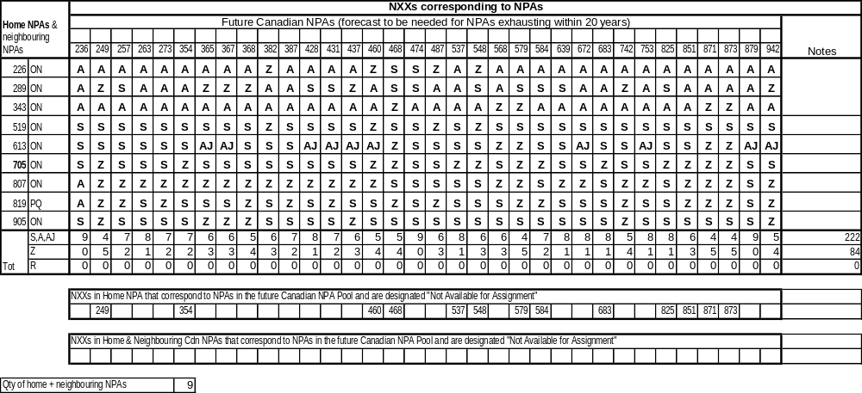

A | Available
S | In-service or Assigned
Z | Not Available

Canadian Geographic NPAs
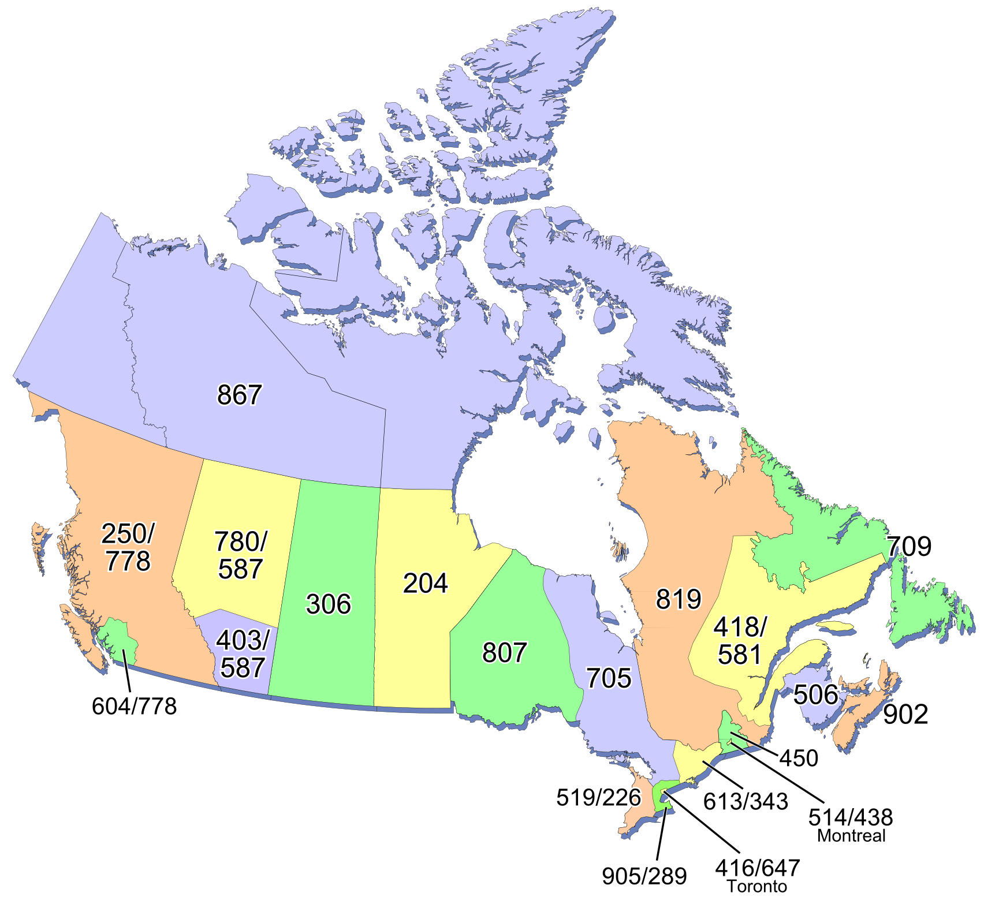
The following is a brief summary of Canadian geographic area code relief history:

- 1947 – AT&T assignment of 86 area codes (9 Canada, 77 continental USA) in format N(0/1)X-NNX-XXXX (where N = 2 to 9 and X = 0 to 9);
  - Ontario: 416, 613;
  - Québec: 514, 418;
  - New Brunswick, Nova Scotia, PEI, Newfoundland & Labrador: 902;
  - Manitoba: 204;
  - Saskatchewan: 306;
  - Alberta: 403;
  - British Columbia: 604
- 1953 - new area code 519 for Ontario split from parts of 416 & 613
- 1955 – new area code 506 split from 902 for New Brunswick & Newfoundland & Labrador (902 retained for Nova Scotia & PEI)
- 1957 - new area code 705 for Ontario split from parts of 613 and 519
- 1957 - new area code 819 for Québec split from parts of 514 & 418
- 1960 - Yukon & the southern & western parts of the Northwest Territories begin to interconnect and use Alberta 403 area code
- 1962 - new area code 709 for Newfoundland & Labrador split from 506 (506 retained by New Brunswick)
- 1962 - new area code 807 for Ontario split from 705; 416/705 boundary modified (Peterborough area moves into 705)
- 1973 – NANP CO Code format changes from NNX to NXX; NANP format becomes N(0 or 1)X – NXX – XXXX (Interchangeable CO Codes); first NPA to change is NPA 213 in California; other NPAs changed gradually until Interchangeable NPA Codes were introduced in 1995
- 1975 - Québec's 819 area code extended to include Bell Canada part of the Northwest Territories
- 1990 – First Canadian Interchangeable CO Codes implemented in NPA 416
- 1993 (Oct) - new area code 905 splits from 416: 416 retained for Toronto Ontario; 905 for areas surrounding Toronto
- 1995 – Area Code format changes from N(0/1)X to NXX (Interchangeable NPA Codes); NANP format becomes NXX – NXX – XXXX
- 1996 (Oct) - new area code 250 splits from 604 in BC; 604 for southwestern mainland BC including Vancouver; 250 for Vancouver Island and BC Mainland excluding Lower Mainland
- 1997 (Oct) – new area code 867 implemented for Yukon and Northwest Territories (including Nunavut) including northern parts of Alberta previously served by 403 and northern parts of Québec previously served by 819; 403 is made exclusive to Alberta ; 819 is made exclusive to Québec
- 1998 (June) - new area code 450 splits from 514 in Québec; 514 retained for Montreal area, 450 for area surrounding Montreal
- 1999 (Jan) - new area code 780 splits from 403 in Alberta; 780 for N. Alberta (Edmonton); 403 retained for S. Alberta (Calgary)
- 2001 (March) - new area code 647 overlay on 416 in Toronto Ontario; mandatory ten-digit local dialling implemented (first Canadian overlay)
- 2001 (June) - new area code 289 overlay on 905 surrounding Toronto Ontario; mandatory ten-digit local dialling implemented
- 2001 (Nov) - new area code 778 (Greater Vancouver Regional District, Abbotsford and Mission) concentrated overlay of part of 604 (Lower Mainland BC including Vancouver); remaining 604 NXXs retained for 604 area outside the concentrated overlay; mandatory ten-digit local dialling implemented in 604 & 778
- 2006 (Oct) – new area code 226 overlay of 519 SW Ontario; mandatory ten-digit local dialling implemented in 226 & 519
- 2006 (Oct) – mandatory ten-digit local dialling implemented in area codes 613 & 819
- 2006 (Nov) – new area code 438 overlay of 514 Montreal area; mandatory ten-digit local dialling implemented in area codes 438, 450 and 514
- 2007 (July) – new area code 778 concentrated overlay of 604 is extended to cover all of British Columbia (province-wide overlay) to provide relief for area code 250; remaining 604 CO Codes become assignable throughout 604 region
- 2008 (Sept) – new area code 581 overlay of 418 NE Québec area including Québec City; mandatory ten-digit local dialling implemented (mandatory ten-digit local dialling becomes universal in the Province of Québec)
- 2008 (Sept) – new area code 587 overlay of 403 and 780 to serve all of Alberta (province-wide overlay); mandatory ten-digit local dialling implemented (mandatory ten-digit local dialling becomes universal in the Province of Alberta)
- 2008 (Sept) – mandatory ten-digit local dialling implemented in 250 area in British Columbia (mandatory ten-digit local dialling becomes universal in the Province of British Columbia)
- 2010 (May) – new 343 overlay of 613 E Ontario including Ottawa
- Total Canadian Geographic NPAs in-service at May 2010 = 28

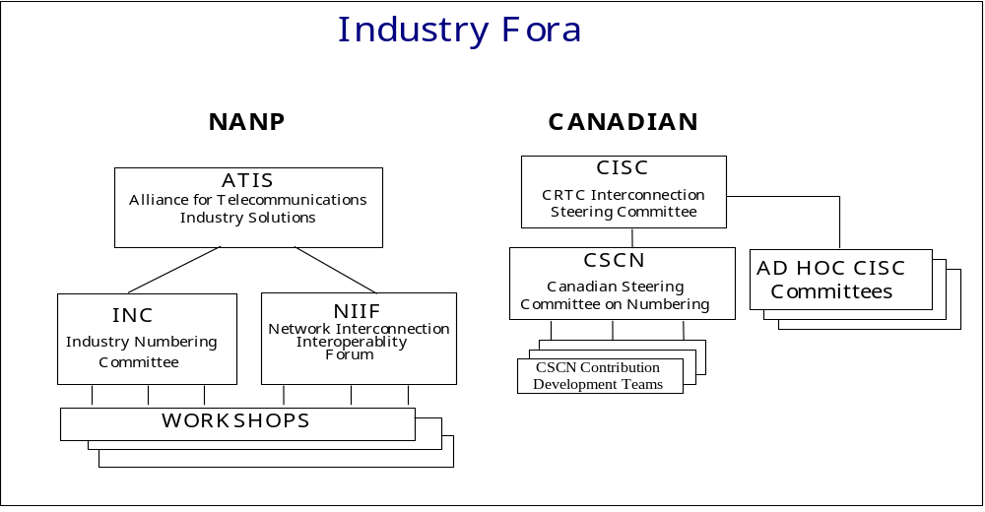
Industry Fora

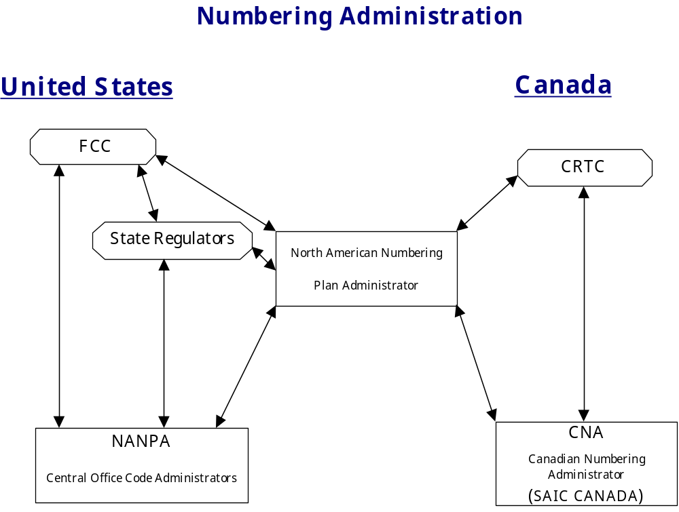
Numbering Administration

Distribution List

Regulatory E-Mail  Distributel Communications Limited  177 Nepean Street  Ottawa, ON  Canada  K2P 0B4  regulatory@distributel.ca | Chris Belanger  Network Operations  Amtelecom  , ON  Canada  Telephone: 705-686-1000  Fax: 705-686-3333  cbelanger@amtelecom.ca
Amedeo Bernardi  Director, Regulatory Matters, Carrier Relations  Ontera  555 Oak Street East  North Bay, ON  Canada  P1B 8L3  Telephone: 705-472-4500 Ext 343  Fax: 705-472-6765  amedeo.bernardi@ontera.ca | Marc Berruyer  Network Planner  Videotron Ltd  2155 Boul. Pie IX, 3e étage, bloc A  Montréal, QC  Canada  H1V 2E4  Telephone: 514-380-4255  Fax: 514-899-8452  marc.berruyer@vtl.quebecor.com
Olena Bilozerska  Network Planning Manager  TELUS  300 Consilium Place, 9th Floor  Scarborough, ON  Canada  M1H 3G2  Telephone: 416-279-8521  Olena.Bilozerska@telus.com | Doug Birdwise  Associate Director - Network Planning  Bell Canada  160 Elgin St., Floor 4 (04-E009)  Ottawa, ON  Canada  K1G 3J4  Telephone: 613-781-4366  Fax: 613-569-9675  doug.birdwise@bell.ca
Samer Bishay  Iristel Inc.  11 Bowan Court  Toronto, ON  Canada  M2K 3A8  Telephone: 416-299-4521  Fax: 416-227-9059  sbishay@iristel.com | Peter Bissonnette  Shaw Communications  900-630 3rd Ave SW  Calgary, AB  Canada  T2P 4L4  Telephone: 403-750-4500  Fax: 403-750-6908  peter.bissonnette@sjrb.ca
Mike Bond  Analyst, Database  Allstream  255 5th Ave SW  Calgary, AB  Canada  T2P 3G6  Telephone: 403-705-9653  Fax: 403-750-7597  michael.bond@allstream.com | Joe Boutros  President  Globility Communications Corporation  108-5343 Dundas St West  Toronto, ON  Canada  M9B 6K5  Telephone: 416-385-0459  Fax: 416-385-0469  jboutros@globility.ca
Laurie Bowie  Network Planning  Bell Canada  162 Southfield Dr.  Strathroy, ON  Canada  N7G 3V6  Telephone: 519-245-8234  Fax: 519-245-5917  laurie.bowie@bell.ca | Claude Brault  Senior Analyst  Canadian Radio-television and Telecommunications Commission  Ottawa, ON  Canada  K1A ON2  Telephone: 819-953-3662  Fax: 819-953-3756  claude.brault@crtc.gc.ca
Glen Brown  Project Engineer  SAIC Canada  60 Queen Street, Suite 1516  Ottawa, ON  Canada  K1P 5Y7  Telephone: 613-683-3291  Fax: 613-563-3399  browng@saiccanada.com | Kimberley Brown  Eastlink  6080 Young St, Suite 604, P.O. Box 8295  Halifax, NS  Canada  B3K 5M1  Telephone: 902-431-1163  Fax: 902-431-1180  kim.brown@corp.eastlink.ca
Melanye Caisse  Telecom Analyst  ISP Telecom Inc  1155 Boul René-Lévesque Ouest Suite 2500  Montréal, QC  Canada  H3B 2K4  Telephone: 416-548-4819  Fax: 416-548-4818  melanye@isptelecom.net | Don Cavanagh  VP  Distributel Communications Limited  177 Nepean Street, Suite 300  Ottawa, ON  Canada  K2P 0B4  Telephone: 613-237-7005  Fax: 613-237-7009  donald.cavanagh@distributel.ca
Joseph Christy  Rogers AT&T Wireless  1 Mount Pleasant Road  Toronto, ON  Canada  M4Y 2Y5  Telephone: 416-935-6149  Fax: 416-935-7525  joseph.christy@rci.rogers.com | Fiona Clegg  CO Code Administration  SAIC Canada  60 Queen Street, Suite 1516  Ottawa, ON  Canada  K1P 5Y7  Telephone: 613-683-3285  Fax: 613-563-3399  cleggf@saiccanada.com
Eric Coburn  IP Management Specialist  Shaw Telecom Inc.  Suite 800, 630 – 3rd Ave SW  Calgary, AB  Canada  T2P 4L4  Telephone: 403-750-7481  Fax: 403-750-6999  dp-tnadmin@sjrb.ca | Jean-Marc D'Aoust  Consultant  Representative for Cogeco Cable Inc.  1720 Route 200  Limoges, ON  Canada  K0A 2M0  Telephone: 613-443-1635  jmdaoust@cgocable.ca
Michael D'Avella  Shaw Communications  900-630 3rd Ave SW  Calgary, AB  Canada  T2P 4L4  Telephone: 403-750-4571  Fax: 403-750-4796  michael.davella@sjrb.ca | Celine Dong  Senior Telecom Provisioning & Cost Analyst  Rogers Wireless Inc.  8200 Dixie Rd  Brampton, ON  Canada  L6T0C1  Telephone: 647-747-4499  celine.dong@rci.rogers.com
John E. Downs  General Manger & President  Nexicom Telephones Inc.  5 King Street East, P.O. Box 178  Millbrook, ON  Canada  L0A 1G0  Telephone: 705-932-4100  Fax: 416-767-2849  jdowns@nexicom.net | Paul Downs  Director  Ontario Telecommunications Association  5160 Explorer Drive, Suite #5  Mississauga, ON  Canada  L4W 4T7  Telephone: 905-282-0771  Fax: 905-282-1675  pdowns@nexicom.net
Paul Downs  President and General Manager  Nexicom Telecommunications Inc.  5 King Street East  Millbrook, ON  Canada  L0A 1G0  Telephone: 705-932-8000  Fax: 705-932-2329  pdowns@nexicom.net | Mona Edmond  Director, Marketing & Communications  Canadian Security Association  610 Alden Road, Suite 100  Markham, ON  Canada  L3R 9Z1  Telephone: 905-513-0622 Ext 242  Fax: 905-513-0624  memond@canasa.org
J Edward Garner  FlexITy Solutions Inc.  45 Vogell Road, 8th Floor  Richmond Hill, ON  Canada  L4B 3P6  Telephone: 905-787-3548  Fax: 905-787-3599  ted.garner@flexity.ca | Jesse Gasteiger  ExaTEL Inc  128 Larch St., Suite 301  Sudbury, ON  Canada  P3E5J8  Telephone: 705-675-0400  Fax: 705-675-0404  jesse@vianet.ca
Anne Gertzbein  Manager Ancillary Services (411/911) & Local PIC/CARE  MTS Allstream  200 Wellington Street West  Toronto, ON  Canada  M5V 3G2  Telephone: 416-640-5229  Fax: 416-640-5219  anne.gertzbein@mtsallstream.com | Helene Gingras  Telebec Ltee  555 Central, 3e étage  Val-d’Or, QC  Canada  J9P 1P6  Telephone: 819-824-7277 ext.7277  Fax: 819-824-7044  hgingras@telebec.com
Willie Grieve  Vice President, Public Policy & Regulatory Affairs  TELUS Communications  10020 - 100 Street NW  Edmonton, AB  Canada  T5J 0N5  Telephone: 780-493-6590  Fax: 780-493-6519  regulatory.affairs@telus.com | Robin Hall  Manager Facilities Planning  Rogers Wireless  Montréal, QC  Canada  Telephone: 514-996-6278  Fax: 514-996-6430  robin.hale@rci.rogers.com
Marian Hearn  Project Executive  Canadian LNP Consortium Inc.  11-300 Earl Grey Drive, Suite 113  Kanata, ON  Canada  K2T 1C1  Telephone: 613-256-2600  Fax: 800-406-9250  hearn@clnpc.ca | Lynne Hewitson  Chapter Manager  CANASA Ontario  610 Alden Road, Suite 100  Markham, ON  Canada  L3R 9Z1  Telephone: 905-513-0622  Fax: 905-513-0624  membership@canasa.org
Larry Hishon  Vice-President Business Development  Fibernetics Corporation  583 Eastgate Walk  Waterloo, ON  Canada  N2K 2V9  Telephone: 519-571-7433  Fax: 519-772-5014  lhishon@fibernetics.ca | Warden Horning  TELUS  10020 100 Street NW  Edmonton, AB  Canada  T5J 0N5  warden.horning@telus.com
Carole Hough  Order Processing West  MTS Allstream  200 Wellington St  Toronto, ON  Canada  M5V 3G2  Telephone: 403-705-6974  Fax: 403-750-9598  carol.hough@mstallstream.com | Jasdev Kalsi  Facilities Coordinator  Rogers Wireless  800 de la Gauchetiere St West Suite 4000  Montréal, QC  Canada  H5A 1K3  Telephone: 514-937-0102 Ext. 4209  jasdev.kalsi@rci.rogers.com
Kira Keast  Rogers Communications Inc.  333 Bloor Street East, 8th Floor  Toronto, ON  Canada  M4W 1G9  kira.keast@rci.rogers.com | Suresh Khare  CO Code Manager  SAIC Canada  60 Queen Street, Suite 1516  Ottawa, ON  Canada  K1P 5Y7  Telephone: 613-683-3296  Fax: 613-563-3399  khares@saiccanada.com
Jeanne Lacombe  Senior Analyst  Canadian Radio-television and Telecommunications Commission  Central Building Les Terrasses de la Chaudière 1 Promenade du Portage  Gatineau, QC  Canada  K1A 0N2  Telephone: 819-997-4586  jeanne.lacombe@crtc.gc.ca | Peter Lang  Manager, Carrier Relations  Rogers Cable Communications Inc. (RCCI)  333 Bloor Street East  Toronto, ON  Canada  M4W 1G9  Telephone: 416-935-7918  Fax: 416-498-3002  Peter.Lang@rci.rogers.com
Elise Lavigne  Coordinator  MTS Allstream  Calgary, AB  Canada  Telephone: 403-705-6946  Fax: 403-705-6283  elise.lavigne@mtsallstream.com | Jeremy Lendvay  Senior Analyst  CRTC  1 Promenade du Portage  Gatineau, QC  Canada  K1A 0N2  Telephone: 819-997-4946  Fax: 819-953-3756  jeremy.lendvay@crtc.gc.ca
Natalie Lessard  SAIC Canada  60 Queen Street, Suite 1516  Ottawa, ON  Canada  K1P 5Y7  Telephone: 613-683-3288  Fax: 613-563-3399  lessardn@saiccanada.com | Chris Liu  Senior IP Telephony Applications Designer  Rogers Cable Communications Inc.  10 Dyas Road  Don Mills, ON  Canada  M3B 1V5  Telephone: 416-649-7290  Fax: 416-649-7201  chris.liu@rci.rogers.com
Bill Mason  Manager, Numbering Administration  Canadian Radio-television and Telecommunications Commission  Central Building Les Terrasses de la Chaudière 1 Promenade du Portage  Gatineau, ON  Canada  K1A 0N2  Telephone: 819-953-8882  Fax: 819-953-0795  bill.mason@crtc.gc.ca | Deirdre Massiah-Gomes  Manager - Planning and Engineering  TELUS  200 Consilium Place, Suite 1600  Scarborough, ON  Canada  M1H 3J3  Telephone: 416-279-3070  Fax: 416-279-3949  deirdre.massiah-gomes@telus.com
Andrew Matoga  President  ISP Telecom  1155 Boul Réne-Lévesque O Suite 2500  Montréal, QC  Canada  H3B 2K4  Telephone: 416-548-4848  Fax: 416-548-4847  andrew@isptelecom.net | Gerry McLaughlin  O.N. Telcom  555 Oak Street East  North Bay, ON  Canada  P1B 8L3  gerry.mclaughlin@ontera.ca
Terry Medd  Vice President, Operations  Shaw Telecom Inc.  Suite 900, 630 – 3rd Ave SW  Calgary, AB  Canada  T2P 4L4  Telephone: 403-750-4500  Fax: 403-750-4501  Terry.Medd@sjrb.ca | Ron Mervis  Amtelecom Communications  18 Sydenham St. PO Box 1800  Aylmer, ON  Canada  N5H 3E7  Telephone: 519-773-1226  Fax: 519-765-3070  rmervis@amtelecom.ca
Scott Mitchell  Cochrane Public Utilities  153 Sixth Avenue, PO Box 640  Cochrane, ON  Canada  P0L 1C0  Telephone: 705-272-4232  Fax: 705-272-3015  smitch@puc.net | Josée Néron  Canadian Local Number Portability Consortium  3003 Southmore Dr. E  Ottawa, ON  Canada  K1V 6Z5  Telephone: 613-526-2651  neron@clnpc.ca
Simon-Pierre Olivier  Director, Regulatory Affairs  Rogers Communications Inc.  1200 McGill College, Bureau 800  Montréal, QC  Canada  H3B 4G7  Telephone: 514-350-6595  simon-pierre.olivier@fidomobile.ca | Francis Paje  Network Planner  Rogers Cable Communications Inc.  8200 Dixie Rd.  Brampton, ON  Canada  L6T 0C1  Telephone: 647-747-1868  Fax: 647-747-4140  francis.paje@rci.rogers.com
Glenn Pilley  Canadian Numbering Administrator  SAIC Canada  60 Queen Street, Suite 1516  Ottawa, ON  Canada  K1P 5Y7  Telephone: 613-683-3289  Fax: 613-563-9293  pilleyg@saiccanada.com | Majella Power  Director - Provisioning  Allstream  200 Wellington St W  Toronto, ON  Canada  M5V 3G2  Telephone: 416-644-9610  Fax: 416-640-5219  majella.power@mtsallstream.com
Robert Quance  President  ISP TELECOM Inc.  630 René-Lévesque blvd. West, Suite 2360  Montréal, QC  Canada  H3B 1S6  Telephone: 514-726-1199  Fax: 514-484-3662  robert@isptelecom.net | Jorge Ramos  President  TelNet Communications  50 Richmond Street East, Suite 107  Oshawa, ON  Canada  L1G 7C7  Telephone: 905-674-2000  Fax: 905-728-7918  george@telnetcommunications.com
Karen Robinson  Telus Mobility  200 Consilium Place  Scarborough, ON  Canada  M1H 3J3  Telephone: 416-279-3053  Karen.Robinson3@telus.com | Bill Sandiford  Telnet Communications  50 Richmond St E  Oshawa, ON  Canada  L1G7C7  Telephone: 905-674-2000  Fax: 905-728-7918  bill@telnetcommunications.com
Leo Santoro  Network Analyst  Bell Mobility  2920 Matheson Blvd East,6th floor  Mississauga, ON  Canada  L4W 4M7  Telephone: 905-282-3021  Fax: 905-282-3106  leo.santoro@bell.ca | Rick Schleihauf  Director - Carrier Relations  Fibernetics Corporation  30 Duke St W Suite 605  Kitchener, ON  Canada  N2H 3W5  Telephone: 519-489-6700 Ext 629  rschleihauf@fibernetics.ca
Donna Sguigna  Manager- Adjunct Capacity Management  Bell Canada  100 Borough Dr Floor 5 Blue  Scarborough, ON  Canada  M1P 4W2  Telephone: 416-296-6172  Fax: 416-296-0685  donna.sguigna@bell.ca | Micheline St-Pierre  Circuit Designer  Telebec & NorthernTel  555 Avenue Centrale, 3ieme étage  Val-d'Or, QC  Canada  J9P 1P6  Telephone: 819-824-7249  Fax: 819-824-7282  mstpierre@telebec.com
Brenda Stevens  Director - Intercarrier Relations  Rogers Cable Communications  333 Bloor St. East, 9th Floor  Toronto, ON  Canada  M4W 1G9  Telephone: 416-935-4898  Fax: 416-935-4875  brenda.stevens@rci.rogers.com | Greg Stirrett  Regulatory Affairs  Thunder BayTelephone  1046 Lithium Dr.  Thunder Bay, ON  Canada  P7B 6G3  Telephone: 807-625-2628  Fax: 807-623-1822  gstirret@tbaytel.net
Bogdan Tanasie  IP Telephony Applications Designer  Rogers Cable Communications Inc.  10 Dyas Road  Don Mills, ON  Canada  M3B 1V5  Telephone: 416-649-7281  bogdan.tanasie@rci.rogers.com | Alan Tang  TELUS Mobility  200 Consiliium Place  Scarborough, ON  Canada  M1H 3J3  Telephone: 416-279-3803  alan.tang@telusmobility.com
Doug Theobald  Cochrane Public Utilities Commission  PO BOX 640, 153 Sixth Avenue  Cochrane, ON  Canada  P0L 1C0  Telephone: 705-272-4232  Fax: 705-272-3015  pucnet@puc.net | Gerry Thompson  Manager, Intercarrier Relations  Rogers Communications Inc. (RCI)  333 Bloor Street East, 9th Floor  Toronto, ON  Canada  M4W 1G9  Telephone: 416-935-5239  Fax: 416-935-7719  Gerry.Thompson@rci.rogers.com
Paul Toth  Amtelecom Communications  18 Sydenham St. E Box 1800  Aylmer, ON  Canada  N5H 3E7  Telephone: 519-773-1218  Fax: 519-765-3217  ptoth@amtelecom.ca | Kathleen Turnsek  ExaTEL  222 McIntrye Street West, Suite 505  North Bay, ON  Canada  P1B 2Y9  Telephone: 705-474-3364  Fax: 705-472-9202  kturnsek@vianet.ca
Tom Wong  Globility Communications Corporation  108-5343 Dundas St West  Toronto, ON  Canada  M9B 6K5  Telephone: 416-238-8802  Fax: 416-385-0469  twong@globility.ca | Sam Yung  Public Policy & Regulatory Affairs  TELUS  21st Floor, 10020-100 Street  Edmonton, AB  Canada  T5J 0N5  Telephone: 780-493-5288  Fax: 780-493-3066  sam.yung@telus.com
Tom Zimnicki
Chief Technology Officer
Fibernetics Corp
55 Northfield Dr East Suite 210
Waterloo, ON
Canada
N2K 3T6
Telephone: 519-489-6700
tom@fibernetics.ca

