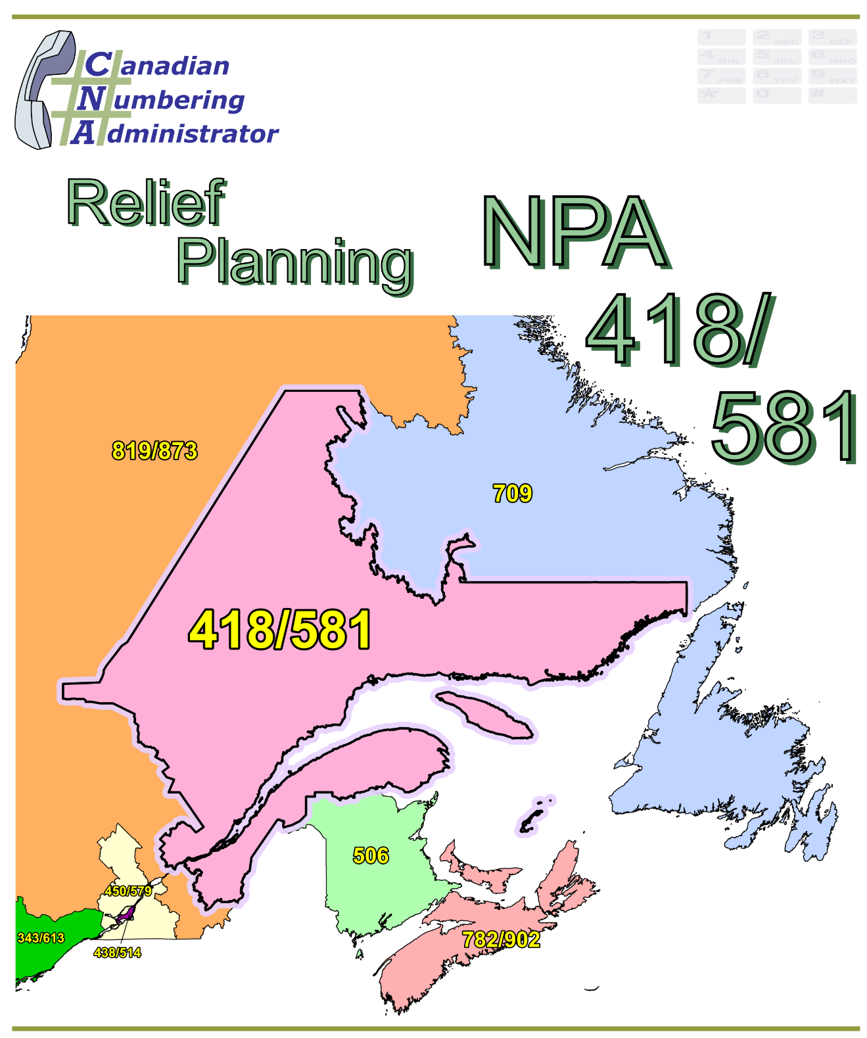

NPA 418/581 Planning Document (PD)

Version 1.0 – 15 November 2016

|  |  |
| --- | --- |
| Canadian Numbering Administrator (CNA)  Suresh Khare  613-683-3296  60 Queen Street, Suite 1516  Ottawa, Ontario K1P 5Y7  khares@leidos.ca | LeidosCanada_halfbackground_small |

**TABLE OF CONTENTS**

[1. INTRODUCTION 1](#_Toc467062463)

[2. NPA RELIEF PLANNING PROCESS 2](#_Toc467062464)

[3. NPA RELIEF METHODS 3](#_Toc467062465)

[4. NPA EXHAUST INFORMATION 4](#_Toc467062466)

[5. RELIEF OPTIONS 4](#_Toc467062467)

[5.1. Distributed Overlay 5](#_Toc467062468)

[5.1.1. Option 1: Distributed Overlay of new NPA Code on NPA 418/581 5](#_Toc467062469)

[5.2. Concentrated Overlay 5](#_Toc467062470)

[5.2.1. Option 2: Concentrated Overlay of new NPA Code on non-TELUS Quebec LIRs 5](#_Toc467062471)

[5.2.2. Option 3: Concentrated Overlay of new NPA Code on non-Bell Quebec LIRs 6](#_Toc467062472)

[5.2.3. Option 4: Concentrated Overlay of new NPA Code North of St. Lawrence 6](#_Toc467062473)

[5.3. Boundary Extension Overlay 6](#_Toc467062474)

[5.3.1. Option 5: NPA 873 Boundary Extension Overlay 6](#_Toc467062475)

[6. SUMMARY OF RELIEF OPTIONS 7](#_Toc467062476)

[7. COMPARATIVE ASSESSMENT OF RELIEF OPTIONS 8](#_Toc467062477)

[7.1. Assessment 9](#_Toc467062478)

[8. DIALLING CHANGES FOR LOCAL CALLS 10](#_Toc467062479)

[9. CO CODES FOR NEW ENTRANTS ONLY 10](#_Toc467062480)

[10. PROPOSED SCHEDULE 11](#_Toc467062481)

[11. JEOPARDY CONTINGENCY PLAN (JCP) 14](#_Toc467062482)

[12. SELECTION OF RELIEF NPA CODE 22](#_Toc467062483)

[13. RECOMMENDATIONS 24](#_Toc467062484)

[ANNEXES 25](#_Toc467062485)

**LIST OF ANNEXES**

**ANNEX A**

[Figure 1 – Overview Map of NPA 418/581](#_Toc458060928)

[Figure 2 – NPA 418/581 Actual and Forecast CO Code Assignments](#_Toc458060929)

[Figure 3 – NPA 418/581 CO Code Exhaust: April 2016 S-NRUF](#_Toc458060930)

[Figure 4 – NPA 418/581 Admin and LEC+WSP Codes: April 2016 S‑NRUF](#_Toc458060931)

[Figure 5 – NPA 418/581 CO Code Exhaust: May 2016 NoC & April 2016 S‑NRUF](#_Toc458060932)

[Figure 6 – NPA 418/581 Admin and LEC+WSP Codes: May 2016 NoC and April 2016 S‑NRUF](#_Toc458060933)

[Figure 7 – NPA 418/581 LIRs](#_Toc458060934)

[Figure 8 – Option 1: Distributed Overlay](#_Toc458060935)

[Figure 9 – Option 2: Concentrated Overlay of new NPA Code on non-TELUS Quebec LIRs](#_Toc458060936)

[Figure 10 – Option 3: Concentrated Overlay of new NPA Code on non-Bell Quebec LIRs](#_Toc458060937)

[Figure 11 – Option 4: Concentrated Overlay of new NPA Code North of St. Lawrence](#_Toc458060938)

[Figure 12 – Option 5: NPA 873 Boundary Extension Overlay](#_Toc458060939)

**ANNEX B**

[Table 1 – Exchange Areas in NPA 418/581 before & after each Relief Option](#_Toc458060940)

[Table 2 – Exchange Areas in NPA 819/873 before & after Boundary Extension Overlay Option](#_Toc458060941)

[Table 3 – Exchange Areas in each LIR](#_Toc458060942)

**ANNEX C**

Distribution List

**ACRONYM LIST**

|  |  |
| --- | --- |
| CATF | Consumer Awareness Task Force |
| CNA | Canadian Numbering Administrator |
| CISC | CRTC Interconnection Steering Committee |
| CLEC | Competitive Local Exchange Carrier |
| CLNPC | Canadian Local Number Portability Consortium |
| CO | Central Office |
| CRTC | Canadian Radio-television and Telecommunications Commission |
| CSCN | Canadian Steering Committee on Numbering |
| G-NRUF | General Numbering Resource Utilization Forecast |
| ILEC | Incumbent Local Exchange Carrier |
| IPD | Initial Planning Document |
| ISP | Internet Service Provider |
| JCP | Jeopardy Contingency Plan |
| J‑NRUF | Jeopardy Numbering Resource Utilization Forecast |
| LEC | Local Exchange Carrier |
| LIR | Local Interconnection Region |
| LNP | Local Number Portability |
| NANP | North American Numbering Plan |
| NANPA | North American Numbering Plan Administrator |
| NITF | Network Implementation Task Force |
| NoC | Notice of Consultation |
| NPA | Numbering Plan Area (Area Code) |
| NRUF | Number Resource Utilization Forecast |
| PD | Planning Document |
| PED | Projected Exhaust Date |
| PL | Planning Letter |
| POI | Point of Interconnection |
| PSAP | Public Safety Answering Point |
| RIP | Relief Implementation Plan |
| R-NRUF | Relief Planning Numbering Resource Utilization Forecast |
| RPC | Relief Planning Committee |
| TSP | Telecommunications Service Provider |
| WNP | Wireless Number Portability |
| WSP | Wireless Service Providers |

**Planning Document (PD) Number Plan Area (NPA) 418/581**

# INTRODUCTION

Area Code 418 was originally assigned to northeast Québec by AT&T in 1947 as one of the 86 area codes to be used in Canada and the continental United States. In 2008 the new Area Code 581 provided relief using the Distributed Overlay method and mandatory ten-digit local dialling was implemented. At that time mandatory ten-digit local dialling became universal in the province of Québec.

Area Code 418/581 consists of 258 Exchange Areas, including the rapidly growing Exchange Areas of Alma, Chicoutimi, La Malbaie, Levis, Montmagny, Québec, Rimouski, Rivière-du-Loup, Sainte-Marie-de-Beauce, St-Georges-de-Beauce, St-Felicien and Thetford Mines in the northern and eastern parts of the province of Québec in Canada. The majority of the projected growth in NPA 418/581 is predominantly limited to these 12 Exchange Areas. In the remaining 246 Exchange Areas there is little projected growth. A list of the Exchange Areas in NPA 418/581 is provided in Annex B Table 1.

Assignment of Central Office (CO) Codes for Local Exchange Carriers (LECs) and Wireless Service Providers (WSPs) has accelerated demand for CO Codes primarily due to the establishment and/or expansion of the Telecommunications Service Providers’ (TSPs) footprints throughout Area Code 418/581. For the purposes of this document a footprint is the first CO Code assigned to a Code Holder in a unique Exchange Area.

The table below provides a brief overview of recent activities leading to the development of this PD for NPA 418/581:

| **Date** | **Activity** |
| --- | --- |
| 15 December 2015 | The Canadian Numbering Administrator (CNA) initiated its January 2016 General Numbering Resource Utilization Forecast (G‑NRUF); |
| 9 March 2016 | The CNA notified Canadian Radio-television and Telecommunications Commission (CRTC) staff that NPA 418/581 was in the Relief Planning window, and asked the CRTC to issue a Telecom Notice of Consultation (NoC) for the establishment of a CRTC Interconnection Steering Committee (CISC) ad hoc committee for area code relief planning in Area Code 418/581 for northeast Québec; |
| 11 March 2016 | The CNA released the aggregate results of the January 2016 G‑NRUF which indicated that the Projected Exhaust Date (PED) for NPA 418/581 had moved in from November 2023 to April 2019; |
| 14 March 2016 | The CNA requested a Special NRUF (S-NRUF) from the current and prospective Code Holders in NPA 418/581; |
| 16 May 2016 | The CNA published the April 2016 S‑NRUF results which indicated that the PED had advanced to March 2019; and |
| 31 May 2016 | The CRTC issued Telecom Notice of Consultation CRTC 2016‑207, in which it established a CISC ad hoc Relief Planning Committee (RPC) to examine options for providing relief to Area Code 418/581 in northeast Québec.  The Notice of Consultation declared a Jeopardy Condition in Area Codes 418/581 and directed the RPC to set aside, at a minimum, 10 CO Codes for initial code assignments for Carriers already providing service in the geographic area served by Area Code 418/581, and 3 CO Codes for initial code assignments exclusively for New Entrants. |
| 2 September 2016 | The CNA published the July 2016 J‑NRUF results.  Version 1 Projected Exhaust Dates remain forecast for March 2019, due to the CO Code assignment restrictions imposed by the CRTC in Telecom Notice of Consultation CRTC 2016-207.  The NPA 418/581 July 2016 J-NRUF Version 2 Projected Exhaust Date is forecast for March 2018. |

The IPD, dated 9 September, was prepared by the CNA in accordance with Telecom Notice of Consultation CRTC 2016‑207 and the Canadian NPA Relief Planning Guideline, Version 6.0 dated 20 November 2014 (the Guideline). A copy of the Guideline is available from the CRTC CISC CSCN guidelines web page at: <http://www.crtc.gc.ca/cisc/eng/cisf3fg.htm>.

The objective of the NPA Relief Planning process is to ensure that CO Codes and telephone numbers are always available for use by TSPs and their customers in the geographic area requiring relief.

It is very important to closely monitor the CO Code requirements of all existing and prospective CO Code Holders so that relief can be timed to ensure that CO Codes and telephone numbers are always available for service providers and customers.

This Planning Document (PD) was developed by the NPA 418/581 Relief Planning Committee based on the IPD and in accordance with the CRTC‑approved Canadian NPA Relief Planning Guideline (the Guideline) dated 20 November 2014. Various options for providing relief in the NPA 418/581 Numbering Plan Area are examined in this PD.

Given the magnitude of this undertaking, intercompany commitment and co‑operation are essential throughout the planning, provisioning and implementation stages of the introduction of a new NPA.

# NPA RELIEF PLANNING PROCESS

The NPA Relief Planning process and the roles of the participants (e.g., CRTC, CNA, CISC, RPC participants, Interested Parties) for NPA Relief Planning are identified in the Guideline.

To increase public awareness and participation in the NPA Relief Planning process, the CRTC has determined that NPA RPCs will be established as ad hoc committees of the CISC. Generally, a separate ad hoc committee is created to deal with relief in each area code. The CNA, in its function as NPA Relief Planning Coordinator, acts as chair of these ad hoc committees. Meetings and conference calls of the ad hoc NPA RPCs are all open to public participation and are conducted in accordance with the CISC Administrative Guidelines which are available from the CRTC website at: <http://www.crtc.gc.ca/cisc/eng/cag.htm>.

NPA Relief Planning is conducted under the regulatory oversight of the CRTC. Notwithstanding the process detailed in the Guideline, the CRTC may exercise its authority under the *Telecommunications Act* to alter this process at any time. The CRTC has the authority under the *Telecommunications Act* to review, modify and give final approval to the Planning Document (PD) and the Relief Implementation Plan (RIP) developed and submitted by the RPC to the CRTC via the CISC process.

Section 6.1.6 of the Canadian NPA Relief Planning Guideline requires the CNA to create and maintain a distribution list of parties who may be interested in participating in the RPC and to provide them with advance notice of the initial RPC meeting and the IPD.

Any person wishing to participate in the NPA Relief Planning process can contact the CNA and request to be added to the RPC distribution lists. More information on how to participate in CRTC public processes is available at: <http://www.crtc.gc.ca/eng/info_sht/g4.htm>.

A summary of Canadian geographic area code relief history is available at: <http://www.cnac.ca/npa_codes/NPA_History.pdf>.

The following table provides a brief history of the evolution of NPA 418/581:

|  |  |
| --- | --- |
| **Year** | **Activity** |
| 1947 | AT&T created the 9 new Area Codes for Canada, 418 was assigned for northeast Québec; and |
| September 2008 | The new Area Code 581 provided relief using the Distributed Overlay Method and mandatory ten-digit local dialling was implemented. At that time, mandatory ten-digit local dialling became universal in the province of Québec. |

The CNA has analysed the S‑NRUF results and has concluded that the average actual annual forecast growth is approximately 46 CO Codes per year. The rest of the forecast demand is due to CO Code requests for establishing a footprint in NPA 418/581 Exchange Areas.

For calculations of future Projected Exhaust Dates (PEDs) of the current and Relief NPAs in all plans the CNA has used average annual growth beyond the six-year forecast period; thereby discounting the footprint expansion.

# NPA RELIEF METHODS

The purpose of this section is to identify and briefly describe NPA Relief Methods.

The Guideline states that “The only Relief Method that should be included in the IPD and PD is the Overlay Method.”

Under the Overlay Method, a relief NPA Code is superimposed or overlaid on top of part or all of an existing NPA. With overlays, changes to existing customers' telephone numbers are not required. The Overlay Method includes three types of overlays that may be identified and assessed. These types of overlays are detailed in Sections 5.1.1 through 5.1.3 of the Guideline, and are:

* Distributed Overlays - a new relief NPA Code is overlaid on top of all of an exhausting NPA;
* Concentrated Overlays - a new relief NPA Code is overlaid on top of part of an exhausting NPA; and
* Boundary Extension Overlays - the boundary of an existing NPA that has spare capacity is extended to overlay part or all of an exhausting NPA.

# NPA EXHAUST INFORMATION

As indicated in the following table, NRUFs for NPA 418/581 were used to determine PEDs, i.e. the dates when CO Codes in NPA 418/581 would be expected to exhaust.

|  |  |
| --- | --- |
| **NRUF** | **Projected Exhaust Date (PED)** |
| G-NRUF January 2015 | November 2023 |
| G-NRUF January 2016 | April 2019 |
| S-NRUF April 2016 | April 2019 |
| S-NRUF April 2016 plus NoC CRTC 2016-207 | March 2019 |
| J-NRUF July 2016 | V 1 March 2019  V 2 March 2018 |

Refer to Annex A, Figures 2, 3, 4, 5, and 6 for graphs of forecast CO Code demand from current and prospective CO Code Holders and charts of Administrative Codes set aside in Area Code 418/581.

# RELIEF OPTIONS

Based on the basic Relief Methods, the following Relief Options were identified and examined in detail:

* Distributed Overlay – One option
* Concentrated Overlay – Three options
* Boundary Extension Overlay – One option

See Annex A, Figures 8 through 12 for diagrams of the Relief Options identified by the CNA.

The Relief Options identified above were evaluated using the following assumptions:

* The Relief Date for the distributed overlay option will be 3rd Q 2018 (six (6) months prior to the NPA 418/581 PED of March 2019 identified using the April 2016 S‑NRUF results).
* The Relief Date for the concentrated overlay options will be 1st Q 2018 (twelve (12) months prior to the NPA 418/581 PED of March 2019 identified using the April 2016 S‑NRUF results).
* The Relief Date for the boundary extension overlay option will be 3rd Q 2018 (six (6) months prior to the NPA 418/581 PED of March 2019 identified using the April 2016 S‑NRUF results).

## Distributed Overlay

One distributed overlay Relief Option was evaluated to provide CO Code relief in the NPA 418/581 geographic area.

### Option 1: Distributed Overlay of new NPA Code on NPA 418/581

This Relief Option would introduce a new NPA Code as an overlay on all 258 Exchange Areas in the NPA 418/581 area. See Annex A Figure 8.

With this Relief Option, the number of separate Relief Planning areas in Québec would not change.

After this distributed overlay, NPA 418/581 and the new NPA would be expected to exhaust in 2034.

## Concentrated Overlay

Three concentrated overlay Relief Options were evaluated to provide CO Code relief in the NPA 418/581 geographic area. These Relief Options are dependent on Local Interconnection Regions (LIRs) in NPA 418/581. See Annex A Figure 7.

### Option 2: Concentrated Overlay of new NPA Code on non-TELUS Quebec LIRs

This Relief Option would overlay a new NPA Code over the non-TELUS Quebec LIRs (123 Exchange Areas) and the remaining 135 Exchange Areas in northeast Québec would continue to grow using CO Codes from NPA 418/581. This concentrated overlay would have to be implemented in April 2018 to ensure a quantity of NXXs is available in NPA 418/581 for forecast growth in the remainder of NPA 418/581. See Annex A Figure 9.

With this Relief Option, the number of separate Relief Planning areas in Québec would increase from four to five.

After this concentrated overlay, NPA 418/581 and the new NPA would be expected to exhaust in Q2 2019 and 2041 respectively.

### Option 3: Concentrated Overlay of new NPA Code on non-Bell Quebec LIRs

This Relief Option would overlay a new NPA Code over the non-Bell Quebec LIRs (166 Exchange Areas) and the remaining 92 Exchange Areas in northeast Québec would continue to grow using CO Codes from NPA 418/581. This concentrated overlay would have to be implemented in April 2018 to ensure a quantity of NXXs is available in NPA 418/581 for forecast growth in the remainder of NPA 418/581. See Annex A Figure 10.

With this Relief Option, the number of separate Relief Planning areas in Québec would increase from four to five.

After this concentrated overlay, NPA 418/581 and the new NPA would be expected to exhaust in Q4 2019 and 2059 respectively.

### Option 4: Concentrated Overlay of new NPA Code North of St. Lawrence

This Relief Option would overlay a new NPA Code over the 112 Exchange Areas North of the St. Lawrence and the remaining 146 Exchange Areas in northeast Québec would continue to grow using CO Codes from NPA 418/581. This concentrated overlay would have to be implemented in April 2018 to ensure a quantity of NXXs is available in NPA 418/581 for forecast growth in the remainder of NPA 418/581. See Annex A Figure 11.

With this Relief Option, the number of separate Relief Planning areas in Québec would increase from four to five.

After this concentrated overlay, NPA 418/581 and the new NPA would be expected to exhaust in Q1 2020 and 2042 respectively.

## Boundary Extension Overlay

One boundary extension overlay Relief Option was evaluated to provide CO Code relief in the NPA 418/581 geographic area.

### Option 5: NPA 873 Boundary Extension Overlay

Currently, NPA 418/581 and 819/873 are expected to exhaust in the years 2019 and 2025 respectively. This Relief Option would realign the boundary of NPA 819/873 to include all 258 Exchange Areas comprising NPA 418/581. NPA 418/581 resources will not be assigned to the 212 Exchange Areas in the current NPA 819/873 area. NPA 819 resources would not be assigned in the 258 Exchange Areas in the current NPA 418/581 area. Local dialling throughout the province of Québec will continue to remain 10-digit. See Annex A Figure 12.

This Relief Option would reduce the number of separate Relief Planning areas in Québec from four to three.

After this Boundary Extension Overlay, NPA 418/581/819/873 would be expected to exhaust in Q1 2021, with a subsequent exhaust in 2028.

# SUMMARY OF RELIEF OPTIONS

| Relief Option | | Projected Exhaust Dates After This Relief | | | Relief - Timing & Type | |
| --- | --- | --- | --- | --- | --- | --- |
| # | Description | NPA 418/581 | New NPA | NPA 873 | Relief Date | Type |
| 1 | Distributed Overlay of new NPA Code on NPA 418/581 |  | 2034 |  | 3Q 2018 | D |
| 2 | Concentrated Overlay of new NPA Code on non-TELUS Quebec LIRs | 2019 | 2041 |  | 1st Q 2018 | C |
| 3 | Concentrated Overlay of new NPA Code on non-Bell Quebec LIRs | 2019 | 2059 |  | 1st Q 2018 | C |
| 4 | Concentrated Overlay of new NPA Code North of St. Lawrence | 2020 | 2042 |  | 1st Q 2018 | C |
| 5 | NPA 873 Boundary Extension Overlay |  |  | 2021  2028 | 3Q 2018 | B |
| Key | B = Boundary Extension Overlay  C = Concentrated Overlay  D = Distributed Overlay | | | | | |

# COMPARATIVE ASSESSMENT OF RELIEF OPTIONS

The RPC identified 5 Relief Options in section 5 of this document. A Pro, Neutral or Con (P, N or C) rating was established for each Relief Option for each of the following attributes. The results are listed in the table below the list of attributes.

1. NPA Code Conservation – quantity of new NPAs required in NPA 418/581 within the next 10 years after relief (2019-2029) (P = 0 new NPAs; N = 1 new NPA; C = 2 or more new NPAs)
2. Number of separate Relief Planning areas in Québec in the long term (P = decrease; N = stays same; C = increase)
3. Level of Carrier Costs – e.g., including implementation, customer awareness, rate of return (P = low; N = medium; C = high)
4. Length of implementation window i.e., length of time for Carriers to implement relief NPA (P = long; N = medium; C = short)
5. Longevity – the length of time between this relief and subsequent relief activity in NPA 418/581 (e.g., a new area code) (P = 15 or more years; N = 9 through 14 years; C = within 8 years)
6. Established Geographic Identities – changes in boundaries of existing NPAs (P = none; N = 1 existing NPA affected, C = more than 1 existing NPA affected)
7. New Geographic Identities – boundaries of new NPA align with boundaries of known areas (e.g., existing NPA areas, provinces) or identifiable geographical features (e.g., rivers, islands) (P = aligns with existing NPA boundaries; N = aligns with geographical features but not with existing NPA boundaries; C = aligns with neither existing NPA boundaries, nor identifiable geographical features)
8. Reprogram Mobile Phones – requirement to reprogram wireless devices to accommodate the number changes (P = low; N = medium; C = high)
9. Potential maximum quantity of NPAs in an Exchange Area in the next 10 years after relief (2019-2029) (P = 2 NPA; N = 3 NPAs; C = 4 NPAs)
10. Does the option provide potential direction(s) for future relief in NPA 418/581 (P = Yes; N = Unknown; C = No)

| **Relief Option** | | **Pro, Neutral or Con for Each Attribute** | | | | | | | | | | **Rating** |
| --- | --- | --- | --- | --- | --- | --- | --- | --- | --- | --- | --- | --- |
| # | **Description** | **A** | **B** | **C** | **D** | **E** | **F** | **G** | **H** | **I** | **J** |  |
| **1** | Distributed Overlay of new NPA Code on NPA 418/581 | P | N | N | P | P | P | P | P | N | P | 7 |
| **2** | Concentrated Overlay of new NPA Code on non-TELUS Quebec LIRs | N | C | C | C | C | P | C | P | N | N | -3 |
| **3** | Concentrated Overlay of new NPA Code on non-Bell Quebec LIRs | N | C | C | C | C | P | C | P | N | N | -3 |
| **4** | Concentrated Overlay of new NPA Code North of St. Lawrence | N | C | C | C | C | P | N | P | N | N | -2 |
| **5** | NPA 873 Boundary Extension Overlay | C | P | C | P | C | N | P | P | N | N | 1 |

It should be noted that none of the options require Exchange Area boundary changes.

If P, N and C are assigned a weighting of +1, 0 and -1, respectively, then analysis of the above table gives the highest rating of 7 points to Relief Option 1, and the next highest rating of 1 point to Relief Option 5 and the subsequent ratings of -2 for Relief Option 4 and, finally, -3 for Relief Options 2 and 3.

Relief Option 1 has the highest rating when assessed based on the above criteria.

## Assessment

The RPC prefers Relief Option 1: Distributed Overlay of new NPA Code on NPA 418/581 for the following reasons:

* The distributed overlay option can be implemented in 4Q 2018 which will provide additional time for customers and carriers to implement the new NPA;
* The existing NPA 418/581 boundary is maintained and no new NPA boundary is created, thus avoiding customer confusion regarding NPA boundaries;
* The quantity of Relief Planning areas in the 418/581 Numbering Plan Area stays the same;
* The distributed overlay option provides long term relief with a PED of 2034;
* For the past 15 years, a vast majority of relief implementations in Canada have been done using the distributed overlay method; and
* The RPC does not see any significant disadvantages to implementing a distributed overlay when compared to a concentrated overlay.

The RPC believes the Concentrated Overlay Options should be rejected for the following reasons:

* All concentrated overlay options do not provide sufficient relief as NPA 418/581 would exhaust in Q2 2019 (Option 2: Concentrated Overlay of new NPA Code on non-TELUS Quebec LIRs), Q4 2019 (Option 3: Concentrated Overlay of new NPA Code on non-Bell Quebec LIRs) and Q1 2020 (Option 4: Concentrated Overlay of new NPA Code North of St. Lawrence);
* All concentrated overlay options will be required to be implemented in 1Q 2018 in order to ensure a quantity of CO Codes is available for assignment in the non-overlaid region. This does not allow enough time for some Carriers to implement the new NPA;
* All concentrated overlay options increase the number of separate Relief Planning areas in the Quebec from four to five. This increases the quantity of geographic areas that would require future relief planning activity which would require customers and Carriers to incur higher future relief costs than the distributed overlay option;
* Options 2 and 3 implement the new NPA on non-contiguous regions resulting in difficulty in providing clear and concise consumer communications;
* Options 2 and 3 create a new NPA boundary between the concentrated overlay NPA and the outlying areas. These boundaries are not easily identifiable which could lead to customer confusion; and
* Option 4 creates a new NPA boundary between the concentrated overlay NPA and the outlying areas. Although the boundary is easily identifiable, there may be some customer confusion with islands and Exchange Areas located in the St. Lawrence River and the Gulf of St. Lawrence.

The RPC believes Relief Option 5: NPA 873 Boundary Extension Overlay should be rejected for the following reasons:

* The Boundary Extension Overlay does not provide sufficient relief as NPA 418/581/819/873 would exhaust in Q1 2021 and it would require immediate relief planning for NPA 418/581/819/873; and
* The subsequent exhaust of the Boundary Extension Overlay would be in 2028, which only provides an NPA life for the new NPA of approximately 7 years.

# DIALLING CHANGES FOR LOCAL CALLS

Currently 10-digit dialling is mandatory for local calls originating within area code 418/581, and for local calls to area code 418/581 from adjacent area code 819/873. Currently 7-digit local dialling exists from Campbellton in NPA 506 (New Brunswick) and from Labrador City–Wabush in NPA 709 (Newfoundland-Labrador) into NPA 418/581.

Local dialling plans will not change when NPA 418/581 relief is implemented.

The Toll call dialling arrangement for NPA 418/581 is not impacted due to the NPA relief.

The table below identifies the current and future local calling dialling scenarios within, to and from home and neighbouring NPAs.

**Local Dialling Plan for Customers in NPA 418/581 and new NPA**

| **Local Calling Scenarios** | **Dial Plan Before Relief\*** | **Dial Plan After Relief\*** |
| --- | --- | --- |
| **Within NPA 418/581** | 10/11-digits | 10/11-digits |
| **From NPA 418/581 into 506, 709, 819 and 873** | 10/11-digits | 10/11-digits |
| **From NPA 819/873 to NPA 418/581** | 10/11-digits | 10/11-digits |
| **From NPAs 506 and 709 into NPA 418/581** | 7/10/11-digits | 7/10/11-digits |

\* dependent on local Carrier

# CO CODES FOR NEW ENTRANTS ONLY

Telecom Notice of Consultation CRTC 2016‑207, *Establishment of a CISC ad hoc committee for relief planning for area codes 418 and 581 in eastern Quebec,* was issued by the Commission on 31 May 2016. In the Notice of Consultation the CRTC declared a Jeopardy Condition for area code 418/581 and noted that area code 418/581 was projected to exhaust in March 2019.

In paragraph 7 of the Notice of Consultation, the Commission directed the NPA 418/581 RPC to set aside at a minimum, ten (10) CO Codes for initial code assignments for Carriers already providing service in the area served by area code 418/581, and three (3) CO Codes for initial code assignments exclusively for New Entrants for a period of two (2) years after the introduction of the new area code in northeast Québec or until the pool is depleted, whichever occurs first. Accordingly, the CNA has set aside thirteen (13) CO Codes, as directed.

Any set‑aside CO Codes remaining unassigned at the end of the two (2) year time period would be returned to the general pool of assignable CO Codes. Further information regarding set-aside CO Codes in a Jeopardy Condition is provided by subparagraphs a), b) and c) of the fifth paragraph of section 9.1 of the Canadian NPA Relief Planning Guideline.

# PROPOSED SCHEDULE

The RPC submits the following schedule for NPA 418/581 relief based on the recommendations contained in this PD and the current PED of March 2019. The RPC will monitor the PED, and if it changes significantly in the future (e.g., is advanced or delayed by greater than six (6) months), the RPC will assess the situation and, if necessary, submit recommendations including a revised schedule to the CRTC for consideration and approval.

**RELIEF IMPLEMENTATION SCHEDULE**

**For an Overlay of new NPA over NPA 418/581**

| **Item** | **Task or Event** | **PRIME** | **START** | **END** |
| --- | --- | --- | --- | --- |
| 1 | CNA identifies NPA exhaust and notifies by e‑mail CRTC staff, CSCN, NANPA & CISC that the NPA will exhaust within 72 months | CNA |  | 11-Mar-16 |
| 2 | CNA conducts S-NRUF & releases results | CNA | 14-Mar-16 | 16-May-16 |
| 3 | CRTC issues Telecom Notice of Consultation regarding establishment of an ad hoc Relief Planning Committee (RPC) and declares a Jeopardy Condition | CRTC |  | 31-May-16 |
| 4 | CNA announces the date for the initial NPA Relief Planning face-to-face meeting & requests contributions | CNA | 09-Sep-16 | 18-Oct-16 |
| 5 | CNA develops and distributes the Initial Planning Document (IPD) to the RPC | CNA | 31-May-16 | 09-Sep-16 |
| 6 | RPC participants review the IPD & submit contributions to the RPC | RPC | 09-Sep-16 | 18-Oct-16 |
| 7 | CNA chairs initial RPC meeting to start development of the Planning Document (PD) & Relief Implementation Plan (RIP) & schedules future meetings/conference calls | CNA, RPC | 26-Oct-16 | 28-Oct-16 |
| 8 | CNA chairs subsequent RPC meetings/conference calls to finalize the PD and RIP | CNA, RPC | 28-Oct-16 | 25-Nov-16 |
| 9 | The RPC creates Consumer Awareness (CATF) and Network implementation (NITF) Task Forces | RPC | 28-Oct-16 | 25-Nov-16 |
| 10 | CNA forwards the PD and RIP to the CISC and CRTC for approval | CNA | 25-Nov-16 | 9-Dec-16 |
| 11 | Special Types of Telecommunications Service Users (9-1-1 PSAPs, alarm companies, ISPs, paging companies, etc.) to identify any concerns to the RPC & CRTC | Special Users | 31-May-16 | 25-Nov-16 |
| 12 | CRTC issues Telecom Decision approving the Relief Method, Relief Date, New NPA & RIP | CRTC | 9-Dec-16 | 9-Mar-17 |
| 13 | CNA obtains relief NPA from NANPA | CNA | 9-Mar-17 | 23-Mar-17 |
| 14 | RPC develops the Planning Letter (PL) |  | 23-Mar-17 | 6-Apr-17 |
| 15 | Task Forces, Telecommunications Service Providers (TSPs) and users implement relief (starts at CRTC approval of Relief Option & Date and ends on Relief Date) | TSPs | 9-Mar-17 | 24-Nov-18 |
| 16 | All TSPs to develop and file individual consumer awareness programs with the CRTC (may be done collectively by a Telecommunications Alliance) (starts at CRTC approval of RIP and should be completed about 24 months prior to the Relief Date) | TSPs | 9-Mar-17 | 30-Mar-17 |
| 17 | CNA issues media release (in coordination with the Telecommunications Alliance) (may start on CRTC approval of the RIP and should be issued at least 18 months prior to the Relief Date) | CNA | 23-Mar-17 | 24-May-17 |
| 18 | CNA submits the PL to NANPA (should be submitted at least 18 months prior to the Relief Date) | CNA | 6-Apr-17 | 20-Apr-17 |
| 19 | NANPA receives and posts the PL to the NANPA website (within 2 weeks of receipt from the CNA) | NANPA | 20-Apr-17 | 4-May-17 |
| 20 | All TSPs implement consumer awareness activities (starts on filing of Consumer Awareness Programs with the CRTC and is completed on the Relief Date) | TSPs | 30-Mar-17 | 24-Nov-18 |
| 21 | All TSPs to notify all customers (residence, business & special customers) of the new overlay NPA (may start with the filing of Consumer Awareness Programs with the CRTC and all customers should be notified at least 18 months prior to the Relief Date) | TSPs | 30-Mar-17 | 24-May-17 |
| 22 | TSPs to submit Progress Report #1 to NITF and Consumer Awareness Task Force (CATF) (starts after completion date for all TSPs to notify their customers and requires 2 weeks) | TSPs | 24-May-17 | 7-Jun-17 |
| 23 | NITF and CATF develop & submit Progress Report #1 to the RPC (linked to TSP reports to NITF and CATF) | NITF & CATF | 7-Jun-17 | 21-Jun-17 |
| 24 | RPC submits Progress Report #1 to CRTC staff (linked to NITF and CATF reports) | RPC | 21-Jun-17 | 5-Jul-17 |
| 25 | iconectiv TRA database updates to add Exchange Areas to new overlay NPA (starts on the date that the PL is posted to the NANPA web site and must be completed by 6 months prior to the Relief Date) | Telcordia TRA | 7-Jun-17 | 24-May-18 |
| 26 | All TSPs and Telecommunications Service Users (including Special Users 9-1-1 PSAPs, alarm companies, ISPs, paging companies, payphone providers, etc.) to implement changes to their telecom equipment & systems to accommodate the new NPA (starts on CRTC approval of RIP and ends on the Relief Date) | Telecom Service Users | 9-Mar-17 | 24-Nov-18 |
| 27 | Payphone Providers Reprogram Payphones (starts on CRTC approval of the RIP and ends on the Relief Date) | Payphone Providers | 9-Mar-17 | 24-Nov-18 |
| 28 | TSPs and database owners/operators to modify systems and industry databases (starts on CRTC approval of the RIP and ends on the Relief Date) | TSPs & Database Owners | 9-Mar-17 | 24-Nov-18 |
| 29 | Operator Services & Directory Assistance Readiness (starts on CRTC approval of the RIP and ends on the Relief Date) | TSPs | 9-Mar-17 | 24-Nov-18 |
| 30 | Directory Publisher Readiness for relief (ability to identify the NPA in telephone numbers in the directory published after the new NPA is activated) (starts on CRTC approval of the RIP and ends on the Relief Date) | Directory Publishers | 9-Mar-17 | 24-Nov-18 |
| 31 | 9-1-1 Systems and Databases Readiness (starts on CRTC approval of the RIP and ends on the Relief Date) | PSAPS, 9‑1‑1 Service Providers & TSPs | 9-Mar-17 | 24-Nov-18 |
| 32 | Network Systems & Equipment Readiness (starts on CRTC approval of the RIP and ends on the Relief Date) | TSPs | 9-Mar-17 | 24-Nov-18 |
| 33 | Service Order & Business System Readiness (starts on CRTC approval of the RIP and ends on the Relief Date) | TSPs | 9-Mar-17 | 24-Nov-18 |
| 34 | International Gateway Switch Translations Readiness for new NPA (starts on CRTC approval of the RIP and ends on the Relief Date) | Int’l TSPs | 9-Mar-17 | 24-Nov-18 |
| 35 | Canadian Local Number Portability Consortium (CLNPC) Database Readiness for new NPA (starts on CRTC approval of the RIP and ends on the Relief Date) | CLNPC & NPAC | 9-Mar-17 | 24-Nov-18 |
| 36 | Toll Free SMS Database Readiness for new NPA (starts on CRTC approval of the RIP and ends on the Relief Date) | Toll TSPs | 9-Mar-17 | 24-Nov-18 |
| 37 | TSPs apply for Test CO Codes in new NPA (applications may be submitted no more than 6 months and no less than 66 days prior to the start date for the Inter-Carrier Testing Period) (Section 7.16.4 of the Guideline) | TSPs | 24-Feb-18 | 19-Jun-18 |
| 38 | Develop Inter-Carrier Network Test Plans and prepare for testing (individual TSPs to make arrangements in accordance with interconnection agreements) (may start on CRTC approval of the RIP and must be completed by start date for the Inter-Carrier Testing Period) | NITF & TSPs | 9-Mar-17 | 24-Aug-18 |
| 39 | All international and domestic TSPs must activate the new NPA in their networks by the start date for the Inter-Carrier Testing Period | TSPs | 9-Mar-17 | 24-Aug-18 |
| 40 | Activation date for new NPA Test CO Codes and Test Numbers in the network must be completed by the start date for the Inter-Carrier Testing Period | TSPs |  | 24-Aug-18 |
| 41 | Inter-Carrier Testing Period (subject to Inter-Carrier Network Test Plans) | NITF & TSPs | 24-Aug-18 | 24-Nov-18 |
| 42 | TSPs to submit Progress Report #2 to NITF and CATF (starts on commencement of Inter-Carrier Testing Period) | TSPs | 24-Aug-18 | 7-Sep-18 |
| 43 | NITF and CATF develop & submit Progress Report #2 to the RPC (linked to TSP reports to NITF and CATF) | NITF & CATF | 7-Sep-18 | 14-Sep-18 |
| 44 | The RPC submits Progress Report #2 to CRTC staff (linked to NITF and CATF reports) | RPC | 14-Sep-18 | 21-Sep-18 |
| 45 | Relief Date (earliest date when CO Codes in new NPA may be activated) |  |  | 24-Nov-18 |
| 46 | TSPs submit Final Report to CATF and NITF (starts on the Relief Date and provides 2 weeks for preparation & submission) | TSPs | 24-Nov-18 | 7-Dec-18 |
| 47 | NITF and CATF develop & submit Final Progress Report to the RPC (linked to TSP reports to NITF and CATF) | NITF & CATF | 7-Dec-18 | 14-Dec-18 |
| 48 | The RPC submits Final Progress Report to CRTC staff (linked to NITF and CATF reports) | RPC | 14-Dec-18 | 7-Jan-19 |
| 49 | TSPs disconnect Test Codes & Numbers, and submit Part 1 form to return Test Codes (starts 1 month after Relief Date and allows 1 month for completion) | TSPs | 2-Jan-19 | 2-Feb-19 |

# JEOPARDY CONTINGENCY PLAN (JCP)

The RPC has developed the following JCP for inclusion in the PD for NPA 418/581. This JCP is based on the example contained in Appendix F to the Canadian NPA Relief Planning Guideline.

This JCP shall remain in effect until superceded by a CRTC-approved JCP, the Jeopardy Condition is suspended, or 66 days prior to the Relief Date.

In Telecom Notice of Consultation CRTC 2016-207 the Commission directed that any CO Code application to the CNA be accompanied by a letter, on company letterhead and signed by a company officer, justifying their request and certifying that the requested CO Code will be in-service within four (4) months of the Effective Date of that application.

During a Jeopardy Condition, CO Code Applicants shall submit all CO Code applications and related correspondence for the Jeopardy NPA to CRTC staff in addition to the CNA. The CNA shall only assign CO Codes from the exhausting NPA to a CO Code Applicant when instructed by CRTC staff.

The following measures shall be implemented in NPA 418/581 while a Jeopardy Condition is in effect.

1. Carriers and/or Telecommunications Service Providers (TSPs):
   1. shall age disconnected residential wireline telephone numbers for a maximum of two months;
   2. shall age disconnected wireless telephone numbers for a maximum of three months;
   3. shall age disconnected business wireline telephone numbers for a maximum of six months. Under special circumstances, the six month aging limit for business telephone numbers may be extended to twelve months, if required, to accommodate local directory publishing dates for high volume call-in applications (e.g., heavily advertised local business numbers such as radio talk shows, food ordering services, ticket sales, chat lines), or for numbers associated with public service emergency applications or for numbers advertised in directories for which customers have requested reference of calls;
   4. shall return all CO Codes that are not being used, nor intended to be used to directly serve customers to the assignment pool within two months (e.g., plant test codes);
   5. should work towards, and encourage existing customers, to either activate or return the reserved numbers to bring the reserved quantity down to a maximum of 10% of the quantity of numbers In-Service for that customer;
   6. shall not allow the quantity of reserved numbers to be increased by new reservation requests by existing customers to more than 10% of the quantity of numbers in service for that customer. In the case of new customers, number reservations shall be limited to 10% of the total quantity of telephone numbers being placed into service for that customer;
   7. shall, within 45 days from the date that the CNA declares a Jeopardy Condition submit a Part 1 Form for each remaining reserved CO Code either returning the reserved CO Code to the CNA or requesting assignment of the reserved CO Code. Once the 45-day period has elapsed, the CNA shall make available for general assignment all CO Codes that are still reserved and have not been applied for as assignments on a Part 1 Form received by the CNA. Within 60 days from the date that the CNA declares a Jeopardy Condition, the CNA shall report to CRTC staff and the RPC as to how many of these codes have been assigned or made available for general assignment;
   8. shall not be permitted to obtain a new CO Code reservation;
   9. shall place all CO Codes assigned prior to the Jeopardy Condition being declared In-Service within three months of the effective date for CO Code activation in the network, or within three months of the date that the Jeopardy Condition was declared. If the CO Code is an Initial Code and the CO Code Holder can demonstrate that, due to circumstances beyond its control, the In-Service date has been delayed beyond the applicable timeframe, then the CNA may grant an extension of up to two months to the In-Service date. The CNA shall initiate reclamation procedures for all CO Codes that have not been placed In-Service within these timeframes unless CRTC staff provides a further extension.
2. For new applications for Initial Codes, each CO Code Holder shall certify that the CO Code will be activated in the network and placed In-Service within four months of the date of application for the Code. If the CNA does not receive a Part 4 Form within this timeframe, confirming that the CO Code has been placed In-Service, the CNA will initiate reclamation measures. If the CO Code Holder can demonstrate that, due to circumstances beyond its control, the In-Service date has been delayed not more than six months from the original application date, then the CNA may grant an extension to the In-Service date, so long as the In-Service date is not more than six months beyond the original application date. If the In-Service date has been delayed more than six months from the original application date, then the CNA shall reclaim the Code unless CRTC staff provides a further extension.
3. When applying for an Additional Code for Growth, a CO Code Holder who is submitting a Part 1 Form and Appendix B worksheet shall also submit a completed Supplementary Form for a Growth CO Code Application (attached) which certifies and/or provides the following information for the specific switching entity/POI and Exchange Area when the Growth CO Code is being requested in a Jeopardy Condition:
   1. certification that all held telephone numbers have been released;
   2. certification that reserved numbers do not exceed ten percent of the total quantity of numbers as defined in Appendix G of the Canadian CO Code (NXX) Assignment Guideline;
   3. certification that each reseller/dealer had been advised of the Jeopardy Condition and the requirement that they would only be allocated additional numbers during the Jeopardy Condition on the provision to the CO Code Holder of written confirmation that their number inventory has been reduced to an amount less than two times the highest quantity of customer numbers assigned in any month during the previous 12 months. Additional numbering resources will only be provided by the CO Code Holder to the reseller/dealer to the extent that the reseller's/dealer's inventory can only increase up to a maximum of three months' inventory;
   4. confirmation that the Part 1 form submitted with the application has the Jeopardy Condition box in section 1.6 checked to certify that the existing CO Codes are projected to exhaust within 4 months of the date of application or within the period specified within an approved JCP, and that the months-to-exhaust is documented on an Appendix B submitted to the CNA;
   5. a completed Telephone Number Utilization Report for the applicable switching entity signed by both a company officer and the company’s authorized representative;
   6. confirmation that the requested Growth CO Code was forecasted in the most recent NRUF or an explanation as to why it was not is attached; and
   7. confirmation that the requested Growth CO Code will be placed In-Service within four months of the date of assignment.
4. Any CO Codes for growth assigned after the implementation of this JCP must be activated in the network and placed In-Service within four months of assignment. In the event that a CO Code Holder is unable to place the CO Code In-Service within four months of the date of assignment, the CO Code Holder must return the assigned CO Code or submit a written request for extension to the CNA. Such written requests must include documentation explaining the reason(s) for the missed date and proposing the new In-Service date. If the explanation includes reasons beyond the control of the CO Code Holder, the CNA may extend the In-Service date a maximum of one month. If the CO Code Holder does not place the CO Code In-Service within the one-month extension, the CNA shall initiate the reclamation process at the end of the one-month extension unless CRTC staff provides a further extension.
5. A Carrier that has multiple switching entities within an Exchange Area shall examine the possibility of, and implement where feasible, number sharing between those switches as a potential method to delay requirements for additional CO Codes.
6. The CNA will request two versions of the J-NRUF input from all current and prospective CO Code Holders quarterly until three (3) months before relief is provided.
   1. The forecasted quantities in Version 1 should be the same as or lower than the April 2016 S‑NRUF input submitted by CO Code Holders for the period up to 66 days prior to the Relief Date. CO Code Holder forecasts may reflect an increase in demand in the period subsequent to the Relief Date.
   2. Version 2 will reflect the actual demand required by the CO Code Holder's current business plan and will be provided for information purposes only.
7. The CNA will compare the initial S‑NRUF input to the recent NRUF inputs, to assess forecasting trends. The CNA shall monitor all inputs and shall test them for reasonableness in consultation with the Carrier. If the CNA is dissatisfied with the reasonableness, or the rationale provided for the deviations, then the matter will be referred to CRTC staff.
8. The CNA will request subsequent J-NRUF input from all current and prospective CO Code Holders quarterly until 3 months before relief is provided.
9. A CO Code Applicant must have submitted a completed J-NRUF to the CNA before the CNA may assign a CO Code to that CO Code Applicant.
10. If a CO Code Applicant wishes to request more CO Codes than it identified in its April 2016 S‑NRUF forecast or initial J‑NRUF, the CO Code Applicant will discuss the matter with the CNA. If the CO Code Applicant wishes to proceed with the request, the CO Code Applicant will forward the request and revised forecast to CRTC staff and the CNA for consideration.
11. The CO Codes identified in the NPA 418/581 CO Code Inventory Chart as “Assignable CO Codes in a Jeopardy Condition” will be assigned in the order determined by the RPC after all CO Codes which are “Available for Assignment as of [day month year]” have been assigned.
12. After each J-NRUF, the CNA shall provide CRTC staff, the RPC and CSCN participants with a report providing an updated NPA 418/581 CO Code Inventory Chart for the NPA in jeopardy as well as the aggregate results of the most recent J-NRUF.
13. Exceptional issues or concerns may be referred by the CNA, or by individual entities (with a courtesy copy to the CNA), to CRTC staff for resolution.
14. In a situation where the Relief Date is on or after the PED, the quantity of CO Codes that may be assigned to a CO Code Applicant prior to the end of the Jeopardy Condition (i.e., 66 days prior to the Relief Date) shall be limited to the quantity forecast by the CO Code Applicant in its April 2016 S‑NRUF forecast (if no previous NRUF has been submitted, then the previous forecast will be deemed to be zero codes). When making requests to obtain CO Codes prior to the end of the Jeopardy Condition (i.e., 66 days prior to the Relief Date), the CO Code Applicant may change the Exchange Area or the month when the CO Code assignment is required, provided a new J-NRUF and explanation accompanies the application. The control imposed by this option may be relaxed if subsequent J-NRUFs defer the PED to after the Relief Date. CO Codes that become available for assignment due to future reduced demand from other current and prospective CO Code Holders may be assigned at the discretion of CRTC staff.
15. If the CNA determines that the implementation of the JCP has not extended the Projected Exhaust Date of the NPA beyond the Relief Date, the CNA will consult with CRTC staff and further CO Code conservation and assignment procedures may be ordered by the Commission (e.g., rationing, lottery, etc.).
16. In Telecom Notice of Consultation 2016-207, the CRTC has directed the CNA to set aside ten (10) CO Codes for Initial Code assignments for Carriers already providing service in the exhausting NPA, and three (3) CO Codes for Initial Code assignments exclusively for New Entrants.[[1]](#footnote-1)
17. The CO Codes set aside for Initial Code assignments exclusively for New Entrants

shall remain unassigned, other than to new entrants, for a period of two years after the introduction of the new area code in NPA 418/581 or until the pool is depleted, whichever occurs first. Each new entrant may only request one CO code from the available pool.

1. The CO Codes set aside for Initial Code assignments for Carriers already providing service in the exhausting NPA shall be made available, subject to any CRTC staff instruction, for Initial Code assignment prior to relief. Any CO Codes from this previously set-aside pool that remain when the Jeopardy Condition ends shall be returned to the pool for Initial Code assignments for applicants in general for assignment following relief.
2. If all other available CO Codes in the exhausting NPA have been assigned, CRTC staff may make some or all of the CO Codes in the two set-aside pools available for assignment to any entity for any purpose.

Supplementary form for a Growth CO Code Application – Page 1 of 2 – Telephone Number Utilization Report

This form is required with each request for an Additional Code for Growth in an NPA where a Jeopardy Condition is in effect. It should be submitted to the CNA together with the Part 1 and Appendix B forms that are required for an application for an Additional Code for Growth. See the Part 1 form for information on how and where to submit the form.

I hereby certify that the following information is true and accurate to the best of my knowledge and has been prepared in accordance with Special Conservation Procedures for a Jeopardy Condition contained in the Canadian NPA Relief Planning Guideline or the applicable approved Jeopardy Contingency Plan.



Name & Signature of Authorized Representative of Code Holder Title Date



Name & Signature of Company Officer (see item 4 of this JCP) Title Date

Contact information: Entity Name: \_\_\_\_\_\_\_\_\_\_\_\_\_\_\_\_\_\_ Contact Name: \_\_\_\_\_\_\_\_\_\_\_\_\_

Address: \_\_\_\_\_\_\_\_\_\_\_\_\_\_\_\_\_\_ City, Province, Postal Code: \_\_\_\_\_\_\_\_\_\_\_\_\_

Telephone: \_\_\_\_\_\_\_\_\_\_\_\_\_\_\_\_\_\_ Facsimile: \_\_\_\_\_\_\_\_\_\_\_\_\_

E-mail: \_\_\_\_\_\_\_\_\_\_\_\_\_\_\_\_\_\_

Switch Identification (Switching Entity/POI) CLLI: \_\_\_\_\_\_\_\_\_\_\_\_\_\_\_ Exchange Area: \_\_\_\_\_\_\_\_\_\_\_\_\_\_\_\_

For the above Switch Identification and Exchange Area for which a Growth CO Code is requested:

I certify that all held telephone numbers have been released

I certify the total quantity of reserved numbers does not exceed ten percent (10%) of the total quantity of telephone numbers as defined in Appendix G of the Canadian CO Code (NXX) Assignment Guideline

I certify that each reseller/dealer has been advised of the Jeopardy Condition and the requirement that they would only be allocated additional numbers during the Jeopardy Condition on the provision to the CO Code Holder of written confirmation that their number inventory has been reduced to an amount less than two (2) times the highest quantity of customer numbers assigned in any month during the previous twelve (12) months. Additional numbering resources will only be provided by the CO Code Holder to the reseller/dealer to the extent that the reseller's/dealer's inventory can only increase up to a maximum of three months' inventory.

The Part 1 form submitted with the application has the Jeopardy Condition box in section 6 checked (this certifies that the existing CO Codes are projected to exhaust within four (4) months of the date of the application or within the period specified in an approved Jeopardy Contingency Plan, and that the months-to-exhaust is documented on an Appendix B submitted to the CNA).

The Telephone Number Utilization Report on page 2 of this form has been completed.

The requested Growth CO Code was forecasted in the most recent NRUF, or an explanation as to why it was not is attached.

The requested Growth CO Code will be placed In-Service within four (4) months of the date of assignment.

**Supplementary Form for a Growth CO Code Application – Page 2 of 2 – Telephone Number Utilization Report**

Use Arial 9 to complete this form. (Note: If the spreadsheet below does not show on your display, please change the Work view to "Print Layout" or "Reading Layout")



Remarks: \_\_\_\_\_\_\_\_\_\_\_\_\_\_\_\_\_\_\_\_\_\_\_\_\_\_\_\_\_\_\_\_\_\_\_\_\_\_\_\_\_\_\_\_\_\_\_\_\_\_\_\_\_\_\_\_\_\_\_\_\_\_\_\_\_\_\_\_\_\_\_\_\_\_\_\_\_\_\_

\_\_\_\_\_\_\_\_\_\_\_\_\_\_\_\_\_\_\_\_\_\_\_\_\_\_\_\_\_\_\_\_\_\_\_\_\_\_\_\_\_\_\_\_\_\_\_\_\_\_\_\_\_\_\_\_\_\_\_\_\_\_\_\_\_\_\_\_\_\_\_\_\_\_\_\_\_\_\_\_\_\_\_\_\_\_\_\_

**NPA 418/581 CO Code Inventory Chart**

The following chart and the instructions it contains will apply in NPA 418/581 in a Jeopardy Condition.

The chart below lists quantities of CO Codes unassignable prior to a Jeopardy Condition, CO Codes that become assignable in a Jeopardy Condition, and CO Codes in NPA 418/581 assigned and In‑service as of 15 November 2016. The CO Codes that become assignable in a Jeopardy Condition shall only be made available for assignment when all other available CO Codes have been assigned in the order listed below.

|  |  | **Overlay** |
| --- | --- | --- |
| **A** | **Total CO Codes in NPAs 418/581 (NXX format)** | **1600** |
|  | | |
| **B** | **CO Codes unassignable prior to a Jeopardy Condition** |  |
| N11 Service Codes (211, 311, 411, 511, 611, 711, 811, 911) | 16 |
| Special Use Codes (555, 950 & 976) | 5 |
| Protected Code(s) | 0 |
| Home NPA Code(s) (418, 581) | 4 |
| Current Neighbouring NPA Codes (506, 709, 819/873) | 6 |
| Future Canadian Geographic NPA Codes(273, 367, 460, 468, 474, 537, 753 and 942) (Note 1) | 16 |
| Plant Test Codes (958 & 959) | 4 |
| Special 7-digit Dialling Codes (310, 610 & 810) | 5 |
| Remaining CO Codes set aside for Initial Codes exclusively for New Entrants | 3 |
| Remaining CO Codes set aside for Initial Codes for carriers already providing service | 5 |
| **Total B** | **64** |
|  | | |
| **C** | **CO Codes assignable prior to a Jeopardy Condition (C=A-B)** | **1536** |
|  | | |
| **D** | CO Codes unassignable prior to a Jeopardy Condition that become assignable in a Jeopardy Condition: |  |
| Future Canadian Geographic NPA Codes (Note 2) | 14 |
| Current Neighbouring NPA Codes (506, 709, and 819) (Note 3) | 6 |
| CO Codes set aside for Initial Code assignments after relief | 5 |
| **Total D** | **25** |
|  | | |
| **E** | **Assignable CO Codes in a Jeopardy Condition (E=C+D)** | **1561** |
| **F** | **Assigned CO Codes as of 15 November 2016** | **1191** |
| **G** | **Net CO Codes available for assignment as of 15 November 2016 without a Jeopardy Condition (G=C-F)** | 345 |
| **H** | **Net CO Codes available for assignment as of 15 November 2016 in a Jeopardy Condition (H=E-F)** | 370 |

**Notes:**

1. 16 out of a total 24 Future Canadian Geographic NPAs are already assigned or assignable as CO Codes in NPA 418/581.
2. CO Codes 273, 367, 460, 468, 474, 537, 753 and 942 are unavailable for assignment in NPA 418/581. CO Code 367 cannot become assignable even in a Jeopardy Condition as it would correspond to the new NPA, therefore must remain unassignable as a CO Code. CO Codes 273, 460, 468, 474, 537, 753 and 942 should become available for assignment in a Jeopardy Condition.
3. In an extreme Jeopardy Condition (i.e., when the Projected Exhaust Date is earlier than the Relief Date), the 3 CO Codes corresponding to current Neighbouring NPA Codes (506, 709 and 819) may be made assignable in certain portions of NPA 418/581 with CRTC staff approval.

# SELECTION OF RELIEF NPA CODE

In the event that the recommended relief option requires a new NPA Code, the criteria for selection of an appropriate area code for relief is addressed in section 4.10 of the Canadian NPA Relief Planning Guideline. The criteria that should be taken into account when Future Canadian Geographic NPAs are being considered as candidates for relief of a specific current Canadian Geographic NPA include the following:

1. The preferred Future Canadian Geographic NPA Code should not be an NPA Code that is assigned as a CO Code in the area that is being relieved (Home NPA(s)).
2. The preferred Future Canadian Geographic NPA Code should not be an NPA Code that is assigned as a CO Code in another NPA within the same province where there is a possibility that a single new NPA Code could be overlaid on more than one NPA within the province, or where boundary realignment could occur that affects another NPA.
3. The preferred Future Canadian Geographic NPA Code should not be an NPA Code that is assigned as a CO Code in an Exchange Area in a neighbouring NPA, if the neighbouring NPA has 7-digit local calling within the NPA, and i) the Exchange Area in the neighbouring NPA where the CO Code is assigned has local calling to the NPA being relieved, or ii) the Exchange Area in the neighbouring NPA where the CO Code is assigned does not have local calling to the NPA being relieved, but other Exchange Areas within that neighbouring NPA have 7-digit local calling to the Exchange Area where the CO Code is assigned as well as local calling to the new NPA.

CO Codes corresponding to Future Canadian Geographic NPA Codes which are not assigned in NPA 418/581 and therefore meet criterion a) above are 273, 367, 460, 468, 474, 537, 753 and 942.

All of the NPA Codes (273, 367, 460, 468, 474, 537, 753 and 942) are therefore equally suitable as a new NPA Code for the relief of NPA 418/581, unless analysis of potential future code reservations for NPA reliefs in other areas of Canada, or TSP cost considerations indicate a preference for one code over another for the relief of NPA 418/581.

The NPA Code Selection Tool located on the CNA web site at <http://www.cnac.ca/npa_codes/relief/NPA_Selection_Tool.xlsx> can assist in selecting a relief NPA Code from the pool of NPA Codes reserved for relief of geographic Canadian NPAs. The following table, extracted from the NPA Code Selection Tool, shows all codes corresponding to Future Canadian Geographic NPA Codes that are designated as unassignable CO Codes in the Home NPA, therefore are preferred candidates when selecting a relief NPA Code for NPA 418/581.

| **NXX corresponding to Future NPA** | **273** | **367** | **460** | **468** | **474** | **537** | **753** | **942** |
| --- | --- | --- | --- | --- | --- | --- | --- | --- |
| Distributed Overlay (Option 1) | ✓ | ✓ | ✓ | ✓ | ✓ | ✓ | ✓ | ✓✓ |
| Concentrated Overlay (Option 2) | ✓ | ✓ | ✓ | ✓ | ✓ | ✓ | ✓ | ✓✓ |
| Concentrated Overlay (Option 3) | ✓ | ✓ | ✓ | ✓ | ✓ | ✓ | ✓ | ✓✓ |
| Concentrated Overlay (Option 4) | ✓ | ✓ | ✓ | ✓ | ✓ | ✓ | ✓ | ✓✓ |
| Boundary Extension Overlay (Option 5) | ✓ | ✓ | ✓ | ✓ | ✓ | ✓ | ✓ | ✓✓ |

✓ Indicates that corresponding CO Code is designated as unassignable in Home NPA(s)

✓✓ Indicates that corresponding CO Code is designated as unassignable in Home NPA(s) and all neighbouring NPA(s)

Based on the above table, all of the Future Canadian Geographic NPA Codes which are not assigned in NPA 418/581 meet all the criteria for relief of NPA 418/581.

On 17 October 2016, the CSCN submitted a consensus TIF Report (CNRE119A.doc) to the CISC/CRTC which recommended that the CRTC direct the Canadian Numbering Administrator (CNA) to set aside the NPA Codes identified in the table below for future relief in those Numbering Plan Areas:

|  |  |  |
| --- | --- | --- |
| Current NPA(s) | Proposed Relief NPA Code | PED |
| 204/431 | 584 | 2027 |
| 249/705 | 683 | 2025 |
| 343/613 | 753 | 2025 |
| 416/437/647 | 942, 387 | 2027 |
| 438/514 | 263 | 2027 |
| 450/579 | 354 | 2023 |
| 819/873 | 468 | 2025 |

The RPC notes that NPA 474 is currently set aside for relief in Saskatchewan in accordance with Telecom Decision CRTC 2010-784.

In order to avoid a conflict with the above, the RPC conducted an assessment of the remaining Future Geographic NPAs that meet the criteria for a Relief NPA in NPA 418/581 (i.e., 273, 367, 460, and 537).

An additional factor considered was the selection of NPAs that would limit new capital investments for Carriers using legacy switching equipment. These Carriers may be required to implement additional switch software to support local dialling across NPA boundaries where the new NPA assignment conflicts with the equivalent CO Code in the neighbouring NPA.

The RPC notes that to minimize the cost impacts on Carriers due to legacy switches, Future Geographic NPA 367 be chosen for relief of NPA 418/581.

# RECOMMENDATIONS

1. The Relief Method should be a distributed overlay of a new NPA Code on Quebec NPA 418/581;
2. NPA Code 367 should be the Relief NPA Code; and
3. The Relief Date should be 24 November 2018 in order to provide Carriers and customers with advanced notification and sufficient lead-time to implement relief in NPA 418/581.

ANNEXES

1. Maps and Figures

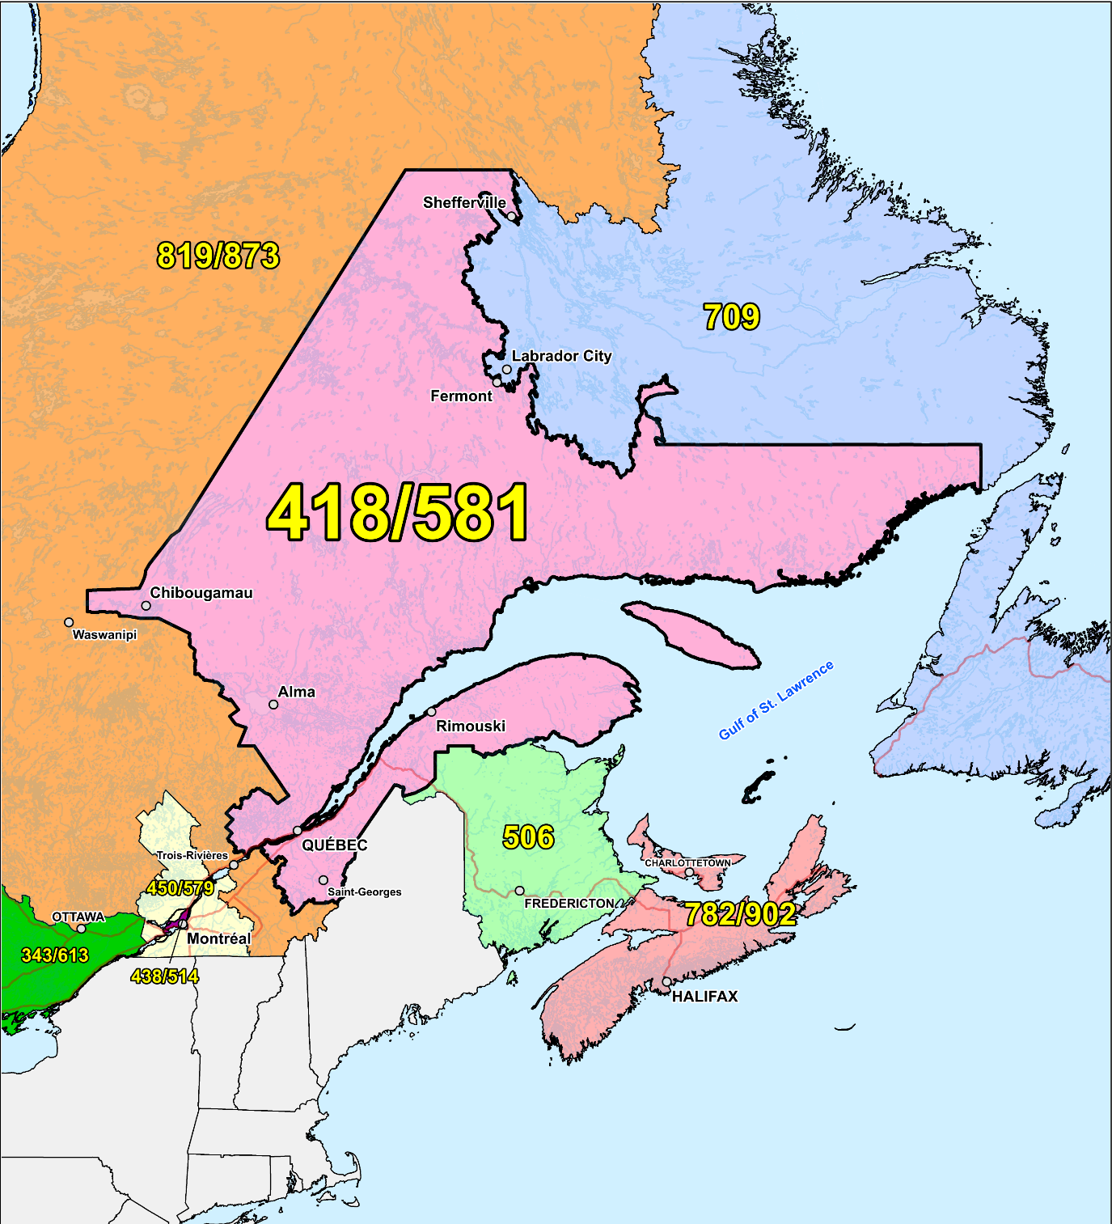

Figure 1 – Overview Map of NPA 418/581



Figure 2 – NPA 418/581 Actual and Forecast CO Code Assignments



Figure 3 – NPA 418/581 CO Code Exhaust: April 2016 S-NRUF



Figure 4 – NPA 418/581 Admin and LEC+WSP Codes: April 2016 S‑NRUF



Figure 5 – NPA 418/581 CO Code Exhaust: May 2016 NoC & April 2016 S‑NRUF



Figure 6 – NPA 418/581 Admin and LEC+WSP Codes: May 2016 NoC and April 2016 S‑NRUF

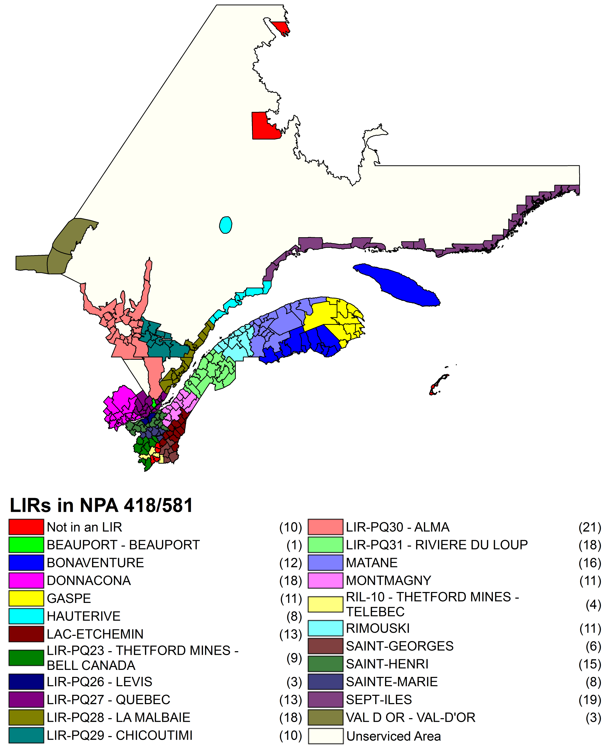

Figure 7 – NPA 418/581 LIRs

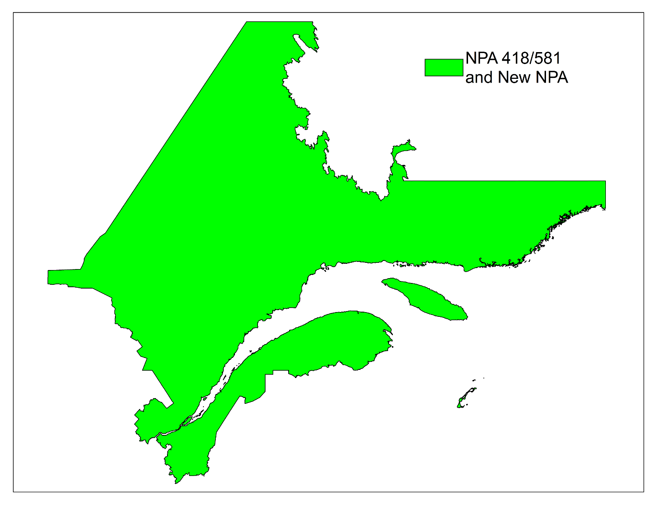

Figure 8 – Option 1: Distributed Overlay

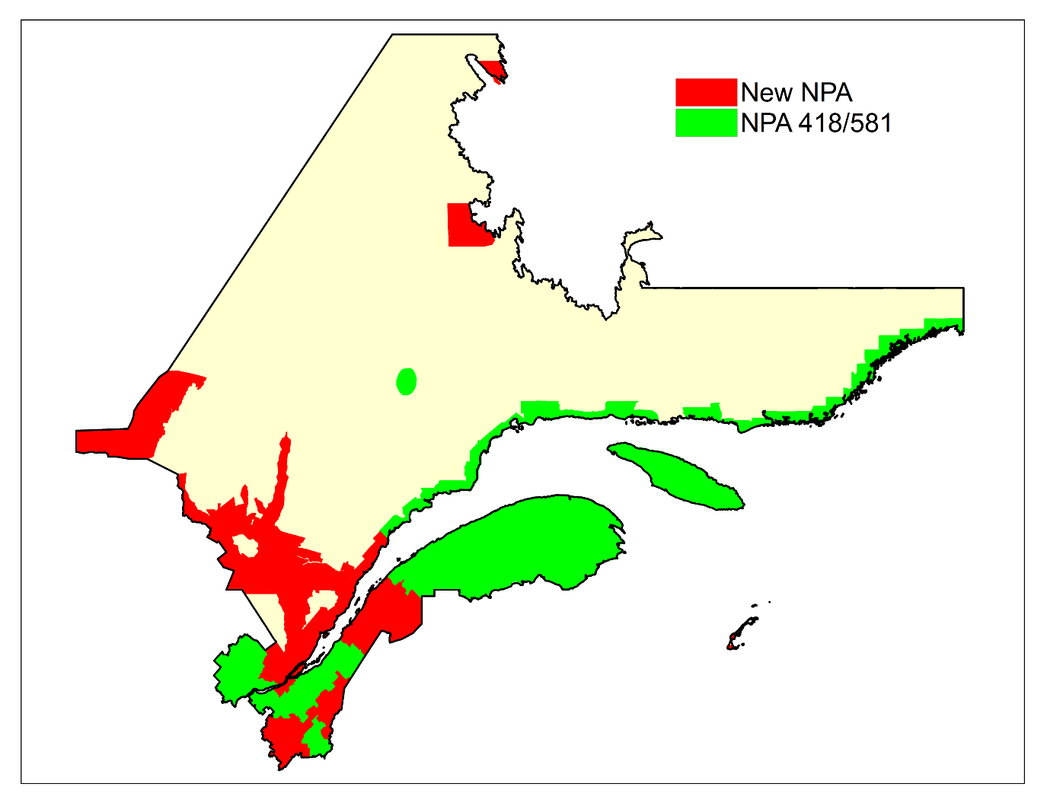

Figure 9 – Option 2: Concentrated Overlay of new NPA Code on non-TELUS Quebec LIRs

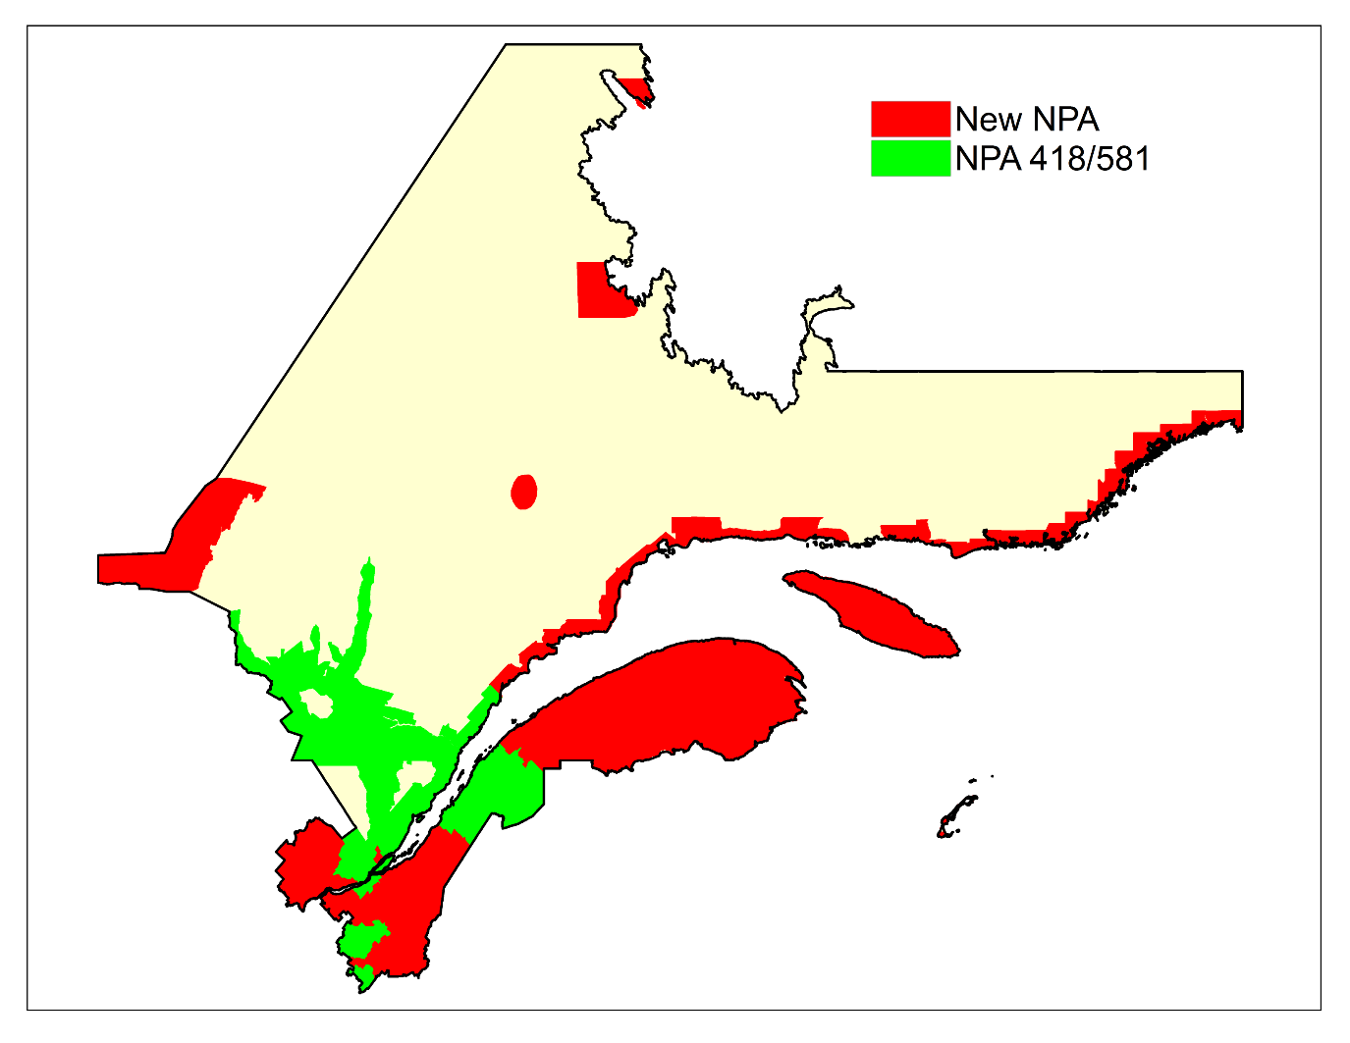Figure 10 – Option 3: Concentrated Overlay of new NPA Code on non-Bell Quebec LIRs

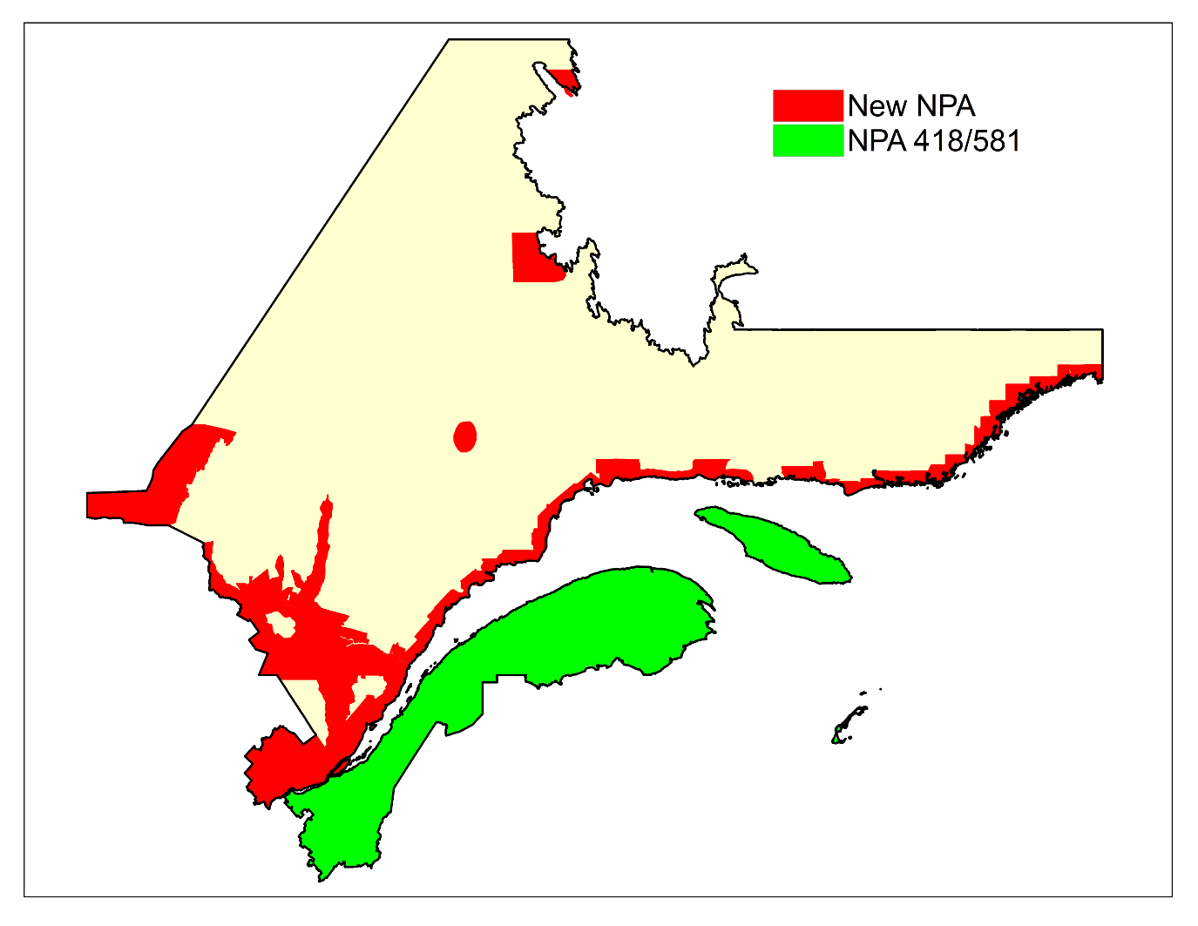

Figure 11 – Option 4: Concentrated Overlay of new NPA Code North of St. Lawrence

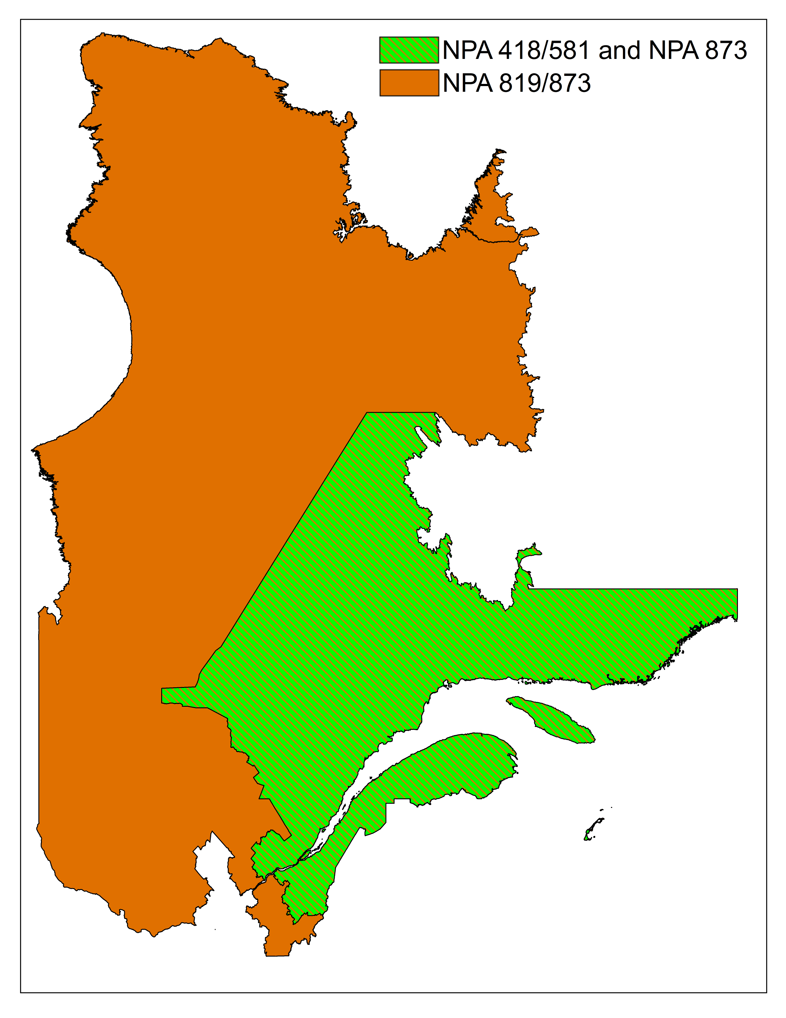

Figure 12 – Option 5: NPA 873 Boundary Extension Overlay

1. NPAs 418/581 & 873 Exchange Areas

Table 1 – Exchange Areas in NPA 418/581 before & after each Relief Option

| **Exchange Area** | **Distributed Overlay** | | **non-TELUS Quebec LIRs** | | **non-Bell Canada LIRs** | | **North of St. Lawrence** | | **Boundary Extension Overlay** | |
| --- | --- | --- | --- | --- | --- | --- | --- | --- | --- | --- |
| **418/581** | **New NPA** | **418/581** | **New NPA** | **418/581** | **New NPA** | **418/581** | **New NPA** | **418/581** | **418/581/873** |
| Aguanish | ✓ | ✓ | ✓ |  |  | ✓ |    | ✓ | ✓ | ✓ |
| Albanel | ✓ | ✓ |  | ✓ | ✓ |  |    | ✓ | ✓ | ✓ |
| Alma | ✓ | ✓ |  | ✓ | ✓ |  |    | ✓ | ✓ | ✓ |
| Amqui | ✓ | ✓ | ✓ |  |  | ✓ | ✓ |    | ✓ | ✓ |
| Anse-St-Jean | ✓ | ✓ |  | ✓ | ✓ |  |    | ✓ | ✓ | ✓ |
| Armagh | ✓ | ✓ | ✓ |  |  | ✓ | ✓ |    | ✓ | ✓ |
| Baie-Comeau | ✓ | ✓ | ✓ |  |  | ✓ |    | ✓ | ✓ | ✓ |
| Baie-Comeau (Hauterive) | ✓ | ✓ | ✓ |  |  | ✓ |    | ✓ | ✓ | ✓ |
| Baie-des-Sables | ✓ | ✓ | ✓ |  |  | ✓ | ✓ |    | ✓ | ✓ |
| Baie-Johan-Beetz | ✓ | ✓ | ✓ |  |  | ✓ |    | ✓ | ✓ | ✓ |
| Baie-Ste-Catherine | ✓ | ✓ |  | ✓ | ✓ |  |    | ✓ | ✓ | ✓ |
| Baie-St-Paul | ✓ | ✓ |  | ✓ | ✓ |  |    | ✓ | ✓ | ✓ |
| Baie-Trinite | ✓ | ✓ | ✓ |  |  | ✓ |    | ✓ | ✓ | ✓ |
| Barachois | ✓ | ✓ | ✓ |  |  | ✓ | ✓ |    | ✓ | ✓ |
| Batiscan | ✓ | ✓ | ✓ |  |  | ✓ |    | ✓ | ✓ | ✓ |
| Beauceville | ✓ | ✓ |  | ✓ |  | ✓ | ✓ |    | ✓ | ✓ |
| Bergeronnes | ✓ | ✓ |  | ✓ | ✓ |  |    | ✓ | ✓ | ✓ |
| Bic | ✓ | ✓ | ✓ |  |  | ✓ | ✓ |    | ✓ | ✓ |
| Biencourt | ✓ | ✓ |  | ✓ | ✓ |  | ✓ |    | ✓ | ✓ |
| Black Lake | ✓ | ✓ |  | ✓ | ✓ |  | ✓ |    | ✓ | ✓ |
| Blanc-Sablon | ✓ | ✓ | ✓ |  |  | ✓ |    | ✓ | ✓ | ✓ |
| Boischatel | ✓ | ✓ |  | ✓ | ✓ |  |    | ✓ | ✓ | ✓ |
| Bonaventure | ✓ | ✓ | ✓ |  |  | ✓ | ✓ |    | ✓ | ✓ |
| Bonne-Esperance | ✓ | ✓ | ✓ |  |  | ✓ |    | ✓ | ✓ | ✓ |
| Cabano | ✓ | ✓ |  | ✓ | ✓ |  | ✓ |    | ✓ | ✓ |
| Cap-aux-Meules | ✓ | ✓ |  | ✓ |  | ✓ | ✓ |    | ✓ | ✓ |
| Cap-Chat | ✓ | ✓ | ✓ |  |  | ✓ | ✓ |    | ✓ | ✓ |
| Cap-des-Rosiers | ✓ | ✓ | ✓ |  |  | ✓ | ✓ |    | ✓ | ✓ |
| Caplan | ✓ | ✓ | ✓ |  |  | ✓ | ✓ |    | ✓ | ✓ |
| Cap-Saint-Ignace | ✓ | ✓ | ✓ |  |  | ✓ | ✓ |    | ✓ | ✓ |
| Carleton | ✓ | ✓ | ✓ |  |  | ✓ | ✓ |    | ✓ | ✓ |
| Causapscal | ✓ | ✓ | ✓ |  |  | ✓ | ✓ |    | ✓ | ✓ |
| Chambord | ✓ | ✓ |  | ✓ | ✓ |  |    | ✓ | ✓ | ✓ |
| Chandler | ✓ | ✓ | ✓ |  |  | ✓ | ✓ |    | ✓ | ✓ |
| Chapais | ✓ | ✓ |  | ✓ |  | ✓ |    | ✓ | ✓ | ✓ |
| Charny | ✓ | ✓ |  | ✓ | ✓ |  | ✓ |    | ✓ | ✓ |
| Chateau-Richer | ✓ | ✓ |  | ✓ |  | ✓ |    | ✓ | ✓ | ✓ |
| Chevery | ✓ | ✓ | ✓ |  |  | ✓ |    | ✓ | ✓ | ✓ |
| Chibougamau | ✓ | ✓ |  | ✓ |  | ✓ |    | ✓ | ✓ | ✓ |
| Chicoutimi | ✓ | ✓ |  | ✓ | ✓ |  |    | ✓ | ✓ | ✓ |
| Chute-aux-Outardes | ✓ | ✓ | ✓ |  |  | ✓ |    | ✓ | ✓ | ✓ |
| Chute-des-Passes | ✓ | ✓ |  | ✓ | ✓ |  |    | ✓ | ✓ | ✓ |
| Clarke City | ✓ | ✓ | ✓ |  |  | ✓ |    | ✓ | ✓ | ✓ |
| Clermont | ✓ | ✓ |  | ✓ | ✓ |  |    | ✓ | ✓ | ✓ |
| Cloridorme | ✓ | ✓ | ✓ |  |  | ✓ | ✓ |    | ✓ | ✓ |
| Colombier | ✓ | ✓ | ✓ |  |  | ✓ |    | ✓ | ✓ | ✓ |
| Courcelles | ✓ | ✓ |  | ✓ |  | ✓ | ✓ |    | ✓ | ✓ |
| Delisle | ✓ | ✓ |  | ✓ | ✓ |  |    | ✓ | ✓ | ✓ |
| Desbiens | ✓ | ✓ |  | ✓ | ✓ |  |    | ✓ | ✓ | ✓ |
| Disraeli | ✓ | ✓ |  | ✓ |  | ✓ | ✓ |    | ✓ | ✓ |
| Dolbeau | ✓ | ✓ |  | ✓ | ✓ |  |    | ✓ | ✓ | ✓ |
| Donnacona | ✓ | ✓ | ✓ |  |  | ✓ |    | ✓ | ✓ | ✓ |
| East Broughton | ✓ | ✓ |  | ✓ | ✓ |  | ✓ |    | ✓ | ✓ |
| Esprit-Saint | ✓ | ✓ | ✓ |  |  | ✓ | ✓ |    | ✓ | ✓ |
| Ferland | ✓ | ✓ |  | ✓ | ✓ |  |    | ✓ | ✓ | ✓ |
| Fermont | ✓ | ✓ |  | ✓ |  | ✓ |    | ✓ | ✓ | ✓ |
| Forestville | ✓ | ✓ | ✓ |  |  | ✓ |    | ✓ | ✓ | ✓ |
| Frampton | ✓ | ✓ | ✓ |  |  | ✓ | ✓ |    | ✓ | ✓ |
| Garthby | ✓ | ✓ |  | ✓ | ✓ |  | ✓ |    | ✓ | ✓ |
| Gaspe | ✓ | ✓ | ✓ |  |  | ✓ | ✓ |    | ✓ | ✓ |
| Girardville | ✓ | ✓ |  | ✓ | ✓ |  |    | ✓ | ✓ | ✓ |
| Godbout | ✓ | ✓ | ✓ |  |  | ✓ |    | ✓ | ✓ | ✓ |
| Grande-Entree | ✓ | ✓ |  | ✓ |  | ✓ | ✓ |    | ✓ | ✓ |
| Grande-Riviere | ✓ | ✓ | ✓ |  |  | ✓ | ✓ |    | ✓ | ✓ |
| Grande-Vallee | ✓ | ✓ | ✓ |  |  | ✓ | ✓ |    | ✓ | ✓ |
| Harrington Harbour | ✓ | ✓ | ✓ |  |  | ✓ |    | ✓ | ✓ | ✓ |
| Havre-Aubert | ✓ | ✓ |  | ✓ |  | ✓ | ✓ |    | ✓ | ✓ |
| Havre-aux-Maisons | ✓ | ✓ |  | ✓ |  | ✓ | ✓ |    | ✓ | ✓ |
| Havre-Saint-Pierre | ✓ | ✓ | ✓ |  |  | ✓ |    | ✓ | ✓ | ✓ |
| Hebertville | ✓ | ✓ |  | ✓ | ✓ |  |    | ✓ | ✓ | ✓ |
| Hebertville-Station | ✓ | ✓ |  | ✓ | ✓ |  |    | ✓ | ✓ | ✓ |
| Ile-aux-Coudres | ✓ | ✓ |  | ✓ | ✓ |  |    | ✓ | ✓ | ✓ |
| Inverness | ✓ | ✓ |  | ✓ | ✓ |  | ✓ |    | ✓ | ✓ |
| Jonquiere | ✓ | ✓ |  | ✓ | ✓ |  |    | ✓ | ✓ | ✓ |
| La Baie (Chicoutimi Co.) | ✓ | ✓ |  | ✓ | ✓ |  |    | ✓ | ✓ | ✓ |
| La Dore | ✓ | ✓ |  | ✓ | ✓ |  |    | ✓ | ✓ | ✓ |
| La Guadeloupe | ✓ | ✓ |  | ✓ |  | ✓ | ✓ |    | ✓ | ✓ |
| La Malbaie | ✓ | ✓ |  | ✓ | ✓ |  |    | ✓ | ✓ | ✓ |
| La Martre | ✓ | ✓ | ✓ |  |  | ✓ | ✓ |    | ✓ | ✓ |
| La Pocatiere | ✓ | ✓ |  | ✓ | ✓ |  | ✓ |    | ✓ | ✓ |
| La Romaine | ✓ | ✓ | ✓ |  |  | ✓ |    | ✓ | ✓ | ✓ |
| Lac Bouchette | ✓ | ✓ |  | ✓ | ✓ |  |    | ✓ | ✓ | ✓ |
| Lac-au-Saumon | ✓ | ✓ | ✓ |  |  | ✓ | ✓ |    | ✓ | ✓ |
| Lac-aux-Sables | ✓ | ✓ | ✓ |  |  | ✓ |    | ✓ | ✓ | ✓ |
| Lac-Etchemin | ✓ | ✓ |  | ✓ |  | ✓ | ✓ |    | ✓ | ✓ |
| Lac-Frontiere | ✓ | ✓ |  | ✓ |  | ✓ | ✓ |    | ✓ | ✓ |
| Lambton | ✓ | ✓ |  | ✓ |  | ✓ | ✓ |    | ✓ | ✓ |
| Laterriere | ✓ | ✓ |  | ✓ | ✓ |  |    | ✓ | ✓ | ✓ |
| Leeds | ✓ | ✓ |  | ✓ | ✓ |  | ✓ |    | ✓ | ✓ |
| Les Boules | ✓ | ✓ | ✓ |  |  | ✓ | ✓ |    | ✓ | ✓ |
| Les Eboulements | ✓ | ✓ |  | ✓ | ✓ |  |    | ✓ | ✓ | ✓ |
| Les Escoumins | ✓ | ✓ |  | ✓ | ✓ |  |    | ✓ | ✓ | ✓ |
| Les Mechins | ✓ | ✓ | ✓ |  |  | ✓ | ✓ |    | ✓ | ✓ |
| Levis | ✓ | ✓ |  | ✓ | ✓ |  | ✓ |    | ✓ | ✓ |
| L'Ile-Verte | ✓ | ✓ |  | ✓ | ✓ |  | ✓ |    | ✓ | ✓ |
| L'Islet | ✓ | ✓ | ✓ |  |  | ✓ | ✓ |    | ✓ | ✓ |
| Loretteville | ✓ | ✓ |  | ✓ | ✓ |  |    | ✓ | ✓ | ✓ |
| Luceville | ✓ | ✓ | ✓ |  |  | ✓ | ✓ |    | ✓ | ✓ |
| Manicouagan 5 | ✓ | ✓ | ✓ |  |  | ✓ |    | ✓ | ✓ | ✓ |
| Maria | ✓ | ✓ | ✓ |  |  | ✓ | ✓ |    | ✓ | ✓ |
| Matane | ✓ | ✓ | ✓ |  |  | ✓ | ✓ |    | ✓ | ✓ |
| Matapedia | ✓ | ✓ | ✓ |  |  | ✓ | ✓ |    | ✓ | ✓ |
| Metabetchouan | ✓ | ✓ |  | ✓ | ✓ |  |    | ✓ | ✓ | ✓ |
| Milot | ✓ | ✓ |  | ✓ | ✓ |  |    | ✓ | ✓ | ✓ |
| Mistissini | ✓ | ✓ |  | ✓ |  | ✓ |    | ✓ | ✓ | ✓ |
| Moisie | ✓ | ✓ | ✓ |  |  | ✓ |    | ✓ | ✓ | ✓ |
| Mont-Joli | ✓ | ✓ | ✓ |  |  | ✓ | ✓ |    | ✓ | ✓ |
| Mont-Louis | ✓ | ✓ | ✓ |  |  | ✓ | ✓ |    | ✓ | ✓ |
| Montmagny | ✓ | ✓ | ✓ |  |  | ✓ | ✓ |    | ✓ | ✓ |
| Murdochville | ✓ | ✓ | ✓ |  |  | ✓ | ✓ |    | ✓ | ✓ |
| Mutton Bay | ✓ | ✓ | ✓ |  |  | ✓ |    | ✓ | ✓ | ✓ |
| Natashquan | ✓ | ✓ | ✓ |  |  | ✓ |    | ✓ | ✓ | ✓ |
| Neuville | ✓ | ✓ | ✓ |  |  | ✓ |    | ✓ | ✓ | ✓ |
| New Carlisle | ✓ | ✓ | ✓ |  |  | ✓ | ✓ |    | ✓ | ✓ |
| New Richmond | ✓ | ✓ | ✓ |  |  | ✓ | ✓ |    | ✓ | ✓ |
| Newport | ✓ | ✓ | ✓ |  |  | ✓ | ✓ |    | ✓ | ✓ |
| Normandin | ✓ | ✓ |  | ✓ | ✓ |  |    | ✓ | ✓ | ✓ |
| Notre-Dame-des-Laurentides | ✓ | ✓ |  | ✓ | ✓ |  |    | ✓ | ✓ | ✓ |
| Notre-Dame-du-Lac | ✓ | ✓ |  | ✓ | ✓ |  | ✓ |    | ✓ | ✓ |
| Nouvelle | ✓ | ✓ | ✓ |  |  | ✓ | ✓ |    | ✓ | ✓ |
| Parc-des-Laurentides | ✓ | ✓ |  | ✓ | ✓ |  |    | ✓ | ✓ | ✓ |
| Pentecote | ✓ | ✓ | ✓ |  |  | ✓ |    | ✓ | ✓ | ✓ |
| Perce | ✓ | ✓ | ✓ |  |  | ✓ | ✓ |    | ✓ | ✓ |
| Peribonka | ✓ | ✓ |  | ✓ | ✓ |  |    | ✓ | ✓ | ✓ |
| Petite-Riviere-St-Francois | ✓ | ✓ |  | ✓ | ✓ |  |    | ✓ | ✓ | ✓ |
| Pointe-a-la-Croix | ✓ | ✓ | ✓ |  |  | ✓ | ✓ |    | ✓ | ✓ |
| Pont-Rouge | ✓ | ✓ | ✓ |  |  | ✓ |    | ✓ | ✓ | ✓ |
| Port-Cartier | ✓ | ✓ | ✓ |  |  | ✓ |    | ✓ | ✓ | ✓ |
| Port-Daniel | ✓ | ✓ | ✓ |  |  | ✓ | ✓ |    | ✓ | ✓ |
| Port-Menier | ✓ | ✓ | ✓ |  |  | ✓ | ✓ |    | ✓ | ✓ |
| Portneuf | ✓ | ✓ | ✓ |  |  | ✓ |    | ✓ | ✓ | ✓ |
| Quebec | ✓ | ✓ |  | ✓ | ✓ |  |    | ✓ | ✓ | ✓ |
| Rimouski | ✓ | ✓ | ✓ |  |  | ✓ | ✓ |    | ✓ | ✓ |
| Riviere-a-Pierre | ✓ | ✓ | ✓ |  |  | ✓ |    | ✓ | ✓ | ✓ |
| Riviere-au-Renard | ✓ | ✓ | ✓ |  |  | ✓ | ✓ |    | ✓ | ✓ |
| Riviere-au-Tonnerre | ✓ | ✓ | ✓ |  |  | ✓ |    | ✓ | ✓ | ✓ |
| Riviere-Bleue | ✓ | ✓ |  | ✓ | ✓ |  | ✓ |    | ✓ | ✓ |
| Riviere-du-Loup | ✓ | ✓ |  | ✓ | ✓ |  | ✓ |    | ✓ | ✓ |
| Riviere-Saint-Jean | ✓ | ✓ | ✓ |  |  | ✓ |    | ✓ | ✓ | ✓ |
| Roberval | ✓ | ✓ |  | ✓ | ✓ |  |    | ✓ | ✓ | ✓ |
| Sacre-Coeur | ✓ | ✓ |  | ✓ | ✓ |  |    | ✓ | ✓ | ✓ |
| Saint-Adelphe | ✓ | ✓ | ✓ |  |  | ✓ |    | ✓ | ✓ | ✓ |
| Saint-Agapit | ✓ | ✓ | ✓ |  |  | ✓ | ✓ |    | ✓ | ✓ |
| Saint-Alexis-de-Matapedia | ✓ | ✓ | ✓ |  |  | ✓ | ✓ |    | ✓ | ✓ |
| Saint-Anselme | ✓ | ✓ | ✓ |  |  | ✓ | ✓ |    | ✓ | ✓ |
| Saint-Antoine-de-Tilly | ✓ | ✓ | ✓ |  |  | ✓ | ✓ |    | ✓ | ✓ |
| Saint-Apollinaire | ✓ | ✓ | ✓ |  |  | ✓ | ✓ |    | ✓ | ✓ |
| Saint-Augustin | ✓ | ✓ | ✓ |  |  | ✓ |    | ✓ | ✓ | ✓ |
| Saint-Augustin (Duplessis) | ✓ | ✓ | ✓ |  |  | ✓ |    | ✓ | ✓ | ✓ |
| Saint-Basile | ✓ | ✓ | ✓ |  |  | ✓ |    | ✓ | ✓ | ✓ |
| Saint-Bernard-de-Dorchester | ✓ | ✓ | ✓ |  |  | ✓ | ✓ |    | ✓ | ✓ |
| Saint-Camille | ✓ | ✓ |  | ✓ |  | ✓ | ✓ |    | ✓ | ✓ |
| Saint-Casimir | ✓ | ✓ | ✓ |  |  | ✓ |    | ✓ | ✓ | ✓ |
| Saint-Charles | ✓ | ✓ | ✓ |  |  | ✓ | ✓ |    | ✓ | ✓ |
| Saint-Come | ✓ | ✓ | ✓ |  |  | ✓ | ✓ |    | ✓ | ✓ |
| Saint-Damien-de-Buckland | ✓ | ✓ | ✓ |  |  | ✓ | ✓ |    | ✓ | ✓ |
| Sainte-Agathe-de-Lotbiniere | ✓ | ✓ | ✓ |  |  | ✓ | ✓ |    | ✓ | ✓ |
| Sainte-Anne-de-la-Perade | ✓ | ✓ | ✓ |  |  | ✓ |    | ✓ | ✓ | ✓ |
| Sainte-Anne-des-Monts | ✓ | ✓ | ✓ |  |  | ✓ | ✓ |    | ✓ | ✓ |
| Sainte-Blandine | ✓ | ✓ | ✓ |  |  | ✓ | ✓ |    | ✓ | ✓ |
| Sainte-Claire | ✓ | ✓ | ✓ |  |  | ✓ | ✓ |    | ✓ | ✓ |
| Sainte-Croix | ✓ | ✓ | ✓ |  |  | ✓ | ✓ |    | ✓ | ✓ |
| Saint-Edouard-de-Lotbiniere | ✓ | ✓ | ✓ |  |  | ✓ | ✓ |    | ✓ | ✓ |
| Sainte-Felicite | ✓ | ✓ | ✓ |  |  | ✓ | ✓ |    | ✓ | ✓ |
| Sainte-Henedine | ✓ | ✓ | ✓ |  |  | ✓ | ✓ |    | ✓ | ✓ |
| Sainte-Justine | ✓ | ✓ |  | ✓ |  | ✓ | ✓ |    | ✓ | ✓ |
| Sainte-Lucie | ✓ | ✓ |  | ✓ |  | ✓ | ✓ |    | ✓ | ✓ |
| Sainte-Marie-de-Beauce | ✓ | ✓ | ✓ |  |  | ✓ | ✓ |    | ✓ | ✓ |
| Sainte-Perpetue | ✓ | ✓ | ✓ |  |  | ✓ | ✓ |    | ✓ | ✓ |
| Sainte-Rose | ✓ | ✓ |  | ✓ |  | ✓ | ✓ |    | ✓ | ✓ |
| Sainte-Thecle | ✓ | ✓ | ✓ |  |  | ✓ |    | ✓ | ✓ | ✓ |
| Saint-Fabien | ✓ | ✓ | ✓ |  |  | ✓ | ✓ |    | ✓ | ✓ |
| Saint-Fabien-de-Panet | ✓ | ✓ |  | ✓ |  | ✓ | ✓ |    | ✓ | ✓ |
| Saint-Flavien | ✓ | ✓ | ✓ |  |  | ✓ | ✓ |    | ✓ | ✓ |
| Saint-Francois | ✓ | ✓ | ✓ |  |  | ✓ | ✓ |    | ✓ | ✓ |
| Saint-Gabriel | ✓ | ✓ | ✓ |  |  | ✓ | ✓ |    | ✓ | ✓ |
| Saint-Gedeon-de-Beauce | ✓ | ✓ | ✓ |  |  | ✓ | ✓ |    | ✓ | ✓ |
| Saint-Georges-de-Beauce | ✓ | ✓ | ✓ |  |  | ✓ | ✓ |    | ✓ | ✓ |
| Saint-Henri-de-Levis | ✓ | ✓ | ✓ |  |  | ✓ | ✓ |    | ✓ | ✓ |
| Saint-Jean-Port-Joli | ✓ | ✓ | ✓ |  |  | ✓ | ✓ |    | ✓ | ✓ |
| Saint-Joseph-de-Beauce | ✓ | ✓ | ✓ |  |  | ✓ | ✓ |    | ✓ | ✓ |
| Saint-Lambert-de-Lauzon | ✓ | ✓ | ✓ |  |  | ✓ | ✓ |    | ✓ | ✓ |
| Saint-Leon-le-Grand | ✓ | ✓ | ✓ |  |  | ✓ | ✓ |    | ✓ | ✓ |
| Saint-Luc | ✓ | ✓ |  | ✓ |  | ✓ | ✓ |    | ✓ | ✓ |
| Saint-Magloire | ✓ | ✓ |  | ✓ |  | ✓ | ✓ |    | ✓ | ✓ |
| Saint-Malachie | ✓ | ✓ | ✓ |  |  | ✓ | ✓ |    | ✓ | ✓ |
| Saint-Marc-des-Carrieres | ✓ | ✓ | ✓ |  |  | ✓ |    | ✓ | ✓ | ✓ |
| Saint-Martin | ✓ | ✓ | ✓ |  |  | ✓ | ✓ |    | ✓ | ✓ |
| Saint-Michel | ✓ | ✓ | ✓ |  |  | ✓ | ✓ |    | ✓ | ✓ |
| Saint-Moise | ✓ | ✓ | ✓ |  |  | ✓ | ✓ |    | ✓ | ✓ |
| Saint-Odilon | ✓ | ✓ |  | ✓ |  | ✓ | ✓ |    | ✓ | ✓ |
| Saint-Pamphile | ✓ | ✓ | ✓ |  |  | ✓ | ✓ |    | ✓ | ✓ |
| Saint-Patrice-de-Beaurivage | ✓ | ✓ | ✓ |  |  | ✓ | ✓ |    | ✓ | ✓ |
| Saint-Paul-de-Montminy | ✓ | ✓ | ✓ |  |  | ✓ | ✓ |    | ✓ | ✓ |
| Saint-Prosper-de-Dorchester | ✓ | ✓ | ✓ |  |  | ✓ | ✓ |    | ✓ | ✓ |
| Saint-Raphael | ✓ | ✓ | ✓ |  |  | ✓ | ✓ |    | ✓ | ✓ |
| Saint-Raymond | ✓ | ✓ | ✓ |  |  | ✓ |    | ✓ | ✓ | ✓ |
| Saint-Rene-de-Matane | ✓ | ✓ | ✓ |  |  | ✓ | ✓ |    | ✓ | ✓ |
| Saint-Roch-des-Aulnaies | ✓ | ✓ | ✓ |  |  | ✓ | ✓ |    | ✓ | ✓ |
| Saint-Simon-de-Rimouski | ✓ | ✓ | ✓ |  |  | ✓ | ✓ |    | ✓ | ✓ |
| Saint-Stanislas | ✓ | ✓ | ✓ |  |  | ✓ |    | ✓ | ✓ | ✓ |
| Saint-Theophile | ✓ | ✓ | ✓ |  |  | ✓ | ✓ |    | ✓ | ✓ |
| Saint-Tite | ✓ | ✓ | ✓ |  |  | ✓ |    | ✓ | ✓ | ✓ |
| Saint-Ubalde | ✓ | ✓ | ✓ |  |  | ✓ |    | ✓ | ✓ | ✓ |
| Saint-Ulric | ✓ | ✓ | ✓ |  |  | ✓ | ✓ |    | ✓ | ✓ |
| Saint-Zacharie | ✓ | ✓ |  | ✓ |  | ✓ | ✓ |    | ✓ | ✓ |
| Sault-au-Mouton | ✓ | ✓ |  | ✓ | ✓ |  |    | ✓ | ✓ | ✓ |
| Sayabec | ✓ | ✓ | ✓ |  |  | ✓ | ✓ |    | ✓ | ✓ |
| Schefferville | ✓ | ✓ |  | ✓ |  | ✓ |    | ✓ | ✓ | ✓ |
| Sept-Iles | ✓ | ✓ | ✓ |  |  | ✓ |    | ✓ | ✓ | ✓ |
| Squatec | ✓ | ✓ |  | ✓ | ✓ |  | ✓ |    | ✓ | ✓ |
| St-Alexandre | ✓ | ✓ |  | ✓ | ✓ |  | ✓ |    | ✓ | ✓ |
| St-Ambroise-de-Chicoutimi | ✓ | ✓ |  | ✓ | ✓ |  |    | ✓ | ✓ | ✓ |
| St-Andre | ✓ | ✓ |  | ✓ | ✓ |  | ✓ |    | ✓ | ✓ |
| Ste-Anne-de-Beaupre | ✓ | ✓ |  | ✓ | ✓ |  |    | ✓ | ✓ | ✓ |
| Ste-Anne-de-Portneuf | ✓ | ✓ |  | ✓ | ✓ |  |    | ✓ | ✓ | ✓ |
| Ste-Brigitte-de-Laval | ✓ | ✓ |  | ✓ | ✓ |  |    | ✓ | ✓ | ✓ |
| Ste-Catherine | ✓ | ✓ |  | ✓ | ✓ |  |    | ✓ | ✓ | ✓ |
| St-Eleuthere | ✓ | ✓ |  | ✓ | ✓ |  | ✓ |    | ✓ | ✓ |
| Ste-Petronille | ✓ | ✓ |  | ✓ | ✓ |  |    | ✓ | ✓ | ✓ |
| St-Ephrem-de-Beauce | ✓ | ✓ |  | ✓ |  | ✓ | ✓ |    | ✓ | ✓ |
| Ste-Rose-du-Nord | ✓ | ✓ |  | ✓ | ✓ |  |    | ✓ | ✓ | ✓ |
| St-Felicien | ✓ | ✓ |  | ✓ | ✓ |  |    | ✓ | ✓ | ✓ |
| St-Ferdinand-D'Halifax | ✓ | ✓ |  | ✓ | ✓ |  | ✓ |    | ✓ | ✓ |
| St-Fereol | ✓ | ✓ |  | ✓ | ✓ |  |    | ✓ | ✓ | ✓ |
| St-Fidele | ✓ | ✓ |  | ✓ | ✓ |  |    | ✓ | ✓ | ✓ |
| St-Fulgence | ✓ | ✓ |  | ✓ | ✓ |  |    | ✓ | ✓ | ✓ |
| St-Gedeon | ✓ | ✓ |  | ✓ | ✓ |  |    | ✓ | ✓ | ✓ |
| St-Hilarion | ✓ | ✓ |  | ✓ | ✓ |  |    | ✓ | ✓ | ✓ |
| St-Honore | ✓ | ✓ |  | ✓ |  | ✓ | ✓ |    | ✓ | ✓ |
| St-Honore (Chicoutimi Co.) | ✓ | ✓ |  | ✓ | ✓ |  |    | ✓ | ✓ | ✓ |
| St-Honore (Temiscouata Co.) | ✓ | ✓ |  | ✓ | ✓ |  | ✓ |    | ✓ | ✓ |
| St-Irenee | ✓ | ✓ |  | ✓ | ✓ |  |    | ✓ | ✓ | ✓ |
| St-Jean-de-Dieu | ✓ | ✓ |  | ✓ | ✓ |  | ✓ |    | ✓ | ✓ |
| St-Jean-ile-d'Orleans | ✓ | ✓ |  | ✓ | ✓ |  |    | ✓ | ✓ | ✓ |
| St-Just-de-Bretenieres | ✓ | ✓ |  | ✓ |  | ✓ | ✓ |    | ✓ | ✓ |
| St-Methode-de-Frontenac | ✓ | ✓ |  | ✓ |  | ✓ | ✓ |    | ✓ | ✓ |
| St-Nicolas | ✓ | ✓ |  | ✓ | ✓ |  | ✓ |    | ✓ | ✓ |
| Stoneham | ✓ | ✓ |  | ✓ | ✓ |  |    | ✓ | ✓ | ✓ |
| St-Pacome | ✓ | ✓ |  | ✓ | ✓ |  | ✓ |    | ✓ | ✓ |
| St-Pascal | ✓ | ✓ |  | ✓ | ✓ |  | ✓ |    | ✓ | ✓ |
| St-Philippe-de-Neri | ✓ | ✓ |  | ✓ | ✓ |  | ✓ |    | ✓ | ✓ |
| St-Prime | ✓ | ✓ |  | ✓ | ✓ |  |    | ✓ | ✓ | ✓ |
| Stratford | ✓ | ✓ |  | ✓ | ✓ |  | ✓ |    | ✓ | ✓ |
| St-Simeon | ✓ | ✓ |  | ✓ | ✓ |  |    | ✓ | ✓ | ✓ |
| St-Tite-des-Caps | ✓ | ✓ |  | ✓ | ✓ |  |    | ✓ | ✓ | ✓ |
| St-Urbain | ✓ | ✓ |  | ✓ | ✓ |  |    | ✓ | ✓ | ✓ |
| St-Victor-de-Beauce | ✓ | ✓ |  | ✓ |  | ✓ | ✓ |    | ✓ | ✓ |
| Tadoussac | ✓ | ✓ |  | ✓ | ✓ |  |    | ✓ | ✓ | ✓ |
| Tete-a-la-Baleine | ✓ | ✓ | ✓ |  |  | ✓ |    | ✓ | ✓ | ✓ |
| Thetford Mines | ✓ | ✓ |  | ✓ | ✓ |  | ✓ |    | ✓ | ✓ |
| Tring Jonction | ✓ | ✓ |  | ✓ | ✓ |  | ✓ |    | ✓ | ✓ |
| Trois-Pistoles | ✓ | ✓ |  | ✓ | ✓ |  | ✓ |    | ✓ | ✓ |
| Val-Alain | ✓ | ✓ | ✓ |  |  | ✓ | ✓ |    | ✓ | ✓ |
| Val-Brillant | ✓ | ✓ | ✓ |  |  | ✓ | ✓ |    | ✓ | ✓ |
| Valcartier | ✓ | ✓ |  | ✓ | ✓ |  |    | ✓ | ✓ | ✓ |
| Vallee-Jonction | ✓ | ✓ | ✓ |  |  | ✓ | ✓ |    | ✓ | ✓ |
| Ville Degelis | ✓ | ✓ |  | ✓ | ✓ |  | ✓ |    | ✓ | ✓ |

Table 2 – Exchange Areas in NPA 819/873 Impacted by Boundary Extension Overlay Option

| **Exchange Area** |
| --- |
| Akulivik |
| Amos |
| Angliers |
| Arthabaska |
| Arundel |
| Asbestos |
| Aston-Jonction |
| Aupaluk |
| Ayer's Cliff |
| Aylmer |
| Barraute |
| Bearn |
| Beaucanton |
| Becancour |
| Belleterre |
| Bishopton |
| Bouchette |
| Bromptonville |
| Buckingham |
| Bury |
| Cadillac |
| Campbell's Bay |
| Champlain |
| Chapeau |
| Charette |
| Chartierville |
| Chelsea |
| Cheneville |
| Chesterville |
| Chisasibi |
| Clericy |
| Clova |
| Coaticook |
| Compton |
| Cookshire |
| Danville |
| Daveluyville |
| Deauville |
| Deschaillons |
| Drummondville |
| Dubuisson |
| Duparquet |
| Dupuy |
| East Angus |
| East Hereford |
| Eastmain |
| Eastmain 1 |
| Fabre |
| Ferme-Neuve |
| Fort-Coulonge |
| Fortierville |
| Frontenac |
| Fugereville |
| Gatineau |
| Gentilly |
| Gracefield |
| Grand'Mere |
| Grand-Remous |
| Grenville |
| Ham-Nord |
| Inukjuak |
| Ivujivik |
| Joutel |
| Kangiqsualujjuaq |
| Kangiqsujuaq |
| Kangirsuk |
| Kazabazua |
| Kingsey-Falls |
| Kuujjuaq |
| Kuujjuaraapik |
| L'Annonciation |
| L'Avenir |
| La Corne |
| La Minerve |
| La Patrie |
| La Reine |
| La Sarre |
| La Tuque |
| Labelle |
| Lac-des-Ecorces |
| Lac-Drolet |
| Lac-du-Cerf |
| Lac-Edouard |
| Lac-Megantic |
| Laforge |
| Latulipe |
| Laurierville |
| Laverlochere |
| Lebel-sur-Quevillon |
| Lorrainville |
| Louiseville |
| Louvicourt |
| Low |
| Luskville |
| Lyster |
| Macamic |
| Magog |
| Malartic |
| Maniwaki |
| Manouane |
| Manseau |
| Maskinonge |
| Matagami |
| Mont-Laurier |
| Montebello |
| Nantes |
| Nedelec |
| Nemaska |
| Nicolet |
| Nominingue |
| Norbertville |
| Normetal |
| North Hatley |
| Notre-Dame-de-la-Paix |
| Notre-Dame-de-la-Salette |
| Notre-Dame-de-Lourdes |
| Notre-Dame-du-Bon-Conseil |
| Notre-Dame-du-Laus |
| Notre-Dame-du-Nord |
| Obedjiwan |
| Ottawa-Hull |
| Palmarolle |
| Papineauville |
| Parc De La Verendrye |
| Parent |
| Perkins |
| Plessisville |
| Princeville |
| Puvirnituk |
| Quaqtaq |
| Quyon |
| Radisson |
| Remigny |
| Richmond |
| Riviere-Heva |
| Rochebaucourt |
| Rock Island |
| Rouyn-Noranda |
| Saint-Albert |
| Saint-Alexis-Des-Monts |
| Saint-Barnabe |
| Saint-Ludger |
| Saint-Paulin |
| Salluit |
| Sanmaur |
| Sawyerville |
| Scotstown |
| Senneterre |
| Shawinigan |
| Shawville |
| Sherbrooke |
| South Durham |
| St-Adolphe-D'Howard |
| St-Adolphe-de-Dudswell |
| St-Andre-Avellin |
| St-Boniface-de-Shawinigan |
| St-Bruno-de-Guigues |
| St-Celestin |
| St-Cyrille |
| St-Donat-de-Montcalm |
| St-Emile-de-Suffolk |
| St-Eugene-de-Guigues |
| St-Faustin |
| St-Felix-de-Kingsey |
| St-Germain-de-Grantham |
| St-Gregoire |
| St-Guillaume |
| St-Jovite |
| St-Leonard-d'Aston |
| St-Malo |
| St-Mathieu |
| St-Nazaire |
| St-Pierre-de-Wakefield |
| St-Pierre-Les-Becquets |
| St-Roch-de-Mekinac |
| St-Sebastien (Frontenac Co.) |
| St-Sylvere |
| St-Wenceslas |
| Ste-Agathe |
| Ste-Angele |
| Ste-Anne-du-Lac |
| Ste-Eulalie |
| Ste-Gertrude |
| Ste-Marie-de-Blandford |
| Ste-Monique-de-Nicolet |
| Ste-Sophie-de-Levrard |
| Stoke |
| Taschereau |
| Tasiujaq |
| Temiscaming |
| Thurso |
| Tingwick |
| Trois-Rivieres |
| Umiujaq |
| Val David |
| Val-D'Or |
| Val-des-Bois |
| Victoriaville |
| Ville-Marie |
| Villeroy |
| Wakefield |
| Warwick |
| Waskaganish |
| Waswanipi |
| Waterville |
| Weedon |
| Wemindji |
| Wickham |
| Windsor |
| Woburn |
| Wotton |
| Yamachiche |

Table 3 – NPA 418/581 Exchange Areas in each LIR

| **LIR Name** | **Exchange** |
| --- | --- |
| Beauport - Beauport | Chateau-Richer |
| Bonaventure | Bonaventure |
| Bonaventure | Caplan |
| Bonaventure | Carleton |
| Bonaventure | Maria |
| Bonaventure | Matapedia |
| Bonaventure | New Carlisle |
| Bonaventure | New Richmond |
| Bonaventure | Nouvelle |
| Bonaventure | Pointe-a-la-Croix |
| Bonaventure | Port-Daniel |
| Bonaventure | Port-Menier |
| Bonaventure | Saint-Alexis-de-Matapedia |
| Donnacona | Batiscan |
| Donnacona | Donnacona |
| Donnacona | Lac-aux-Sables |
| Donnacona | Neuville |
| Donnacona | Pont-Rouge |
| Donnacona | Portneuf |
| Donnacona | Riviere-a-Pierre |
| Donnacona | Saint-Adelphe |
| Donnacona | Saint-Augustin |
| Donnacona | Saint-Basile |
| Donnacona | Saint-Casimir |
| Donnacona | Sainte-Anne-de-la-Perade |
| Donnacona | Sainte-Thecle |
| Donnacona | Saint-Marc-des-Carrieres |
| Donnacona | Saint-Raymond |
| Donnacona | Saint-Stanislas |
| Donnacona | Saint-Tite |
| Donnacona | Saint-Ubalde |
| Gaspe | Barachois |
| Gaspe | Cap-des-Rosiers |
| Gaspe | Chandler |
| Gaspe | Cloridorme |
| Gaspe | Gaspe |
| Gaspe | Grande-Riviere |
| Gaspe | Grande-Vallee |
| Gaspe | Murdochville |
| Gaspe | Newport |
| Gaspe | Perce |
| Gaspe | Riviere-au-Renard |
| Hauterive | Baie-Comeau |
| Hauterive | Baie-Comeau (Hauterive) |
| Hauterive | Baie-Trinite |
| Hauterive | Chute-aux-Outardes |
| Hauterive | Colombier |
| Hauterive | Forestville |
| Hauterive | Godbout |
| Hauterive | Manicouagan 5 |
| Lac-Etchemin | Beauceville |
| Lac-Etchemin | Lac-Etchemin |
| Lac-Etchemin | Lac-Frontiere |
| Lac-Etchemin | Saint-Camille |
| Lac-Etchemin | Sainte-Justine |
| Lac-Etchemin | Sainte-Lucie |
| Lac-Etchemin | Sainte-Rose |
| Lac-Etchemin | Saint-Fabien-de-Panet |
| Lac-Etchemin | Saint-Luc |
| Lac-Etchemin | Saint-Magloire |
| Lac-Etchemin | Saint-Odilon |
| Lac-Etchemin | Saint-Zacharie |
| Lac-Etchemin | St-Just-de-Bretenieres |
| LIR-PQ23 - Thetford Mines - Bell Canada | Black Lake |
| LIR-PQ23 - Thetford Mines - Bell Canada | East Broughton |
| LIR-PQ23 - Thetford Mines - Bell Canada | Garthby |
| LIR-PQ23 - Thetford Mines - Bell Canada | Inverness |
| LIR-PQ23 - Thetford Mines - Bell Canada | Leeds |
| LIR-PQ23 - Thetford Mines - Bell Canada | St-Ferdinand-D'Halifax |
| LIR-PQ23 - Thetford Mines - Bell Canada | Stratford |
| LIR-PQ23 - Thetford Mines - Bell Canada | Thetford Mines |
| LIR-PQ23 - Thetford Mines - Bell Canada | Tring Jonction |
| LIR-PQ26 - Levis | Charny |
| LIR-PQ26 - Levis | Levis |
| LIR-PQ26 - Levis | St-Nicolas |
| LIR-PQ27 - Quebec | Boischatel |
| LIR-PQ27 - Quebec | Loretteville |
| LIR-PQ27 - Quebec | Notre-Dame-des-Laurentides |
| LIR-PQ27 - Quebec | Quebec |
| LIR-PQ27 - Quebec | Ste-Anne-de-Beaupre |
| LIR-PQ27 - Quebec | Ste-Brigitte-de-Laval |
| LIR-PQ27 - Quebec | Ste-Catherine |
| LIR-PQ27 - Quebec | Ste-Petronille |
| LIR-PQ27 - Quebec | St-Fereol |
| LIR-PQ27 - Quebec | St-Jean-ile-d'Orleans |
| LIR-PQ27 - Quebec | Stoneham |
| LIR-PQ27 - Quebec | St-Tite-des-Caps |
| LIR-PQ27 - Quebec | Valcartier |
| LIR-PQ28 - La Malbaie | Baie-Ste-Catherine |
| LIR-PQ28 - La Malbaie | Baie-St-Paul |
| LIR-PQ28 - La Malbaie | Bergeronnes |
| LIR-PQ28 - La Malbaie | Clermont |
| LIR-PQ28 - La Malbaie | Ile-aux-Coudres |
| LIR-PQ28 - La Malbaie | La Malbaie |
| LIR-PQ28 - La Malbaie | Les Eboulements |
| LIR-PQ28 - La Malbaie | Les Escoumins |
| LIR-PQ28 - La Malbaie | Petite-Riviere-St-Francois |
| LIR-PQ28 - La Malbaie | Sacre-Coeur |
| LIR-PQ28 - La Malbaie | Sault-au-Mouton |
| LIR-PQ28 - La Malbaie | Ste-Anne-de-Portneuf |
| LIR-PQ28 - La Malbaie | St-Fidele |
| LIR-PQ28 - La Malbaie | St-Hilarion |
| LIR-PQ28 - La Malbaie | St-Irenee |
| LIR-PQ28 - La Malbaie | St-Simeon |
| LIR-PQ28 - La Malbaie | St-Urbain |
| LIR-PQ28 - La Malbaie | Tadoussac |
| LIR-PQ29 - Chicoutimi | Anse-St-Jean |
| LIR-PQ29 - Chicoutimi | Chicoutimi |
| LIR-PQ29 - Chicoutimi | Ferland |
| LIR-PQ29 - Chicoutimi | Jonquiere |
| LIR-PQ29 - Chicoutimi | La Baie (Chicoutimi Co.) |
| LIR-PQ29 - Chicoutimi | Laterriere |
| LIR-PQ29 - Chicoutimi | St-Ambroise-de-Chicoutimi |
| LIR-PQ29 - Chicoutimi | Ste-Rose-du-Nord |
| LIR-PQ29 - Chicoutimi | St-Fulgence |
| LIR-PQ29 - Chicoutimi | St-Honore (Chicoutimi Co.) |
| LIR-PQ30 - Alma | Albanel |
| LIR-PQ30 - Alma | Alma |
| LIR-PQ30 - Alma | Chambord |
| LIR-PQ30 - Alma | Chute-des-Passes |
| LIR-PQ30 - Alma | Delisle |
| LIR-PQ30 - Alma | Desbiens |
| LIR-PQ30 - Alma | Dolbeau |
| LIR-PQ30 - Alma | Girardville |
| LIR-PQ30 - Alma | Hebertville |
| LIR-PQ30 - Alma | Hebertville-Station |
| LIR-PQ30 - Alma | La Dore |
| LIR-PQ30 - Alma | Lac Bouchette |
| LIR-PQ30 - Alma | Metabetchouan |
| LIR-PQ30 - Alma | Milot |
| LIR-PQ30 - Alma | Normandin |
| LIR-PQ30 - Alma | Parc-des-Laurentides |
| LIR-PQ30 - Alma | Peribonka |
| LIR-PQ30 - Alma | Roberval |
| LIR-PQ30 - Alma | St-Felicien |
| LIR-PQ30 - Alma | St-Gedeon |
| LIR-PQ30 - Alma | St-Prime |
| LIR-PQ31 - Riviere du Loop | Biencourt |
| LIR-PQ31 - Riviere du Loop | Cabano |
| LIR-PQ31 - Riviere du Loop | La Pocatiere |
| LIR-PQ31 - Riviere du Loop | L'Ile-Verte |
| LIR-PQ31 - Riviere du Loop | Notre-Dame-du-Lac |
| LIR-PQ31 - Riviere du Loop | Riviere-Bleue |
| LIR-PQ31 - Riviere du Loop | Riviere-du-Loup |
| LIR-PQ31 - Riviere du Loop | Squatec |
| LIR-PQ31 - Riviere du Loop | St-Alexandre |
| LIR-PQ31 - Riviere du Loop | St-Andre |
| LIR-PQ31 - Riviere du Loop | St-Eleuthere |
| LIR-PQ31 - Riviere du Loop | St-Honore (Temiscouata Co.) |
| LIR-PQ31 - Riviere du Loop | St-Jean-de-Dieu |
| LIR-PQ31 - Riviere du Loop | St-Pacome |
| LIR-PQ31 - Riviere du Loop | St-Pascal |
| LIR-PQ31 - Riviere du Loop | St-Philippe-de-Neri |
| LIR-PQ31 - Riviere du Loop | Trois-Pistoles |
| LIR-PQ31 - Riviere du Loop | Ville Degelis |
| Matane | Amqui |
| Matane | Baie-des-Sables |
| Matane | Cap-Chat |
| Matane | Causapscal |
| Matane | La Martre |
| Matane | Lac-au-Saumon |
| Matane | Les Mechins |
| Matane | Matane |
| Matane | Mont-Louis |
| Matane | Sainte-Anne-des-Monts |
| Matane | Sainte-Felicite |
| Matane | Saint-Leon-le-Grand |
| Matane | Saint-Rene-de-Matane |
| Matane | Saint-Ulric |
| Matane | Sayabec |
| Matane | Val-Brillant |
| Montmagny | Armagh |
| Montmagny | Cap-Saint-Ignace |
| Montmagny | L'Islet |
| Montmagny | Montmagny |
| Montmagny | Saint-Damien-de-Buckland |
| Montmagny | Sainte-Perpetue |
| Montmagny | Saint-Francois |
| Montmagny | Saint-Jean-Port-Joli |
| Montmagny | Saint-Pamphile |
| Montmagny | Saint-Paul-de-Montminy |
| Montmagny | Saint-Roch-des-Aulnaies |
| RIL-10 - Thetford Mines - Telebec | Disraeli |
| RIL-10 - Thetford Mines - Telebec | La Guadeloupe |
| RIL-10 - Thetford Mines - Telebec | St-Honore |
| RIL-10 - Thetford Mines - Telebec | St-Methode-de-Frontenac |
| Rimouski | Bic |
| Rimouski | Esprit-Saint |
| Rimouski | Les Boules |
| Rimouski | Luceville |
| Rimouski | Mont-Joli |
| Rimouski | Rimouski |
| Rimouski | Sainte-Blandine |
| Rimouski | Saint-Fabien |
| Rimouski | Saint-Gabriel |
| Rimouski | Saint-Moise |
| Rimouski | Saint-Simon-de-Rimouski |
| Sainte-Marie | Frampton |
| Sainte-Marie | Saint-Bernard-de-Dorchester |
| Sainte-Marie | Sainte-Agathe-de-Lotbiniere |
| Sainte-Marie | Sainte-Henedine |
| Sainte-Marie | Sainte-Marie-de-Beauce |
| Sainte-Marie | Saint-Joseph-de-Beauce |
| Sainte-Marie | Saint-Patrice-de-Beaurivage |
| Sainte-Marie | Vallee-Jonction |
| Saint-Georges | Saint-Come |
| Saint-Georges | Saint-Gedeon-de-Beauce |
| Saint-Georges | Saint-Georges-de-Beauce |
| Saint-Georges | Saint-Martin |
| Saint-Georges | Saint-Prosper-de-Dorchester |
| Saint-Georges | Saint-Theophile |
| Saint-Henri | Saint-Agapit |
| Saint-Henri | Saint-Anselme |
| Saint-Henri | Saint-Antoine-de-Tilly |
| Saint-Henri | Saint-Apollinaire |
| Saint-Henri | Saint-Charles |
| Saint-Henri | Sainte-Claire |
| Saint-Henri | Sainte-Croix |
| Saint-Henri | Saint-Edouard-de-Lotbiniere |
| Saint-Henri | Saint-Flavien |
| Saint-Henri | Saint-Henri-de-Levis |
| Saint-Henri | Saint-Lambert-de-Lauzon |
| Saint-Henri | Saint-Malachie |
| Saint-Henri | Saint-Michel |
| Saint-Henri | Saint-Raphael |
| Saint-Henri | Val-Alain |
| Sept-Iles | Aguanish |
| Sept-Iles | Baie-Johan-Beetz |
| Sept-Iles | Blanc-Sablon |
| Sept-Iles | Bonne-Esperance |
| Sept-Iles | Chevery |
| Sept-Iles | Clarke City |
| Sept-Iles | Harrington Harbour |
| Sept-Iles | Havre-Saint-Pierre |
| Sept-Iles | La Romaine |
| Sept-Iles | Moisie |
| Sept-Iles | Mutton Bay |
| Sept-Iles | Natashquan |
| Sept-Iles | Pentecote |
| Sept-Iles | Port-Cartier |
| Sept-Iles | Riviere-au-Tonnerre |
| Sept-Iles | Riviere-Saint-Jean |
| Sept-Iles | Saint-Augustin (Duplessis) |
| Sept-Iles | Sept-Iles |
| Sept-Iles | Tete-a-la-Baleine |
| Val D Or - Val-D'Or | Chapais |
| Val D Or - Val-D'Or | Chibougamau |
| Val D Or - Val-D'Or | Mistissini |
|  | Cap-aux-Meules |
|  | Courcelles |
|  | Fermont |
|  | Grande-Entree |
|  | Havre-Aubert |
|  | Havre-aux-Maisons |
|  | Lambton |
|  | Schefferville |
|  | St-Ephrem-de-Beauce |
|  | St-Victor-de-Beauce |

1. Distribution List

|  |  |
| --- | --- |
| Telecommunications Xittel Inc  1350 rue Royale, bureau 800  Trois-Rivieres, QC  Canada  G9A 4J4  clec-admin@xittel.net | 9144-3036 Quebec Inc. (Navigue.com )  reglementaire.clec@navigue.com |
| CLEC Admin  Comwave Networks  61 Wildcat Road  Toronto, ON  Canada  M3J 2P5  clecteam@comwave.net | Andreea Badea  Iristel Inc.  11 Bowan Court  Toronto, ON  Canada  M2K 3A8  Telephone: 416-800-4747  abadea@iristel.ro |
| Rishi Bahall  Director, Network Engineering & Infrastructure  YAK Communications (Canada) Corp  48 Yonge St, Suite 1200  Toronto, ON  Canada  Telephone: 416-204-0224  Fax: 416-640-1089  Bahall@Globalive.com | Jenoshan Balasingam  IXICA Communications Inc.  174 Shropshire Drive  Toronto, ON  Canada  M1P 1Z7  Telephone: 844-747-2729 ext: 1100  jenoshan@ixica.com |
| Jean Bélanger  Treasurer  La Compagnie de Téléphone de St-Victor  264 Rue St-Joseph  Saint-Victor, Beauce, QC  Canada  G0M 2B0  Telephone: 418-588-0123  Fax: 418-588-8888  telvic@telvic.net | Marc Berruyer  Network Planner  Videotron General Partnership  2155 Boul. Pie IX, 3e etage, bloc A  Montreal, QC  Canada  H1V 2E4  Telephone: 514-380-4255  Fax: 514-899-8452  marc.berruyer@videotron.com |
| Olena Bilozerska  Network Planning Manager I, TS CC Planning & Management  TELUS  200 Consilium Place, Floor 6  Scarborough, ON  Canada  M1H 3G2  Telephone: 647-837-1798  Olena.Bilozerska@telus.com | Doug Birdwise  Interested Party  109 Westpark Drive  Ottawa, ON  Canada  K1B 3G4  Telephone: 613-830-0081  douglas.birdwise@sympatico.ca |
| Samer Bishay  CEO  Iristel Inc.  11 Bowan Court  Toronto, ON  Canada  M2K 3A8  Telephone: 416-800-9999  Fax: 416-628-0891  sbishay@iristel.com | Eric Boer  Director, Voice Network Services  teliPhone Navigata-Westel  1210-200 Granville St  Vancouver, BC  Canada  V6C 1S4  Telephone: 604-990-2058  Fax: 604-990-2040  eric.boer@teliphone.com |
| Laurie Bowie  Network Planning  Bell Canada  100 Dundas Street, Floor 4G  London, ON  Canada  N6A 5B6  Telephone: 519-850-5818  laurie.bowie@bell.ca | Glen Brown  Division Manager  Leidos Canada Inc.  60 Queen Street, Suite 1516  Ottawa, ON  Canada  K1P 5Y7  Telephone: 613-683-3291  Fax: 613-563-3399  browng@leidos.ca |
| Joseph Cabrera  Senior Analyst - Dispute Resolution and Regulatory Implementation  Canadian Radio-television and Telecommunications Commission  1 Promenade du Portage  Gatineau, QC Canada  J8X 4B1  Telephone: 819-934-6352  Fax: 819-997-4610  joseph.cabrera@crtc.gc.ca | Melanye Caisse  Telecom Analyst  ISP Telecom Inc  1155 Boul Rene-Levesque Ouest Suite 2500  Montreal, QC  Canada  H3B 2K4  Telephone: 416-548-4819  Fax: 416-548-4818  melanye@isptelecom.net |
| Don Cavanagh  VP  Distributel Communications Limited  177 Nepean Street, Suite 300  Ottawa, ON  Canada  K2P 0B4  Telephone: 613-237-7005  Fax: 613-237-7009  donald.cavanagh@distributel.ca | JF Champagne  Executive Director  Canadian Security Association, National Office  610 Alden Road, Suite 100  Markham, ON  Canada  L3R 9Z1  Telephone: 905-513-0622  Fax: 905-513-0624  jfchampagne@canasa.org |
| Fiona Clegg  CO Code Administration  Leidos Canada Inc.  60 Queen Street, Suite 1516  Ottawa, ON  Canada  K1P 5Y7  Telephone: 613-683-3285  Fax: 613-563-3399  cleggf@leidos.ca | David Comrie  CNA  Leidos Canada Inc.  1516 - 60 Queen Street  Ottawa, ON  Canada  K1P 5Y7  Telephone: 613-683-3287  Fax: 613-563-3399  comried@leidos.ca |
| Doug Cooper  Director, Network Profitability and Planning  Primus Canada  5343 Dundas St W Suite 108  Toronto, ON  Canada  Telephone: 416-207-7760  dcooper@primustel.ca | Diane Dolan  Voice Service Manager  TekSavvy Solutions Inc  227 rue Montcalm  Gatineau, QC  Canada  J8Y 3B9  Telephone: 819-484-1234  ddolan@teksavvy.ca |
| Irma Dulay  Primus Telecommunications Canada Inc.  500- 5343 Dundas St West  Toronto, ON  Canada  M9B 6K5  Telephone: 416-207-7151  Fax: 877-329-6875  idulay@primustel.ca | Yves Duval  Directeur de l-exploitation  Sogetel inc.  111 Rue du 12-Novembre  Nicolet, QC  Canada  J3T 1S3  Telephone: 819-293-1266  Fax: 819-293-6120  yves.duval@sogetel.com |
| Kurt Eby  Director of Regulatory Affairs  Canadian Wireless Telecommunications Association (CWTA)  80 Elgin Street, Suite 30  Ottawa, ON  Canada  K1P 6R2  Telephone: 613-233-5884 Ext. 213  Fax: 613-233-2032  documentcontrol@cwta.ca | Mona Emond  Director, Marketing & Communications  Canadian Security Association  610 Alden Road, Suite 100  Markham, ON  Canada  L3R 9Z1  Telephone: 905-513-0622 Ext 242  Fax: 905-513-0624  memond@canasa.org |
| Austin He  Network Planning Analyst,Carrier Relations,Network Profitability & Planning  Primus Telecommunications Canada Inc.  5343 Dundas Street W. Suite 500  Toronto, ON  Canada  M9B 6K5  Telephone: 416-207-3361  ahe@primustel.ca | Marian Hearn  Project Executive  Canadian LNP Consortium Inc.  350 Palladium Drive, Suite 208  Kanata, ON  Canada  K2V 1A8  Telephone: 613-287-0225  Fax: 800-406-9250  marian.hearn@clnpc.ca |
| Lynne Hewitson  Membership Manager  Canadian Security Association (CANASA)  610 Alden Road  Markham, ON  Canada  L3R 9Z1  Telephone: 905-513-0622 ext 223  Fax: 905-513-0624  membership@canasa.org | Larry Hishon  Vice-President Business Development  Fibernetics Corporation  583 Eastgate Walk  Waterloo, ON  Canada  N2K 2V9  Telephone: 519-571-7433  Fax: 519-772-5014  lhishon@fibernetics.ca |
| Alan Jordache  Senior Engineer  TELUS Mobility  200 Consilium Pl, Floor 13  Scarborough, ON  M1H 3J3  Telephone: 416-279-3248  Fax: 416-279-3930  ALAN.JORDACHE@TELUS.COM | Stephanie Jackson  Manager - Public Services Integration; Traffic Engineering  Rogers Communications Canada Inc.  8200 Dixie Road  Brampton, ON  Canada  L6T 0C1  Telephone: 647-747-4402  Fax: 647-747-4557  stephanie.jackson@rci.rogers.com |
| Jasdev Kalsi  Senior Telecom Analyst  Rogers Communications Canada Inc.  800 de la Gauchetiere St West, Suite 4000  Montreal, QC  Canada  H5A 1K3  Telephone: 514-981-8442  jasdev.kalsi@rci.rogers.com | Suresh Khare  CO Code Manager  Leidos Canada Inc.  60 Queen Street, Suite 1516  Ottawa, ON  Canada  K1P 5Y7  Telephone: 613-683-3296  Fax: 613-563-3399  khares@leidos.ca |
| Phillip Koneswaran  VP - Business  IXICA Communications Inc.  174 Shropshire Drive  Toronto, ON  Canada  M1P 1Z7  Telephone: 844-747-2729 ext: 2100  phillip@ixica.com | Rock Lacroix  9163-7918 Quebec Inc (CoopTel)  5521 Chemin de l'Areoport  Valcourt, QC  Canada  J0E 2L0  Telephone: 450-532-6060  Fax: 450-532-6050  ipsolutions@cooptel.qc.ca |
| Suzanne Lamarre  Conseillère stratégique  Groupe Maskatel LP  Montreal, QC  Canada  Telephone: 514-799-5003  suzanne@lamarrestrategies.com | Raymonde Lapierre  La Compagnie de Téléphone de Lambton Inc.  233 rue du Collège  Lambton, QC  Canada  G0M 1H0  Telephone: 418-486-2627  Fax: 418-486-7627  tellambton@tellambton.net |
| Natalie Lessard  CO Code Administration  Leidos Canada Inc.  60 Queen Street, Suite 1516  Ottawa, ON  Canada  K1P 5Y7  Telephone: 613-683-3288  Fax: 613-563-3399  lessardn@leidos.ca | Wanda Marie Mali  Manager - National Numbering Solutions  Bell Canada  100 Borough Dr, Floor 5 Blue  Scarborough, ON  M1P4W2  Telephone: 416-296-6076  Fax: 416-296-0685  wanda\_marie.mali@bell.ca |
| John C. Manning  Director  NANPA  46000 Center Oak Plaza  Sterling, VA  USA  20166  Telephone: 571-434-5770  Fax: 571-434-5502  john.manning@neustar.biz | Deirdre Massiah-Gomes  Manager - Technology Strategy  TELUS  200 Consilium Place, Suite 1600  Scarborough, ON  Canada  M1H 3J3  Telephone: 416-279-9000  Fax: 416-279-3949  deirdre.massiah-gomes@telus.com |
| Andrew Matoga  President  ISP Telecom  1155 Boul Rene-Levesque O Suite 2500  Montreal, QC  Canada  H3B 2K4  Telephone: 416-548-4848  Fax: 416-548-4847  andrew@isptelecom.net | Nicola McLaughlin  Team Lead  Allstream  200 Wellington St W. F12  Toronto, ON  Canada  M5V 3G2  Telephone: 416-640-5271  nicola.mclaughlin@zayo.com |
| John Muise  Director of Service Implementation & Project Management  Distributel Communications Limited  300-177 Nepean Street  Ottawa, ON  Canada  K2P 0B4  Telephone: 613-237-3019  Fax: 613-237-7009  john.muise@distributel.ca | Sundar Nagulan  SS7 Voice Engineer  Comwave Networks  61 Wildcat Rd  Toronto, ON  M3J 2P5  Telephone: 416-663-9700 X 3210  snagulan@comwave.net |
| Louise Naud  WNP Projet Coordinator  Telebec/NorthernTel  555, av Centrale  Val-d'Or, QC  Canada  J9P 1P6  Telephone: 819-824-7238  Fax: 819-824-7282  Lnaud@telebec.com | Catherine O’Grady  Senior Manager, Provisioning  Allstream  200 Wellington St W. F12  Toronto, ON  Canada  M5V 3G2  Telephone: 416-644-9703  catherine.ogrady@zayo.com |
| Jocelyne Patry  Secretary-Treasurer & General Manager  La Cie de Téléphone de Courcelles Inc.  Case postale 10, 101 Avenue Champlain  Courcelles, Cté Beauce Sud, QC  Canada  G0M 1C0  Telephone: 418-483-5255  Fax: 418-483-5855  jpatry@telcourcelles.qc.ca | Valerie Plaskacz  Canadian Radio-television and Telecommunications Commission  1 Promenade du Portage  Gatineau, QC  Canada  J8X 4B1  Telephone: 819-994-1576  Valerie.Plaskacz@crtc.gc.ca |
| Michelle Preda  Regulatory Affairs Manager  Iristel  675 Cochrane Dr  Markham, ON  L3R0B8  Telephone: 416-800-0032  mpreda@iristel.ro | Lucie Pugliese  Administrator  Numbering Alliance  1575 Saturne  Brossard, QC  Canada  J4X 1N4  Telephone: 450-465-8277  Fax: 450-465-0703  lucie.pugliese@sympatico.ca |
| Sarah Reilly  Porting Group Manager - Telecommunications  Distributel Communications Limited  177 Nepean Street, Suite 300  Ottawa, ON  Canada  K2P 0B4  Telephone: 613-237-7191  sarah.reilly@distributel.ca | Karen Robinson  Telus Mobility  200 Consilium Place  Scarborough, ON  Canada  M1H 3J3  Telephone: 416-279-3053  Karen.Robinson3@telus.com |
| Lyne Rodrigue  Le Téléphone de St-Éphrem Inc.  31 rue Bureau  St-Éphrem De Beauce, QC  Canada  G0M 1R0  Telephone: 418-484-2010  Fax: 418-484-2120  telstep@telstep.net | Leo Santoro  Network Analyst  Bell Mobility  5115 Creekbank Rd, Floor 3  Mississauga, ON  Canada  L4W 5R1  Telephone: 905-282-3021  Fax: 905-282-3106  leo.santoro@bell.ca |
| Rick Schleihauf  Vice President Regulatory Affairs & Carrier Relations  Fibernetics Corporation  605 Boxwood Drive  Cambridge, ON  Canada  N3E 1A5  Telephone: 519-489-6700 ext 629  Fax: 519-653-7686  rschleihauf@fibernetics.ca | Eric St-Yves  Analyste Planification  Videotron  2155 Pie IX  Montreal, QC  H1V 2E4  Telephone: 514-380-4751  eric.st-yves@videotron.com |
| Gerry Thompson  Manager, Intercarrier Relations  Rogers Communications Canada Inc.  350 Bloor Street East, 6th Floor  Toronto, ON  Canada  M4W 0A1  Telephone: 416-935-5239  Fax: 416-935-7719  Gerry.Thompson@rci.rogers.com | Eric Unrau  Director Marketing & Product Development  Teliphone Navigata-Westel Communication Inc  1210-200 Granville St  Vancouver, BC  Canada  V6G 1S4  Telephone: 604-990-2084  Fax: 604-990-2092  eric.unrau@teliphone.ca |
| Denis Viens  Technicien Commutation  Cooptel  5521, Chemin de l'Aéroport  Valcourt, QC  J0E2L0  Telephone: 450-532-5656  Fax: 450-532-3148  dviens@cooptel.coop | Kelly Walsh  Company Security Officer / Senior System Specialist  Leidos Canada Inc.  60 Queen Street, Suite 1516  Ottawa, ON  Canada  K1P 5Y7  Telephone: 613-683-3290  Fax: 613-563-3399  walshkel@leidos.ca |
| Vince Yelle  Telecommunications Xittel Inc  Telephone: 819-370-3232  Fax: 819-374-0325  vyelle@xittel.net | Albert Yin  Comwave Networks Inc.  Telephone: 416-663-9700 Ext 330  Fax: 416-736-3165  ayin@comwave.net |

1. For the purposes of this document, a New Entrant is an entity who, at the time of its first request for the assignment of CO code(s) in an NPA, does not provide any telephony services and does not hold any CO codes within the boundaries of the exhausting NPA. [↑](#footnote-ref-1)