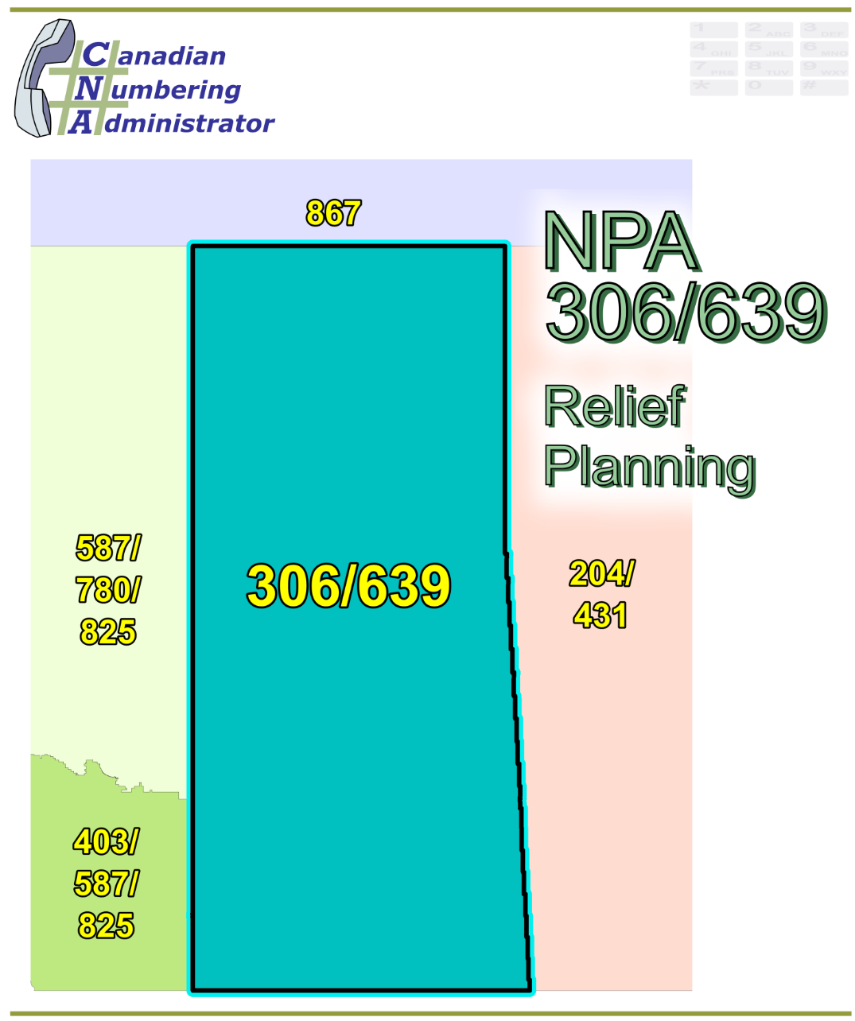

NPA 306/639 Initial Planning Document (IPD)

Version 1.0 – 12 October 2018

|  |  |
| --- | --- |
| Canadian Numbering Administrator (CNA)  Suresh Khare  613-683-3296  60 Queen Street, Suite 1516  Ottawa, Ontario K1P 5Y7  khares@leidos.ca | LeidosCanada_halfbackground_small |

**TABLE OF CONTENTS**

[1. INTRODUCTION 1](#_Toc526321615)

[2. NPA RELIEF PLANNING PROCESS 2](#_Toc526321616)

[3. NPA RELIEF METHODS 3](#_Toc526321617)

[4. NPA EXHAUST INFORMATION 3](#_Toc526321618)

[5. RELIEF OPTIONS 4](#_Toc526321619)

[5.1. Distributed Overlay 4](#_Toc526321620)

[5.2. Concentrated Overlay 4](#_Toc526321621)

[5.2.1. Concentrated Overlay #1 of NPA 474 on the Central LIRs 5](#_Toc526321622)

[5.2.2. Concentrated Overlay #2 of NPA 474 on the non-Central LIRs 5](#_Toc526321623)

[5.2.3. Concentrated Overlay #3 of NPA 474 on the Southern LIRs 5](#_Toc526321624)

[5.2.4. Concentrated Overlay #4 of NPA 474 on the Northern LIRs 5](#_Toc526321625)

[5.2.5. Concentrated Overlay #5 of NPA 474 on the South Eastern LIRs 5](#_Toc526321626)

[5.2.6. Concentrated Overlay #6 of NPA 474 on the North Western LIRs 6](#_Toc526321627)

[5.2.7. Concentrated Overlay #7 of NPA 474 on the Regina/Saskatoon EAS 6](#_Toc526321628)

[5.2.8. Concentrated Overlay #8 of NPA 474 on the Moose Jaw/Regina/Saskatoon EAS 6](#_Toc526321629)

[6. SUMMARY OF RELIEF OPTIONS 7](#_Toc526321630)

[7. COMPARATIVE ASSESSMENT OF RELIEF OPTIONS 8](#_Toc526321631)

[7.1. Assessment 9](#_Toc526321632)

[8. DIALLING CHANGES FOR LOCAL CALLS 9](#_Toc526321633)

[9. PROPOSED SCHEDULE 9](#_Toc526321634)

[10. JEOPARDY CONTINGENCY PLAN (JCP) 13](#_Toc526321635)

[11. SELECTION OF RELIEF NPA CODE 20](#_Toc526321636)

[12. RECOMMENDATIONS 21](#_Toc526321637)

[ANNEXES 22](#_Toc526321638)

**LIST OF ANNEXES**

**ANNEX A**

[Figure 1 – Overview Map of NPA 306/639](#_Toc526321639)

[Figure 2 – NPA 306/639 Actual and Forecast CO Code Assignments](#_Toc526321640)

[Figure 3 – NPA 306/639 CO Code Exhaust: January 2017 G‑NRUF](#_Toc526321641)

[Figure 4 – NPA 306/639 Admin and LEC+WSP Codes: January 2017 G‑NRUF](#_Toc526321642)

[Figure 5 – NPA 306/639 CO Code Exhaust: July 2017 R-NRUF](#_Toc526321643)

[Figure 6 – NPA 306/639 Admin and LEC+WSP Codes: July 2017 R‑NRUF](#_Toc526321644)

[Figure 7 – NPA 306/639 CO Code Exhaust: January 2018 G‑NRUF](#_Toc526321645)

[Figure 8 – NPA 306/639 Admin and LEC+WSP Codes: January 2018 G‑NRUF](#_Toc526321646)

[Figure 9 – NPA 306/639 CO Code Exhaust: May 2018 R-NRUF](#_Toc526321647)

[Figure 10 – NPA 306/639 Admin and LEC+WSP Codes: May 2018 R‑NRUF](#_Toc526321648)

[Figure 11 – NPA 306/639 LIRs](#_Toc526321649)

[Figure 12 – Distributed Overlay](#_Toc526321650)

[Figure 13 – Concentrated Overlay #1 (Central LIRs)](#_Toc526321651)

[Figure 14 – Concentrated Overlay #2 (non-Central LIRs)](#_Toc526321652)

[Figure 15 – Concentrated Overlay #3 (Southern LIRs)](#_Toc526321653)

[Figure 16 – Concentrated Overlay #4 (Northern LIRs)](#_Toc526321654)

[Figure 17 – Concentrated Overlay #5 (South Eastern LIRs)](#_Toc526321655)

[Figure 18 – Concentrated Overlay #6 (North Western LIRs)](#_Toc526321656)

[Figure 19 – Concentrated Overlay #7 (Regina and Saskatoon EAS)](#_Toc526321657)

[Figure 20 – Concentrated Overlay #8 (Moose Jaw, Regina and Saskatoon EAS)](#_Toc526321658)

**ANNEX B**

[Table 1 – NPA 306/639 Exchange Areas for Each Relief Option](#_Toc526321659)

[Table 2 – Exchange Areas in Each LIR](#_Toc526321660)

**ANNEX C**

Distribution List

**ACRONYM LIST**

|  |  |
| --- | --- |
| CATF | Consumer Awareness Task Force |
| CNA | Canadian Numbering Administrator |
| CISC | CRTC Interconnection Steering Committee |
| CLEC | Competitive Local Exchange Carrier |
| CLNPC | Canadian Local Number Portability Consortium |
| CO | Central Office |
| CRTC | Canadian Radio-television and Telecommunications Commission |
| CSCN | Canadian Steering Committee on Numbering |
| EAS | Extended Area Service |
| G-NRUF | General Numbering Resource Utilization Forecast |
| ILEC | Incumbent Local Exchange Carrier |
| IPD | Initial Planning Document |
| ISP | Internet Service Provider |
| JCP | Jeopardy Contingency Plan |
| J‑NRUF | Jeopardy Numbering Resource Utilization Forecast |
| LEC | Local Exchange Carrier |
| LIR | Local Interconnection Region |
| LNP | Local Number Portability |
| NANP | North American Numbering Plan |
| NANPA | North American Numbering Plan Administrator |
| NITF | Network Implementation Task Force |
| NoC | Notice of Consultation |
| NPA | Numbering Plan Area (Area Code) |
| NRUF | Numbering Resource Utilization Forecast |
| PD | Planning Document |
| PED | Projected Exhaust Date |
| PL | Planning Letter |
| POI | Point of Interconnection |
| PSAP | Public Safety Answering Point |
| RIP | Relief Implementation Plan |
| R-NRUF | Relief Planning Numbering Resource Utilization Forecast |
| RPC | Relief Planning Committee |
| TSP | Telecommunications Service Provider |
| WNP | Wireless Number Portability |
| WSP | Wireless Service Provider |

**Initial Planning Document (IPD) Numbering Plan Area (NPA) 306/639**

**Yellow highlight implies that these sections should be reviewed and updated in any planning document contribution(s).**

# INTRODUCTION

Numbering Plan Area (NPA) 306, commonly referred to as an area code, was originally assigned to Saskatchewan by AT&T in 1947 as one of the 86 area codes to be used in Canada and the continental United States.

In May 2013 the new area code 639 provided relief using the Distributed Overlay Method and mandatory ten-digit local dialling was implemented in the province of Saskatchewan. The following table provides a high level summary of the history of area code usage in the area currently served by NPA 306/639 since 1947.

|  |  |
| --- | --- |
| **Year** | **Activity** |
| 1947 | Area code 306 is assigned to Saskatchewan by AT&T |
| 2013  (May) | New area code 639 overlay of 306 to serve all of Saskatchewan; mandatory ten-digit local dialling implemented (mandatory ten-digit local dialling becomes universal in the Province of Saskatchewan) |

NPA 306/639 consists of 228 Exchange Areas, including some of the rapidly growing Exchange Areas of Moose Jaw, Regina and Saskatoon. Based on the May 2018 R‑NRUF results, approximately one-third of the growth in NPA 306/639 is forecast to occur in these three Exchange Areas. 148 of the 228 Exchange Areas have forecast growth, 80 Exchange Areas currently show no growth and 58% of these 80 Exchange Areas are currently using NPA 639 CO Codes. Based on the above, no particular area is causing the exhaust of the CO Codes. A list of the Exchange Areas in NPA 306/639 is provided in Annex B, Table 1.

Approximately 63% of Exchange Areas are currently showing the establishment and/or expansion of a Telecommunications Service Providers’ (TSPs) footprint throughout Saskatchewan. For the purposes of this document a footprint is the first CO Code assigned to a Code Holder in a unique Exchange Area.

The table below provides a brief overview of recent activities leading to the development of this IPD for NPA 306/639.

| **Date** | **Activity** |
| --- | --- |
| 22 October 2010 | In Telecom Decision CRTC 2010-784, NPA Code 474 was set aside for relief of NPA 306.  **For the purposes of this document the new NPA will be 474.** |
| 8 March 2018 | The CNA published the January 2018 G-NRUF results which indicated that the PED had advanced to June 2022. |
| 23 April 2018 | Based on the G-NRUF releases and that the NPA 306/639 Projected Exhaust Date had advanced more than two years the CNA initiated a May 2018 R-NRUF for NPA 306/639. |
| 11 July 2018 | The CRTC released Telecom Notice of Consultation CRTC 2018-236 - *Establishment of a CISC ad hoc committee for relief planning for area codes 306 and 639 in Saskatchewan*. |
| 27 July 2018 | The CNA published the May 2018 R-NRUF results which indicated that the PED had moved out to September 2022. |

This IPD is prepared by the CNA in accordance with Telecom Notice of Consultation CRTC 2018‑236 and the *Canadian NPA Relief Planning Guideline*, Version 6.0 dated 20 November 2014 (the Guideline). A copy of the Guideline is available from the Canadian Radio-Television and Telecommunications Commission (CRTC), CRTC Interconnection Steering Committee (CISC), Canadian Steering Committee on Numbering (CSCN) guidelines web page at: <http://www.crtc.gc.ca/cisc/eng/cisf3fg.htm>.

The objective of the NPA Relief Planning process is to ensure that CO Codes and telephone numbers are always available for use by TSPs and their customers in the geographic area requiring relief.

It is very important to closely monitor the CO Code requirements of all existing and prospective CO Code Holders so that relief can be timed to ensure that CO Codes and telephone numbers are always available for service providers and customers.

Various options for providing NPA relief in the NPA 306/639 geographic area are identified in this IPD. Given the magnitude of this undertaking, intercompany commitment and co‑operation are essential throughout the planning, provisioning and implementation stages of the introduction of a new NPA.

# NPA RELIEF PLANNING PROCESS

The NPA Relief Planning process and the roles of the participants (i.e. CRTC, CNA, CISC, Relief Planning Committee (RPC) participants and Interested Parties) for NPA Relief Planning are identified in the Guideline.

To increase public awareness and participation in the NPA Relief Planning process, the CRTC has determined that NPA RPCs will be established as ad hoc committees of the CISC. Generally, a separate ad hoc committee is created to deal with relief in each area code. The CNA, in its function as NPA Relief Planning Coordinator, acts as chair of these ad hoc committees. Meetings and conference calls of the ad hoc NPA RPCs are all open to public participation and are conducted in accordance with the *CISC Administrative Guidelines* which are available from the CRTC website at: <http://www.crtc.gc.ca/cisc/eng/cag.htm>.

NPA Relief Planning is conducted under the regulatory oversight of the CRTC. Notwithstanding the process detailed in the Guideline, the CRTC may exercise its authority under the *Telecommunications Act* to alter this process at any time. The CRTC has the authority under the *Telecommunications Act* to review, modify and give final approval to the Planning Document (PD) and the Relief Implementation Plan (RIP) developed and submitted by the RPC to the CRTC via the CISC process.

Section 6.1.6 of the *Canadian NPA Relief Planning Guideline* requires the CNA to create and maintain a distribution list of parties who may be interested in participating in the RPC and to provide them with advance notice of the initial RPC meeting and the release of an IPD.

Any person wishing to participate in the NPA Relief Planning process can contact the CNA and request to be added to the RPC distribution list. More information on how to participate in CRTC public processes is available at: <http://www.crtc.gc.ca/eng/info_sht/g4.htm>.

A summary of Canadian geographic area code relief history is available at: <http://www.cnac.ca/npa_codes/NPA_History.pdf>.

# NPA RELIEF METHODS

The purpose of this section is to identify and briefly describe NPA Relief Methods.

The Guideline states that: “The only Relief Method that should be included in the IPD and PD [Planning Document] is the Overlay Method.”

Under the Overlay Method, a relief NPA Code is superimposed or overlaid on top of part or all of an existing NPA. With an overlay, changes to existing customers' telephone numbers are not required. The Overlay Method includes three types of overlays that may be identified and assessed. These types of overlays are detailed in Sections 5.1.1 through 5.1.3 of the Guideline, and are:

* Distributed Overlays - a new relief NPA Code is overlaid on top of all of an exhausting NPA;
* Concentrated Overlays - a new relief NPA Code is overlaid on top of part of an exhausting NPA; and
* Boundary Extension Overlays - the boundary of an existing NPA that has spare capacity is extended to overlay part or all of an exhausting NPA.

# NPA EXHAUST INFORMATION

As indicated in the following table, NRUFs for NPA 306/639 were used to determine PEDs, i.e. the dates when CO Codes in NPA 306/639 would be expected to exhaust.

|  |  |
| --- | --- |
| **NRUF** | **Projected Exhaust Date (PED)** |
| G-NRUF January 2017 | July 2022 |
| R-NRUF July 2017 | November 2024 |
| G‑NRUF January 2018 | June 2022 |
| R-NRUF May 2018 | September 2022 |

Refer to Annex A, Figures 2 through 10 for graphs of forecast CO Code demand from current and prospective CO Code Holders and charts of Administrative Codes set aside in area code 306/639.

# RELIEF OPTIONS

Based on the basic Relief Methods, the following Relief Options were identified and examined in detail:

* Distributed Overlay – One option
* Concentrated Overlay – Seven options

The Relief Options identified above were evaluated using the following assumptions:

* The CNA compared the average forecast growth for the next six years (61 CO Codes) and the five year period from January 2019 until January 2024 (30 CO Codes), the median forecast growth for the next six years (34 CO Codes) and the median (84 CO Codes) and average historical (103 CO Codes) growth for the past five years. The five year average forecast growth of 30 CO Codes was used to identify the PED for all relief options.
* The Relief Date for the Distributed Overlay Option will be Q3 2021 (approximately 12 months prior to the NPA 306/639 PED of September 2022 identified using the May 2018 R‑NRUF results).
* The Relief Date for the seven options that use a Concentrated Overlay will be Q1 2021 (approximately 18 months prior to the NPA 306/639 PED of September 2022 identified using the May 2018 R‑NRUF results). This length of time is required to ensure that a sufficient number of CO Codes remain available to provide for the future growth of NPA 306/639.

A high-level Local Interconnection Region (LIR) map has been provided for reference purposes in Annex A, Figure 11.

See Annex A, Figures 12 through 20 for diagrams of the Relief Options identified by the CNA.

The Boundary Extension Overlay Relief Method was not examined in detail in this IPD because this would create an NPA boundary that crosses provincial/territorial borders.

## Distributed Overlay

One Distributed Overlay Relief Option was evaluated which would overlay NPA 474 over all 228 Exchange Areas in the NPA 306/639 area. See Annex A, Figure 12.

The introduction of a Distributed Overlay would keep the same number of NPA Relief Planning areas in Saskatchewan.

After this Distributed Overlay, CO Codes in the NPA 306/474/639 area would be expected to exhaust in Q4 2048.

## Concentrated Overlay

Seven Concentrated Overlay Relief Options were evaluated to provide CO Code relief in the NPA 306/639 geographic area. These Relief Options are dependent on LIRs and Extended Area Service (EAS) in NPA 306/639. See Annex A, Figures 13 through 20.

The introduction of a Concentrated Overlay in the NPA 306/639 area creates an additional NPA Relief Planning area in Saskatchewan (i.e., an increase from 1 to 2).

To ensure a quantity of CO Codes is available in NPA 306/639 for forecast growth in the remainder of NPA 306/639, all Concentrated Overlay Options will be implemented in Q1 2021 (approximately 18 months prior to the PED).

### Concentrated Overlay #1 of NPA 474 on the Central LIRs

This Relief Option would overlay the NPA 474 on the 74 Exchange Areas of the Regina and Saskatoon LIRs. The remaining 154 Exchange Areas of the Moose Jaw, North Battleford, Prince Albert, Swift Current, Weyburn, and Yorkton LIRs would continue to grow using CO Codes from NPA 306/639. See Annex A, Figure 13.

After this Concentrated Overlay CO Codes in the NPA 306/639 area and NPA 306/474/639 area would be expected to exhaust in Q1 2025 and Q2 2069, respectively.

### Concentrated Overlay #2 of NPA 474 on the non-Central LIRs

This Relief Option would overlay the NPA 474 on the 154 Exchange Areas of the Moose Jaw, North Battleford, Prince Albert, Swift Current, Weyburn, and Yorkton LIRs. The remaining 74 Exchange Areas of the Regina and Saskatoon LIRs would continue to grow using CO Codes from NPA 306/639. See Annex A, Figure 14.

After this Concentrated Overlay, CO Codes in the NPA 306/639 area and the NPA 306/474/639 area would be expected to exhaust in Q3 2024 and Q4 2064, respectively.

### Concentrated Overlay #3 of NPA 474 on the Southern LIRs

This Relief Option would overlay NPA 474 on the 116 Exchange Areas of the Moose Jaw, Regina, Swift Current, Weyburn, and Yorkton LIRs. The remaining 112 Exchange Areas of the North Battleford, Prince Albert, and Saskatoon LIRs would continue to grow using CO Codes from NPA 306/639. See Annex A, Figure 15.

After this Concentrated Overlay, CO Codes in the NPA 306/639 area and the NPA 306/474/639 area would be expected to exhaust in Q2 2025 and Q2 2060, respectively.

### Concentrated Overlay #4 of NPA 474 on the Northern LIRs

This Relief Option would overlay NPA 474 on the 112 Exchange Areas of the North Battleford, Prince Albert, and Saskatoon LIRs. The remaining 116 Exchange Areas of the Moose Jaw, Regina, Swift Current, Weyburn, and Yorkton LIRs would continue to grow using CO Codes from NPA 306/639. See Annex A, Figure 16.

After this Concentrated Overlay, CO Codes in the NPA 306/639 area and the NPA 306/474/639 area would be expected to exhaust in Q3 2024 and Q2 2076, respectively.

### Concentrated Overlay #5 of NPA 474 on the South Eastern LIRs

This Relief Option would overlay NPA 474 on the 96 Exchange Areas of the Moose Jaw, Regina, Weyburn, and Yorkton LIRs. The remaining 132 Exchange Areas of the North Battleford, Prince Albert, Saskatoon, and Swift Current LIRs would continue to grow using CO Codes from NPA 306/639. See Annex A, Figure 17.

After this Concentrated Overlay, CO Codes in the NPA 306/639 area and the NPA 306/474/639 area would be expected to exhaust in Q1 2025 and Q4 2066, respectively.

### Concentrated Overlay #6 of NPA 474 on the North Western LIRs

This Relief Option would overlay NPA 474 on the 132 Exchange Areas of the North Battleford, Prince Albert, Saskatoon, and Swift Current LIRs. The remaining 96 Exchange Areas of the Moose Jaw, Regina, Weyburn, and Yorkton LIRs would continue to grow using CO Codes from NPA 306/639. See Annex A, Figure 18.

After this Concentrated Overlay, CO Codes in the NPA 306/639 area and the NPA 306/474/639 area would be expected to exhaust in Q4 2024 and Q1 2067, respectively.

### Concentrated Overlay #7 of NPA 474 on the Regina/Saskatoon EAS

This Relief Option would overlay NPA 474 on the 17 Exchange Areas of the Regina and Saskatoon EAS. The remaining 211 Exchange Areas outside of the Regina and Saskatoon EAS would continue to grow using CO Codes from NPA 306/639. See Annex A, Figure 19.

After this Concentrated Overlay, CO Codes in the NPA 306/639 area and the NPA 306/474/639 area would be expected to exhaust in Q4 2024 and Q1 2076, respectively.

### Concentrated Overlay #8 of NPA 474 on the Moose Jaw/Regina/Saskatoon EAS

This Relief Option would overlay NPA 474 on the 21 Exchange Areas of the Moose Jaw, Regina and Saskatoon EAS. The remaining 207 Exchange Areas outside the Moose Jaw, Regina and Saskatoon EAS would continue to grow using CO Codes from NPA 306/639. See Annex A, Figure 20.

After this Concentrated Overlay CO Codes in the NPA 306/639 area and the NPA 306/474/639 area would be expected to exhaust in Q3 2025 and Q2 2066, respectively.

# SUMMARY OF RELIEF OPTIONS

|  |  |  |  |
| --- | --- | --- | --- |
| **Relief Option** | **Projected Exhaust Dates** | | **Subsequent Relief Dates** |
| **NPA 306/639** | **NPA 474** |
| Distributed Overlay | Sep-2022 | Dec-2048 | Dec-2047 |
| Concentrated Overlay #1  (Central LIRs) | Mar-2025 | Apr-2069 | Mar-2024  Apr-2068 |
| Concentrated Overlay #2  (non-Central LIRs) | Sep-2024 | Oct-2064 | Sep-2023  Oct-2063 |
| Concentrated Overlay #3  (Southern LIRs) | Jun-2025 | Apr-2060 | Jun-2024  Apr-2059 |
| Concentrated Overlay #4  (Northern LIRs) | Aug-2024 | May-2076 | Aug-2023  May-2075 |
| Concentrated Overlay #5  (South Eastern LIRs) | Jan-2025 | Oct-2066 | Jan-2024  Oct-2065 |
| Concentrated Overlay #6  (North Western LIRs) | Oct-2024 | Jan-2067 | Oct-2023  Jan-2066 |
| Concentrated Overlay #7  (Regina/Saskatoon EAS) | Oct-2024 | Mar-2076 | Oct-2023  Mar-2075 |
| Concentrated Overlay #8  (Moose Jaw/Regina/Saskatoon EAS) | Aug-2025 | May-2066 | Aug-2024  May-2065 |

**Notes:**

1. **For the Distributed Overlay Relief Option NPA 474 would be in service in Q3 2021.**
2. **For all Concentrated Overlay Relief Options NPA 474 would be in service in Q1 2021.**
3. **For all Concentrated Overlay Relief Options with a PED in 2024 and 2025, subsequent relief planning of NPA 306/639 would be required immediately.**

# COMPARATIVE ASSESSMENT OF RELIEF OPTIONS

The CNA has provided the template below to assist the RPC with their comparative assessment of the Relief Options identified in Section 5 of the IPD. On review of the IPD/PD the RPC may modify the criteria and will complete the table.

The RPC identified X Relief Options in Section 5 of this document. A Pro, Neutral or Con (P, N or C) rating was established for each Relief Option for each of the following attributes. The results are listed in the table below the list of attributes.

1. NPA Code Conservation – quantity of new NPAs required in NPA 306/639 within the next XX years after relief (20XX – 20XX) (P = 0 new NPAs; N = 1 new NPA; C = 2 or more new NPAs)
2. Number of separate Relief Planning areas in Saskatchewan in the long term (P = decrease; N = stays same; C = increase)
3. Level of Carrier Costs – e.g., network implementation, customer awareness (P = Low; N = Medium; C = High)
4. Length of implementation window i.e. length of time available for Carriers to implement relief NPA (P = longest; C = shortest)
5. Longevity – the length of time between this relief and subsequent relief activity in NPA 306/639 (e.g., a new area code) (P = 15 or more years; N = 9 through 14 years; C = within 8 years)
6. Established Geographic Identities – changes in boundaries of existing NPAs (P = none; C = 1 or more existing NPAs affected)
7. New Geographic Identities – boundaries of new NPA align with boundaries of known areas (e.g., existing NPA areas, provinces) or identifiable geographic features (e.g., rivers, islands) (P = aligns with existing NPA boundaries; N = aligns with geographic features but not with existing NPA boundaries; C = aligns with neither existing NPA boundaries, nor identifiable geographic features)
8. Potential maximum quantity of NPAs in an Exchange Area in the next 10 years after relief (20XX-20XX) (P = 2 NPA; N = 3 NPAs; C = 4 NPAs)

| **Relief Option**  **Description** | **Pro, Neutral or Con for Each Attribute** | | | | | | | | **Rating** |
| --- | --- | --- | --- | --- | --- | --- | --- | --- | --- |
| **A** | **B** | **C** | **D** | **E** | **F** | **G** | **H** |
| Distributed Overlay |  |  |  |  |  |  |  |  |  |
| Concentrated Overlay #1  (Central LIRs) |  |  |  |  |  |  |  |  |  |
| Concentrated Overlay #2  (non-Central LIRs) |  |  |  |  |  |  |  |  |  |
| Concentrated Overlay #3  (Southern LIRs) |  |  |  |  |  |  |  |  |  |
| Concentrated Overlay #4  (Northern LIRs) |  |  |  |  |  |  |  |  |  |
| Concentrated Overlay #5  (South Eastern LIRs) |  |  |  |  |  |  |  |  |  |
| Concentrated Overlay #6  (North Western LIRs) |  |  |  |  |  |  |  |  |  |
| Concentrated Overlay #7  (Regina/Saskatoon EAS) |  |  |  |  |  |  |  |  |  |
| Concentrated Overlay #8  (Moose Jaw/Regina/Saskatoon EAS) |  |  |  |  |  |  |  |  |  |

It should be noted that none of the options require Exchange Area boundary changes.

If P, N and C are assigned a weighting of +1, 0 and -1, respectively, then analysis of the above table gives the highest rating of X points to Relief Option X, and the next highest rating of X points to Relief Option X and the subsequent ratings of X for Relief Options X and X and, finally, X for Relief Options X and X.

Relief Option X has the highest rating when assessed based on the above criteria.

## Assessment

To be completed by RPC.

# DIALLING CHANGES FOR LOCAL CALLS

Currently 10-digit dialling is mandatory for local calls originating within area code NPA 306/639. Local dialling plans will not change with this relief.

The addition of NPA 474 will not affect the dialling plan for long-distance calls originating within NPA 306/639 and NPA 474.

# PROPOSED SCHEDULE

The CNA has provided the template below to assist the RPC with the development of the relief implementation schedule.

The RPC submits the following schedule for NPA 306/639 relief based on the recommendations contained in this PD and the current PED of September 2022. The RPC will monitor the PED, and if it changes significantly in the future, the RPC will assess the situation and, if necessary, submit recommendations including a revised schedule to the CRTC for consideration and approval.

**RELIEF IMPLEMENTATION SCHEDULE**

**For an Overlay of NPA 474 over NPA 306/639**

To be completed by RPC.

| **Item** | **Task or Event** | **PRIME** | **START** | **END** |
| --- | --- | --- | --- | --- |
| 1 | CNA identifies NPA exhaust of June 2022 and notifies by e-mail CRTC staff, CSCN, North American Numbering Plan Administrator (NANPA) & CISC that the NPA will exhaust within the future six year time period | CNA |  | 8-Apr-18 |
| 2 | CRTC issues Telecom Notice of Consultation regarding establishment of an ad hoc Relief Planning Committee | CRTC |  | 11-Jul-18 |
| 3 | CNA conducts initial R-NRUF and releases results indicating the PED has moved out to September 2022 | CNA | 23-Apr-18 | 27-Jul-18 |
| 4 | RPC Chair starts preparing and submitting RPC Chair Reports to the CISC, on an as required basis | RPC Chair | 11-Jul-18 |  |
| 5 | CNA develops and distributes Initial Planning Document (IPD) to RPC | CNA | 8-Apr-18 | 12-Oct-18 |
| 6 | CNA announces the date for the initial NPA Relief Planning face-to-face meeting & requests contributions | CNA |  | 12-Oct-18 |
| 7 | RPC participants review IPD & submit contributions to RPC | RPC | 12-Oct-18 | 20-Nov-18 |
| 8 | CNA chairs initial RPC meeting to start development of PD, RIP & Planning Letter (PL), & schedules future meetings/conference calls including creation of & consultation with CATF and NITF | CNA, RPC | 27-Nov-18 | 28-Nov-18 |
| 9 | CNA chairs subsequent RPC meetings/conference calls to finalize PD & RIP | CNA, RPC | 29-Nov-18 |  |
| 10 | CNA forwards the PD and RIP to the CISC and CRTC for approval | CNA |  |  |
| 11 | Special Types of Telecommunications Service Users (911 Public Safety Answering Points (PSAPs), alarm companies, Internet Service Providers (ISPs), paging companies, etc.) to identify any concerns to RPC & CRTC | Special Users |  |  |
| 12 | CRTC issues Telecom Decision approving the Relief Method, Relief Date, New NPA & RIP | CRTC |  |  |
| 13 | CNA obtains relief NPA from NANPA | CNA |  |  |
| 14 | RPC develops the PL | RPC |  |  |
| 15 | Task Forces, TSPs and users implement relief (starts upon CRTC approval of RIP and ends on Relief Date) | TSPs |  |  |
| 16 | All TSPs to develop and file individual consumer awareness programs with the CRTC (may be done collectively by Telecommunications Alliance) (starts upon CRTC approval of RIP) | TSPs |  |  |
| 17 | CNA issues media release (in coordination with TSPs and/or Telecommunication Alliance) (may start upon CRTC approval of RIP) | CNA |  |  |
| 18 | CNA submits PL and RIP to NANPA | CNA |  |  |
| 19 | NANPA receives and posts PL to NANPA website (within 2 weeks of receipt from the CNA) | NANPA |  |  |
| 20 | All TSPs implement consumer awareness activities (starts upon filing of Consumer Awareness Programs with the CRTC and is completed on the Relief Date) | TSPs |  |  |
| 21 | All TSPs to notify all customers (including residence, business & special customers) of the new overlay NPA (may start upon the filing of Consumer Awareness Programs with the CRTC) | TSPs |  |  |
| 22 | TSPs to submit Progress Report #1 to Network Implementation Task Force (NITF) and Consumer Awareness Task Force (CATF) (starts after completion date for all TSPs to notify their customers and requires 2 weeks) | TSPs |  |  |
| 23 | NITF and CATF develop & submit Progress Report #1 to RPC (linked to TSP reports to NITF and CATF) | NITF & CATF |  |  |
| 24 | RPC submits Progress Report #1 to CRTC staff (linked to NITF and CATF reports) | RPC |  |  |
| 25 | iconectiv TRA updates database to add Exchange Areas to new overlay NPA (starts on the date that the PL is posted to the NANPA web site and must be completed by 6 months prior to the Relief Date) | iconectiv TRA |  |  |
| 26 | All Telecommunications Service Users (including Special Users 911 PSAPs, alarm companies, ISPs, paging companies, etc.) to implement changes to their telecom equipment & systems to accommodate the new NPA (starts upon CRTC approval of RIP and ends on the Relief Date) | Telecom Service Users |  |  |
| 27 | Payphone Providers Reprogram Payphones (starts upon CRTC approval of RIP and ends on the Relief Date) | Payphone Providers |  |  |
| 28 | TSPs and database owners/operators to modify systems and industry databases (starts upon CRTC approval of RIP and ends on the Relief Date) | TSPs & Database Owners |  |  |
| 29 | Operator Services & Directory Assistance Readiness (starts upon CRTC approval of RIP and ends on the Relief Date) | TSPs |  |  |
| 30 | Directory Publisher Readiness for overlays (ability to identify the NPA in telephone numbers in the directory published after the Overlay NPA is activated) (starts upon CRTC approval of RIP and ends on the Relief Date) | Directory Publishers |  |  |
| 31 | 9-1-1 Systems and Databases Readiness (starts upon CRTC approval of RIP and ends on the Relief Date) | PSAPS,  9 1 1 Service Providers & TSPs |  |  |
| 32 | Network Systems & Equipment Readiness (starts upon CRTC approval of RIP and ends on the Relief Date) | TSPs |  |  |
| 33 | Service Order & Business System Readiness (starts upon CRTC approval of RIP and ends on the Relief Date) | TSPs |  |  |
| 34 | International Gateway Switch Translations Readiness for new NPA (starts upon CRTC approval of RIP and ends on the Relief Date) | Int’l TSPs |  |  |
| 35 | Canadian Local Number Portability Consortium (CLNPC) Database Readiness for new NPA (starts upon CRTC approval of RIP and ends on the Relief Date) | CLNPC & NPAC |  |  |
| 36 | Toll Free SMS Database Readiness for new NPA (starts upon CRTC approval of RIP and ends on the Relief Date) | Toll TSPs |  |  |
| 37 | TSPs apply for Test CO Codes in new NPA (applications may be submitted no more than 6 months and no less than 66 days prior to the start date for the Inter-Carrier Testing Period) (Section 7.16.4 Canadian RP GL) | TSPs |  |  |
| 38 | Develop Inter-Carrier Network Test Plans and prepare for testing (individual TSPs to make arrangements in accordance with interconnection agreements) (may start upon CRTC approval of RIP and must be completed by start date for the Inter-Carrier Testing Period) | NITF & TSPs |  |  |
| 39 | All international and domestic TSPs must activate the new NPA in their networks by the start date for the Inter-Carrier Testing Period | TSPs |  |  |
| 40 | Activation date for Overlay NPA Test CO Codes and Test Numbers in network (should be completed by the start date for the Inter-Carrier Testing Period) | TSPs |  |  |
| 41 | Inter-Carrier Testing Period (subject to Inter-Carrier Network Test Plans) (starts about 3 months prior to the Relief Date, and ends about 1 month after the Relief Date) | NITF & TSPs |  |  |
| 42 | TSPs to submit Progress Report #2 to NITF and CATF (starts on commencement of Inter-Carrier Testing Period) | TSPs |  |  |
| 43 | NITF and CATF develop & submit Progress Report #2 to RPC (linked to TSP reports to NITF and CATF) | NITF & CATF |  |  |
| 44 | RPC submits Progress Report #2 to CRTC staff (linked to NITF and CATF reports) | RPC |  |  |
| 45 | Relief Date (earliest date when CO Codes in new NPA may be activated) |  |  |  |
| 46 | TSPs submit Final Report to CATF and NITF (starts on Relief Date and provides 2 weeks for preparation & submission) | TSPs |  |  |
| 47 | NITF and CATF develop & submit Final Progress Report to RPC (linked to TSP reports to NITF and CATF) | NITF & CATF |  |  |
| 48 | The RPC submits Final Progress Report to CRTC staff (linked to NITF and CATF reports) | RPC |  |  |
| 49 | TSPs disconnect Test Codes & Numbers, and submit Part 1 form to return Test Codes (starts 1 month after Relief Date and allows 1 month for completion) | TSPs |  |  |
| 50 | RPC Chair submits, to the CISC, the final RPC Chair report indicating that theNPA 306/639 ad hoc RPC is no longer required | RPC Chair |  |  |

# JEOPARDY CONTINGENCY PLAN (JCP)

The CNA has provided the template below to assist the RPC with the development of the Jeopardy Contingency Plan (JCP).

The RPC has developed the following JCP for inclusion in the PD for NPA 306/639. This JCP is based on the example contained in Appendix F to the *Canadian NPA Relief Planning Guideline*.

This JCP shall remain in effect until superseded by a CRTC-approved JCP, the Jeopardy Condition is suspended or 66 days prior to the Relief Date.

The following measures shall be implemented in NPA 306/639 while a Jeopardy Condition is in effect.

During a Jeopardy Condition, CO Code Applicants shall submit all CO Code applications and related correspondence for the Jeopardy NPA to CRTC staff in addition to the CNA. The CNA shall only assign CO Codes from the exhausting NPA to a CO Code Applicant when instructed by CRTC staff.

1. Carriers and/or Telecommunications Service Providers (TSPs):
   1. shall age disconnected residential wireline telephone numbers for a maximum of two months;
   2. shall age disconnected wireless telephone numbers for a maximum of three months;
   3. shall age disconnected business wireline telephone numbers for a maximum of six months. Under special circumstances, the six month aging limit for business telephone numbers may be extended to twelve months, if required, to accommodate local directory publishing dates for high volume call-in applications (e.g., heavily advertised local business numbers such as radio talk shows, food ordering services, ticket sales, chat lines), or for numbers associated with public service emergency applications or for numbers advertised in directories for which customers have requested reference of calls;
   4. shall return all CO Codes that are not being used, nor intended to be used to directly serve customers to the assignment pool within two months (e.g., plant test codes);
   5. should work towards, and encourage existing customers, to either activate or return the reserved numbers to bring the reserved quantity down to a maximum of 10% of the quantity of numbers In-Service for that customer;
   6. shall not allow the quantity of reserved numbers to be increased by new reservation requests by existing customers to more than 10% of the quantity of numbers in service for that customer. In the case of new customers, number reservations shall be limited to 10% of the total quantity of telephone numbers being placed into service for that customer;
   7. shall, within 45 days from the date that the CNA declares a Jeopardy Condition submit a Part 1 Form for each remaining reserved CO Code either returning the reserved CO Code to the CNA or requesting assignment of the reserved CO Code. Once the 45-day period has elapsed, the CNA shall make available for general assignment all CO Codes that are still reserved and have not been applied for as assignments on a Part 1 Form received by the CNA. Within 60 days from the date that the CNA declares a Jeopardy Condition, the CNA shall report to CRTC staff and the RPC as to how many of these codes have been assigned or made available for general assignment;
   8. shall not be permitted to obtain a new CO Code reservation;
   9. shall place all CO Codes assigned prior to the Jeopardy Condition being declared In-Service within three months of the effective date for CO Code activation in the network, or within three months of the date that the Jeopardy Condition was declared. If the CO Code is an Initial Code and the CO Code Holder can demonstrate that, due to circumstances beyond its control, the In-Service date has been delayed beyond the applicable timeframe, then the CNA may grant an extension of up to two months to the In-Service date. The CNA shall initiate reclamation procedures for all CO Codes that have not been placed In-Service within these timeframes unless CRTC staff provides a further extension.
2. For new applications for Initial Codes, each CO Code Holder shall certify that the CO Code will be activated in the network and placed In-Service within four months of the date of application for the Code. If the CNA does not receive a Part 4 Form within this timeframe, confirming that the CO Code has been placed In-Service, the CNA will initiate reclamation measures. If the CO Code Holder can demonstrate that, due to circumstances beyond its control, the In-Service date has been delayed not more than six months from the original application date, then the CNA may grant an extension to the In-Service date, so long as the In-Service date is not more than six months beyond the original application date. If the In-Service date has been delayed more than six months from the original application date, then the CNA shall reclaim the Code unless CRTC staff provides a further extension.
3. When applying for an Additional Code for Growth, a CO Code Holder who is submitting a Part 1 Form and Appendix B worksheet shall also submit a completed Supplementary Form for a Growth CO Code Application (attached) which certifies and/or provides the following information for the specific switching entity/POI and Exchange Area when the Growth CO Code is being requested in a Jeopardy Condition:
   1. certification that all held telephone numbers have been released;
   2. certification that reserved numbers do not exceed ten percent of the total quantity of numbers as defined in Appendix G of the Canadian CO Code (NXX) Assignment Guideline;
   3. certification that each reseller/dealer had been advised of the Jeopardy Condition and the requirement that they would only be allocated additional numbers during the Jeopardy Condition on the provision to the CO Code Holder of written confirmation that their number inventory has been reduced to an amount less than two times the highest quantity of customer numbers assigned in any month during the previous 12 months. Additional numbering resources will only be provided by the CO Code Holder to the reseller/dealer to the extent that the reseller's/dealer's inventory can only increase up to a maximum of three months' inventory;
   4. confirmation that the Part 1 form submitted with the application has the Jeopardy Condition box in section 1.6 checked to certify that the existing CO Codes are projected to exhaust within 4 months of the date of application and that the months-to-exhaust is documented on an Appendix B submitted to the CNA;
   5. a completed Telephone Number Utilization Report for the applicable switching entity signed by both a company officer and the company’s authorized representative;
   6. confirmation that the requested Growth CO Code was forecasted in the most recent NRUF or an explanation as to why it was not is attached; and
   7. confirmation that the requested Growth CO Code will be placed In-Service within four months of the date of assignment.
4. Any CO Codes for growth assigned after the implementation of this JCP must be activated in the network and placed In-Service within four months of assignment. In the event that a CO Code Holder is unable to place the CO Code In-Service within four months of the date of assignment, the CO Code Holder must return the assigned CO Codes or submit a written request for extension to the CNA. Such written requests must include documentation explaining the reason(s) for the missed date and proposing the new In-Service date. If the explanation includes reasons beyond the control of the CO Code Holder, the CNA may extend the In-Service date a maximum of one month. If the CO Code Holder does not place the CO Code In-Service within the one-month extension, the CNA shall initiate the reclamation process at the end of the one-month extension unless CRTC staff provides a further extension.
5. A Carrier that has multiple switching entities within an Exchange Area shall examine the possibility of, and implement where feasible, number sharing between those switches as a potential method to delay requirements for additional CO Codes.
6. The CNA will request two versions (two separate worksheets (Form 1 and Form 2)) of the J-NRUF input from all current and prospective CO Code Holders quarterly until three (3) months before relief is provided.
   1. The forecasted quantities in Form 1 should be the same as or lower than the last R-NRUF input submitted, prior to declaration of a Jeopardy Condition. CO Code Holder forecasts may reflect an increase in demand in the period subsequent to the Relief Date.
   2. Form 2 will reflect the actual demand required by the CO Code Holder's current business plan and will be provided for information purposes only.
7. The CNA will compare the initial J-NRUF input to the recent NRUF inputs, to assess forecasting trends. The CNA shall monitor all inputs and shall test them for reasonableness in consultation with the Carrier. If the CNA is dissatisfied with the reasonableness, or the rationale provided for the deviations, then the matter will be referred to the CRTC staff.
8. The CNA will request subsequent J-NRUF input from all current and prospective CO Code Holders quarterly until 3 months before relief is provided. If one or more R-NRUFs have already been conducted, and depending on the severity of the Jeopardy Condition, the CNA may defer a J-NRUF by up to two months if such a deferral brings the timing of that J‑NRUF and subsequent J-NRUFs into alignment with other NRUFs that are conducted at 12, 6 or 3 month intervals. Subsequent J-NRUF input will be compared with the initial J‑NRUF input to evaluate the effectiveness of the JCP. The CNA shall monitor all J-NRUF inputs and shall test them for reasonableness in consultation with the Telecommunications Service Providers. If the CNA is dissatisfied with the reasonableness, or the rationale provided for the changed forecasts, then the matter will be referred to CRTC staff.
9. A CO Code Applicant must have submitted a completed J-NRUF to the CNA before the CNA may assign a CO Code to that CO Code Applicant.
10. If a CO Code applicant wishes to request more CO Codes than it identified in its most recent J NRUF, the CO Code Applicant should discuss the matter with the CNA. If the CO Code Applicant wishes to proceed with the request, the CO Code Applicant will forward the request and revised forecast to CRTC staff and the CNA for consideration.
11. The CO Codes identified in the NPA CO Code Inventory Chart as “Assignable CO Codes in a Jeopardy Condition” will be assigned in the order determined by the RPC after all CO Codes which are “Available for Assignment as of [day month year] have been assigned.
12. After each J-NRUF, the CNA shall provide CRTC staff, the RPC and CSCN participants with a report providing an updated NPA CO Code Inventory Chart for the NPA in jeopardy as well as the aggregate results of the most recent J-NRUF.
13. Exceptional issues or concerns may be referred by the CNA, or by individual entities (with a courtesy copy to the CNA), to the CRTC staff for resolution.
14. In a situation where the Relief Date is on or after the PED, the quantity of CO Codes that may be assigned to a CO Code Applicant prior to the end of the Jeopardy Condition (i.e. 66 days prior to the Relief Date) shall be limited to the quantity forecasted by the CO Code Applicant in its most recent NRUF forecast submitted prior to the Jeopardy Condition being declared by the CNA (if no previous NRUF was submitted, then the previous forecast will be deemed to be zero codes). When making requests to obtain CO Codes prior to the end of the Jeopardy Condition (i.e. 66 days prior to the Relief Date), the CO Code Applicant may change the Exchange Area or the month when the CO Code assignment is required, provided a new J-NRUF and explanation accompanies the application. The control imposed by this option may be relaxed if subsequent J-NRUFs defer the PED to after the Relief Date. CO Codes that become available for assignment due to future reduced demand from other current and prospective CO Code Holders may be assigned at the discretion of CRTC staff.
15. If the CNA determines that the implementation of the JCP has not extended the Projected Exhaust Date of the NPA beyond the Relief Date, the CNA will consult with CRTC staff and further CO Code conservation and assignment procedures may be ordered by the Commission (e.g., rationing, lottery, etc.).

Supplementary form for a Growth CO Code Application – Page 1 of 2 – Telephone Number Utilization Report

This form is required with each request for an Additional Code for Growth in an NPA where a Jeopardy Condition is in effect. It should be submitted to the CNA together with the Part 1 and Appendix B forms that are required for an application for an Additional Code for Growth. See the Part 1 form for information on how and where to submit the form.

I hereby certify that the following information is true and accurate to the best of my knowledge and has been prepared in accordance with Special Conservation Procedures for a Jeopardy Condition contained in the *Canadian NPA Relief Planning Guideline* or the applicable approved Jeopardy Contingency Plan.



Name & Signature of Authorized Representative of Code Holder Title Date



Name & Signature of Company Officer (see item 3 of this JCP) Title Date

Contact information: Entity Name: \_\_\_\_\_\_\_\_\_\_\_\_\_\_\_\_\_\_ Contact Name: \_\_\_\_\_\_\_\_\_\_\_\_\_

Address: \_\_\_\_\_\_\_\_\_\_\_\_\_\_\_\_\_\_ City, Province, Postal Code: \_\_\_\_\_\_\_\_\_\_\_\_\_

Telephone: \_\_\_\_\_\_\_\_\_\_\_\_\_\_\_\_\_\_ Facsimile: \_\_\_\_\_\_\_\_\_\_\_\_\_

E-mail: \_\_\_\_\_\_\_\_\_\_\_\_\_\_\_\_\_\_

Switch Identification (Switching Entity/POI) CLLI: \_\_\_\_\_\_\_\_\_\_\_\_\_\_\_ Exchange Area: \_\_\_\_\_\_\_\_\_\_\_\_\_\_\_\_

For the above Switch Identification and Exchange Area for which a Growth CO Code is requested:

I certify that all held telephone numbers have been released

I certify the total quantity of reserved numbers does not exceed ten percent (10%) of the total quantity of telephone numbers as defined in Appendix G of the *Canadian CO Code (NXX) Assignment Guideline*

I certify that each reseller/dealer has been advised of the Jeopardy Condition and the requirement that they would only be allocated additional numbers during the Jeopardy Condition on the provision to the CO Code Holder of written confirmation that their number inventory has been reduced to an amount less than two (2) times the highest quantity of customer numbers assigned in any month during the previous twelve (12) months. Additional numbering resources will only be provided by the CO Code Holder to the reseller/dealer to the extent that the reseller's/dealer's inventory can only increase up to a maximum of three months' inventory.

The Part 1 form submitted with the application has the Jeopardy Condition box in section 6 checked (this certifies that the existing CO Codes are projected to exhaust within four (4) months of the date of the application or within the period specified in an approved Jeopardy Contingency Plan, and that the months-to-exhaust is documented on an Appendix B submitted to the CNA).

The Telephone Number Utilization Report on page 2 of this form has been completed.

The requested Growth CO Code was forecasted in the most recent NRUF, or an explanation as to why it was not is attached.

The requested Growth CO Code will be placed In-Service within four (4) months of the date of assignment.

**Supplementary Form for a Growth CO Code Application – Page 2 of 2 – Telephone Number Utilization Report**

Use Arial 9 to complete this form. (Note: If the spreadsheet below does not show on your display, please change the Work view to "Print Layout" or "Reading Layout")



Remarks: \_\_\_\_\_\_\_\_\_\_\_\_\_\_\_\_\_\_\_\_\_\_\_\_\_\_\_\_\_\_\_\_\_\_\_\_\_\_\_\_\_\_\_\_\_\_\_\_\_\_\_\_\_\_\_\_\_\_\_\_\_\_\_\_\_\_\_\_\_\_\_\_\_\_\_\_\_\_\_

\_\_\_\_\_\_\_\_\_\_\_\_\_\_\_\_\_\_\_\_\_\_\_\_\_\_\_\_\_\_\_\_\_\_\_\_\_\_\_\_\_\_\_\_\_\_\_\_\_\_\_\_\_\_\_\_\_\_\_\_\_\_\_\_\_\_\_\_\_\_\_\_\_\_\_\_\_\_\_\_\_\_\_\_\_\_\_\_

**NPA 306/639 CO Code Inventory Chart**

The following chart and the instructions it contains will apply in NPA 306/639 in a Jeopardy Condition.

The chart below lists quantities of CO Codes unassignable prior to a Jeopardy Condition, CO Codes that become assignable in a Jeopardy Condition and CO Codes in NPA 306/639 assigned and In‑service as of 12 October 2018. The CO Codes that become assignable in a Jeopardy Condition shall only be made available for assignment when all other available CO Codes have been assigned in the order listed below.

|  |  |  |
| --- | --- | --- |
|  |  | **Quantity** |
| **A** | **Total CO Codes in NPAs 306/639** **(NXX format)** | **1600** |
|  | | |
| **B** | **CO Codes unassignable prior to a Jeopardy Condition** |  |
|  | N11 Service Codes (211, 311, 411, 511, 611, 711, 811, 911) | 16 |
|  | Special Use Codes (555, 950 & 976) | 6 |
|  | Home NPA Code(s) | 4 |
|  | Current Neighbouring NPA Codes (204,431) | 4 |
|  | Future Geographic NPA Codes (474, 568, 851, 871, 942)  (Note 1 & 2) | 10 |
|  | Plant Test Codes (958 & 959) | 4 |
|  | Special 7-digit Dialling Codes (310, 610 & 810) | 5 |
|  | CO Codes set aside for Initial Codes only | 0 |
|  | CO Codes set aside for New Entrants only | 0 |
|  | **Total B** | 49 |
|  | | |
| **C** | **CO Codes assignable prior to a Jeopardy Condition (C=A-B)** | **1551** |
|  | | |
| **D** | CO Codes unassignable prior to a Jeopardy Condition that become assignable in a Jeopardy Condition: |  |
| Future Canadian Geographic NPA Codes (Notes 1 & 2) | 8 |
| Current Neighbouring NPA Codes (204, 431) (Note 3) | 4 |
| **Total D** | **12** |
|  | | |
| **E** | **Assignable CO Codes in a Jeopardy Condition (E=C+D)** | **1563** |
| **F** | **Assigned CO Codes as of 12 October 2018** | **1320** |
| **G** | **Net CO Codes available for assignment as of 12 October 2018 without a Jeopardy Condition (G=C-F)** | 231 |
| **H** | **Net CO Codes available for assignment as of 12 October 2018 in a Jeopardy Condition (H=E-F)** | 243 |

**Notes:**

1. In Telecom Decision CRTC 2010-784, NPA Code 474 was set aside for relief of NPA 306.
2. CO Codes 474, 568, 851, 871 and 942 should become assignable in a Jeopardy Condition. At least one of these CO Code might not become assignable even in a Jeopardy Condition as it should be the relief NPA.
3. In an extreme Jeopardy Condition (i.e. when the Projected Exhaust Date is earlier than the Relief Date), the current Neighbouring NPA Codes 204, and 431 could be assignable with CRTC staff approval.

.

# SELECTION OF RELIEF NPA CODE

In the event that the recommended Relief Option requires a new NPA Code, the criteria for selection of an appropriate area code for relief is addressed in section 4.10 of the *Canadian NPA Relief Planning Guideline*. The criteria that should be taken into account when Future Canadian Geographic NPAs are being considered as candidates for relief of a specific current Canadian Geographic NPA include the following:

1. The preferred Future Canadian Geographic NPA Code should not be an NPA Code that is assigned as a CO Code in the area that is being relieved (Home NPA(s)).
2. The preferred Future Canadian Geographic NPA Code should not be an NPA Code that is assigned as a CO Code in another NPA within the same province where there is a possibility that a single new NPA Code could be overlaid on more than one NPA within the province, or where boundary realignment could occur that affects another NPA.
3. The preferred Future Canadian Geographic NPA Code should not be an NPA Code that is assigned as a CO Code in an Exchange Area in a neighbouring NPA, if the neighbouring NPA has 7-digit local calling within the NPA and i) the Exchange Area in the neighbouring NPA where the CO Code is assigned has local calling to the NPA being relieved or ii) the Exchange Area in the neighbouring NPA where the CO Code is assigned does not have local calling to the NPA being relieved, but other Exchange Areas within that neighbouring NPA have 7-digit local calling to the Exchange Area where the CO Code is assigned as well as local calling to the new NPA.

CO Codes corresponding to Future Canadian Geographic NPA Codes which are not assigned in NPA 306/639 and therefore meet criterion a) above are 474, 568, 851, 871, and 942.

Criterion b) is not applicable since Saskatchewan has a single Numbering Plan Area.

Criterion c) is not applicable since NPA 306/639, neighbouring NPA 204/431 and NPA 403/587/780/825) have 10‑digit local calling and neighbouring NPA 867 does not have local dialling with NPA 306/639.

The NPA Code Selection Tool located on the CNA web site at <http://www.cnac.ca/npa_codes/relief/NPA_Selection_Tool.xlsx> can assist in selecting a relief NPA Code from the pool of NPA Codes reserved for relief of geographic Canadian NPAs. The following table, extracted from the NPA Code Selection Tool, shows all codes corresponding to Future Canadian Geographic NPA Codes that are designated as unassignable CO Codes in the Home NPA, therefore are preferred candidates when selecting a relief NPA Code for NPA 306/639.

| **NXX corresponding to Future NPA** | **474** | **568** | **851** | **871** | **942** |
| --- | --- | --- | --- | --- | --- |
| Distributed Overlay | ✓ | ✓ | ✓ | ✓ | ✓ |
| All Concentrated Overlays | ✓ | ✓ | ✓ | ✓ | ✓ |

✓ Indicates that corresponding CO Code is designated as unassignable in Home NPA(s)

All of the NPA Codes (474, 568, 851, 871, and 942) are therefore equally suitable as a new NPA Code for the relief of NPA 306/639, unless analysis of potential future code reservations for NPA relief in other areas of Canada, or TSP cost considerations indicate a preference for one code over another for the relief of NPA 306/639.

In Telecom Decision CRTC 2010-784, the Commission determined that area code 474 should be set aside as a potential future relief area code for Saskatchewan.

# RECOMMENDATIONS

To be completed by RPC

ANNEXES

1. Maps and Figures

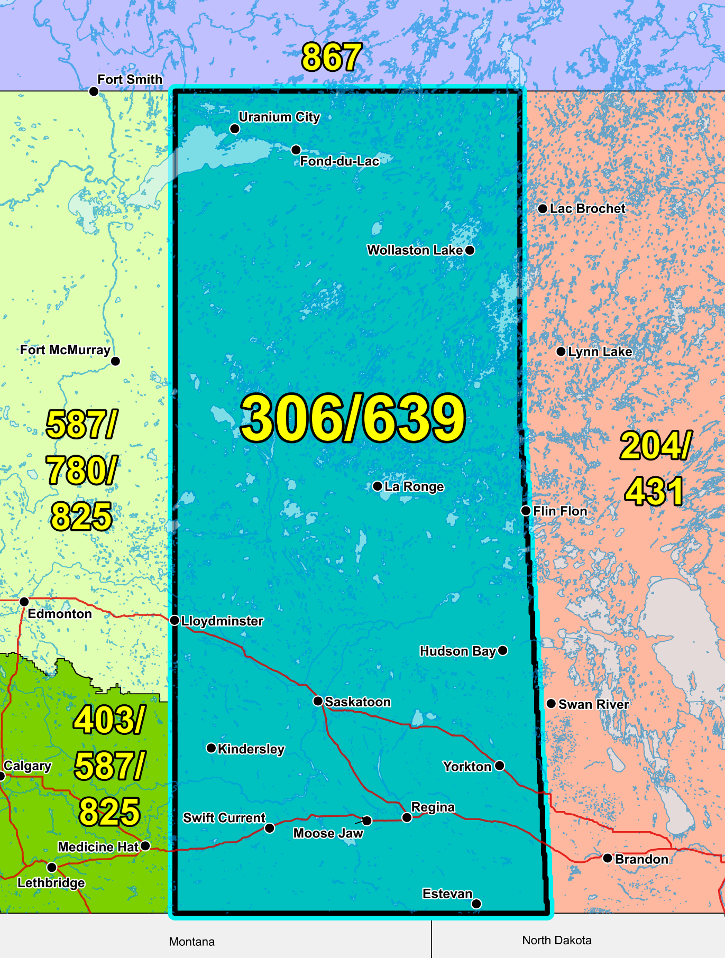

Figure 1 – Overview Map of NPA 306/639

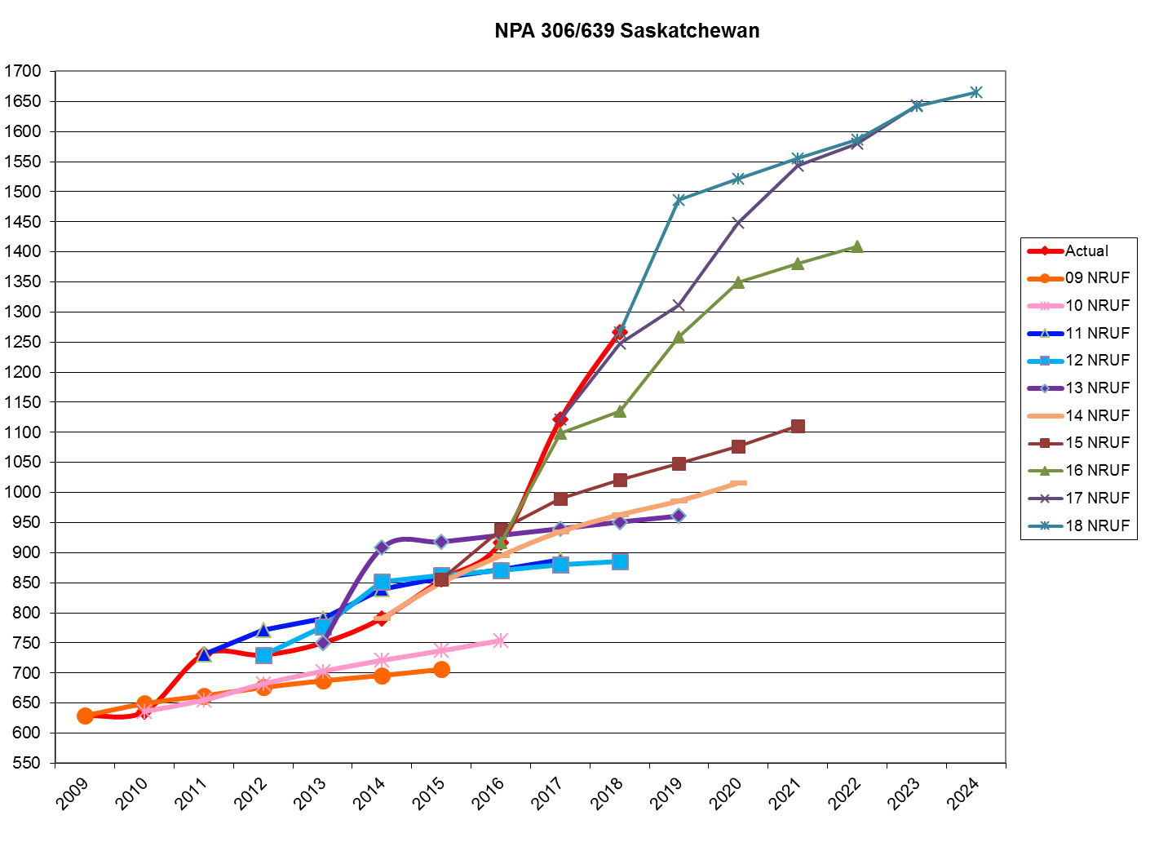

Figure 2 – NPA 306/639 Actual and Forecast CO Code Assignments



Figure 3 – NPA 306/639 CO Code Exhaust: January 2017 G‑NRUF



Figure 4 – NPA 306/639 Admin and LEC+WSP Codes: January 2017 G‑NRUF



Figure 5 – NPA 306/639 CO Code Exhaust: July 2017 R-NRUF



Figure 6 – NPA 306/639 Admin and LEC+WSP Codes: July 2017 R‑NRUF



Figure 7 – NPA 306/639 CO Code Exhaust: January 2018 G‑NRUF



Figure 8 – NPA 306/639 Admin and LEC+WSP Codes: January 2018 G‑NRUF



Figure 9 – NPA 306/639 CO Code Exhaust: May 2018 R-NRUF



Figure 10 – NPA 306/639 Admin and LEC+WSP Codes: May 2018 R‑NRUF

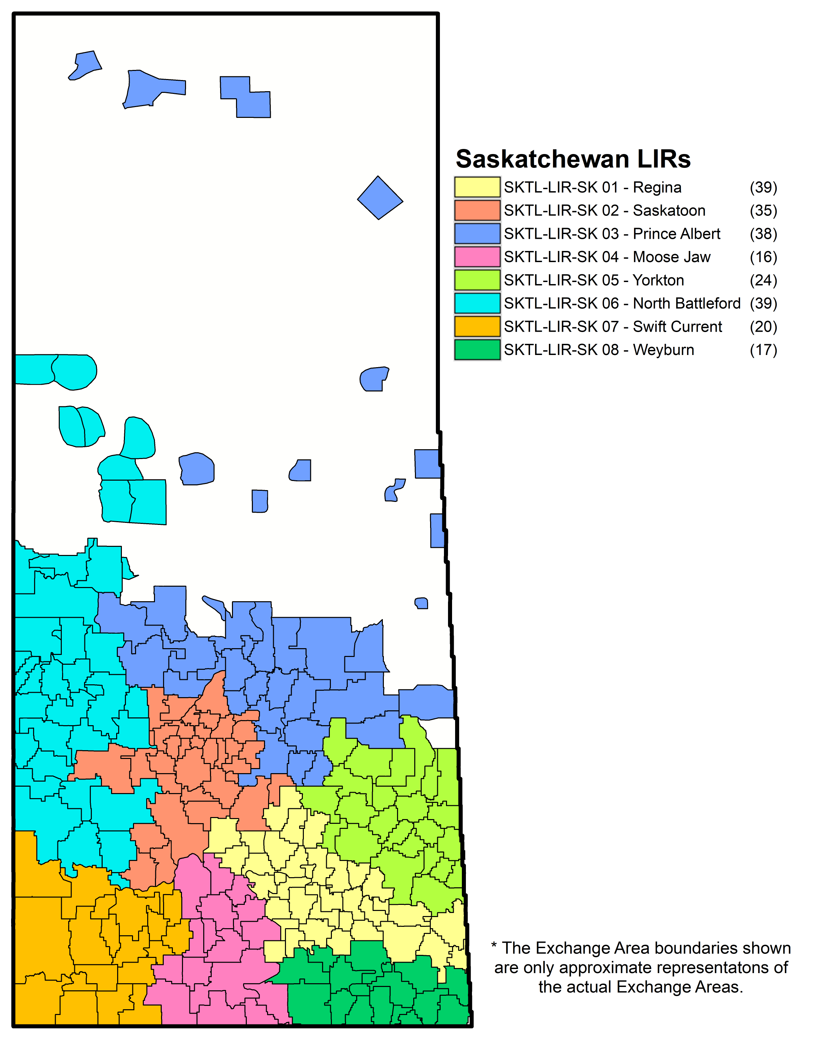

Figure 11 – NPA 306/639 LIRs

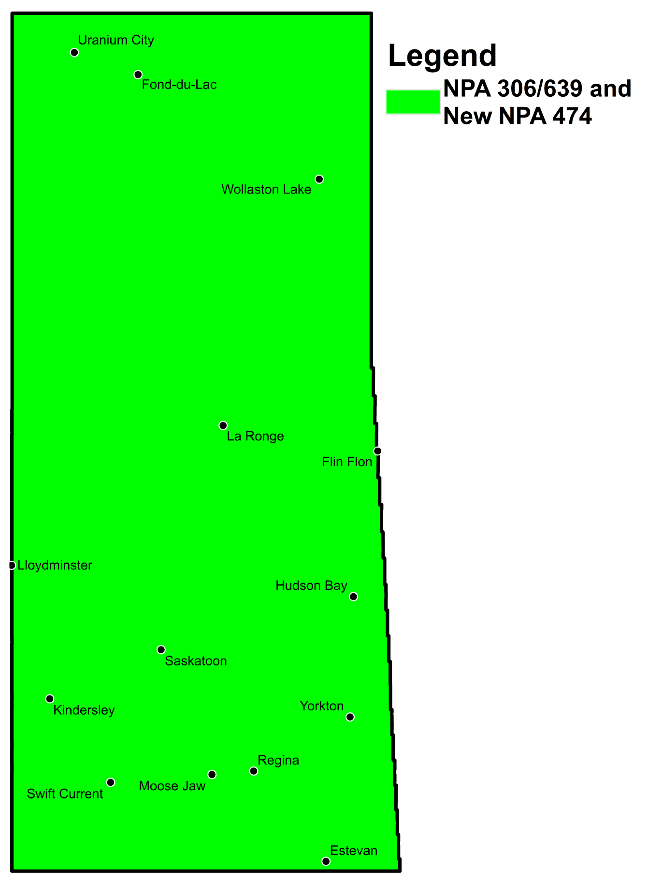

Figure 12 – Distributed Overlay

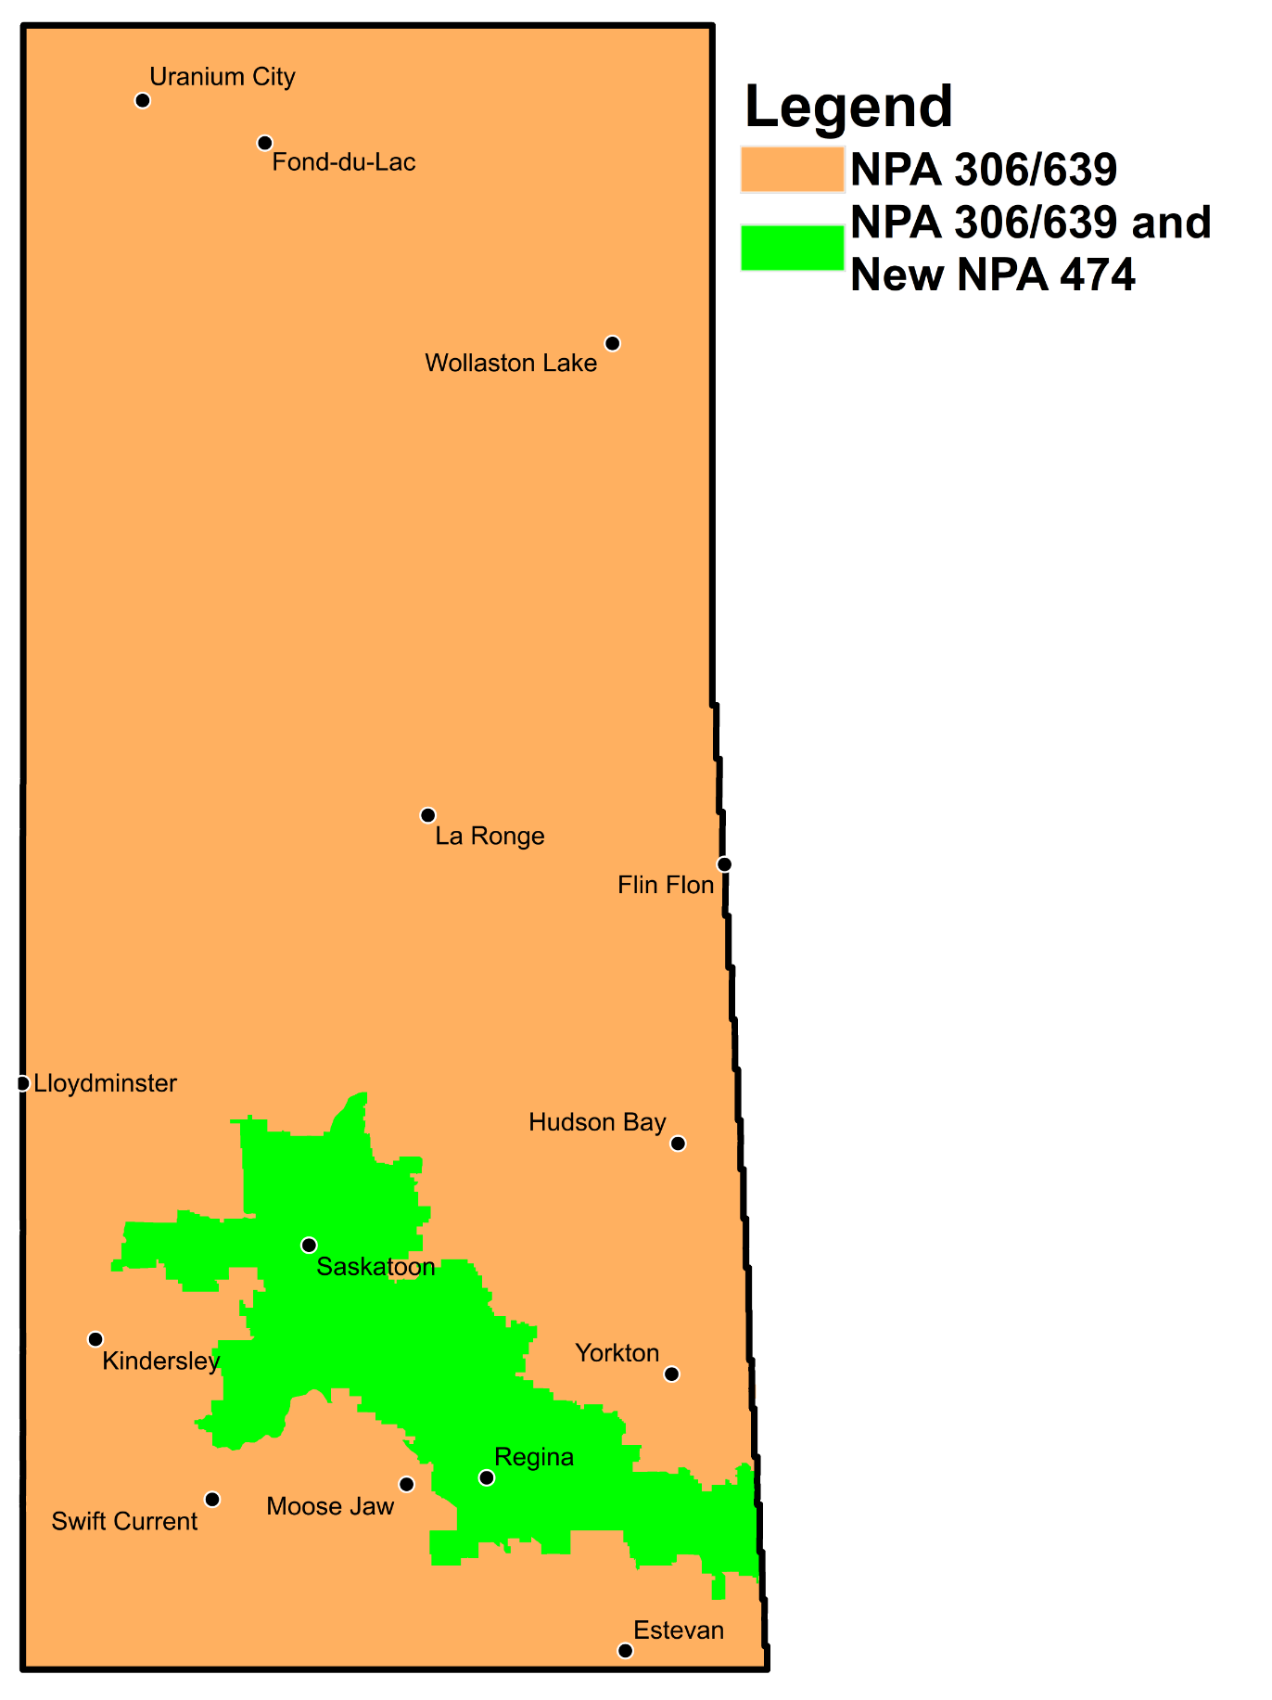

Figure 13 – Concentrated Overlay #1 (Central LIRs)

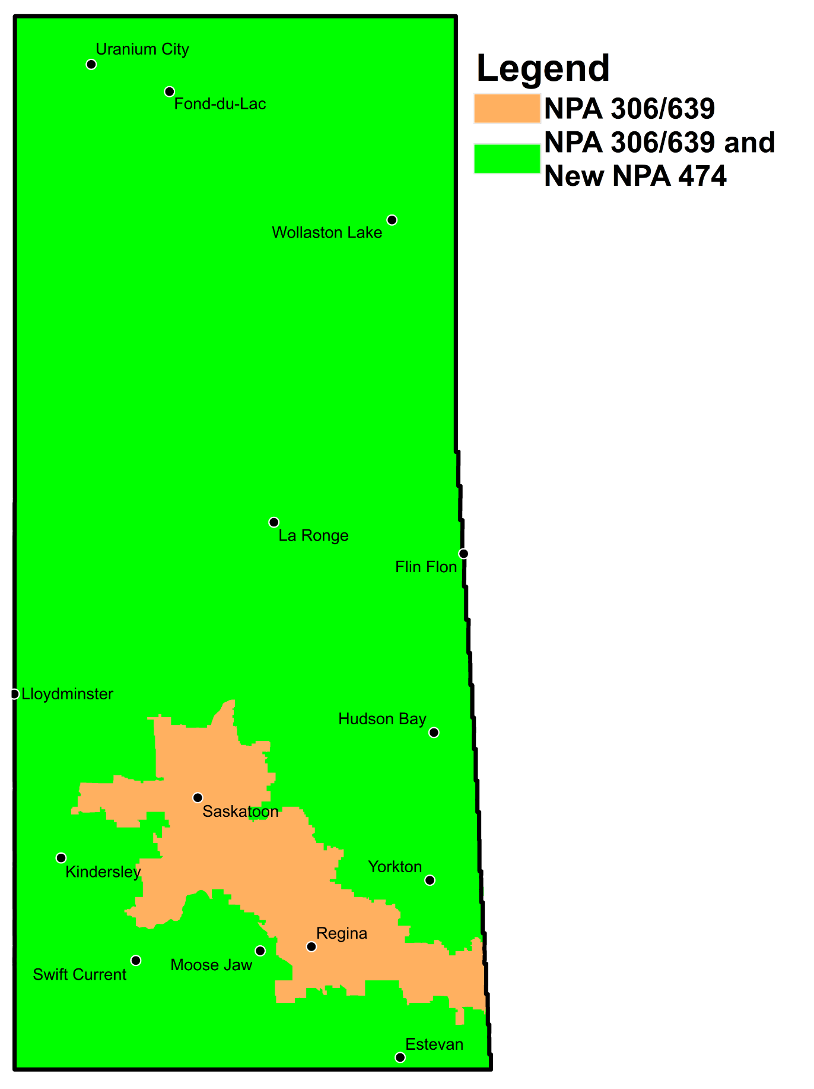

Figure 14 – Concentrated Overlay #2 (non-Central LIRs)

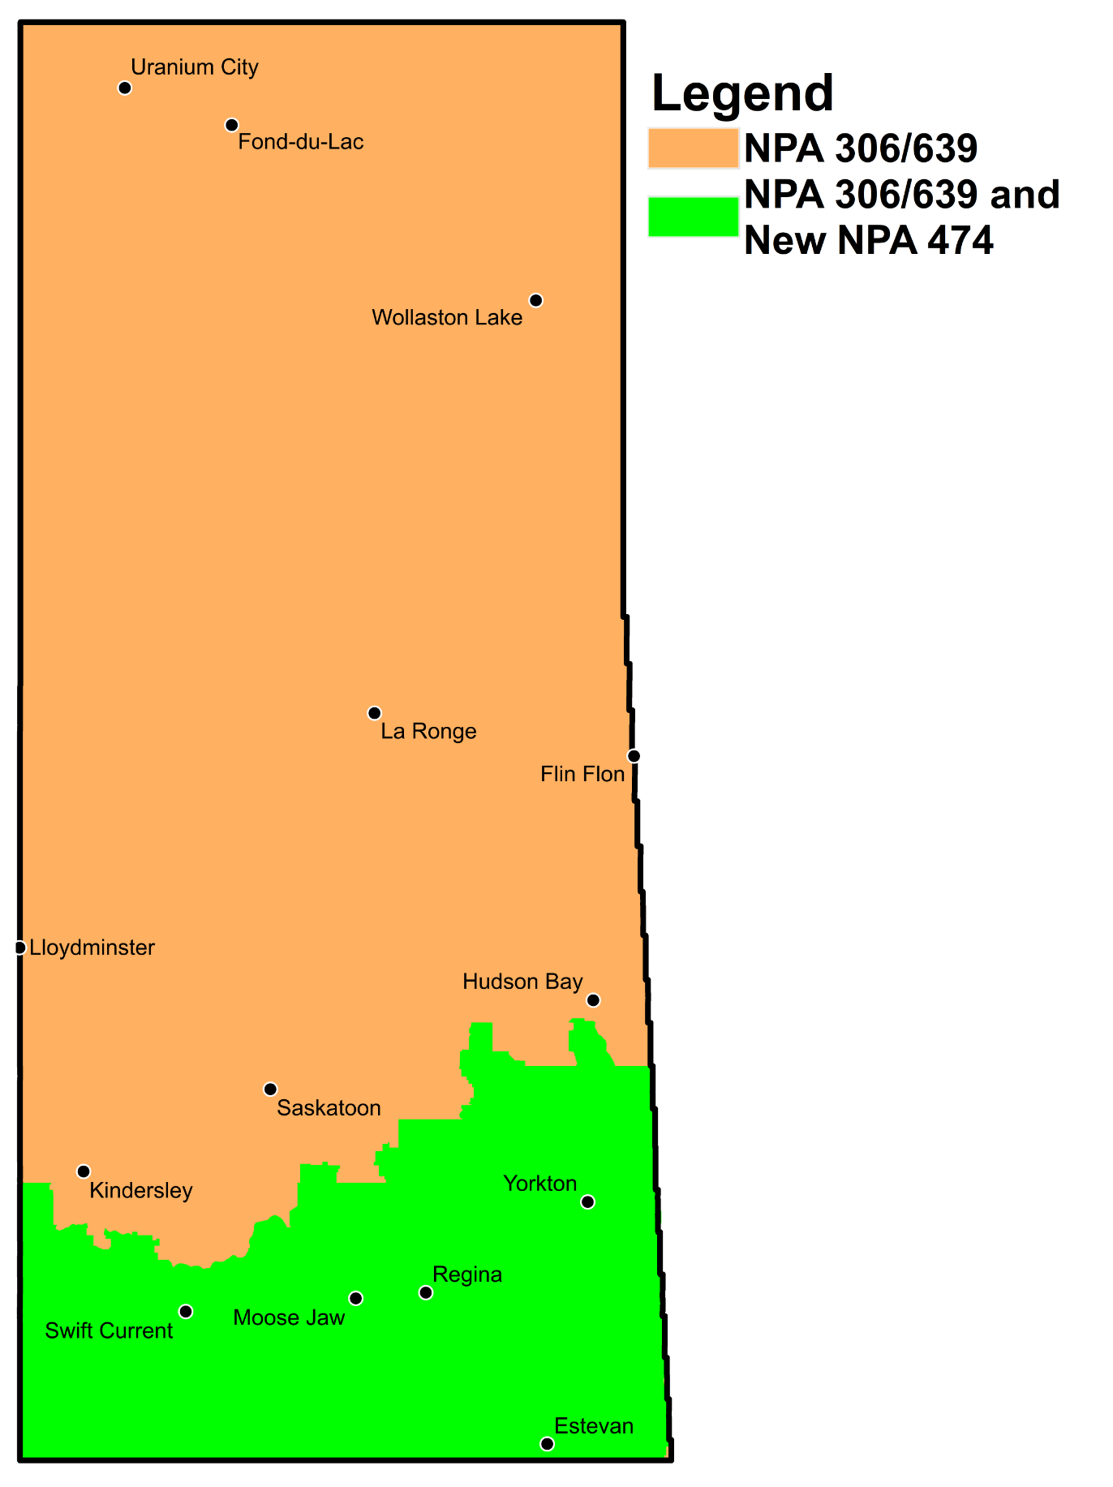

Figure 15 – Concentrated Overlay #3 (Southern LIRs)

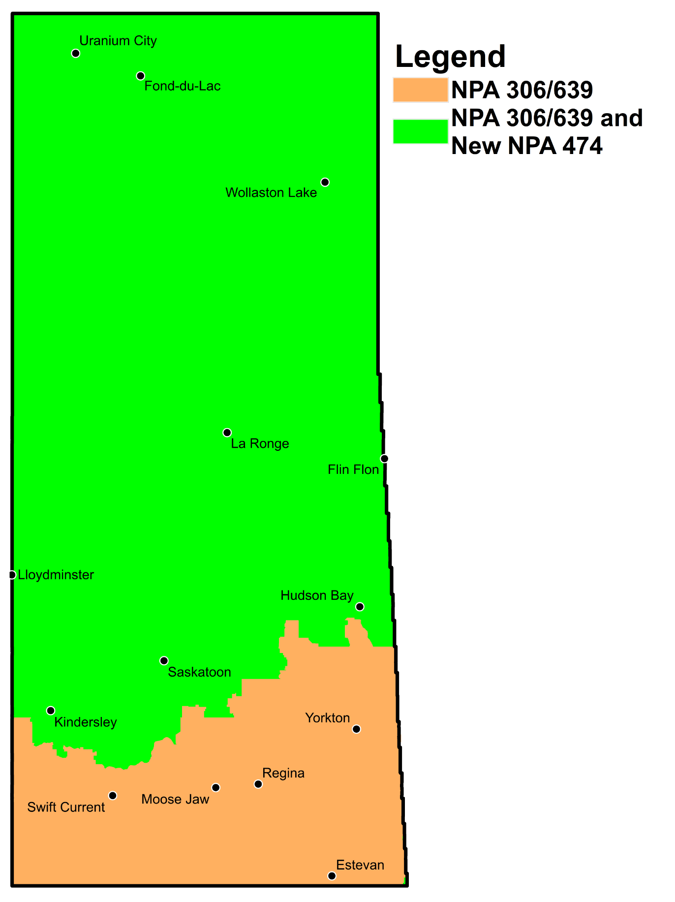

Figure 16 – Concentrated Overlay #4 (Northern LIRs)

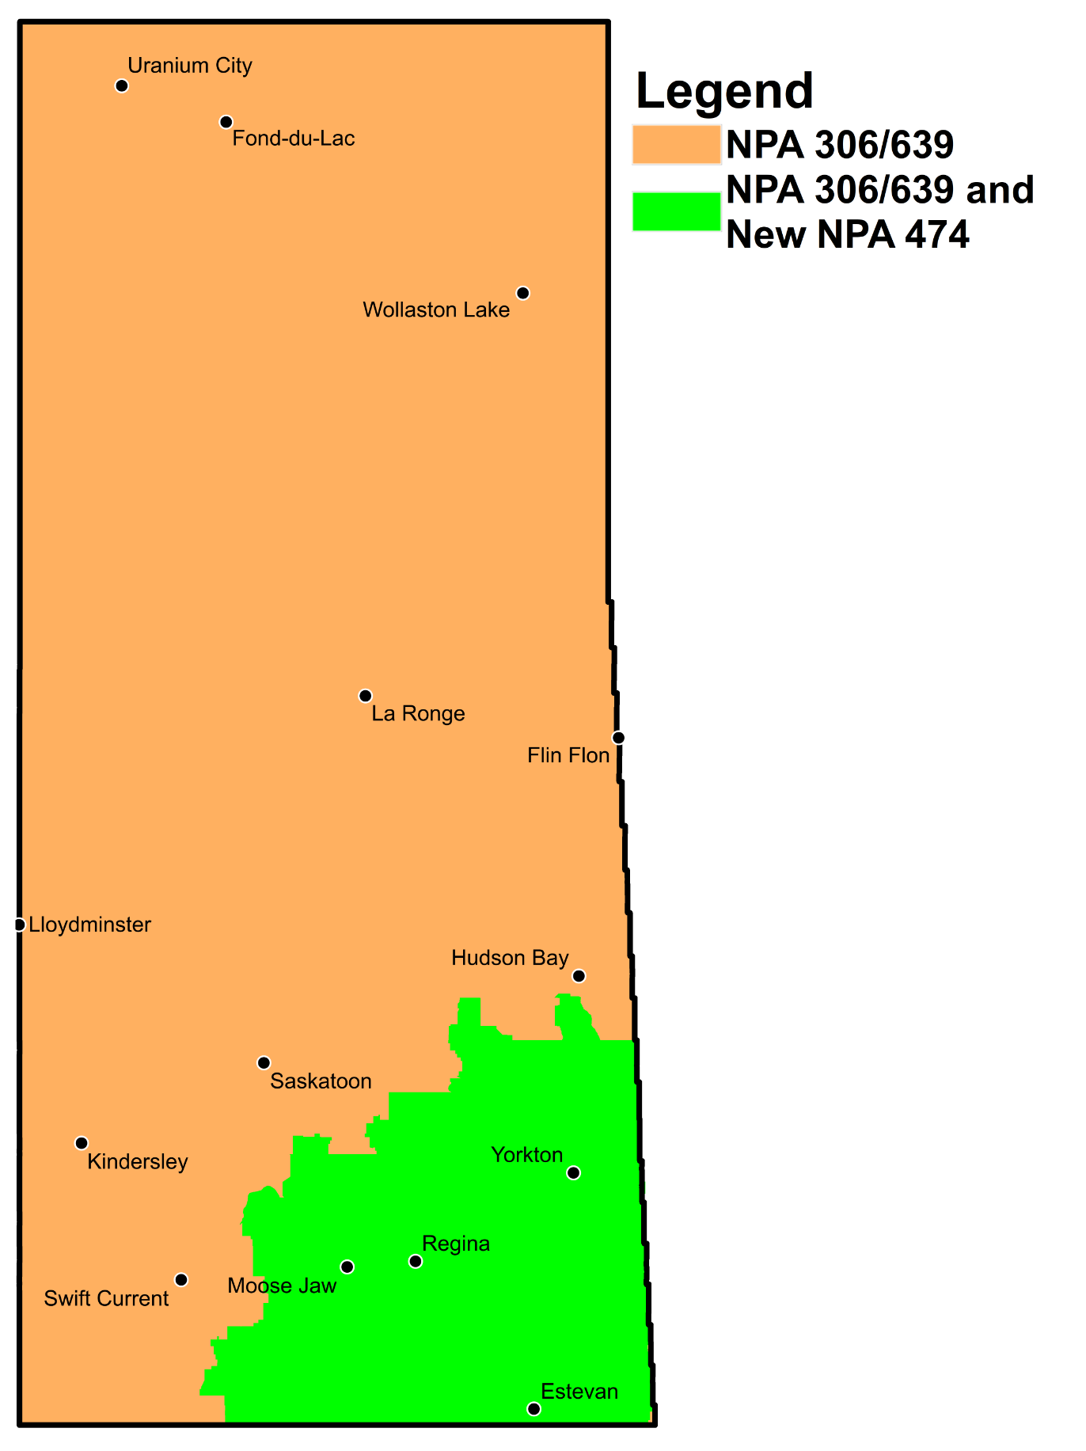

Figure 17 – Concentrated Overlay #5 (South Eastern LIRs)

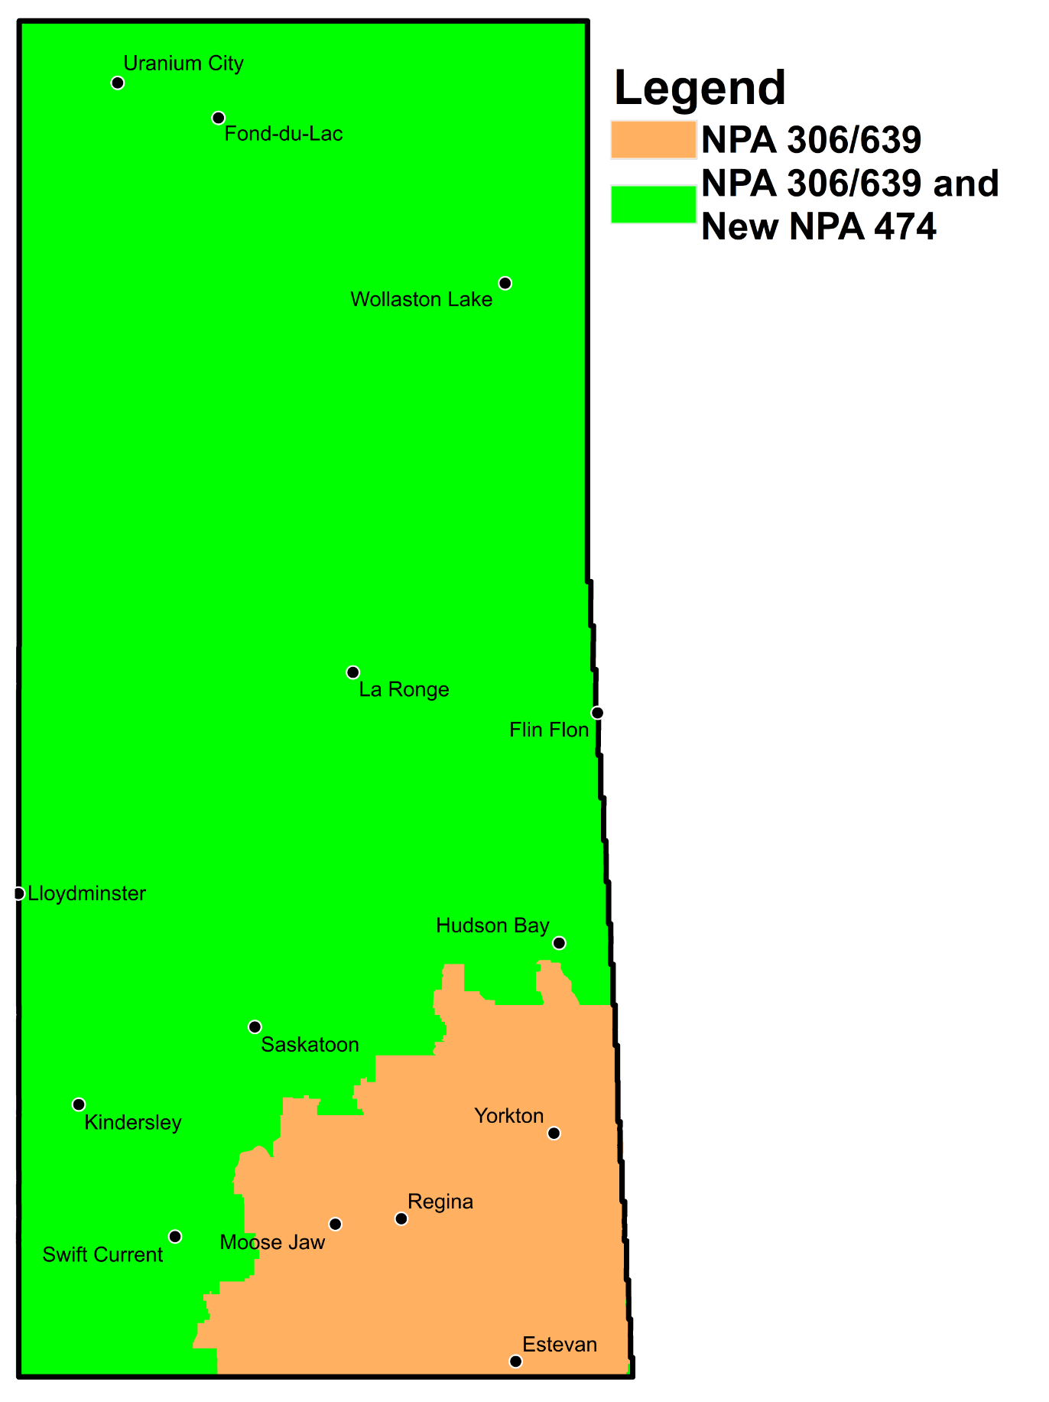

Figure 18 – Concentrated Overlay #6 (North Western LIRs)

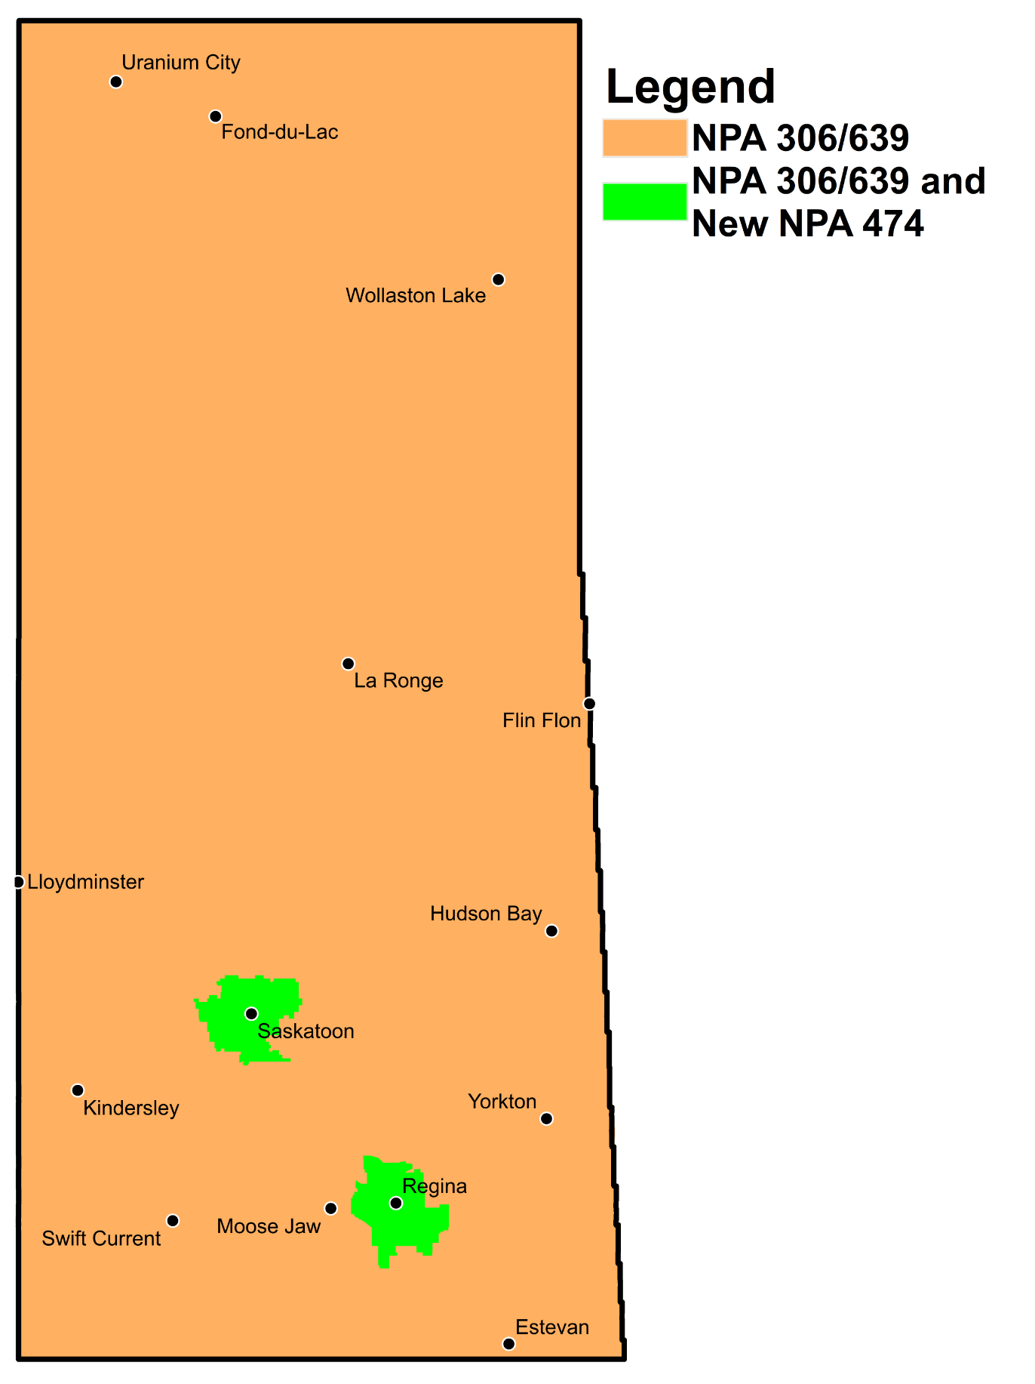

Figure 19 – Concentrated Overlay #7 (Regina and Saskatoon EAS)

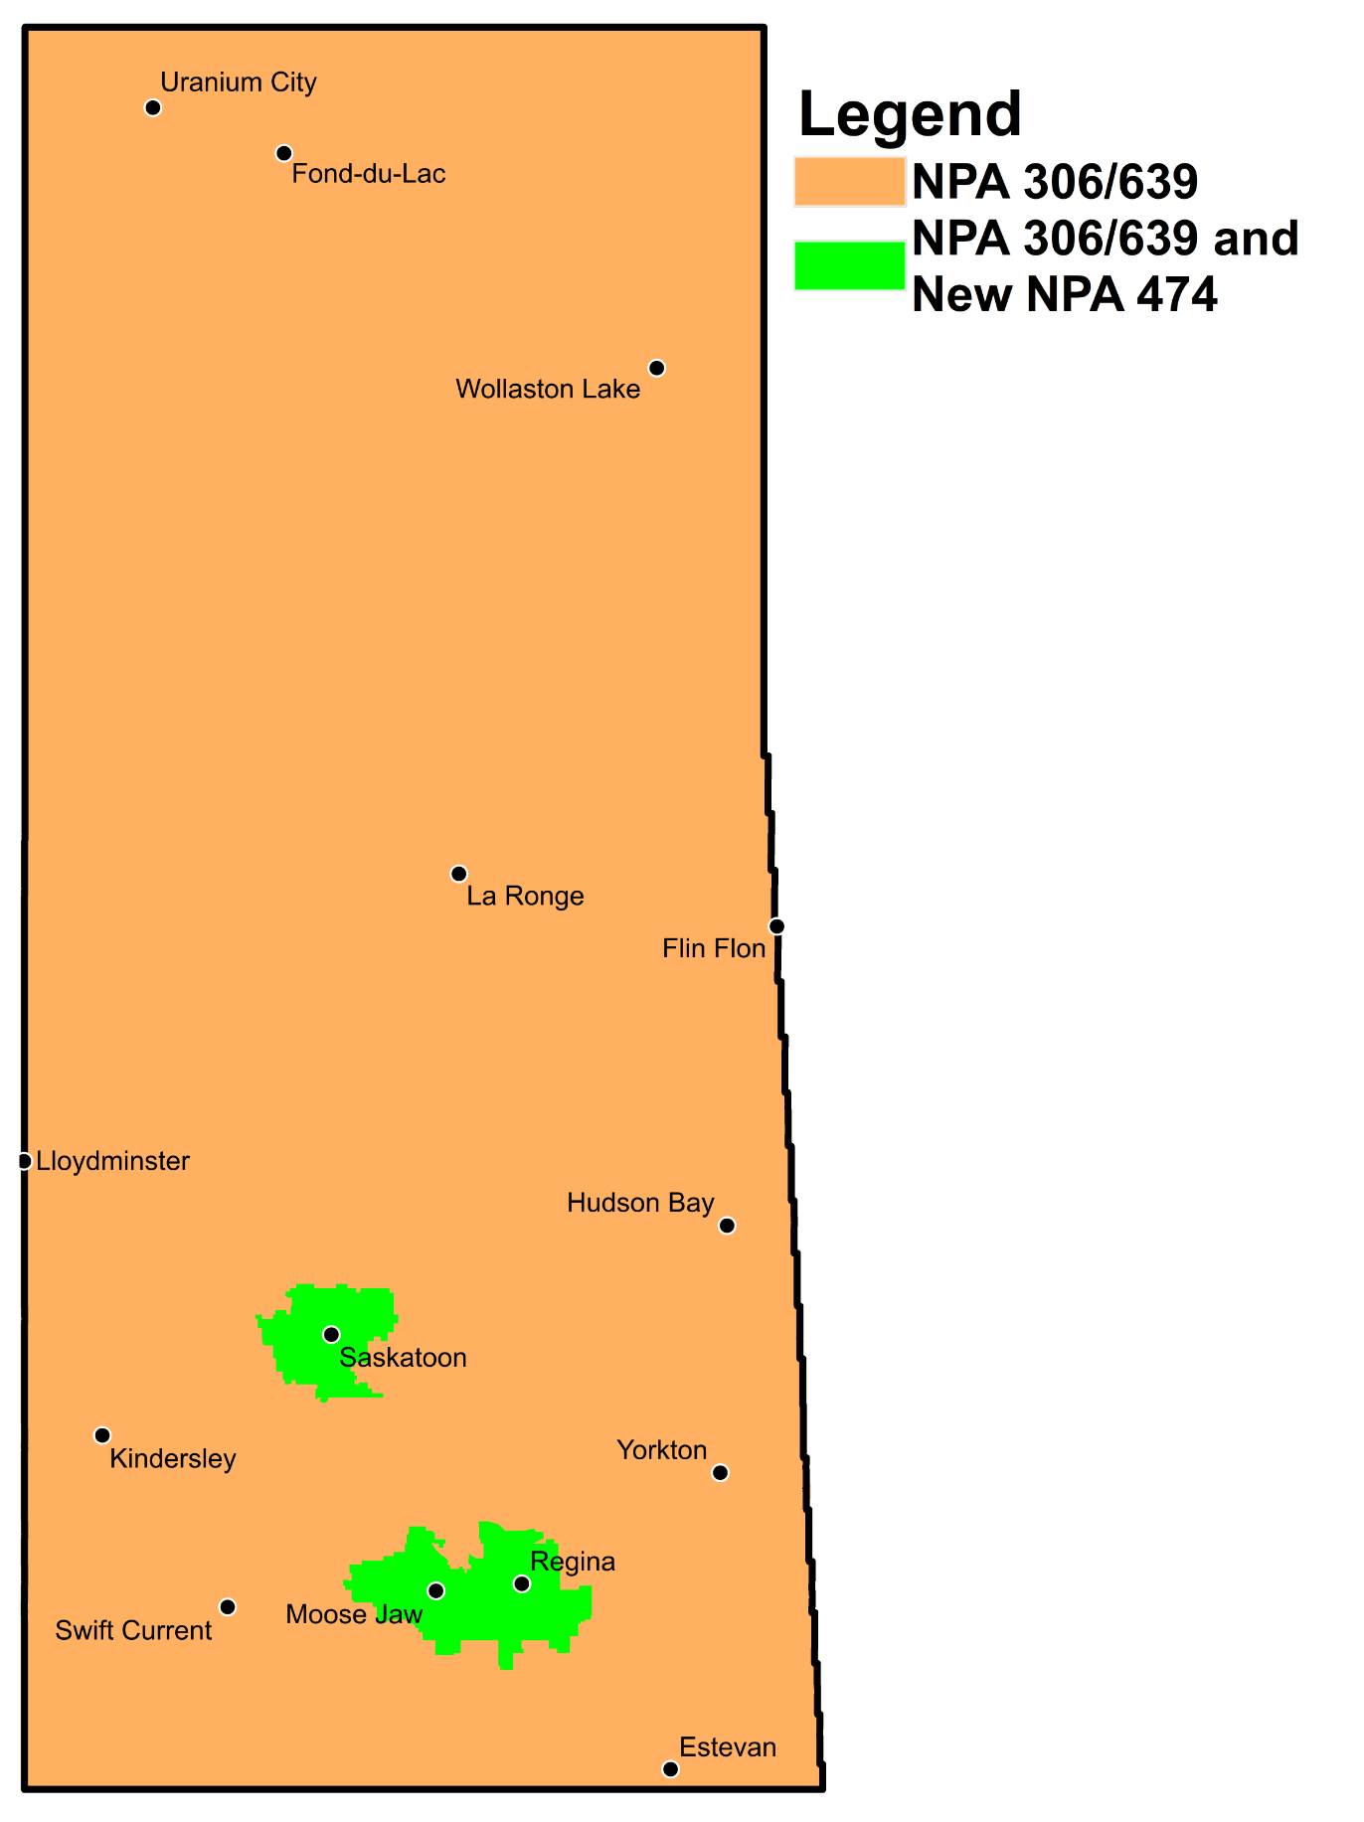

Figure 20 – Concentrated Overlay #8 (Moose Jaw, Regina and Saskatoon EAS)

1. NPA 306/639 SASKATCHEWAN Exchange Areas

Table 1 – NPA 306/639 Exchange Areas for Each Relief Option

| **Exchange** | **Distributed**  **Overlay** | **Contracted Overlays** | | | | | | | | | | | | | | | |
| --- | --- | --- | --- | --- | --- | --- | --- | --- | --- | --- | --- | --- | --- | --- | --- | --- | --- |
| **Option 1** | | **Option 2** | | **Option 3** | | **Option 4** | | **Option 5** | | **Option 6** | | **Option 7** | | **Option 8** | |
| **(Central)** | | **(non-Central)** | | **(Southern)** | | **(Northern)** | | **(South East)** | | **(North West)** | | **Regina/**  **Saskatoon EAS** | | **Moose Jaw/**  **Regina/**  **Saskatoon EAS** | |
| **NPA 306/474/639** | **NPA 306/474/639** | **NPA 306/639** | **NPA 306/474/639** | **NPA 306/639** | **NPA 306/474/639** | **NPA 306/639** | **NPA 306/474/639** | **NPA 306/639** | **NPA 306/474/639** | **NPA 306/639** | **NPA 306/474/639** | **NPA 306/639** | **NPA 306/474/639** | **NPA 306/639** | **NPA 306/474/639** | **NPA 306/639** |
| Aberdeen | ✓ | ✓ |  |  | ✓ |  | ✓ | ✓ |  |  | ✓ | ✓ |  | ✓ |  | ✓ |  |
| Allan | ✓ | ✓ |  |  | ✓ |  | ✓ | ✓ |  |  | ✓ | ✓ |  |  | ✓ |  | ✓ |
| Alvena | ✓ | ✓ |  |  | ✓ |  | ✓ | ✓ |  |  | ✓ | ✓ |  |  | ✓ |  | ✓ |
| Asquith | ✓ | ✓ |  |  | ✓ |  | ✓ | ✓ |  |  | ✓ | ✓ |  | ✓ |  | ✓ |  |
| Assiniboia | ✓ |  | ✓ | ✓ |  | ✓ |  |  | ✓ | ✓ |  |  | ✓ |  | ✓ |  | ✓ |
| Avonlea | ✓ | ✓ |  |  | ✓ | ✓ |  |  | ✓ | ✓ |  |  | ✓ |  | ✓ |  | ✓ |
| Balcarres | ✓ | ✓ |  |  | ✓ | ✓ |  |  | ✓ | ✓ |  |  | ✓ |  | ✓ |  | ✓ |
| Balgonie | ✓ | ✓ |  |  | ✓ | ✓ |  |  | ✓ | ✓ |  |  | ✓ | ✓ |  | ✓ |  |
| Beauval | ✓ |  | ✓ | ✓ |  |  | ✓ | ✓ |  |  | ✓ | ✓ |  |  | ✓ |  | ✓ |
| Beechy | ✓ | ✓ |  |  | ✓ |  | ✓ | ✓ |  |  | ✓ | ✓ |  |  | ✓ |  | ✓ |
| Bengough | ✓ |  | ✓ | ✓ |  | ✓ |  |  | ✓ | ✓ |  |  | ✓ |  | ✓ |  | ✓ |
| Bethune | ✓ | ✓ |  |  | ✓ | ✓ |  |  | ✓ | ✓ |  |  | ✓ |  | ✓ |  | ✓ |
| Bienfait | ✓ |  | ✓ | ✓ |  | ✓ |  |  | ✓ | ✓ |  |  | ✓ |  | ✓ |  | ✓ |
| Big River | ✓ |  | ✓ | ✓ |  |  | ✓ | ✓ |  |  | ✓ | ✓ |  |  | ✓ |  | ✓ |
| Biggar | ✓ | ✓ |  |  | ✓ |  | ✓ | ✓ |  |  | ✓ | ✓ |  |  | ✓ |  | ✓ |
| Birch Hills | ✓ |  | ✓ | ✓ |  |  | ✓ | ✓ |  |  | ✓ | ✓ |  |  | ✓ |  | ✓ |
| Blaine Lake | ✓ | ✓ |  |  | ✓ |  | ✓ | ✓ |  |  | ✓ | ✓ |  |  | ✓ |  | ✓ |
| Borden | ✓ | ✓ |  |  | ✓ |  | ✓ | ✓ |  |  | ✓ | ✓ |  |  | ✓ |  | ✓ |
| Briercrest | ✓ |  | ✓ | ✓ |  | ✓ |  |  | ✓ | ✓ |  |  | ✓ |  | ✓ | ✓ |  |
| Broadview | ✓ | ✓ |  |  | ✓ | ✓ |  |  | ✓ | ✓ |  |  | ✓ |  | ✓ |  | ✓ |
| Bruno | ✓ | ✓ |  |  | ✓ |  | ✓ | ✓ |  |  | ✓ | ✓ |  |  | ✓ |  | ✓ |
| Buffalo Narrows | ✓ |  | ✓ | ✓ |  |  | ✓ | ✓ |  |  | ✓ | ✓ |  |  | ✓ |  | ✓ |
| Cabri | ✓ |  | ✓ | ✓ |  | ✓ |  |  | ✓ |  | ✓ | ✓ |  |  | ✓ |  | ✓ |
| Calder | ✓ |  | ✓ | ✓ |  | ✓ |  |  | ✓ | ✓ |  |  | ✓ |  | ✓ |  | ✓ |
| Canoe Narrows | ✓ |  | ✓ | ✓ |  |  | ✓ | ✓ |  |  | ✓ | ✓ |  |  | ✓ |  | ✓ |
| Canora | ✓ |  | ✓ | ✓ |  | ✓ |  |  | ✓ | ✓ |  |  | ✓ |  | ✓ |  | ✓ |
| Canwood | ✓ |  | ✓ | ✓ |  |  | ✓ | ✓ |  |  | ✓ | ✓ |  |  | ✓ |  | ✓ |
| Carlyle | ✓ |  | ✓ | ✓ |  | ✓ |  |  | ✓ | ✓ |  |  | ✓ |  | ✓ |  | ✓ |
| Carnduff | ✓ |  | ✓ | ✓ |  | ✓ |  |  | ✓ | ✓ |  |  | ✓ |  | ✓ |  | ✓ |
| Carrot River | ✓ |  | ✓ | ✓ |  |  | ✓ | ✓ |  |  | ✓ | ✓ |  |  | ✓ |  | ✓ |
| Central Butte | ✓ |  | ✓ | ✓ |  | ✓ |  |  | ✓ | ✓ |  |  | ✓ |  | ✓ |  | ✓ |
| Christopher Lake | ✓ |  | ✓ | ✓ |  |  | ✓ | ✓ |  |  | ✓ | ✓ |  |  | ✓ |  | ✓ |
| Churchbridge | ✓ |  | ✓ | ✓ |  | ✓ |  |  | ✓ | ✓ |  |  | ✓ |  | ✓ |  | ✓ |
| Climax | ✓ |  | ✓ | ✓ |  | ✓ |  |  | ✓ |  | ✓ | ✓ |  |  | ✓ |  | ✓ |
| Coderre | ✓ |  | ✓ | ✓ |  | ✓ |  |  | ✓ | ✓ |  |  | ✓ |  | ✓ |  | ✓ |
| Colonsay | ✓ | ✓ |  |  | ✓ |  | ✓ | ✓ |  |  | ✓ | ✓ |  |  | ✓ |  | ✓ |
| Consul | ✓ |  | ✓ | ✓ |  | ✓ |  |  | ✓ |  | ✓ | ✓ |  |  | ✓ |  | ✓ |
| Coronach | ✓ |  | ✓ | ✓ |  | ✓ |  |  | ✓ | ✓ |  |  | ✓ |  | ✓ |  | ✓ |
| Craik | ✓ | ✓ |  |  | ✓ | ✓ |  |  | ✓ | ✓ |  |  | ✓ |  | ✓ |  | ✓ |
| Creighton | ✓ |  | ✓ | ✓ |  |  | ✓ | ✓ |  |  | ✓ | ✓ |  |  | ✓ |  | ✓ |
| Cudworth | ✓ | ✓ |  |  | ✓ |  | ✓ | ✓ |  |  | ✓ | ✓ |  |  | ✓ |  | ✓ |
| Cumberland House | ✓ |  | ✓ | ✓ |  |  | ✓ | ✓ |  |  | ✓ | ✓ |  |  | ✓ |  | ✓ |
| Cupar | ✓ | ✓ |  |  | ✓ | ✓ |  |  | ✓ | ✓ |  |  | ✓ |  | ✓ |  | ✓ |
| Cut Knife | ✓ |  | ✓ | ✓ |  |  | ✓ | ✓ |  |  | ✓ | ✓ |  |  | ✓ |  | ✓ |
| Dalmeny | ✓ | ✓ |  |  | ✓ |  | ✓ | ✓ |  |  | ✓ | ✓ |  | ✓ |  | ✓ |  |
| Davidson | ✓ | ✓ |  |  | ✓ | ✓ |  |  | ✓ | ✓ |  |  | ✓ |  | ✓ |  | ✓ |
| Delisle | ✓ | ✓ |  |  | ✓ |  | ✓ | ✓ |  |  | ✓ | ✓ |  | ✓ |  | ✓ |  |
| Dillon | ✓ |  | ✓ | ✓ |  |  | ✓ | ✓ |  |  | ✓ | ✓ |  |  | ✓ |  | ✓ |
| Dinsmore | ✓ | ✓ |  |  | ✓ |  | ✓ | ✓ |  |  | ✓ | ✓ |  |  | ✓ |  | ✓ |
| Duck Lake | ✓ | ✓ |  |  | ✓ |  | ✓ | ✓ |  |  | ✓ | ✓ |  |  | ✓ |  | ✓ |
| Dundurn | ✓ | ✓ |  |  | ✓ |  | ✓ | ✓ |  |  | ✓ | ✓ |  | ✓ |  | ✓ |  |
| Earl Grey | ✓ | ✓ |  |  | ✓ | ✓ |  |  | ✓ | ✓ |  |  | ✓ |  | ✓ |  | ✓ |
| Eastend | ✓ |  | ✓ | ✓ |  | ✓ |  |  | ✓ |  | ✓ | ✓ |  |  | ✓ |  | ✓ |
| Edam | ✓ |  | ✓ | ✓ |  |  | ✓ | ✓ |  |  | ✓ | ✓ |  |  | ✓ |  | ✓ |
| Elrose | ✓ |  | ✓ | ✓ |  |  | ✓ | ✓ |  |  | ✓ | ✓ |  |  | ✓ |  | ✓ |
| Esterhazy | ✓ |  | ✓ | ✓ |  | ✓ |  |  | ✓ | ✓ |  |  | ✓ |  | ✓ |  | ✓ |
| Estevan | ✓ |  | ✓ | ✓ |  | ✓ |  |  | ✓ | ✓ |  |  | ✓ |  | ✓ |  | ✓ |
| Eston | ✓ |  | ✓ | ✓ |  |  | ✓ | ✓ |  |  | ✓ | ✓ |  |  | ✓ |  | ✓ |
| Eyebrow | ✓ |  | ✓ | ✓ |  | ✓ |  |  | ✓ | ✓ |  |  | ✓ |  | ✓ |  | ✓ |
| Fillmore | ✓ |  | ✓ | ✓ |  | ✓ |  |  | ✓ | ✓ |  |  | ✓ |  | ✓ |  | ✓ |
| Foam Lake | ✓ |  | ✓ | ✓ |  | ✓ |  |  | ✓ | ✓ |  |  | ✓ |  | ✓ |  | ✓ |
| Fond Du Lac | ✓ |  | ✓ | ✓ |  |  | ✓ | ✓ |  |  | ✓ | ✓ |  |  | ✓ |  | ✓ |
| Fort Qu'Appelle | ✓ | ✓ |  |  | ✓ | ✓ |  |  | ✓ | ✓ |  |  | ✓ |  | ✓ |  | ✓ |
| Francis | ✓ | ✓ |  |  | ✓ | ✓ |  |  | ✓ | ✓ |  |  | ✓ |  | ✓ |  | ✓ |
| Frontier | ✓ |  | ✓ | ✓ |  | ✓ |  |  | ✓ |  | ✓ | ✓ |  |  | ✓ |  | ✓ |
| Glaslyn | ✓ |  | ✓ | ✓ |  |  | ✓ | ✓ |  |  | ✓ | ✓ |  |  | ✓ |  | ✓ |
| Goodsoil | ✓ |  | ✓ | ✓ |  |  | ✓ | ✓ |  |  | ✓ | ✓ |  |  | ✓ |  | ✓ |
| Gravelbourg | ✓ |  | ✓ | ✓ |  | ✓ |  |  | ✓ | ✓ |  |  | ✓ |  | ✓ |  | ✓ |
| Green Lake | ✓ |  | ✓ | ✓ |  |  | ✓ | ✓ |  |  | ✓ | ✓ |  |  | ✓ |  | ✓ |
| Grenfell | ✓ | ✓ |  |  | ✓ | ✓ |  |  | ✓ | ✓ |  |  | ✓ |  | ✓ |  | ✓ |
| Gull Lake | ✓ |  | ✓ | ✓ |  | ✓ |  |  | ✓ |  | ✓ | ✓ |  |  | ✓ |  | ✓ |
| Hafford | ✓ | ✓ |  |  | ✓ |  | ✓ | ✓ |  |  | ✓ | ✓ |  |  | ✓ |  | ✓ |
| Hague | ✓ | ✓ |  |  | ✓ |  | ✓ | ✓ |  |  | ✓ | ✓ |  |  | ✓ |  | ✓ |
| Hanley | ✓ | ✓ |  |  | ✓ |  | ✓ | ✓ |  |  | ✓ | ✓ |  |  | ✓ |  | ✓ |
| Hepburn | ✓ | ✓ |  |  | ✓ |  | ✓ | ✓ |  |  | ✓ | ✓ |  |  | ✓ |  | ✓ |
| Herbert | ✓ |  | ✓ | ✓ |  | ✓ |  |  | ✓ |  | ✓ | ✓ |  |  | ✓ |  | ✓ |
| Hodgeville | ✓ |  | ✓ | ✓ |  | ✓ |  |  | ✓ |  | ✓ | ✓ |  |  | ✓ |  | ✓ |
| Holdfast | ✓ | ✓ |  |  | ✓ | ✓ |  |  | ✓ | ✓ |  |  | ✓ |  | ✓ |  | ✓ |
| Hudson Bay | ✓ |  | ✓ | ✓ |  |  | ✓ | ✓ |  |  | ✓ | ✓ |  |  | ✓ |  | ✓ |
| Humboldt | ✓ |  | ✓ | ✓ |  |  | ✓ | ✓ |  |  | ✓ | ✓ |  |  | ✓ |  | ✓ |
| Ile-A-La-Crosse | ✓ |  | ✓ | ✓ |  |  | ✓ | ✓ |  |  | ✓ | ✓ |  |  | ✓ |  | ✓ |
| Imperial | ✓ | ✓ |  |  | ✓ | ✓ |  |  | ✓ | ✓ |  |  | ✓ |  | ✓ |  | ✓ |
| Indian Head | ✓ | ✓ |  |  | ✓ | ✓ |  |  | ✓ | ✓ |  |  | ✓ |  | ✓ |  | ✓ |
| Invermay | ✓ |  | ✓ | ✓ |  | ✓ |  |  | ✓ | ✓ |  |  | ✓ |  | ✓ |  | ✓ |
| Ituna | ✓ |  | ✓ | ✓ |  | ✓ |  |  | ✓ | ✓ |  |  | ✓ |  | ✓ |  | ✓ |
| Kamsack | ✓ |  | ✓ | ✓ |  | ✓ |  |  | ✓ | ✓ |  |  | ✓ |  | ✓ |  | ✓ |
| Kelvington | ✓ |  | ✓ | ✓ |  | ✓ |  |  | ✓ | ✓ |  |  | ✓ |  | ✓ |  | ✓ |
| Kerrobert | ✓ |  | ✓ | ✓ |  |  | ✓ | ✓ |  |  | ✓ | ✓ |  |  | ✓ |  | ✓ |
| Kincaid | ✓ |  | ✓ | ✓ |  | ✓ |  |  | ✓ | ✓ |  |  | ✓ |  | ✓ |  | ✓ |
| Kindersley | ✓ |  | ✓ | ✓ |  |  | ✓ | ✓ |  |  | ✓ | ✓ |  |  | ✓ |  | ✓ |
| Kinistino | ✓ |  | ✓ | ✓ |  |  | ✓ | ✓ |  |  | ✓ | ✓ |  |  | ✓ |  | ✓ |
| Kipling | ✓ | ✓ |  |  | ✓ | ✓ |  |  | ✓ | ✓ |  |  | ✓ |  | ✓ |  | ✓ |
| Kyle | ✓ |  | ✓ | ✓ |  |  | ✓ | ✓ |  |  | ✓ | ✓ |  |  | ✓ |  | ✓ |
| La Loche | ✓ |  | ✓ | ✓ |  |  | ✓ | ✓ |  |  | ✓ | ✓ |  |  | ✓ |  | ✓ |
| La Ronge | ✓ |  | ✓ | ✓ |  |  | ✓ | ✓ |  |  | ✓ | ✓ |  |  | ✓ |  | ✓ |
| Lafleche | ✓ |  | ✓ | ✓ |  | ✓ |  |  | ✓ | ✓ |  |  | ✓ |  | ✓ |  | ✓ |
| Lampman | ✓ |  | ✓ | ✓ |  | ✓ |  |  | ✓ | ✓ |  |  | ✓ |  | ✓ |  | ✓ |
| Langenburg | ✓ |  | ✓ | ✓ |  | ✓ |  |  | ✓ | ✓ |  |  | ✓ |  | ✓ |  | ✓ |
| Langham | ✓ | ✓ |  |  | ✓ |  | ✓ | ✓ |  |  | ✓ | ✓ |  | ✓ |  | ✓ |  |
| Lanigan | ✓ | ✓ |  |  | ✓ |  | ✓ | ✓ |  |  | ✓ | ✓ |  |  | ✓ |  | ✓ |
| Lashburn | ✓ |  | ✓ | ✓ |  |  | ✓ | ✓ |  |  | ✓ | ✓ |  |  | ✓ |  | ✓ |
| Leader | ✓ |  | ✓ | ✓ |  | ✓ |  |  | ✓ |  | ✓ | ✓ |  |  | ✓ |  | ✓ |
| Leask | ✓ |  | ✓ | ✓ |  |  | ✓ | ✓ |  |  | ✓ | ✓ |  |  | ✓ |  | ✓ |
| Lemberg | ✓ | ✓ |  |  | ✓ | ✓ |  |  | ✓ | ✓ |  |  | ✓ |  | ✓ |  | ✓ |
| Leoville | ✓ |  | ✓ | ✓ |  |  | ✓ | ✓ |  |  | ✓ | ✓ |  |  | ✓ |  | ✓ |
| Lestock | ✓ |  | ✓ | ✓ |  | ✓ |  |  | ✓ | ✓ |  |  | ✓ |  | ✓ |  | ✓ |
| Lloydminster | ✓ |  | ✓ | ✓ |  |  | ✓ | ✓ |  |  | ✓ | ✓ |  |  | ✓ |  | ✓ |
| Loon Lake | ✓ |  | ✓ | ✓ |  |  | ✓ | ✓ |  |  | ✓ | ✓ |  |  | ✓ |  | ✓ |
| Lucky Lake | ✓ | ✓ |  |  | ✓ |  | ✓ | ✓ |  |  | ✓ | ✓ |  |  | ✓ |  | ✓ |
| Lumsden | ✓ | ✓ |  |  | ✓ | ✓ |  |  | ✓ | ✓ |  |  | ✓ | ✓ |  | ✓ |  |
| Luseland | ✓ |  | ✓ | ✓ |  |  | ✓ | ✓ |  |  | ✓ | ✓ |  |  | ✓ |  | ✓ |
| Macklin | ✓ |  | ✓ | ✓ |  |  | ✓ | ✓ |  |  | ✓ | ✓ |  |  | ✓ |  | ✓ |
| Maidstone | ✓ |  | ✓ | ✓ |  |  | ✓ | ✓ |  |  | ✓ | ✓ |  |  | ✓ |  | ✓ |
| Mankota | ✓ |  | ✓ | ✓ |  | ✓ |  |  | ✓ | ✓ |  |  | ✓ |  | ✓ |  | ✓ |
| Maple Creek | ✓ |  | ✓ | ✓ |  | ✓ |  |  | ✓ |  | ✓ | ✓ |  |  | ✓ |  | ✓ |
| Marquis | ✓ |  | ✓ | ✓ |  | ✓ |  |  | ✓ | ✓ |  |  | ✓ |  | ✓ | ✓ |  |
| Marshall | ✓ |  | ✓ | ✓ |  |  | ✓ | ✓ |  |  | ✓ | ✓ |  |  | ✓ |  | ✓ |
| Maryfield | ✓ | ✓ |  |  | ✓ | ✓ |  |  | ✓ | ✓ |  |  | ✓ |  | ✓ |  | ✓ |
| Maymont | ✓ |  | ✓ | ✓ |  |  | ✓ | ✓ |  |  | ✓ | ✓ |  |  | ✓ |  | ✓ |
| Meacham | ✓ | ✓ |  |  | ✓ |  | ✓ | ✓ |  |  | ✓ | ✓ |  |  | ✓ |  | ✓ |
| Meadow Lake | ✓ |  | ✓ | ✓ |  |  | ✓ | ✓ |  |  | ✓ | ✓ |  |  | ✓ |  | ✓ |
| Meath Park | ✓ |  | ✓ | ✓ |  |  | ✓ | ✓ |  |  | ✓ | ✓ |  |  | ✓ |  | ✓ |
| Melfort | ✓ |  | ✓ | ✓ |  |  | ✓ | ✓ |  |  | ✓ | ✓ |  |  | ✓ |  | ✓ |
| Melville | ✓ |  | ✓ | ✓ |  | ✓ |  |  | ✓ | ✓ |  |  | ✓ |  | ✓ |  | ✓ |
| Meota | ✓ |  | ✓ | ✓ |  |  | ✓ | ✓ |  |  | ✓ | ✓ |  |  | ✓ |  | ✓ |
| Midale | ✓ |  | ✓ | ✓ |  | ✓ |  |  | ✓ | ✓ |  |  | ✓ |  | ✓ |  | ✓ |
| Milestone | ✓ | ✓ |  |  | ✓ | ✓ |  |  | ✓ | ✓ |  |  | ✓ |  | ✓ |  | ✓ |
| Montmartre | ✓ | ✓ |  |  | ✓ | ✓ |  |  | ✓ | ✓ |  |  | ✓ |  | ✓ |  | ✓ |
| Moose Jaw | ✓ |  | ✓ | ✓ |  | ✓ |  |  | ✓ | ✓ |  |  | ✓ |  | ✓ | ✓ |  |
| Moosomin | ✓ | ✓ |  |  | ✓ | ✓ |  |  | ✓ | ✓ |  |  | ✓ |  | ✓ |  | ✓ |
| Morse | ✓ |  | ✓ | ✓ |  | ✓ |  |  | ✓ |  | ✓ | ✓ |  |  | ✓ |  | ✓ |
| Mortlach | ✓ |  | ✓ | ✓ |  | ✓ |  |  | ✓ | ✓ |  |  | ✓ |  | ✓ | ✓ |  |
| Mossbank | ✓ |  | ✓ | ✓ |  | ✓ |  |  | ✓ | ✓ |  |  | ✓ |  | ✓ |  | ✓ |
| Naicam | ✓ |  | ✓ | ✓ |  |  | ✓ | ✓ |  |  | ✓ | ✓ |  |  | ✓ |  | ✓ |
| Neidpath | ✓ |  | ✓ | ✓ |  | ✓ |  |  | ✓ |  | ✓ | ✓ |  |  | ✓ |  | ✓ |
| Neilburg | ✓ |  | ✓ | ✓ |  |  | ✓ | ✓ |  |  | ✓ | ✓ |  |  | ✓ |  | ✓ |
| Neville | ✓ |  | ✓ | ✓ |  | ✓ |  |  | ✓ |  | ✓ | ✓ |  |  | ✓ |  | ✓ |
| Nipawin | ✓ |  | ✓ | ✓ |  |  | ✓ | ✓ |  |  | ✓ | ✓ |  |  | ✓ |  | ✓ |
| Nokomis | ✓ | ✓ |  |  | ✓ | ✓ |  |  | ✓ | ✓ |  |  | ✓ |  | ✓ |  | ✓ |
| Norquay | ✓ |  | ✓ | ✓ |  | ✓ |  |  | ✓ | ✓ |  |  | ✓ |  | ✓ |  | ✓ |
| North Battleford | ✓ |  | ✓ | ✓ |  |  | ✓ | ✓ |  |  | ✓ | ✓ |  |  | ✓ |  | ✓ |
| North Portal | ✓ |  | ✓ | ✓ |  | ✓ |  |  | ✓ | ✓ |  |  | ✓ |  | ✓ |  | ✓ |
| Odessa | ✓ | ✓ |  |  | ✓ | ✓ |  |  | ✓ | ✓ |  |  | ✓ |  | ✓ |  | ✓ |
| Osler | ✓ | ✓ |  |  | ✓ |  | ✓ | ✓ |  |  | ✓ | ✓ |  | ✓ |  | ✓ |  |
| Outlook | ✓ | ✓ |  |  | ✓ |  | ✓ | ✓ |  |  | ✓ | ✓ |  |  | ✓ |  | ✓ |
| Oxbow | ✓ |  | ✓ | ✓ |  | ✓ |  |  | ✓ | ✓ |  |  | ✓ |  | ✓ |  | ✓ |
| Paddockwood | ✓ |  | ✓ | ✓ |  |  | ✓ | ✓ |  |  | ✓ | ✓ |  |  | ✓ |  | ✓ |
| Pangman | ✓ |  | ✓ | ✓ |  | ✓ |  |  | ✓ | ✓ |  |  | ✓ |  | ✓ |  | ✓ |
| Paradise Hill | ✓ |  | ✓ | ✓ |  |  | ✓ | ✓ |  |  | ✓ | ✓ |  |  | ✓ |  | ✓ |
| Patuanak | ✓ |  | ✓ | ✓ |  |  | ✓ | ✓ |  |  | ✓ | ✓ |  |  | ✓ |  | ✓ |
| Pelican Narrows | ✓ |  | ✓ | ✓ |  |  | ✓ | ✓ |  |  | ✓ | ✓ |  |  | ✓ |  | ✓ |
| Pelly | ✓ |  | ✓ | ✓ |  | ✓ |  |  | ✓ | ✓ |  |  | ✓ |  | ✓ |  | ✓ |
| Pennant | ✓ |  | ✓ | ✓ |  | ✓ |  |  | ✓ |  | ✓ | ✓ |  |  | ✓ |  | ✓ |
| Pense | ✓ | ✓ |  |  | ✓ | ✓ |  |  | ✓ | ✓ |  |  | ✓ | ✓ |  | ✓ |  |
| Perdue | ✓ | ✓ |  |  | ✓ |  | ✓ | ✓ |  |  | ✓ | ✓ |  |  | ✓ |  | ✓ |
| Pierceland | ✓ |  | ✓ | ✓ |  |  | ✓ | ✓ |  |  | ✓ | ✓ |  |  | ✓ |  | ✓ |
| Pinehouse | ✓ |  | ✓ | ✓ |  |  | ✓ | ✓ |  |  | ✓ | ✓ |  |  | ✓ |  | ✓ |
| Plenty | ✓ |  | ✓ | ✓ |  |  | ✓ | ✓ |  |  | ✓ | ✓ |  |  | ✓ |  | ✓ |
| Ponteix | ✓ |  | ✓ | ✓ |  | ✓ |  |  | ✓ |  | ✓ | ✓ |  |  | ✓ |  | ✓ |
| Porcupine Plain | ✓ |  | ✓ | ✓ |  |  | ✓ | ✓ |  |  | ✓ | ✓ |  |  | ✓ |  | ✓ |
| Preeceville | ✓ |  | ✓ | ✓ |  | ✓ |  |  | ✓ | ✓ |  |  | ✓ |  | ✓ |  | ✓ |
| Prince Albert | ✓ |  | ✓ | ✓ |  |  | ✓ | ✓ |  |  | ✓ | ✓ |  |  | ✓ |  | ✓ |
| Prudhomme | ✓ | ✓ |  |  | ✓ |  | ✓ | ✓ |  |  | ✓ | ✓ |  |  | ✓ |  | ✓ |
| Punnichy | ✓ | ✓ |  |  | ✓ | ✓ |  |  | ✓ | ✓ |  |  | ✓ |  | ✓ |  | ✓ |
| Qu'Appelle | ✓ | ✓ |  |  | ✓ | ✓ |  |  | ✓ | ✓ |  |  | ✓ |  | ✓ |  | ✓ |
| Quill Lake | ✓ |  | ✓ | ✓ |  |  | ✓ | ✓ |  |  | ✓ | ✓ |  |  | ✓ |  | ✓ |
| Radisson | ✓ | ✓ |  |  | ✓ |  | ✓ | ✓ |  |  | ✓ | ✓ |  |  | ✓ |  | ✓ |
| Radville | ✓ |  | ✓ | ✓ |  | ✓ |  |  | ✓ | ✓ |  |  | ✓ |  | ✓ |  | ✓ |
| Raymore | ✓ | ✓ |  |  | ✓ | ✓ |  |  | ✓ | ✓ |  |  | ✓ |  | ✓ |  | ✓ |
| Redvers | ✓ |  | ✓ | ✓ |  | ✓ |  |  | ✓ | ✓ |  |  | ✓ |  | ✓ |  | ✓ |
| Regina | ✓ | ✓ |  |  | ✓ | ✓ |  |  | ✓ | ✓ |  |  | ✓ | ✓ |  | ✓ |  |
| Regina Beach | ✓ | ✓ |  |  | ✓ | ✓ |  |  | ✓ | ✓ |  |  | ✓ | ✓ |  | ✓ |  |
| Rhein | ✓ |  | ✓ | ✓ |  | ✓ |  |  | ✓ | ✓ |  |  | ✓ |  | ✓ |  | ✓ |
| Riceton | ✓ | ✓ |  |  | ✓ | ✓ |  |  | ✓ | ✓ |  |  | ✓ | ✓ |  | ✓ |  |
| Rockglen | ✓ |  | ✓ | ✓ |  | ✓ |  |  | ✓ | ✓ |  |  | ✓ |  | ✓ |  | ✓ |
| Rose Valley | ✓ |  | ✓ | ✓ |  | ✓ |  |  | ✓ | ✓ |  |  | ✓ |  | ✓ |  | ✓ |
| Rosetown | ✓ |  | ✓ | ✓ |  |  | ✓ | ✓ |  |  | ✓ | ✓ |  |  | ✓ |  | ✓ |
| Rosthern | ✓ | ✓ |  |  | ✓ |  | ✓ | ✓ |  |  | ✓ | ✓ |  |  | ✓ |  | ✓ |
| Rouleau | ✓ | ✓ |  |  | ✓ | ✓ |  |  | ✓ | ✓ |  |  | ✓ | ✓ |  | ✓ |  |
| Saltcoats | ✓ |  | ✓ | ✓ |  | ✓ |  |  | ✓ | ✓ |  |  | ✓ |  | ✓ |  | ✓ |
| Sandy Bay | ✓ |  | ✓ | ✓ |  |  | ✓ | ✓ |  |  | ✓ | ✓ |  |  | ✓ |  | ✓ |
| Saskatoon | ✓ | ✓ |  |  | ✓ |  | ✓ | ✓ |  |  | ✓ | ✓ |  | ✓ |  | ✓ |  |
| Semans | ✓ | ✓ |  |  | ✓ | ✓ |  |  | ✓ | ✓ |  |  | ✓ |  | ✓ |  | ✓ |
| Shaunavon | ✓ |  | ✓ | ✓ |  | ✓ |  |  | ✓ |  | ✓ | ✓ |  |  | ✓ |  | ✓ |
| Shellbrook | ✓ |  | ✓ | ✓ |  |  | ✓ | ✓ |  |  | ✓ | ✓ |  |  | ✓ |  | ✓ |
| Smeaton | ✓ |  | ✓ | ✓ |  |  | ✓ | ✓ |  |  | ✓ | ✓ |  |  | ✓ |  | ✓ |
| Southend | ✓ |  | ✓ | ✓ |  |  | ✓ | ✓ |  |  | ✓ | ✓ |  |  | ✓ |  | ✓ |
| Southey | ✓ | ✓ |  |  | ✓ | ✓ |  |  | ✓ | ✓ |  |  | ✓ |  | ✓ |  | ✓ |
| Speers | ✓ |  | ✓ | ✓ |  |  | ✓ | ✓ |  |  | ✓ | ✓ |  |  | ✓ |  | ✓ |
| Spiritwood | ✓ |  | ✓ | ✓ |  |  | ✓ | ✓ |  |  | ✓ | ✓ |  |  | ✓ |  | ✓ |
| Springside | ✓ |  | ✓ | ✓ |  | ✓ |  |  | ✓ | ✓ |  |  | ✓ |  | ✓ |  | ✓ |
| St. Louis | ✓ |  | ✓ | ✓ |  |  | ✓ | ✓ |  |  | ✓ | ✓ |  |  | ✓ |  | ✓ |
| St. Walburg | ✓ |  | ✓ | ✓ |  |  | ✓ | ✓ |  |  | ✓ | ✓ |  |  | ✓ |  | ✓ |
| Stanley Mission | ✓ |  | ✓ | ✓ |  |  | ✓ | ✓ |  |  | ✓ | ✓ |  |  | ✓ |  | ✓ |
| Stony Rapids | ✓ |  | ✓ | ✓ |  |  | ✓ | ✓ |  |  | ✓ | ✓ |  |  | ✓ |  | ✓ |
| Stoughton | ✓ |  | ✓ | ✓ |  | ✓ |  |  | ✓ | ✓ |  |  | ✓ |  | ✓ |  | ✓ |
| Strasbourg | ✓ | ✓ |  |  | ✓ | ✓ |  |  | ✓ | ✓ |  |  | ✓ |  | ✓ |  | ✓ |
| Sturgis | ✓ |  | ✓ | ✓ |  | ✓ |  |  | ✓ | ✓ |  |  | ✓ |  | ✓ |  | ✓ |
| Swift Current | ✓ |  | ✓ | ✓ |  | ✓ |  |  | ✓ |  | ✓ | ✓ |  |  | ✓ |  | ✓ |
| Theodore | ✓ |  | ✓ | ✓ |  | ✓ |  |  | ✓ | ✓ |  |  | ✓ |  | ✓ |  | ✓ |
| Tisdale | ✓ |  | ✓ | ✓ |  |  | ✓ | ✓ |  |  | ✓ | ✓ |  |  | ✓ |  | ✓ |
| Torquay | ✓ |  | ✓ | ✓ |  | ✓ |  |  | ✓ | ✓ |  |  | ✓ |  | ✓ |  | ✓ |
| Tribune | ✓ |  | ✓ | ✓ |  | ✓ |  |  | ✓ | ✓ |  |  | ✓ |  | ✓ |  | ✓ |
| Turnor Lake | ✓ |  | ✓ | ✓ |  |  | ✓ | ✓ |  |  | ✓ | ✓ |  |  | ✓ |  | ✓ |
| Turtleford | ✓ |  | ✓ | ✓ |  |  | ✓ | ✓ |  |  | ✓ | ✓ |  |  | ✓ |  | ✓ |
| Unity | ✓ |  | ✓ | ✓ |  |  | ✓ | ✓ |  |  | ✓ | ✓ |  |  | ✓ |  | ✓ |
| Uranium City | ✓ |  | ✓ | ✓ |  |  | ✓ | ✓ |  |  | ✓ | ✓ |  |  | ✓ |  | ✓ |
| Val Marie | ✓ |  | ✓ | ✓ |  | ✓ |  |  | ✓ |  | ✓ | ✓ |  |  | ✓ |  | ✓ |
| Vanguard | ✓ |  | ✓ | ✓ |  | ✓ |  |  | ✓ |  | ✓ | ✓ |  |  | ✓ |  | ✓ |
| Vonda | ✓ | ✓ |  |  | ✓ |  | ✓ | ✓ |  |  | ✓ | ✓ |  | ✓ |  | ✓ |  |
| Wadena | ✓ |  | ✓ | ✓ |  | ✓ |  |  | ✓ | ✓ |  |  | ✓ |  | ✓ |  | ✓ |
| Wakaw | ✓ | ✓ |  |  | ✓ |  | ✓ | ✓ |  |  | ✓ | ✓ |  |  | ✓ |  | ✓ |
| Waldheim | ✓ | ✓ |  |  | ✓ |  | ✓ | ✓ |  |  | ✓ | ✓ |  |  | ✓ |  | ✓ |
| Waskesiu Lake | ✓ |  | ✓ | ✓ |  |  | ✓ | ✓ |  |  | ✓ | ✓ |  |  | ✓ |  | ✓ |
| Watrous | ✓ | ✓ |  |  | ✓ |  | ✓ | ✓ |  |  | ✓ | ✓ |  |  | ✓ |  | ✓ |
| Watson | ✓ |  | ✓ | ✓ |  |  | ✓ | ✓ |  |  | ✓ | ✓ |  |  | ✓ |  | ✓ |
| Wawota | ✓ | ✓ |  |  | ✓ | ✓ |  |  | ✓ | ✓ |  |  | ✓ |  | ✓ |  | ✓ |
| Webb | ✓ |  | ✓ | ✓ |  | ✓ |  |  | ✓ |  | ✓ | ✓ |  |  | ✓ |  | ✓ |
| Weyburn | ✓ |  | ✓ | ✓ |  | ✓ |  |  | ✓ | ✓ |  |  | ✓ |  | ✓ |  | ✓ |
| Whitewood | ✓ | ✓ |  |  | ✓ | ✓ |  |  | ✓ | ✓ |  |  | ✓ |  | ✓ |  | ✓ |
| Wilcox | ✓ | ✓ |  |  | ✓ | ✓ |  |  | ✓ | ✓ |  |  | ✓ | ✓ |  | ✓ |  |
| Wilkie | ✓ |  | ✓ | ✓ |  |  | ✓ | ✓ |  |  | ✓ | ✓ |  |  | ✓ |  | ✓ |
| Wollaston Lake | ✓ |  | ✓ | ✓ |  |  | ✓ | ✓ |  |  | ✓ | ✓ |  |  | ✓ |  | ✓ |
| Wolseley | ✓ | ✓ |  |  | ✓ | ✓ |  |  | ✓ | ✓ |  |  | ✓ |  | ✓ |  | ✓ |
| Wynyard | ✓ |  | ✓ | ✓ |  | ✓ |  |  | ✓ | ✓ |  |  | ✓ |  | ✓ |  | ✓ |
| Yellow Creek | ✓ |  | ✓ | ✓ |  |  | ✓ | ✓ |  |  | ✓ | ✓ |  |  | ✓ |  | ✓ |
| Yellow Grass | ✓ |  | ✓ | ✓ |  | ✓ |  |  | ✓ | ✓ |  |  | ✓ |  | ✓ |  | ✓ |
| Yorkton | ✓ |  | ✓ | ✓ |  | ✓ |  |  | ✓ | ✓ |  |  | ✓ |  | ✓ |  | ✓ |

Table 2 – Exchange Areas in Each LIR

| **LIR Name** | **Exchange** |
| --- | --- |
| Moose Jaw | Assiniboia |
| Moose Jaw | Bengough |
| Moose Jaw | Briercrest |
| Moose Jaw | Central Butte |
| Moose Jaw | Coderre |
| Moose Jaw | Coronach |
| Moose Jaw | Eyebrow |
| Moose Jaw | Gravelbourg |
| Moose Jaw | Kincaid |
| Moose Jaw | Lafleche |
| Moose Jaw | Mankota |
| Moose Jaw | Marquis |
| Moose Jaw | Moose Jaw |
| Moose Jaw | Mortlach |
| Moose Jaw | Mossbank |
| Moose Jaw | Rockglen |
| North Battleford | Beauval |
| North Battleford | Buffalo Narrows |
| North Battleford | Canoe Narrows |
| North Battleford | Cut Knife |
| North Battleford | Dillon |
| North Battleford | Edam |
| North Battleford | Elrose |
| North Battleford | Eston |
| North Battleford | Glaslyn |
| North Battleford | Goodsoil |
| North Battleford | Green Lake |
| North Battleford | Ile-A-La-Crosse |
| North Battleford | Kerrobert |
| North Battleford | Kindersley |
| North Battleford | Kyle |
| North Battleford | La Loche |
| North Battleford | Lashburn |
| North Battleford | Lloydminster |
| North Battleford | Loon Lake |
| North Battleford | Luseland |
| North Battleford | Macklin |
| North Battleford | Maidstone |
| North Battleford | Marshall |
| North Battleford | Maymont |
| North Battleford | Meadow Lake |
| North Battleford | Meota |
| North Battleford | Neilburg |
| North Battleford | North Battleford |
| North Battleford | Paradise Hill |
| North Battleford | Patuanak |
| North Battleford | Pierceland |
| North Battleford | Plenty |
| North Battleford | Rosetown |
| North Battleford | Speers |
| North Battleford | St. Walburg |
| North Battleford | Turnor Lake |
| North Battleford | Turtleford |
| North Battleford | Unity |
| North Battleford | Wilkie |
| Prince Albert | Big River |
| Prince Albert | Birch Hills |
| Prince Albert | Canwood |
| Prince Albert | Carrot River |
| Prince Albert | Christopher Lake |
| Prince Albert | Creighton |
| Prince Albert | Cumberland House |
| Prince Albert | Fond Du Lac |
| Prince Albert | Hudson Bay |
| Prince Albert | Humboldt |
| Prince Albert | Kinistino |
| Prince Albert | La Ronge |
| Prince Albert | Leask |
| Prince Albert | Leoville |
| Prince Albert | Meath Park |
| Prince Albert | Melfort |
| Prince Albert | Naicam |
| Prince Albert | Nipawin |
| Prince Albert | Paddockwood |
| Prince Albert | Pelican Narrows |
| Prince Albert | Pinehouse |
| Prince Albert | Porcupine Plain |
| Prince Albert | Prince Albert |
| Prince Albert | Quill Lake |
| Prince Albert | Sandy Bay |
| Prince Albert | Shellbrook |
| Prince Albert | Smeaton |
| Prince Albert | Southend |
| Prince Albert | Spiritwood |
| Prince Albert | St. Louis |
| Prince Albert | Stanley Mission |
| Prince Albert | Stony Rapids |
| Prince Albert | Tisdale |
| Prince Albert | Uranium City |
| Prince Albert | Waskesiu Lake |
| Prince Albert | Watson |
| Prince Albert | Wollaston Lake |
| Prince Albert | Yellow Creek |
| Regina | Avonlea |
| Regina | Balcarres |
| Regina | Balgonie |
| Regina | Bethune |
| Regina | Broadview |
| Regina | Craik |
| Regina | Cupar |
| Regina | Davidson |
| Regina | Earl Grey |
| Regina | Fort Qu'Appelle |
| Regina | Francis |
| Regina | Grenfell |
| Regina | Holdfast |
| Regina | Imperial |
| Regina | Indian Head |
| Regina | Kipling |
| Regina | Lemberg |
| Regina | Lumsden |
| Regina | Maryfield |
| Regina | Milestone |
| Regina | Montmartre |
| Regina | Moosomin |
| Regina | Nokomis |
| Regina | Odessa |
| Regina | Pense |
| Regina | Punnichy |
| Regina | Qu'Appelle |
| Regina | Raymore |
| Regina | Regina |
| Regina | Regina Beach |
| Regina | Riceton |
| Regina | Rouleau |
| Regina | Semans |
| Regina | Southey |
| Regina | Strasbourg |
| Regina | Wawota |
| Regina | Whitewood |
| Regina | Wilcox |
| Regina | Wolseley |
| Saskatoon | Aberdeen |
| Saskatoon | Allan |
| Saskatoon | Alvena |
| Saskatoon | Asquith |
| Saskatoon | Beechy |
| Saskatoon | Biggar |
| Saskatoon | Blaine Lake |
| Saskatoon | Borden |
| Saskatoon | Bruno |
| Saskatoon | Colonsay |
| Saskatoon | Cudworth |
| Saskatoon | Dalmeny |
| Saskatoon | Delisle |
| Saskatoon | Dinsmore |
| Saskatoon | Duck Lake |
| Saskatoon | Dundurn |
| Saskatoon | Hafford |
| Saskatoon | Hague |
| Saskatoon | Hanley |
| Saskatoon | Hepburn |
| Saskatoon | Langham |
| Saskatoon | Lanigan |
| Saskatoon | Lucky Lake |
| Saskatoon | Meacham |
| Saskatoon | Osler |
| Saskatoon | Outlook |
| Saskatoon | Perdue |
| Saskatoon | Prudhomme |
| Saskatoon | Radisson |
| Saskatoon | Rosthern |
| Saskatoon | Saskatoon |
| Saskatoon | Vonda |
| Saskatoon | Wakaw |
| Saskatoon | Waldheim |
| Saskatoon | Watrous |
| Swift Current | Cabri |
| Swift Current | Climax |
| Swift Current | Consul |
| Swift Current | Eastend |
| Swift Current | Frontier |
| Swift Current | Gull Lake |
| Swift Current | Herbert |
| Swift Current | Hodgeville |
| Swift Current | Leader |
| Swift Current | Maple Creek |
| Swift Current | Morse |
| Swift Current | Neidpath |
| Swift Current | Neville |
| Swift Current | Pennant |
| Swift Current | Ponteix |
| Swift Current | Shaunavon |
| Swift Current | Swift Current |
| Swift Current | Val Marie |
| Swift Current | Vanguard |
| Swift Current | Webb |
| Weyburn | Bienfait |
| Weyburn | Carlyle |
| Weyburn | Carnduff |
| Weyburn | Estevan |
| Weyburn | Fillmore |
| Weyburn | Lampman |
| Weyburn | Midale |
| Weyburn | North Portal |
| Weyburn | Oxbow |
| Weyburn | Pangman |
| Weyburn | Radville |
| Weyburn | Redvers |
| Weyburn | Stoughton |
| Weyburn | Torquay |
| Weyburn | Tribune |
| Weyburn | Weyburn |
| Weyburn | Yellow Grass |
| Yorkton | Calder |
| Yorkton | Canora |
| Yorkton | Churchbridge |
| Yorkton | Esterhazy |
| Yorkton | Foam Lake |
| Yorkton | Invermay |
| Yorkton | Ituna |
| Yorkton | Kamsack |
| Yorkton | Kelvington |
| Yorkton | Langenburg |
| Yorkton | Lestock |
| Yorkton | Melville |
| Yorkton | Norquay |
| Yorkton | Pelly |
| Yorkton | Preeceville |
| Yorkton | Rhein |
| Yorkton | Rose Valley |
| Yorkton | Saltcoats |
| Yorkton | Springside |
| Yorkton | Sturgis |
| Yorkton | Theodore |
| Yorkton | Wadena |
| Yorkton | Wynyard |
| Yorkton | Yorkton |

1. Distribution List

|  |  |
| --- | --- |
| Iristel  team.regulatory@iristel.com | Rogers  NumberAdmin@rci.rogers.com |
| Numbering E-Mail  Distributel Communications Limited  177 Nepean Street  Ottawa, ON  Canada  K2P 0B4  numbering@distributel.ca | NXX Admin  Bell Canada  nxx.admin@bell.ca |
| Regulatory Affairs  Shaw Telecom Inc.  630 - 3 Ave SW  Calgary, AB  Canada  T2P 4L4  regulatory@sjrb.ca | Regulatory Affairs  Regulatory Affairs  SaskTel  Telephone: 306-777-2592  document.control@sasktel.com |
| Andreea Badea  Iristel Inc.  11 Bowan Court  Toronto, ON  Canada  M2K 3A8  Telephone: 416-800-4747  abadea@iristel.ro | Geoff Batstone  V.P., General Counsel  Distributel Communications Limited  177 Nepean Street, Suite 300  Ottawa, ON  Canada  Telephone: 613-319-9964  geoff.batstone@distributel.ca |
| Vivek Bhardwaj  Traffic Specialist  Rogers Communications  8200 Dixie Rd.  Brampton, ON  Canada  L6T 0C1  Telephone: 647-747-3569  vivek.bhardwaj@rci.rogers.com | Olena Bilozerska  Network Planning Manager I, TS CC Planning & Management  TELUS  200 Consilium Place, Floor 6  Scarborough, ON  Canada  M1H 3G2  Telephone: 647-837-1798  Olena.Bilozerska@telus.com |
| Doug Birdwise  Interested Party  109 Westpark Drive  Ottawa, ON  Canada  K1B 3G4  Telephone: 613-830-0081  douglas.birdwise@sympatico.ca | Samer Bishay  CEO  Iristel Inc.  11 Bowan Court  Toronto, ON  Canada  M2K 3A8  Telephone: 416-800-9999  Fax: 416-628-0891  sbishay@iristel.com |
| Laurie Bowie  Network Planning  Bell Canada  100 Dundas Street, Floor 4G  London, ON  Canada  N6A 5B6  Telephone: 519-850-5818  laurie.bowie@bell.ca | Glen Brown  Division Manager  Leidos Canada Inc.  60 Queen Street, Suite 1516  Ottawa, ON  Canada  K1P 5Y7  Telephone: 613-683-3291  Fax: 613-563-3399  browng@leidos.ca |
| Joseph Cabrera  Senior Analyst - Dispute Resolution and Regulatory Implementation  CRTC  1 Promenade du Portage  Gatineau, QC  Canada  J8X 4B1  Telephone: 819-934-6352  Fax: 819-997-4610  joseph.cabrera@crtc.gc.ca | Don Cavanagh  VP  Distributel Communications Limited  177 Nepean Street, Suite 300  Ottawa, ON  Canada  K2P 0B4  Telephone: 613-237-7005  Fax: 613-237-7009  donald.cavanagh@distributel.ca |
| Fiona Clegg  CO Code Administration  Leidos Canada Inc.  60 Queen Street, Suite 1516  Ottawa, ON  Canada  K1P 5Y7  Telephone: 613-683-3285  Fax: 613-563-3399  cleggf@leidos.ca | Eric Coburn  IP Management Specialist  Shaw Telecom Inc.  Suite 800, 630 – 3rd Ave SW  Calgary, AB  Canada  T2P 4L4  Telephone: 403-750-7481  Fax: 403-750-6999  dp-tnadmin@sjrb.ca |
| David Comrie  CNA  Leidos Canada Inc.  1516 - 60 Queen Street  Ottawa, ON  Canada  K1P 5Y7  Telephone: 613-683-3287  Fax: 613-563-3399  comried@leidos.ca | James Deane  CEO & Corporate Officers  Access Communications  2250 Park St  Regina, SK  S4N7K7  Telephone: 306-565-5340  Fax: 306-565-5395  jim.deane@myaccess.coop |
| Irma Dulay  Primus Telecommunications Canada Inc.  500- 5343 Dundas St West  Toronto, ON  Canada  M9B 6K5  Telephone: 416-207-7151  Fax: 877-329-6875  idulay@primustel.ca | Jean-Michel Dupuis  Senior Public Services Specialist  Rogers Communications Canada Inc.  800 rue de la Gauchetiere Ouest, Suite 4000  Montreal, QC  Canada  H5A 1K3  Telephone: 1-866-501-7727  Fax: 1-800-506-3962  jeanmichel.dupuis@rci.rogers.com |
| Mona Emond  Director, Marketing & Communications  Canadian Security Association  610 Alden Road, Suite 100  Markham, ON  Canada  L3R 9Z1  Telephone: 905-513-0622 Ext 242  Fax: 905-513-0624  memond@canasa.org | Iann Gorrill  Network Architect  Access Communications  2250 Park St  Regina, AB  S4N7K7  Telephone: 306-565-5396  Fax: 306-565-5395  iann.gorrill@myaccess.coop |
| Carmela Haines  VP Finances & Admin & Corporate Officer  Access Communications  2250 Park St  Regina, SK  S4N7K7  Telephone: 306-565-5351  Fax: 306-565-5395  carmela.haines@myaccess.coop | Austin He  Network Planning Analyst,Carrier Relations,Network Profitability & Planning  Primus Telecommunications Canada Inc.  5343 Dundas Street W. Suite 500  Toronto, ON  Canada  M9B 6K5  Telephone: 416-207-3361  ahe@primustel.ca |
| Marian Hearn  Project Executive  Canadian LNP Consortium Inc.  350 Palladium Drive, Suite 208  Kanata, ON  Canada  K2V 1A8  Telephone: 613-287-0225  Fax: 800-406-9250  marian.hearn@clnpc.ca | Lynne Hewitson  Membership Manager  Canadian Security Association (CANASA)  610 Alden Road  Markham, ON  Canada  L3R 9Z1  Telephone: 905-513-0622 ext 223  Fax: 905-513-0624  membership@canasa.org |
| Larry Hishon  Vice-President Business Development  Fibernetics Corporation  583 Eastgate Walk  Waterloo, ON  Canada  N2K 2V9  Telephone: 519-571-7433  Fax: 519-772-5014  lhishon@fibernetics.ca | Steven Hrabok  Product Specialist - Digital Phone  Shaw  Suite 800, 630 - 3rd Ave SW  Calgary, AB  Canada  T2P 4L4  Telephone: 403-234-6284  Fax: 403-750-6969  dp-tnadmin@sjrb.ca |
| Keith Irish  Director, Corporate & Marketing Communications  Allstream  Telephone: 416-646-6527  keith.irish@allstream.com | Stephanie Jackson  Manager - Public Services Integration; Traffic Engineering  Rogers Communications Canada Inc.  8200 Dixie Road  Brampton, ON  Canada  L6T 0C1  Telephone: 647-747-4402  Fax: 647-747-4557  stephanie.jackson@rci.rogers.com |
| Judy Kachuik  Network Planning - Routing  SaskTel  2121 Saskatchewan Drive, 8th Floor  Regina, SK  Canada  S4P2Z2  Telephone: 306-777-2199  Fax: 306-359-7788  judy.kachuik@sasktel.com | Suresh Khare  CO Code Manager  Leidos Canada Inc.  60 Queen Street, Suite 1516  Ottawa, ON  Canada  K1P 5Y7  Telephone: 613-683-3296  Fax: 613-563-3399  khares@leidos.ca |
| Graham LeGeyt  Principal Systems Architect  Shaw Communications Inc.  2728 Hopewell Place, N.E.  Calgary, AB  Canada  T1Y 7J7  Telephone: 403-781-4940  graham.legeyt@sjrb.ca | Natalie Lessard  CO Code Administration  Leidos Canada Inc.  60 Queen Street, Suite 1516  Ottawa, ON  Canada  K1P 5Y7  Telephone: 613-683-3288  Fax: 613-563-3399  lessardn@leidos.ca |
| Anita Mack  Sr Business Planner - Technology Strategy and Business Processes  SaskTel  2121 Saskatchewan Drive  Regina, SK  Canada  S4P 2Z2  Telephone: 306-777-2244  anita.mack@sasktel.com | Jennifer Mack  Traffic Specialist  Rogers Communications  8200 Dixie Rd.  Brampton, ON  Canada  L6T 0C1  Telephone: 647-747-2168  jennifer.mack@rci.rogers.ca |
| Wanda Marie Mali  Manager - National Numbering Solutions  Bell Canada  100 Borough Dr, Floor 5 Blue  Scarborough, ON  M1P4W2  Telephone: 416-296-6076  Fax: 416-296-0685  wanda\_marie.mali@bell.ca | Deirdre Massiah-Gomes  Manager - Technology Strategy  TELUS  200 Consilium Place, Suite 1600  Scarborough, ON  Canada  M1H 3J3  Telephone: 416-279-9000  Fax: 416-279-3949  deirdre.massiah-gomes@telus.com |
| Sabrena McBride  Product Manager  T-Mobile USA  3625 132nd Ave SE  Bellevue, WA  USA  98006  Telephone: 877-413-5903  Sabrena.mcbride32@t-mobile.com | Nancy McIntyre  Mgr - Planning & Engineering  TELUS  3777 Kingsway Floor 07S  Burnaby, BC  V5H 3Z7  Telephone: 604-908-2029  nancy.mcintyre2@telus.com |
| Nicola McLaughlin  Team Lead  Allstream  200 Wellington St W. F12  Toronto, ON  Canada  M5V 3G2  Telephone: 416-640-5271  Nicola.mclaughlin@allstream.com | Rodger McNabb  Manager Contracts and Receivables  Canadian LNP Consortium Inc.  350 Palladium Drive. Suite 208  Kanata, ON  Canada  K2V 1A8  Telephone: 613-287-0226  rodger.mcnabb@clnpc.ca |
| Daniel Morrison  Specialist - Voice Network Services  Bell Canada  100 Dundas St Flr 3  London, ON  Canada  N6A 5B6  Telephone: 519-850-6386  daniel.morrison@bell.ca | Sundar Nagulan  Team Lead - Voice Engineering  Comwave Networks  61 Wildcat Rd  Toronto, ON  M3J 2P5  Telephone: 647-427-8363  snagulan@comwave.net |
| Catherine O’Grady  Senior Manager, Provisioning  Allstream  200 Wellington St W. F12  Toronto, ON  Canada  M5V 3G2  Telephone: 416-644-9703  catherine.ogrady@allstream.com | Simon-Pierre Olivier  Director, Regulatory Affairs  Rogers Communications Canada Inc.  800 de la Gauchetiere West, 4th Floor  Montreal, QC  Canada  H5A 1K3  Telephone: 514-350-6595  Fax: 514-734-6622  simon-pierre.olivier@fidomobile.ca |
| Valerie Plaskacz  Canadian Radio-television and Telecommunications Commission  1 Promenade du Portage  Gatineau, QC  Canada  J8X 4B1  Telephone: 819-994-1576  Valerie.Plaskacz@crtc.gc.ca | Michelle Preda  Regulatory Affairs Manager  Iristel  675 Cochrane Dr  Markham, ON  L3R0B8  Telephone: 416-800-0032  mpreda@iristel.ro |
| Marc Pressault  Manager, Customer Champion  Distributel Communications Limited  177 Nepean Street, Suite 400  Ottawa, ON  Canada  K2P 0B4  Telephone: 613-317-3357  Marc.Presseault@distributel.ca | Sarah Reilly  Porting Group Manager - Telecommunications  Distributel Communications Limited  177 Nepean Street, Suite 300  Ottawa, ON  Canada  K2P 0B4  Telephone: 613-237-7191  sarah.reilly@distributel.ca |
| Brian Reyes  Traffic Specialist  Rogers Communications  8200 Dixie Rd  Brampton, ON  L6T0C1  Telephone: 647-747-4657  brian.reyes@rci.rogers.com | Karen Robinson  Telus Mobility  200 Consilium Place  Scarborough, ON  Canada  M1H 3J3  Telephone: 416-279-3053  Karen.Robinson3@telus.com |
| Leo Santoro  Network Analyst  Bell Mobility  5115 Creekbank Rd, Floor 3  Mississauga, ON  Canada  L4W 5R1  Telephone: 905-282-3021  Fax: 905-282-3106  leo.santoro@bell.ca | Rick Schleihauf  VP – Regulatory Affairs and Carrier Relations  Fibernetics Corporation  605 Boxwood Drive  Cambridge, ON  Canada  N3E 1A5  Telephone: 519-489-6700 ext 629  Fax: 519-653-7686  rschleihauf@corp.fibernetics.ca |
| Ken Shackleton  Manager, Telephony Traffic Systems  Shaw Communications Inc.  2728 Hopewell Place NE  Calgary, AB  Canada  T1Y 7J7  ken.shackleton@sjrb.ca | Eric Smith  Vice President, Regulatory Affairs  Canadian Wireless Telecommunications Association (CWTA)  80 Elgin Street, Suite 30  Ottawa, ON  Canada  K1P 6R2  Telephone: 613-233-5884 Ext. 255  Fax: 613-233-2032  documentcontrol@cwta.ca |
| Gerry Thompson  Manager, Intercarrier Relations  Rogers Communications Canada Inc.  350 Bloor Street East, 6th Floor  Toronto, ON  Canada  M4W 0A1  Telephone: 416-935-5239  Fax: 416-935-7719  Gerry.Thompson@rci.rogers.com | Bruce Uy  TN Administrator  Shaw Telecom Inc  Suite 800, 630 - 3 Ave SW  Calgary, AB  T2P4L4  Telephone: 403-234-6271  Fax: 403-750-6999  bruce.uy@sjrb.ca |
| Craig Van Ham  VP Technology  Access Communications  2250 Park St  Regina, SK  S4N7K7  Telephone: 306-565-5365  Fax: 306-565-5395  Craig.vanham@myaccess.coop | Ron Wagner  Manager-Regulatory Affairs  SaskTel  2121 Saskatchewan Drive, 12th Floor  Regina, SK  Canada  S4P 2Y2  Telephone: 306-777-3386  Fax: 306-565-6216  ron.wagner@sasktel.com |
| Kelly T. Walsh  CNA System Administrator  Leidos Canada Inc.  60 Queen St, Suite 1516  Ottawa, ON  Canada  K1P 5Y7  Telephone: 613-683-3290  Fax: 613-563-3399  walshkel@leidos.ca |