Number: PL- XXX
Date: 16 February 2017
From: Canadian Numbering Administrator (CNA)
Subject: NPA 879 to Overlay NPA 709 (Newfoundland & Labrador, Canada)
Related Previous Planning Letter: N/A
_____________________________________________________________________

In Telecom Decision CRTC 2017-35, dated 2 February 2017, the Canadian Radio-television and Telecommunications Commission (CRTC) directed that relief for Newfoundland and Labrador area code 709 be provided through a distributed overlay using new area code 879 effective 24 November 2018.

The new area code 879 has been assigned by the North American Numbering Plan Administrator (NANPA) and will be implemented on the relief date of 24 November 2018 as a distributed overlay over the geographic area of the province of Newfoundland and Labrador currently served by the 709 area code. The area code 709 consists of 211 Exchange Areas serving the province of Newfoundland and Labrador which includes the major communities of Corner Brook, Gander, Grand Falls, Happy Valley – Goose Bay, Labrador City – Wabush, Marystown and St. John’s. A map showing the location of the area served by NPA 709, and a list of the 211 Exchange Areas are attached to this letter.

Commencing on 17 August 2018, many calls dialled with 7 digits will first be connected to a network announcement notifying callers that the local number they have dialled must be preceded by its area code and that their call will now proceed after which the call will be completed. Carriers operating in NPA 709 that opt to employ a network announcement will phase in this network announcement from 17 to 24 August 2018 and maintain it until mandatory 10-digit local dialling is introduced on 10 November 2018.

When mandatory local 10-digit dialling begins, many calls dialled with 7 digits will be connected to a network announcement informing the caller that the number they dialled must be preceded by its area code, their call cannot be completed as dialled, and to hang up and redial using the area code. Carriers operating in NPA 709 that opt to employ a network announcement will phase in this network announcement from 10 to 17 November 2018, and replace it by a standard network announcement starting between 2 February and 2 March 2019.

The dialling plan for the area served by NPA codes 709 and 879 will be as follows:

- All local calls, including Extended Area Service calls, originating within the 709/879 overlay area must be dialled with 10-digits; i.e., NPA-NXX-XXXX.
- Toll and alternatively billed calls originating within the 709/879 overlay area will continue to be dialled with 10-digits after the appropriate prefix digit(s).

All international and domestic Telecommunications Service Providers (TSPs) should ensure that the new 879 NPA is activated throughout their networks by 24 May 2018 which is the start date for network testing.

The following test numbers for the new NPA 879 will be made available effective 24 May 2018. Routing of calls to area code 879 can be verified by dialing the 8378 (TEST) numbers which do not provide answer supervision. Billing of calls to area code 879 can be verified by dialing the 2455 (BILL) numbers which provide answer supervision.

Test Number | Exchange Area  (Rate Center) | Carrier
879-610-8378 and -2455 | St. John’s | Bell Canada
879-620-8378 and -2455 | St. John’s | Bell Canada
879-630-8378 and -2455 | Corner Brook | Bell Canada
879-640-8378 and -2455 | Happy-Valley – Goose Bay | Bell Canada
879-710-8378 and -2455 | St. John’s | TELUS Integrated Communications
879-999-8378 and -2455 | St. John’s | TELUS Mobility
879-888-8378 and -2455 | St. John’s | Rogers Communications Partnership (Wireless)
879-777-8378 and -2455 | St. John’s | Rogers Communications Partnership (Wireline)

Calls successfully completed to test numbers will receive the following announcement:
“You have successfully completed a call to the 879 area code test number at [CARRIER NAME] in Newfoundland (or Labrador), Canada.”

The disconnection dates for the test numbers will be between 2 January 2019 and 2 February 2019.

Central Office (NXX) Codes within NPA 879 may be assigned to TSPs starting from 24 May 2018, but cannot be activated in the PSTN prior to the Relief Date of 24 November 2018.

General questions about this relief activity may be directed to Glen Brown or Suresh Khare, of the Canadian Numbering Administrator (CNA), at 613-563-7242. Specific questions related to telecommunications services and network routing should be directed to the appropriate TSP.

Attachments

Attachment 1
Map of the NPA 709 area
(After relief the NPA 709 area will be the NPA 709/879 area)

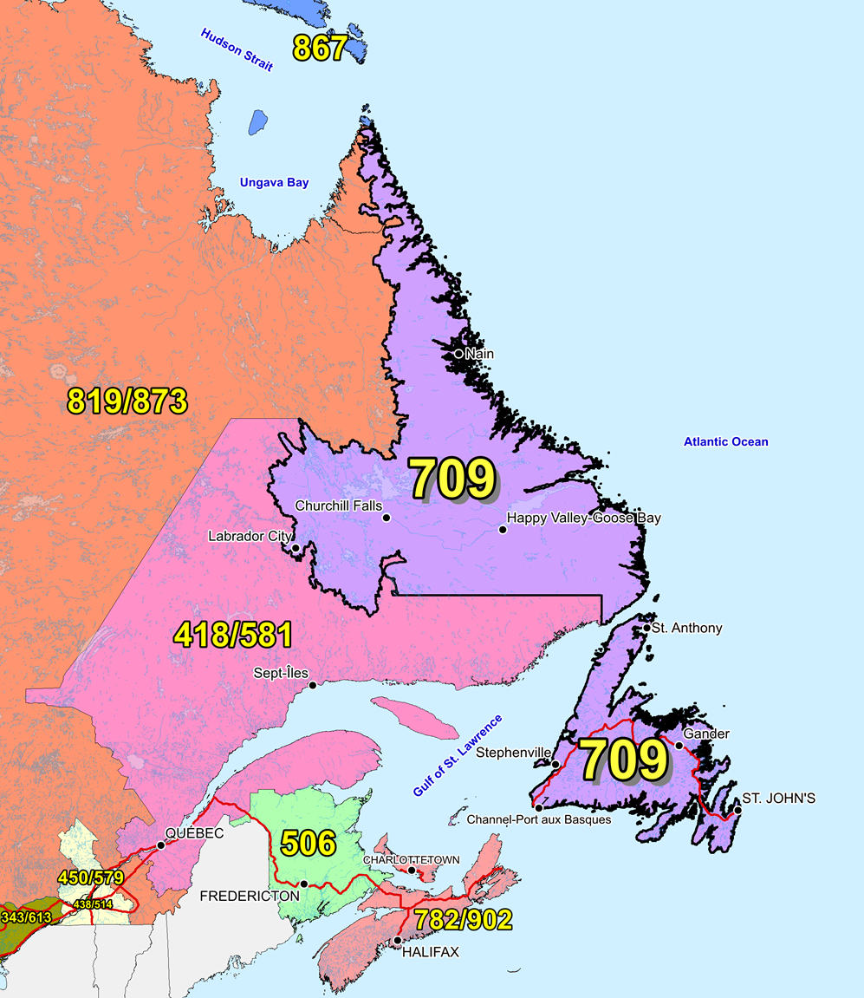

Attachment 2
Exchange Areas in NPA 709

Existing Exchange Areas in NPA 709; these will be in NPA 709 and 879 after the overlay

Arnold's Cove
Badger
Baie Verte
Bay L'Argent
Bay Roberts
Beaumont
Bell Island
Belleoram
Bellevue
Benoit's Cove
Birchy Bay
Bishop's Falls
Black Duck Cove
Black Tickle
Bonavista
Botwood
Boyd's Cove
Branch
Brent's Cove
Brig Bay
Brigus
Brown's Arm
Buchans
Burgeo
Burin
Burlington
Campbellton
Cape Broyle
Carbonear
Carmanville
Cartwright
Catalina
Centreville
Chance Cove
Change Islands
Chapel Arm
Charlottetown (Bonavista Bay)
Charlottetown (Labrador)
Churchill Falls
Clarenville
Clarke's Head
Codroy
Come By Chance
Comfort Cove - Newstead
Conche
Cook's Harbour
Coomb's Cove
Corner Brook
Cottrell's Cove
Cow Head
Daniel's Harbour
Deer Lake
Degras
Eastport
Englee
English Harbour East
English Harbour West
Fairhaven
Fermeuse
Fleur De Lys
Flower's Cove
Fogo
Forteau
Francois
Freshwater
Gambo
Gander
Garden Cove
Garnish
Gaultois
Glenwood
Glovertown
Grand Bank
Grand Falls
Grandois
Green Island Cove
Greenspond
Grey River
Griquet
Hampden
Happy Valley - Goose Bay
Harbour Breton
Harbour Main
Hare Bay
Harry's Harbour
Hawkes Bay
Heart's Content
Heart's Delight
Hermitage
Hickman's Harbour
Hillgrade
Hillview
Hopedale
Horwood
Island Harbour
Isle Aux Morts
Jackson's Arm
Jamestown
Jeffreys
Joe Batt's Arm
King's Cove
King's Point
L'Anse Au Loup
Labrador City - Wabush
Ladle Cove
Lamaline
LaPoile
Lark Harbour
LaScie
Leading Tickles
Lewisporte
Little Bay
Little Bay Islands
Little Harbour
Little Heart's Ease
Long Harbour
Long Pond
Lourdes
Lower Island Cove
Lumsden
Main Brook
Makkovik
Mary's Harbour
Marystown
McCallum
McIvers
Millertown
Milltown
Ming's Bight
Monkstown
Monroe
Moreton's Harbour
Mount Carmel
Musgrave Harbour
Musgravetown
Nain
Natuashish
New Chelsea
New Harbour
Newman's Cove
Nipper's Harbour
Norman's Bay
Norris Arm
Northwest River
Old Perlican
Pacquet
Paradise River
Pasadena
Petit Forte
Pinsent's Arm
Plate Cove
Point Leamington
Pool's Cove
Port Albert
Port Au Port
Port Aux Basques
Port Blandford
Port Hope Simpson
Port Rexton
Port Saunders
Portugal Cove
Postville
Pouch Cove
Princeton
Raleigh
Ramea
Red Bay
Reef's Harbour
Rencontre East
Rigolet
River Of Ponds
Robert's Arm
Rocky Harbour
Roddickton
Rose Blanche
Rushoon
Seal Cove (Fortune Bay)
Seal Cove (White Bay)
Seldom
Sop's Arm
South Brook
Springdale
St. Alban's
St. Anthony
St. Brendan's
St. Bride's
St. George's
St. John's
St. Lawrence
St. Lewis
St. Mary's
Stephenville
Stephenville Crossing
Summerford
Summerside
Terra Nova
Terrenceville
Torbay
Trepassey
Triton
Trout River
Twillingate
Upper Island Cove
Wesleyville
Western Bay
Westport
Whitbourne
Wild Cove
Williams Harbour
Witless Bay
Woody Point

