NPA 226/519/548 RELIEF
(Implementation of New Overlay NPA 382)

NETWORK IMPLEMENTATION TASK FORCE (NITF)
PROGRESS REPORT TO THE RELIEF PLANNING COMMITTEE (RPC)
17 July 2023

INTRODUCTION

This NITF Progress Report is submitted to the Relief Planning Committee (RPC) and CRTC staff for NPA 226/519/548 as required under Telecom Decision CRTC 2018-235.

The objective of the Network Implementation Plan (NIP) is as follow:

- Make all network and interconnection modifications to implement the new NPA Code 382 in the NPA 226/519/548 area.

The role of the NITF is to identify and address network implementation issues that affect all carriers. The responsibilities of the NITF include, but are not limited to:

- Develop and agree on a NIP and schedule;
- Develop and submit progress reports;
- Identify and address NIP issues;
- Act as single point of contact on NIP issues;
- Identify any network concerns or issues regarding the implementation of relief and advise the RPC, the Commission or Commission staff as appropriate; and,
- Develop inter-network test plans, as necessary.

The role of the individual NITF representative of each TSP is to ensure that its TSP organization develops, submits and implements its individual network implementation plan in accordance with the NIP and associated schedule. Each representative acts as the single point of contact for implementation of the NIP and activities for its organization. Each TSP is responsible to develop, submit and implement its individual network implementation plan in accordance with the industry level NIP.

All TSPs are required to provide progress reports to the NITF for submission to the RPC in accordance with the Relief Implementation Schedule.

Test Plans and Tests, if required, shall be arranged on a bilateral basis between interconnecting TSPs in accordance with bilateral agreements and the Relief Implementation Schedule.

Individual TSPs and industry database owners/operators (e.g., Canadian Local Number Portability Consortium) should notify the NITF, or Commission staff, or the Commission, as appropriate, if there are any problems or concerns with modifying their systems and databases in time to implement relief in accordance with the RIP.

The NPA Relief Implementation Plan (RIP) requires periodic progress reports by each Telecommunications Service Provider (TSP) operating in the NPA and by the Network Implementation Task Forces (NITF) established for each NPA relief project.

The Relief Implementation Plan Schedule indicates that the following Progress Reports are required:

49 | TSPs submit Final Report to CATF and NITF (starts on Relief Date and provides 2 weeks for preparation & submission) | TSPs | 2023-06-19 | 2023-07-03
50 | NITF and CATF develop & submit Final Progress Report to RPC (linked to TSP reports to NITF and CATF) | NITF & CATF | 2023-07-04 | 2023-07-18
51 | RPC reviews and approves NITF and CATF Final Progress Report | RPC | 2023-07-18 | 2023-08-01
52 | The RPC submits Final Progress Report to CRTC staff (linked to NITF and CATF reports) | RPC | 2023-08-01 | 2023-08-16

CARRIER PROGRESS REPORTS

Attached to this NITF Progress Report are the individual Progress Reports submitted by the following Carriers (CO Code Holders):

- Allstream
- Bell Canada (including Bell Mobility)
- Bragg Communications (Eastlink)
- Brooke Telecom
- Fibernetics Corporation
- Hay Communications
- Huron Communications
- Quadro Telecommunications
- Rogers Communications (including Fido)
- Teksavvy Solutions
- TELUS (TELUS Mobility and TELUS Integrated Communications)
- Tuckersmith Communications

The known TSPs that did not submit a progress report to the NITF are:

- AMTELECOM
- Beanfield Technologies
- Bruce Telecom
- Comwave Networks
- Distributel Communications
- Execulink Telecom (including No Norwich Telecommunications)
- Freedom Mobile
- Gosfield North Communications
- Innsysvoice
- Iristel
- ISP Telecom
- Ixica Communications
- Managed Network Systems
- Mornington Communications
- Peoples Telecommunications Cooperative of Forest
- Primus Telecommunications
- Wightman Communications

The NITF is not aware of any other current or future TSPs that may decide to operate in the affected NPA prior to the relief date.

NETWORK IMPLEMENTATION PLAN PROGRESS

The NITF is following the schedule in the RIP for this NPA (see Attachment 1). All network implementation activities are proceeding according to the schedule contained in the Relief Implementation Plan (RIP).

The NITF reports that no major problems were identified by TSPs during the implementation of relief in accordance with the current Relief Implementation Plan.

However, the NITF advises that there are several known TSPs that did not submit a progress report to the NITF. It is expected that those TSPs will submit their reports directly to the CRTC.

Submitted by:

Marie-Christine Hudon
Chair NITF

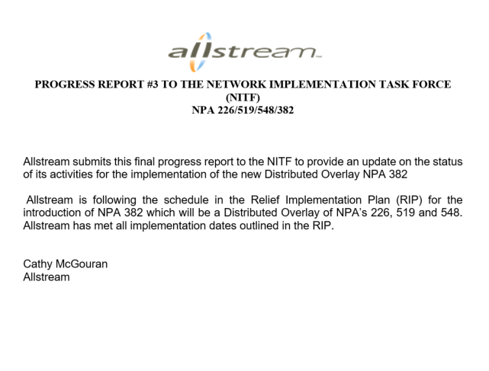

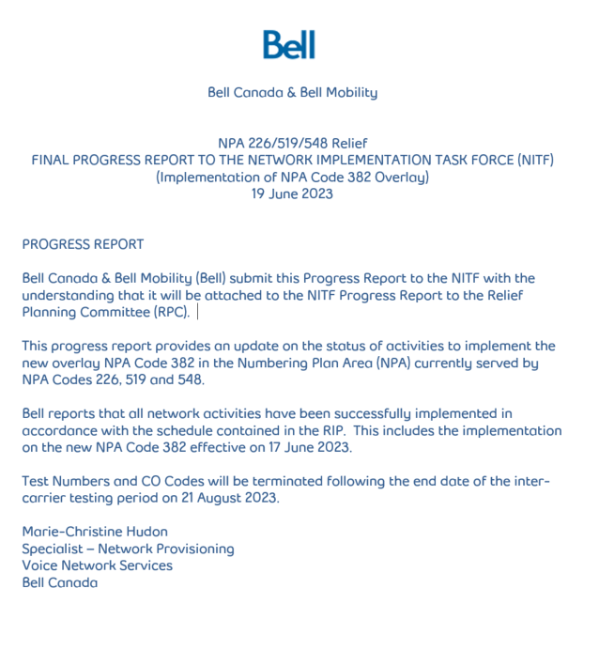

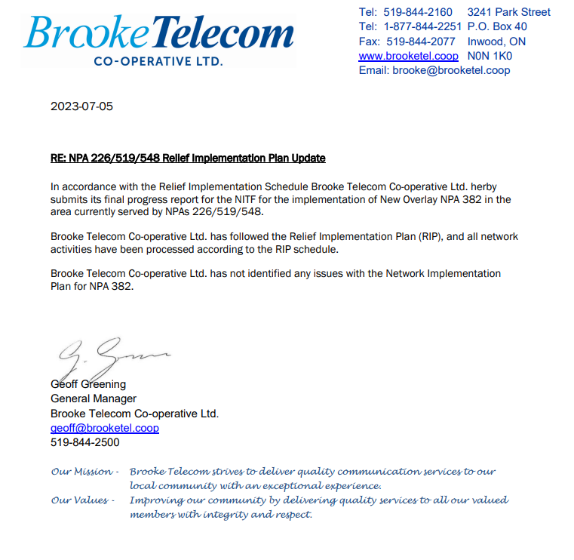

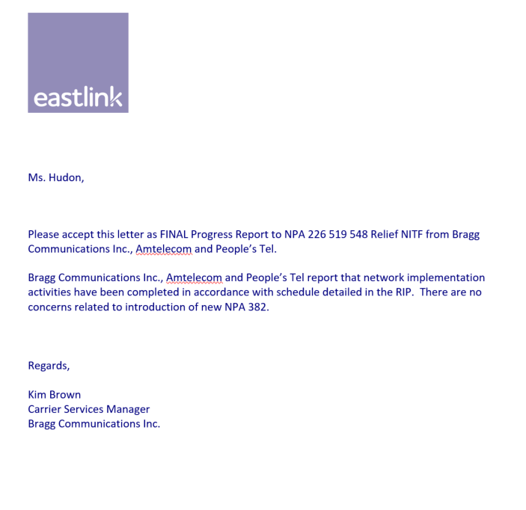

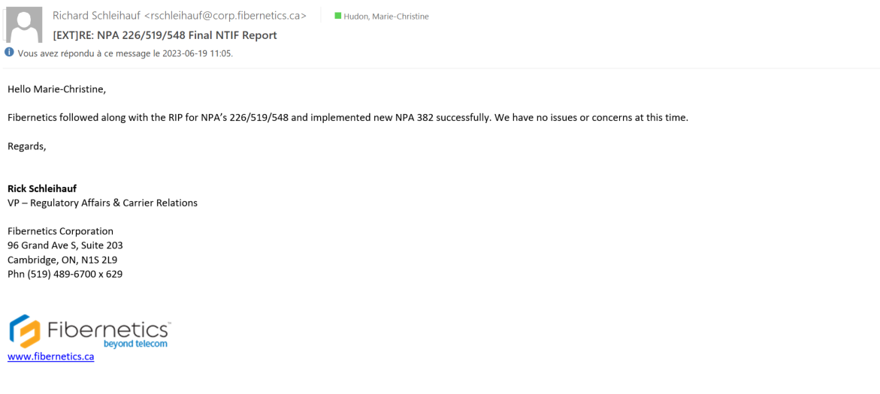

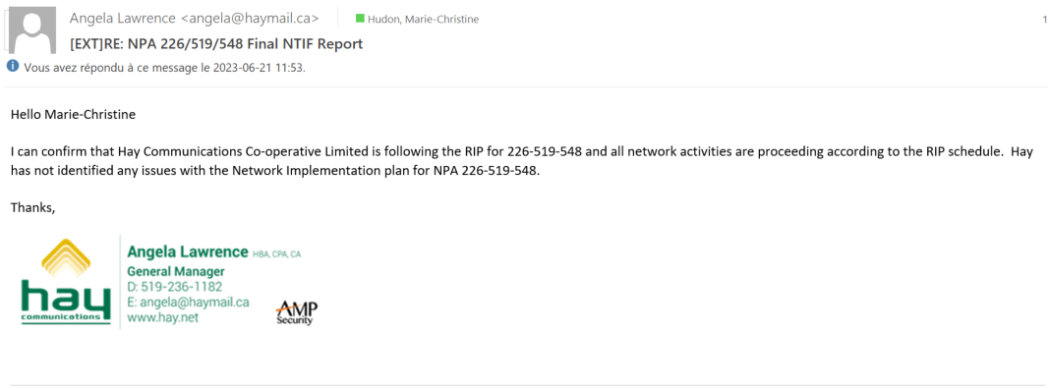

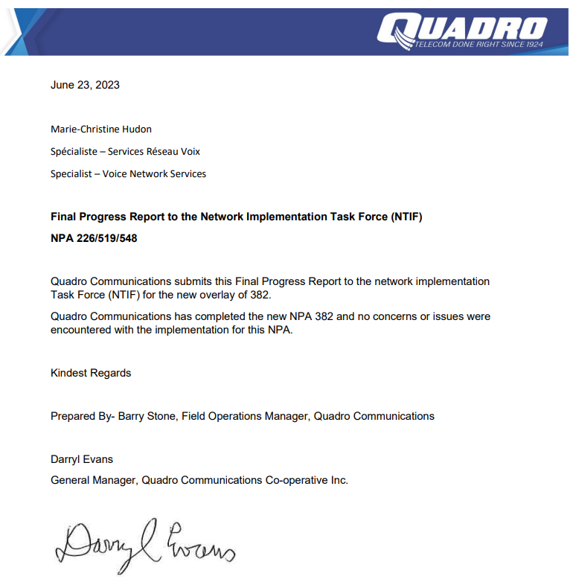

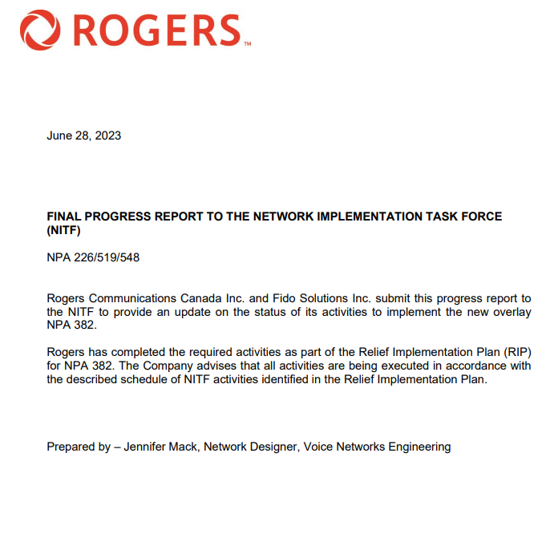

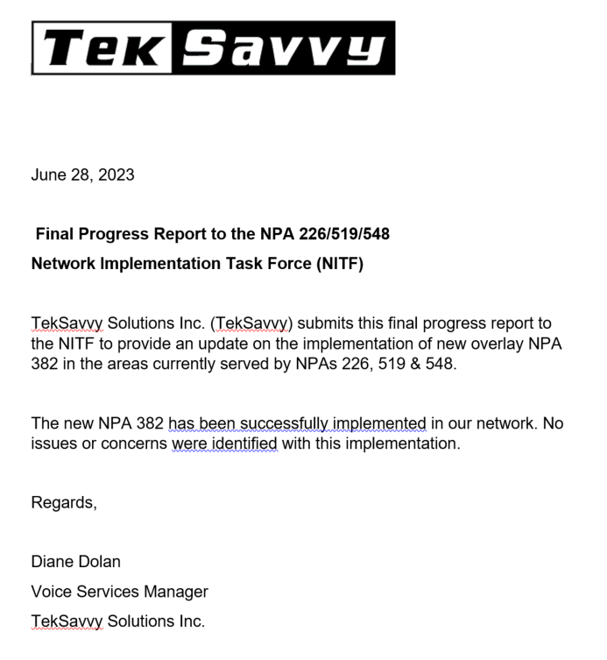

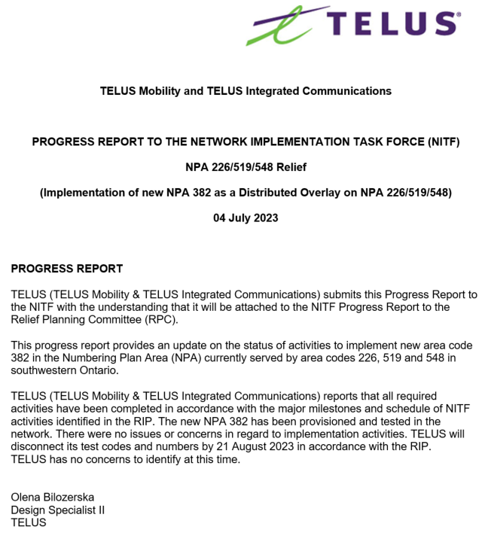

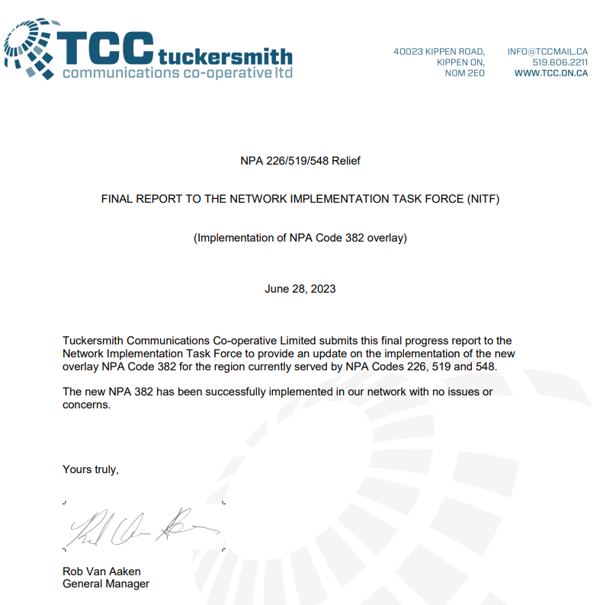

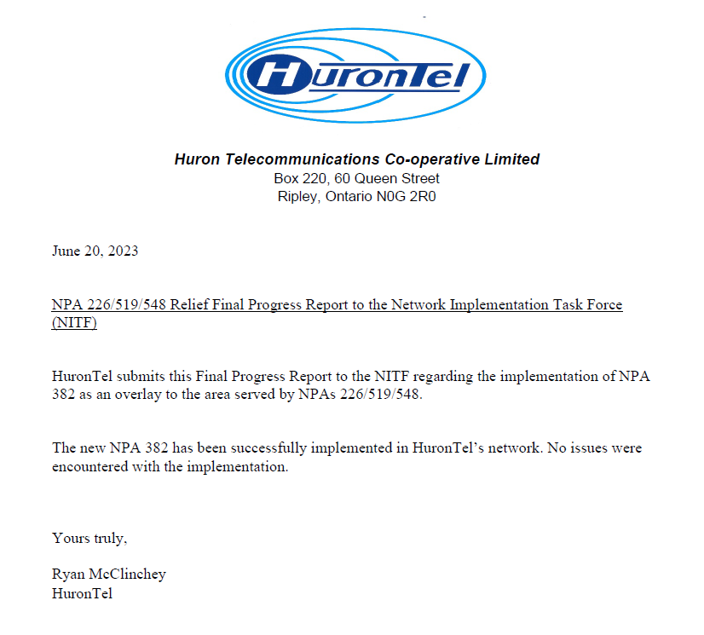

Attachment 1
NPA 226/519/548 Relief Schedule

Item | Task or Event | PRIME | START | END
1 | NPA 382 is set aside for future relief of southwestern Ontario NPAs 226/519/548 per Telecom Decision CRTC 2013-575. For the purpose of this document the new NPA will be 382 | CRTC |  | October 30, 2013
2 | CNA identifies NPA exhaust of January 2025 and notifies CRTC staff, CSCN, NANPA & CISC by email that the NPA will exhaust within the future six year time period | CNA |  | February 23, 2021
3 | CNA published the Initial R-NRUF (July 2021) results which indicated that PED has deferred to August 2024 | CNA | June 15, 2021 | August 19, 2021
4 | CRTC issues Telecom Notice of Consultation regarding establishment of an ad hoc Relief Planning Committee | CRTC |  | July 30, 2021
5 | RPC Chair starts preparing and submitting RPC Chair Reports to the CISC, on an as required basis. | RPC Chair | July 30, 2021 | September 26, 2023
6 | CNA conducts January 2021 R-NRUF results indicating the PED has advanced to April 2024. | CNA |  | February 23, 2021
7 | CNA issues July 2021 R-NRUF results indicating the PED has been deferred to August 2024. | CNA |  | August 19, 2021
8 | CNA releases the PROC | CNA |  | September 21, 2021
9 | RPC participants review PROC & submit contributions to RPC |  | September 21, 2021 | October 13, 2021
10 | CNA chairs initial RPC conference call to start development of PD and RIP and schedules future meetings/conference calls including creation & consultation with CATF and NITF | CNA, RPC | October 14, 2021 | October 14, 2021
11 | CNA chairs subsequent RPC conference calls to finalize PD & RIP | CNA, RPC | October 14, 2021 | October 28, 2021
12 | CNA forwards the PD and RIP to the CISC and CRTC for approval | CNA | October 28, 2021 | November 4, 2021
13 | Special Types of Telecommunications Service Users (911 PSAPs, alarm companies, ISPs, paging companies, etc.) to identify any concerns to RPC & CRTC | Special Users | October 14, 2021 | November 4, 2021
14 | CRTC issues Telecom Decision approving the Relief Method, Relief Date, New NPA and RIP | CRTC | November 4, 2021 | May 4, 2022
15 | CNA obtains relief NPA from NANPA | CNA | May 4, 2022 | May 6, 2022
16 | All Telecom Service Providers (TSPs) to develop and file individual consumer awareness programs with the CRTC (may be done collectively by Telecommunications Alliance) (starts upon CRTC approval of RIP) | TSPs | May 4, 2022 | September 17, 2022
17 | CNA submits PL to NANPA | CNA |  | May 6, 2022
18 | NANPA receives and posts Planning Letter to NANPA website (within 2 weeks of receipt from the CNA) | NANPA | May 6, 2022 | May 17, 2022
19 | All TSPs implement consumer awareness activities (starts upon filing of Consumer Awareness Programs with the CRTC and is completed on the Relief Date) | TSPs | September 17, 2022 | June 17, 2023
20 | CNA issues media release (in coordination with TSPs and/or Telecommunication Alliance) (may start upon CRTC approval of RIP) | CNA | May 4, 2022 | November 17, 2022
21 | All TSPs to notify all customers (including residence, business & special customers) of the new overlay NPA (may start upon the filing of Consumer Awareness Programs with the CRTC) | TSPs | September 17, 2022 | November 17, 2022
22 | TSPs to submit Progress Report #1 to NITF and CATF (starts after completion date for all TSPs to notify their customers and requires 2 weeks) | TSPs | November 17, 2022 | December 1, 2022
23 | NITF and CATF develop & submit Progress Report #1 to RPC (linked to TSP reports to NITF and CATF) | NITF & CATF | December 1, 2022 | December 15, 2022
24 | RPC reviews and approves NITF and CATF Progress Report #1 | RPC | December 15, 2022 | January 13, 2023
25 | RPC submits Progress Report #1 to CRTC staff (linked to NITF and CATF reports) | RPC | January 13, 2023 | January 27, 2023
26 | CNA submits database updates to iconectiv for the new NPA (starts at date of PL publication and should be completed by 7 months before the Test Date) | CNA |  | August 17, 2022
27 | iconectiv TRA database updates to add Exchange Areas to new overlay NPA (starts on the date that the PL is posted to the NANPA web site and must be completed by 6 months prior to the Test Date) | iconectiv TRA | August 17, 2022 | September 17, 2022
28 | All Telecommunications Service Users (including Special Users 911 PSAPs, alarm companies, ISPs, paging companies, etc.) to implement changes to their telecom equipment & systems to accommodate the new NPA (starts upon CRTC approval of RIP and ends on the Relief Date) | Telecom Service Users | May 4, 2022 | June 17, 2023
29 | Payphone Providers Reprogram Payphones (starts upon CRTC approval of RIP and ends on the Relief Date) | Payphone Providers | May 4, 2022 | June 17, 2023
30 | TSPs and database owners/operators to modify systems and industry databases (starts upon CRTC approval of RIP and ends on the Relief Date) | TSPs & Database Owners | May 4, 2022 | June 17, 2023
31 | Operator Services & Directory Assistance Readiness (starts upon CRTC approval of RIP and ends on the Relief Date) | TSPs | May 4, 2022 | June 17, 2023
32 | Directory Publisher Readiness for overlays (ability to identify the NPA in telephone numbers in the directory published after the Overlay NPA is activated) (starts upon CRTC approval of RIP and ends on the Relief Date) | Directory Publishers | May 4, 2022 | June 17, 2023
33 | 9-1-1 Systems and Databases Readiness (starts upon CRTC approval of RIP and ends on the Relief Date) | PSAPS, 9 1 1 Service Providers & TSPs | May 4, 2022 | June 17, 2023
34 | Network Systems & Equipment Readiness (starts upon CRTC approval of RIP and ends on the Relief Date) | TSPs | May 4, 2022 | June 17, 2023
35 | Service Order & Business System Readiness (starts upon CRTC approval of RIP and ends on the Relief Date) | TSPs | May 4, 2022 | June 17, 2023
36 | International Gateway Switch Translations Readiness for new NPA (starts upon CRTC approval of RIP and ends on the Relief Date) | Int’l TSPs | May 4, 2022 | June 17, 2023
37 | Canadian Local Number Portability Consortium (CLNPC) Database Readiness for new NPA (starts upon CRTC approval of RIP and ends on the Relief Date) | CLNPC & NPAC | May 4, 2022 | June 17, 2023
38 | Toll Free SMS Database Readiness for new NPA (starts upon CRTC approval of RIP and ends on the Relief Date) | Toll TSPs | May 4, 2022 | June 17, 2023
39 | TSPs apply for Test CO Codes in new NPA (applications may be submitted no more than 6 months and no less than 66 days prior to the start date for the Inter-Carrier Testing Period) (Section 7.16.4 Canadian RP GL) | TSPs | September 17, 2022 | January 10, 2023
40 | Develop Inter-Carrier Network Test Plans and prepare for testing (individual TSPs to make arrangements in accordance with interconnection agreements) (may start upon CRTC approval of RIP and must be completed by start date for the Inter-Carrier Testing Period) | NITF & TSPs | May 4, 2022 | March 17, 2023
41 | All international and domestic Telecommunications Service Providers (TSPs) must activate the new NPA in their networks by the start date for the Inter-Carrier Testing Period | TSPs | May 4, 2022 | March 17, 2023
42 | Activation date for Overlay NPA Test CO Codes and Test Numbers in network (should be completed by the start date for the Inter-Carrier Testing Period) | TSPs |  | March 17, 2023
43 | Inter-Carrier Testing Period (subject to Inter-Carrier Network Test Plans) (starts about 3 months prior to the Relief Date, and ends about 1 month after the Relief Date) | NITF & TSPs | March 17, 2023 | July 14, 2023
44 | TSPs to submit Progress Report #2 to NITF (starts on commencement of Inter-Carrier Testing Period) | TSPs | March 17, 2023 | March 31, 2023
45 | NITF develops & submits Progress Report #2 to RPC (linked to TSP reports to NITF) | NITF | March 31, 2023 | April 18, 2023
46 | RPC reviews and approves NITF Progress Report #2 | RPC | April 18, 2023 | May 2, 2023
47 | RPC submits Progress Report #2 to CRTC staff (linked to NITF report) | RPC | May 2, 2023 | May 16, 2023
48 | Relief Date (earliest date when CO Codes in new NPA may be activated) |  |  | June 17, 2023
49 | TSPs submit Final Report to CATF and NITF (starts on Relief Date and provides 2 weeks for preparation & submission) | TSPs | June 19, 2023 | July 3, 2023
50 | NITF and CATF develop & submit Final Progress Report to RPC (linked to TSP reports to NITF and CATF) | NITF & CATF | July 4, 2023 | July 18, 2023
51 | RPC reviews and approves NITF and CATF Final Progress Report | RPC | July 18, 2023 | August 1, 2023
51 | The RPC submits Final Progress Report to CRTC staff (linked to NITF and CATF reports) | RPC | August 1, 2023 | August 16, 2023
52 | TSPs disconnect Test Codes & Numbers, and submit Part 1 form to return Test Codes (starts 1 month after Relief Date and allows 1 month for completion) | TSPs | July 14, 2023 | August 21, 2023
53 | RPC Chair submits, to the CISC, the final RPC Chair report indicating that the NPA 226/519/548 ad hoc RPC is no longer required | RPC Chair | August 21, 2023 | September 26, 2023

